Experiment 1: Confusion Matrix

Aim
To compare actual and predicted values using a confusion matrix and visualize it as a heatmap.

Python Program
import numpy as np
from sklearn.metrics import confusion_matrix
import seaborn as sns
import matplotlib.pyplot as plt

actual = np.array(['Dog','Dog','Dog','Not Dog','Dog',
'Not Dog','Dog','Dog','Not Dog','Not Dog'])
predicted = np.array(['Dog','Not Dog','Dog','Not Dog','Dog',
'Dog','Dog','Dog','Not Dog','Not Dog'])

conf_matrix = confusion_matrix(actual, predicted)
print(conf_matrix)
sns.heatmap(conf_matrix, annot=True, fmt='g',
xticklabels=['Dog','Not Dog'],
yticklabels=['Dog','Not Dog'], cmap='RdPu')
plt.xlabel('Predicted', fontsize=16)
plt.ylabel('Actual', fontsize=16)
plt.title('Confusion Matrix', fontsize=20)
plt.show()

Sample Output
[[5 1]
[1 3]]
Correct predictions = 5 + 3 = 8
Accuracy = (8 / 10) x 100 = 80%
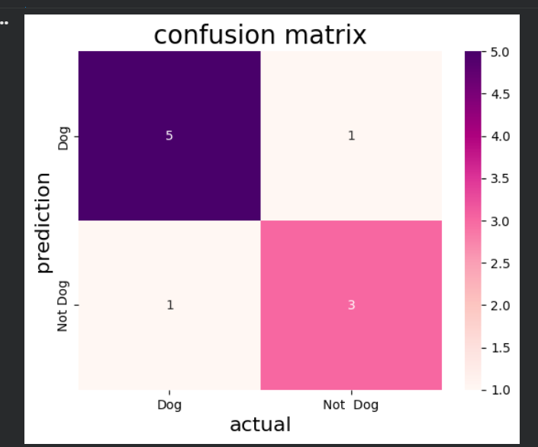

Result
The confusion matrix was displayed successfully and the accuracy was 80%.

