Experiment 2: Covariance, Eigenvalues and Eigenvectors Analysis

Aim
To calculate covariance, eigenvalues and eigenvectors using NumPy and Pandas, and visualize the data with Matplotlib.

Python Program
import numpy as np
import pandas as pd
import matplotlib.pyplot as plt

data = {'X': [2, 4, 6, 8, 10],
'Y': [3, 5, 7, 9, 11]}
df = pd.DataFrame(data)
print('Dataset:\n', df)

cov = df.cov()
print('Covariance Matrix:\n', cov)
values, vectors = np.linalg.eig(cov)
print('Eigenvalues:\n', values)
print('Eigenvectors:\n', vectors)

plt.scatter(df['X'], df['Y'], color='blue')
plt.xlabel('X')
plt.ylabel('Y')
plt.title('Covariance Analysis')
plt.show()

Sample Output
Covariance Matrix:
X Y
X 10.0 10.0
Y 10.0 10.0
Eigenvalues: [20. 0.]
Eigenvectors (signs may vary):
[[ 0.7071 -0.7071]
[ 0.7071 0.7071]]
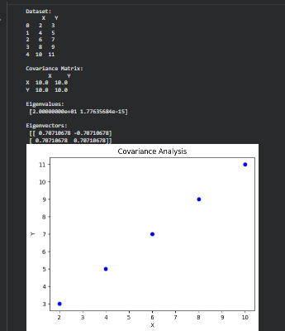

Result
The covariance matrix, eigenvalues and eigenvectors were calculated successfully and the scatter plot was displayed.

