Experiment 3: Probability Distributions and Bayes’ Theorem
Aim
To calculate a probability distribution, apply Bayes’ theorem and visualize the distribution using Python.
Python Program
import numpy as np
import matplotlib.pyplot as plt
x = np.array([1, 2, 3, 4, 5])
p = np.array([0.1, 0.2, 0.3, 0.2, 0.2])
print('Values:', x)
print('Probabilities:', p)
print('Total Probability:', np.sum(p))
pa = 0.6
pb = 0.5
pba = 0.4
pab = (pba * pa) / pb
print('Bayes Probability:', pab)
plt.bar(x, p, color='blue')
plt.xlabel('Values')
plt.ylabel('Probability')
plt.title('Probability Distribution')
plt.show()

Sample Output
Values: [1 2 3 4 5]
Probabilities: [0.1 0.2 0.3 0.2 0.2]
Total Probability: 1.0
Bayes Probability: 0.48
Formula: P(A|B) = P(B|A) x P(A) / P(B)
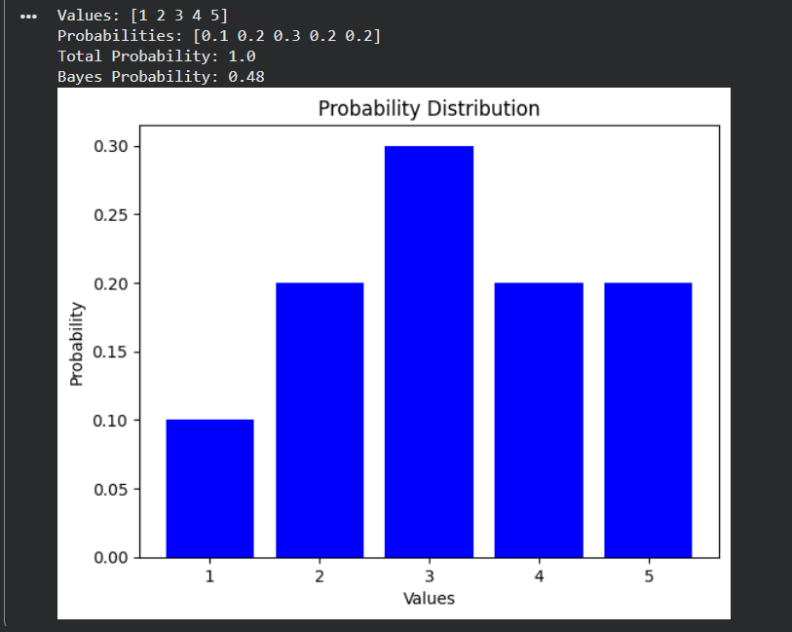
Result
The probability distribution was visualized successfully and Bayes’ theorem gave
P(A|B) = 0.48 (48%).

