**Subchapter1(Complexity Analysis and Notations, Sorting and Searching Algorithms)**

# Time and Space complexity

## What is efficiency in programming?

Efficiency in programming refers to the optimization of various aspects of a software system to ensure it operates smoothly, effectively, and with minimal resource consumption. This optimization can involve several dimensions:

* **Time Efficiency:** This refers to how quickly a program executes its tasks. Efficient programs minimize execution time by employing algorithms and data structures that are designed to perform tasks in the fastest possible manner.
* **Space Efficiency**: Also known as memory efficiency, this refers to the amount of memory a program uses to store data and execute tasks. Efficient programs manage memory usage carefully, avoiding unnecessary allocation and deallocation of memory and minimizing the overall memory footprint.
* **Algorithmic Efficiency:** This involves choosing the most appropriate algorithms and data structures for a given task. Some algorithms are inherently more efficient than others for specific types of operations, so selecting the right algorithm can greatly impact the overall efficiency of a program.
* **Resource Efficiency:** This encompasses the efficient utilization of hardware resources such as CPU, disk I/O, network bandwidth, etc. Efficient programs manage resources effectively to minimize wastage and ensure optimal performance.
* **Code Efficiency:** This involves writing clean, concise, and well-structured code that is easy to understand, maintain, and debug. Efficient code is also modular and reusable, reducing duplication and promoting code organization.

Efficiency in programming is crucial because it directly impacts factors such as user experience, system performance, scalability, and resource utilization. Writing efficient code requires careful planning, profiling, and optimization throughout the development process.

**Why efficiency is important?**

Efficiency in programming is important for several reasons:

* **Performance:** Efficient programs run faster and use fewer system resources, resulting in better overall performance. This is critical for applications that require real-time responsiveness or handle large volumes of data.
* **Cost-Effectiveness:** Efficient programs consume fewer resources such as CPU time, memory, and energy, leading to cost savings, especially in cloud computing environments where resource usage is billed.
* **Scalability:** Efficient programs are better equipped to handle increased workloads and scale with growing user demands. They can accommodate more users or process larger datasets without experiencing performance degradation.
* **User Experience:** Efficient programs provide a smoother and more responsive user experience. Users expect applications to respond quickly to their inputs, and inefficient programs can lead to frustration and dissatisfaction.
* **Reliability:** Inefficient code may lead to memory leaks, excessive CPU usage, or other issues that can cause crashes or system failures. Efficient programs are more reliable and less prone to such problems.
* **Competitive Advantage:** In competitive markets, efficiency can be a key differentiator. Products and services that perform better and consume fewer resources are more likely to gain a competitive edge and attract users.
* **Maintainability**: Efficient code is often more readable, modular, and well- organized, making it easier to maintain and debug. This reduces the time and effort required for ongoing development and support.

Overall, efficiency is crucial for achieving optimal performance, cost- effectiveness, scalability, reliability, and user satisfaction in software development. It requires careful attention to design, algorithm selection, resource management, and code optimization throughout the development lifecycle.

## Time Efficiency

**Time Efficiency:** Time efficiency refers to how quickly a program can complete its tasks or operations. It is concerned with minimizing the time taken to execute algorithms, process data, and respond to user inputs. Time-efficient programs are able to accomplish their objectives in the shortest possible time, leading to better user experience, improved system performance, and increased productivity.

Techniques for improving time efficiency include:

* **Using efficient algorithms and data structures:** Choosing algorithms and data structures that have lower time complexity (such as O(1), O(log n), O(n), etc.) for the specific tasks at hand.
* **Algorithm optimization:** Refining algorithms to reduce unnecessary operations, improve loop structures, or apply optimization techniques like memorization or dynamic programming.
* **Parallelization:** Leveraging concurrency and parallel processing to execute tasks simultaneously, thus reducing overall execution time. Profiling and optimization: Identifying performance bottlenecks through profiling tools and optimizing critical sections of code for faster execution.

## Space Efficiency

Space Efficiency: Space efficiency, also known as memory efficiency, refers to how effectively a program manages and utilizes memory resources. It involves minimizing the amount of memory required to store data structures, variables, and program instructions. Space-efficient programs consume less memory, reducing the risk of memory exhaustion, improving system stability, and allowing more efficient use of hardware resources.

Techniques for improving space efficiency include:

* **Choosing appropriate data structures:** Selecting data structures that minimize memory overhead and suit the requirements of the application, such as arrays, linked lists, trees, or hash tables.
* **Memory management:** Efficiently allocating and deallocating memory, avoiding memory leaks, and minimizing fragmentation through techniques like object pooling or smart pointers.
* **Data compression:** Compressing data to reduce its memory footprint while maintaining integrity, especially useful for storing large datasets or transferring data over networks.
* **Garbage collection:** Employing garbage collection mechanisms to automatically reclaim memory occupied by unused objects or variables, reducing memory wastage. Both time and space efficiency are critical considerations in software development, as they directly impact the performance, scalability, reliability, and resource utilization of software systems. Balancing time and space efficiency often involves trade-offs, and developers must carefully consider the requirements and constraints of their applications to optimize both aspects effectively.

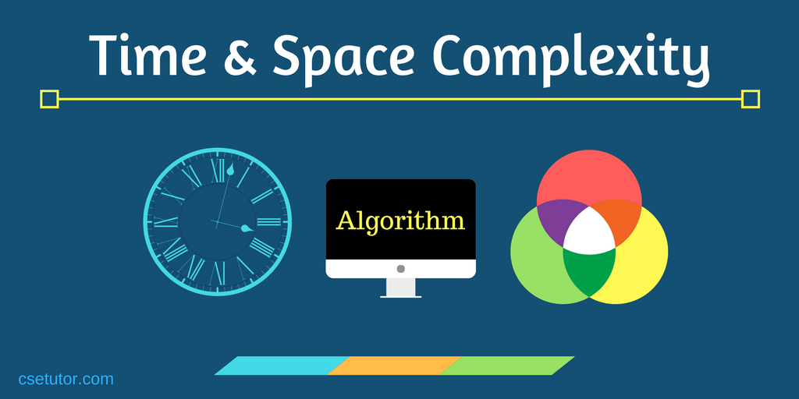

## Understanding time and space complexity analysis of algorithms:

### Time Complexity:

* + Time complexity is a measure of the amount of time an algorithm takes to run as a function of the length of the input.
  + It helps in understanding how the runtime of an algorithm grows with the size of the input.
  + It is often expressed using Big O notation, which describes the upper bound on the growth rate of an algorithm's runtime.

### Space Complexity:

* + Space complexity is a measure of the amount of memory space an algorithm requires as a function of the length of the input.
  + It helps in understanding how much memory an algorithm consumes relative to the size of the input.
  + Similar to time complexity, space complexity is also expressed using Big O notation.

### Big O Notation:

* + Big O notation provides an upper bound on the growth rate of an algorithm's time or space requirements.
  + It describes the worst-case scenario of an algorithm's performance.
  + Common notations include O(1) for constant time, O(n) for linear time, O(n^2) for quadratic time, etc.

### How to Analyse Time Complexity:

* + Identify the basic operations in the algorithm.
  + Determine how many times each basic operation is executed in terms of the input size.
  + Combine these counts into an expression, and simplify it to find the dominant term, which represents the overall time complexity.

### How to Analyse Space Complexity:

* + Identify the memory usage of the algorithm, including variables, data structures, and recursive calls.
  + Determine how the memory usage scales with the input size.
  + Express the space usage as a function of the input size, and simplify it to find the dominant term, which represents the overall space complexity.

### Comparing Algorithms:

* + Time and space complexity analysis allows us to compare different algorithms and choose the most efficient one for a given problem.
  + An algorithm with lower time and space complexity is generally considered more efficient.

### Importance of Complexity Analysis:

* + Complexity analysis helps in designing efficient algorithms and optimizing existing ones.
  + It provides insights into the scalability of algorithms, helping in making informed decisions about algorithm selection in various contexts.

### Limitations:

* + Time and space complexity analysis provides theoretical insights but may not always reflect real-world performance accurately.
  + It assumes uniformity in input distribution and hardware characteristics, which may not hold true in practical scenarios.

### Trade-offs:

* + Sometimes, optimizing for one aspect (e.g., time complexity) may result in a trade-off with another aspect (e.g., space complexity).
  + Understanding these trade-offs is crucial in algorithm design and optimization.

### Continuous Learning:

* + As you encounter more algorithms and problems, continue practicing time and space complexity analysis to improve your skills in algorithm design and analysis.

## Big o notation and its significance in measuring algorithm efficiency notes.

Big O notation is a mathematical notation used in computer science to describe the asymptotic behaviour of functions and algorithms. Here are some notes on Big O notation and its significance in measuring algorithm efficiency:

### Definition:

* + Big O notation represents the upper bound or worst-case scenario of the time or space complexity of an algorithm.
  + It describes how the runtime or memory usage of an algorithm grows as the size of the input increases.

### Significance:

* + Big O notation provides a standardized and concise way to compare the efficiency of algorithms without getting into implementation-specific details.
  + It helps in understanding how an algorithm will perform as the size of the input approaches infinity.
  + Big O notation is crucial for analysing and optimizing algorithms, as it highlights areas where improvements can be made to enhance efficiency.

### Key Concepts:

* + **O(1):** Constant time complexity. The runtime or space usage of the algorithm remains constant regardless of the size of the input.
  + **O(n):** Linear time complexity. The runtime or space usage of the algorithm grows linearly with the size of the input.
  + **O(log n):** Logarithmic time complexity. The runtime grows logarithmically with the size of the input.
  + **O(n^2):** Ǫuadratic time complexity. The runtime grows quadratically with the size of the input.
  + **O(2^n):** Exponential time complexity. The runtime grows exponentially with the size of the input.

### Importance:

* + Efficient algorithms with lower time or space complexity (lower Big O notation) are preferred in real-world applications, especially for large datasets or performance-critical systems.
  + Big O notation helps in selecting the most appropriate algorithm for a given problem, balancing between time and space efficiency based on the requirements.

### Limitations:

* + Big O notation provides an upper bound on the growth rate of an algorithm but may not accurately reflect its performance in all cases.
  + It simplifies complex runtime behaviours into broad categories, potentially overlooking constant factors, lower-order terms, or specific input distributions.

### Analysing Algorithms:

* + When analysing algorithms, it's essential to consider both time and space complexity to understand their overall efficiency.
  + Big O notation allows for a systematic approach to compare algorithms and identify the most efficient solution for a given problem.

### Continuous Learning:

* + Understanding Big O notation is essential for any computer scientist or programmer.
  + Continuous practice and exposure to different algorithms and problem- solving techniques help in mastering the concepts of algorithm efficiency and complexity analysis.

In summary, Big O notation is a fundamental concept in computer science for measuring algorithm efficiency. It provides a standardized way to describe how the runtime or space usage of an algorithm scales with the size of the input, enabling informed decisions in algorithm design and optimization.

### What is sorting and searching algorithm?

**Sorting Algorithm:** A sorting algorithm is a method for arranging the elements of a list or array in a specific order, typically in ascending or descending order. The primary goal of sorting algorithms is to rearrange the elements of the list into a particular sequence, making it easier to search for specific elements, perform efficient data retrieval, and facilitate various operations like binary search, merge, or join operations.

**Searching Algorithm:** A searching algorithm is a method used to locate a target value within a collection of data. The collection can be an array, list, or any other data structure. Searching algorithms typically take a target value and a collection of data as input and determine whether the target value exists within the collection. If the target value is found, the algorithm may also return the index or position of the value in the collection. Searching algorithms are essential for efficiently retrieving specific information from large datasets or collections of data.

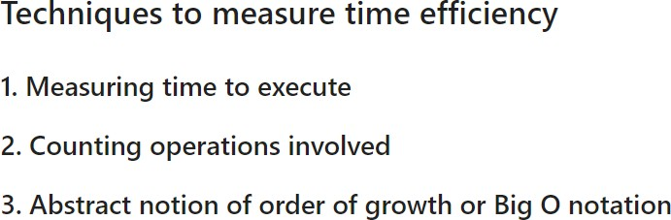

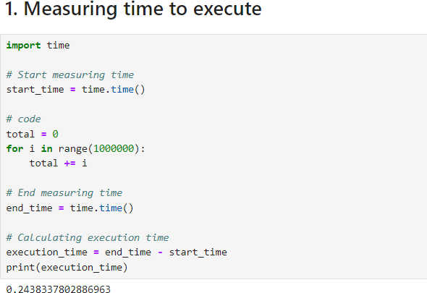

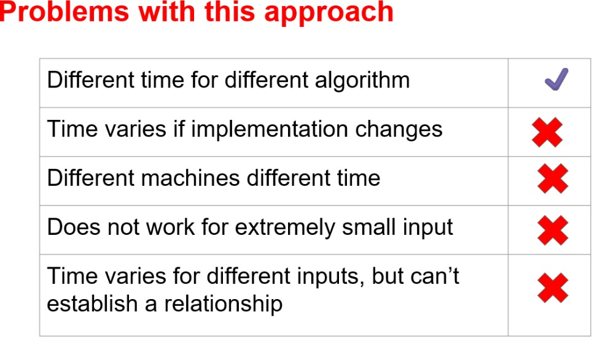

## Counting the operation involved

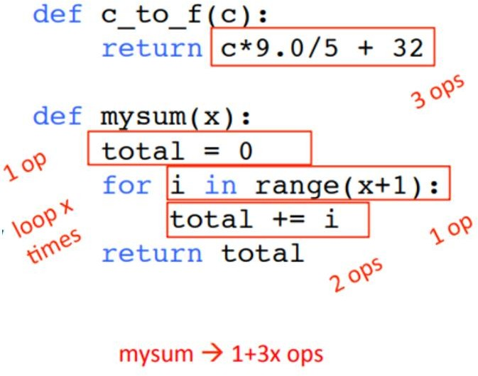

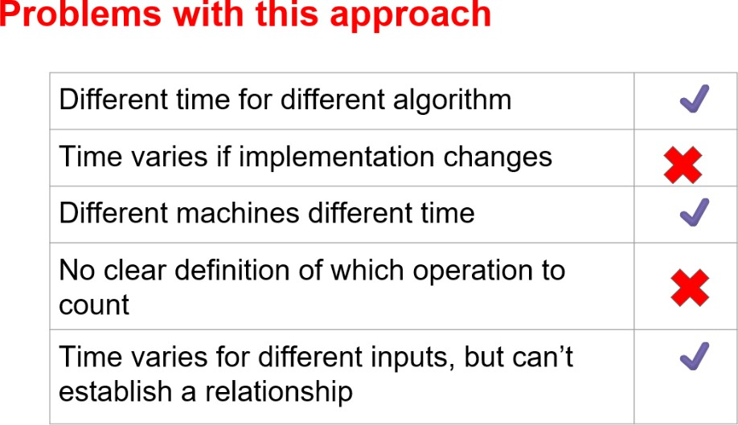

1. **Big 0 notation**
   1. To solve a problem there can be multiple algorithms, we want to find the best and efficient algorithm.
   2. We want to evaluate the scalability, for smaller problems every algorithm behaves in the same way, but for a big algorithm the time and space efficiency matters a lot. example the frontend of a website.
   3. We want to evaluate in terms of input size means the mathematical relationship between the input and time efficiency.

* Best case --> When the number is the first element in the list.¶
* Average case --> When the number is in between the list.
* Worst case --> when the number is in last position or number is not in the list

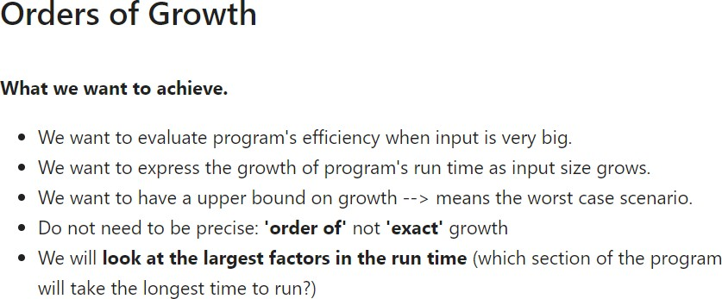

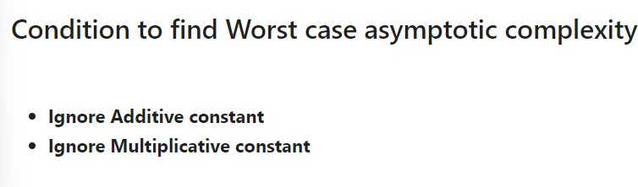

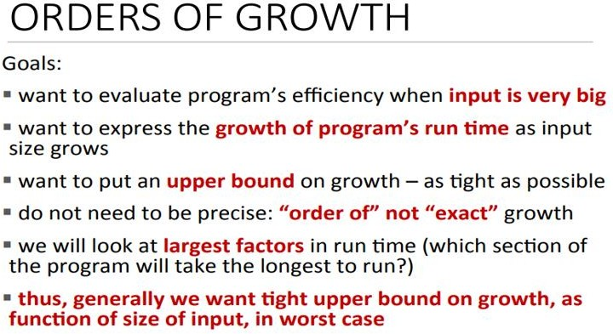

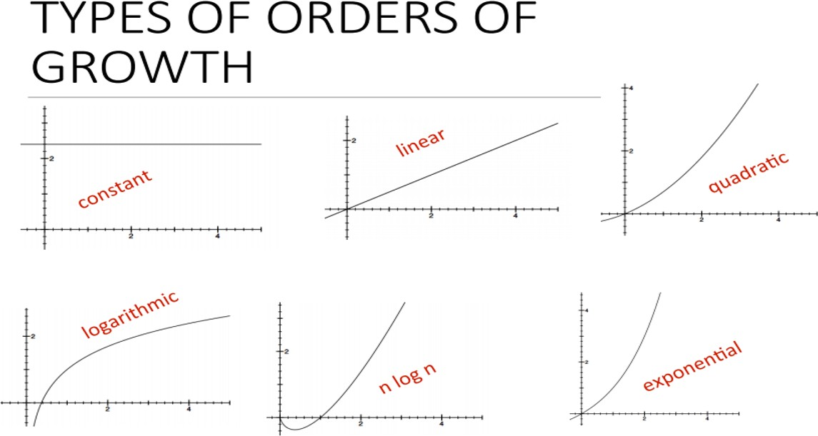

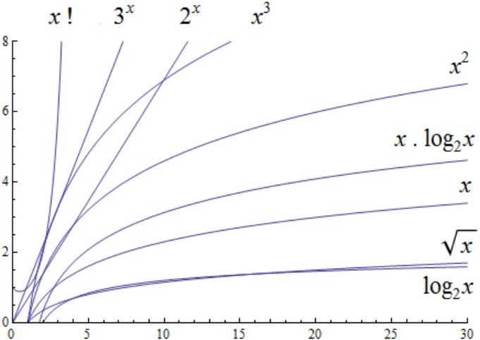

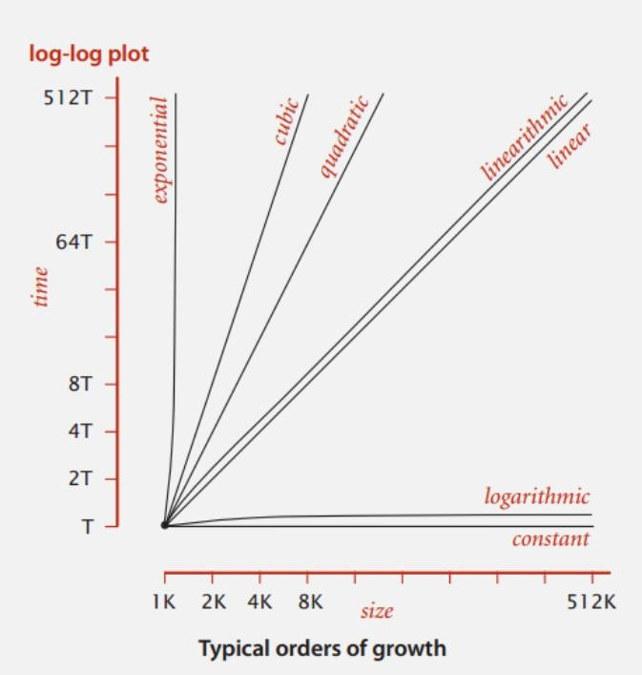

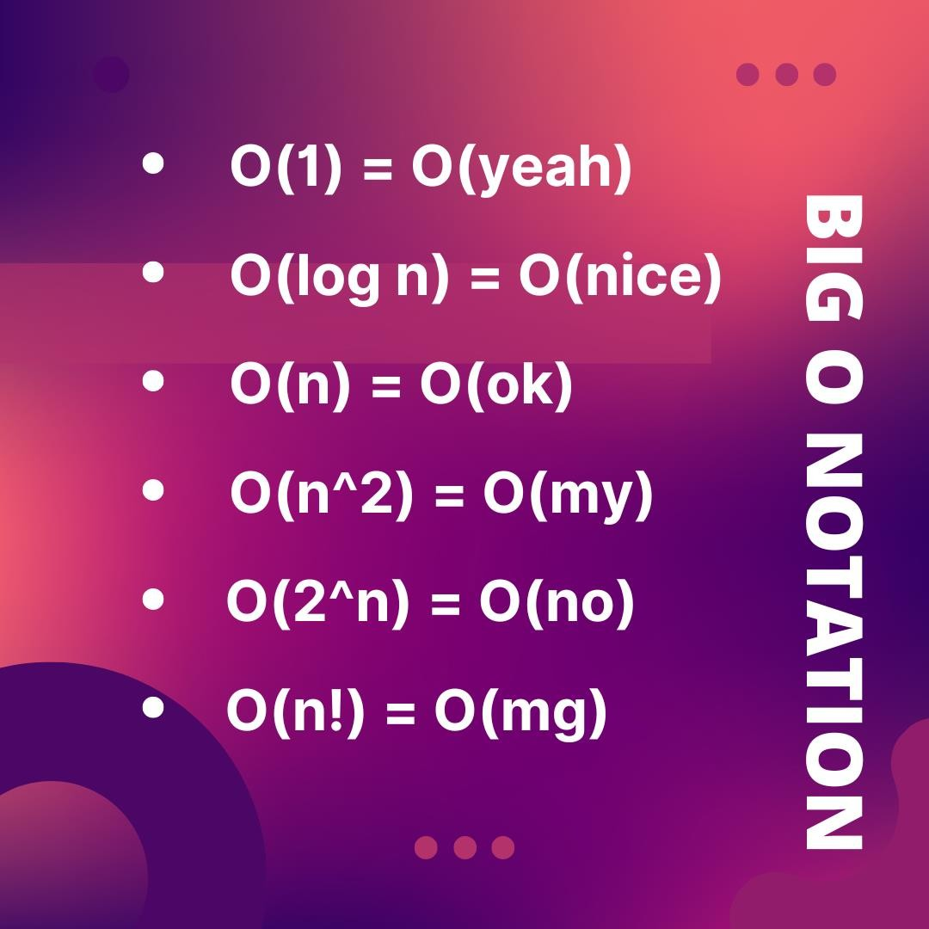

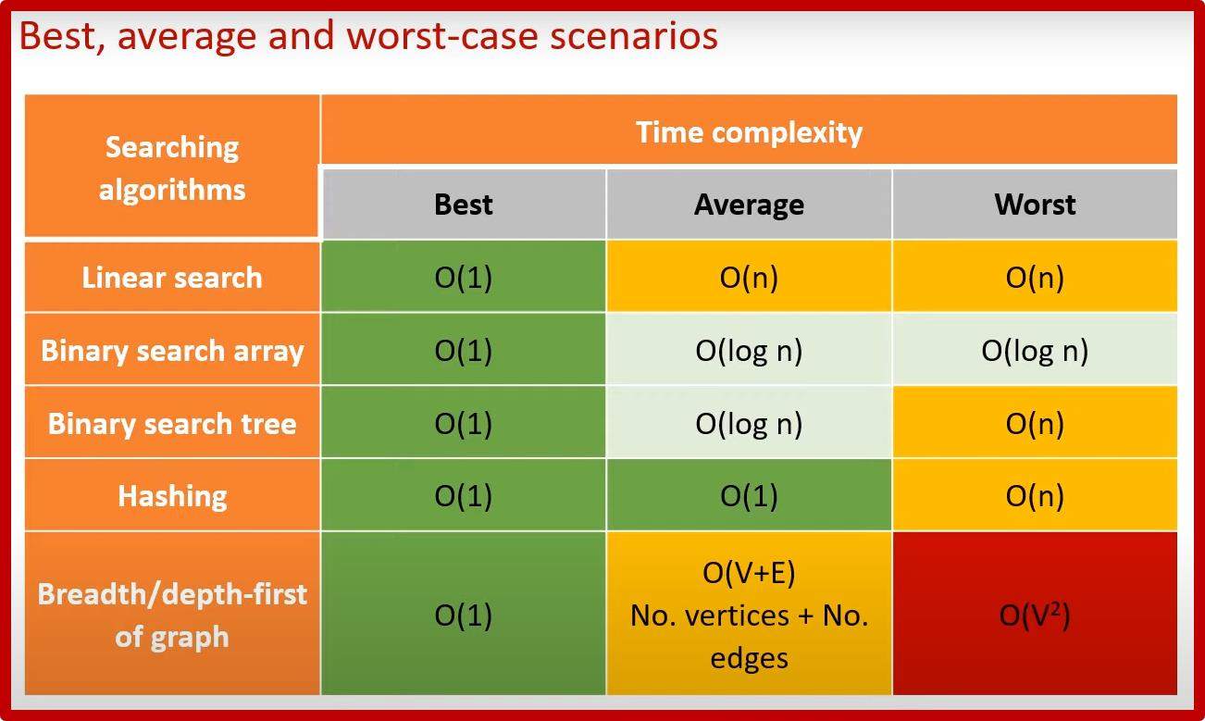

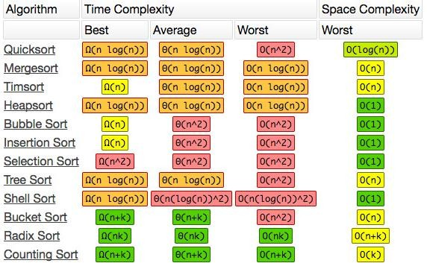

## Worst to best time Complexity

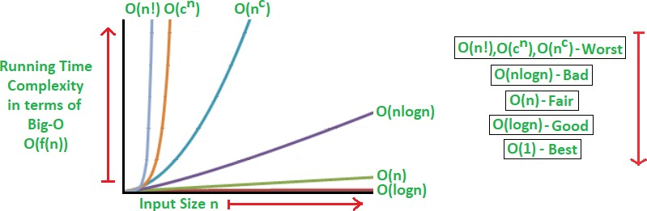

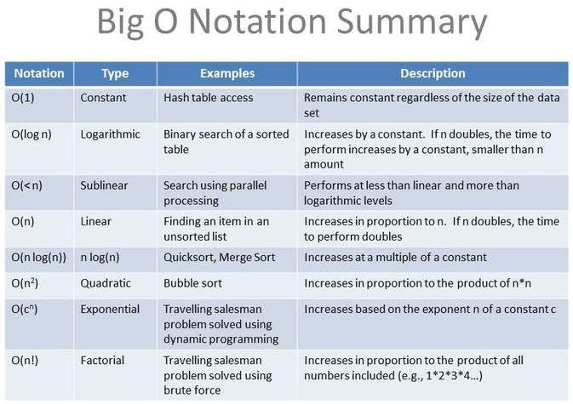

**Various types of sorting and searching algorithms and its time complexity.**

### Sorting Algorithms:

* 1. **Bubble Sort:**
     + Simplest sorting algorithm that repeatedly steps through the list, compares adjacent elements, and swaps them if they are in the wrong order.
     + It has a time complexity of O(n^2) in the worst and average cases.

### Selection Sort:

* + - Divides the input list into two parts: a sorted sub-list and an unsorted sub-list.
    - In each iteration, it selects the smallest (or largest) element from the unsorted sub-list and moves it to the sorted sub-list.
    - It has a time complexity of O(n^2) in all cases.

### Insertion Sort:

* + - Builds the final sorted array (or list) one item at a time.
    - It takes each element from the input list and inserts it into its correct position in the sorted part of the list.
    - It has a time complexity of O(n^2) in the worst and average cases but can perform well for small datasets or nearly sorted lists.

### Merge Sort:

* + - A divide-and-conquer algorithm that recursively divides the input list into smaller sub-lists until each sub-list contains one element.
    - It then merges adjacent sub-lists in a sorted manner until a single sorted list is obtained.
    - It has a time complexity of O(n log n) in all cases.

### Ǫuick Sort:

* + - Another divide-and-conquer algorithm that selects a pivot element and partitions the array around the pivot.
    - It recursively sorts the subarrays on either side of the pivot.
    - It has a time complexity of O(n log n) in the average and best cases, but O(n^2) in the worst case (which can be mitigated with random pivot selection or other optimizations).

### Heap Sort:

* + - Builds a binary heap from the input array and repeatedly extracts the maximum (for max heap) or minimum (for min heap) element from the heap and reconstructs the heap until the array is sorted.
    - It has a time complexity of O(n log n) in all cases.

**Searching Algorithms:**

### Linear Search:

* + Iterates through each element of the array until the target element is found.
  + It has a time complexity of O(n) in the worst case.

### Binary Search:

* + Requires a sorted array and repeatedly divides the search interval in half until the target element is found.
  + It has a time complexity of O(log n) in the worst case.

### Hash Table:

* + Utilizes a hash function to compute an index into an array of buckets or slots, from which the desired value can be found.
  + Provides constant-time average-case complexity for search, insert, and delete operations (O(1)), but worst-case complexity can be O(n) if there are collisions.

### Binary Search Tree (BST):

* + A binary tree data structure where the left subtree of a node contains only nodes with keys less than the node's key, and the right subtree contains only nodes with keys greater than the node's key.
  + Allows for efficient search, insert, and delete operations with a time complexity of O(log n) on average for balanced trees, but it can degrade to O(n) in the worst case for unbalanced trees.

These notes provide an overview of various sorting and searching algorithms along with their complexities and characteristics. Each algorithm has its strengths and weaknesses, and the choice of algorithm depends on factors such as the size of the dataset, the presence of pre-sorted data, memory constraints, and the desired performance characteristics.