

# ASSESSMENT 2

Fundamental of Programming

5001

Submitted by:

### Harinder Kaur

Student ID: 24135850

[h.kaur82@student.scu.edu.au](mailto:h.kaur82@student.scu.edu.au)

**GitHub Link**

<https://github.com/Harinder-kaur-dhot/Assignment2.git>

**Algorithm for the program**

1. Declare variables:

array for storing marks for 30 students.

assignmentName for storing assignment name.

min to find the lowest marks.

Max to find the highest marks.

Mean to find the average of all marks.

Variance, deviation, standardDeviation to find the standard deviation.

i for iteration.

studentHighest, studentLowest to store students with highest lowest marks.

1. Input assignmentName
2. Input marks

Step 1: Initialise a loop using iteration counter i = 0

Step 2: Input assignment marks, increment counter and check i < 30.

Step 3: Check if input < = 30, if true then push input into marks [30].

Step 4: else print invalid input and decrement counter by 1 (i--).

1. Print marks

Step 1: Initialise a loop using iteration counter i = 0

Step 2: print marks[i], increment I (i++)

Step 3: check (i<30): true, then continue the loop.

1. Find the highest and the lowest marks.

Step 1: Initialise

max = marks [0], min = marks[0], studentHighest =0, studentLowest =0

Step 2: Initialise a loop using iteration counter i = 1 with condition i < 30

Step 3: Check if marks [i] > max : true, then assign marks[i] value to max, i++

If marks [i] == max, increment studentHighest by 1

Step 4: Check if marks [i] < min : true, then assign marks[i] value to min, i++

If marks [i] == min, increment studentLowest by 1

1. Print max and min with studentHighest and studentLowest respectively.
2. Find Mean

Step 1: initialise sum = 0

Step 2: Initialise a loop using iteration counter i = 0

Step 3: add marks[i] value into sum (sum = sum + marks[i])

Step 4: Divide the sum by 30

1. Print mean.
2. Find Standard Deviation

Step 1: Initialise deviation = 0

Step 2: Initialise a loop using iteration counter i = 0

Step 3: Add the square of the difference of marks[i] and mean into deviation.

Step 4: Divide the deviation by 30, square root the result, and insert it into standardDeviation.

1. Print standardDeviation.

**Pseudocode for the program**

1. Declare:

array marks [30]

String assignmentName

double min, max, mean, standardDeviation, variance, sum.

Int i, studentHighest, studentLowest.

1. //F1: input assignment name

Input assignmentName

1. //F2: input marks for 30 students

Repeat for iteration (i) when i<=30

If marks [i] <=30

Input marks[30]

Else //F4: invalid input if greater than 30

invalid input

i--;

1. //F4: print student marks

Repeat for iteration (i) when i<=30

Print student marks[i]

1. //F5: finding the highest and Lowest marks

Initialisation:

min = marks [0]

max = marks [0]

studentHighest = 1

studentLowest = 1

1. Repeat for iteration (i) when i<=30

//finding highest

if marks [i] >= max

if marks [i] > max

marks [i] = max

studentHighest = 1

else studentHighest + 1 //count number of students scored highest.

//finding lowest

else if marks [i] <= min

if marks [i] > min

marks [i] = min

studentLowest = 1

else studentLowest + 1 //count number of students scored Lowest.

1. print min and max along with the number of students who scored highest and lowest marks.
2. //F6: finding mean and standard deviation of the marks obtained

initialisation

sum = 0

deviation = 0

1. //finding mean

Repeat for iteration (i) when i<=30

sum = sum + marks [i]

mean = sum / 30

1. Print mean.
2. //finding standard deviation

Repeat for iteration (i) when i<=30

deviation = deviation + (marks [i] -mean)2

Variance = deviation / 30

standardDeviation = √variance

1. Print standardDeviation.

**Progress at GitHub**

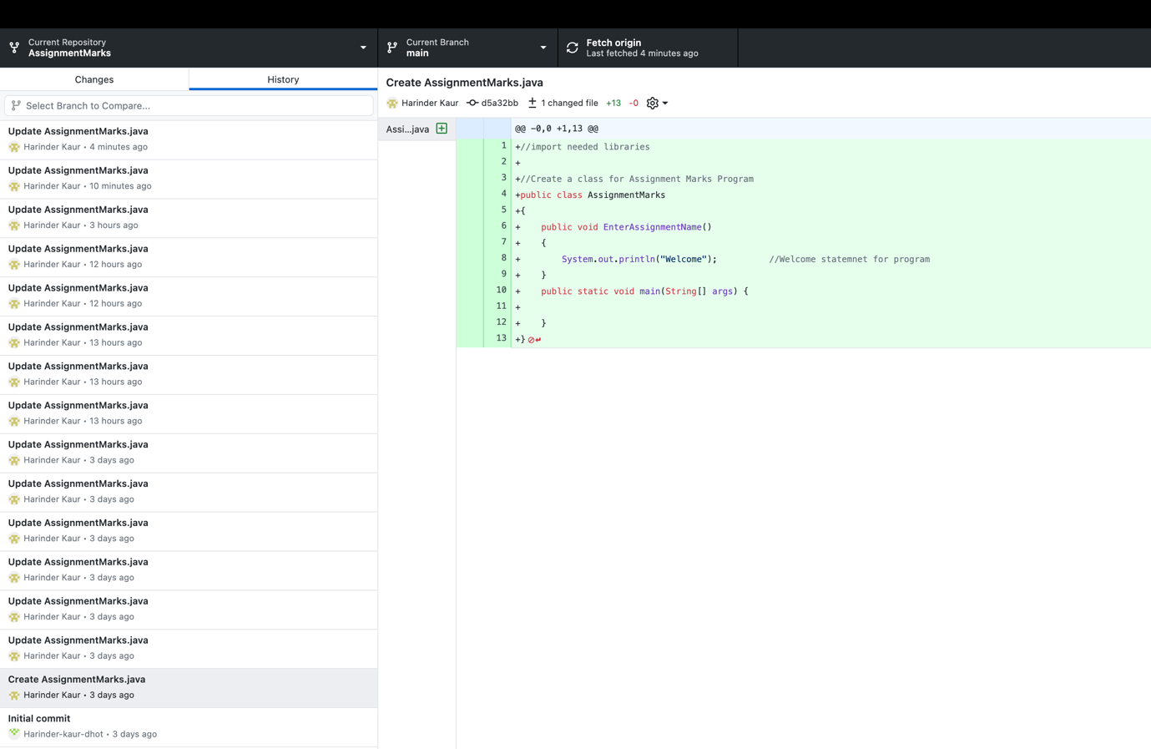

**Program**

//import needed libraries

import java.util.Scanner;

//Create a class for Assignment Marks Program

public class AssignmentMarks

{

//declare variable in class to use variable globally

String assignmentName; //declare variable to store Assignmnet name

double [] marks = new double[30]; //declare array to store marks

double min, max, mean, standardDeviation, variance; //declare variable to perform functions

int i, studentHighest = 1, studentLowest = 1; //declare variable for iteration

public void EnterAssignmentName() //F1: Method for receiving assignmnet name (f1)

{

System.out.println("Welcome"); //Welcome statemnet for program

System.out.println("Please Enter the Name of the Assignment");

Scanner input = new Scanner(System.in);

assignmentName = input.nextLine(); //Received assignment name

}

public void EnterStudentMarks() //F2: method for receiving marks

{

System.out.println("Please enter the marks of " + assignmentName + " for 30 students");

Scanner input = new Scanner(System.in);

for(i=0;i<30;i++)

{

System.out.println("Enter " + assignmentName +" marks for student " + (i+1));

double temp = input.nextDouble();

if(temp <= 30)

{

marks[i]=temp;

}

else

{

System.out.println("Invalid Input"); //F3: invalid input for marks more than 30

i--;

}

}

}

public void DisplayMarks() //F4: displaying marks

{

for(i=0;i<30;i++)

{

System.out.println("Marks of student " + (i+1) + " in " + this.assignmentName + ": " + this.marks[i]);

}

}

public void MaxMin() //F5: find highest and lowest marks

{

min = marks[0];

max = marks[0];

for(i=0;i<30;i++)

{

if(max <= marks[i])

{

if (max < marks [i])

{

max = marks[i];

studentHighest = 1;

}

else if(max == marks[i])

{

studentHighest = studentHighest + 1;

max = marks[i];

}

}

else if(min >= marks[i])

{

if(min > marks[i])

{

min = marks[i];

studentLowest = 1;

}

else if(min == marks[i])

{

studentLowest = studentLowest + 1;

min = marks[i];

}

}

}

System.out.println("The hightest marks obtained by " + this.studentHighest + " students in " + this.assignmentName + ": " + this.max);

System.out.println("The lowest marks obtained by " + this.studentLowest + " students in " + this.assignmentName + ": " + this.min);

}

public void MeanCalculate() //F6: finding mean of all marks obtained

{

double sum = 0;

for(i=0;i<30;i++)

{

sum = sum + marks[i];

}

mean = sum/30;

System.out.println("The mean of all marks obtained " + this.mean);

}

public void StandardDeviationCalculation() //F6: finding Standarad deviation

{

double deviation = 0;

for(i=0;i<30;i++)

{

deviation = deviation + ((marks[i] - mean) * (marks[i] - mean));

}

variance = deviation / 30;

standardDeviation = Math.sqrt(variance);

System.out.println("The standard deviation of all marks obtained " + this.standardDeviation);

}

public static void main(String[] args) {

AssignmentMarks assignmentObject = new AssignmentMarks(); //object for calling all methods

assignmentObject.EnterAssignmentName();

assignmentObject.EnterStudentMarks();

assignmentObject.DisplayMarks();

assignmentObject.MaxMin();

assignmentObject.MeanCalculate();

assignmentObject.StandardDeviationCalculation();

}

}

**Output**

