**File lists:**

1) *.aia file can be imported onto mit App inventor and worked on.

Just replace the IP address with that of network to which nodemcu is connected.

2)rccar - Contains the .ino file for the ESP - Gas Inspection Bot.

Program connects to WiFi and then works over http requests. You have to coordinate what you send from the app and whatyou receive at the ESP.

**Steps to execute:**

1. First upload the code to nodemcu, and get the ip address from the serial monitor

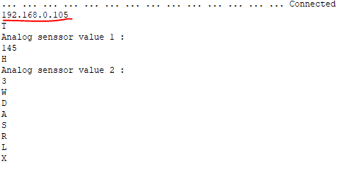

1. Change the IP address in app
   1. Projects -> import .aia file
   2. Select block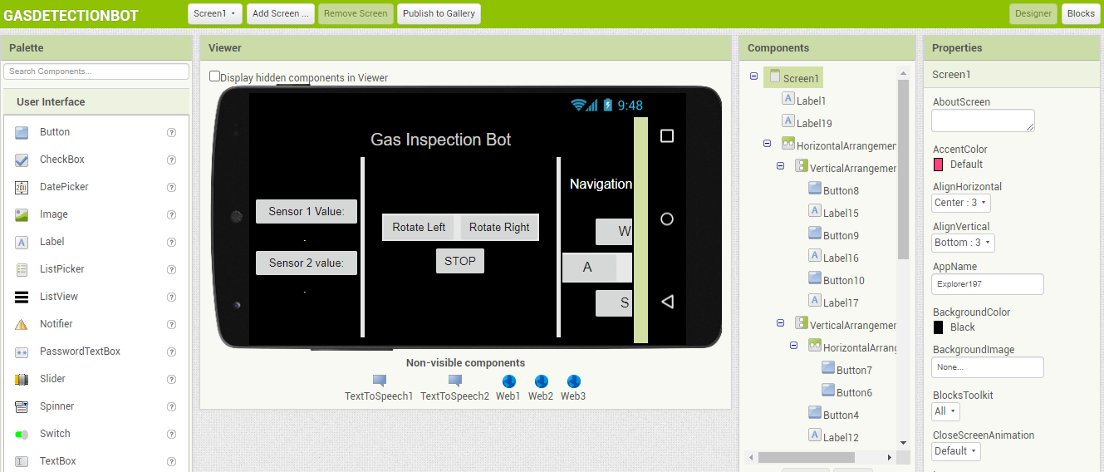
   3. Replace all the IP address

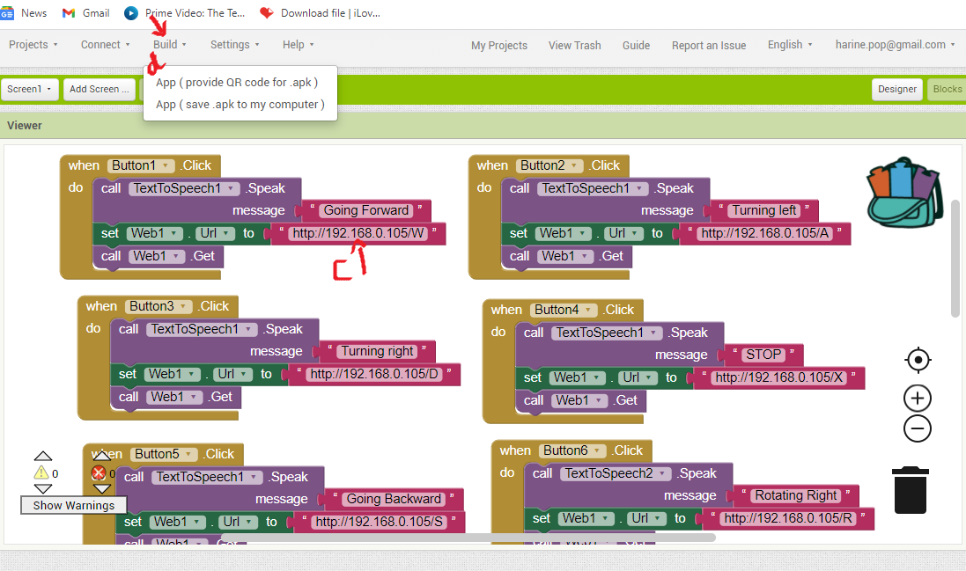

* 1. Click build and generate QR
  2. Scan and install the app

3.To live stream pi camera – 192.168.0.106:5000

(refer : https://youtu.be/zfBHD4v8hD0)