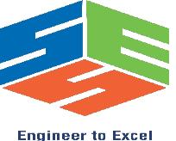
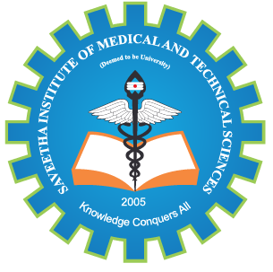
SIMATS ENGINEERING

Saveetha Institute of Medical and Technical Sciences
Chennai- 602105

Student Name: Harineeshree.S (192512162)
Course Code : ECA1009 Slot : B
Course Name: Microprocessors and Microcontrollers
Course Faculty: Dr. J. Mohana

Microprocessors and Microcontrollers

Experiment No.: 1 d.

