Logistics Delivery Performance Analysis and Delivery Time Prediction

Week 4 — Predictive Modeling and Optimization in Logistics Systems
Technical Project Report
Prepared by: Yeddula Harine
Repository: https://github.com/Harineyeddula19/logistics-delivery-performance-analysis Dataset: foodtimedataset.xlsx
Scope: baseline modeling, test evaluation, cross-validation and randomized tuning

Executive Summary
This project develops and evaluates regression models to estimate delivery time from food-delivery records. The cleaned dataset contains 10,001 rows and 17 columns. Delivery Time is missing in 961 rows, leaving 9,040 records with known target values. Linear Regression was used as a baseline and Random Forest Regressor as a nonlinear alternative. On the held-out test set of 1,808 records, baseline Random Forest achieved MAE 2.345, RMSE 3.216 and R² 0.962, compared with MAE 3.199, RMSE 4.962 and R² 0.908 for Linear Regression. A six-candidate randomized search with three-fold cross-validation produced a best cross-validation MAE of 2.498. The tuned model scored test MAE 2.351, RMSE 3.215 and R² 0.962, so it did not meaningfully improve over the baseline. Results are promising on this split but are not a guarantee of deployment performance. The target unit and feature availability at prediction time should be verified before operational use.

Problem Statement and Objectives
Delivery-time estimation can support operational planning by helping logistics teams anticipate longer journeys, review assignments and identify cases needing attention. The objective is to predict recorded Delivery Time from available delivery, location, weather, traffic and order attributes.
- Prepare a dataset with known target values.
- Compare Linear Regression with Random Forest Regressor.
- Evaluate with MAE, RMSE and R² on a held-out test set.
- Use cross-validation and randomized hyperparameter search to explore Random Forest settings.
- Translate findings into practical recommendations and document limitations.

Dataset Overview
The source file was foodtimedataset.xlsx, loaded from the project's cleaned outputs folder. It contains 10,001 records and 17 columns. The target is Delivery Time. Since 961 rows have missing target values, those rows were excluded from supervised modeling, leaving 9,040 records.
Item | Description
Total records | 10,001
Columns | 17
Known Delivery Time records | 9,040
Rows excluded due to missing target | 961
Training set | 7,232 records (80%)
Test set | 1,808 records (20%)
Split | train_test_split; test_size=0.20; random_state=42
Numerical predictors included Delivery Person Age, Delivery Person Ratings, restaurant and delivery coordinates, Temperature, Humidity, Precipitation and Distance. Categorical predictors included Order Type, Vehicle Type, Weather Description and Traffic Level. ID and Delivery Person ID were excluded as identifiers.
Unit note: the units of Delivery Time and Distance were not verified in the available project information. All error metrics are therefore reported in recorded target units, not as minutes or kilometres.

Data Preparation and Preprocessing
- Rows with missing Delivery Time were removed from the modeling frame.
- ID and Delivery Person ID were excluded from predictors.
- Missing numerical predictors were imputed using the training-set median.
- Missing categorical predictors were imputed using the training-set most frequent category.
- OneHotEncoder(handle_unknown='ignore') encoded categorical variables.
- Preprocessing was wrapped in a ColumnTransformer and Pipeline to fit transforms within training folds.
- The data was split 80/20 using random_state=42.
This pipeline design helps prevent preprocessing leakage. However, a random split can place similar records from the same time periods or areas in both sets. Time-based and/or geographic validation is recommended to estimate performance on future or unfamiliar deliveries.

Models

Linear Regression
Linear Regression served as the baseline model. It estimates a linear relationship between the encoded predictors and Delivery Time, providing a reference for evaluating whether a more flexible model improves accuracy.

Random Forest Regressor
Random Forest combines predictions from multiple decision trees and can model nonlinear patterns and interactions. The baseline used 100 trees, random_state=42 and n_jobs=-1. Both models used the same preprocessing pipeline and the same held-out test set.

Evaluation Metrics and Results
MAE is the mean absolute prediction error; lower is better. RMSE is the square root of mean squared error and penalizes larger errors more strongly; lower is better. R² indicates the proportion of target variation explained relative to a mean-prediction baseline; higher is better.
Model | MAE | RMSE | R²
Linear Regression | 3.199 | 4.962 | 0.908
Baseline Random Forest | 2.345 | 3.216 | 0.962
Tuned Random Forest | 2.351 | 3.215 | 0.962
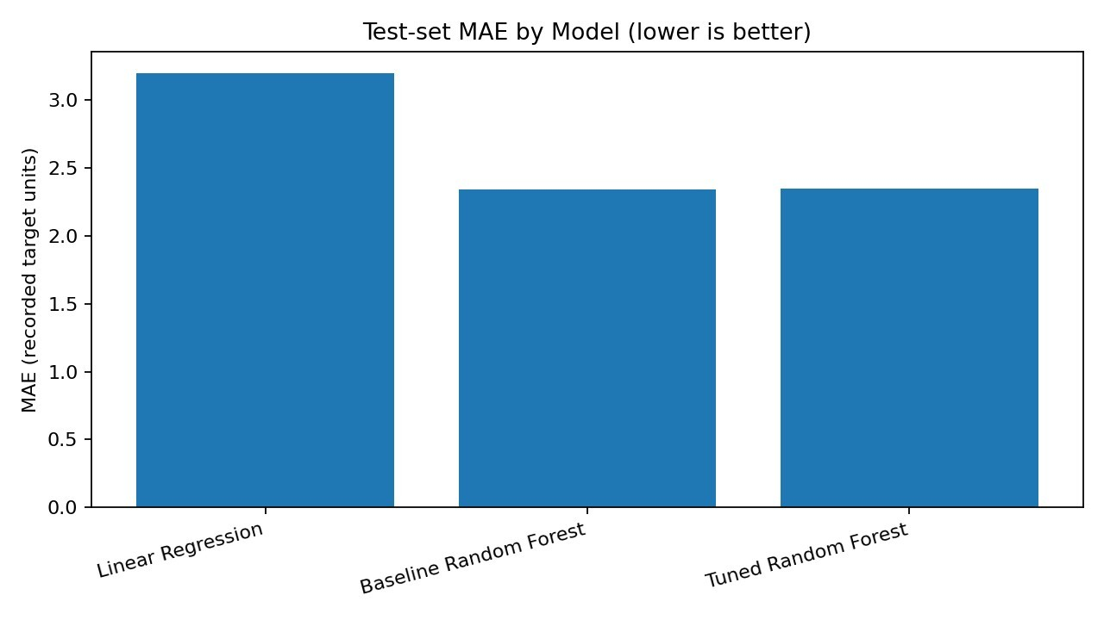
Figure 1. Test-set MAE comparison. Lower MAE indicates smaller average absolute prediction error.
Baseline Random Forest outperformed Linear Regression on all three metrics. Its MAE was approximately 26.7% lower than the Linear Regression MAE. R² of 0.962 means the model explained about 96.2% of the observed variation on this test split. It does not guarantee equivalent performance in a live environment.

Cross-Validation and Hyperparameter Tuning
RandomizedSearchCV was run on the training set using three-fold cross-validation and negative MAE as the scoring function. Six candidate combinations were evaluated, totalling 18 fits. The held-out test set was not used to select hyperparameters.
Search setting | Values considered
n_estimators | 100, 200
max_depth | None, 15, 25
min_samples_leaf | 1, 2, 4
max_features | 1.0, 'sqrt'
Cross-validation | 3 folds
Search size | 6 candidates; 18 fits
Best CV MAE | 2.498
Best parameters: n_estimators=200, min_samples_leaf=1, max_features=1.0 and max_depth=15. The tuned model scored test MAE 2.351, RMSE 3.215 and R² 0.962. Compared with baseline, MAE was worse by 0.006, RMSE improved by 0.001, and R² was unchanged to three decimal places. These differences are negligible; the baseline is retained as the practical default. The cross-validation MAE of 2.498 is a validation estimate and is distinct from the test MAE.
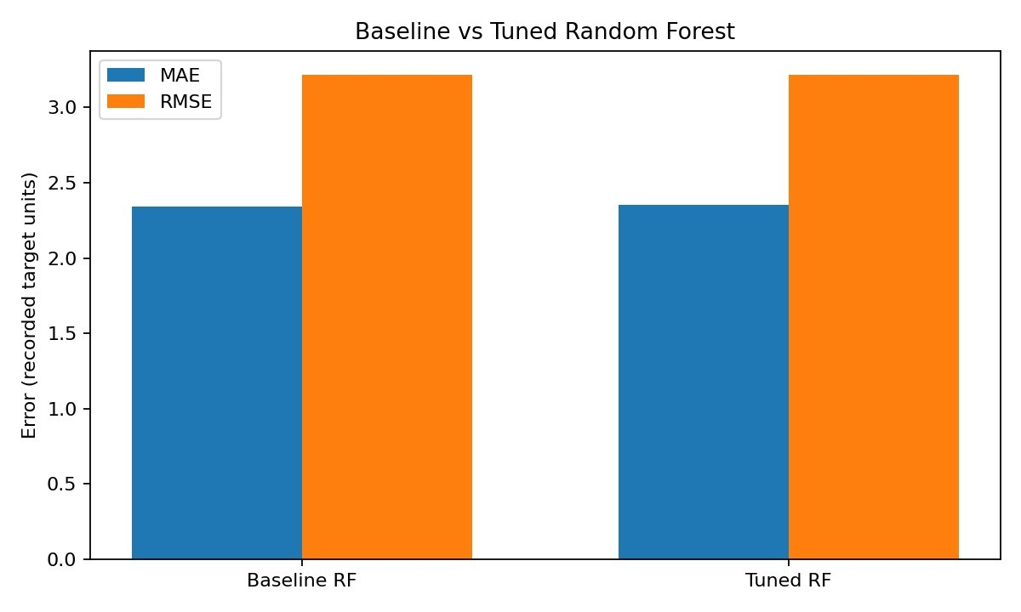
Figure 2. Baseline versus tuned Random Forest error metrics.

Prediction and Residual Diagnostics
The actual-versus-predicted plot showed most points close to the diagonal reference line, indicating that many predictions were close to observed values. The residual plot showed many residuals around zero, but the spread increased for some higher predicted values and several larger positive residuals were visible. A positive residual (actual minus predicted) means actual delivery time exceeded the prediction; a negative residual means the prediction was higher than the actual value.
These diagnostics indicate that prediction errors vary across records. Longer deliveries and unusual cases deserve additional analysis. The plots do not establish that the model is equally accurate for all groups.

Feature-Importance Findings
The leading feature-importance values visible in the notebook output were Traffic Level — Very High
(0.504651), Traffic Level — High (0.196790), Distance (0.102160), Traffic Level — Moderate (0.060762),
Order Type — Drinks (0.032520) and Temperature (0.026362). Restaurant Latitude (0.009402), Delivery Location Latitude (0.009230), Delivery Location Longitude (0.008093) and Humidity (0.007442) complete the displayed top ten.
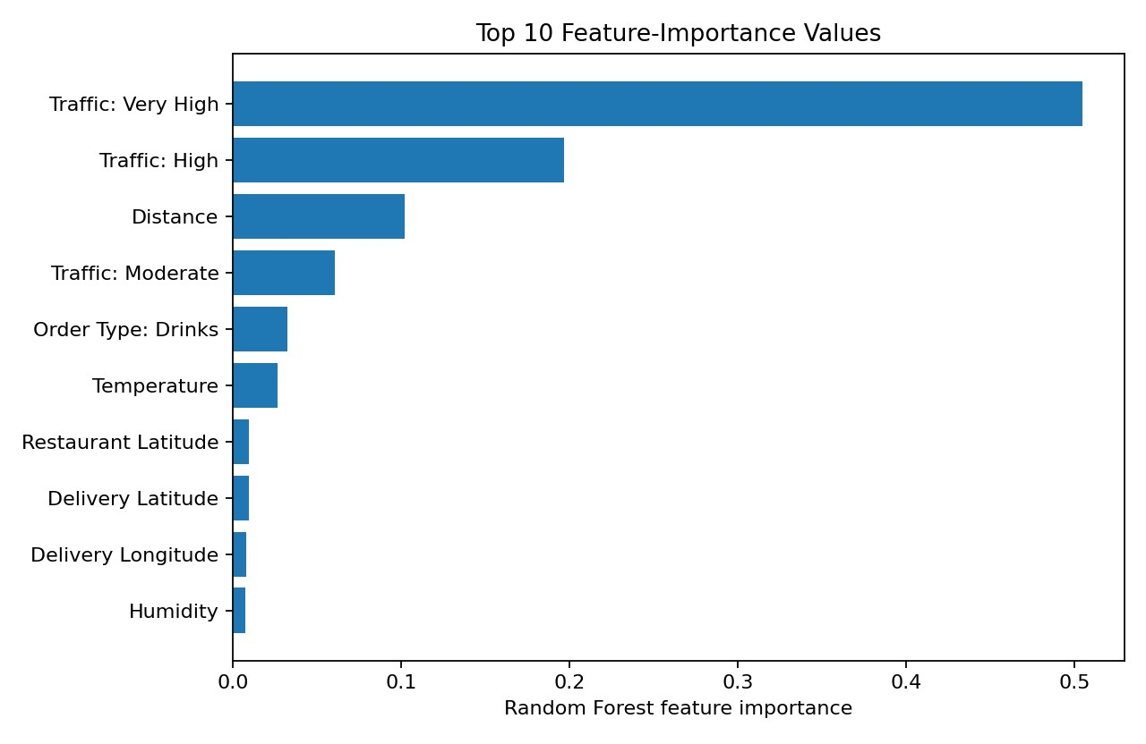
Figure 3. Top ten feature-importance values transcribed from the notebook output.
Traffic categories and Distance were influential predictors in this fitted model. Feature importance indicates how the model uses variables for prediction; it does not prove causation and may be affected by correlated predictors.

Logistics Optimization Recommendations

Traffic-aware planning
Where traffic data or a reliable forecast is available before dispatch, incorporate it into delivery-time estimation. If recorded traffic is only known after assignment, use a pre-dispatch forecast or exclude that field from an advance-planning model.

Review long-distance deliveries
Distance was among the leading predictors. Review long-distance orders for feasible route alternatives, realistic delivery windows and appropriate rider allocation. The current model does not calculate an optimal route.

Flag uncertain cases
Consider a manual-review queue for predictions with large estimated delay or uncertainty. The current model produces point predictions; validated prediction intervals have not been developed.

Confirm predictor availability
Check whether traffic, ratings, weather and other features are available at the intended prediction time.
Exclude variables that are only observed after delivery or could leak outcome information.

Monitor by segment
Track errors by traffic level, distance band, order type, vehicle type, time period and geography where available, so aggregate scores do not conceal weaker performance in particular groups.

Limitations and Future Work
- The Delivery Time unit has not been verified; metrics are reported in recorded target units.
- A random split may overestimate generalization. Use time-based and/or geographic holdout validation in future work.
- Predictor availability at dispatch must be checked, especially for traffic and delivery-person ratings.
- Feature importance is not causal evidence; correlated variables can affect importance values.
- The tuning search was limited to six candidates and three-fold cross-validation.
- The model has not been tested in a live workflow; no measured on-time-rate improvement, cost saving or operational impact is claimed.
- Verify dataset licensing and attribution before publishing raw data in a public repository.

Conclusion
This project established a regression workflow for delivery-time prediction and compared Linear Regression with Random Forest. Baseline Random Forest achieved the strongest overall test metrics: MAE 2.345, RMSE 3.216 and R² 0.962. Three-fold cross-validation and randomized tuning produced a tuned configuration but did not meaningfully improve test performance. Traffic categories and Distance were the most influential features in the displayed importance output. The findings support further study of traffic-aware planning, but deployment should wait until the target unit and predictor timing are confirmed and time-based/geographic validation is completed.

Appendix A. Reproducibility Notes
Core tools: Python, pandas, NumPy, Matplotlib and scikit-learn. The notebook used train_test_split,
ColumnTransformer, SimpleImputer, OneHotEncoder, Pipeline, LinearRegression,
RandomForestRegressor, mean_absolute_error, mean_squared_error, r2_score and
RandomizedSearchCV. Keep the notebook and output artifacts in the project repository, but do not publish the raw dataset unless redistribution rights are confirmed.
Repository: https://github.com/Harineyeddula19/logistics-delivery-performance-analysis

Appendix B. Representative Python Code Snippets
The following excerpts illustrate the core workflow implemented in the Week 4 notebook. They are representative snippets rather than a replacement for the complete runnable notebook. The full notebook contains the executed pipeline, evaluation, plotting, and randomized-search steps.

B1. Load data and define predictors and target
import pandas as pd
df = pd.read_excel("outputs/food_delivery_cleaned.xlsx") model_df = df.dropna(subset=["Delivery Time"]).copy()
X = model_df.drop(columns=["ID", "Delivery Person ID", "Delivery Time"]) y = model_df["Delivery Time"]

B2. Split the data and create preprocessing pipelines
from sklearn.model_selection import train_test_split from sklearn.compose import ColumnTransformer from sklearn.pipeline import Pipeline
from sklearn.preprocessing import OneHotEncoder from sklearn.impute import SimpleImputer
X_train, X_test, y_train, y_test = train_test_split(
X, y, test_size=0.20, random_state=42
)
num_cols = X.select_dtypes(include=["number"]).columns.tolist() cat_cols = X.select_dtypes(include=["object", "category"]).columns.tolist()
preprocessor = ColumnTransformer([
("num", SimpleImputer(strategy="median"), num_cols), ("cat", Pipeline([
("imputer", SimpleImputer(strategy="most_frequent")),
("encoder", OneHotEncoder(handle_unknown="ignore"))
]), cat_cols)
])

B3. Train and evaluate regression models
import numpy as np from sklearn.linear_model import LinearRegression from sklearn.ensemble import RandomForestRegressor
from sklearn.metrics import mean_absolute_error, mean_squared_error, r2_score
linear_model = Pipeline([
("preprocessor", preprocessor),
("model", LinearRegression())
])
rf_model = Pipeline([
("preprocessor", preprocessor), ("model", RandomForestRegressor(
n_estimators=100, random_state=42, n_jobs=-1
))
])
linear_model.fit(X_train, y_train) rf_model.fit(X_train, y_train)
pred = rf_model.predict(X_test) mae = mean_absolute_error(y_test, pred) rmse = np.sqrt(mean_squared_error(y_test, pred)) r2 = r2_score(y_test, pred)

B4. Cross-validation and randomized hyperparameter search
from sklearn.model_selection import RandomizedSearchCV
search = RandomizedSearchCV( estimator=Pipeline([
("preprocessor", preprocessor),
("model", RandomForestRegressor(random_state=42, n_jobs=-1))
]),
param_distributions={
"model__n_estimators": [100, 200],
"model__max_depth": [None, 15, 25],
"model__min_samples_leaf": [1, 2, 4],
"model__max_features": [1.0, "sqrt"]
},
n_iter=6, scoring="neg_mean_absolute_error", cv=3, random_state=42, n_jobs=-1, refit=True
)
search.fit(X_train, y_train) best_model = search.best_estimator_ tuned_pred = best_model.predict(X_test)

Appendix C. Code Documentation: End-to-End Modeling Workflow
This appendix expands the representative snippets into a coherent, documented workflow. The code is adapted to the column names and evaluation approach used in the project. The reported metric values elsewhere in this report are the outputs recorded during the notebook runs; the code below demonstrates how the workflow is implemented.

C1. Load the cleaned dataset and define the target
This step loads the cleaned Excel file, excludes rows with an unknown target, and removes identifier columns from the predictors. Update the file path if the project folder is stored elsewhere.
import pandas as pd import numpy as np
data_path = r"outputs\food_delivery_cleaned.xlsx" df = pd.read_excel(data_path)
model_df = df.dropna(subset=["Delivery Time"]).copy()
X = model_df.drop(columns=["ID", "Delivery Person ID", "Delivery Time"]) y = model_df["Delivery Time"]
print("Model records:", len(model_df)) print("Predictor columns:", X.shape[1]) print("Missing targets:", y.isna().sum())

C2. Split data and preprocess numerical and categorical columns
The split is performed before fitting the preprocessing steps. Median and most-frequent imputers, together with one-hot encoding, are placed inside a pipeline so that preprocessing is learned from training data rather than the full dataset.
from sklearn.model_selection import train_test_split from sklearn.compose import ColumnTransformer from sklearn.pipeline import Pipeline
from sklearn.preprocessing import OneHotEncoder from sklearn.impute import SimpleImputer
X_train, X_test, y_train, y_test = train_test_split(
X, y, test_size=0.20, random_state=42
)
num_cols = X.select_dtypes(include=["number"]).columns.tolist() cat_cols = X.select_dtypes(include=["object", "category"]).columns.tolist()
num_pipe = Pipeline([
("imputer", SimpleImputer(strategy="median"))
])
cat_pipe = Pipeline([
("imputer", SimpleImputer(strategy="most_frequent")),
("encoder", OneHotEncoder(handle_unknown="ignore"))
])
preprocessor = ColumnTransformer([
("num", num_pipe, num_cols),
("cat", cat_pipe, cat_cols)
])
print("Train records:", len(X_train)) print("Test records:", len(X_test))

C3. Train baseline models and evaluate performance
Both models use the same preprocessing and test set. MAE and RMSE are error measures for which lower values are better; R-squared is a goodness-of-fit measure for which higher values are generally preferred.
from sklearn.linear_model import LinearRegression from sklearn.ensemble import RandomForestRegressor
from sklearn.metrics import mean_absolute_error, mean_squared_error, r2_score
linear_model = Pipeline([
("preprocessor", preprocessor),
("model", LinearRegression())
])
baseline_rf = Pipeline([
("preprocessor", preprocessor), ("model", RandomForestRegressor(
n_estimators=100, random_state=42, n_jobs=-1
))
])
linear_model.fit(X_train, y_train) baseline_rf.fit(X_train, y_train)
def evaluate(name, model, X_test, y_test): pred = model.predict(X_test) return {
"Model": name,
"MAE": mean_absolute_error(y_test, pred),
"RMSE": np.sqrt(mean_squared_error(y_test, pred)),
"R2": r2_score(y_test, pred)
}
results = pd.DataFrame([ evaluate("Linear Regression", linear_model, X_test, y_test), evaluate("Baseline Random Forest", baseline_rf, X_test, y_test)
])
print(results.round(3))

C4. Cross-validation and hyperparameter tuning
RandomizedSearchCV tests a limited sample of parameter combinations using three-fold crossvalidation. The search is fitted only on the training set; the test set remains reserved for final evaluation.
from sklearn.model_selection import RandomizedSearchCV
search_space = {
"model__n_estimators": [100, 200],
"model__max_depth": [None, 15, 25],
"model__min_samples_leaf": [1, 2, 4],
"model__max_features": [1.0, "sqrt"] }
search = RandomizedSearchCV( estimator=Pipeline([
("preprocessor", preprocessor),
("model", RandomForestRegressor(random_state=42, n_jobs=-1))
]),
param_distributions=search_space, n_iter=6,
scoring="neg_mean_absolute_error", cv=3,
random_state=42,
n_jobs=-1,
refit=True
)
search.fit(X_train, y_train)
tuned_model = search.best_estimator_ print("Best parameters:", search.best_params_) print("Best CV MAE:", round(-search.best_score_, 3))
tuned_pred = tuned_model.predict(X_test) tuned_result = {
"MAE": mean_absolute_error(y_test, tuned_pred),
"RMSE": np.sqrt(mean_squared_error(y_test, tuned_pred)),
"R2": r2_score(y_test, tuned_pred)
}
print({k: round(v, 3) for k, v in tuned_result.items()})

C5. Derive practical findings from feature importance
For the fitted Random Forest, transformed feature names can be aligned with importance values. This supports a descriptive ranking of predictors. Importance is not causal evidence and should be interpreted with domain knowledge.
fitted_prep = baseline_rf.named_steps["preprocessor"] fitted_model = baseline_rf.named_steps["model"]
importance = pd.DataFrame({
"Feature": fitted_prep.get_feature_names_out(),
"Importance": fitted_model.feature_importances_ }).sort_values("Importance", ascending=False) print(importance.head(10))

C6. Optimization decision logic (pseudocode)
The current project proposes operational strategies rather than claiming measured savings or implementing a live optimizer. A future dispatch-support workflow could use the prediction as one input to a review process:
FOR each new delivery:
collect only predictors available at dispatch time validate required fields and feature units estimate delivery time using the validated model
IF predicted time exceeds an operations-defined threshold:
flag the order for review
check route alternatives, traffic forecast, and rider availability ELSE:
continue with normal dispatch workflow log actual delivery time when completed monitor prediction error by traffic, distance, vehicle, and location retrain only after validating new data and model performance
This pseudocode is a proposed future operational process, not a deployed optimization system. The threshold must be chosen by the logistics team and evaluated against service goals and resource constraints. Before use, verify the target's unit and ensure that each predictor is available before dispatch.

