Week 3: Advanced Data Analysis and Visualization in Logistics
Project: Logistics Delivery Performance Analysis and Delivery Time Prediction
Logistics Data Analyst Internship | Week 3

1. Introduction and Objective
This report documents exploratory data analysis (EDA) performed on a publicly available food-delivery dataset used for the logistics delivery performance project. The goal was to understand delivery-time distribution, explore relationships between delivery time and operational factors, and present findings through Python visualizations. The analysis is descriptive and does not establish that any factor causes a delay.

2. Dataset Description
The dataset was obtained from Zenodo and loaded from the cleaned Excel output created during Week 2. The loaded dataset contains 10,001 rows and 17 columns, including delivery-person age and ratings, restaurant and delivery coordinates, order type, vehicle type, temperature, humidity, precipitation, weather description, traffic level, distance, and delivery time. There are 9,040 non-missing delivery-time values.
During Week 2 preprocessing, missing predictor values such as Distance and Traffic Level were filled, while missing Delivery Time values were preserved because Delivery Time is the analysis target. Therefore, descriptive statistics for imputed predictor columns may include filled values and should not be interpreted as statistics of originally observed values only. The Week 3 correlation reported below was calculated on the analysis dataset after preprocessing, so the imputation of missing Distance values may influence the coefficient.

3. Tools and Methodology
Python was used in Jupyter Notebook. pandas and NumPy supported data inspection and calculations, and Matplotlib was used for visualization. The workflow included descriptive statistics, a delivery-time histogram, a traffic-level box plot, a distance-versus-time scatter plot, average-time bar charts, and a numeric correlation matrix. The visualizations were saved as PNG files in the project's outputs folder.
A histogram was selected to inspect distribution and skewness; a box plot to compare medians, spread, and potential outliers; a scatter plot to explore two numeric variables; bar charts to compare group averages; and a correlation matrix to summarize pairwise linear associations.

4. Descriptive Statistics
Metric | Mean | Median | Observed range
Delivery Person Age | 29.52 | 29.00 | 15.00–50.00
Delivery Person Ratings | 4.63 | 4.70 | 1.00–6.00
Temperature | 22.94 | 23.00 | 6.77–29.05
Humidity | 66.17 | 67.00 | 27.00–94.00
Precipitation | 0.02 | 0.00 | 0.00–1.46
Distance | 14.21 | 13.40 | 1.55–59.84
Delivery Time | 37.66 | 35.98 | 5.80–157.75
Delivery time has a mean of 37.66 and a median of 35.98, with values ranging from 5.80 to 157.75. The mean being higher than the median is consistent with a right-skewed distribution. Distance has a mean of 14.21 and a median of 13.40. The maximum recorded delivery-person rating is 6.00; the intended rating scale should be verified before drawing conclusions from that field.

5. Visualizations and Interpretations

Figure 1. Distribution of Delivery Time
The histogram is right-skewed. Most observations appear concentrated roughly between 20 and 50 recorded units, while a smaller number extend beyond 80 and some approach 160. The histogram makes the distribution and long upper tail visible.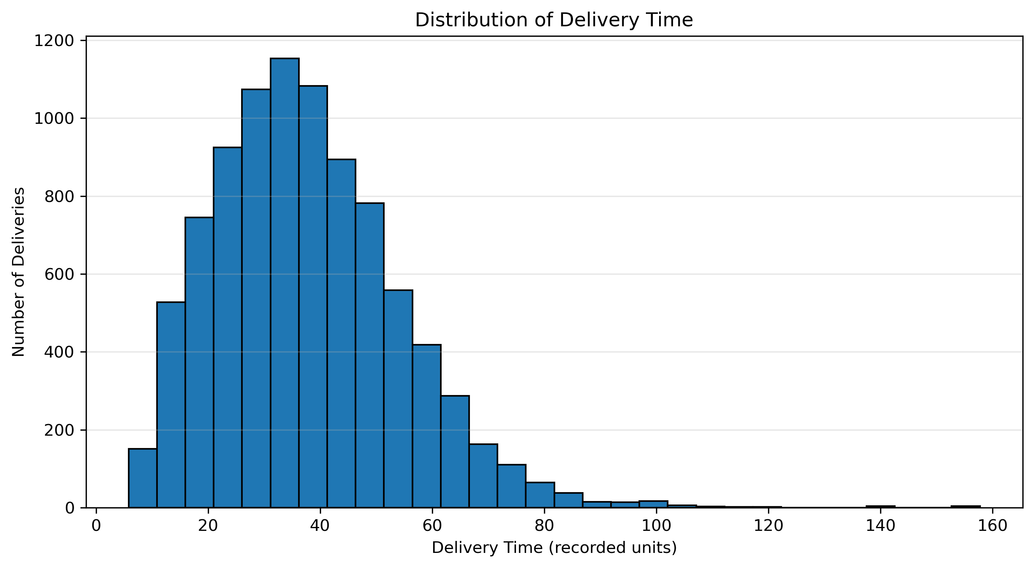

Figure 2. Delivery Time by Traffic Level — Box Plot
The box plot shows progressively higher medians across traffic categories and many high-value outliers in the Very High category. It allows comparison of group medians, interquartile ranges, and potential outliers.
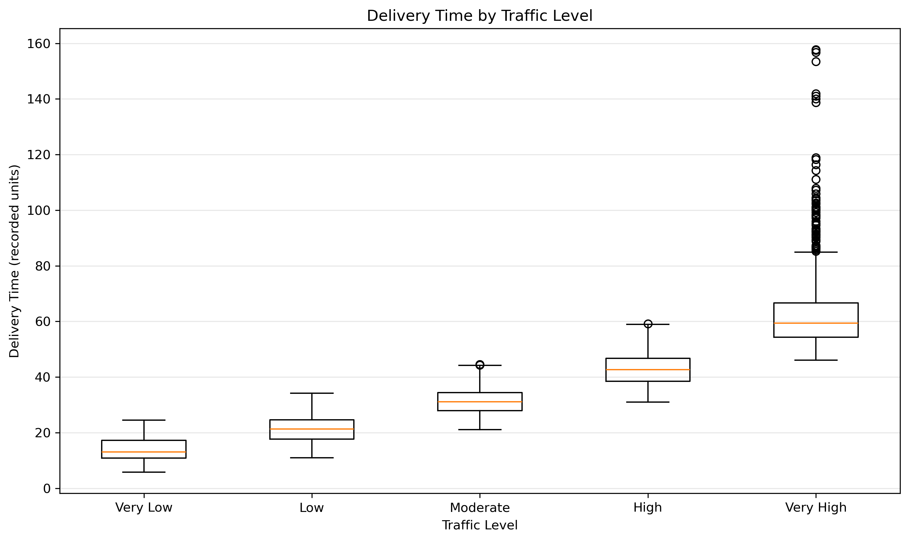

Figure 3. Distance vs. Delivery Time — Scatter Plot
The scatter plot shows an upward pattern: delivery time generally increases with distance. The spread also appears wider at larger distances, and some deliveries take longer than others at similar distances.
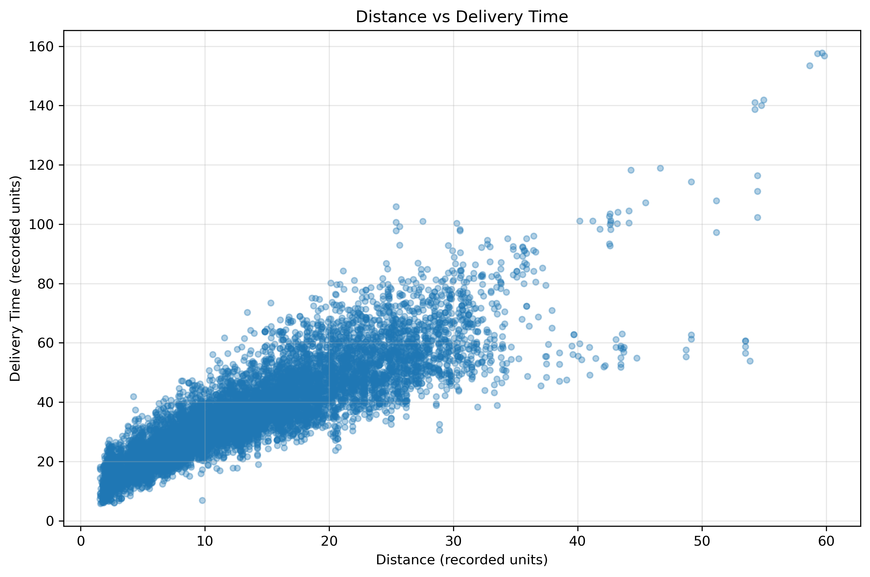

Figure 4. Average Delivery Time by Vehicle Type
Average times were bicycle 31.40, electric scooter 36.99, motorcycle 37.66, and scooter 37.82 recorded units. Bicycle records had the lowest average and scooter records the highest. These differences may reflect distance, traffic, or other differences between the groups.
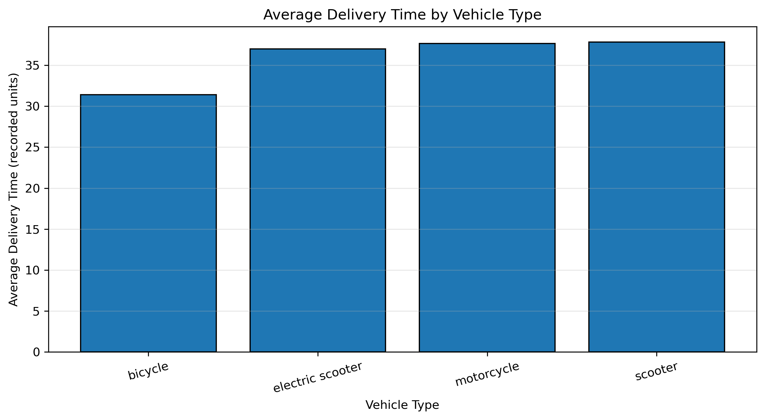

Figure 5. Correlation Matrix of Numeric Variables
The Pearson correlation between Distance and Delivery Time was +0.869 in the preprocessed analysis dataset. To validate this result, the correlation was recalculated using only records where both values were originally observed. This validation used 9,035 records and also returned +0.869 when rounded to three decimal places. The matching rounded results indicate that the reported relationship is robust to this particular missing-distance imputation check. Other correlations were small: humidity and precipitation +0.23, temperature and precipitation +0.22, ratings and distance −0.11, and ratings and delivery time −0.10. Correlation measures linear association and does not establish causation.
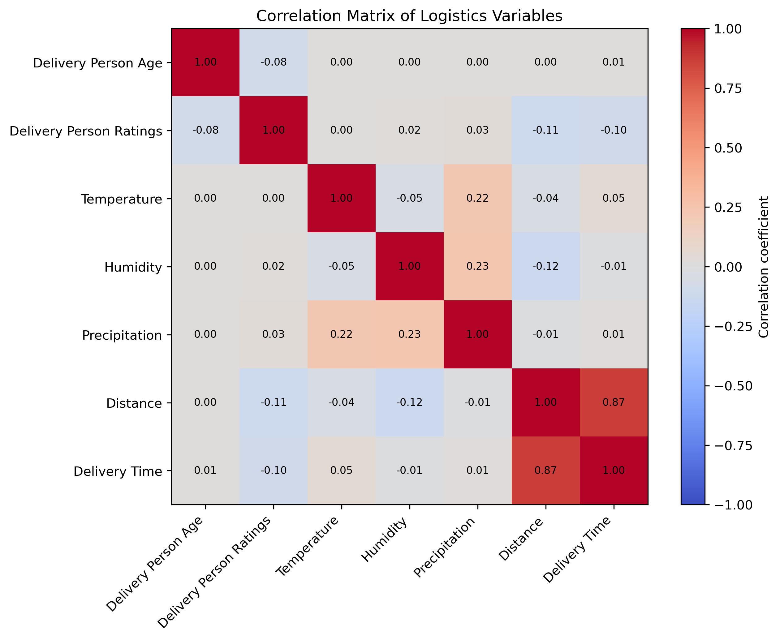

Figure 6. Average Delivery Time by Traffic Level
The averages were Very Low 13.89, Low 21.40, Moderate 31.34, High 42.76, and Very High 62.26 recorded units. The Very High average is about 4.48 times the Very Low average. The pattern suggests an association between traffic category and recorded delivery time, not proof of causation.
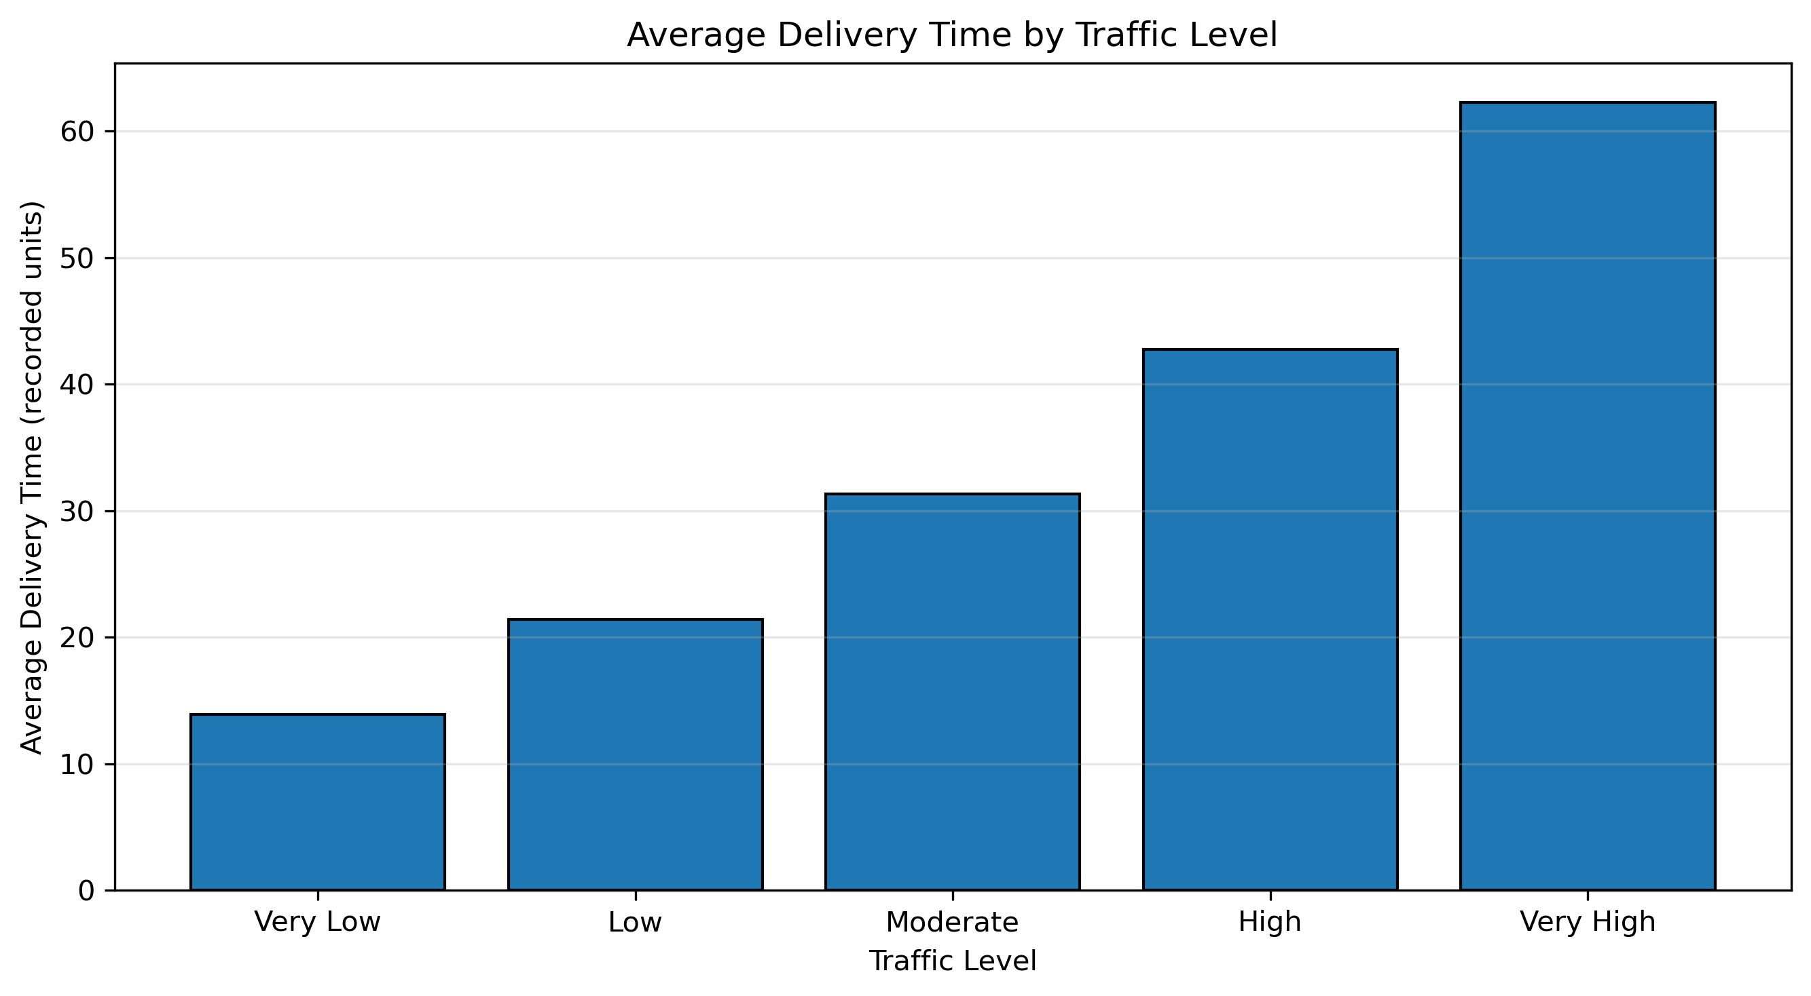

Figure 7. Average Delivery Time by Order Type
The averages were Meal 33.90 (n=2,281), Buffet 35.44 (n=2,173), Snack 38.05 (n=2,310), and Drinks 43.14 (n=2,276). Drinks had the highest average and Meal the lowest, a difference of 9.24 recorded units. This does not show that order type itself causes longer delivery times.

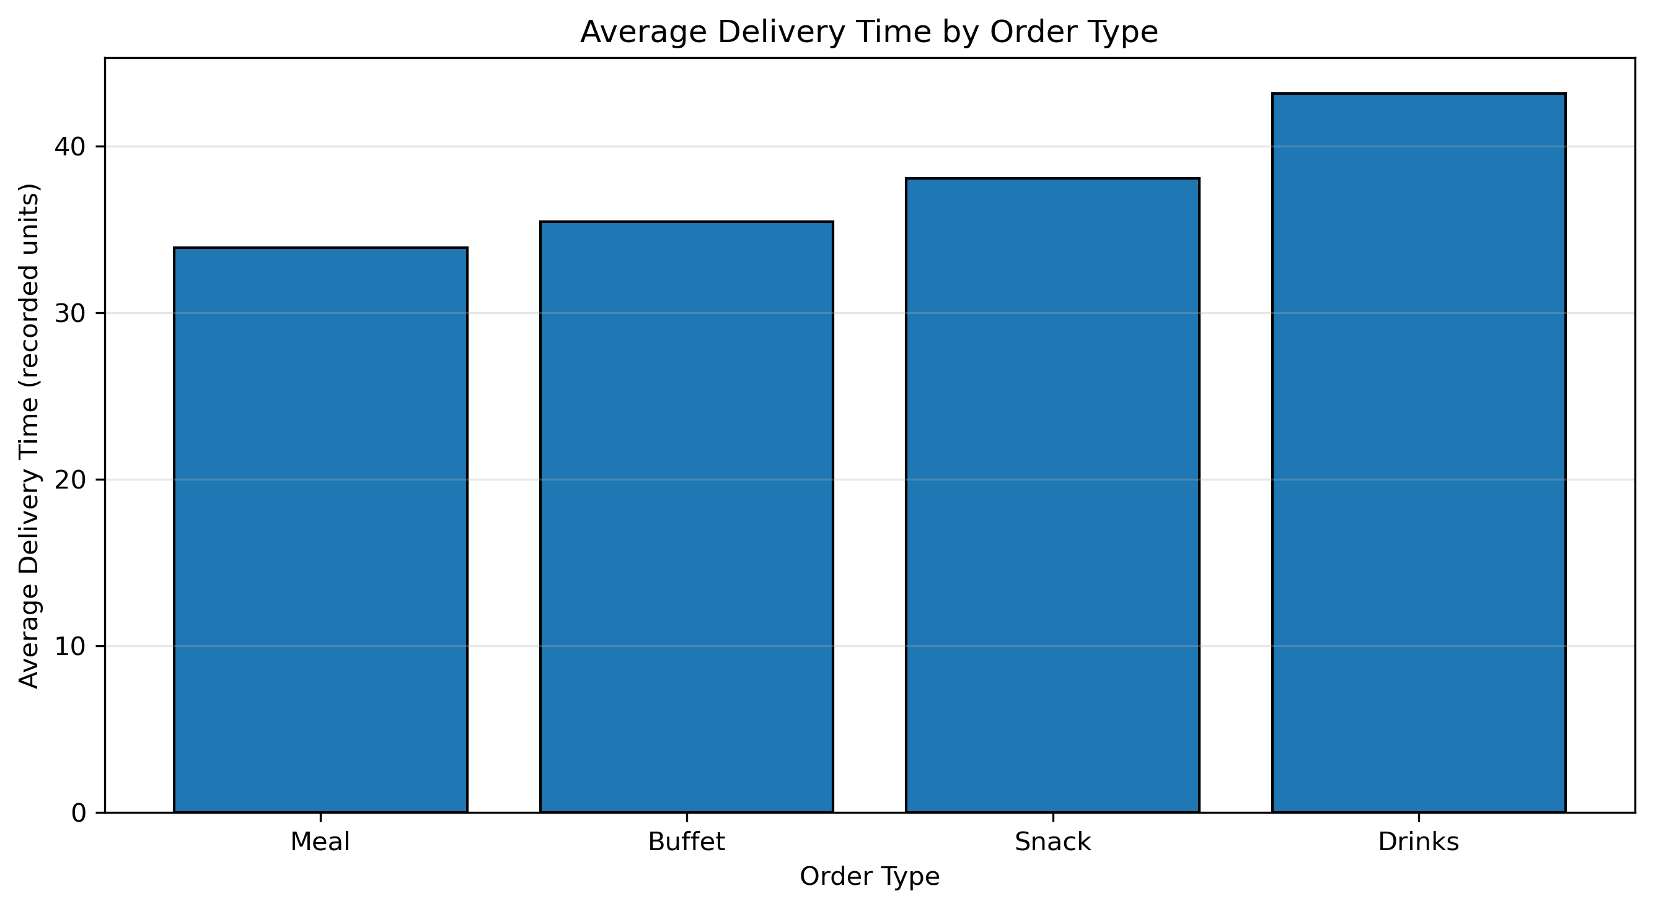

6. Traffic Category Record Counts
Traffic level | All records | Records with delivery time
Very Low | 632 | 632
Low | 1,726 | 1,718
Moderate | 2,219 | 2,212
High | 2,736 | 2,730
Very High | 1,772 | 1,748
Unknown / missing traffic | 916 | Not part of five-category comparison

7. Recommendations
- Investigate traffic-aware route planning and scheduling, particularly for deliveries classified as High or Very High traffic.
- Use distance as an important candidate feature for further delivery-time analysis because it has a strong positive correlation with delivery time.
- Compare vehicle types only after accounting for distance and traffic; group averages alone can be misleading.
- Review unusually long delivery-time observations and confirm their validity before removing or capping them.
- Verify the units of Distance and Delivery Time and confirm the intended delivery-person rating scale.
- For predictive modelling, split the data into training and test sets before fitting preprocessing transformations to avoid data leakage.
- Do not report on-time delivery rates or delivery costs because the dataset does not contain a verified on-time flag or cost field.

8. Limitations
The dataset originally contained missing predictor values and missing Delivery Time values. Missing predictor values were imputed during preprocessing, while missing Delivery Time values were retained. The distance–delivery-time correlation was checked against rows where both values were originally observed: 9,035 records produced a correlation of +0.869, matching the preprocessed result to three decimal places. Measurement units were not independently verified. The correlation matrix covers selected numeric fields and may not reveal nonlinear or combined effects. The analysis is observational and does not prove causation. No verified on-time flag or delivery-cost variable was available for direct analysis.

9. Conclusion and Reflection
The EDA demonstrates how descriptive statistics and visualizations can help logistics analysts understand delivery performance. The strongest numerical finding was the positive correlation between distance and delivery time (+0.869). Average delivery time also increased consistently across traffic categories, while group averages differed by vehicle and order type. These patterns can guide further investigation, but operational decisions should account for missing data, measurement definitions, and differences between groups.

Appendix: Example Python Code
# Descriptive statistics
numeric_columns = [
"Delivery Person Age", "Delivery Person Ratings",
"Temperature", "Humidity", "Precipitation",
"Distance", "Delivery Time"
]
display(df[numeric_columns].describe().round(2))
# Distance-delivery time correlation
correlation_data = df[["Distance", "Delivery Time"]].dropna()
print(correlation_data["Distance"].corr(correlation_data["Delivery Time"]))
# Average delivery time by traffic
traffic_summary = (
df.dropna(subset=["Delivery Time", "Traffic Level"])
.groupby("Traffic Level")["Delivery Time"]
.mean()
)
display(traffic_summary.round(2))
# Save a histogram
plt.figure(figsize=(9, 5))
plt.hist(df["Delivery Time"].dropna(), bins=30, edgecolor="black")
plt.xlabel("Delivery Time (recorded units)")
plt.ylabel("Number of Deliveries")
plt.title("Distribution of Delivery Time")
plt.tight_layout()
plt.savefig(output_folder / "delivery_time_distribution.png", dpi=300)
plt.show()
Validation check: correlation using originally observed values
# Load the original, un-imputed dataset for a sensitivity check
raw_df = pd.read_excel(
r"C:\Users\Sai Pratheek\OneDrive\Desktop\logistics-delivery-performance-analysis\data\foodtimedataset.xlsx"
)
observed_pairs = raw_df[["Distance", "Delivery Time"]].dropna()
observed_corr = observed_pairs["Distance"].corr(observed_pairs["Delivery Time"])
print("Rows with originally observed Distance and Delivery Time:", len(observed_pairs))
print("Correlation using originally observed pairs:", round(observed_corr, 3))

