SAMPLE OUTPUTS

1.Which users did not log in during the past 5 months?

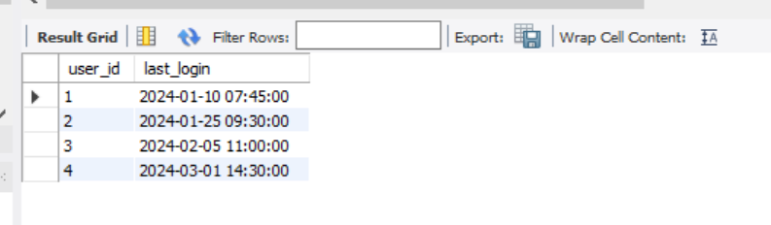

2.How many users and sessions were there in each quarter, ordered from newest to oldest?

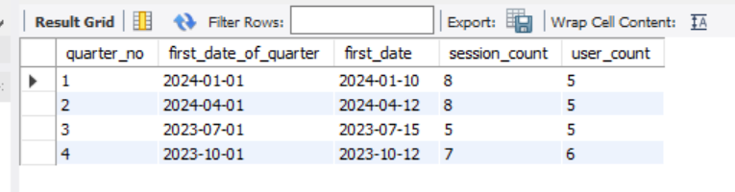

3. Which users logged in during January 2024 but did not log in during November 2023?

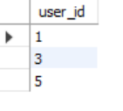

4. What is the percentage change in sessions from the last quarter?

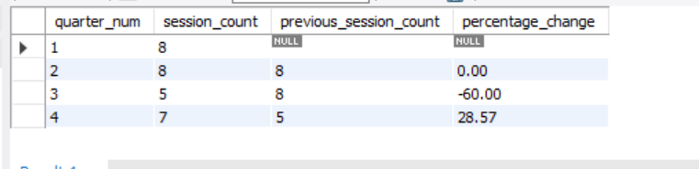

5. Which user had the highest session score each day?

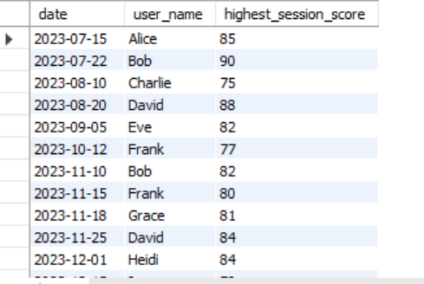

6. Which users have had a session every single day since their first login?

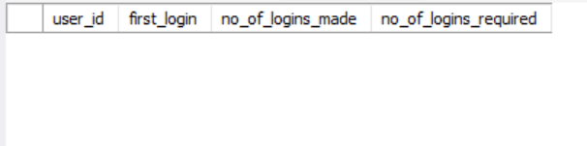

7. On what dates were there no logins at all?

