PROJECT TITLE : DESIGN AND IMPLEMENTION OF AN

IBM CLOUD IMAGE RECOGNITION

PHASE 1

***Problem Definition and Design Thinking:***

In this part you will need to understand the problem statement and create a document on what have you understood and how will you proceed ahead with solving the problem. Please think on a design and present in form of a document.

***Problem Definition:***

The project involves creating an image recognition system using IBM Cloud Visual Recognition. The goal is to develop a platform where users can upload images, and the system accurately classifies and describes the image contents. This will enable users to craft engaging visual stories with the help of AI-generated captions, enhancing their connection with the audience through captivating visuals and compelling narratives.

Design Thinking:

***1) Image Recognition Setup:***

* Set up the IBM Cloud Visual Recognition service and obtain the necessary API keys.

*2) User Interface:*

* Design a user-friendly interface for users to upload images and view the AI-generated captions.

***3) Image Classification:***

* Implement the image classification process using the IBM Cloud Visual Recognition API.

***4) AI-Generated Captions:***

* Integrate natural language generation to create captions for the recognized images.

***5) User Engagement:***

* Design features to allow users to explore, save, and share their AIenhanced images

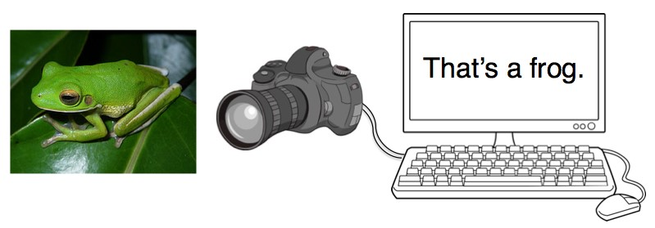

***6) WHAT IS IMAGE RECOGNITION ?***

* This isn’t a general introduction to Artificial Intelligence, Machine Learning or Deep Learning.And this isn’t a discussion about whether AI will enslave humankind or merely steal all our jobs. You can find plenty of speculation and some premature fearmongering elsewhere.And this isn’t a discussion about whether AI will enslave humankind or merely steal all our jobs. You can find plenty of speculation and some premature fearmongering elsewhere.
* I’m currently on a journey to learn about Artificial Intelligence and Machine Learning. And the way I learn best is by not only reading stuff, but by actually building things and getting some hands-on experience. And that’s what this post is about. I want to show you how you can build a system that performs a simple computer vision task: recognizing image content.
* I don’t claim to be an expert myself. I’m still learning, and there is a lot to learn. I’m describing what I’ve been playing around with, and if it’s somewhat interesting or helpful to you, that’s great! If, on the other hand, you find mistakes or have suggestions for improvements, please let me know, so that I can learn from you.
* You don’t need any prior experience with machine learning to be able to follow along. The example code is written in Python, so a basic knowledge of Python would be great, but knowledge of any other programming language is probably enough

***7) Why image recognition?***

* Image recognition is a great task for developing and testing machine learning approaches. Vision is debatably our most powerful sense and comes naturally to us humans. But how do we actually do it? How does the brain translate the image on our retina into a mental model of our surroundings? I don’t think anyone knows exactly.

### *8) Image classification and the CIFAR-10 dataset*

### We will try to solve a problem which is as simple and small as possible while still being difficult enough to teach us valuable lessons. All we want the computer to do is the following: when presented with an image (with specific image dimensions), our system should analyze it and assign a single label to it. It can choose from a fixed number of labels, each being a category describing the image’s content. Our goal is for our model to pick the correct category as often as possible. This task is called image classification.

### *9) Supervised Learning*

### How can we use the image dataset to get the computer to learn on its own? Even though the computer does the learning part by itself, we still have to tell it what to learn and how to do it. The way we do this is by specifying a general process of how the computer should evaluate images.

*10) THE FINAL DESTNIATION*

* By observing the image and giving the solution or answer to the user is known as the image recognition these are mostly used in traffic signals, websites ,etc….