PHOTOGRAPHER PORTFOLIO WEBSITE — DOCUMENTATION REPORT
Name: Harini B. R.
Project Title: Photographer Portfolio Website
Internship Domain:Front-end Development
Date: October 2025

1. ABSTRACT
The Photographer Portfolio Website is a responsive, elegant, and user-friendly platform designed to showcase the work of a professional photographer. It provides visitors with an engaging visual experience, highlighting the photographer’s portfolio, services, and contact information. The website aims to help the photographer display artistic skills, attract clients, and enhance professional credibility through an online presence.

2. OBJECTIVES
- To design a responsive website using HTML, CSS, and JavaScript.
- To create an online portfolio for showcasing photographs.
- To ensure the website works seamlessly on all screen sizes.
- To implement sections like Home, About, Gallery, and Contact.
- To use simple and lightweight code optimized for performance.

3. SCOPE OF THE PROJECT
The project serves as a digital identity for a photographer. It can be expanded to include advanced features like an online booking system, social media integration, and an image store. Currently, the scope covers front-end development, visual design, and responsive layout implementation.

4. TECHNOLOGIES USED
Component | Technology / Tool
Frontend Languages | HTML5, CSS3
Framework / Library | None (Pure CSS, Media Queries used for responsiveness)
Design Tools | Figma / Canva (for layout & mockup)
Code Editor | Visual Studio Code
Browsers Tested | Google Chrome, Microsoft Edge, Firefox

5. SYSTEM REQUIREMENTS
Hardware Requirements
- Minimum 2 GB RAM
- Any modern processor
- 500 MB free disk space
Software Requirements
- Any modern browser (Chrome, Edge, Firefox)
- Code editor (VS Code recommended)
- Internet connection (for external fonts or icons if used)

6. PROJECT MODULES
- Home Section:
  - Displays the photographer’s name and tagline.
  - Contains navigation links to other sections.
- About Section:
  - Describes the photographer’s background, experience, and style.
- Gallery Section:
  - Displays selected images in a grid layout.
  - Includes hover effects and responsiveness for mobile screens.
4.Footer:
  - Contains social media links and copyright information.

7. WEBSITE DESIGN OVERVIEW
The website follows a clean and minimalistic design approach, focusing on visual storytelling.
The layout uses consistent spacing, typography, and color palette for professional aesthetics.
Responsive media queries are used to ensure smooth adaptation on tablets and mobile devices.

8. FILE STRUCTURE
frontend/
├── index.html
├── session.html

├── style.css
├── images/
│ ├── image1.jpeg
│ ├── image2.jpeg
│ └── ...
└── README.md and script.js file

9. HOW TO RUN THE PROJECT
- Download the project ZIP file or clone it.
- Extract all files into a folder.
- Open index.html in any modern browser.

10. OUTPUT / SCREENSHOTS

- Home section
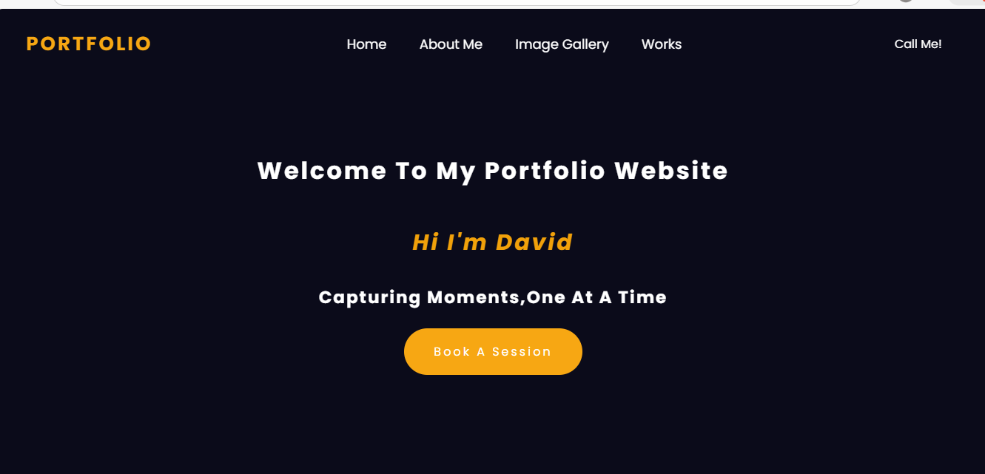
Gallery Section


- About Section
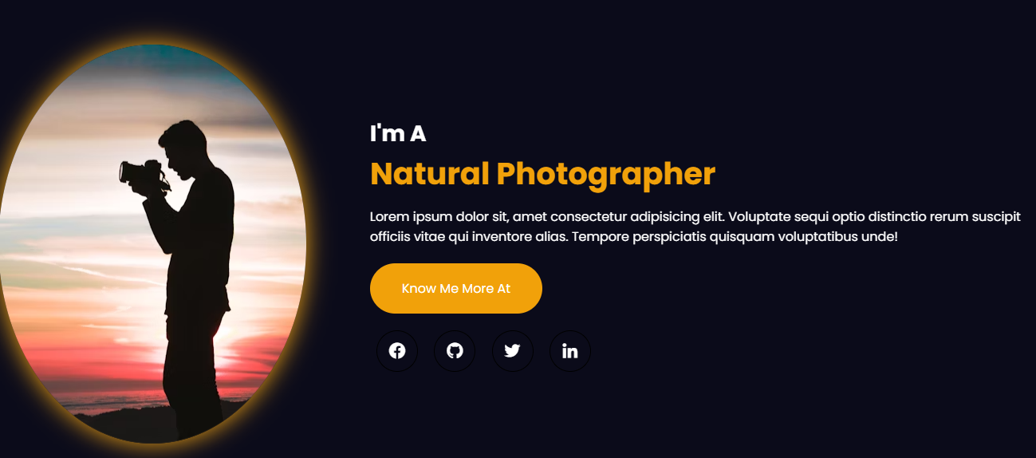

  - work section
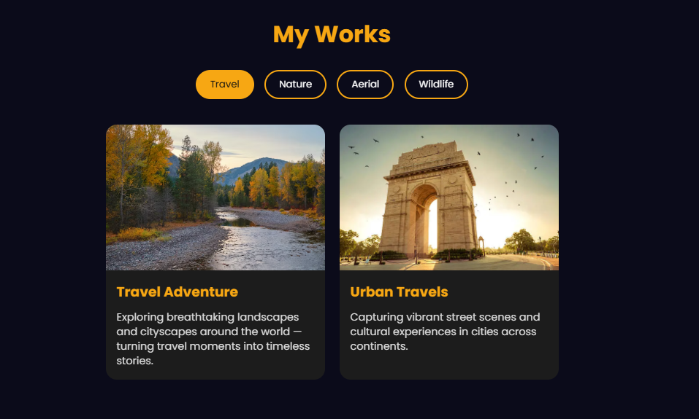
- footer section


  - Book A Session form
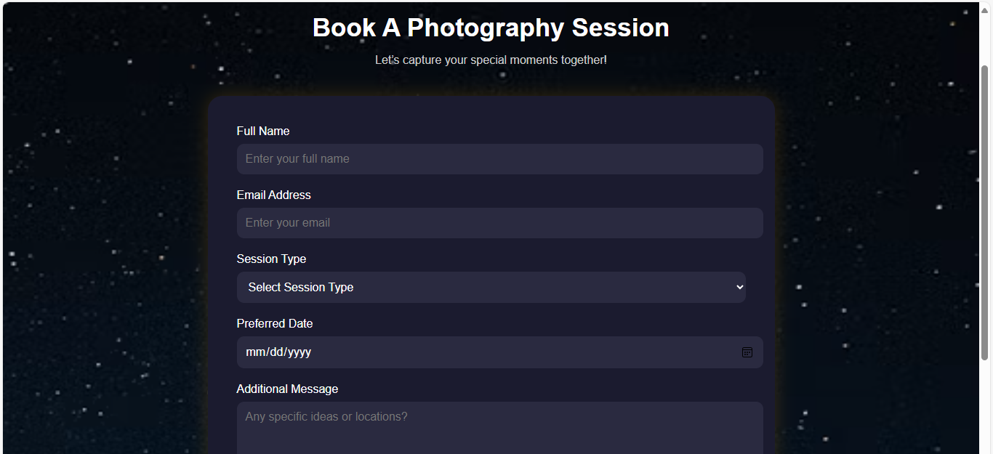

- Mobile view
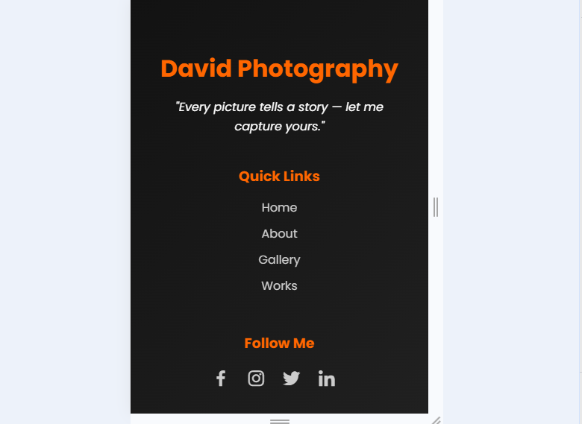

11. RESULTS
The website successfully displays the photographer’s portfolio with a fully responsive layout.
It loads quickly, adapts to multiple screen sizes, and provides smooth navigation.

12. CONCLUSION
The project demonstrates the ability to design and develop a professional and visually appealing website using fundamental web technologies. The Photographer Portfolio Website effectively showcases creativity and technical skills. It can serve as a base for more advanced projects involving backend systems or CMS integration.

13. FUTURE ENHANCEMENTS
- Add user authentication for admin photo uploads.
- Include photo category filters.
- Implement booking or appointment feature.
- Add backend (Spring Boot / Node.js) for dynamic content.

14. REFERENCES
- W3Schools — HTML, CSS Tutorials
- MDN Web Docs
- Freepik / Unsplash — Royalty-Free Images

