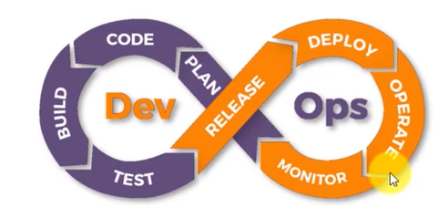

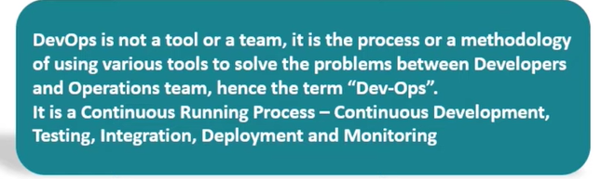

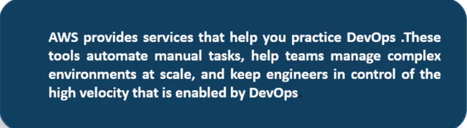

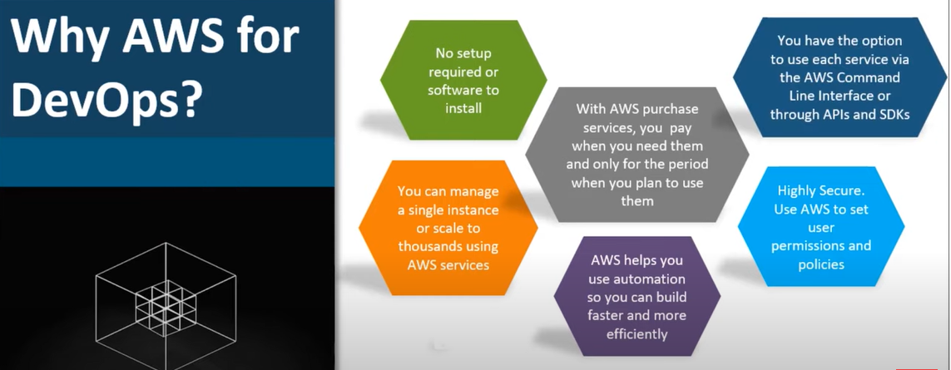

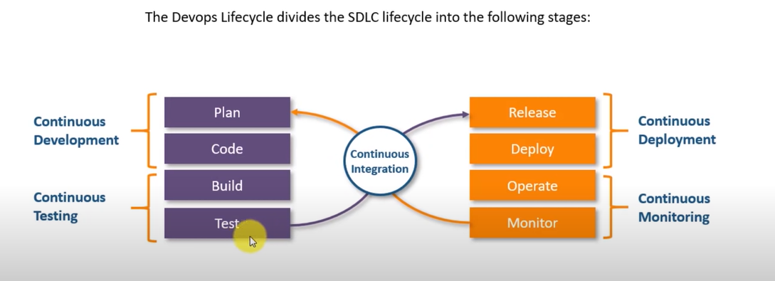

Continuous Development – We push our code to version control system, it is identified by the continuous integration tool, so the first job it does is it pushes on to the testing server—where the code is built and tested. If the test succeeds the continuous integration tool pushes it to production server,  
If the bugs are identified the feedback is given threw continuous monitoring to developer. If there is any bugs in production server, the logs are generated and stored, continuously monitored

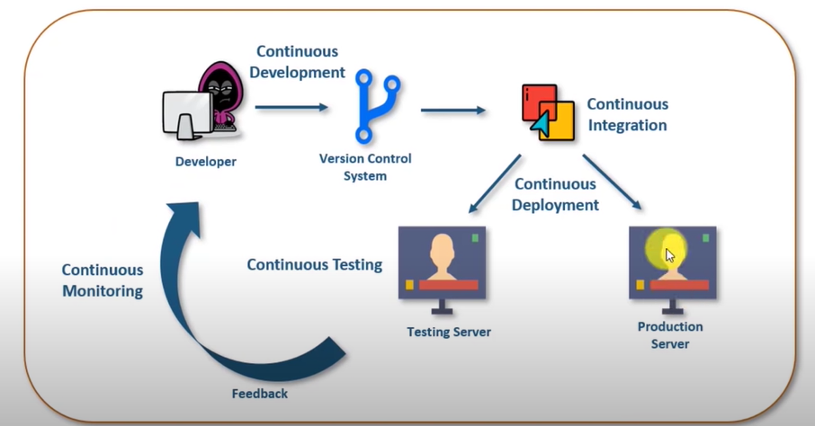

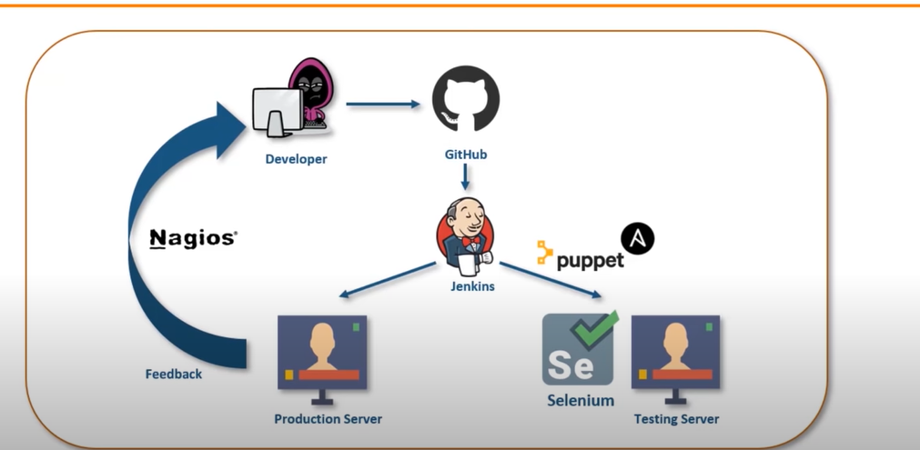

Developer pushes the code to GitHub, from git Jenkins automatically detects that code has been changed, from GitHub it pulls the code and pushes it on to the testing server and it installs all the software’s required in the testing server (container, docker, puppet, ansible). If the test successful, Jenkins pushes the code to production. On production server Nagios continuously monitor it for the user activity (how many users are logged on, what the users are saying about it), all the information saved in Nagios and viewed by developers team via Nagios dashboard.

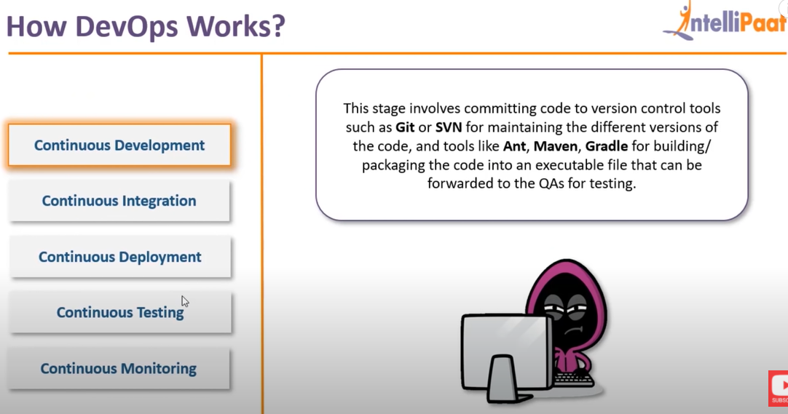

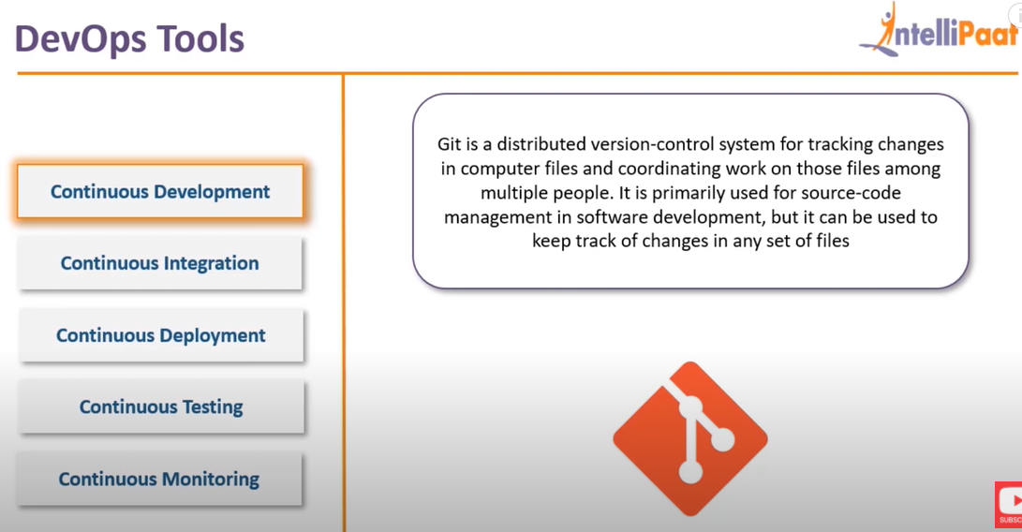

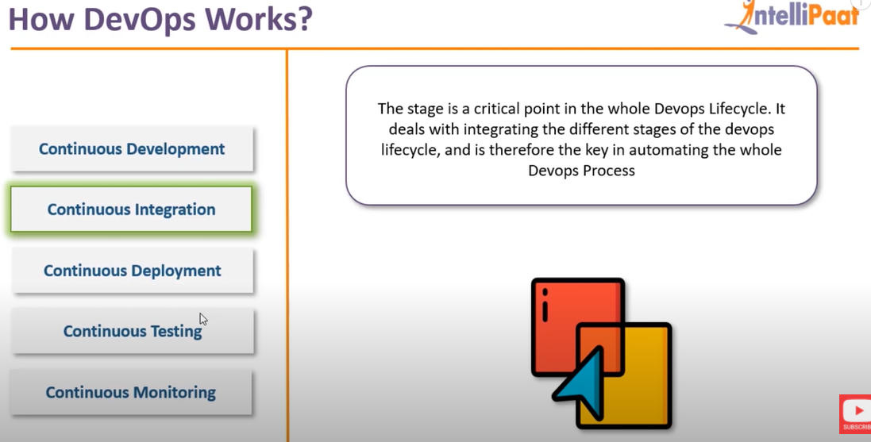

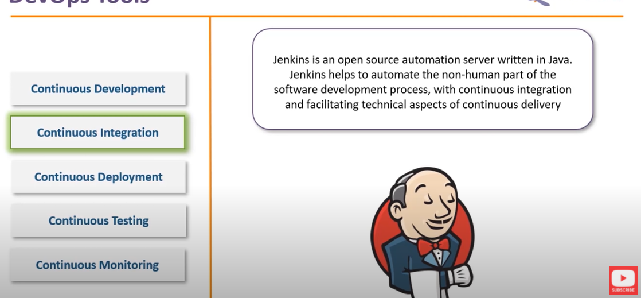

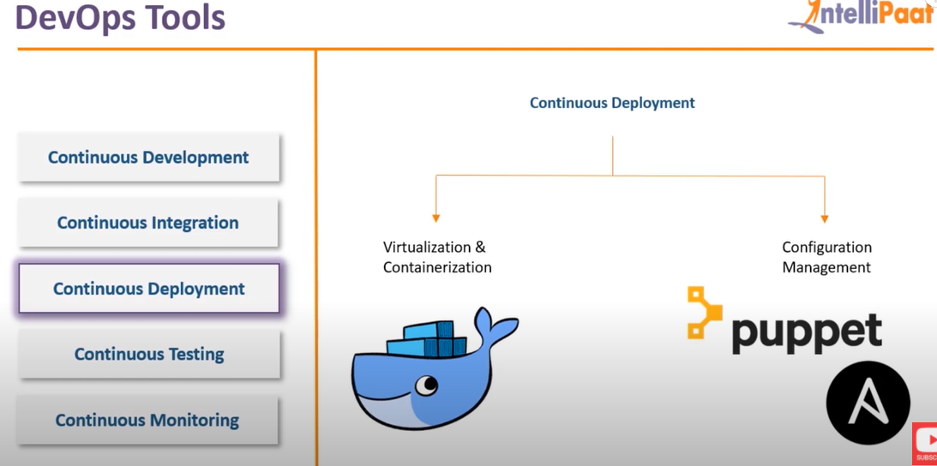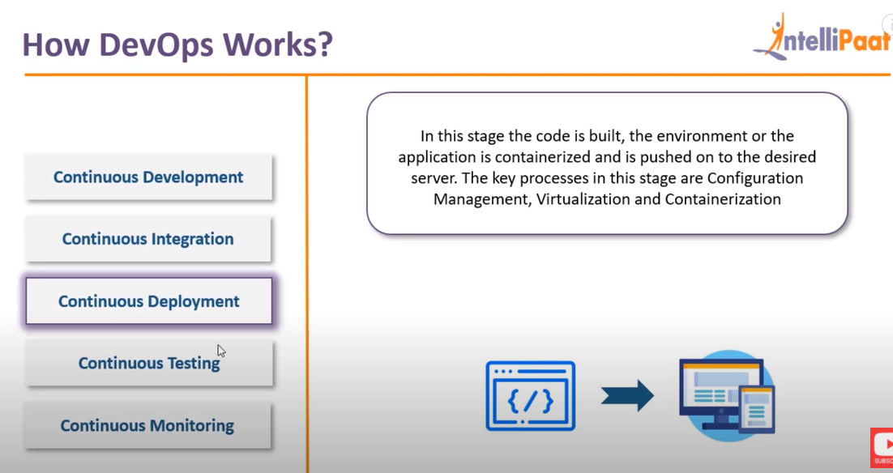

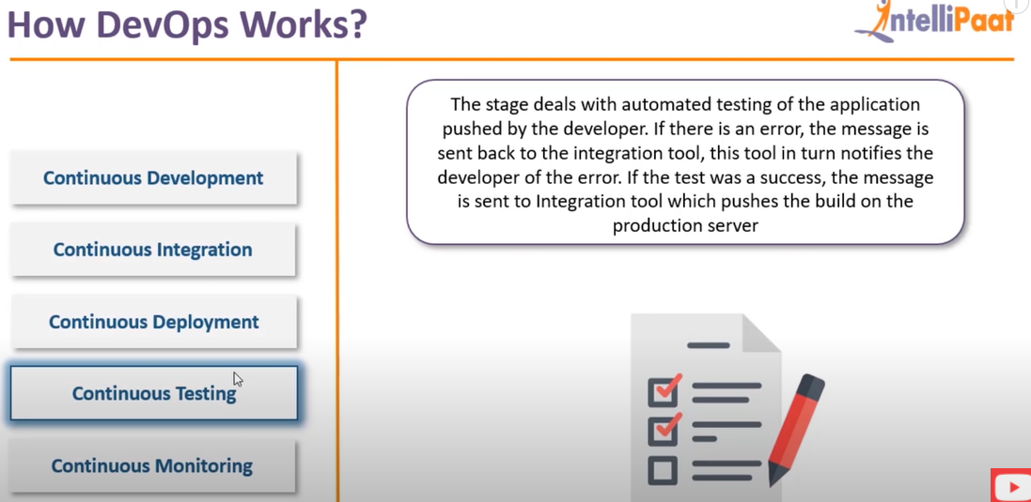

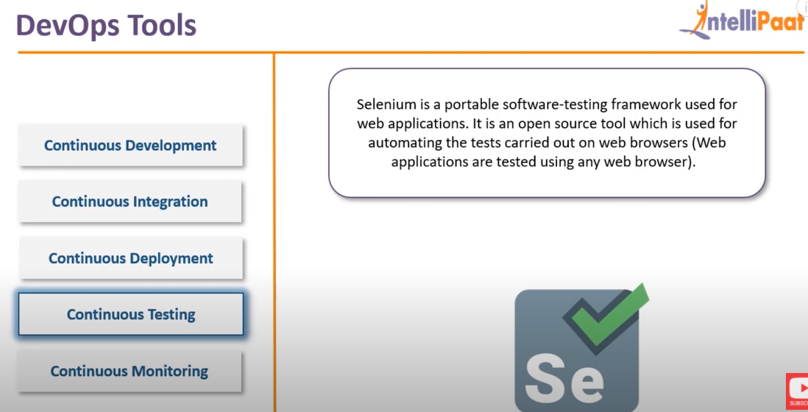

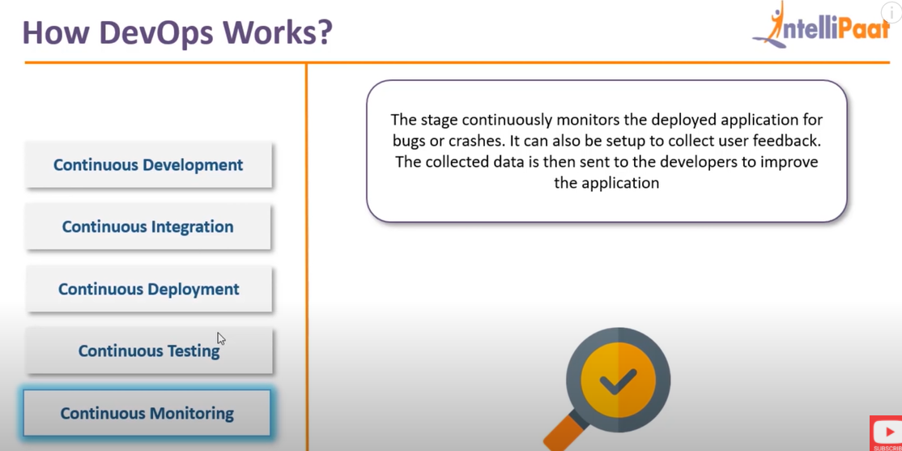

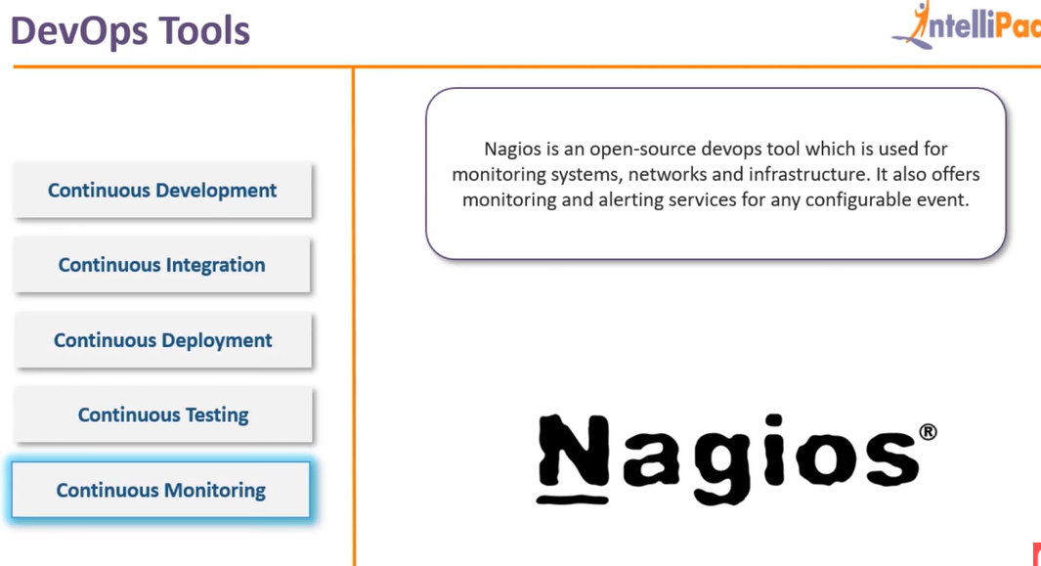

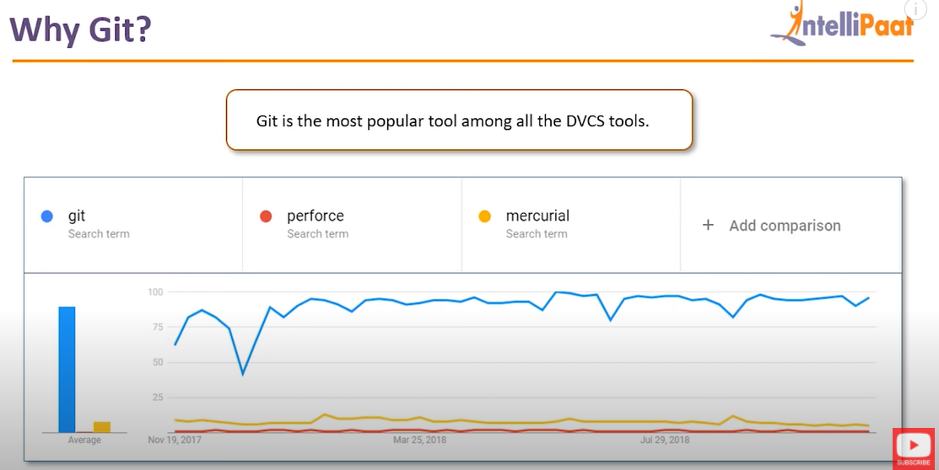

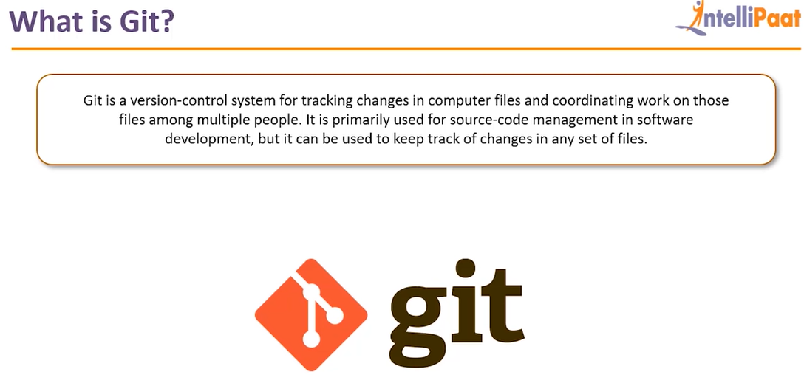

git init

git add .

git status

git commit -m “first commit”

git remote add origin “URL”

git push origin master

**To clone**

git clone url

** To create a branch **

git branch feature1

git branch -D feature1 (to delete a branch)

git branch (to check the branches)

git checkout feature1

git log (used to see history)

git stash (used to solve conflicts between feature and master branch)

git revert commit_id (used to revert changes)

git checkout commit_id(used to check what changes we have made )

git diff commit_id1 commit_id2

git diff HEAD . (used to find diff between latest commit(head) and current file)