Soil Moisture Level Indicator

## Aim

The aim of this project is to develop a low-cost, energy-efficient soil moisture detection system that provides a clear visual indication of soil conditions. The application of this system is useful in:

- Agriculture: Prevents overwatering or underwatering of crops.

- Gardening: Helps in maintaining household plants.

- Automation Systems: Can be integrated into automatic irrigation systems.

# Abstract

Soil moisture monitoring is crucial for effective irrigation and plant growth. This project presents a Soil Moisture Indicator using an LM358 operational amplifier (Op-Amp). The circuit detects soil moisture levels and provides a visual indication using LED. When the soil is dry, the green LED doesn’t light up, indicating the need for watering. When the soil is adequately moist, the green LED turns on, signaling sufficient moisture levels. This simple, cost-effective device helps in efficient water management for agriculture, gardening, and plant care.

## Components Required

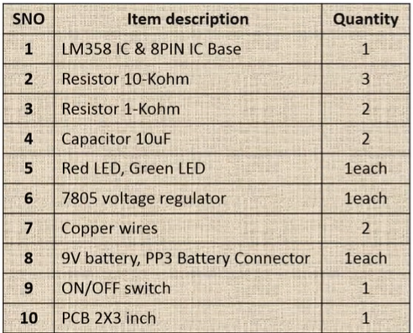

## Circuit Diagram

The circuit diagram of the Soil Moisture Indicator is shown below:

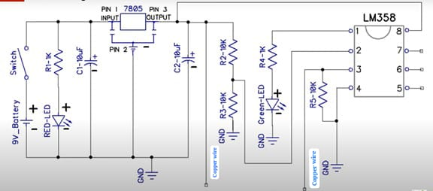

## Working Principle

The soil moisture indicator works based on the principle of comparator operation using the LM358 IC.

### Operation Steps:

**1. Power Supply Regulation:**

- The 9V battery provides power to the circuit.

- A 7805 voltage regulator converts this 9V to 5V DC for circuit operation.

- A red LED is used to indicate power status.

**2. Moisture Detection:**

- Two probes are inserted into the soil to measure moisture content.

- If the soil is dry, its resistance is high, which affects the voltage at the input of LM358.

- If the soil is moist, its resistance is low, allowing current to flow and changing the voltage levels.

**3. Comparator Circuit Using LM358:**

- The LM358 Op-Amp compares the voltage levels from the soil probe and a reference voltage set using resistors.

**LM358 IC Pin Configuration:**

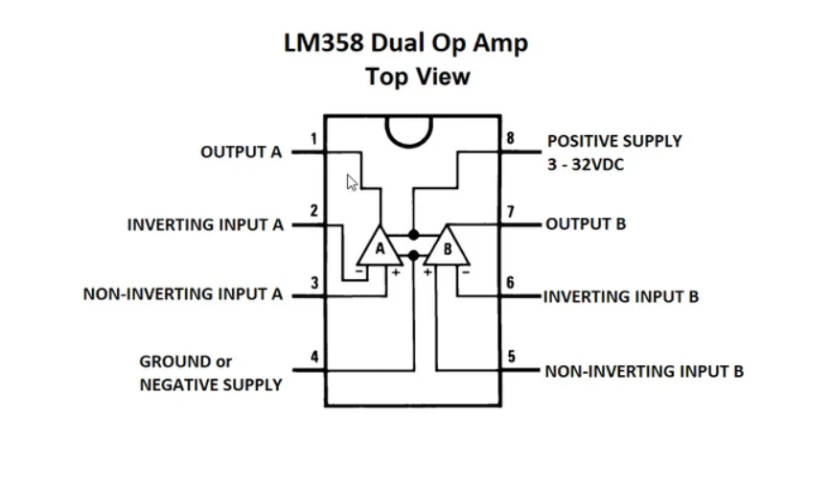

- If the soil is dry, the comparator output doesn’t activate the green LED, signaling low moisture.

- If the soil is wet, the comparator output activates the green LED, indicating sufficient moisture.

## Applications

- Agricultural farms for monitoring soil moisture.

- Home gardening for houseplants and lawns.

- Greenhouses to optimize irrigation systems.

- Automatic irrigation systems by integrating with water pumps.

## Conclusion

This project successfully demonstrates a simple and effective soil moisture indicator using the LM358 Op-Amp. By providing a clear LED indication, it helps users take timely action to water plants, thus conserving water and improving plant health. This system is a low-cost, easy-to-build, and useful tool for farmers, gardeners, and plant enthusiasts.