End-to-End Text Sentiment Analysis using ANN, RNN, LSTM, GRU

and TensorFlow

Project Overview
The “End-to-End Text Sentiment Analysis using ANN, RNN, LSTM, GRU and TensorFlow” project aims to develop an automated system for classifying IMDb movie reviews as positive or negative. The project uses the IMDb Dataset of 50K Movie Reviews and follows a complete NLP workflow including data analysis, text preprocessing, tokenization, sequence encoding, and feature representation.
Different deep learning models such as ANN, Simple RNN, LSTM, GRU, and Bidirectional LSTM are developed, trained, and compared using performance metrics such as Accuracy, Precision, Recall, F1 Score, and ROC-AUC. The best-performing model is integrated into a Flask web application that provides individual and batch sentiment prediction along with prediction probabilities and model performance analysis.

Phase 1 – Data Understanding
The Data Understanding phase focuses on analyzing the IMDb Dataset of 50K Movie Reviews before applying preprocessing and deep learning techniques. This phase helps to understand the dataset structure, data quality, sentiment distribution, and characteristics of the review text.

Dataset Description
The dataset contains 50,000 movie reviews with two main columns: review and sentiment. The review column contains the textual movie review, while the sentiment column contains either positive or negative labels. Therefore, the project is treated as a binary text classification problem.

Dataset Inspection
The dataset was inspected to understand its size, columns, data types, sample records, and overall structure. This initial analysis helped identify the important features and target variable required for sentiment classification.

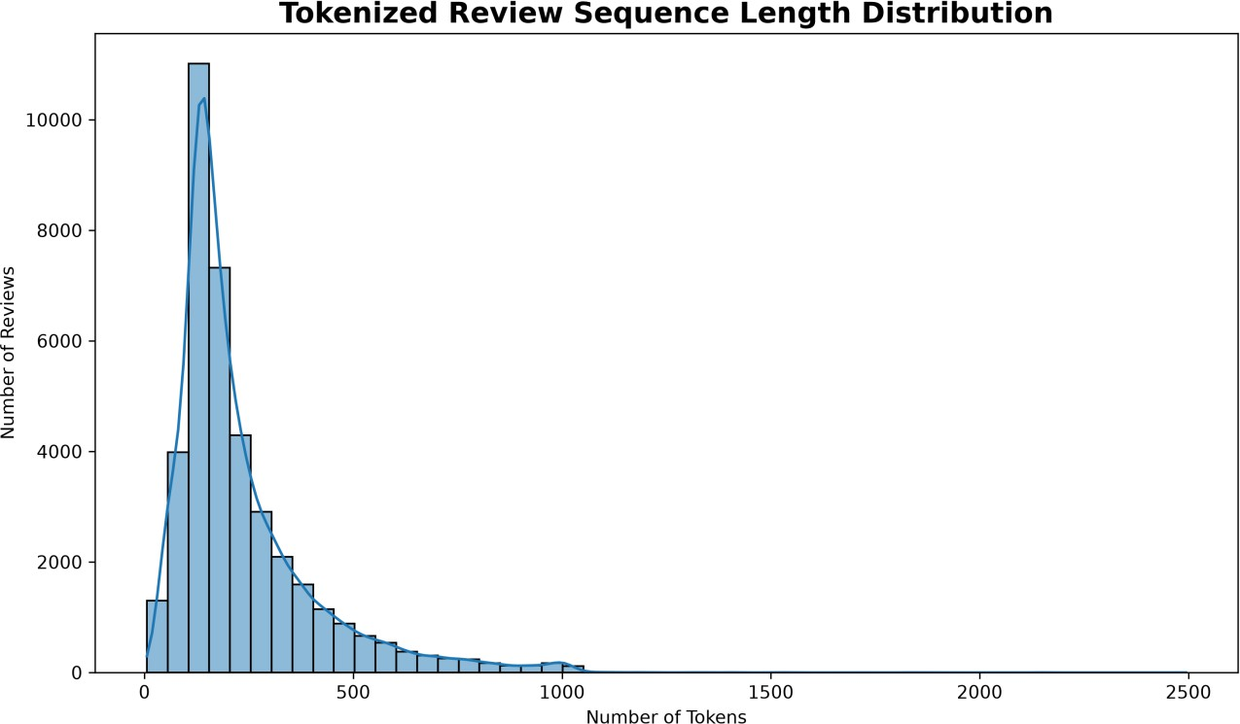
Figure 1: Sequence length Distribution

Sentiment Distribution
The distribution of positive and negative reviews was analyzed to understand the balance of the target classes. The dataset contains a nearly balanced distribution of both sentiment categories, making it suitable for supervised learning.
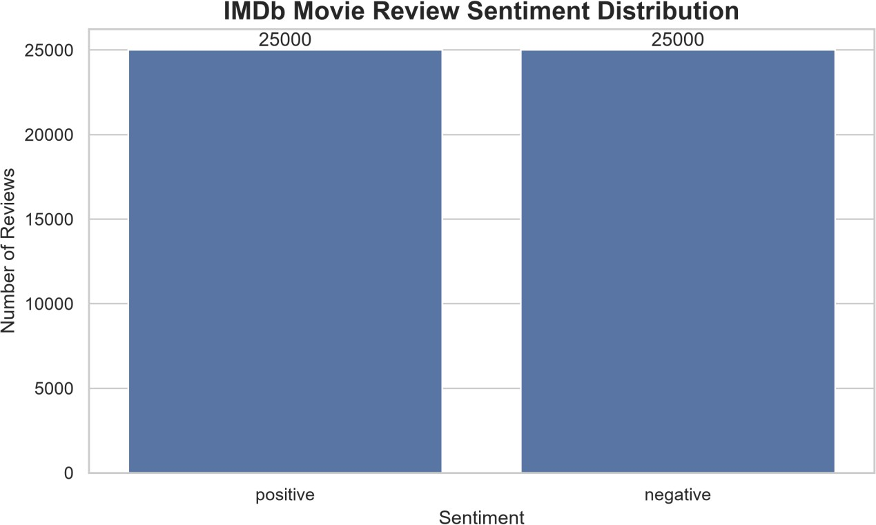
Figure 2: Sentiment Distribution

Missing Value Analysis
The dataset was checked for missing values in the review and sentiment columns. This analysis ensured that incomplete records could be identified before further processing and model development.

Duplicate Analysis
Duplicate records were analyzed to identify repeated reviews in the dataset. Duplicate records can affect model training and evaluation, so they were examined and handled before proceeding to the next phase.

Review Length Analysis
The length of the reviews was analyzed to understand the variation in textual data. A review-length distribution was generated to identify short, medium, and long reviews. This analysis was useful for deciding the sequence length required during tokenization and padding.

Word Frequency Analysis
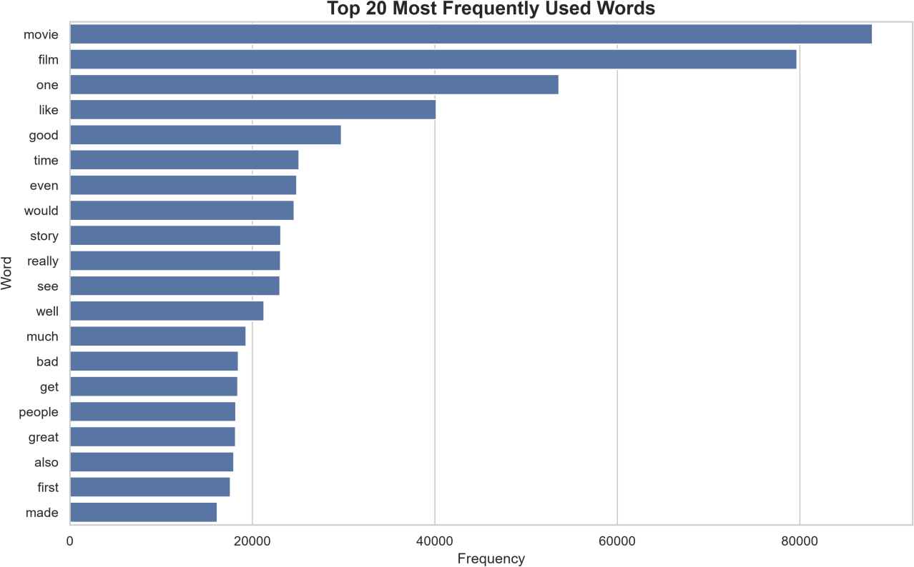
Frequently occurring words were analyzed to understand the common vocabulary used in IMDb reviews. This provided insights into movie-related terms, descriptive words, and frequently occurring language patterns.

Figure 3: Frequency Analysis

Word Cloud Analysis
A word cloud was generated to provide a visual representation of frequently used words. Frequently occurring words appear more prominently, helping to understand the overall vocabulary of the dataset.
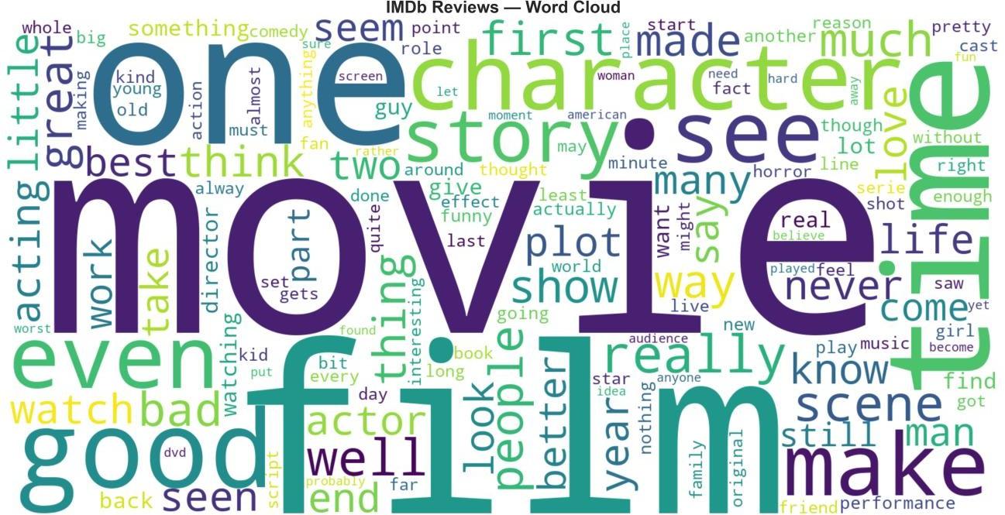
Figure 4: word cloud

Negation Analysis
Negation words such as not, no, and never were identified as important sentiment-related terms. Negation can change the meaning of a sentence, such as “The movie is good” and “The movie is not good.” Therefore, such information needs to be considered during preprocessing.

Outcome
The Data Understanding phase provided a clear overview of the IMDb movie review dataset. The dataset structure, sentiment distribution, missing values, duplicates, review lengths, vocabulary, and important sentiment patterns were analyzed.

Phase 2 – Text Preprocessing
The IMDb movie review dataset contains raw textual reviews that may include HTML tags, special characters, unnecessary spaces, and words that provide limited value for sentiment classification.

The preprocessing steps included lowercasing the text, removing HTML tags, removing non-alphabetic characters, and eliminating extra spaces.
Stopwords were also identified and analyzed during exploratory preprocessing. However, stopword removal was not applied to the final reviews used for deep learning, since words such as not, never, and no can carry important sentiment information.
After cleaning, additional text statistics such as word count and character count were calculated to understand the structure and length of the reviews. The cleaned dataset was then prepared for tokenization and numerical sequence representation.

Preprocessing Steps
- Convert text to lowercase – Ensures that words such as Movie and movie are treated as the same word.
- Remove HTML tags – Removes tags such as <br /> that are commonly present in IMDb reviews.
- Remove special characters – Keeps alphabetic characters and removes unnecessary symbols and numbers.
- Remove extra spaces – Converts multiple spaces into a single space.
- Analyze stopwords – English stopwords were identified, but they were not blindly removed because some words can be important for sentiment.
- Calculate text statistics – Word count and character count were calculated for further analysis.
- Prepare for tokenization – The cleaned text was subsequently converted into numerical sequences for RNN, LSTM, GRU, and Bi-LSTM models.

Example:
Original review:
This movie was <br /> AMAZING!!! I really enjoyed it.

After preprocessing:
this movie was amazing i really enjoyed it
This cleaned text can then be passed to the tokenizer for conversion into numerical sequences.

Phase 3 – Feature Representation
After text preprocessing, the cleaned reviews cannot be directly given to machine learning or deep learning models because the models require numerical input. Therefore, feature representation was performed to convert textual reviews into numerical forms. Different representation techniques were explored to understand which approach is most suitable for sentiment classification.

Tokenization and Integer Encoding
Tokenization converts each review into a sequence of integer IDs, where each unique word is assigned a numerical index. A tokenizer with a maximum vocabulary size of 30,000 words was used. An <OOV> token was included to represent words that are not present in the selected vocabulary.
For example:
"this movie is excellent"
↓
[15, 28, 7, 421]
These integer sequences are later used as input for the RNN, LSTM, GRU, and Bi-LSTM models.

TF-IDF
TF-IDF (Term Frequency–Inverse Document Frequency) represents each review as a numerical vector based on the importance of words within the dataset.
TF-IDF gives higher importance to words that are frequent in a particular review but less common across the entire collection of reviews. Very common words receive lower importance.
In this project, TF-IDF was configured with:
- Maximum features: 50,000
- N-grams: Unigrams and bigrams (1, 2)
- Minimum document frequency: 2
- Maximum document frequency: 95%
- Sublinear TF: Enabled
TF-IDF was combined with Logistic Regression to create a traditional machine-learning baseline. It achieved strong performance and provided a useful comparison against the deep learning models.

Word Embeddings
Word embeddings represent words as dense numerical vectors instead of simple integer IDs. Words with similar meanings can have similar vector representations.
For example:
excellent → [0.21, -0.14, 0.73, ...]
amazing → [0.19, -0.11, 0.69, ...]
In the project, an embedding dimension of 128 was considered for representing words in a dense vector space.
Unlike integer encoding, embeddings can capture useful relationships between words and provide a better representation for neural-network-based text classification.

Trainable Embedding Layer
A trainable embedding layer was used as part of the deep learning representation. Instead of using fixed word vectors, the embedding weights are learned during model training according to the sentiment-classification task.
The configuration used was:
- Vocabulary size: 30,000
- Embedding dimension: 128
- Maximum sequence length: 500
The embedding layer converts the integer token sequences into dense 128-dimensional vectors. These representations are then processed by neural networks such as GRU, LSTM, RNN, and Bi-LSTM.

Feature Representation Summary
Representation Type Size Purpose

Tokenization + Integer Encoding
Integer sequences
500 tokens Input representation for deep

TF-IDF Sparse vectors 50,000 features
learning
Word Embeddings Dense vectors 128
dimensions
Traditional ML baseline
Semantic word representation

Trainable Embedding Layer Learned dense
vectors
128
dimensions
Deep learning models

Phase 3 established multiple representations of the same textual data. TF-IDF was used to establish a traditional machine-learning baseline, while integer encoding and trainable embeddings provided the numerical representation required for the RNN-based deep learning models.

Phase 4 – Deep Learning Models
Models were developed to establish a performance benchmark for the IMDb sentiment classification task. Both a traditional neural-network approach and recurrent deep learning models were evaluated using the integer-encoded and padded review sequences prepared in the previous phases.
The main objective of this phase was to determine how different baseline architectures perform before moving to more advanced model experimentation and optimization.

ANN
An Artificial Neural Network (ANN) was first developed as a simple deep learning baseline. The integer-encoded reviews were passed through an embedding representation, followed by pooling and dense layers.
The ANN provides a basic reference point for understanding whether a more complex sequence-based architecture such as GRU or LSTM can improve sentiment classification.

RNN
A Simple RNN was implemented to process the review sequences sequentially. Unlike the ANN, the RNN considers the order of words in the review.
The model processes the input sequence one step at a time and maintains a hidden state containing information from previous words.
However, the Simple RNN baseline showed relatively weak performance compared with the other models, demonstrating the limitations of basic recurrent networks for longer movie reviews.

LSTM
An LSTM (Long Short-Term Memory) model was developed to improve sequence learning. LSTM uses memory cells and gates to retain important information and reduce the vanishing-gradient problem associated with basic

RNNs.

This allows the model to capture longer-term dependencies within movie reviews more effectively.

GRU
A GRU (Gated Recurrent Unit) model was also evaluated. GRU uses update and reset gates to control how information is retained or discarded.
It provides sequence modeling capabilities similar to LSTM while using a simpler architecture.
In the baseline experiments, the GRU achieved the best overall performance among the tested recurrent deep learning models.

Bi-LSTM
A Bidirectional LSTM (Bi-LSTM) was used to process the review sequence in both forward and backward directions.
This allows the model to obtain contextual information from both previous and following words in the sequence, providing a richer representation of the review.

Baseline Performance
The baseline models were evaluated using:
- Accuracy – Overall percentage of correctly classified reviews.
- Precision – How many predicted positive reviews were actually positive.
- Recall – How many actual positive reviews were correctly identified.
- F1 Score – Harmonic mean of precision and recall.
- ROC-AUC – Measures the model's ability to distinguish between positive and negative classes across classification thresholds.

Model | Accuracy | Precision | Recall | F1 Score | ROC-AUC
ANN | 75.02% | 96.71% | 51.99% | 67.62% | 95.23%
RNN | 50.53% | 59.00% | 4.74% | 8.78% | 51.14%
GRU | 88.47% | 88.20% | 88.91% | 88.56% | 94.35%
LSTM | 88.26% | 87.91% | 88.83% | 88.37% | 94.02%
Bi-LSTM | 87.82% | 89.39% | 85.94% | 87.63% | 94.21%

Conclusion
The baseline comparison showed that GRU performed best overall, achieving 88.47% accuracy and 88.56% F1 score. LSTM produced very similar results, while the Simple RNN performed poorly on the task.
Therefore, the GRU architecture was selected as the strongest baseline candidate for further experimentation and optimization in the subsequent phases.
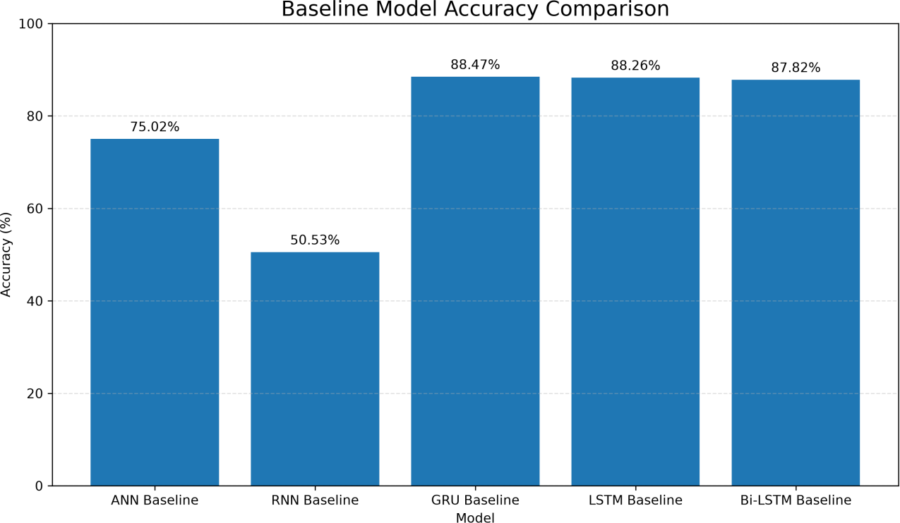

Figure 5: Baseline Accuracy Comparison

Phase 5 – Model Improvement
Different deep learning architectures and training configurations were experimented with to improve the baseline performance obtained in Phase 4. The main focus was to understand how model architecture, sequence processing, regularization, optimizer, learning rate, and training parameters affect sentiment classification performance.

Model Architecture Experimentation
The main recurrent neural network architectures considered were:
- RNN
- LSTM
- GRU

Bidirectional LSTM
These models were compared to determine which architecture could capture sentiment-related information from movie reviews more effectively.

GRU Experimentation
Since the GRU provided strong baseline performance, additional experiments were performed using GRU-based architectures.
Different configurations of:
- Number of GRU units
- Dense-layer size
- Dropout
- Batch Normalization
- Optimizer
- Learning rate
were tested to improve the model's generalization ability.

Optimizer Experimentation
Different optimizers were considered for training the neural networks:
- Adam
- RMSprop

SGD

The optimizer controls how the model updates its weights during training.
Adam and RMSprop were particularly useful for recurrent neural networks because they adapt the learning process based on the gradients obtained during training.

Learning Rate Experimentation
Different learning rates were tested to determine how quickly the model should update its weights.
A learning rate that is too high can cause unstable training, while a very small learning rate can make training slow.
The experiments included lower learning-rate configurations, eventually identifying Adam with a learning rate of 0.0005 as an effective configuration for the final GRU model.

Regularization
Dropout was used to reduce overfitting by randomly disabling a portion of neurons during training.
Batch normalization was also experimented with to improve training stability and convergence.
These techniques were evaluated based on their effect on validation and test performance.

Training Configuration
The models were trained using parameters such as:
- Maximum sequence length: 500
- Vocabulary size: 30,000
- Embedding dimension: 128
- GRU/LSTM units: 128
- Batch size: 64
- Epochs: 10
- Binary cross-entropy loss
- Adam/RMSprop/SGD optimizers
Validation data was monitored during training to compare different

configurations.

Model Evaluation
Each experiment was evaluated using:
- Accuracy
- Precision
- Recall
- F1 Score
- ROC-AUC
- Training and validation loss
- Training time
Confusion matrices and training-history plots were also generated to understand classification errors and model learning behavior.

Best Configuration
The experimentation eventually identified the GRU with Adam optimizer and learning rate 0.0005 as the strongest configuration.

Metric | Performance
Accuracy | 90.02%
F1 Score | 90.27%
ROC-AUC | 95.61%
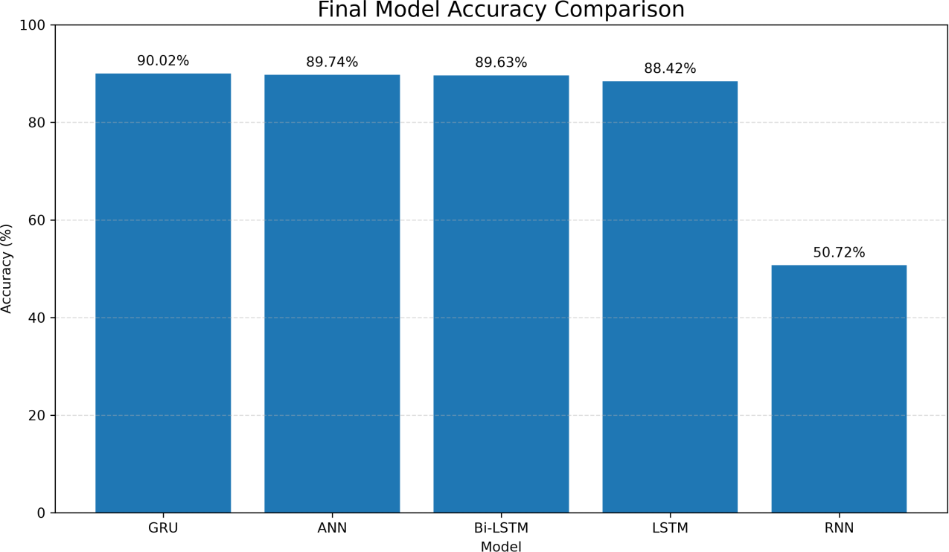

Figure 6: Accuracy Comparison

Conclusion
Phase 5 demonstrated that model performance can be improved through systematic experimentation with architecture, optimizer, learning rate, regularization, and training parameters.
Among the tested configurations, the GRU-based model with Adam optimizer and a learning rate of 0.0005 provided the best overall performance and was selected for final evaluation and deployment in the following phases.

Phase 6 – Model Evaluation
It ocused on the detailed evaluation and comparison of the trained sentiment classification models. The objective was to identify the most reliable model based on its performance on unseen validation and test data.
The selected models from the previous experimentation phase were evaluated using multiple classification metrics rather than relying only on accuracy.

Model Performance Evaluation
The models were evaluated using the following metrics:
- Accuracy – Measures the overall percentage of correctly classified reviews.
- Precision – Measures how accurately the model identifies positive reviews.
- Recall – Measures how many actual positive reviews are correctly detected.
- F1 Score – Provides a balance between precision and recall.
- ROC-AUC – Measures the model's ability to distinguish between positive and negative reviews.

Confusion Matrix
A confusion matrix was generated for the models to examine the number of:
- True Positives (TP) – Positive reviews correctly classified as positive.
- True Negatives (TN) – Negative reviews correctly classified as negative.
- False Positives (FP) – Negative reviews incorrectly classified as positive.
- False Negatives (FN) – Positive reviews incorrectly classified as negative.
The confusion matrices helped identify the types of classification errors made by each model.

Training and Validation Analysis
Training and validation accuracy and loss were also analyzed.
The training accuracy shows how well the model performs on the training data, while validation accuracy shows how well it generalizes to unseen validation data.
Similarly, training and validation loss were compared to identify possible overfitting or underfitting.
A small and consistent difference between training and validation performance indicates better generalization.

Final Model Selection
The final GRU model was selected based on the overall deep-learning experimentation results and its suitability for the project's sequence-based sentiment classification objective.
The selected configuration was:
- Model: GRU
- GRU units: 128

Embedding dimension: 128
- Vocabulary size: 30,000

Maximum sequence length: 500
- Optimizer: Adam
- Learning rate: 0.0005
- Output activation: Sigmoid
- Loss function: Binary Cross-Entropy

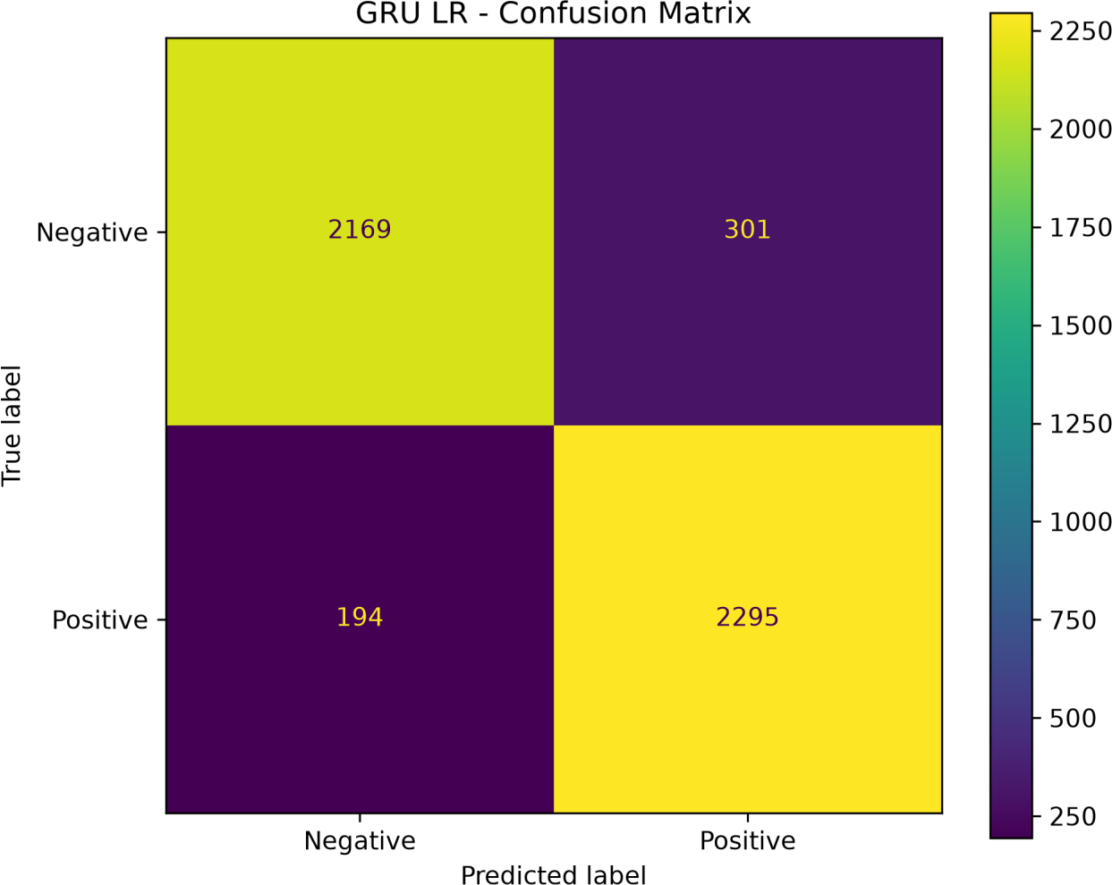

Figure 7: GRU Confusion Matrix

Conclusion
Provided a detailed comparison of the developed models using classification metrics, confusion matrices, and training/validation performance. The analysis confirmed that the GRU model achieved strong sentiment classification performance and was suitable for integration into the final application.

Phase 7 – Model Comparison
All trained models were compared using Accuracy, Precision, Recall, F1 Score, and ROC-AUC.
The models compared were:
- ANN
- RNN
- LSTM
- GRU
- Bi-LSTM
- TF-IDF + Logistic Regression

Rank | Model | Accuracy | Precision | Recall | F1  Score | ROC-AUC | Average Precision
1 | GRU Adam LR 0.0005 | 0.90018 | 0.88405 | 0.92206 | 0.90265 | 0.95607 | 0.94124
2 | ANN Batch 128 | 0.89736 | 0.90707 | 0.88630 | 0.89657 | 0.95759 | 0.95187
3 | Bi-LSTM  RMSprop | 0.89635 | 0.91094 | 0.87947 | 0.89493 | 0.95005 | 0.94631
4 | LSTM ReduceLR | 0.88425 | 0.88531 | 0.88389 | 0.88460 | 0.94395 | 0.93548
5 | RNN Batch 128 | 0.50716 | 0.50913 | 0.50422 | 0.50666 | 0.50967 | 0.51400

The comparison results were visualized using tables and charts to identify the best-performing model. Based on the deep learning experiments, GRU was selected as the final model because it provided strong performance with a simpler architecture.
The selected GRU model was then saved and integrated into the Flask application for sentiment prediction.

Phase 8 – Model Interpretation

The final GRU model was analyzed to understand how well the model makes sentiment predictions and where it may make incorrect classifications.
The model's predictions were examined using confusion matrix, classification metrics, prediction probabilities, and sample review analysis. Positive and negative predictions were compared to identify correct and incorrect classifications.
The analysis also helped understand model confidence and misclassified reviews, especially reviews containing mixed or subtle sentiment.

Key Analysis
- Confusion Matrix
- Accuracy, Precision, Recall, and F1 Score
- ROC-AUC and Average Precision
- Prediction confidence
- Correct and incorrect predictions
- Analysis of difficult or ambiguous reviews

Conclusion
Model interpretation helped identify the strengths and limitations of the final GRU model. The model performs well on clearly positive and negative reviews but may occasionally misclassify reviews containing mixed, subtle, or context-dependent sentiment.

Flask Web Application
The final sentiment analysis model was deployed using Flask, a lightweight Python web framework. The application provides a simple interface for users to enter movie reviews and receive sentiment predictions.

Main Features
- Home Page – Provides an overview of the sentiment analysis system.
- Single Review Prediction – Predicts whether a review is positive or negative.
- Batch Prediction – Allows users to upload a CSV file containing multiple reviews.
- Model Comparison – Displays the performance of different models.

- Text Analytics – Displays dataset and model-related visualizations.

- Download Results – Allows batch prediction results to be downloaded as a CSV file.

Prediction Process
User Review
↓

Tokenizer
↓

Integer Encoding
↓

Padding (500)
↓

GRU Model
↓

Prediction Probability
↓
Positive / Negative

Technologies Used
- Python – Main programming language
- Pandas & NumPy – Data processing and numerical operations
- NLTK – Text preprocessing and stopword analysis
- Scikit-learn – TF-IDF, Logistic Regression, and evaluation metrics
- TensorFlow & Keras – Deep learning model development
- RNN, LSTM, GRU & Bi-LSTM – Sentiment classification models
- Matplotlib & Seaborn – Data visualization
- Flask – Web application and model deployment
- HTML, CSS & Bootstrap – Web interface development

- Jupyter Notebook – Model development and experimentation

- Pickle – Saving and loading the tokenizer and preprocessing configuration
- Git & GitHub – Version control and project management
- IMDb 50K Movie Reviews Dataset – Dataset used for sentiment classification
- ​

Screenshots

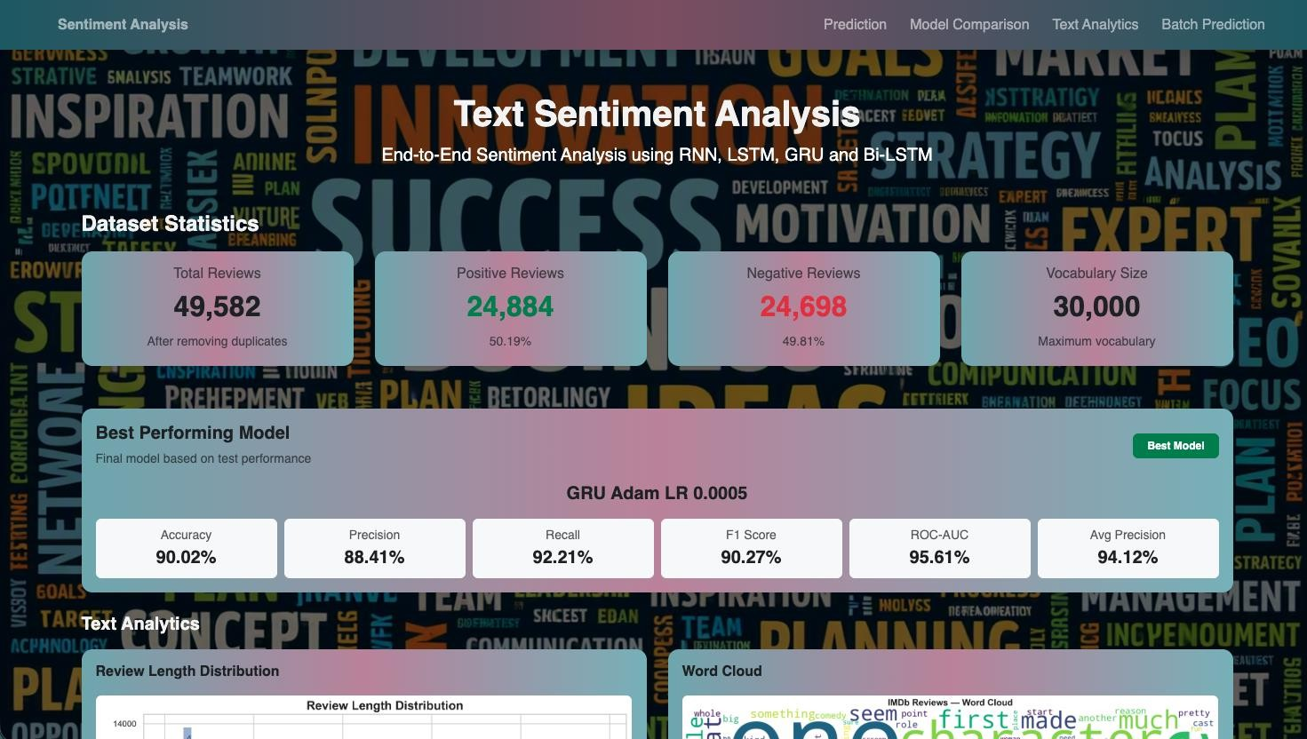
Figure 8: home page

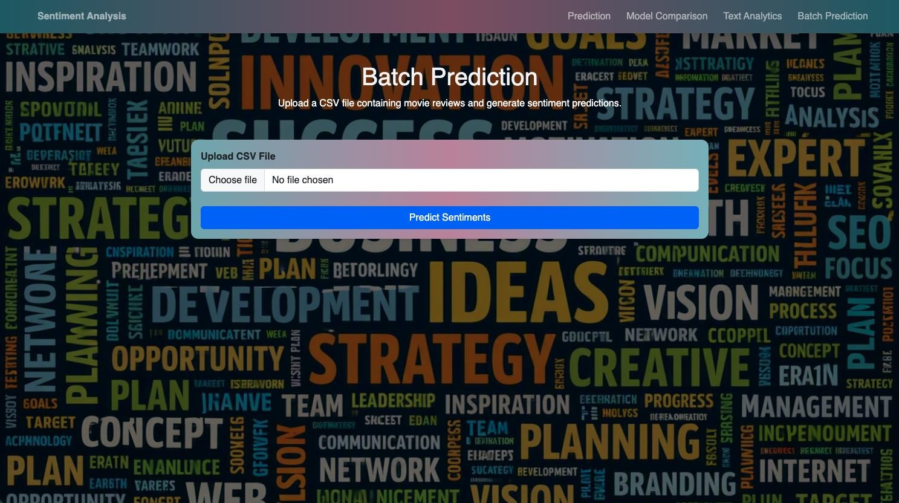
Figure 9: Prediction

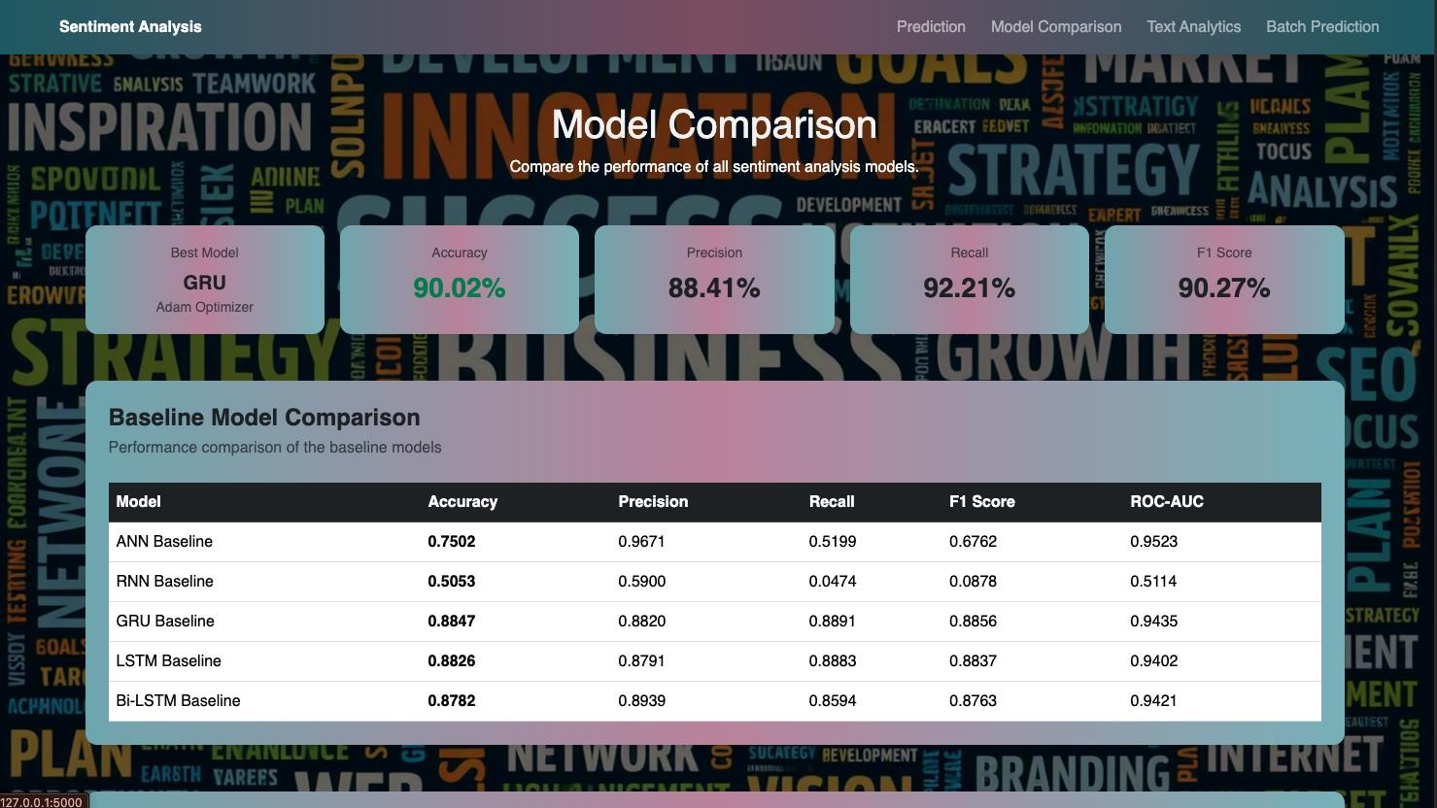
Figure 10: Model Comparison

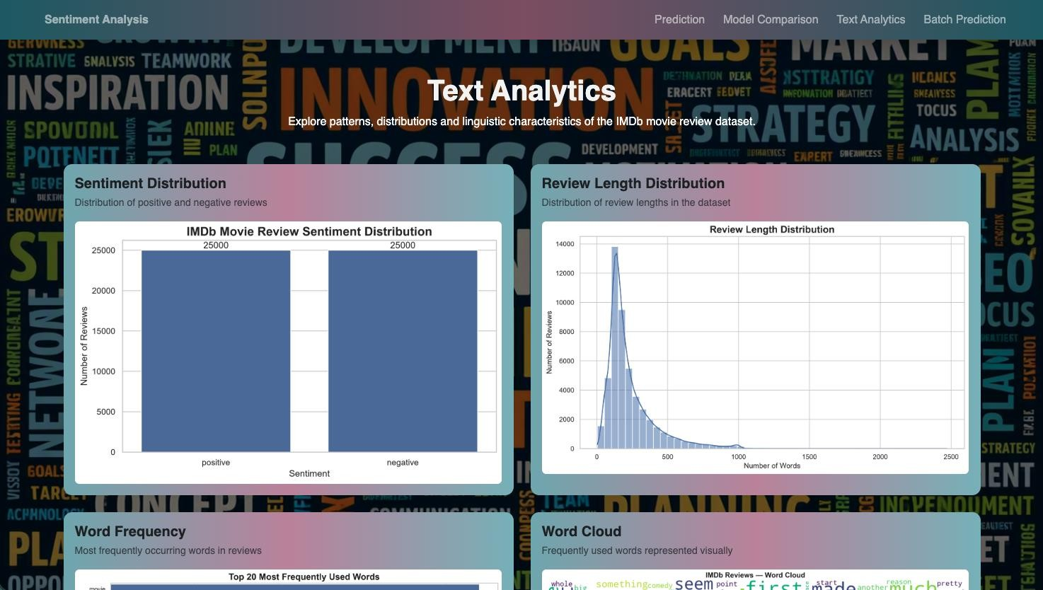
Figure 11: Analytics


Figure 12: Batch Prediction

Final Conclusion
The IMDb Sentiment Analysis project successfully developed an end-to-end system for classifying movie reviews as Positive or Negative. The project included data analysis, text preprocessing, tokenization, TF-IDF representation, word embeddings, and deep learning model development.
Different models such as ANN, RNN, LSTM, GRU, and Bi-LSTM were trained and evaluated using Accuracy, Precision, Recall, F1 Score, and ROC-AUC. Among the deep learning models, the GRU model with Adam optimizer and learning rate 0.0005 achieved the best overall performance with 90.02% accuracy and 90.27% F1 Score.
The final GRU model was integrated into a Flask web application, providing single-review prediction, batch prediction, model comparison, and text analytics features. Overall, the project demonstrates how Natural Language Processing and Deep Learning can be effectively applied to automatic sentiment classification of movie reviews.

