House Price Prediction using Machine Learning

Project Overview
This project predicts residential house prices using machine learning techniques. Various regression algorithms are trained and evaluated, with the best-performing model deployed through a professional Flask web application.

Dataset Overview
The dataset contains detailed information about residential properties, including physical characteristics, location, quality, condition, and sale information.
Each row represents one house, while each column represents a specific property attribute.
Attribute | Value
Dataset Name | House Prices – Advanced Regression Techniques
Dataset Type | Structured Tabular Data
Domain | Real Estate
Prediction Type | Regression
Target Variable | SalePrice
Number of Records | 1,460
Total Columns | 81
File Used | train.csv

Phase 1 -Data Understanding
The House Prices – Advanced Regression Techniques dataset contains 1,460 records and 81 columns, comprising 38 numerical features, 43 categorical features, and 1 target variable (Sale Price). The dataset includes property-related information such as location, size, construction quality, condition, and sale details, which are used to predict the final selling price of a house.

Missing Values
The dataset contains missing values in features such as LotFrontage, Alley, MasVnrType, MasVnrArea, Basement, Garage, PoolQC, Fence, and MiscFeature. These missing values were handled using appropriate imputation techniques based on the feature type to ensure data completeness.

Duplicate Records
The dataset was checked for duplicate records, and no duplicate entries were found. Therefore, no rows were removed before further preprocessing and analysis.
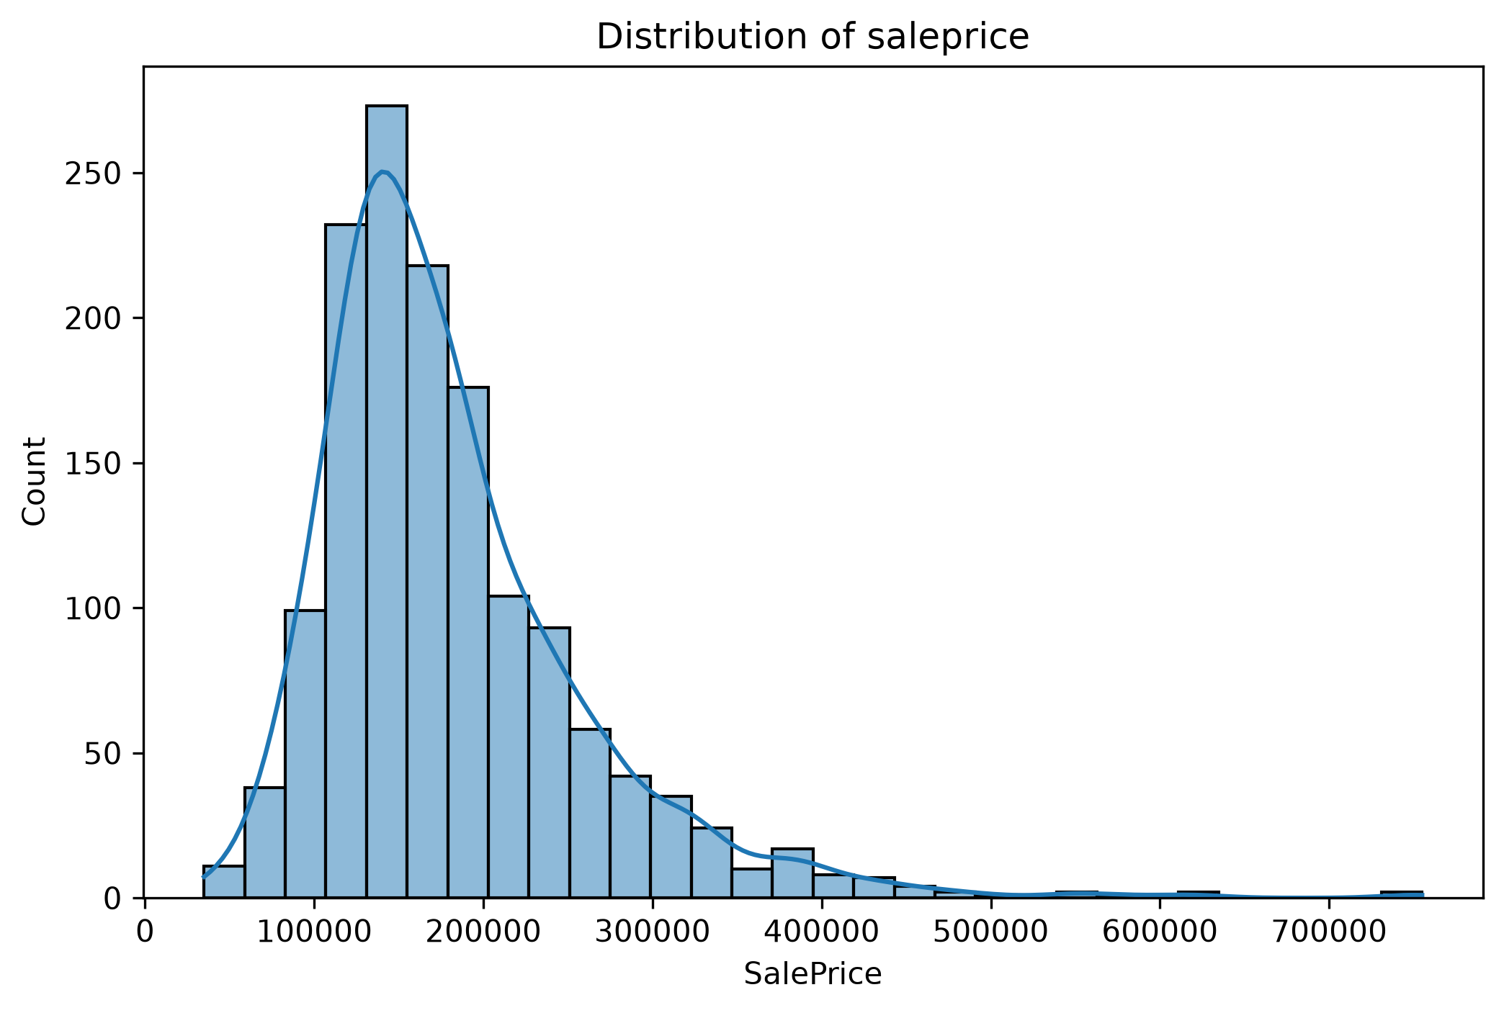

Figure 1:Saleprice Distribution

Phase 2 – Data Preprocessing
- Handled missing values
- Removed duplicates
- Treated outliers using IQR
- Encoded categorical variables
- Applied Log Transformation to skewed features
- Applied Standard Scaling to numerical features
- Performed Feature Engineering

Feature Engineering
- OverallQual
- GrLivArea
- GarageYrBlt
- GarageCars
- TotalSF
- BsmtFinSF1
- LotArea
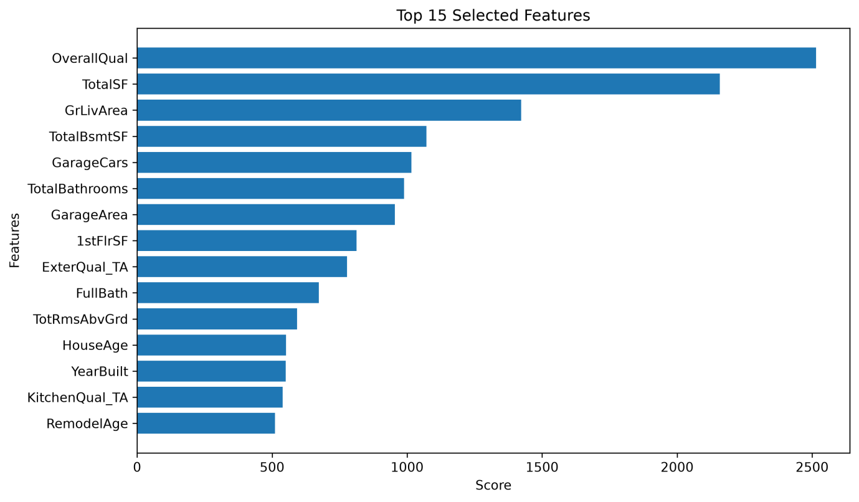
Figure 2: Top 15 Selected features

Phase 3 – Exploratory Data Analysis(EDA)
- Feature vs Target Analysis
- Correalation Analysis
- outlier analysis
- Feature Importance Exploration
- Relation Between variables

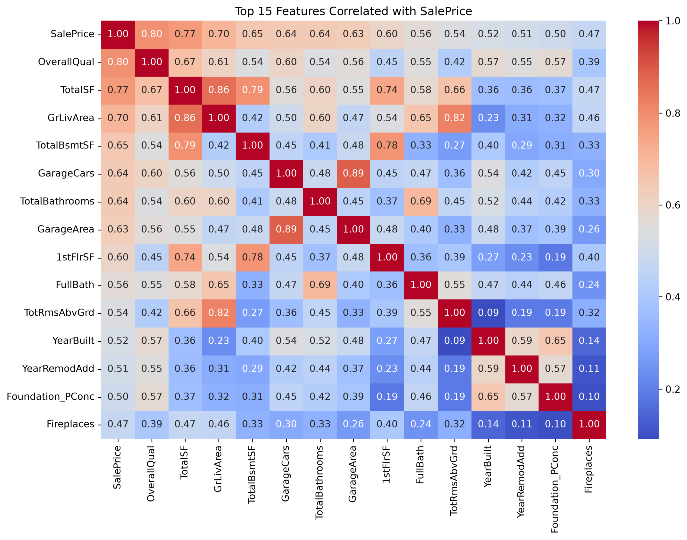
Figure 3: Correlation Heatmap

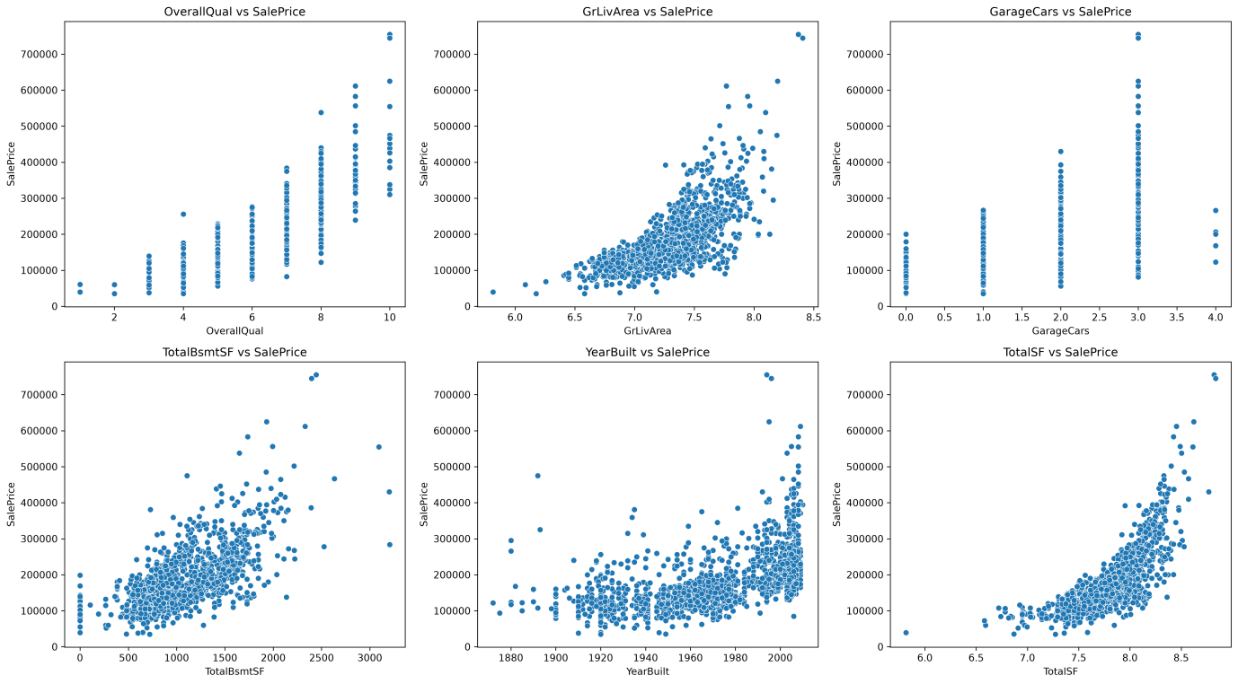
Figure 4: Correlation Heatmap

Phase 4 - Model Development
- Train Test Split
- Linear Regression
- Decision Tree
- Random Forest
- Gradient Boosting
- XGBoost
- LightGBM
- CatBoost

Model Comparison
S.No | Model | MAE | MSE | RMSE | R² Score
1 | Linear Regression | 0.22534.897952 | 3.015176e+09 | 54910.618382 | 0.454141
2 | Decision Tree | 26273.643836 | 1.473032e+09 | 38380.092897 | 0.733327
3 | Random Forest | 16595.651918 | 6.276960e+08 | 25053.862473 | 0.886364
4 | Gradient Boosting | 15228.036023 | 4.677599e+08 | 21627.756577 | 0.915318
5 | XGBoost | 16524.613281 | 5.605974e+08 | 23676.938991 | 0.898511
6 | LightGBM | 15909.718895 | 5.848068e+08 | 24182.779722 | 0.894128
7 | CatBoost | 13834.611536 | 3.772849e+08 | 19423.822517 | 0.931697

Outcome
CatBoost achieved the best performance.
A CatBoost Regressor was trained using the training dataset. CatBoost is an advanced gradient boosting algorithm that provides strong predictive performance and reduces overfitting. The model was evaluated using MAE, MSE, RMSE, and R² Score.

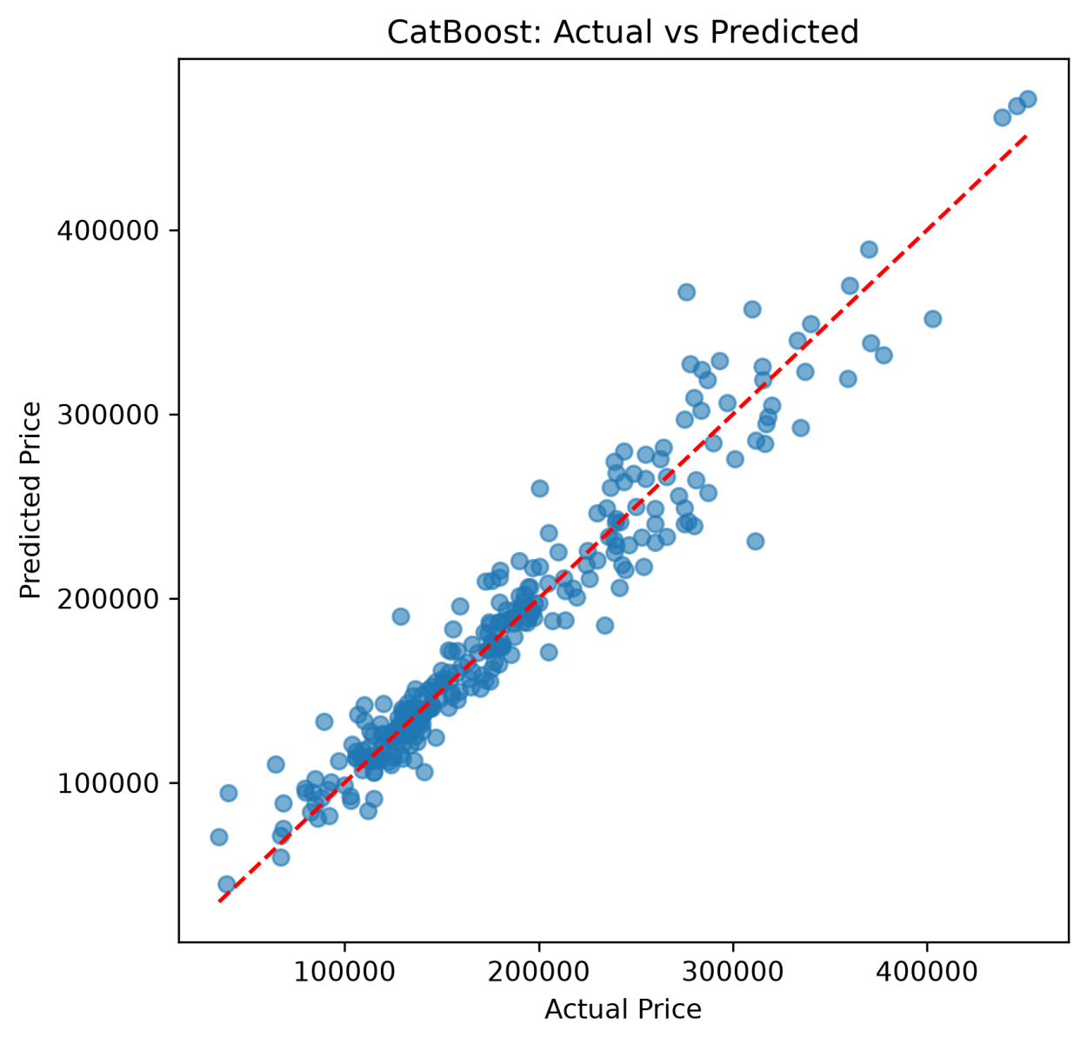
Figure 5: Actual VS Predicted

Phase 5 – Model Improvement & Optimization
Multicollinearity(VIF)

Variance Inflation Factor (VIF) analysis was performed to detect multicollinearity among the features. Although a few variables showed high or infinite VIF values due to strong correlations, they were retained because they contain valuable predictive information and contribute to the overall model performance
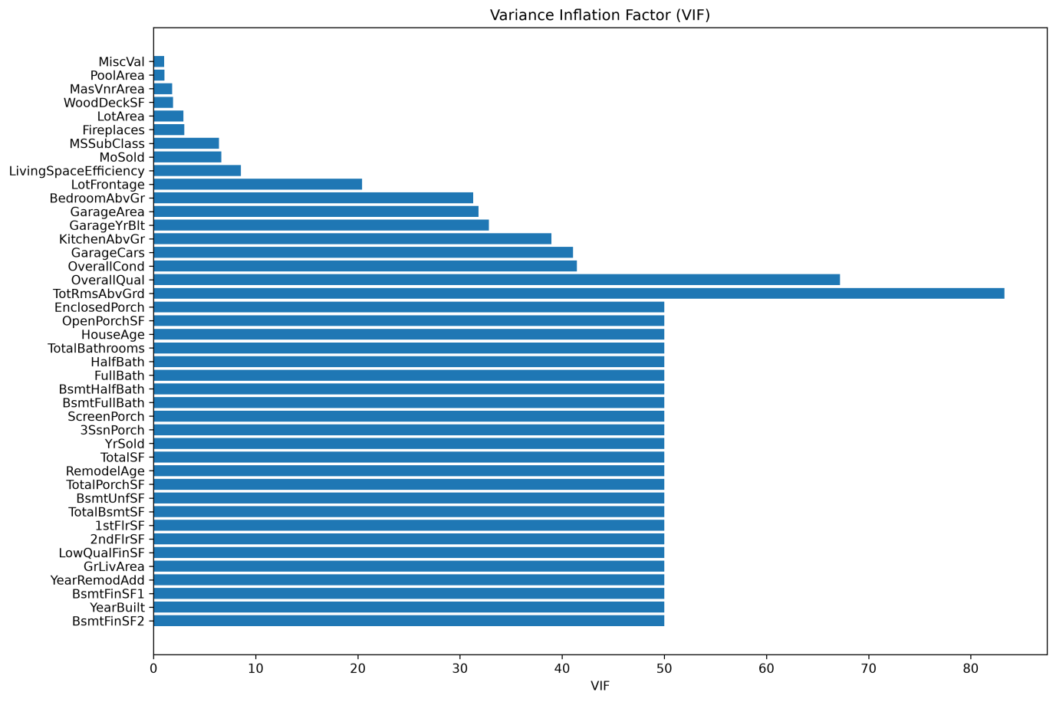
Figure 6:Variance infaltion factor(VIF)

Cross Validation

A 5-fold cross-validation was performed on the Linear Regression, Decision Tree Regressor, Random Forest Regressor, Gradient Boosting Regressor, XGBoost Regressor, LightGBM Regressor, and CatBoost Regressor models to evaluate their performance and generalization ability. The average R² score and standard deviation were calculated for each model to ensure a reliable and consistent performance evaluation.

Validation Table

No | Model | Mean R² | Std Dev
1 | Linear Regression | 0.902705 | 0.011296
2 | Decision Tree | 0.743312 | 0.023186
3 | Random Forest | 0.876992 | 0.008083
4 | Gradient Boosting | 0.902667 | 0.005530
5 | XGBoost | 0.885854 | 0.007263
6 | LightGBM | 0.899311 | 0.005988
7 | CatBoost | 0.914009 | 0.004822

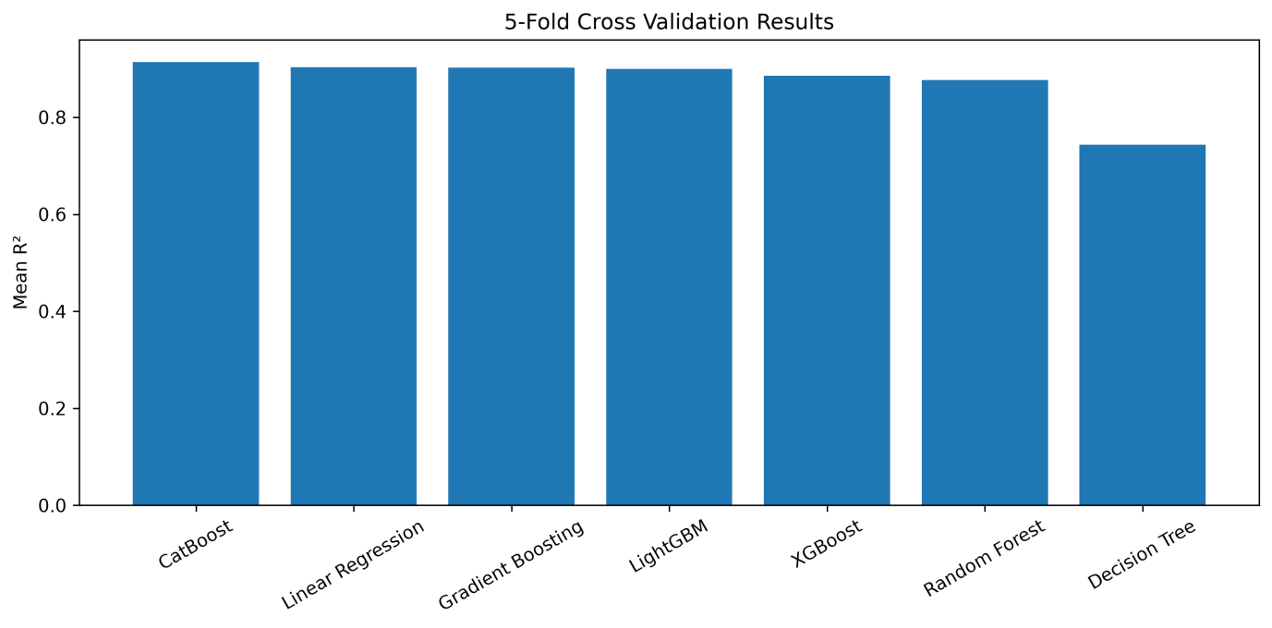
Figure 7: Cross validation

Hyperparameter Tuning
Hyperparameter tuning was performed to improve the performance of the regression models. Linear Regression was trained using its default configuration, as it does not have significant hyperparameters to optimize. The Decision Tree Regressor, Random Forest Regressor, Gradient Boosting Regressor, XGBoost Regressor, LightGBM Regressor, and CatBoost Regressor were optimized using RandomizedSearchCV with 5-fold cross-validation. The R² score was used as the evaluation metric to identify the optimal hyperparameter combinations and improve the models' predictive performance.
Hyperparameter Search Space for Regression Models :
Model | Hyperparameters Tuned
Linear Regression | Default parameters (no hyperparameter tuning)
Decision Tree Regressor | max_depth, min_samples_split, min_samples_leaf
Random Forest Regressor | n_estimators, max_depth, min_samples_split, min_samples_leaf
Gradient Boosting Regressor | n_estimators, learning_rate, max_depth
XGBoost Regressor | n_estimators, learning_rate, max_depth
LightGBM Regressor | n_estimators, learning_rate, max_depth
CatBoost Regressor | iterations, learning_rate, depth

No | Model | MAE | MSE | RMSE | R2
1 | Decision Tree (Tuned) | 23058.125753 | 9.746211e+08 | 31218.921788 | 0.823557
2 | Random Forest (Tuned) | 16336.485458 | 6.067234e+08 | 24631.756382 | 0.890161
3 | Gradient Boosting (Tuned) | 15037.077031 | 4.668676e+08 | 21607.119068 | 0.915480
4 | XGBoost (Tuned) | 14809.859375 | 4.396696e+08 | 20968.300646 | 0.920403
5 | LightGBM (Tuned) | 15441.468325 | 4.997429e+08 | 22354.929249 | 0.909528
6 | CatBoost (Tuned) | 14311.229939 | 3.977711e+08 | 19944.198843 | 0.927989

Among the tuned regression models, CatBoost Regressor achieved the best performance with the highest R² score (0.9280) and the lowest MAE, MSE, and RMSE. Therefore, it was selected as the final model for deployment due to its superior prediction accuracy and overall performance.

Phase 6 - Model Evaluation & Comparison¶

The optimized regression models were evaluated using MAE, MSE, RMSE, R² Score, Adjusted R², and 5-fold Cross-Validation Score. These metrics were used to compare the predictive accuracy and generalization performance of each model on the test dataset.

Model Evaluation Results
Model | MAE | MSE | RMSE | R² Score | Adjusted R² | CV Score
CatBoost | 14,311.23 | 3.98 × 10⁸ | 19,944.20 | 0.9280 | 0.8983 | 0.9098
XGBoost | 14,809.86 | 4.40 × 10⁸ | 20,968.30 | 0.9204 | 0.8876 | 0.9057
Gradient Boosting | 15,037.08 | 4.67 × 10⁸ | 21,607.12 | 0.9155 | 0.8806 | 0.9023
LightGBM | 15,441.47 | 5.00 × 10⁸ | 22,354.93 | 0.9095 | 0.8722 | 0.9071
Random Forest | 16,336.49 | 6.07 × 10⁸ | 24,631.76 | 0.8902 | 0.8448 | 0.8783
Decision Tree | 23,058.13 | 9.75 × 10⁸ | 31,218.92 | 0.8236 | 0.7508 | 0.7793

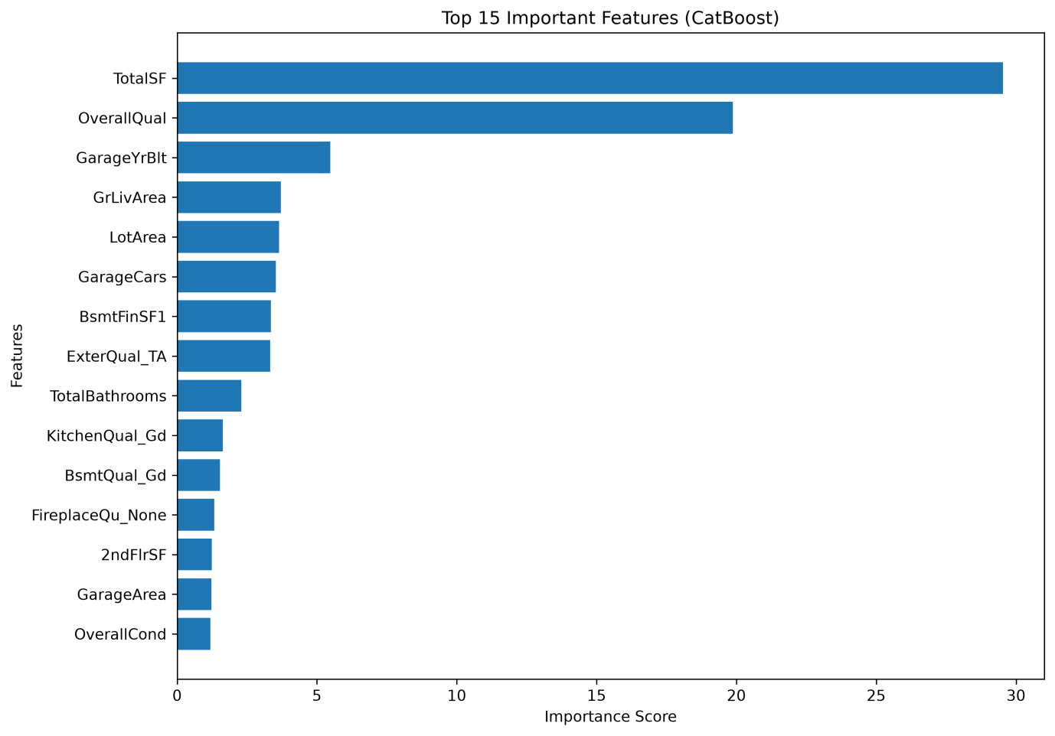
Figure 8: Catboost Important Features

Best Model Selection
Among all evaluated regression models, CatBoost achieved the best overall performance. It produced the highest R² Score (0.927989) and Adjusted R² (0.898275), while also achieving the lowest MAE, MSE, and RMSE values. The 5-fold Cross Validation Score of 0.909774 demonstrates that the model generalizes well to unseen data. Therefore, CatBoost was selected as the final model for house price prediction.

Phase 7 – Model Interpretation
Business Objective
Develop and compare multiple regression models to accurately predict house prices. This identifies the best-performing model through preprocessing, optimization, and evaluation to support reliable property valuation.

Model Assumptions
· Historical data represents the housing market.
· Selected features influence house prices.
· Missing values and outliers are handled.
· Training and testing data have similar distributions.
· The model generalizes well to unseen data.

Feature Importance
Feature importance was analyzed using the CatBoost model. TotalSF, OverallQual, HouseAge, TotalBathrooms, and GrLivArea were identified as the most influential features for predicting house prices.

Regression Model Comparison
All models were evaluated using MAE, MSE, RMSE, R² Score, Adjusted R², and Cross-Validation Score. CatBoost achieved the best overall performance and was selected as the final model.

Advantages and Limitations
Model | Advantage | Limitation
Linear Regression | Simple and fast | Poor on non-linear data
Decision Tree | Easy to interpret | Overfitting
Random Forest | Robust and accurate | Higher training time
Gradient Boosting | High accuracy | Slower training
XGBoost | Excellent performance | Complex tuning
LightGBM | Fast and efficient | Sensitive to parameters
CatBoost | Highest accuracy | Higher computational cost

Final Model Selection
CatBoost was selected as the final model because it achieved the highest R² Score (0.927989) and the lowest prediction errors, making it the most accurate model.

Business Recommendations
· Use CatBoost for house price prediction.
· Retrain the model with new market data.
· Focus on important features such as TotalSF and OverallQual.
· Deploy the model as a Flask web application for real-time predictions.

Phase 8 – Flask Web Application
Overview
The Flask web application provides an interactive platform for predicting house prices, comparing regression models, and exploring analytical insights using the trained CatBoost model.

Dashboard
- Dataset Overview
- Model Comparison Summary
- Performance Metrics

Prediction Module
- Property Details Input
- House Price Prediction
- Prediction Result
- Important Feature Contribution
- Shap explanation

Model Comparison
- Regression Model Comparison
- Evaluation Metrics
- Best Model Highlight

Analytics Dashboard
- Interactive EDA
- Correlation Heatmap
- Feature Distributions
- Feature Importance
- Residual Analysis

Reports
- Prediction Report
- Model Evaluation Report
- Model Comparison Report
- EDA report
- Data Preprocessing Report

Technologies Used
- Python
- Flask
- Pandas
- NumPy
- Scikit-learn
- XGBoost
- LightGBM
- CatBoost
- Matplotlib
- Seaborn
- HTML5
- CSS3
- Bootstrap 5
- Git
- GitHub
Application Workflow

User Input
↓
Data Preprocessing
↓
CatBoost Model
↓
House Price Prediction
↓
SHAP Explainability
↓
Display Prediction, Feature Contributions

Screenshots
Home dashboard
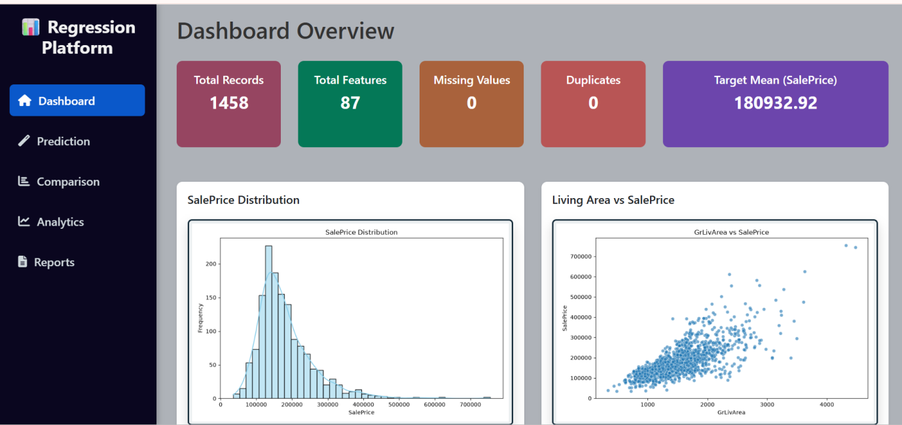

Prediction Page

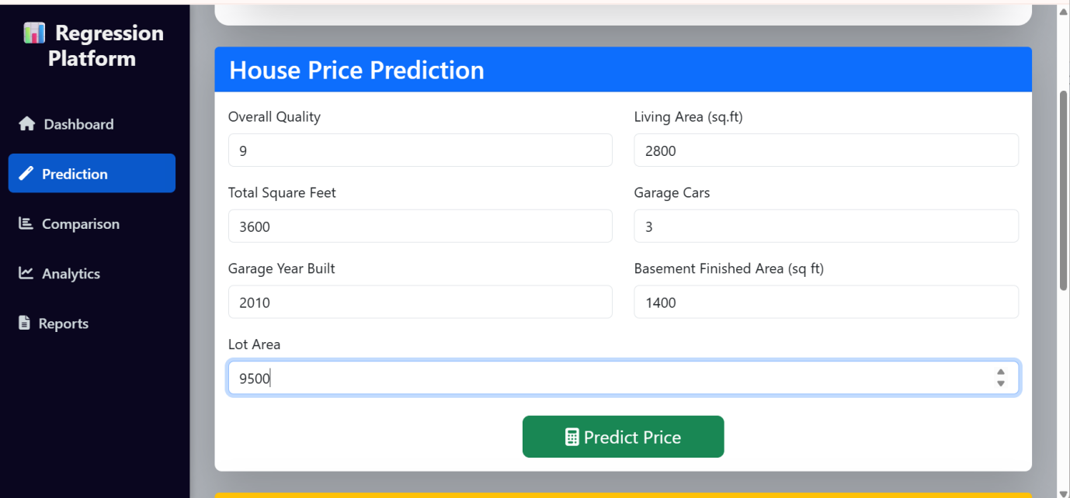

SHAP Explainability

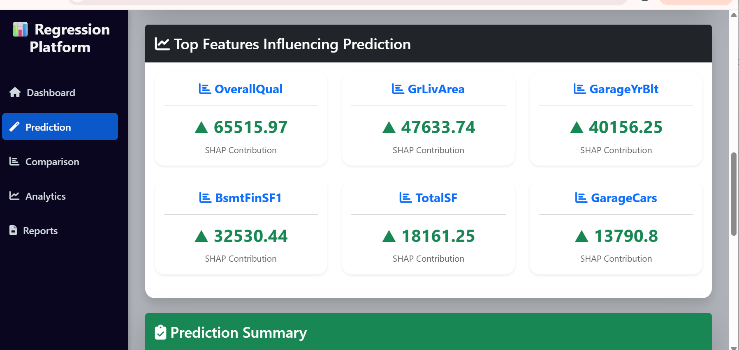

Model Comparison

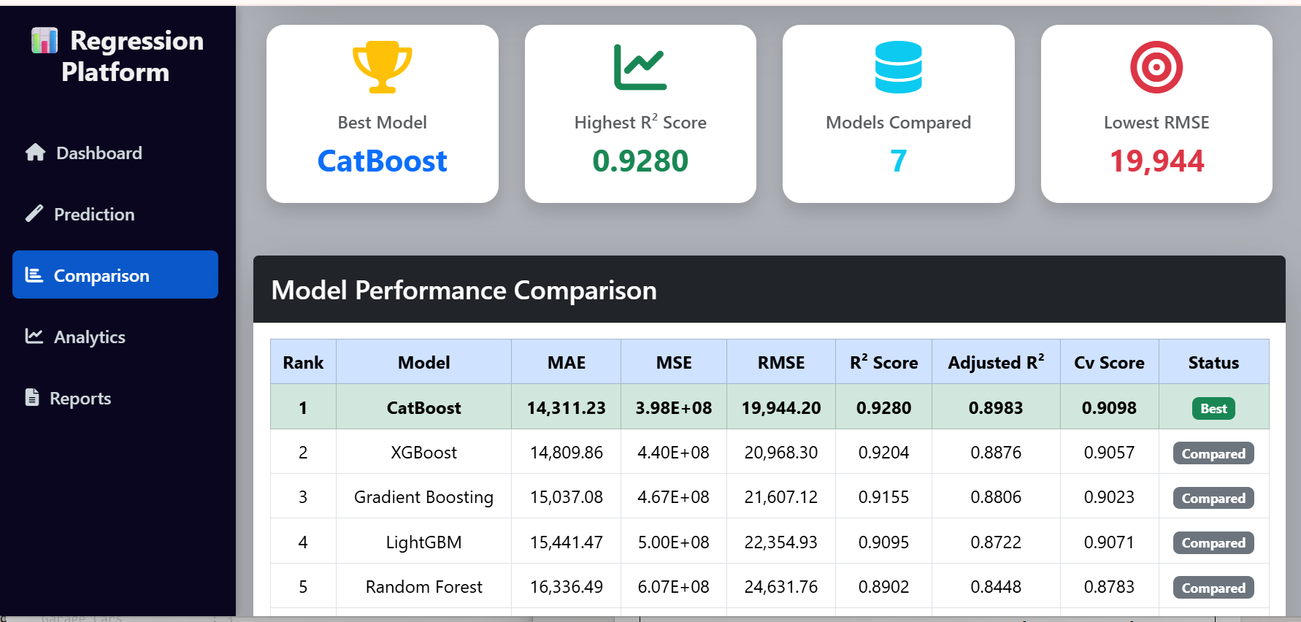

Analytics Dashboard

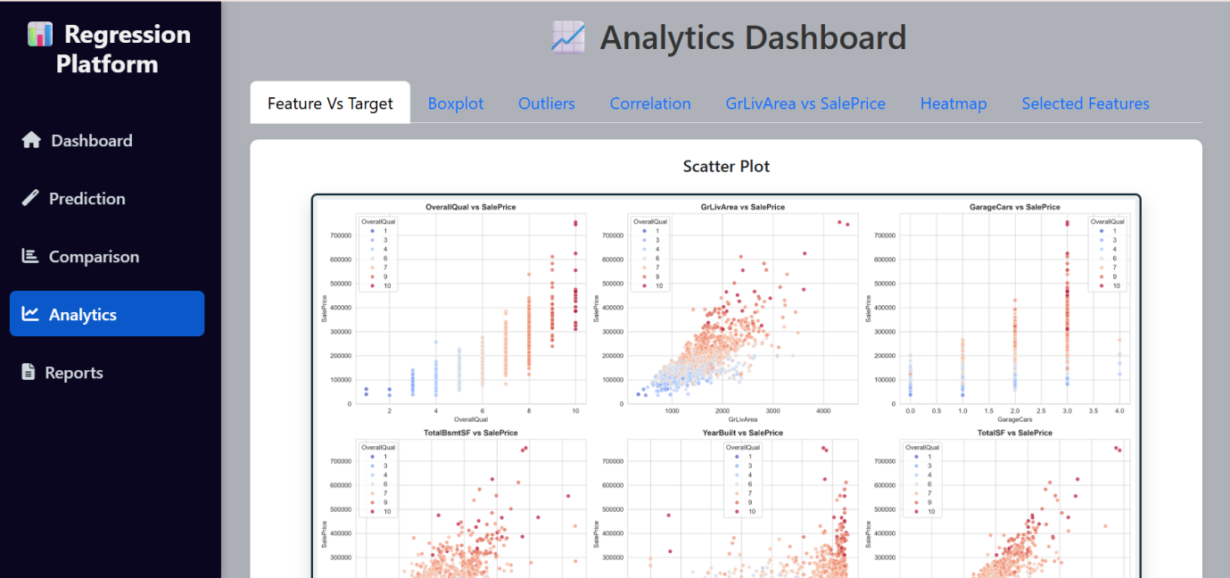

Reports

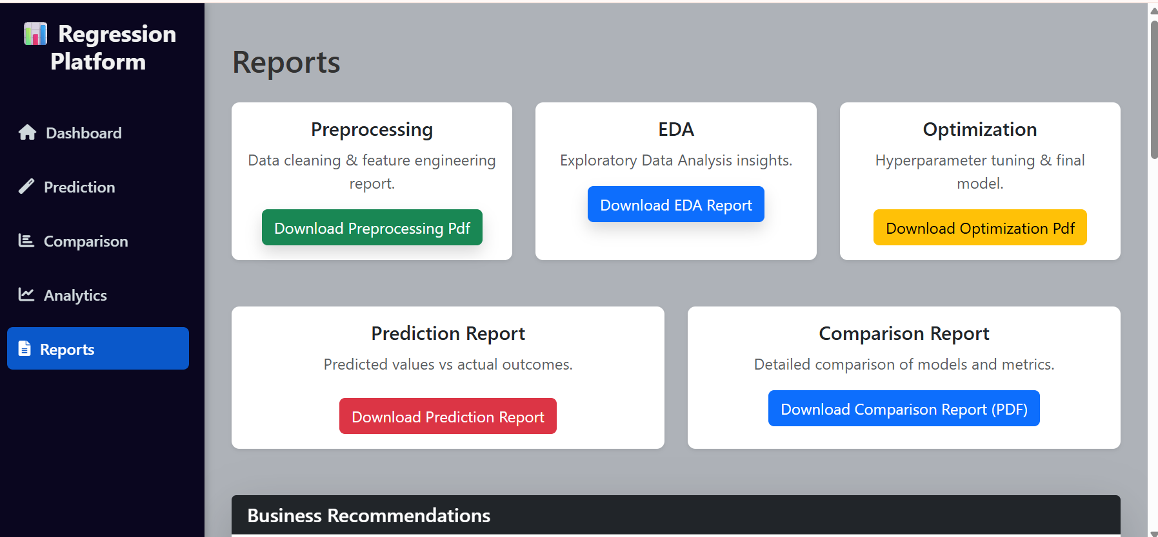

Conclusion
A complete machine learning solution was developed to accurately predict house prices using multiple regression models. After preprocessing, feature engineering, hyperparameter tuning, and performance evaluation, the CatBoost Regressor was selected as the final model due to its superior accuracy. The model was deployed through a Flask web application, providing real-time house price prediction, SHAP-based feature explanations, model comparison, analytics, and report generation in an interactive and user-friendly

