# Chapter 1

**INTRODUCTION**

**Power electronics** is the application of [electronics](https://en.wikipedia.org/wiki/Electronics) to the control and conversion of [electric](https://en.wikipedia.org/wiki/Electric_power) [power.](https://en.wikipedia.org/wiki/Electric_power)

The first high-power electronic devices were made using [mercury-arc valves](https://en.wikipedia.org/wiki/Mercury-arc_valve). In modern systems, the conversion is performed with [semiconductor](https://en.wikipedia.org/wiki/Semiconductor) switching devices such as [diodes](https://en.wikipedia.org/wiki/Diode), [thyristors](https://en.wikipedia.org/wiki/Thyristor), and [power transistors](https://en.wikipedia.org/wiki/Power_transistor) such as the [power MOSFET](https://en.wikipedia.org/wiki/Power_MOSFET) and [IGBT.](https://en.wikipedia.org/wiki/IGBT) In contrast to electronic systems concerned with the transmission and processing of signals and data, substantial amounts of electrical energy are processed in power electronics. An AC/DC converter ([rectifier](https://en.wikipedia.org/wiki/Rectifier)) is the most typical power electronics device found in many consumer electronic devices, e.g. [television](https://en.wikipedia.org/wiki/Television) sets, personal [computers,](https://en.wikipedia.org/wiki/Computer) [battery chargers,](https://en.wikipedia.org/wiki/Battery_charger) etc. The power range is typically from tens of [watts](https://en.wikipedia.org/wiki/Watt) to several hundred watts. In industry, a common application is the [variable speed drive (VSD)](https://en.wikipedia.org/wiki/Adjustable-speed_drive) that is used to control an [induction motor.](https://en.wikipedia.org/wiki/Induction_motor) The power range of VSDs starts from a few hundred watts and ends at tens of [megawatts](https://en.wikipedia.org/wiki/Megawatt).

The power conversion systems can be classified according to the type of the input and output power:

* AC to DC ([rectifier](https://en.wikipedia.org/wiki/Rectifier))
* DC to AC ([inverter](https://en.wikipedia.org/wiki/Power_inverter))
* DC to DC ([DC-to-DC converter](https://en.wikipedia.org/wiki/DC-to-DC_converter))
* AC to AC ([AC-to-AC converter](https://en.wikipedia.org/wiki/AC/AC_converter))

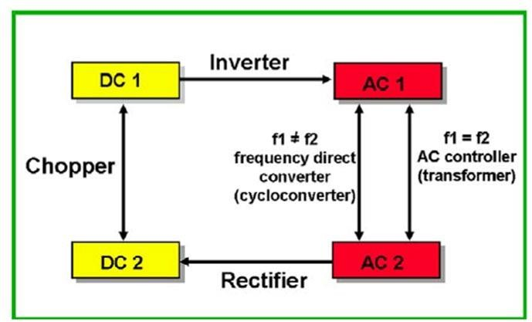

Figure 1.1 Power Conversion

## LITERATURE SURVEY

**Ciobotaru, Mihai, et al. "PV inverter simulation using MATLAB/Simulink graphical environment and PLECS blockset." *IECON 2006-32nd Annual Conference on IEEE Industrial Electronics*. IEEE, 2006.**

This paper is focused on the simulation of the control of a power system before its real-time implementation. First a particular case for simulation of single-phase PV inverter in Simulink is described focusing on the control design. The controller can be then automatically tested online using dSPACE system. Secondly PLECS, a new Simulink blockset implemented as a circuit simulator is introduced. The combination of the two tools provides a good environment for the

switching power converter simulator. PLECS is a well suited tool for modeling electrical circuits within MATLAB/Simulink environment. One of the major strength of combining PLECS with Simulink is not only the speed of the simulations, the simplicity of making the circuit, but also the advantage of simulating electrical circuits and controlling them within Control blocks built in standard Simulink environment. However, the combination of circuit software with system software could lead to confusion for novice users. Furthermore, the line connections between elements do not represent the same concept.

#### Srinivasan, Ganesh Kumar, et al. "Trends and challenges in multi-level inverter with reduced switches." *Electronics* 10.4 (2021): 368.

Much research had been undertaken to design multilevel inverters with reduced circuit components, minimum losses, low cost, and compact size with high efficiency. A survey is made in this paper to identify the type of multilevel inverter used in high and medium power applications such as Electric Vehicle, Power drives, Grid integration systems, etc. A detailed review is conducted on the recent multilevel inverter design with reduced switch count to find out the challenges and key issues. Significant issues of various multilevel inverter designs are provided in terms of number of diodes, switches, source Electronics 2021, 10, 368 21 of 23 utilization and filter requirement. A new 81-level switched ladder inverter is configured using MATLAB/Simulink and tested with change in resistive and impedance load at equal period of time. The results were analyzed in terms of harmonic content. Further, the output of 81-level inverter is connected to 0.25 HP, 110 V single phase

**Shneen, Salam Waley, FatinNabeel Abdullah, and Dina Harith Shaker. "Simulation model of single phase PWM inverter by using MATLAB/Simulink." *International Journal of Power Electronics and Drive Systems* 12.1 (2021): 212.**

The characteristic of this system includes first the parameters of DC-AC inverter like switching type diode, transistor or thirestor. Second, the characteristic of PWM like amplitude value and

frequency. Finally, the filter and load characteristic and types like LC filter and Rload. In simulation of DC to AC PWM inverter, selected MOSFET with 1 kHz frequency switching for 300VDC input to more than 100VAC output. Simulation of this proposed model for voltage regulation was conducted with the aim of validating system, simulation results show that the proposed system can be used effectively in many Applications that fit the specifications of the proposed system.

**YingYing, Jia, et al. "Application and Simulation of SVPWM in three phase inverter." *Proceedings of 2011 6th International Forum on Strategic Technology*. Vol. 1. IEEE, 2011.**

In this paper deeper analysis of the SVPWM algorithm is taken and the three-phase inverter system-level simulation model based on SVPWM algorithm is built, it can be seen from the simulation model that this control algorithm has good dynamic performance, when doing current control, according to the tracked current vector, selecting optimized voltage vector to conduct PWM current tracking control in order to gain better tracking current command under relatively lower switching frequency. Under the same wavefonn quality conditions, SVPWM control has a lower switching frequency, which can effectively reduce the switching loss of the power switch, and is more suitable for high power load application induction motor. The speed of the induction motor is observed for change in input voltages and the various speed curves were presented. Variation in the speed with respect to change in load torque is plotted in this paper, thus the performance of the single phase induction motor fed by 81-level switched ladder inverter is found satisfactory.

**Jain, Kapil, and PradyumnChaturvedi. "Matlab-based simulation & analysis of three-level SPWM inverter." *International Journal of Soft Computing And Engineering (Ijsce)* 2 (2012).** The simulation of the inverters namely conventional three and two level inverter was carried using sinusoidal pulse width modulation (SPWM) .it has shown that decrease in voltage and

current THD in moving from two level inverter to three level inverter. This paper briefly explains theory of sinusoidal pulse width modulation (SPWM) for two and three level inverter and performance of both inverters was tested using RL load. It has shown that load current for three level inverter are much more sinusoidal and improvement in the line current waveform and decrease in the THD from two level to three level inverter and decrease in the THD as the frequency is increased

**Gandhi, Krupa, K. L. Mokariya, and Deepa Karvat. "Simulation of PWM inverter for VFD application Using MATLAB." *International Journal of Engineering Research and Development* 10.4 (2014): 94-103.**

The proposed prototype of the PWM synchronous rectifier is based on the 1kW power module and the DSP-based control unit. For the proper operation the PWM rectifier requires the feedback information about all state variables. Hence the necessary voltage and current sensors have been constructed and examined. The supporting and protective electronic devices have been designed to enhance the safety of the AC/DC converter and its control system during the different conditions. Voltage Oriented Control of the PWM rectifier has been implemented into the DSP-based control system. The advanced programming environment has facilitated coding in C language and provided the user-friendly interface between the host computer and the DSP evaluation board while executing the control programs. The simulation results have confirmed the proper approach to the design process showing the precious advantages of the synchronous rectifier AC/DC converter in the real applications.

**Gebreel, ABD Almula GM. *Simulation and implementation of two-level and three-level inverters by Matlab and RT-LAB*. Diss. The Ohio State University, 2011**.

This chapter provides the performance of the three-phase three-level inverter. The inverter has been simulated and improved by employing SVPWM control scheme. The use of three-level inverters reduces the harmonic components of the output voltage compared with the two-level

inverter at the same switching frequency. Based on the analysis of SVPWM, a simulation system by both MATLAB and RT-LAB are set up to study the working process of the three-level inverter. Based on the simulation results, a three-level inverter was designed by MATLAB, and an experiment by RT-LAB was done to verify the performance and the waveforms of the inverter. The simulation results of three phase current, line to neutral voltage and line to line voltage by MATLAB were shown. When the output voltage is suitable and the system parameters are properly selected, the output phase voltage is of five-level and the output line voltage is of three level, and the output line current is almost sinusoidal. Results by both MATLAB (off time) and RT-LAB are the same. As a result, the experimental results by RT- LAB mostly agree with the simulation results by MATLAB The simulation and experimental results of the output line to line voltage of the three level inverter operated as a six-step inverter.

**Ayadi, M., et al. "Electro-thermal simulation of a three phase inverter with cooling system." *Journal of Modelling and Simulation of Systems* 1.3 (2010): 163-170.**

A thermal investigation of a three phase inverter has been achieved. A simplified 1D thermal model has been used. This model takes into account the thermal influence between the different module chips based on the technique of superposition. A water cooling system has been developed. This system takes into account the junction temperature of IGBT to not exceed 120°C fixed by the book qualifications.

**Kumar, K. Vinoth, et al. "Simulation and comparison of SPWM and SVPWM control for three phase inverter." *ARPN journal of engineering and applied sciences* 5.7 (2010): 61-74.** Space vector Modulation Technique has become the most popular and important PWM technique for Three Phase Voltage Source Inverters for the control of AC Induction, Brushless DC, Switched Reluctance and Permanent Magnet Synchronous Motors. In this paper first comparative analysis of Space Vector PWM with conventional SPWM for a two level Inverter is carried out. The Simulation study reveals that SVPWM gives 15% enhanced fundamental output

with better quality i.e. lesser THD compared to SPWM. PWM strategies viz. SPWM and SVPWM are implemented in MATLAB/SIMULINK software and its performance is compared with conventional PWM techniques. Owing to their fixed carrier frequencies c f in conventional PWM strategies, there are cluster harmonics around the multiples of carrier frequency. PWM strategies viz. Sinusoidal PWM and SVPWM utilize a changing carrier frequency to spread the harmonics continuously to a wideband area so that the peak harmonics are reduced greatly.

#### Can, Erol. "Novel high multilevel inverters investigated on simulation." *Electrical Engineering* 99.2 (2017): 633-638.

This paper presented a novel multilevel inverter topology which converts direct current energy to alternating current energy. Six-level, 9-level and 11-level inverters were performed at the MATLAB SIMULINK after inverter models were designed with the proposed inverter topology. When the inverter levels increased from six to 11, harmonic distortions of converting energies decreased to demanded levels. According to results of simulations, proposed inverter topology is highly acceptable for energy converting and power electronic applications.

## OBJECTIVES

* + - To understand the different types of DC-AC Converters
    - To Understand the different methods to simulate the different types of Inverters
    - To analyse the waveforms of DC-AC Converters
    - To get familiarized with the operational principles of the DC-AC converters
    - To Simulate different types of Dc-AC Converters

# CHAPTER 2

**DC/AC Converters (Inverters)**

Inverter is the **device which converts DC into AC is known as Inverter.** Most of the commercial, industrial, and residential loads require **Alternating Current (AC)** sources. One of the main problems with [AC sources is that they cannot be stored in batteries](https://www.electricaltechnology.org/2013/06/why-we-cant-store-ac-in-batteries.html) where storage is important for backup power.

This flaw can be overcome by direct current sources. Alternating current is converted into **direct current (DC)** for storage purposes. The polarity of DC sources doesn’t change with time like AC sources so, DC can be stored in **batteries** and **ultra-capacitors.** Whenever AC is required to run AC appliances, then DC is converted back into AC to run AC appliances.

### Different Types of Inverters

Inverters are classified into many different categories based on the applied input source, connection wise, output voltage wise etc.

### Input Source Wise Classification

The inverter can be defined as the device which converts DC input supply into AC output where input may be a **voltage source** or **current source**. Inverters are mainly classified into two main categories.

### Voltage Source Inverter (VSI)

The inverter is known as voltage source inverter when the input of the inverter is a constant DC voltage source. The input to the voltage source inverter has a **stiff DC voltage source**. Stiff DC voltage source means that the impedance of DC voltage source is zero. Practically, DC sources

have some negligible impedance. VSI are assumed to be supplied with ideal voltage sources (very low impedance sources). The AC output voltage is completely determined by the states of switching devices in the inverter and the applied DC source.

### Current Source Inverter (CSI)

The inverter is known as current source inverter when the input of the inverter is a constant DC current source. Stiff current is supplied to the CSI (current source inverter) from the DC source where the DC source have high impedance. Usually, a large inductor or closed loop-controlled current are used to provide stiff current. The resulting current wave is stiff which is not influenced by the load. The AC output current is completely determined by the states of switching devices in the inverter and the DC applied source.

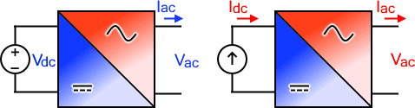

Fig 2.1 VSI & CSI

The output voltage and [current](https://www.electricaltechnology.org/2020/04/electric-current.html) waveform of the inverter circuit, vo, and io respectively, are assumed to be AC quantities. These are stated in terms of RMS values normally while the deviation of these waveforms from their fundamental and sinusoidal components is represented in the terms of THD factors. THD shows the total harmonic distortion.

### Output Phase Wise Classification

According to the output voltage and current phases, inverters are divided into two main categories. Single-phase inverters and three-phase inverters.

### Single Phase Inverters

A single-phase inverter converts DC input into Single phase output. The output voltage/current of single-phase inverter has exactly one phase which has a nominal frequency of 50HZ or 60Hz a nominal voltage. The Nominal voltage is defined as the voltage level at which Electrical system operates. There are different nominal voltages i.e. 120V, 220V, 440V, 690V, 3.3KV, 6.6KV, 11kV, 33kV, 66kV, 132kV, 220kV, 400kV and 765kV.

Low nominal voltages can be directly achieved by inverter using an internal transformer or buck- boost circuitry while for high nominal voltages, external step-up transformers are used.

Single-phase inverters are used for low loads. There are more losses in single-phase as well as the efficiency of single-phase is low with respect to three-phase inverter. Therefore, 3 phase inverters are preferred for high loads.

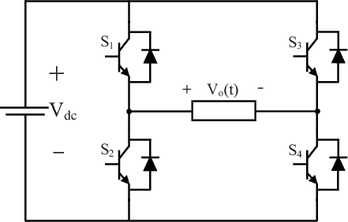

Fig 2.2 Single Phase Inverter

### Three Phase Inverters

Three-phase inverters convert DC into three-phase power. Three-phase power provides three alternating currents which are uniformly separated in phase angle. Amplitudes and frequencies of all three waves generated at the output are same with slight variations due to load while each wave has a 120o phase shift from each other.

Basically, a single 3-phase inverter is 3 single-phase inverters, where phases of each inverter are 120 degrees apart and each single-phase inverter is connected to one of the three load terminals.

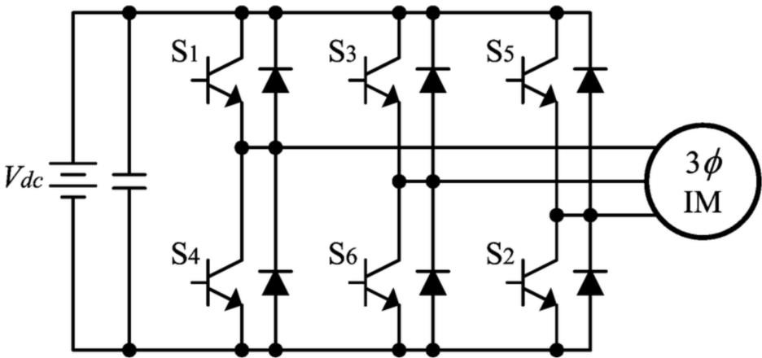

Fig 2.3 Three Phase Inverter

There are different topologies for constructing a 3 phase voltage inverter circuit. In case of bridge inverter, operating by 120-degree mode, the [Switches](https://www.electricaltechnology.org/2014/11/types-of-switches-electrical.html) of three-phase inverters are operated such that each switch operates T/6 of the total time which creates output waveform that has 6 steps. There is a zero-voltage step between negative and positive voltage levels of the square waveform.

Inverter power ratings can be further increased. For constructing inverters with high power ratings, 2 inverters (three-phase inverters) are connected in series for high voltage rating. For high current rating, 2 six-step three inverters can be connected.

### Methods of Commutation Wise Classification

Silicon controlled rectifiers are mainly divided into two main types according to commutation techniques. **Line commutated** and **force commutated** inverters are used commonly while other commutated inverters i.e., Auxiliary commutated inverters and complementary commutated inverters are not used commonly. The two main types are briefly discussed here.

### Line Commutated

In these types of inverters, the AC circuits’ the line voltage is accessible over the device; the device is turned off when the current in [SCR](https://www.electricaltechnology.org/2015/06/thyristor-silicon-controlled-rectifier-scr.html) experience zero characteristics. This commutation process is known as line commutation while inverters working on this principle are known as Line commutated Inverters.

### Force Commutated

The supply does not experience zero points in this type of commutation. That’s why some outside source is needed to commutate the device. This process of commutation is known as force commutation while inverters based on this process are known as Force commutated inverters.

### Connections of Thyristors and Commutating Element Wise Classification

**Series Inverters**

The series inverter consists of a pair of [thyristors](https://www.electricaltechnology.org/2015/06/thyristor-silicon-controlled-rectifier-scr.html) and **RLC** (Resistance, Inductor and capacitor) circuit. One thyristor is connected in parallel with the RLC circuit while one in series between DC source and RLC circuit. This inverter is known as a series inverter because the load is directly connected in series with DC source with the help of T1.

Series inverter is also known as a **self-commutated** inverter because thyristors of this inverter are commutated by their own from the load. Another name for this inverter is “**Load commutated inverter**”. This name is given because LCR is the load which provides commutation.

### Parallel Inverters

The parallel inverter consists of two thyristors (T1 & T2), one capacitor, center-tapped transformer, and an inductor. Thyristors are used for providing a path to the flow of current while inductor L is used to make the current source constant. These thyristors are turned ON and OFF, controlled by commutation capacitor connected between them. The **complementary commutation** method is used for turning ON and turning OFF capacitors. A complementary commutation means that when T1 is ON, the firing angel is applied to T2, then the capacitor will turn OFF T1. The exact case is when T2 is ON and firing angel is applied to T1, then because of capacitor voltage, the T2 will turn OFF. Output current and voltage are Io and Vo respectively.

It is known as **Parallel inverters** because in working condition, capacitor C comes in parallel with the load via the transformer. Parallel inverters are also known as center tapped transformers inverter because it has a center-tapped transformer in between load and driving circuitry. The purpose of transformer is to change DC into AC of the required voltage.

### Bridge Type Inverters

There are two types of single-phase H-bridge inverters and one famous type of three-phase inverter known as three-phase H-bridge inverter. These two types are discussed here.

### Half Bridge Inverter

[Half-bridge inverter](https://www.electricaltechnology.org/2020/06/half-h-bridge-inverter-its-modes-of-operation-with-waveforms.html) requires two electronic switches to operate. The switches may be MOSFETs, IJBTs, BJTs or Thyristors. Half bridge with thyristor and BJT switches requires two extra [diodes](https://www.electricaltechnology.org/2018/12/types-of-diodes-their-applications.html) except in pure resistive loads while MOSFETs have a built-in body diode. In simple words, two switches are enough for purely resistive load while other loads (Inductive & capacitive) require two extra diodes. These diodes are known as **feedback diode** or **freewheeling diodes**.

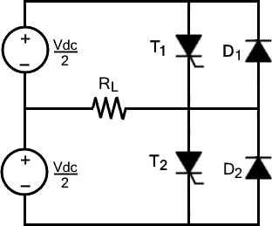

Fig 2.4 Half Bridge Inverter

### Full Bridge Inverter

[Single-phase full bridge inverter](https://www.electricaltechnology.org/2020/09/full-bridge-inverter.html) has four controlled switches which control the direction of flow of current in the load. The bridge has 4 feedback diodes that feedback the stored energy in the load back into the source. These feedback diodes function only when all thyristors are off and load is other than pure resistive load.

For any load, only 2 thyristors will work at a time. Thyristors T1 and T2 will conduct in one period while T3 and T4 will conduct in another period. In other words, when T1 and T2 are in ON condition, T3 and T4 are off while when T3 and T4 are ON, then other two are OFF. Turning ON more than two thyristors at a time will cause a short circuit which will produce excessive heat and immediately burning the circuit. The construction of full bridge inverter is just like a half bridge inverter where full bridge inverter has an extra leg with it.

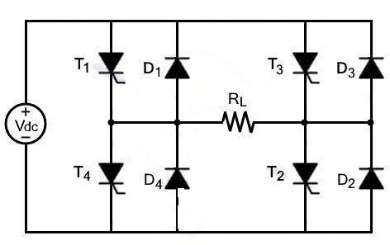

Fig 2.5 Full Bridge Inverter

### Three Phase Bridge Inverters:

Industrial and other heavy loads require three-phase power. To run these heavy loads from storage devices or other DC sources, three-phase inverters are required. Three-phase bridge inverters can be used for this purpose.

Three-phase bridge inverter is another type of bridge inverter that consists of 6 controlled switches and 6 diodes as shown in the figure. This bridge can be operated in two different modes based on the degree of gate pulses. These modes are known as **180-degree mode** and **120- degree mode** which are defined below.

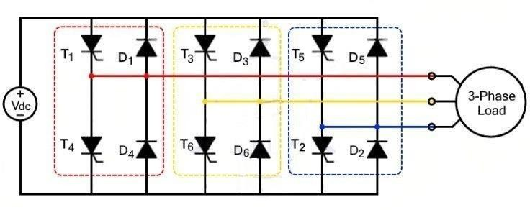

Fig 2.6 Three Phase H Bridge Inverter

### 180-degree Mode

In this mode of operation, three thyristors will be in the conduction mode where each out of three thyristors will provide single phases correspondingly. In each leg, one complementary thyristor will be turned ON for half of the time. In other words, one thyristor will be turned ON for half time while other will be closed. In degrees, half time can be represented as 180 degrees. There will be a 120-degree shift between each leg.

|  |  |  |  |  |
| --- | --- | --- | --- | --- |
| **0-60°** | **60°-120°** | **120°-180°** | **180°-240°** | **240°-300°** |
| T1 | T1 | T1 | T4 | T4 |
| T6 | T6 | T3 | T3 | T3 |
| T5 | T2 | T2 | T2 | T5 |

The time gaps between the commutations of the complementary thyristor in one leg is zero. This can cause short circuit. To avoid the problem of short-circuiting, 120-degree mode of operation is preferred.

### 120-degree Mode:

In this mode of operation, only two thyristors out of six will operate at a time where each switch in each leg will conduct for 120o. There is a time delay of 60o between the operations of two thyristors in each leg which prevents a short circuit.

|  |  |  |  |  |
| --- | --- | --- | --- | --- |
| **0-60°** | **60°-120°** | **120°-180°** | **180°-240°** | **240°-300°** |
| T1 | T1 | DEAD TIME | T4 | T4 |
| T6 | DEAD TIME | T3 | T3 | DEAD TIME |
| DEAD TIME | T2 | T2 | DEAD TIME | T5 |

### Multilevel Inverter (MLI)

Multilevel inverters convert the DC signal into multilevel staircase waveform. The output waveform of multilevel inverter does not alternate between positive and negative directly but in multi steps. As the smoothness of the waveform is directly proportional to the number of voltage levels. Therefore, multi-level inverter will generate a much smoother wave. This property of smaller steps makes it useable for practical applications as discussed previously.

### Advantages of Multi-level Inverter

* **Better voltage waveform:** using multilevel inverter, one can achieve better voltage waveform.
* **Switching frequency** can be reduced further for the PWM operation.
* **High voltage using low rating devices:** using multilevel inverter, high AC voltage can be generated using low voltage rating devices. In case of traditional inverters, the number of switches is fewer than MLI. Therefore, high rating switches are required which are available in limited amount and are much expensive. MLI inverters have many switches where each switch is responsible for a small level of voltage and control current to some extent. Instead of controlling a huge level of voltage as in case of traditional two-level inverter.
* **Reduce the filter size** because the wave generated by multilevel inverter is near to a required sinusoidal wave so there will be a smaller number of harmonics. The filter size is inversely proportional to the number of harmonics required to be removed. The output wave of MLI has a smaller number of harmonics. Therefore, smaller filters are enough for removing harmonics.
* **Better power Quality:** Multi level inverters provide relatively better power quality.
* **Low THD**: As the output wave become smoother, the total harmonic distortion reduces. The output wave of MLI is near to pure sinusoidal wave, so in this case, the THD reduces.
* **Low switching losses**: losses are directly proportional to frequency. The main switching losses are due to the overlapping of voltage and current. According to P=VI, there will be no

loss if one of them is zero. The inverse relationship between current and voltage shows that after switching on, the current will start increasing while voltage will decrease. In case of turning-off the switch, the voltage will increase and current will decrease. The time of interference between current and voltage will be maximum if the transition time is maximum. Though inverters are needed to be operated with maximum frequency for better response, but the amount of losses will be uncontrollable. In case of multilevel inverters, these switching losses can be reduced.

* Reduced losses by low on-state voltage and off-state leakage current.

### Cascaded H-bridge Inverter

The word cascaded mean to be in series connection. These inverters are known as cascaded H- bridge inverters because two H-bridge inverters are connected in cascaded mode. In other words, two H-bridge inverters are connected in series which will provide a voltage wave of more than two levels.

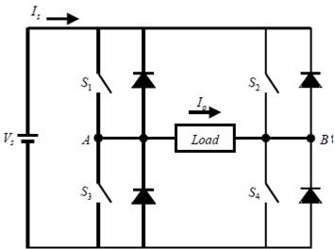

Fig 2.7 Cascaded H Bridge Multilevel Inverter

### PWM Wise Classification

PWM are used for the internal control of inverter as well as to modify the shapes of output voltage as near to sine wave as possible. Some other reasons using PWM techniques are

* To get rid of lower harmonics in the output voltage
* Minimize the requirement of the filter because low [harmonics](https://www.electricaltechnology.org/2018/02/harmonics.html) will be already eliminated using PWM while higher harmonics can be removed easily.
* Easy control of output voltage using various PWM techniques.

### Single Pulse Width Modulation (Single PWM)

The gating signal for the switch in single pulse width modulation is generated by comparing a reference pulse with triangular carrier wave. The comparison will produce a single pulse per half cycle of the output wave hence the name Single pulse width modulation. In other words, two pulses are provided for reference where each pulse provide half cycle of the output voltage.

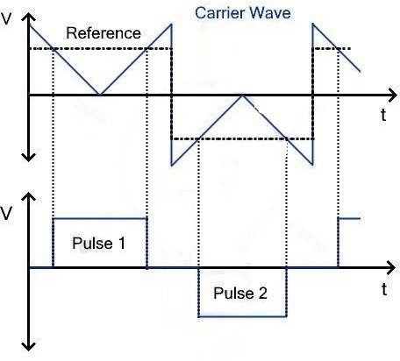

Fig 2.8 Single Pulse Width Modulation (Single PWM)

### Multiple Pulse Width Modulation (Multiple PWM)

The limitations of SPWM inverters are overcame by MPWM where multiple reference pulses are compared with high frequency triangular wave for each half-cycle of the output voltage. The number of pulses required for each half can be derived from the equation.

#### Number of pulses required = fc / (2fo)

Where fo is the frequency of the output signal while fc is the carrier frequency.

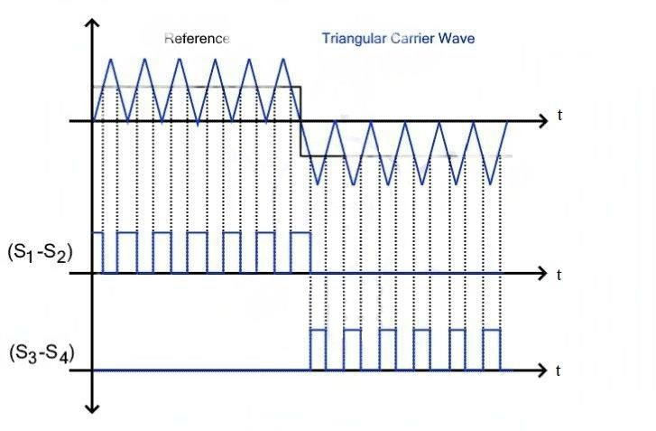

Fig 2.9 Multiple Pulse Width Modulation (Multiple PWM)

### Sinusoidal Pulse Width Modulation (SPWM)

In this technique, the width of the pulse will wave according to the amplitude of reference sinusoidal wave. This reference signal will decide the output frequency of the voltage wave while modulation index will decide the RMS value of sinusoidal output voltage. The gate pulses generated for the switches are by comparing triangular carrier wave with reference sinusoidal wave. The reference signal used in this technique is a sinusoidal wave so known as Sinusoidal pulse width modulation.

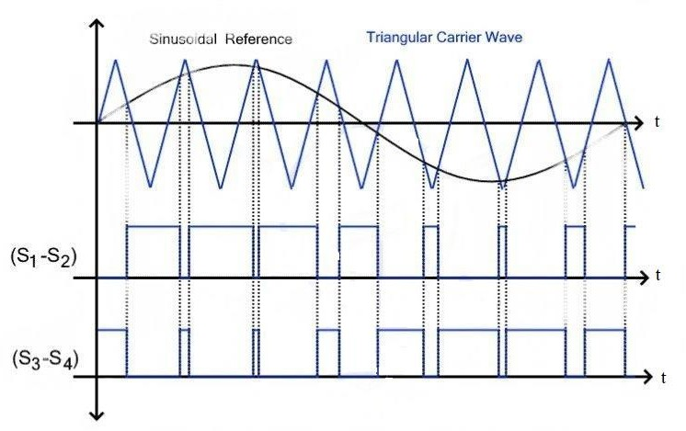

Fig 2.10 Sinusoidal Pulse Width Modulation (SPWM)

Several pulses are used for each half cycle of the output voltage but instead of same pulse widths, the width of the pulses increase proportionally to the sine wave. The width of the pulses will increase in the sinusoidal manner. Just like a sinusoidal wave alternates after specific period of time, the resulting pulses will too, as shown in the figure.

### Modified Sinusoidal Pulse Width Modulation (MSPWM)

In MSPWM technique the first and last 60 degree of each half wave is used for modulation. This PWM technique will provide a much smoother sine wave as compared to previously discussed techniques.

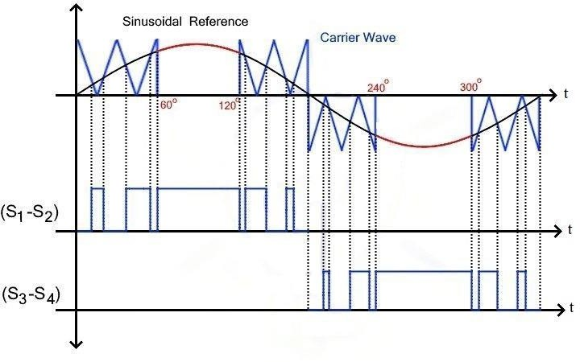

Fig 2.11 Modified Sinusoidal Pulse Width Modulation (MSPWM)

# CHAPTER 3

**SIMULINK MODELLING OF DC/AC CONVERTERS (INVERTERS)**

#### THREE PHASE SPWM INVERTER FOR A MOTOR LOAD

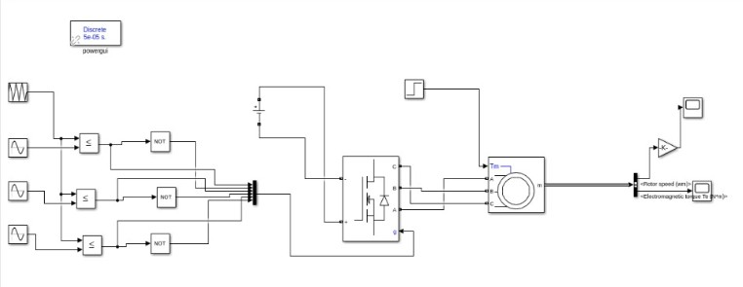

Fig 3.1 Simulated model of Three Phase SPWM Inverter for a motor load

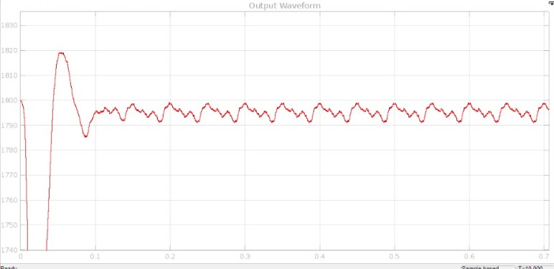

Fig 3.2 Simulated output of Three Phase SPWM Inverter for a motor load

#### FIVE LEVEL CASCADED H BRIDE MULTI LEVEL INVERTER USING SPWM TECHNIQUE

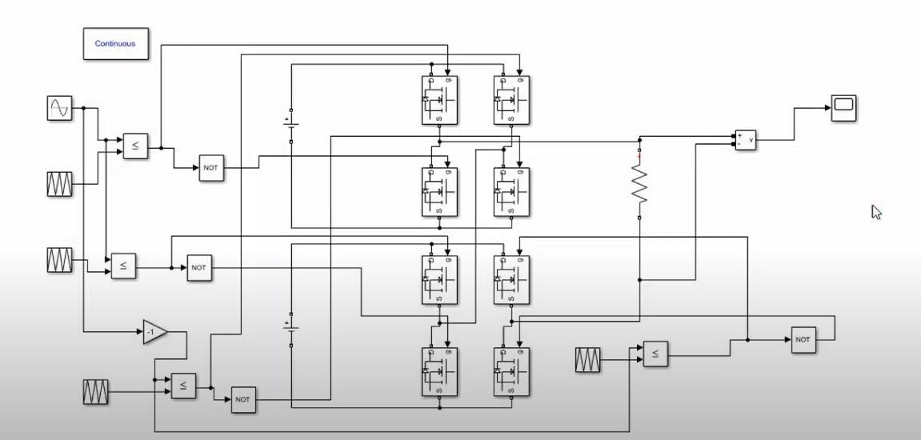

Fig 3.3 Simulated model of Five level Cascaded H Bridge Multi Level Inverter using SPWM Technique

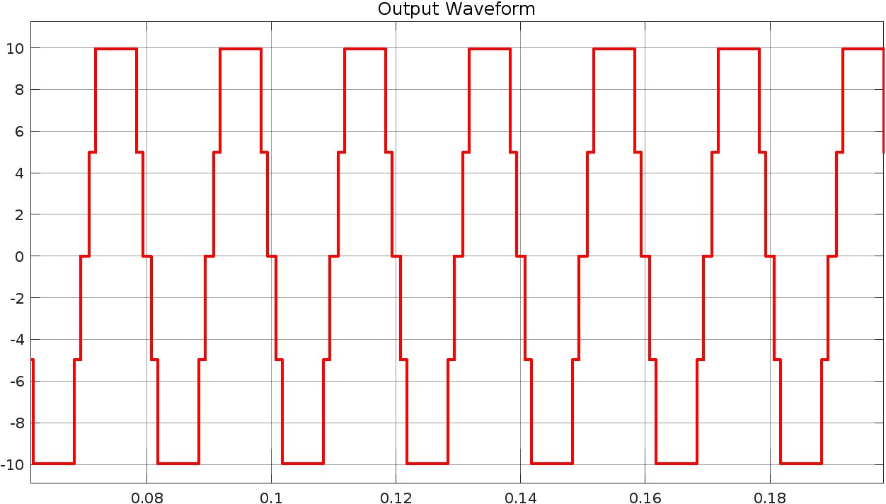

Fig 3.4 Simulated output of Five level Cascaded H Bridge Multi Level Inverter using SPWM Technique

#### SEVEN LEVEL CASCADED H BRIDE MULTI LEVEL INVERTER

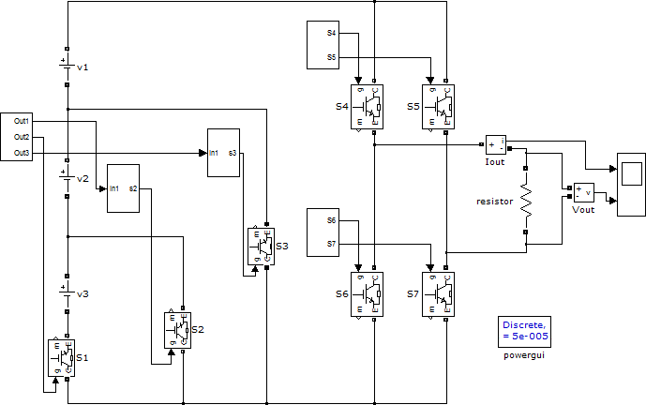

Fig 3.5 Simulated model of Seven level Cascaded H Bridge Multi Level Inverter

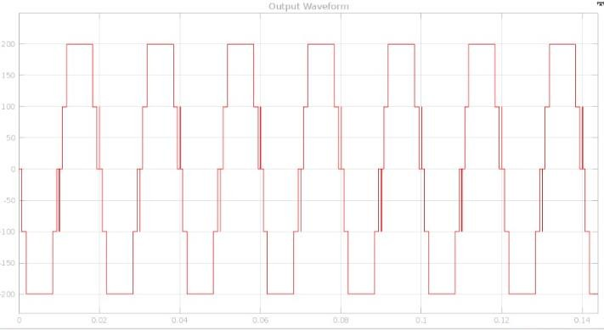

Fig 3.6 Simulated output of Seven level Cascaded H Bridge Multi Level Inverter

#### FIVE LEVEL CASCADED H BRIDGE MULTI LEVEL INVERTER

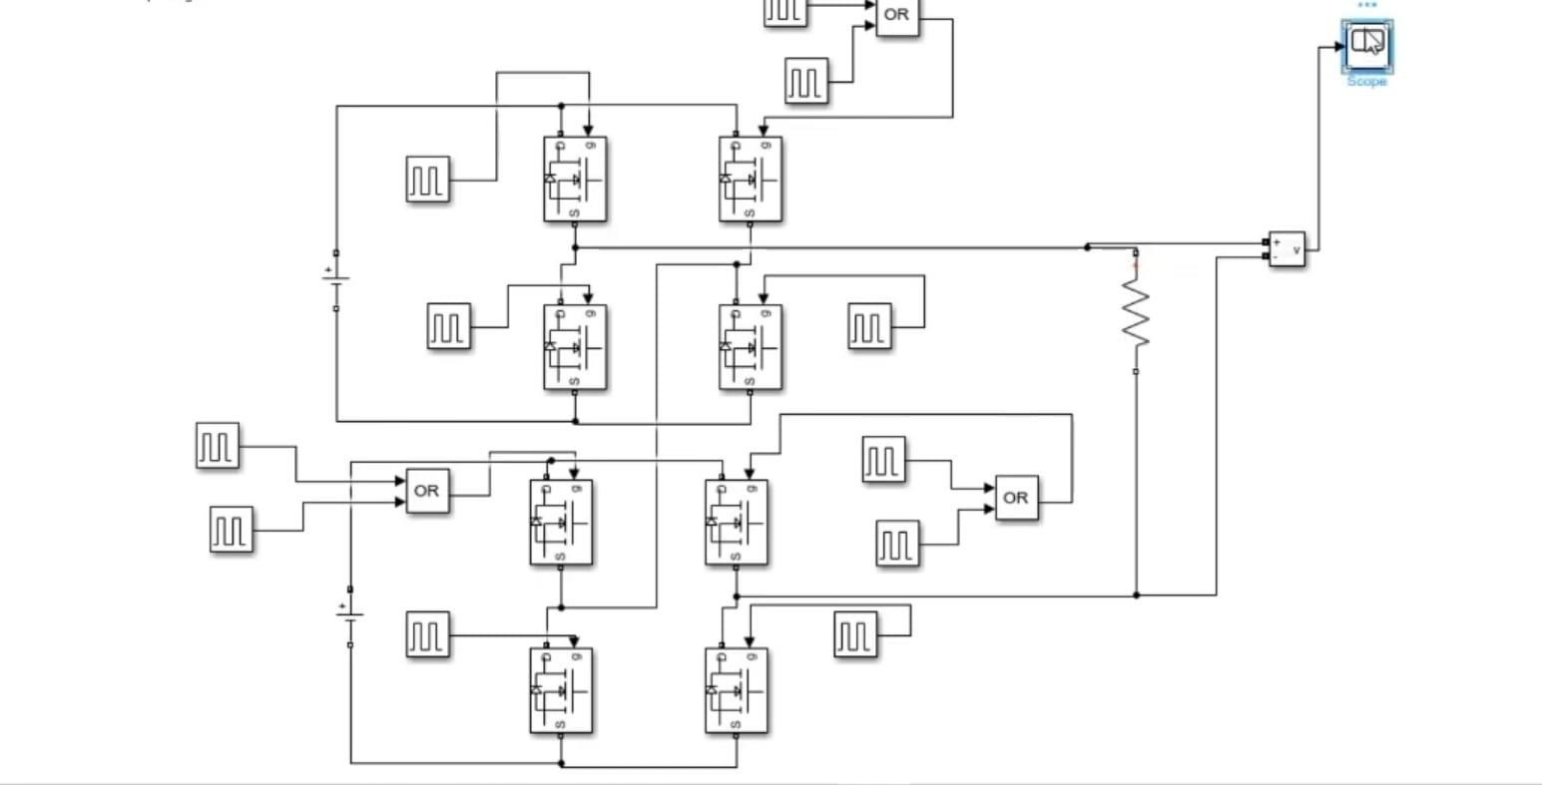

Fig 3.7 Simulated model of Five level Cascaded H Bridge Multi Level Inverter

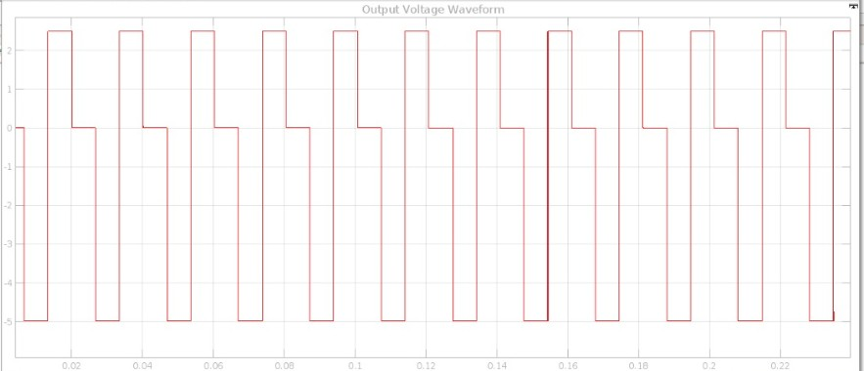

Fig 3.8 Simulated output of Five level Cascaded H Bridge Multi Level Inverter

#### FULL WAVE BRIDGE INVERTER

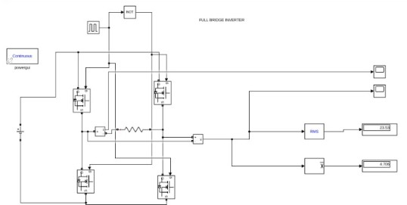

Fig 3.9 Simulated model of Full Wave Bridge Inverter

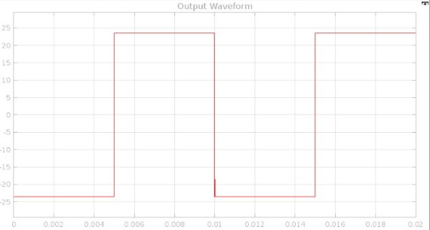

Fig 3.10 Simulated output of Full Wave Bridge Inverter

#### SINGLE PHASE HALF WAVE INVERTER

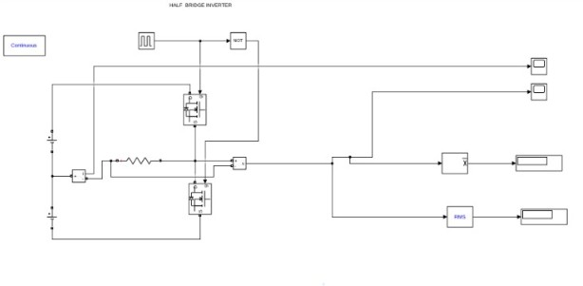

Fig 3.11 Simulated model of Single Phase Half Wave Inverter

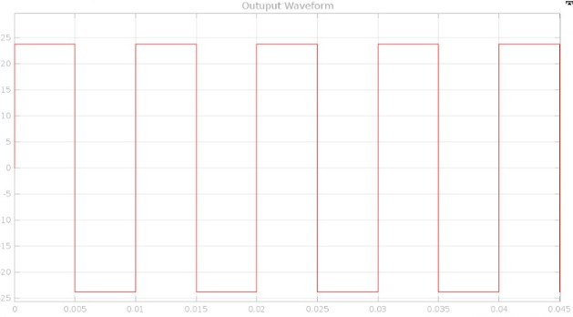

Fig 3.12 Simulated output of Single Phase Half Wave Inverter

#### INVERTER USING SINUSOIDAL PULSE WIDTH MODULATION

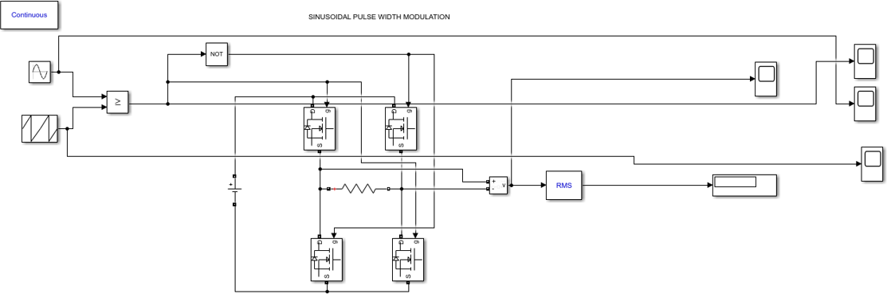

Fig 3.13 Simulated model of Inverter using Sinusoidal Pulse Width Modulation

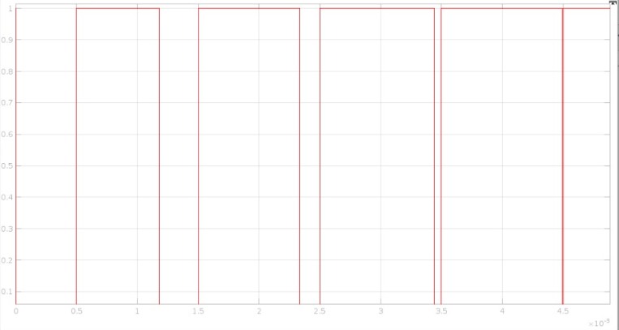

Fig 3.14 Simulated output of Inverter using Sinusoidal Pulse Width Modulation

#### INVERTER USING MULTIPLE PULSE WIDTH MODULATION

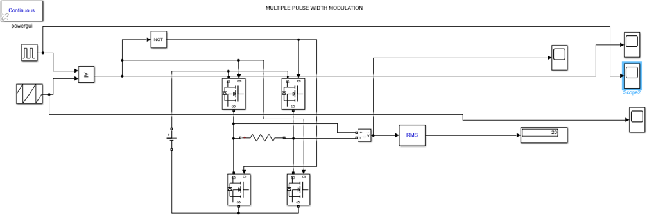

Fig 3.15 Simulated model of Inverter using Multiple Pulse Width Modulation

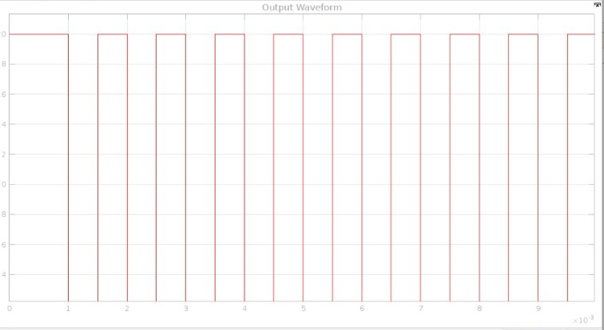

Fig 3.16 Simulated output of Inverter using Multiple Pulse Width Modulation

#### THREE PHASE INVERTER OPERATING IN 120 DEGREE MODE

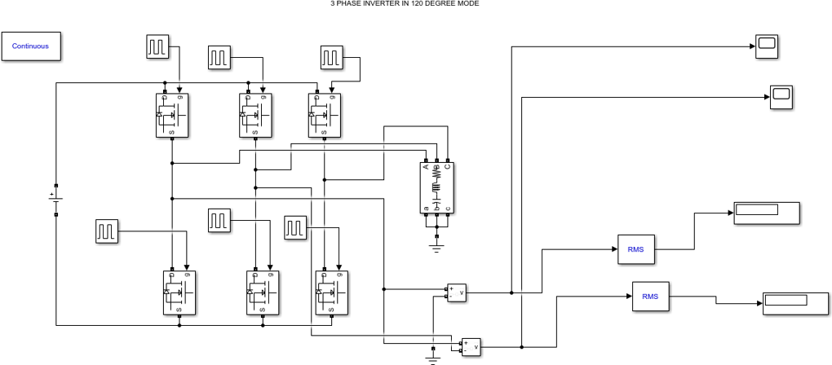

Fig 3.17 Simulated model of Three Phase Inverter operating in 120 degree mode

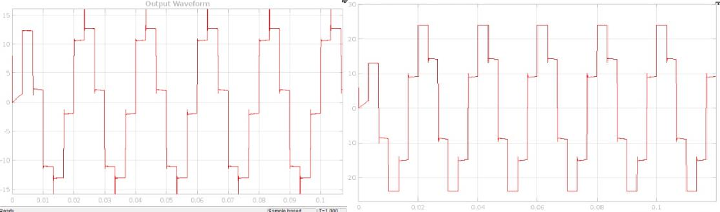

Fig 3.18 Simulated output of Three Phase Inverter operating in 120 degree mode

#### THREE PHASE INVERTER OPERATING IN 180 DEGREE MODE

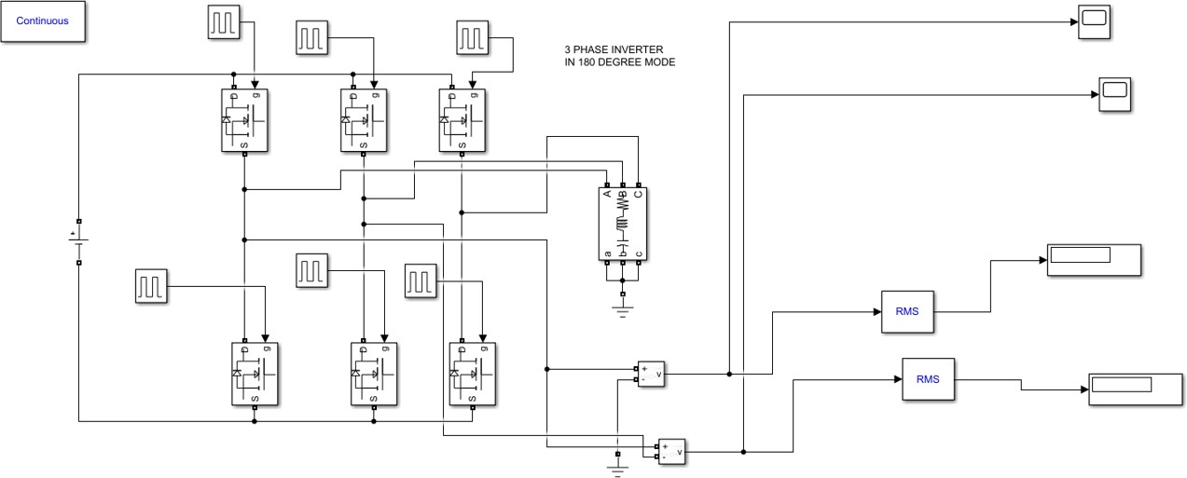

Fig 3.19 Simulated model of Three Phase Inverter operating in 180 degree mode

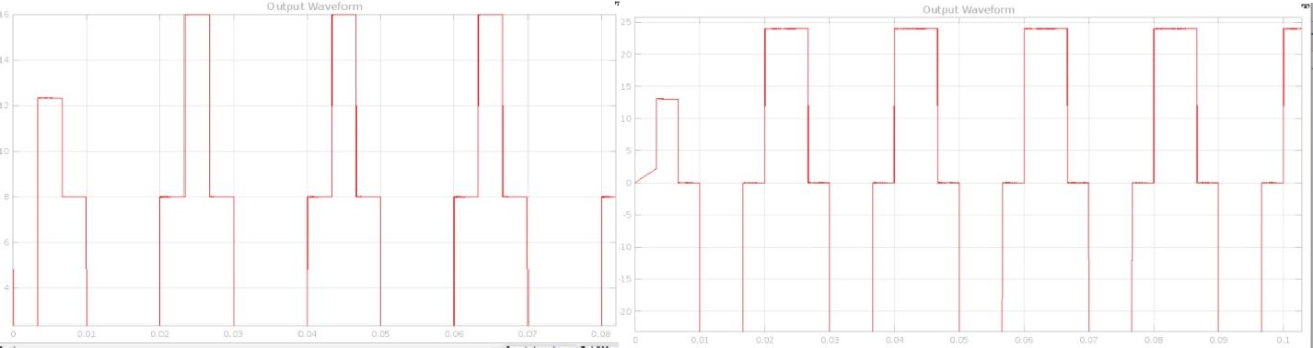

Fig 3.20 Simulated output of Three Phase Inverter operating in 180 degree mode

# CONCLUSION

It is possible to simulate many electrical power converters only using Simulink toolbox of MATLAB, thus avoiding the purchase of expensive and complex dedicated software. The simulation method is based on the variable topology approach where switching conditions of semiconductor are realized by switching functions.

Simulation has traditionally not received the attention it deserves in management science courses. Through simulation, students can explore the content of the simulation. They have the freedom to change any parameter in the simulation and observe the result. Single Phase Half Wave, Full Wave Bridge, cascaded H Bridge, Inverters Using Different Modulation Techniques, Three phase Inverter operating in 120/180 degree mode etc. Inverter circuits with different load were simulated using MATLAB/Simulink and the obtained experimental results were verified. To put the study in hands of the readers, the operation of all simulated circuits in different modes had been detailed above with neat diagram and its respective simulated model and output.

# FUTURE SCOPE

The control technique for multilevel power converters can be further simplified and generalized to different levels and other class of power converters and inverters. The levels of multilevel configuration can be increased and further improvements in terms of performance and power quality issues can be broadly studied and could be implemented with hardware circuits.

The same cascaded multilevel inverter configuration can be installed for other applications like SVC system and performance can be studied for larger AC systems. The proposed system can be designed for larger electrical drives and parameters can be monitored and varied dynamically with high speed network interconnections. Hence the power quality problems in power distribution can be controlled or completely eliminated. The effect of EMI is not dealt in this thesis which can be studied in detail for specific techniques with latest equipment.

The quality of the power supplied to the consumers and electrical utilities should adhere to the stringent norms prescribed for the power quality. In order to ensure the same power quality at all levels of consumer usage, the dedicated low cost integrated chips for these kinds of applications could be developed and manufactured in large scale. This makes the technology easily accessible to common man.

# REFERENCES

1. Ciobotaru, Mihai, et al. "PV inverter simulation using MATLAB/Simulink graphical environment and PLECS block set." *IECON 2006-32nd Annual Conference on IEEE Industrial Electronics*. IEEE, 2006.
2. Srinivasan, Ganesh Kumar, et al. "Trends and challenges in multi-level inverter with reduced switches." *Electronics* 10.4 (2021): 368.
3. Shneen, Salam Waley, FatinNabeel Abdullah, and Dina Harith Shaker. "Simulation model of single phase PWM inverter by using MATLAB/Simulink." *International Journal of Power Electronics and Drive Systems* 12.1 (2021): 212.
4. YingYing, Jia, et al. "Application and Simulation of SVPWM in three phase inverter." *Proceedings of 2011 6th International Forum on Strategic Technology*. Vol. 1. IEEE, 2011.
5. Jain, Kapil, and PradyumnChaturvedi. "Matlab-based simulation & analysis of three- level SPWM inverter." *International Journal Of Soft Computing And Engineering (Ijsce)* 2 (2012).
6. Gandhi, Krupa, K. L. Mokariya, and Deepa Karvat. "Simulation of PWM inverter for VFD application Using MATLAB." *International Journal Of Engineering Research And Development* 10.4 (2014): 94-103.
7. Gebreel, ABD Almula GM. *Simulation and implementation of two-level and three-level inverters by Matlab and RT-LAB*. Diss. The Ohio State University, 2011.
8. Ayadi, M., et al. "Electro-thermal simulation of a three phase inverter with cooling system." *Journal of Modelling and Simulation of Systems* 1.3 (2010): 163-170.
9. Kumar, K. Vinoth, et al. "Simulation and comparison of SPWM and SVPWM control for three phase inverter." *ARPN journal of engineering and applied sciences* 5.7 (2010): 61- 74.
10. Can, Erol. "Novel high multilevel inverters investigated on simulation." *Electrical Engineering* 99.2 (2017): 633-638.