1. ReactJS-HOL

**Code:  
app.js**

function App() {

  return (

    <div>

      <h1>Welcome to the first session of React</h1>

    </div>

  );

}

export default App; **Output**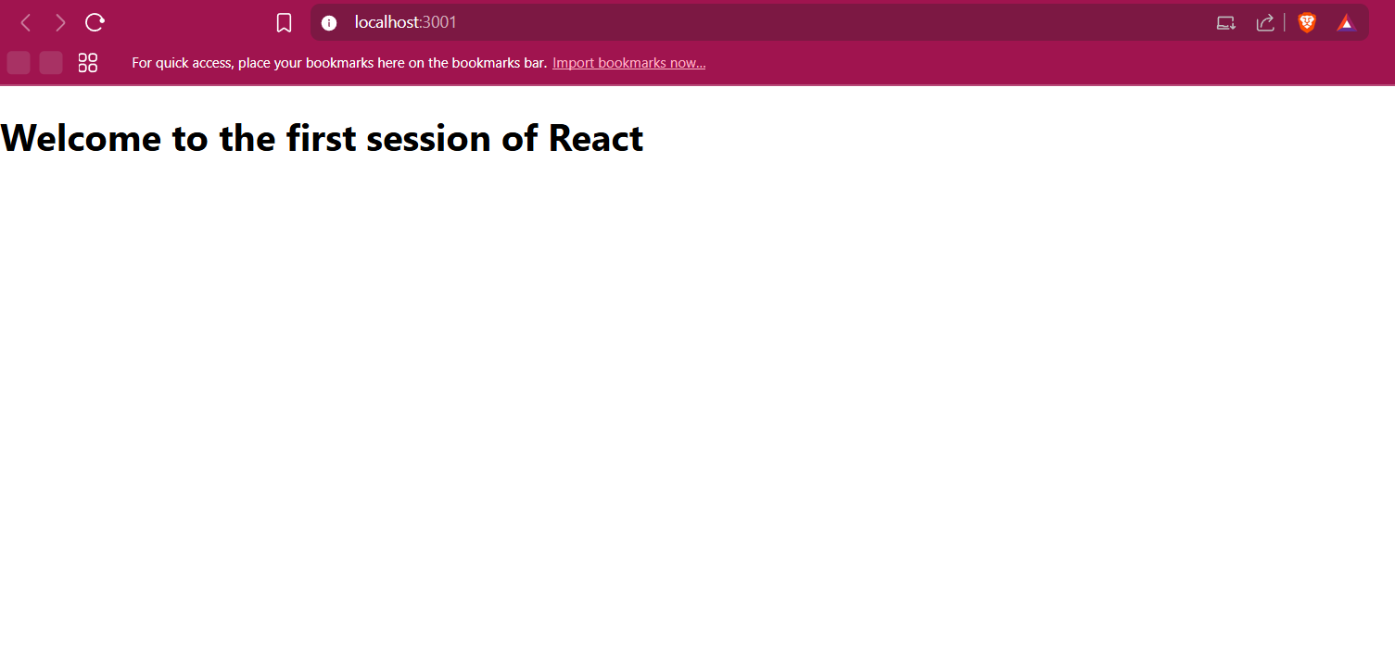2. ReactJS-HOL

**Code:**

**Home.js**

function Home() {

  return (

    <div>

      <h2>Welcome to the Home page of Student Management Portal</h2>

    </div>

  );

}

export default Home;

**About.js**function About() {

  return (

    <div>

      <h2>Welcome to the About page of the Student Management Portal</h2>

    </div>

  );

}

export default About;

**Contact.js**

function Contact() {

  return (

    <div>

      <h2>Welcome to the Contact page of the Student Management Portal</h2>

    </div>

  );

}

export default Contact;

**App.js**

import Home from './Components/Home';

import About from './Components/About';

import Contact from './Components/Contact';

function App() {

  return (

    <div>

      <Home />

      <About />

      <Contact />

    </div>

  );

}

export default App;

**Output:**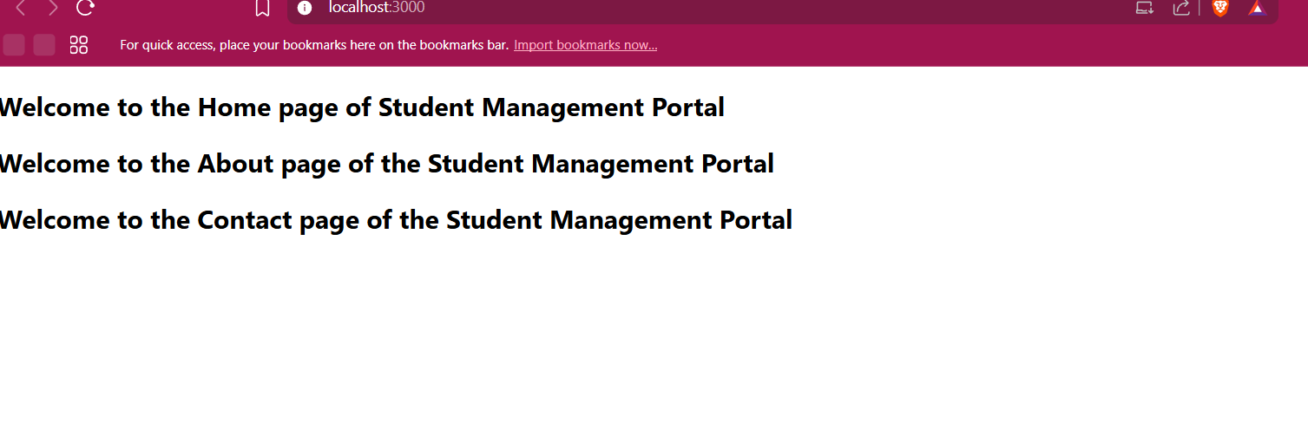3. ReactJS-HOL

**Code:**

**CalculateScore.js**

import '../Stylesheets/mystyle.css';

function CalculateScore(props) {

  const score = ((props.Total / props.Goal) * 100).toFixed(2);

  return (

    <div className="student-details">

      <h2>Student Details:</h2>

      <p><strong className="label name">Name:</strong> <span className="value name">{props.Name}</span></p>

      <p><strong className="label school">School:</strong> <span className="value school">{props.School}</span></p>

      <p><strong className="label total">Total:</strong> <span className="value total">{props.Total} Marks</span></p>

      <p><strong className="label score">Score:</strong> <span className="value score">{score}%</span></p>

    </div>

  );

}

export default CalculateScore;  
 **mystyle.css**.student-details {

text-align: center;

margin-top: 50px;

font-family: Arial, sans-serif;

}

.student-details h2 {

color: brown;

font-size: 30px;

}

.label.name, .value.name {

color: blue;

font-weight: bold;

}

.label.school, .value.school {

color: crimson;

font-weight: bold;

}

.label.total, .value.total {

color: darkred;

font-weight: bold;

}

.label.score, .value.score {

color: green;

font-weight: bold;

}  
  
**App.js**import React from 'react';

import './App.css';

import CalculateScore from './Components/CalculateScore';

function App() {

return (

<div className="App">

<CalculateScore Name="Steeve" School="DNV Public School" Total={284} Goal={3} />

</div>

);

}

export default App;

**Output:**

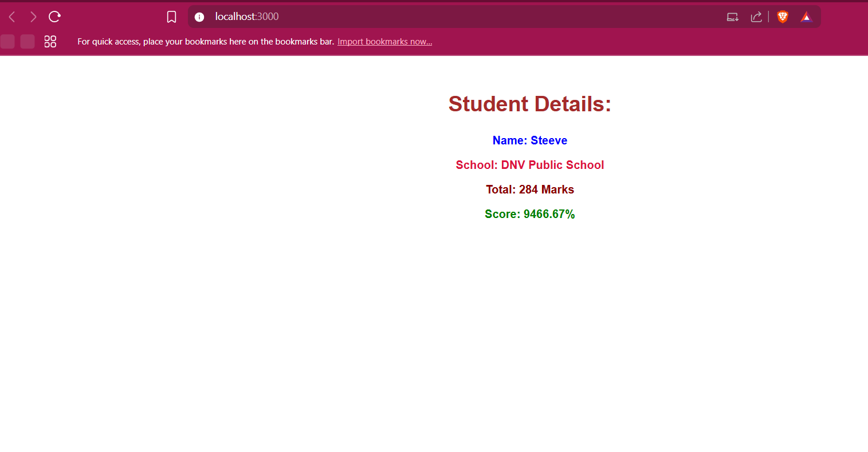

4. ReactJS-HOL

**Code:**

**App.js**

import './App.css';

import Posts from './Posts';

function App() {

  return (

    <div className="App">

      <h1>Welcome to Blog App</h1>

      <Posts />

    </div>

  );

}

export default App;

**post.js**import React from 'react';

class Post extends React.Component {

  render() {

    return (

      <div className="post">

        <h3>{this.props.title}</h3>

        <p>{this.props.body}</p>

      </div>

    );

  }

}

export default Post;

**posts.js**import React from 'react';

import Post from './Post';

class Posts extends React.Component {

  constructor(props) {

    super(props);

    this.state = {

      posts: [],

      hasError: false

    };

  }

  loadPosts() {

    fetch('https://jsonplaceholder.typicode.com/posts')

      .then((res) => res.json())

      .then((data) => this.setState({ posts: data }))

      .catch((error) => {

        console.error('Error fetching posts:', error);

        this.setState({ hasError: true });

      });

  }

  componentDidMount() {

    this.loadPosts();

  }

  componentDidCatch(error, info) {

    this.setState({ hasError: true });

    alert("Something went wrong: " + error);

  }

  render() {

    if (this.state.hasError) {

      return <h2>Failed to load posts.</h2>;

    }

    return (

      <div>

        <h2>Blog Posts</h2>

        {this.state.posts.map((post) => (

          <Post key={post.id} title={post.title} body={post.body} />

        ))}

      </div>

    );

  }

}

export default Posts;

**Output:**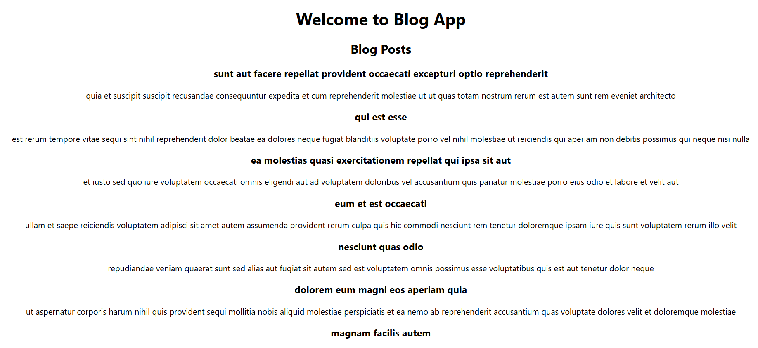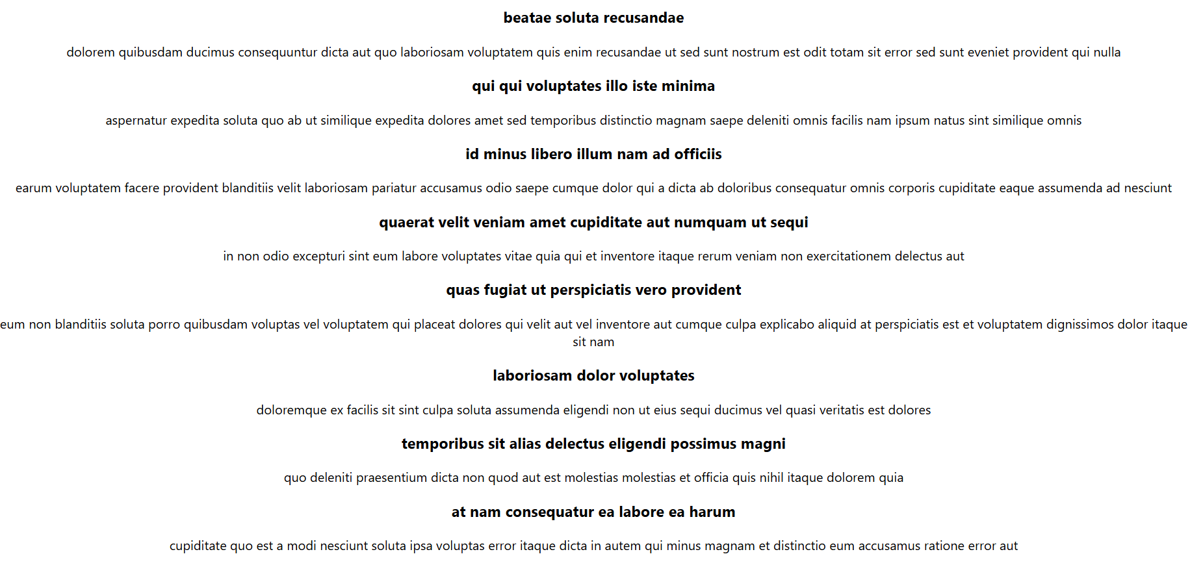5. ReactJS-HOL

**Code:**CohortDetails.module.css

.box {

width: 300px;

display: inline-block;

margin: 10px;

padding: 10px 20px;

border: 1px solid black;

border-radius: 10px;

}

dt {

font-weight: 500;

}

**CohortDetails.js**

import styles from './CohortDetails.module.css';

function CohortDetails(props) {

const statusStyle = {

color: props.status === 'ongoing' ? 'green' : 'blue',

};

return (

<div className={styles.box}>

<h3 style={statusStyle}>{props.name}</h3>

<dl>

<dt>Trainer</dt>

<dd>{props.trainer}</dd>

<dt>Track</dt>

<dd>{props.track}</dd>

<dt>Status</dt>

<dd>{props.status}</dd>

</dl>

</div>

);

}

export default CohortDetails;

**App.js**

import './App.css';

import CohortDetails from './CohortDetails';

function App() {

return (

<div className="App">

<h2>My Academy Dashboard</h2>

<CohortDetails name="React Basics" trainer="Hari" track="Frontend" status="ongoing" />

<CohortDetails name="Java Sprint" trainer="Raj" track="Backend" status="completed" />

</div>

);

}

export default App;

**Output:**

