**9.ReactJS  
Code:  
MergedPlayers.js**

const MergedPlayers = () => {

  const T20Players = [

    { name: "Rishabh" },

    { name: "Shreyas" },

    { name: "Gill" }

  ];

  const RanjiTrophyPlayers = [

    { name: "Prithvi" },

    { name: "Sarfaraz" },

    { name: "Ruturaj" }

  ];

  const merged = [...T20Players, ...RanjiTrophyPlayers];

  return (

    <div>

      <h3>List of Indian Players Merged:</h3>

      <ul>

        {merged.map((player, idx) => (

          <li key={idx}>{player.name}</li>

        ))}

      </ul>

    </div>

  );

};

export default MergedPlayers;

**OddEvenPlayers.js**

const OddEvenPlayers = ({ list }) => {

  const odd = list.filter((_, i) => i % 2 !== 0);

  const even = list.filter((_, i) => i % 2 === 0);

  return (

    <div>

      <h3>Odd Players</h3>

      <ul>

        {odd.map((item, idx) => (

          <li key={idx}>{item.name}</li>

        ))}

      </ul>

      <h3>Even Players</h3>

      <ul>

        {even.map((item, idx) => (

          <li key={idx}>{item.name}</li>

        ))}

      </ul>

    </div>

  );

};

export default OddEvenPlayers;

**players.js**

export const players = [

  { name: "Virat", score: 88 },

  { name: "Rohit", score: 95 },

  { name: "Hardik", score: 65 },

  { name: "Bumrah", score: 45 },

  { name: "Dhoni", score: 55 },

  { name: "Sachin", score: 100 },

  { name: "Rahul", score: 60 },

  { name: "Surya", score: 80 }

];

**App.js:**

import { useState } from "react";

import { players } from "./data/players";

import OddEvenPlayers from "./components/OddEvenPlayers";

import MergedPlayers from "./components/MergedPlayers";

function App() {

  const [flag, setFlag] = useState(true);

  return (

    <div>

      <button onClick={() => setFlag(!flag)}>Toggle</button>

      {flag ? (

        <div>

          <h3>List of Players:</h3>

          <ul>

            {players.map((item, idx) => (

              <li key={idx}>

                {item.name} - {item.score}

              </li>

            ))}

          </ul>

          <h3>List of Players having Scores Less than 70:</h3>

          <ul>

            {players

              .filter((player) => player.score < 70)

              .map((player, idx) => (

                <li key={idx}>{player.name}</li>

              ))}

          </ul>

        </div>

      ) : (

        <div>

          <h3>Indian Team:</h3>

          <OddEvenPlayers list={players} />

          <MergedPlayers />

        </div>

      )}

    </div>

  );

}

export default App;

**index.js**

import React from "react";

import ReactDOM from "react-dom/client";

import App from "./App";

const root = ReactDOM.createRoot(document.getElementById("root"));

root.render(

  <React.StrictMode>

    <App />

  </React.StrictMode>

);

**Output :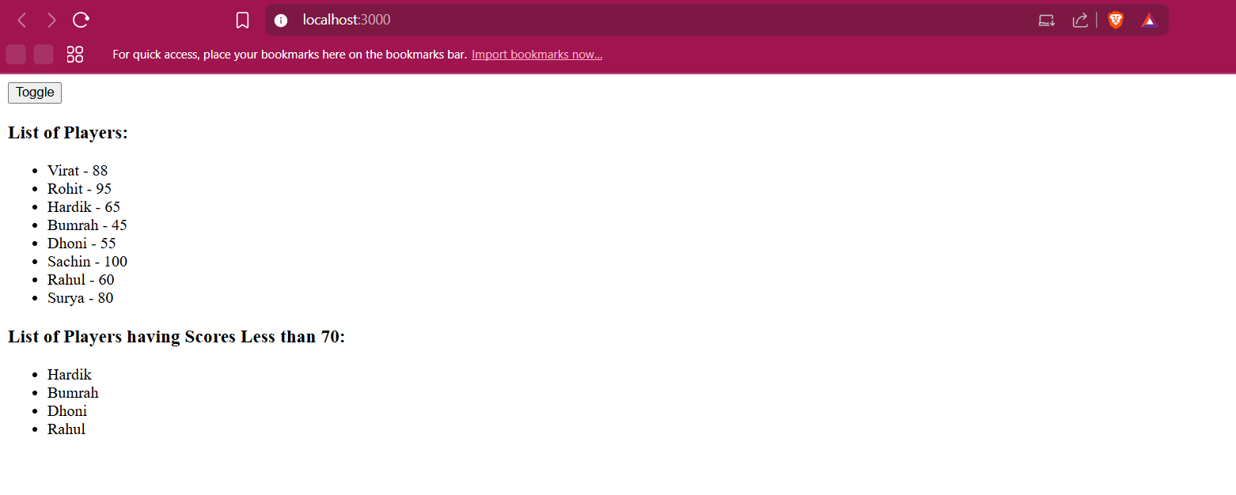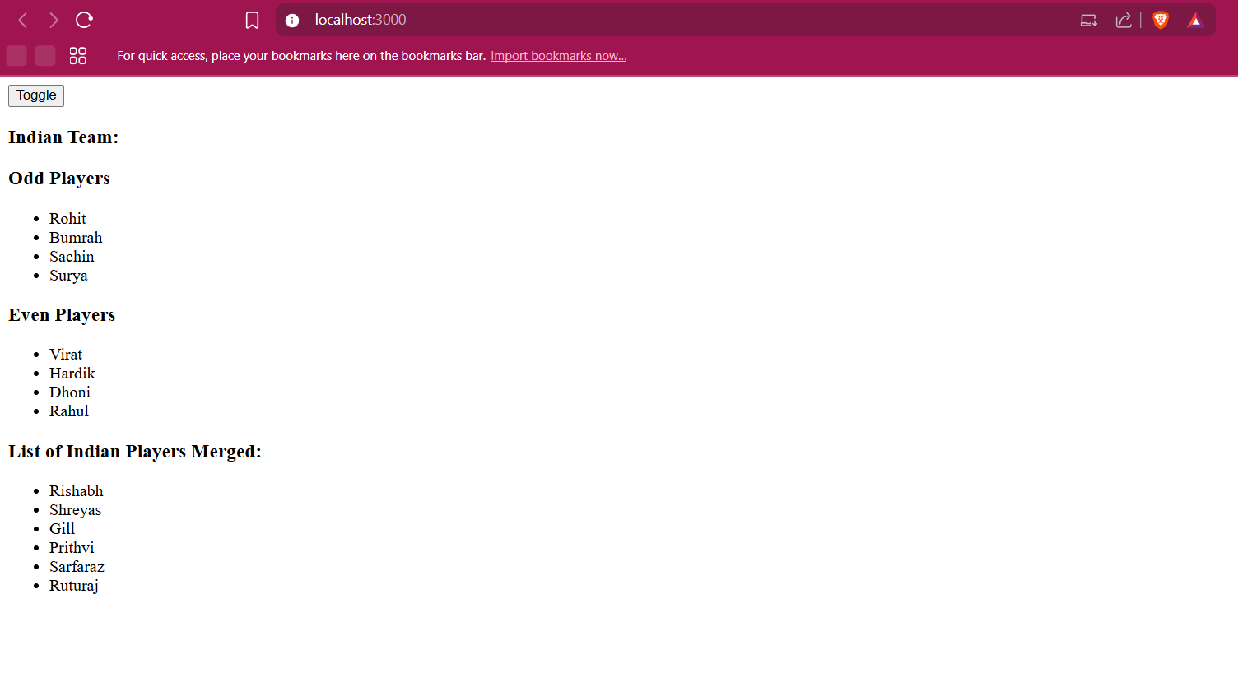 10.ReactJS  
Code:  
offices.js**export const offices = [

{

name: "WeWork Residency",

rent: 45000,

address: "MG Road, Bangalore",

image: "https://via.placeholder.com/150"

},

{

name: "Innov8 Cowork",

rent: 75000,

address: "Powai, Mumbai",

image: "https://via.placeholder.com/150"

},

{

name: "91Springboard",

rent: 60000,

address: "Koramangala, Bangalore",

image: "https://via.placeholder.com/150"

},

{

name: "Regus Office",

rent: 85000,

address: "Connaught Place, Delhi",

image: "https://via.placeholder.com/150"

}

];  
  
**officelist.js**

const OfficeList = ({ data }) => {

  return (

    <div>

      {data.map((office, idx) => {

        const rentStyle = {

          color: office.rent < 60000 ? "red" : "green",

          fontWeight: "bold"

        };

        return (

          <div key={idx} style={{ border: "1px solid gray", padding: "10px", margin: "10px 0" }}>

            <h3>{office.name}</h3>

            <img src={office.image} alt={office.name} width="150" height="100" />

            <p>Address: {office.address}</p>

            <p style={rentStyle}>Rent: ₹{office.rent}</p>

          </div>

        );

      })}

    </div>

  );

};

export default OfficeList;

**app.js**

import { offices } from "./data/offices";

import OfficeList from "./components/officelist";

function App() {

  const heading = <h1>🏢 Office Space Rental Listings</h1>;

  return (

    <div style={{ padding: "20px", fontFamily: "Arial" }}>

      {heading}

      <OfficeList data={offices} />

    </div>

  );

}

export default App;

**index.js**

import ReactDOM from "react-dom/client";

import App from "./App";

const root = ReactDOM.createRoot(document.getElementById("root"));

root.render(<App />);

**Output: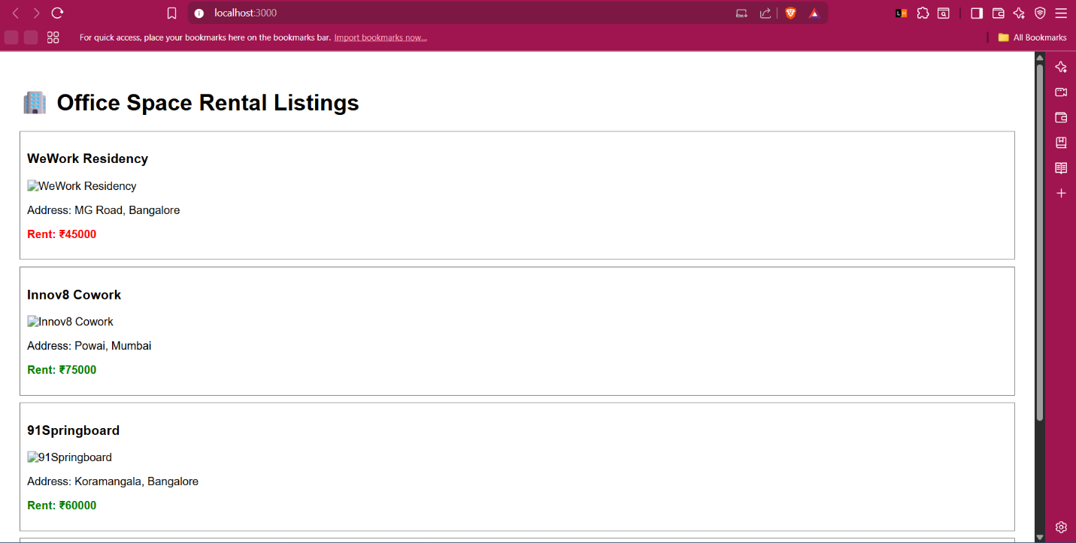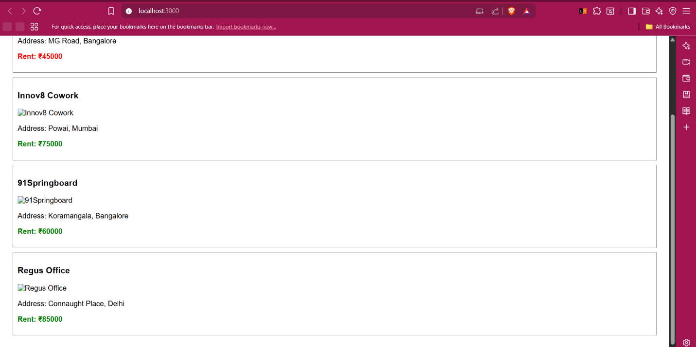 11.ReactJS  
Code:  
counter.js**

import  { Component } from "react";

class Counter extends Component {

  constructor(props) {

    super(props);

    this.state = {

      count: 0

    };

  }

  increment = () => {

    this.setState({ count: this.state.count + 1 });

  };

  sayHello = () => {

    console.log("Hello! Welcome to the counter.");

  };

  handleIncrement = () => {

    this.increment();

    this.sayHello();

  };

  decrement = () => {

    this.setState({ count: this.state.count - 1 });

  };

  render() {

    return (

      <div>

        <h3>Counter Value: {this.state.count}</h3>

        <button onClick={this.handleIncrement}>Increase</button>

        <button onClick={this.decrement}>Decrease</button>

      </div>

    );

  }

}

export default Counter;

**cuncurrencycontrol.js**

import  { useState } from "react";

const CurrencyConverter = () => {

  const [rupees, setRupees] = useState("");

  const [euros, setEuros] = useState("");

  const handleChange = (e) => {

    setRupees(e.target.value);

  };

  const handleSubmit = (e) => {

    e.preventDefault();

    const euroValue = (parseFloat(rupees) / 90).toFixed(2);

    setEuros(euroValue);

  };

  return (

    <div>

      <h3>Currency Converter (INR ➡ EUR)</h3>

      <form onSubmit={handleSubmit}>

        <input

          type="number"

          placeholder="Enter amount in INR"

          value={rupees}

          onChange={handleChange}

        />

        <button type="submit">Convert</button>

      </form>

      {euros && <p>Converted Value in Euros: €{euros}</p>}

    </div>

  );

};

export default CurrencyConverter;

**SyntheticEventExample.js**

const SyntheticEventExample = () => {

  const handleClick = (e) => {

    e.preventDefault(); // synthetic event

    alert("I was clicked");

  };

  return (

    <div>

      <button onClick={handleClick}>OnPress</button>

    </div>

  );

};

export default SyntheticEventExample;

**welcomebutton.js**

const sayWelcome = (message) => {

  alert(`Welcome message: ${message}`);

};

const WelcomeButton = () => {

  return (

    <div>

      <button onClick={() => sayWelcome("Welcome!")}>Say Welcome</button>

    </div>

  );

};

export default WelcomeButton;

**app.js**

import Counter from "./components/Counter";

import WelcomeButton from "./components/WelcomeButton";

import SyntheticEventExample from "./components/SyntheticEventExample";

import CurrencyConverter from "./components/CurrencyConverter";

function App() {

  return (

    <div style={{ padding: "20px", fontFamily: "Arial" }}>

      <h1>🎯 React Event Handling Examples</h1>

      <Counter />

      <WelcomeButton />

      <SyntheticEventExample />

      <CurrencyConverter />

    </div>

  );

}

export default App;

**index.js**import React from 'react';

import ReactDOM from 'react-dom/client';

import './index.css';

import App from './App';

import reportWebVitals from './reportWebVitals';

const root = ReactDOM.createRoot(document.getElementById('root'));

root.render(

  <React.StrictMode>

    <App />

  </React.StrictMode>

);

// If you want to start measuring performance in your app, pass a function

// to log results (for example: reportWebVitals(console.log))

// or send to an analytics endpoint. Learn more: https://bit.ly/CRA-vitals

reportWebVitals();

**OUTPUT :**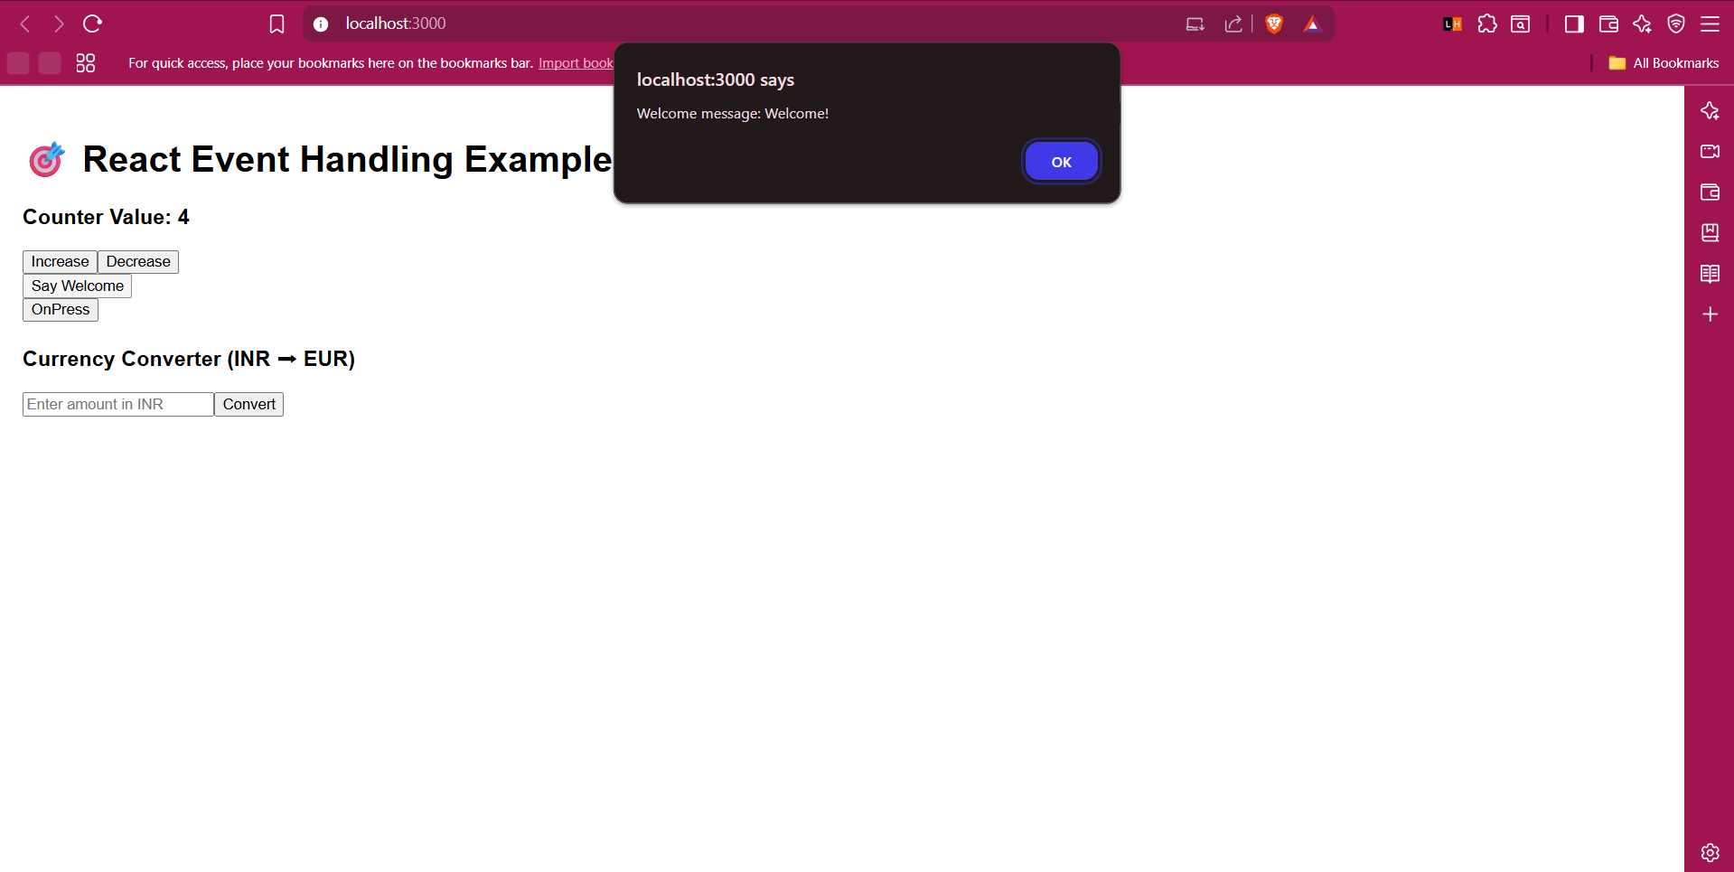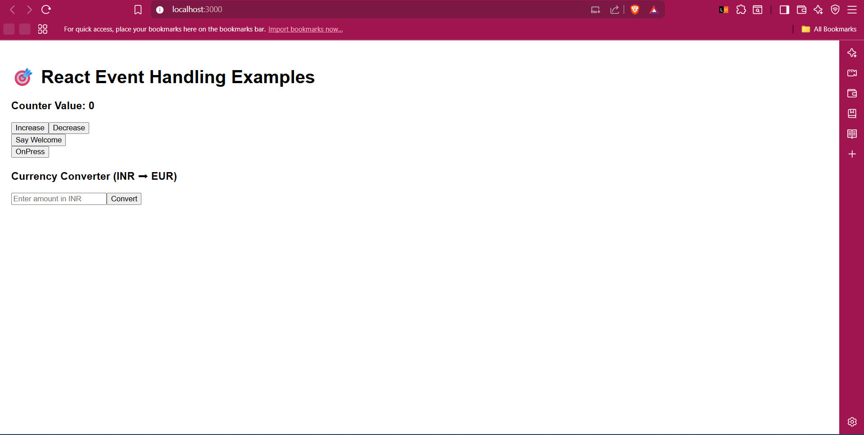

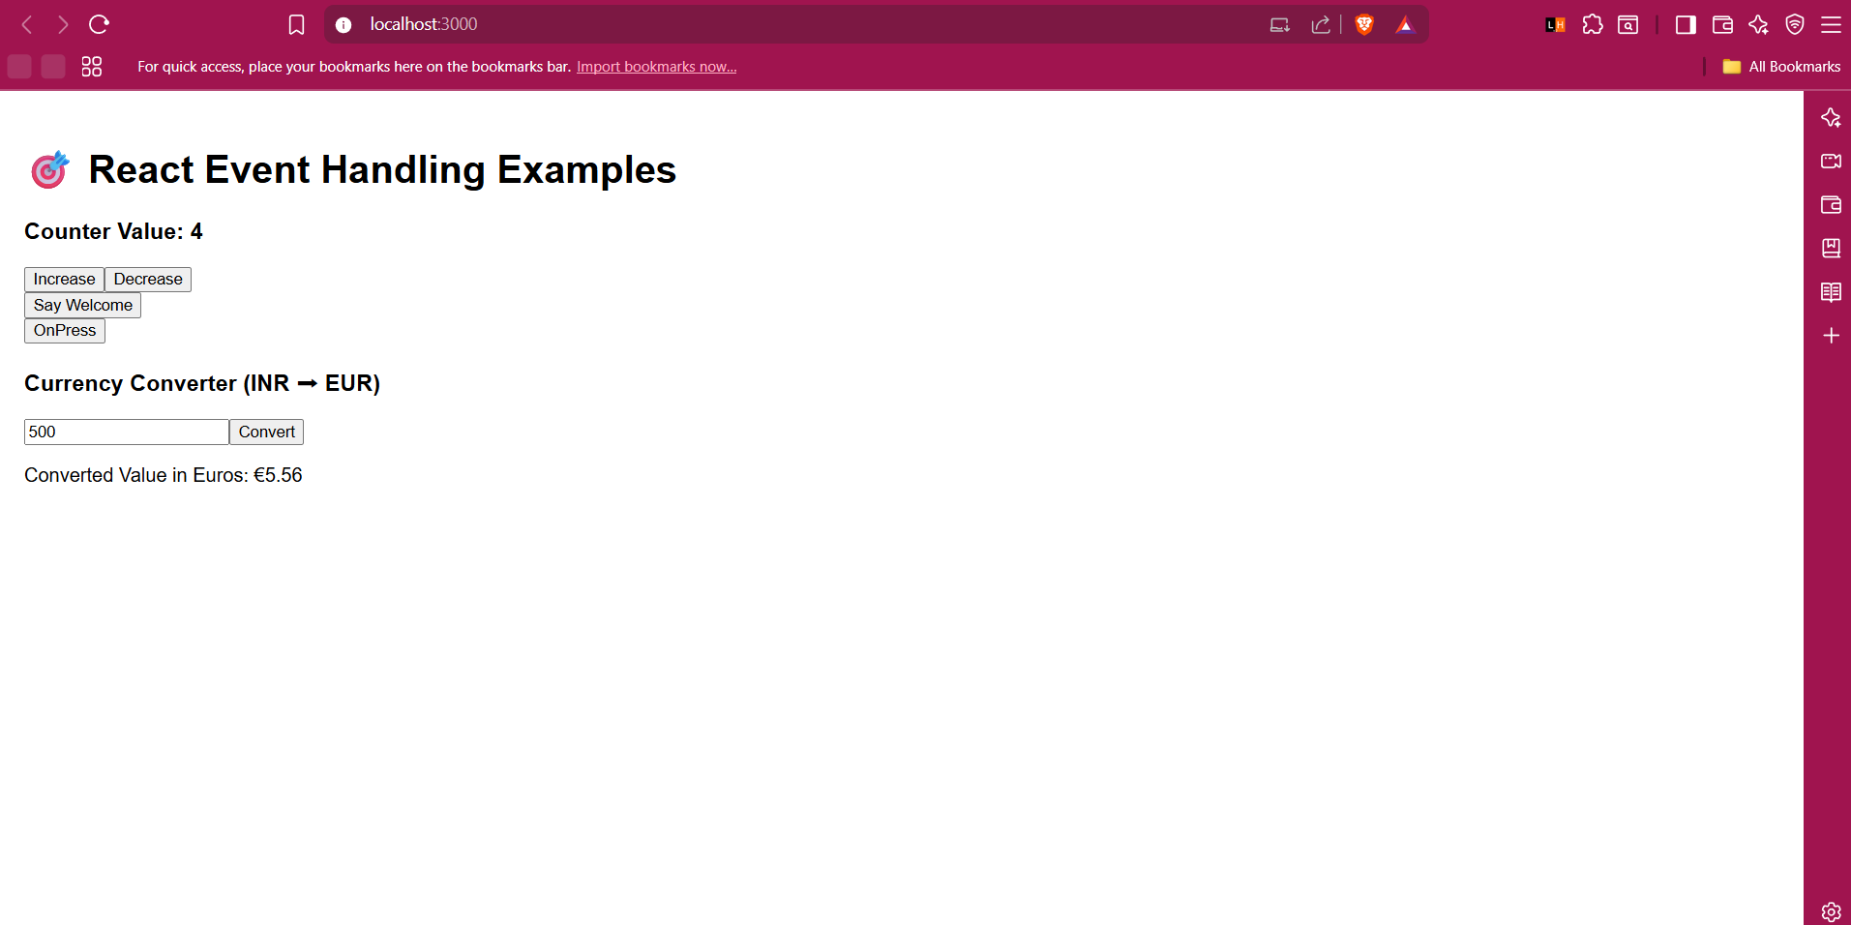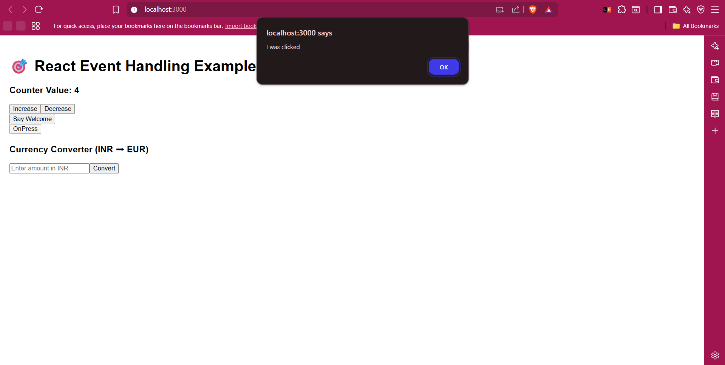 **12.ReactJS  
Code:  
  
GuestPage.js**

import React from "react";

const GuestPage = () => {

return (

<div>

<h2>Welcome Guest!</h2>

<p>You can browse available flights below:</p>

<ul>

<li>IndiGo - BLR to DEL - ₹4500</li>

<li>Air India - MAA to BOM - ₹6200</li>

<li>SpiceJet - HYD to GOA - ₹3000</li>

</ul>

</div>

);

};

export default GuestPage;  
  
**UserPage.js**

import React from "react";

const UserPage = () => {

return (

<div>

<h2>Welcome User!</h2>

<p>You can now book your tickets:</p>

<button>Book Flight to Delhi</button>

<button>Book Flight to Mumbai</button>

</div>

);

};

export default UserPage;  
  
  
**App.js**

import React, { useState } from "react";

import GuestPage from "./components/GuestPage";

import UserPage from "./components/UserPage";

function App() {

const [isLoggedIn, setIsLoggedIn] = useState(false); // State to manage login

const handleLogin = () => {

setIsLoggedIn(true);

};

const handleLogout = () => {

setIsLoggedIn(false);

};

let content; // Element variable for conditional rendering

if (isLoggedIn) {

content = <UserPage />;

} else {

content = <GuestPage />;

}

return (

<div style={{ padding: "20px", fontFamily: "Arial" }}>

<h1>✈️ Flight Ticket Booking App</h1>

{isLoggedIn ? (

<button onClick={handleLogout}>Logout</button>

) : (

<button onClick={handleLogin}>Login</button>

)}

<hr />

{content}

</div>

);

}

export default App;  
  
**index.js**

import React from "react";

import ReactDOM from "react-dom/client";

import App from "./App";

const root = ReactDOM.createRoot(document.getElementById("root"));

root.render(<App />);  
  
  
**Output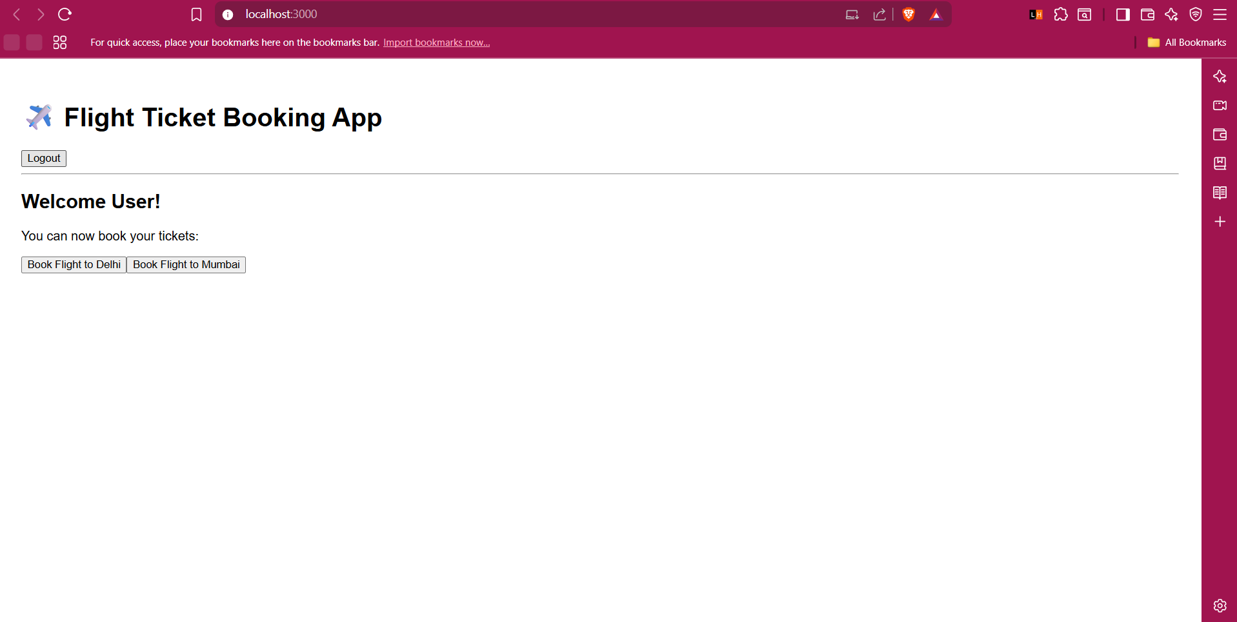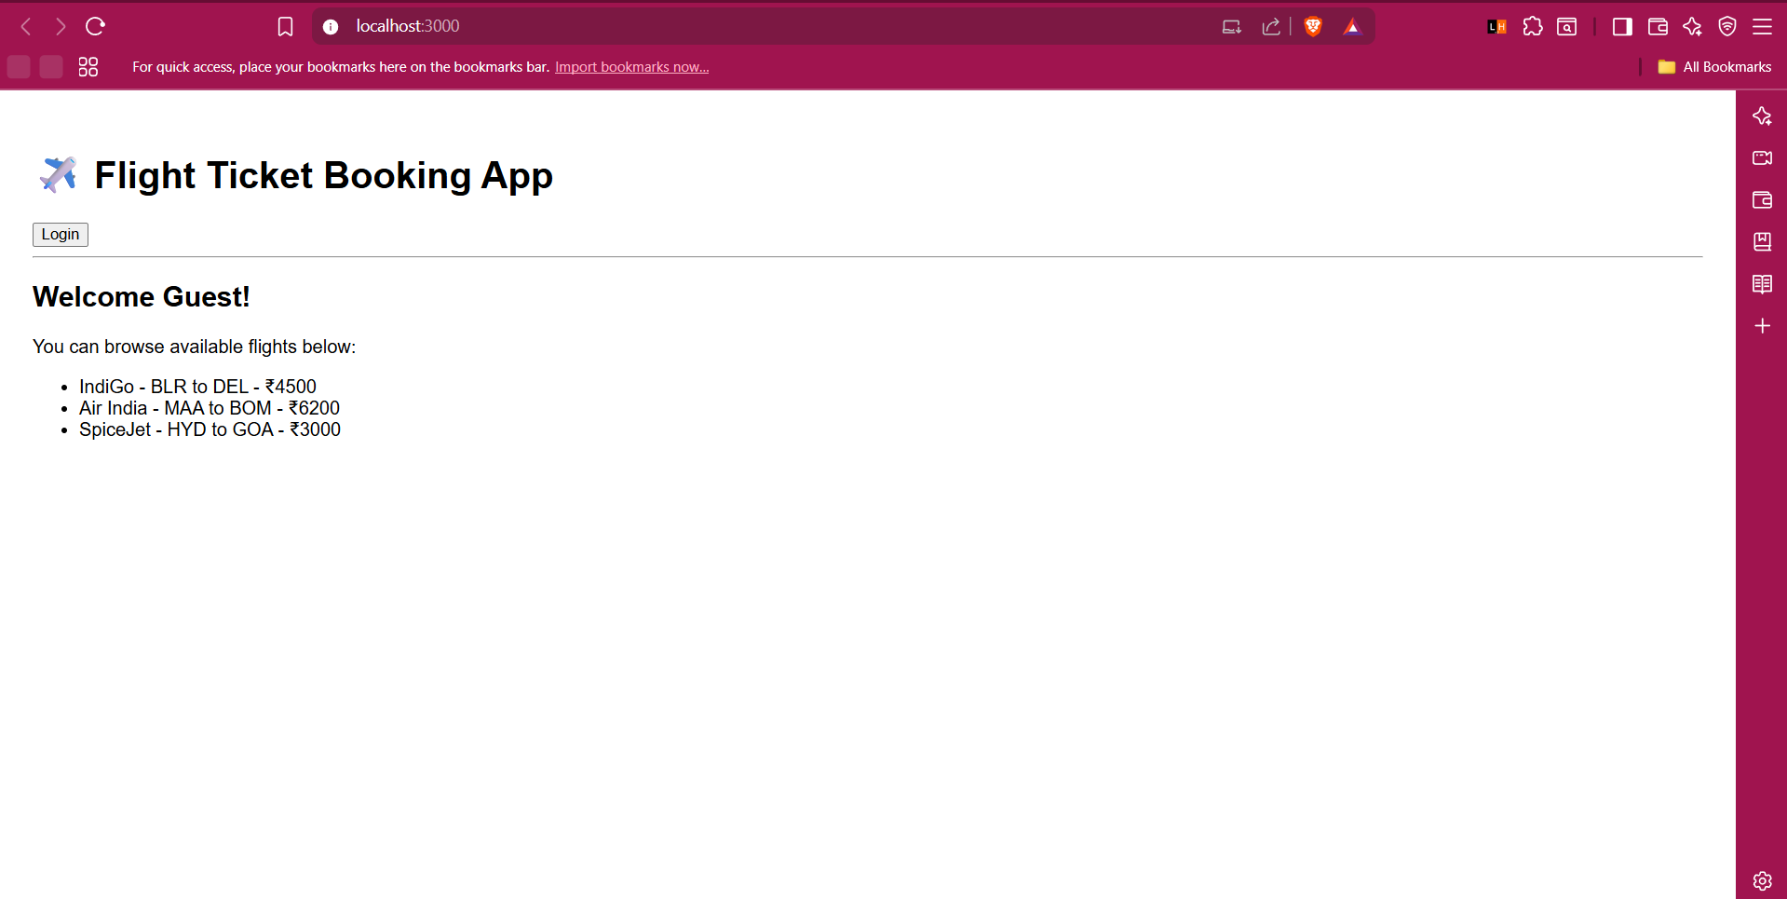 13.ReactJS  
Code:  
  
App.js**

import CourseDetails from "./components/CourseDetails";

import BookDetails from "./components/BookDetails";

import BlogDetails from "./components/BlogDetails";

function App() {

  const courses = [

    { name: "Angular", date: "4/5/2021" },

    { name: "React", date: "6/3/20201" }

  ];

  const books = [

    { name: "Master React", price: 670 },

    { name: "Deep Dive into Angular 11", price: 800 },

    { name: "Mongo Essentials", price: 450 }

  ];

  const blogs = [

    {

      title: "React Learning",

      author: "Stephen Biz",

      content: "Welcome to learning React!"

    },

    {

      title: "Installation",

      author: "Schewzdenier",

      content: "You can install React from npm."

    }

  ];

  return (

    <div style={{ display: "flex", padding: "40px", fontFamily: "Arial, sans-serif" }}>

      <CourseDetails courses={courses} />

      <BookDetails books={books} />

      <BlogDetails blogs={blogs} />

    </div>

  );

}

export default App;

**bookdetails,js**a

const BookDetails = ({ books }) => {

  return (

    <div style={{ flex: 1, borderRight: "4px solid green", paddingRight: "20px", paddingLeft: "20px" }}>

      <h2>Book Details</h2>

      {books.map((book, index) => (

        <div key={index} style={{ marginBottom: "15px" }}>

          <h3>{book.name}</h3>

          <p>{book.price}</p>

        </div>

      ))}

    </div>

  );

};

export default BookDetails;

**blogdetails.js**

const BlogDetails = ({ blogs }) => {

  return (

    <div style={{ flex: 1, paddingLeft: "20px" }}>

      <h2>Blog Details</h2>

      {blogs.map((blog, index) => (

        <div key={index} style={{ marginBottom: "15px" }}>

          <h3>{blog.title}</h3>

          <strong>{blog.author}</strong>

          <p>{blog.content}</p>

        </div>

      ))}

    </div>

  );

};

export default BlogDetails;

**coursedetails.js**

const CourseDetails = ({ courses }) => {

  return (

    <div style={{ flex: 1, borderRight: "4px solid green", paddingRight: "20px" }}>

      <h2>Course Details</h2>

      {courses.map((course, index) => (

        <div key={index} style={{ marginBottom: "15px" }}>

          <h3>{course.name}</h3>

          <p>{course.date}</p>

        </div>

      ))}

    </div>

  );

};

export default CourseDetails;

**Output:  
