DAY-6
Machine learning
Preprocessing
Dataset:Titanic
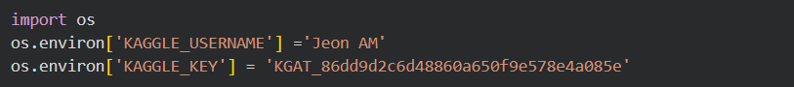
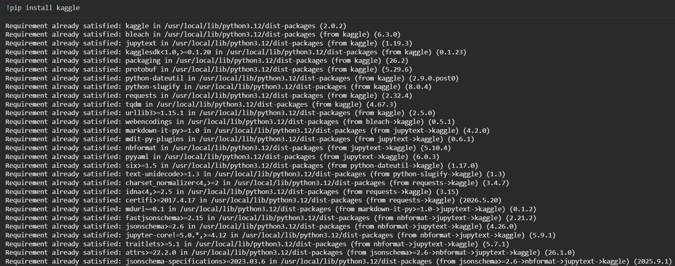
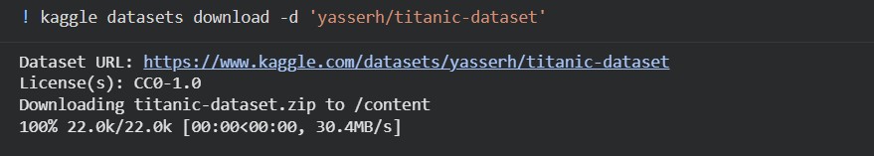
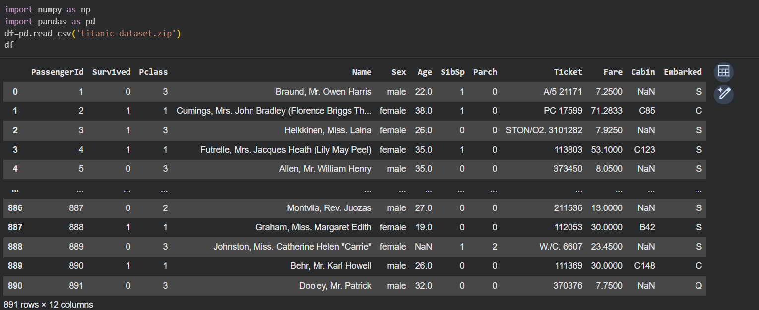
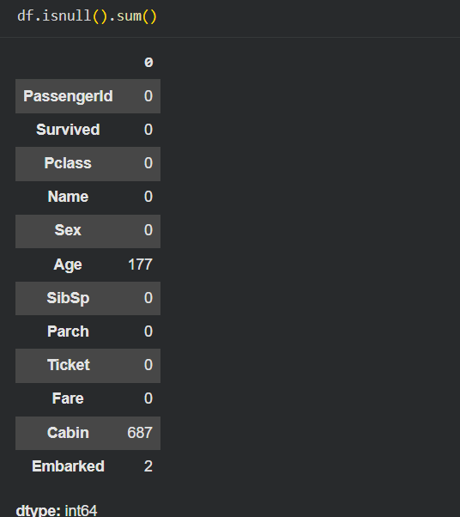
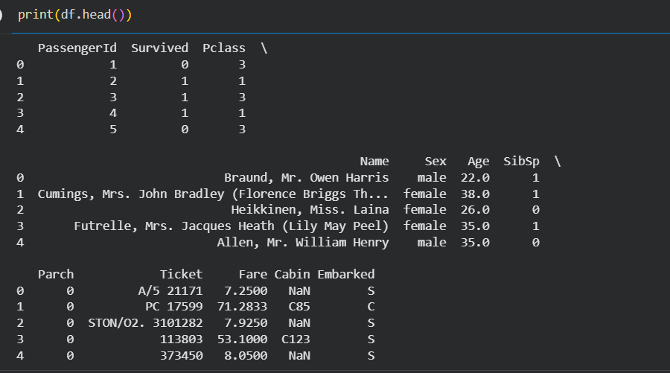
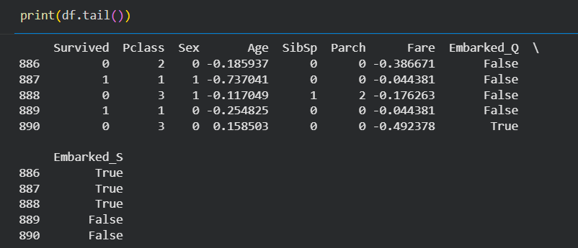
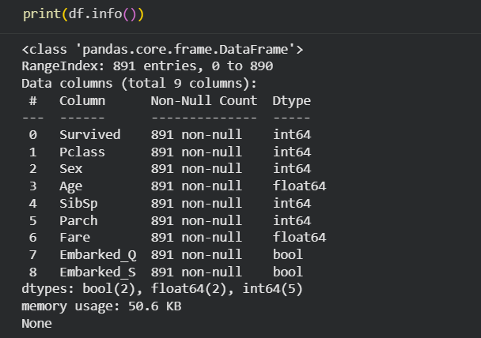
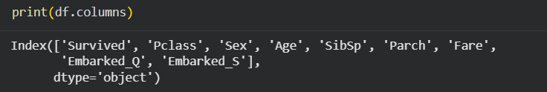
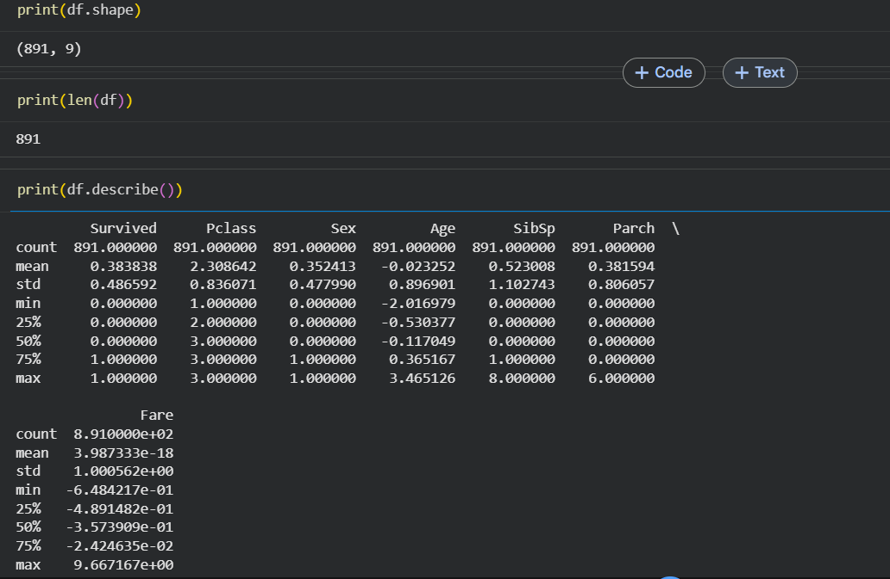
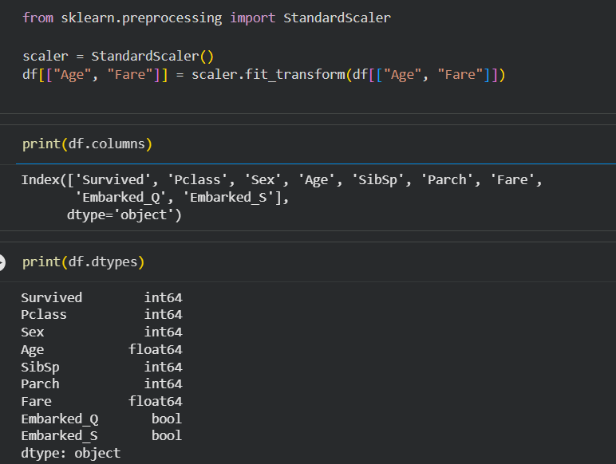
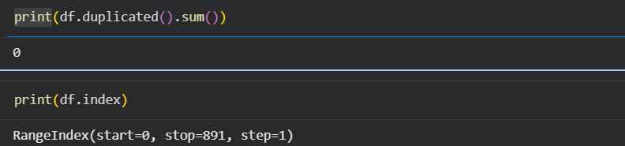
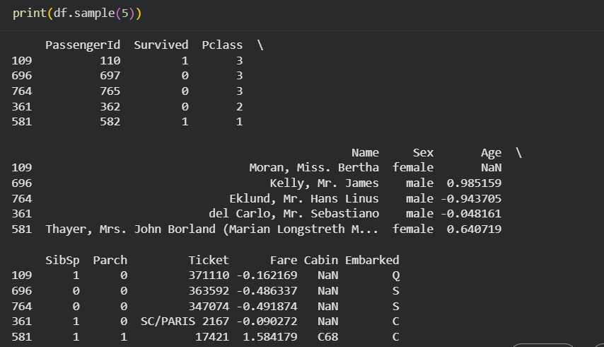
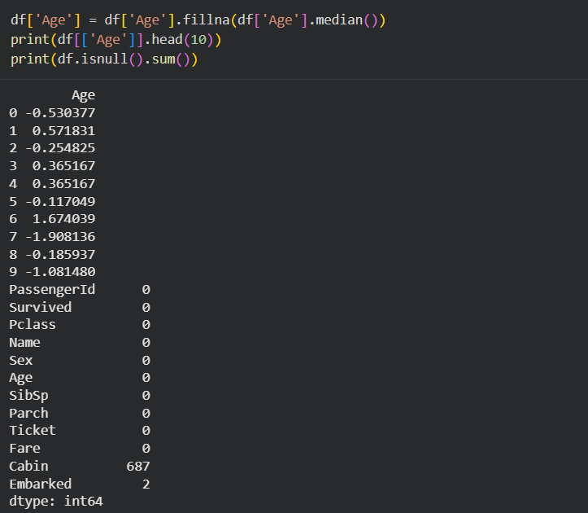
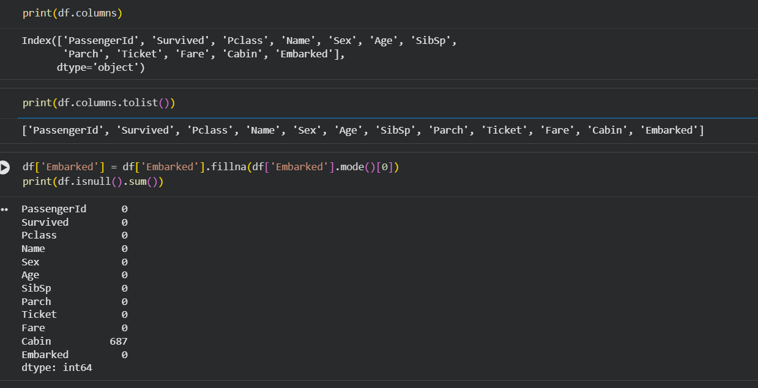
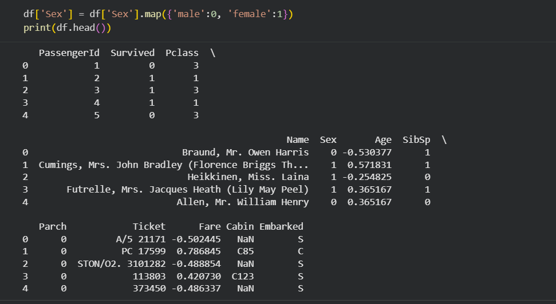
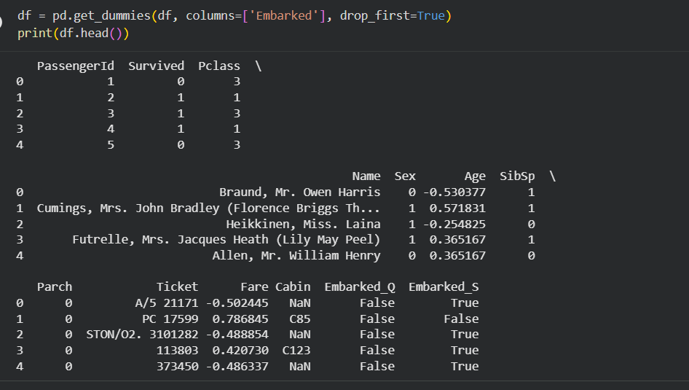
CODECHEF:
1.FLOW006
Sum of Digits
You're given an integer N. Write a program to calculate the sum of all the digits of N.
Input Format
The first line contains an integer T, the total number of testcases. Then follow T lines, each line contains an integer N.
Output Format
For each test case, calculate the sum of digits of N, and display it in a new line.
Constraints
- $1≤T≤1000$
- $1≤N≤1000000$
Sample 1:
Input
Output
3
12345
31203
2123
15
9
8
Program:
t = int(input())
for i in range(t):
n = input()
total = 0
for digit in n:
total += int(digit)
print(total)
OUTPUT:
Sample Input:
3
12345
31203
2123
Sample Output:
15
9
8
2.FLOW017
Second Largest
Three numbers A, B and C are the inputs. Write a program to find second largest among them.
Input Format
The first line contains an integer T, the total number of testcases. Then T lines follow, each line contains three integers A, B and C.
Output Format
For each test case, display the second largest among A, B and C, in a new line.
Constraints
- 1 ≤ T ≤ 1000
- 1 ≤ A,B,C ≤ 1000000
Sample 1:
Input
Output
3
120 11 400
10213 312 10
10 3 450
120
312
10
Program:
t = int(input())
for i in range(t):
a, b, c = map(int, input().split())
nums = [a, b, c]
nums.sort()
print(nums[1])
OUTPUT:
Sample Input:
3
120 11 400
10213 312 10
10 3 450

Sample Output:
120
312
10
3.LECANDY
Little Elephant and Candies
A Little Elephant and his friends from the Zoo of Lviv like candies very much.
There are N elephants in the Zoo. The elephant with number K (1 ≤ K ≤ N) will be happy if he receives at least A_{K} candies. There are C candies in all in the Zoo.
The Zoo staff is interested in knowing whether it is possible to make all the N elephants happy by giving each elephant at least as many candies as he wants, that is, the K^{th} elephant should receive at least A_{K} candies. Each candy can be given to only one elephant. Print Yes if it is possible and No otherwise.
Input
The first line of the input file contains an integer T, the number of test cases. T test cases follow. Each test case consists of exactly 2 lines. The first line of each test case contains two space separated integers N and C, the total number of elephants and the total number of candies in the Zoo respectively. The second line contains N space separated integers A₁, A₂, ..., A_{N}.
Output
For each test case output exactly one line containing the string Yes if it possible to make all elephants happy and the string No otherwise. Output is case sensitive. So do not print YES or yes.
Constraints
1 ≤ T ≤ 1000
1 ≤ N ≤ 100
1 ≤ C ≤ 10⁹
1 ≤ A_{K} ≤ 10000, for K = 1, 2, ..., N
Sample 1:
Input
Output
2
2 3
1 1
3 7
4 2 2
Yes
No
Explanation:
Case 1. We can give one candy to the first elephant and two candies to the second elephant and make them both happy. Hence the answer is Yes. Alternatively we can give one candy to each elephant and left one candy for ourselves but they again will be happy.
Case 2. Even if we give four candies to the first elephant and two candies to the second elephant we will have only one candy left and can not make last elephant happy since he needs two candies for his happiness. Hence the answer is No.
Program:
t = int(input())
for _ in range(t):
n, c = map(int, input().split())
a = list(map(int, input().split()))
if sum(a) <= c:
print("Yes")
else:
print("No")
OUTPUT:
Sample Input:
2
2 3
1 1
3 7
4 2 2
Sample Output:
Yes
No
4.MOVIEWKN
Movie Weekend
Little Egor is a huge movie fan. He likes watching different kinds of movies: from drama movies to comedy movies, from teen movies to horror movies. He is planning to visit cinema this weekend, but he's not sure which movie he should watch.
There are n movies to watch during this weekend. Each movie can be characterized by two integers L_{i} and R_{i}, denoting the length and the rating of the corresponding movie. Egor wants to watch exactly one movie with the maximal value of L_{i} × R_{i}. If there are several such movies, he would pick a one with the maximal R_{i} among them. If there is still a tie, he would pick the one with the minimal index among them.
Your task is to help Egor to pick a movie to watch during this weekend.
Input
The first line of the input contains an integer T denoting the number of test cases.
The first line of the test case description contains an integer n.
The second line of the test case description contains n integers L₁, L₂, ...,L_{n}. The following line contains n integers R₁, R₂, ..., R_{n}.
Output
For each test case, output a single integer i denoting the index of the movie that Egor should watch during this weekend. Note that we follow 1-based indexing.
Constraints
- 1 ≤ T ≤ 5
- 1 ≤ n ≤ 100
- 1 ≤ L_{i}, R_{i} ≤ 100
Sample 1:
Input
Output
2
2
1 2
2 1
4
2 1 4 1
2 4 1 4
1
2
Explanation:
In the first example case, both films have the same value of L × R, but the first film has a better rating.
In the second example case, the second and the fourth movies are equally good, but the second movie has a smaller index.
Program:
import sys
t = int(sys.stdin.readline())
for i in range(t):
n = int(sys.stdin.readline())
L = list(map(int, sys.stdin.readline().split()))
R = list(map(int, sys.stdin.readline().split()))
best_idx, max_lr, max_r = 0, -1, -1
for i in range(n):
lr, r = L[i] * R[i], R[i]
if lr > max_lr or (lr == max_lr and r > max_r):
max_lr, max_r, best_idx = lr, r, i + 1
print(best_idx)
OUTPUT:
Sample Input:
2
2
1 2
2 1
4
2 1 4 1
2 4 1 4
Sample Output:
1
2

