ASG Airlines
End-to-End Data Engineering Pipeline
Project Documentation
HARINI S
M.Sc. Data Science
25MDT0103
Vellore Institute of Technology

1. Project Overview
ASG Airlines needed a clean, analysis-ready version of its operational data to track flight performance in Power BI. The raw data comes from a single Excel workbook (UseCase_-_Airlines.xlsx) with four sheets: flights, bookings, passengers, and payments. As-is, this data has missing values, duplicate rows, inconsistent placeholders, and passenger-level personal information that should not enter a reporting layer.
The objective was to build a Python/Pandas pipeline that reads the raw workbook, validates it for structural and data-quality issues, cleans and standardizes what can be reasonably fixed, flags what cannot be fixed with confidence, removes personally identifiable information (PII), and produces a single flight-level dataset ready for Power BI.
The final output is flights_analytics_ready.csv - one row per flight, with derived fields such as route, flight date, duration, an overnight-flight indicator, and a duration-anomaly flag. It supports four KPIs: average flight duration, route-wise traffic, delays/anomalies, and distribution of flights by airline.
2. Dataset Description
The source is a single workbook, UseCase_-_Airlines.xlsx, with four sheets:
Sheet | Rows / Cols | Purpose | Key Columns
flights | 1020 rows, 7 cols | One row per flight record (schedule/route level) | flight_id, airline, source, destination, departure_time, arrival_time, duration
bookings | 1000 rows, 9 cols | One row per passenger booking, links a passenger to a flight | booking_id, passenger_id, flight_id, booking_date, status, passport_number, seat_number, emergency_contact_name, emergency_contact_phone
passengers | 1039 rows, 9 cols | One row per passenger record, referenced by bookings | passenger_id, first_name, last_name, age, gender, email, phone, aadhaar_id, date_of_birth
payments | 1000 rows, 4 cols | One row per payment made against a booking | payment_id, booking_id, amount, payment_method
These fall into two levels of data:
- Flight-level data - the flights sheet, the basis for the final analytics dataset.
- Booking / passenger / payment data - transactional and personal data. It is validated and summarized in this project but not merged into the flight-level analytics dataset (see Sections 6 and 9).
3. Technology Stack
No database, cloud service, or BI tool was implemented as part of this pipeline - Power BI is the intended downstream consumer of the output file.
- Python 3 - core language for the pipeline
- Pandas / NumPy - reading, validating, cleaning, transforming, and aggregating data
- Jupyter Notebook - development environment (Airlines_Pipeline.ipynb)
- Excel (.xlsx) - source format, read using pandas.ExcelFile / read_excel
- hashlib (SHA-256) - one-way hashing of PII identifiers (aadhaar_id, passport_number)
- Python logging module - structured log messages during ingestion and saving
- CSV - output format of the final analytics-ready dataset
4. Architecture Diagram
The pipeline runs as a single linear notebook, from the raw Excel workbook to a flight-level CSV file.
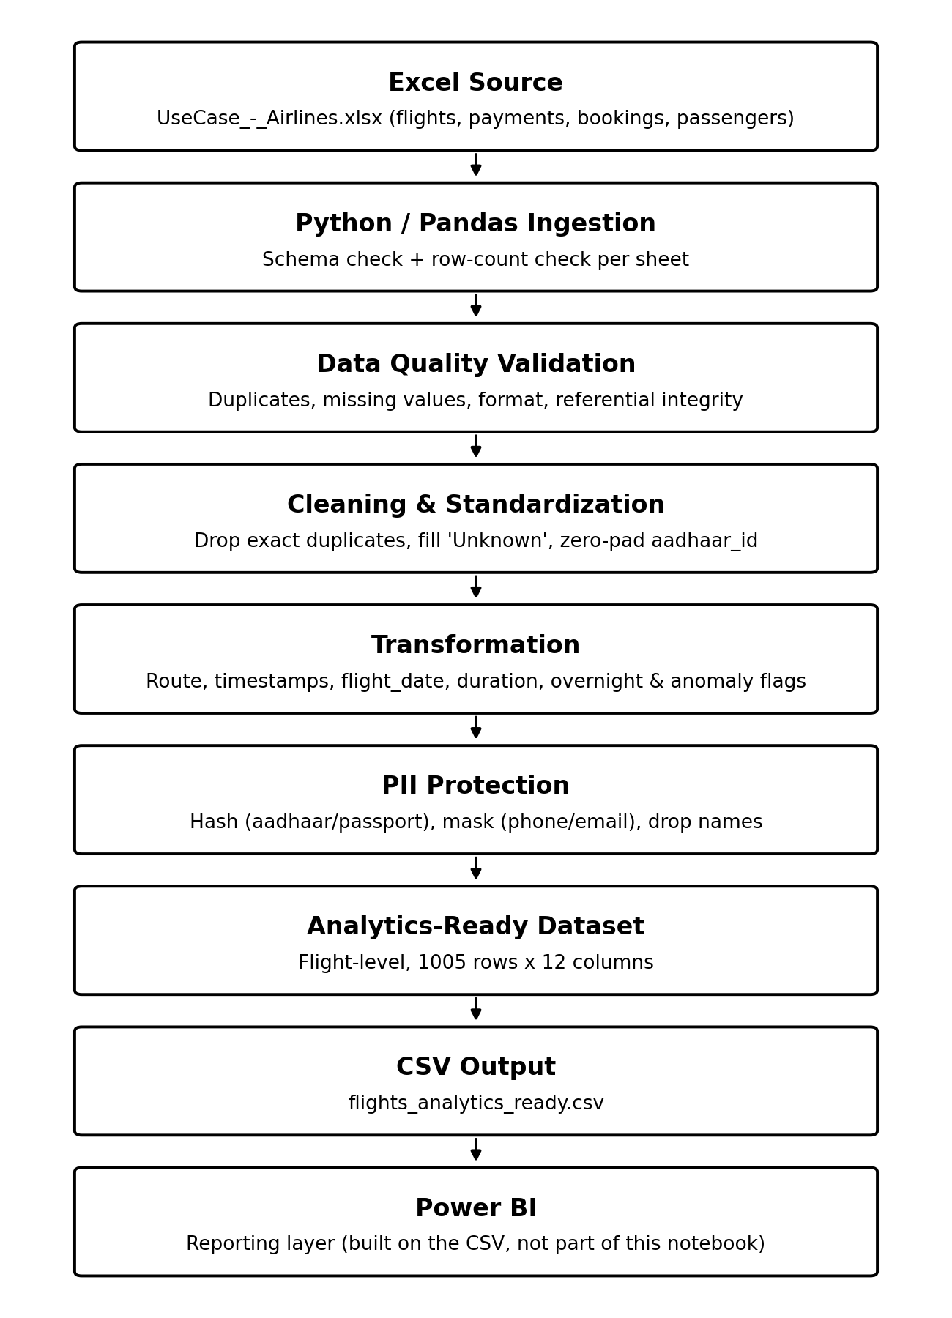
Figure 1 - Solution architecture, as implemented in the notebook
The workbook is opened read-only and never modified. Each sheet is loaded and checked against an expected column list and minimum row count before anything else happens - a missing file, missing sheet, column mismatch, or empty sheet stops the pipeline immediately. Validation only measures and records issues; cleaning then applies the fixes; transformation derives route, dates, duration, and flags; PII protection hashes/masks/drops identifying fields; and the flight-level analytics table is written to CSV for Power BI.
5. Data Flow Diagram
The diagram shows data moving from the four raw sheets through validation and cleaning, then splitting into two independent paths: flight-level transformation (feeding the analytics dataset) and PII handling for passengers/bookings (kept separate, not merged in).
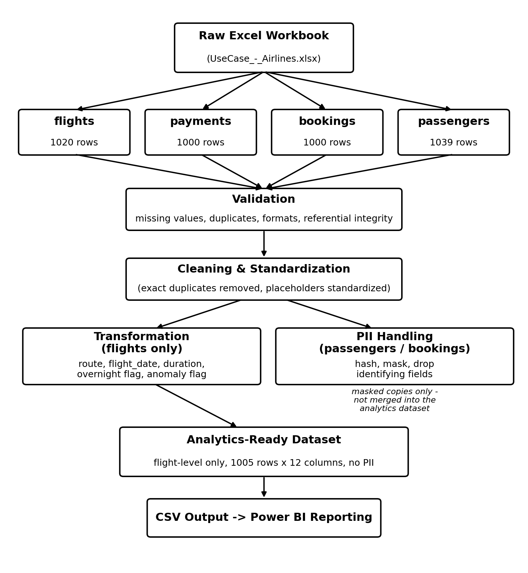
Figure 2 - Data flow from raw Excel sheets to the analytics-ready CSV
6. Data Model
The four sheets are related through identifier columns, but not every relationship is safe to use for joining.
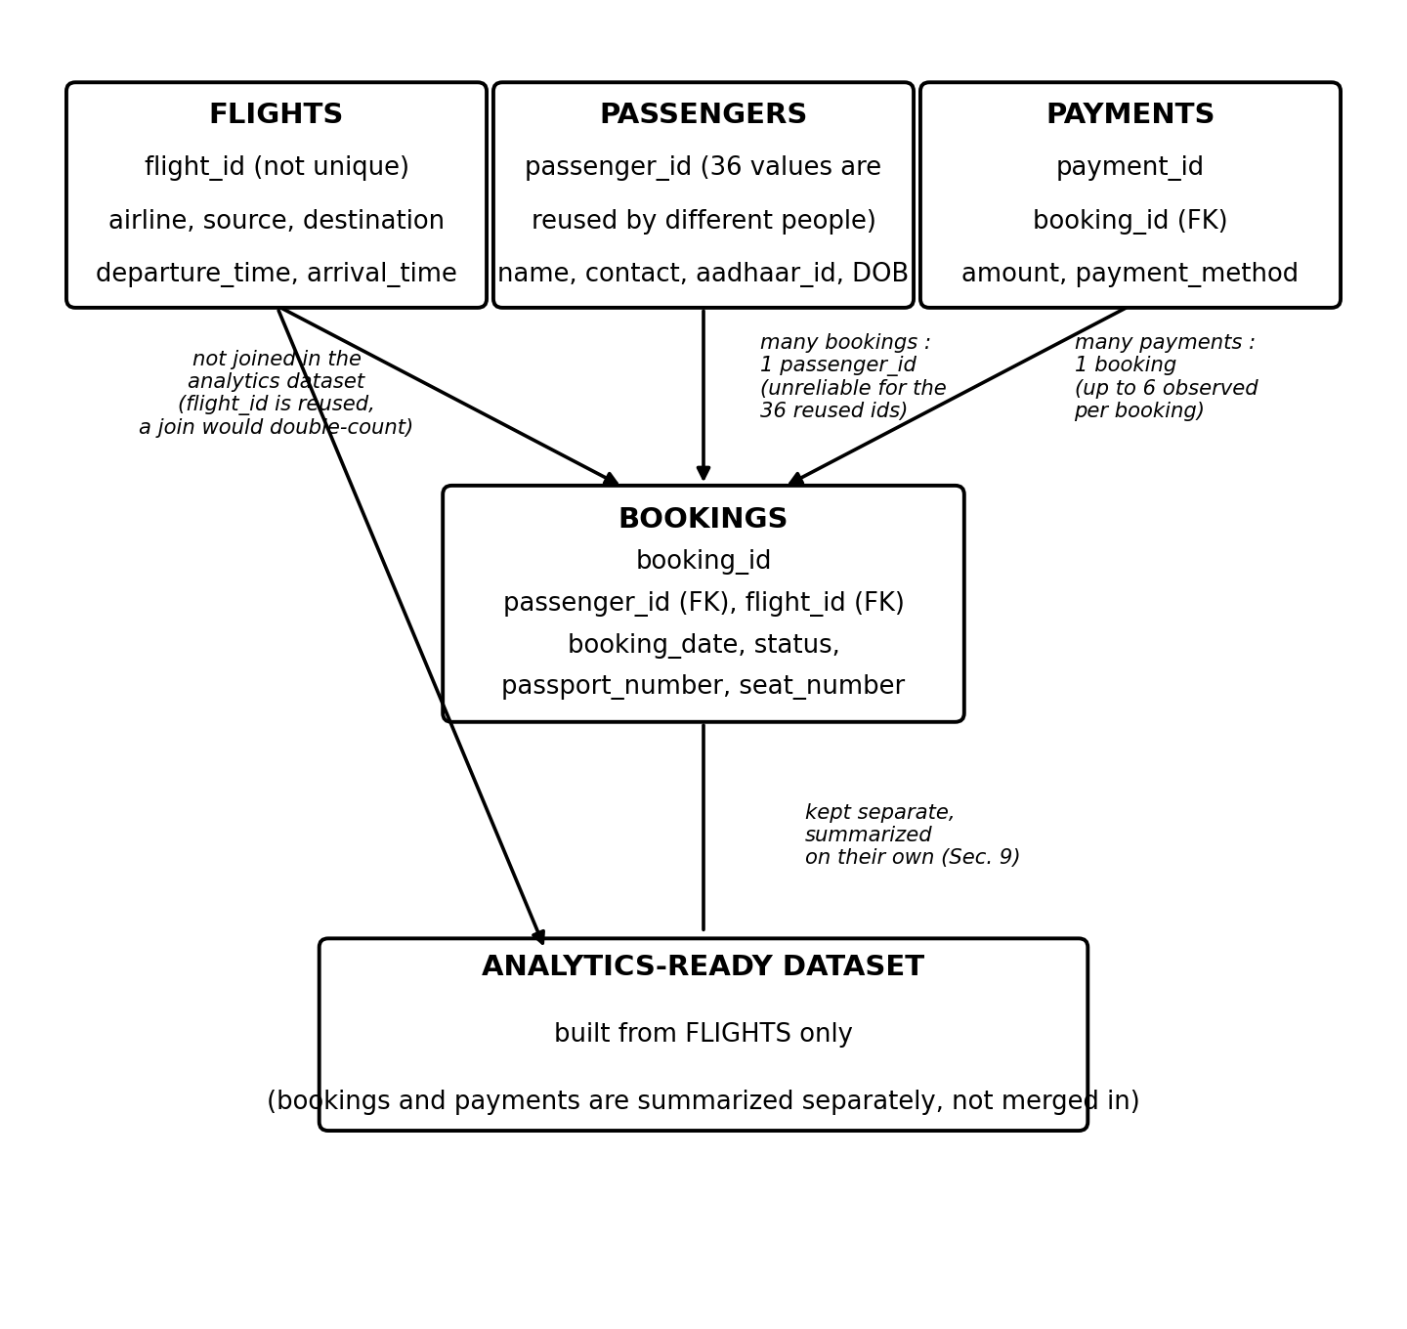
Figure 3 - Data model and join reliability between the four source tables
- Flights: flight_id is not a unique key - flight number 6F250 appears twice with different source/destination and timestamps, a genuine reused flight number, not a duplicate row.
- Bookings to Passengers: referential integrity holds, but 36 passenger_id values are shared by different real people (different names, aadhaar numbers, and dates of birth). This makes the join unreliable for those 36 ids.
- Bookings to Flights: deliberately not used for merging - since flight_id is reused, aggregating bookings by flight_id would apply the same count to both 6F250 rows, inflating both.
- Payments to Bookings: a genuine one-to-many relationship (up to 6 payment attempts observed for one booking_id); referential integrity holds.
Because of this, the analytics-ready dataset is built only from the flights table. Bookings and payments are validated and summarized separately.
7. Data Quality Issues
Issue | How It Was Detected | What Was Done
15 exact duplicate rows in flights | df.duplicated() found 15 full-row duplicates | Dropped (drop_duplicates())
flight_id 6F250 appears twice with different data | Rows sharing a flight_id checked; the two rows differ in source/destination/timestamps | Kept both - genuine reused flight number, not a duplicate
airline missing (41 NaN) and literal 'UNKNOWN' (31) | isna() count plus check for placeholder string 'UNKNOWN' | Both standardized to 'Unknown' (72 values total)
1 flight (SJ192) has arrival before departure | Calculated duration (arrival - departure) was negative (~ -19 hrs) vs. recorded duration of 5 hrs | Flagged as anomaly (duration_anomaly_flag), not corrected
bookings.status missing (45) and literal 'INVALID' (30) | isna() plus check for 'INVALID' | Both standardized to 'Unknown' (75 values total); row kept
payments.amount missing (48) and literal 'INVALID' (30) | isna() plus check for 'INVALID' | Flagged as unusable (amount_invalid_flag), row kept - 78 rows total (7.8% of payments)
passenger_id reused for different people | 36 passenger_id values had duplicate rows with different aadhaar_id/date_of_birth | Flagged (id_conflict_flag) on 75 affected rows - not merged, not guessed
aadhaar_id has 10, 11, or 12-digit values | String length checked; a real Aadhaar number is always 12 digits | Zero-padded to 12 digits (114 values corrected: 5 were 10-digit, 109 were 11-digit)
passengers.last_name missing (10) | isna() count on last_name | Filled with 'Unknown'
Referential integrity across bookings->passengers, bookings->flights, payments->bookings | Orphan-row check (child id not present in parent) | 0 orphaned rows found in every case - no action needed
8. Data Cleaning & Validation
The cleaning rules follow directly from the validation findings in Section 7. Nothing was cleaned that was not first measured and justified.
Missing Values
- flights.airline: NaN and 'UNKNOWN' both standardized to 'Unknown'.
- bookings.status: NaN and 'INVALID' both standardized to 'Unknown'; row kept.
- passengers.last_name: NaN filled with 'Unknown' - no way to recover the real value.
- payments.amount: NaN and 'INVALID' not filled with a guessed number - flagged via amount_invalid_flag; row kept since amount is not needed for any required KPI.
Duplicate Handling
- Exact duplicate rows (identical across every column) were dropped only in flights (15 rows).
- bookings, payments, and passengers were checked for exact duplicates - none found.
- Rows sharing a flight_id but differing in other columns (6F250) were kept as a reused flight number, not a duplicate.
Identifier Validation & Standardization
- flight_id format was validated against a pattern built from prefixes actually observed (6F, AI, SJ, UK) plus exactly 3 digits. All 1020 raw values matched - no correction needed.
- aadhaar_id was zero-padded to a fixed 12-digit string, since shorter values were most likely caused by leading zeros lost when stored as a number.
- flights.source and flights.destination were upper-cased and stripped of extra whitespace as a safeguard.
Timestamp Handling & Referential Integrity
- departure_time and arrival_time were converted to proper datetime values; both already include a date component, so an overnight arrival date is naturally one day later - no manual rollover logic needed.
- The one case where arrival precedes departure (SJ192) was not corrected - flagged as a duration anomaly since it is unclear which timestamp is wrong.
- bookings.passenger_id vs. passengers.passenger_id, bookings.flight_id vs. flights.flight_id, and payments.booking_id vs. bookings.booking_id were all checked for orphan rows - all three checks returned 0 orphans, enforced with assertions so the pipeline fails loudly if that ever changes.
9. Transformation Logic
- Route: created by concatenating cleaned source and destination with a hyphen, e.g. CCU-MAA - a single field to group and filter on for route-wise traffic.
- Timestamp Standardization: departure_time and arrival_time converted to proper pandas datetime values using pd.to_datetime(); no timezone conversion or reformatting was needed.
- Flight Date: flight_date is the calendar date component of departure_time (departure_time.dt.date), used for any date-based grouping.
10. Flight Duration & Overnight Handling
Flight Duration
- duration_minutes is calculated as (arrival_time - departure_time), converted to minutes, and cross-checked against the raw duration field in the workbook. One flight (SJ192) disagreed by more than 5 minutes, feeding the anomaly flag.
- duration_hours is duration_minutes divided by 60, rounded to 2 decimal places, for readability in charts.
Overnight Flight Handling
- overnight_flag = True when the calendar date of arrival_time differs from the calendar date of departure_time - a straightforward date-equality check since both timestamps already carry a full date. 123 of 1005 flights were flagged as overnight.
Duration Anomaly Handling
- duration_anomaly_flag = True when calculated duration_minutes is negative, or disagrees with the raw duration field by more than 5 minutes. Only 1 flight (SJ192) met this condition. Anomalous rows are flagged, not corrected or dropped, and are excluded only when computing the average-duration KPI so they do not distort that number.
11. PII Protection
The source data contains passenger-level personal information across two sheets:
Sheet | PII Fields | Protection Applied
passengers | first_name, last_name | Dropped entirely from the masked export
passengers | aadhaar_id | Hashed (SHA-256, truncated to 12 characters)
passengers | email, phone | Masked (partial characters retained for spot-checking only)
passengers | date_of_birth | Retained only in the internal cleaned table, not in any exported/masked view
bookings | passport_number | Hashed (SHA-256, truncated to 12 characters)
bookings | emergency_contact_name | Dropped entirely from the masked export
bookings | emergency_contact_phone | Masked (partial characters retained for spot-checking only)
Direct identifiers (aadhaar_id, passport_number) are hashed with SHA-256, so the same value always hashes the same way without exposing the original number. Contact details are masked to allow visual spot-checking without enabling contact. Names are dropped completely.
The final analytics-ready dataset does not depend on this masking to be safe - it is built only from the flights table and never includes a passenger- or booking-level row. An explicit assertion checks the analytics dataset's columns against the full list of PII field names before the file is saved.
12. Assumptions
- A duplicate row is an exact match across every column (pandas .duplicated()), not a partial or fuzzy match.
- flight_id is validated using a pattern derived from prefixes actually observed (6F, AI, SJ, UK) plus exactly 3 digits, rather than a generic industry format.
- An overnight flight is any flight where the calendar date of arrival differs from the calendar date of departure.
- A duration anomaly is any flight where calculated duration is negative, or disagrees with the workbook's recorded duration by more than 5 minutes - a threshold chosen to tolerate normal rounding, not hide genuine problems.
- Reused flight_id values (6F250) are handled carefully since flight_id is not a unique key - joining other tables on it and merging back would silently double-count metrics for the affected flights.
- bookings and payments are not joined into the flight-level analytics dataset: a bookings-to-flights join is unsafe for the reason above, and none of the four required KPIs depend on payment amounts (also ~7.8% unusable).
- A valid analytics record is a flights row that survived exact-duplicate removal - 1005 of the original 1020 rows.
- The dataset has no scheduled departure/arrival time field, only the actual one - this limits what "Delays/Anomalies" can mean (Section 13.3).
13. KPI Definitions
All four KPIs are computed directly from the analytics-ready dataset (analytics_df), which is flight-level with 1005 rows.
13.1 Average Flight Duration
Mean of duration_minutes, excluding the 1 row flagged as a duration anomaly. Overall average: 164.5 minutes.
Airline | Avg. Duration (minutes)
Air India | 163.1
IndiGo | 167.7
SpiceJet | 163.6
Unknown | 166.1
Vistara | 162.7
13.2 Route-wise Traffic
Count of flights per route (source-destination pair), across all 30 distinct routes in the cleaned dataset. Busiest route: BOM-CCU with 90 flights. Quietest: BLR-MAA with 16 flights.
13.3 Delays / Anomalies
The workbook only records actual departure and arrival time - there is no scheduled time field, so a true scheduled-vs-actual delay cannot be calculated. "Delays/Anomalies" is instead represented by duration_anomaly_flag: 1 of 1005 flights is flagged, an anomaly rate of about 0.1%.
13.4 Distribution of Flights by Airline
Airline | Flight Count
IndiGo | 249
SpiceJet | 236
Air India | 233
Vistara | 218
Unknown | 69
The "Unknown" airline group (69 flights) reflects the 72 raw values that were missing or the placeholder 'UNKNOWN' before standardization; the count differs slightly since a few of those rows were also among the exact duplicates removed.
14. Power BI Reporting
No .pbix file or dashboard screenshot was part of the source files - this section describes the reporting layer the analytics-ready dataset is designed to support.
The analytics-ready CSV is flat and flight-level, so it loads directly into Power BI as a single table. It can support:
- KPI cards for total flights, average flight duration, and duration-anomaly rate
- A bar chart of route-wise traffic (route on the axis, flight count as the value)
- A bar or column chart of flight distribution by airline
- A duration analysis view - average or distribution of duration_hours, optionally split by airline or route
- An anomaly analysis view - filtering to duration_anomaly_flag = True
- Slicers on airline, route, flight_date, and overnight_flag
Because the dataset excludes passenger and booking data by design, none of these visuals can expose passenger-level PII.
15. Error Handling & Logging
The notebook is written to fail loudly and early rather than silently continue with bad data.
Situation | How It Is Handled
Missing source file | FileNotFoundError raised immediately if the raw workbook path does not exist
Missing sheet(s) | ValueError listing exactly which expected sheet(s) are missing
Schema mismatch | Each sheet's column list compared to an expected list; mismatch raises ValueError showing both
Empty sheet | Assertion checks every loaded sheet has more than 0 rows
Successful load | INFO log records row/column count per sheet, e.g. "Loaded 'flights': 1020 rows, 7 columns - schema OK"
Unexpected duplicates/orphans in bookings and payments | Assertions check these counts are exactly 0, and stop the notebook if violated
PII leaking into the analytics dataset | Assertion checks that no PII column names appear in the final analytics_df before saving
Analytics dataset losing its flight-level grain | Assertion checks analytics_df has the same row count as the cleaned flights table
Output not written | Assertion checks the output CSV actually exists on disk immediately after saving
16. Final Output
Property | Value
Output filename | flights_analytics_ready.csv
Output location | ../data/processed/flights_analytics_ready.csv (relative to notebook)
Number of records | 1005
Number of columns | 12
Columns | flight_id, airline, source, destination, route, departure_time, arrival_time, flight_date, duration_minutes, duration_hours, overnight_flag, duration_anomaly_flag
PII excluded | Confirmed - checked with an assertion before saving (Section 11)
17. Conclusion
This project took a single raw Excel workbook covering flights, bookings, passengers, and payments, and turned it into one clean, flight-level, PII-safe dataset ready for Power BI reporting.
The main data-quality problems handled were: 15 exact duplicate flight rows, missing or placeholder airline and booking-status values, a small number of passenger_id values shared by different real people, inconsistent aadhaar_id digit lengths, and one flight (SJ192) with an arrival time earlier than its departure time. Each was either corrected with a clearly justified rule or flagged rather than guessed at.
Flight duration was derived directly from departure and arrival timestamps rather than trusted blindly from the raw duration field, which surfaced the SJ192 anomaly. Overnight flights (123 of them) were identified with a simple date comparison, with no manual midnight-rollover logic needed.
PII was protected by hashing direct identifiers, masking contact details, and dropping names from any masked export - and more fundamentally, by keeping the final analytics dataset at the flight level only, so no passenger or booking field is present in it at all.
The result is a 1005-row, 12-column CSV file that directly supports the four required KPIs - average flight duration, route-wise traffic, delays/anomalies, and airline distribution - and is ready to be loaded into Power BI as the reporting layer for this case study.

