**BRAZIL HOUSE RENT DATASET USING EDA TECHNIQUE**

**DATASET OUTLINE :**

This dataset contains 10692 properties to rent with 13 different features

city: City where the property is located

area: Property area

rooms: Quantity of rooms

bathroom: Quantity of bathroom

parking spaces: Quantity of parking spaces

floor: Floor

animals: Accept animals?

furniture: Furniture?

hoa (R$): Homeowners association tax

rent amount (R$)sort: Rent amount

property tax: municipal property tax

fire insurance (R$): fire insurance value

total (R$): the sum of all values

**EDA TECHNIQUE :**

exploratory data analysis (EDA) is an approach to analyzing data sets to **summarize their main characteristics,** often with visual methods. A statistical model can be used or not, but primarily EDA is for **seeing what the data can tell us beyond the formal modeling or hypothesis testing task**.

DATA UPLOAD :

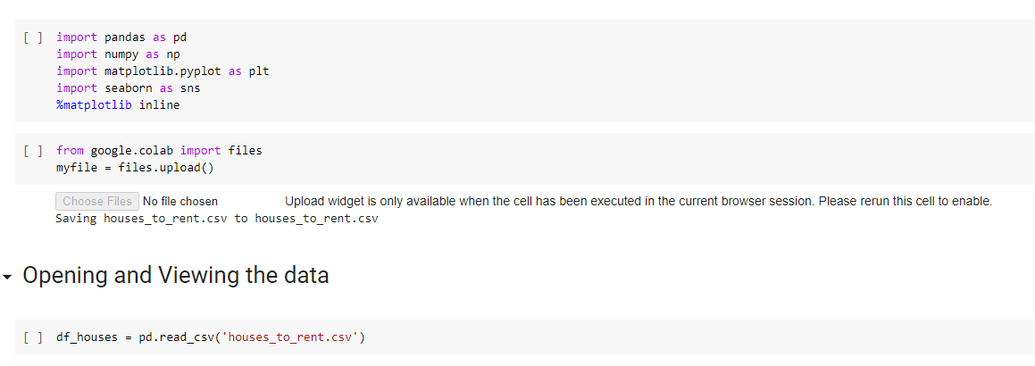

DATA PREPROCESSING :

EDA TECHNIQUE :

HANDLING OUTLIERS :

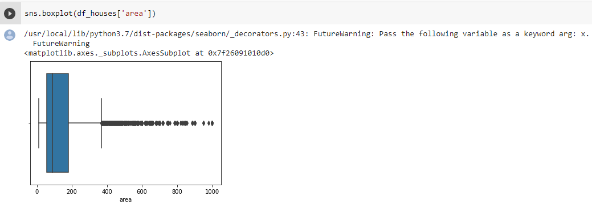

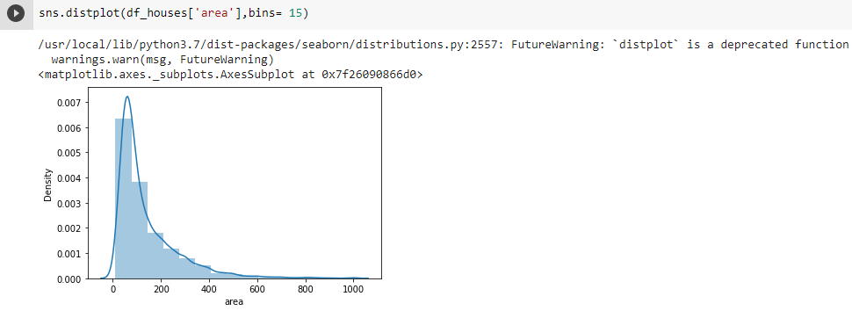

EXPLORATORY DATA ANALYSIS :

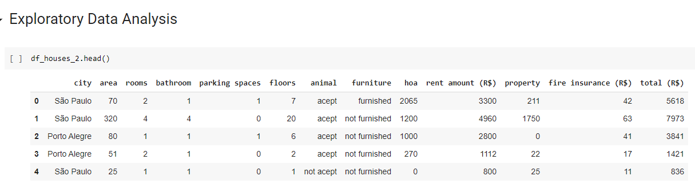

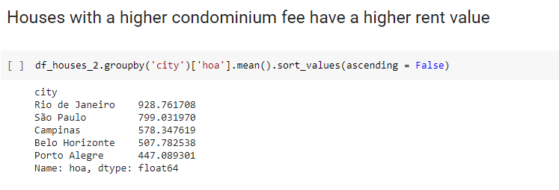

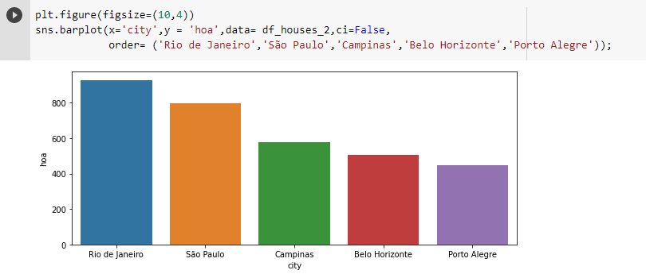

FURNITURE VARIABLE :

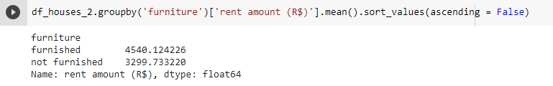

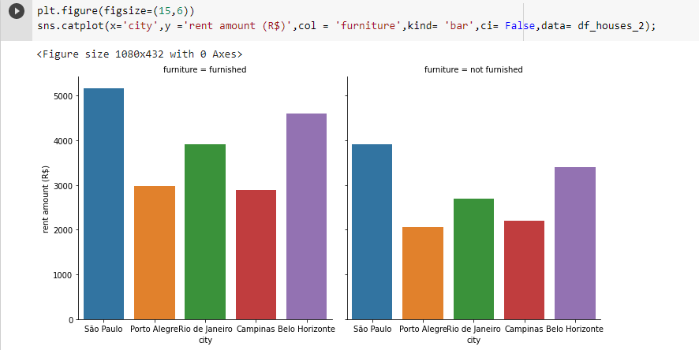

**CORRELATION BETWEEN RENT AMOUNT AND PARKING SPACES:**

