**MALARIA DATASET**

**DATASET OUTLINE :**

Country : countries that affected malaria all over the world.

No.of cases : No.of people affected by malaria all over the world.

No.of deaths : No.of death rate due to malaria.

No.of cases_median : seasonal no.of cases all over the world.

No.of cases _min : minimum no.of cases in world range .

No.of cases_max : maximum no.of cases in world range .

No.of deaths_median : seasonal no.of death all over the world.

No.of deaths_min : minimum no.of cases in world range.

No.of deaths_max : maximum no.of cases in world range.

**DATASET VISUALIZATION :**

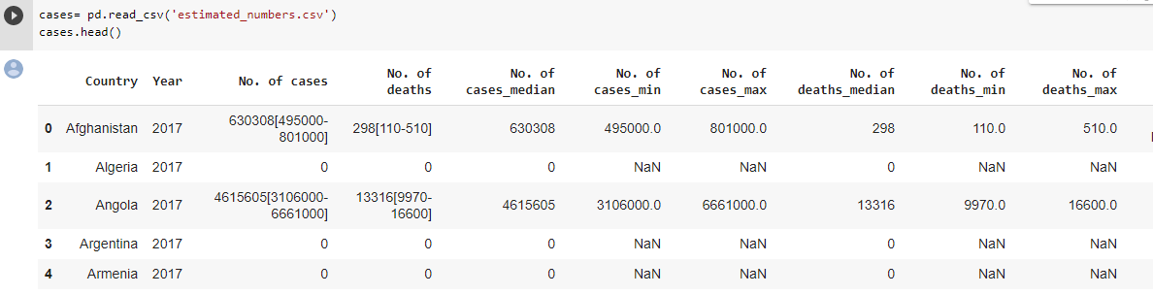

**INCIDENCE_PER_1000_POP_AT_RISK DATASET :**

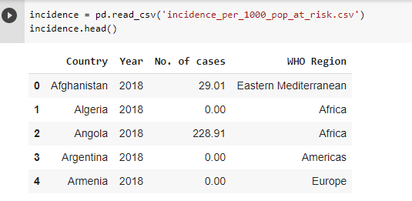

**REPORTED_NUMBERS DATASET :**

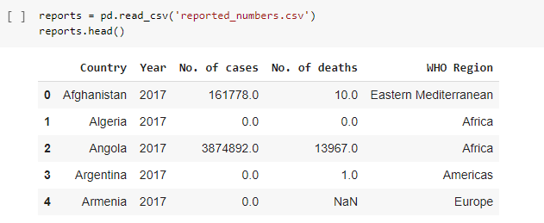

**DATA PRE-INFORMATION :**

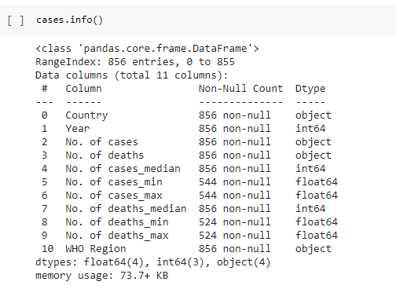

**VISUALIZATION OF NO.OF CASES IN 2016 :**



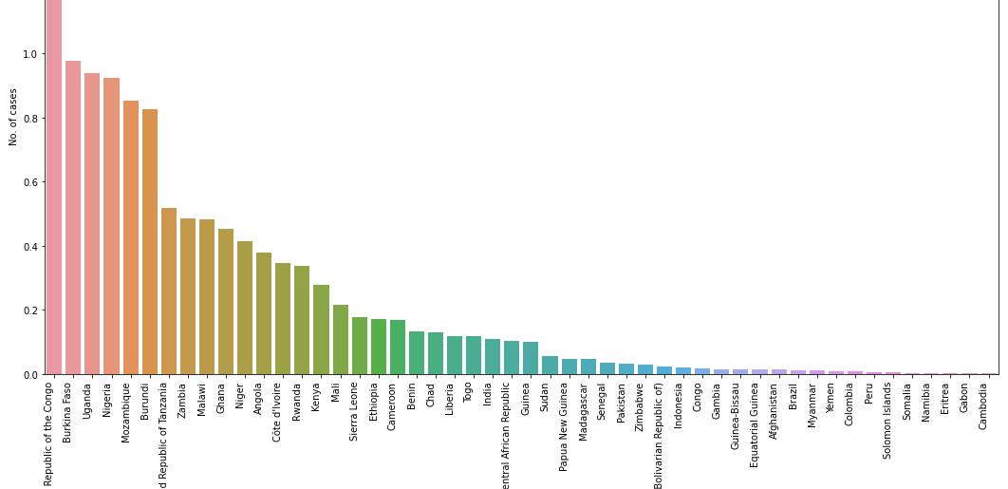

**Relationship between number of cases and number of deaths reported :**

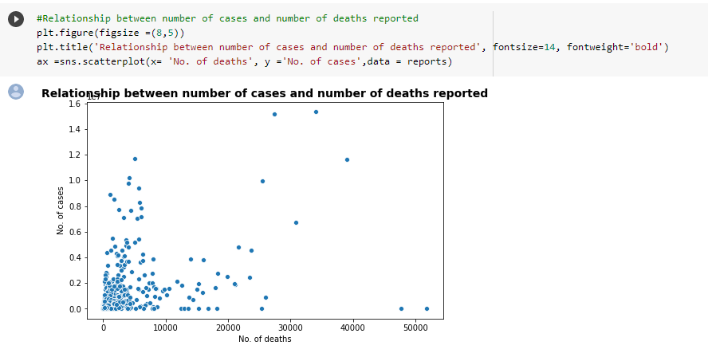

**MALARIA DEATH AND CASES OVER THE YEAR :**

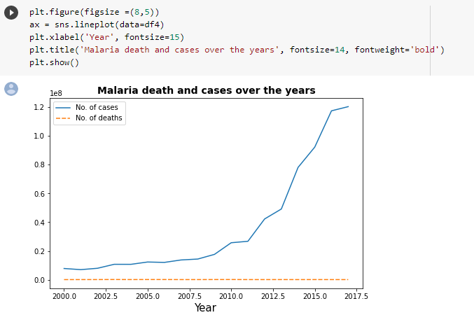

**MALARIA DEATH AND CASES IN PARTICULAR WHO REGION :**

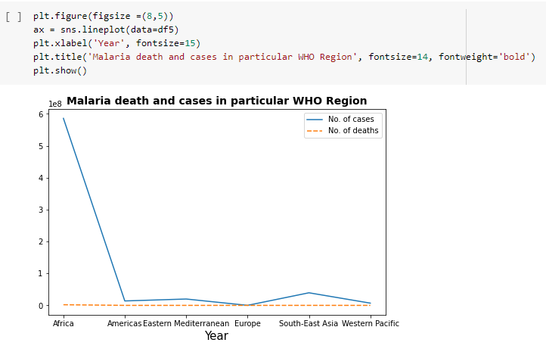

**FITTING REGRESSION LINE :**

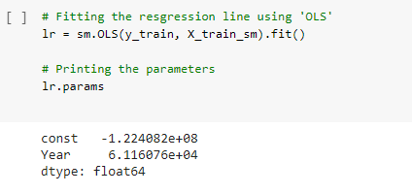

**SUMMARY OF THE REGRESSION LINE FITTED:**

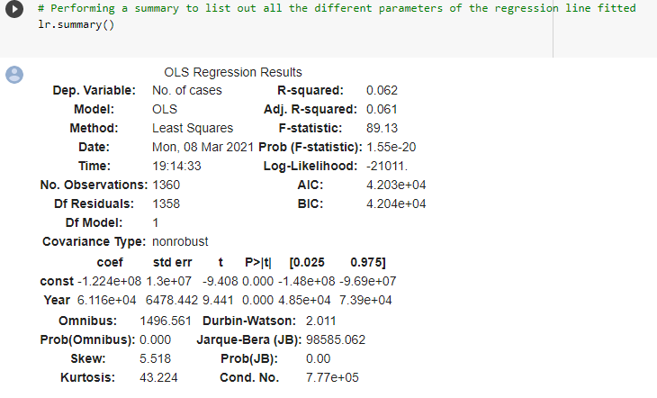

**VISUALIZATION OF REGRESSION LINE :**

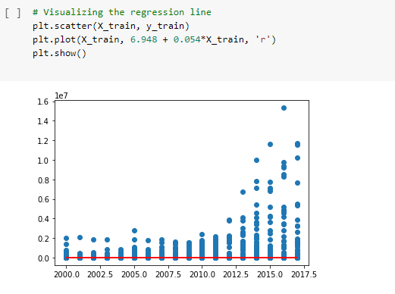

**R – SQUARED VALUE :**

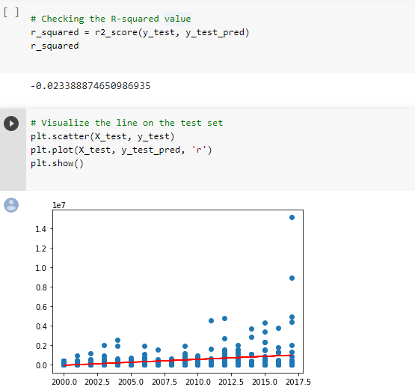

INTERPREDICTING THE RESULTS :

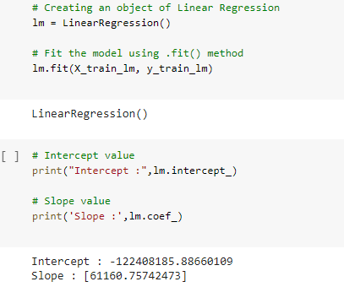

PREDICTING THE R2 SCORE :

