**Create a simple cloud so=ware applica?on for Library book reserva?on system for SIMATS library using any Cloud Service Provider to demonstrate SaaS include the necessary fields such as Title of the book, author, publica?ons, Year, edi?on, no of copies, Rack no, status (taken/returned) etc.**

**AIM:**

To Create a simple cloud so1ware applica3on for Library book reserva3on system for SIMATS library using any Cloud Service Provider.

**PROCEDURE:**

**STEP 1:**

Open browser and get into zoho ceator. Then sign in and click “Create applica3on”. Below given screenshot will appear, hear type the applica3on name of your Aim.

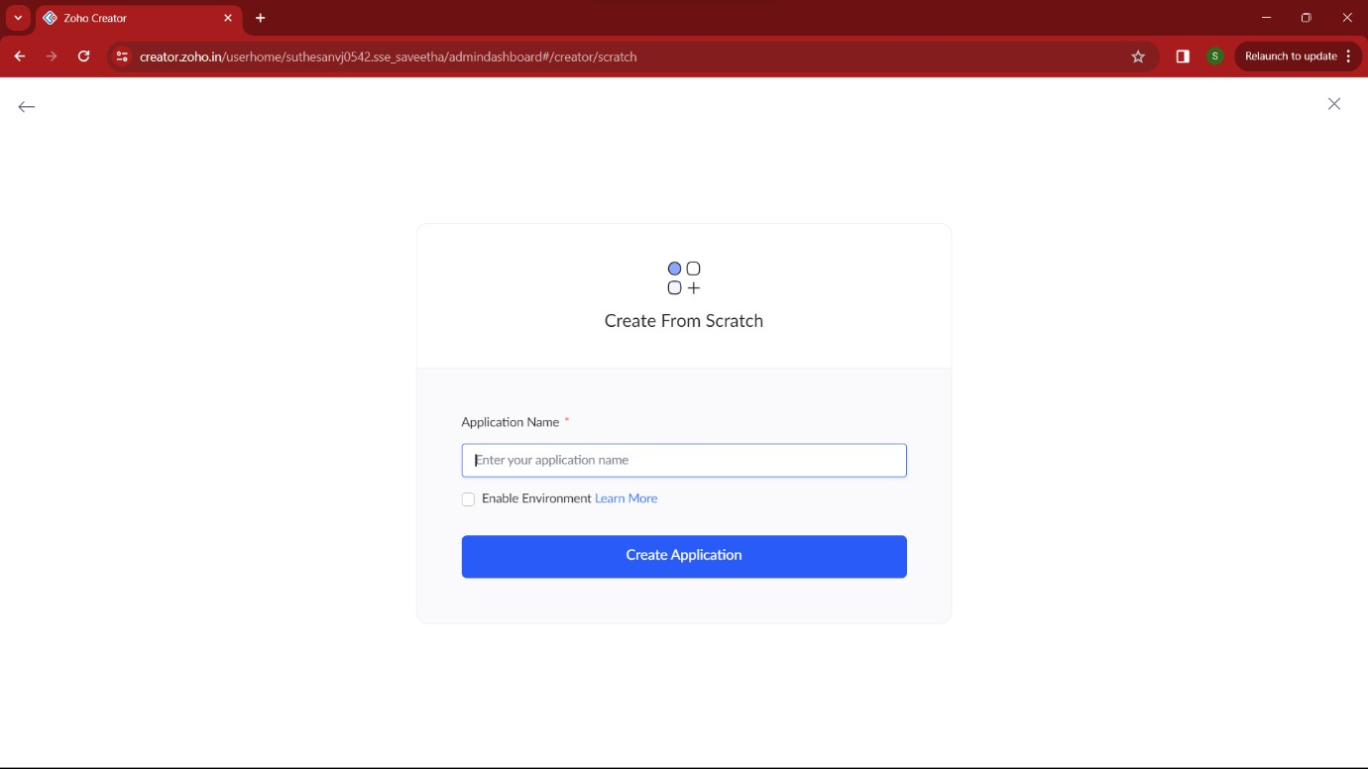

**STEP 2:**

Then select “start from scratch” op3on and select the proper component from the 4 components listed. For my applica3on I just selected “forms” for the login creden3als.

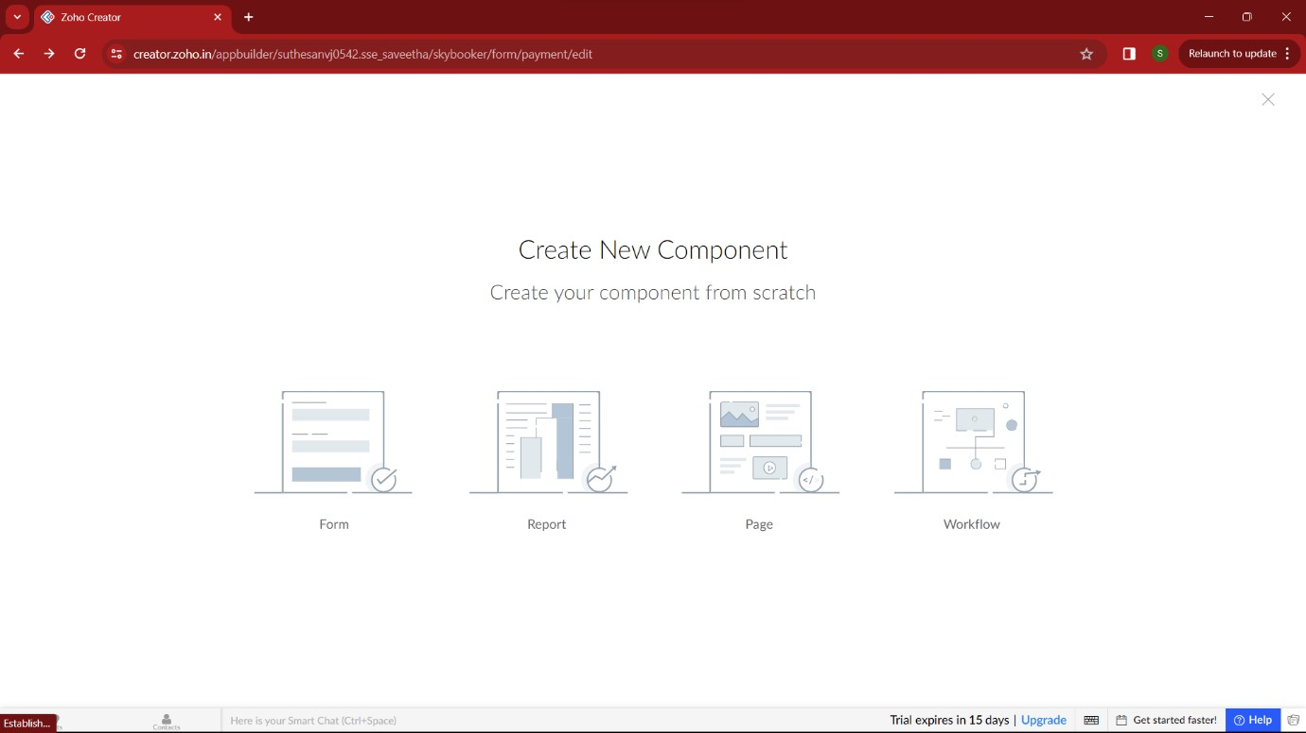

**STEP 3:**

In forms, below given op3ons will be given. From here we can get sample templates of our requirements, otherwise we can import already saved schema for our applica3on. I just selected “ from scratch” op3on for my applica3on.

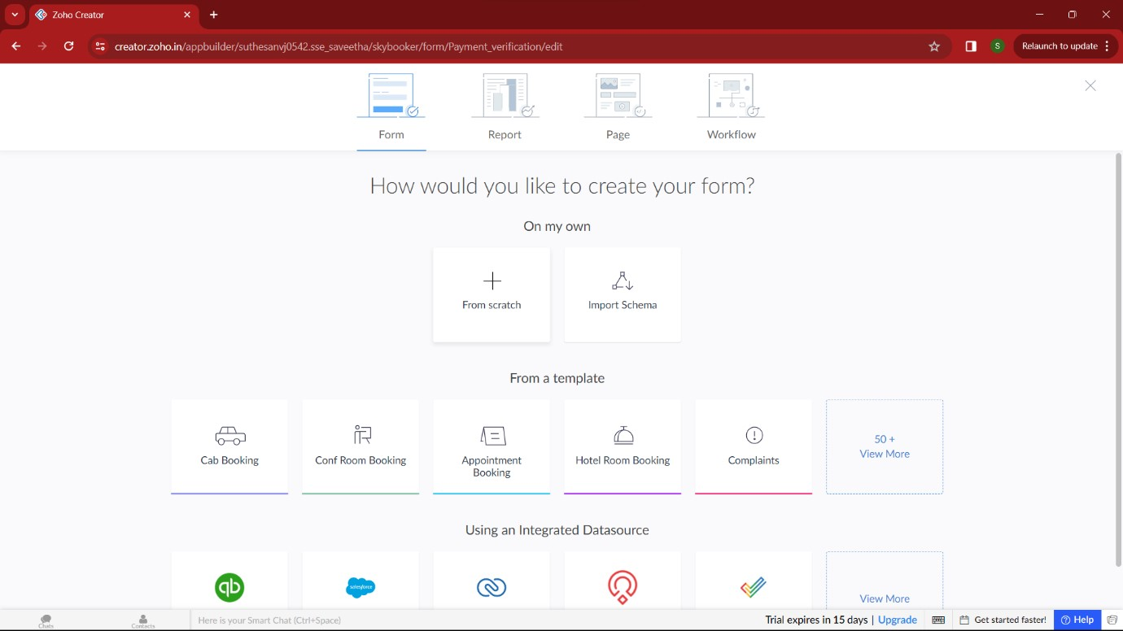

**STEP 4:**

Then provide an appropriate name for our applica3on in the name form which shown below. I gave “CampusReads” for my “Library book reserva3on system”

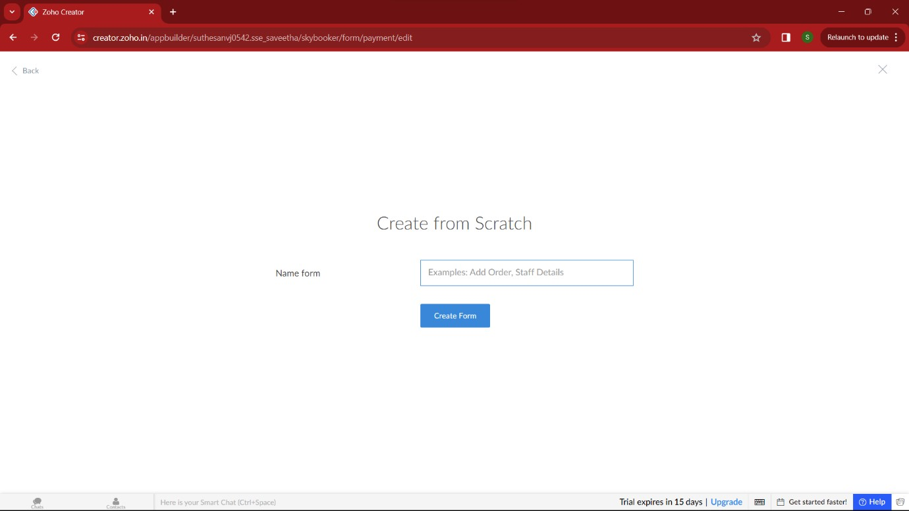

**STEP 5:**

by clicking “+” symbol shown in the picture given below, we can add number of forms in our applica3on. Firstly I placed login form in my applica3on with the essen3al credent

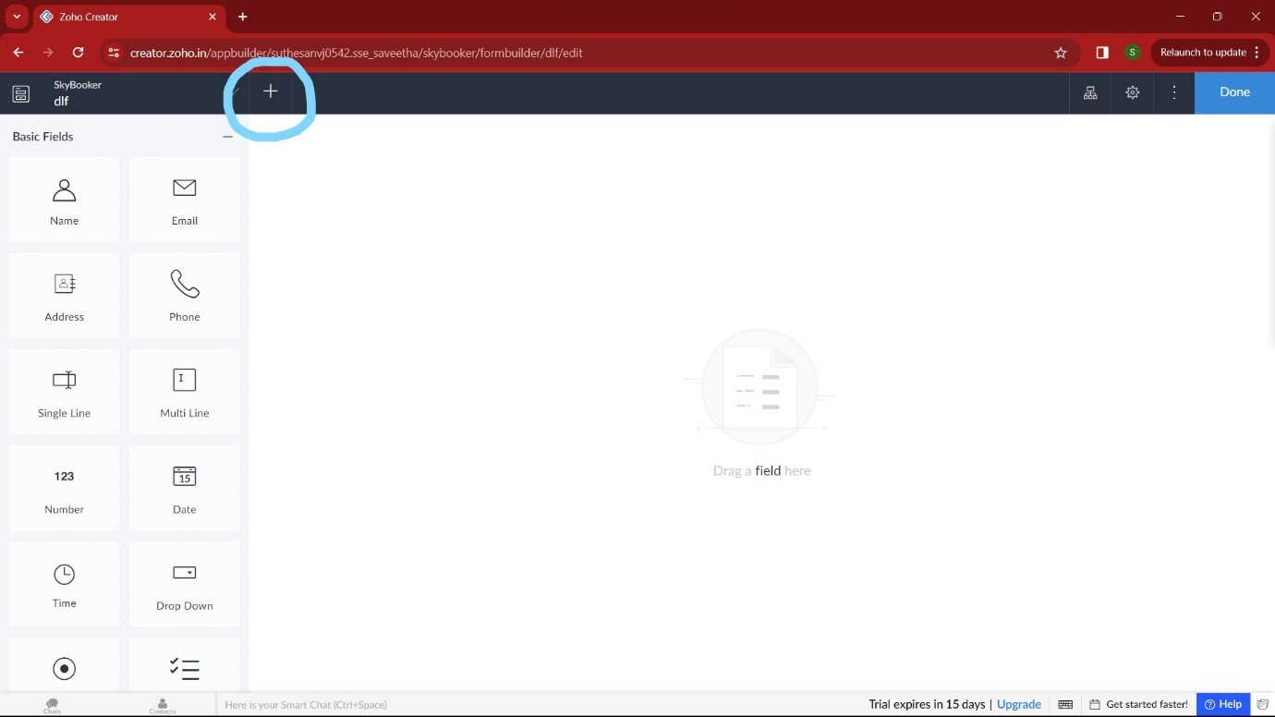

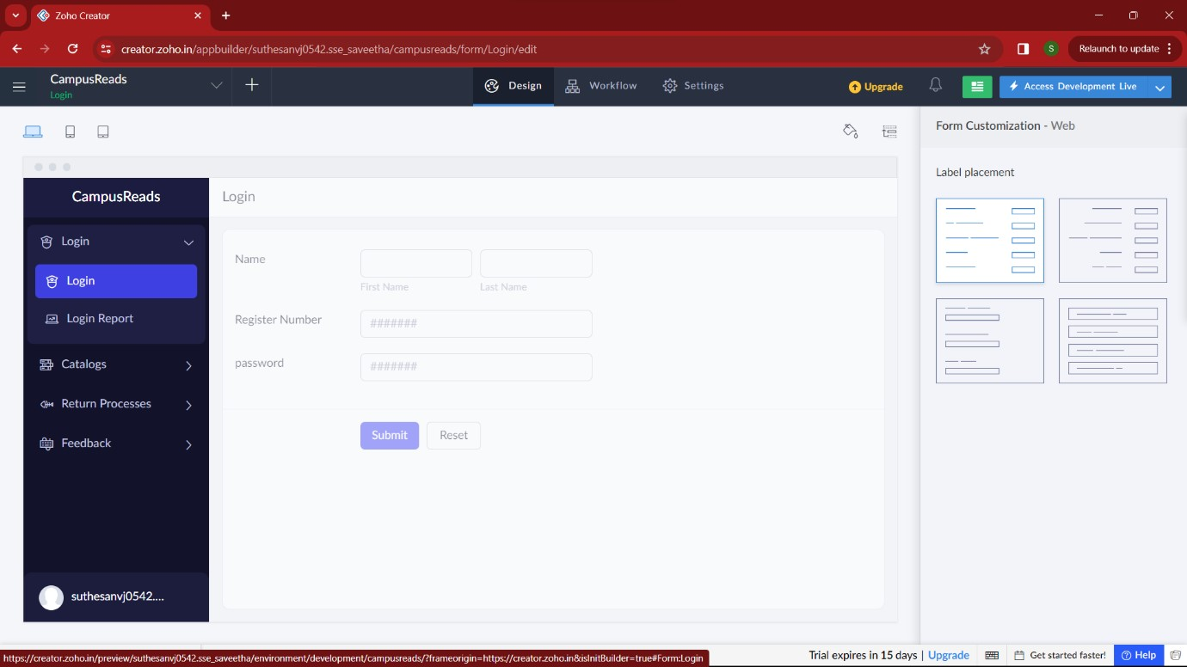

**STEP 7:**

Then I added another form namely “Catalogs”. It gets the required datas from the user, and checks the availability of the book.

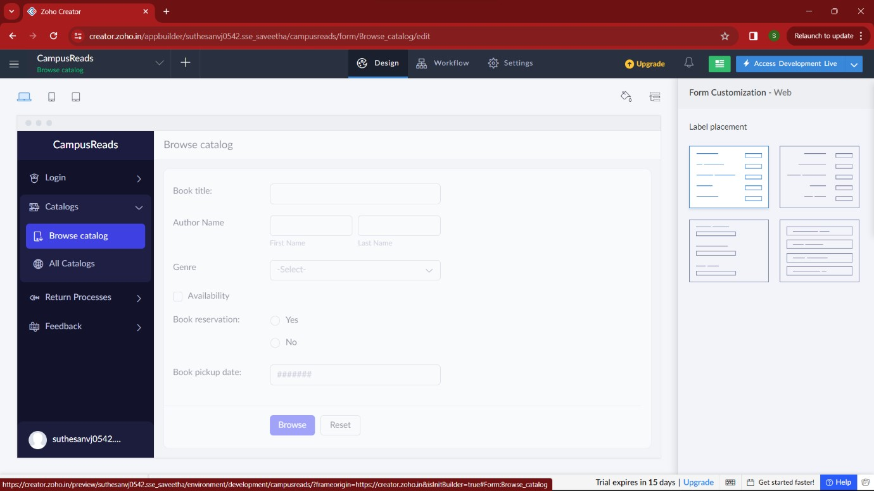

**STEP 8:**

Then I added another form namely “Return type” which shows the fine amount and return date of the book.

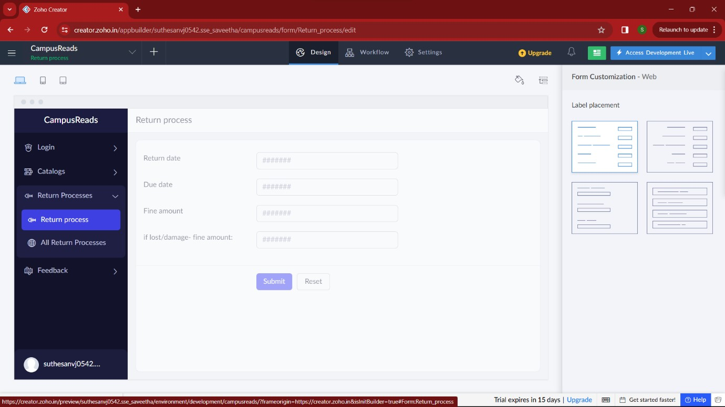

**STEP 9:**

Then in the next form I added “feedback” of this service. Here user can give their feedback on these process..

