**Create a simple cloud so=ware applica?on for Mark Sheet Processing System using any Cloud**

**Service Provider to demonstrate SaaS include the necessary fields such as name of the student, Reg no of the student, Subjects , Marks, Average, percentage, rank, overall performance etc.**

**AIM:**

To Create a simple cloud so1ware applica3on for Mark Sheet Processing System using any Cloud Service Provider.

**PROCEDURE:**

**STEP 1:**

Open browser and get into zoho ceator. Then sign in and click “Create applica3on”. Below given screenshot will appear, hear type the applica3on name of your Aim.

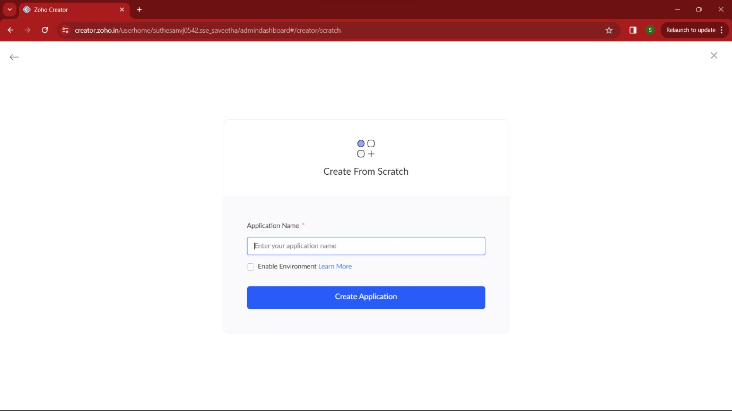

**STEP 2:**

Then select “start from scratch” op3on and select the proper component from the 4 components listed. For my applica3on I just selected “forms” for the login creden3als.

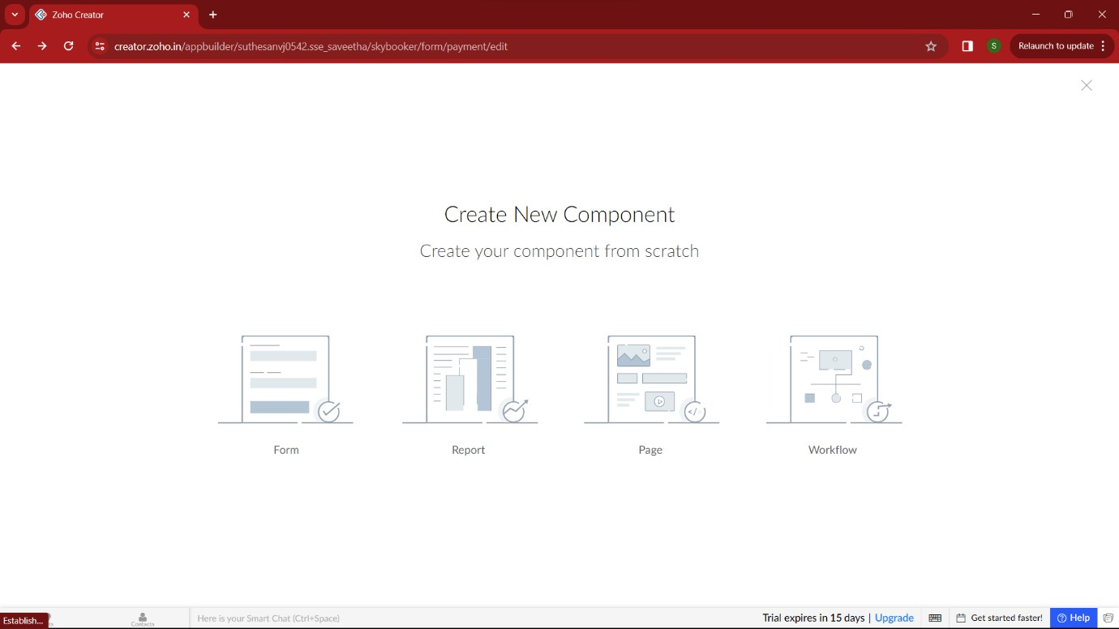

**STEP 3:**

In forms, below given op3ons will be given. From here we can get sample templates of our requirements, otherwise we can import already saved schema for our applica3on. I just selected “ from scratch” op3on for my applica3on.

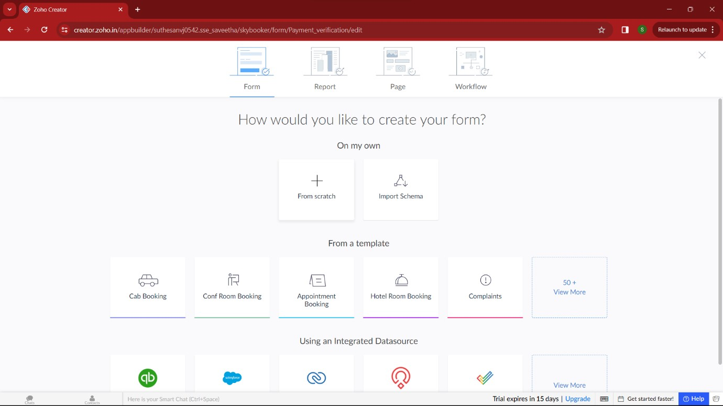

**STEP 4:**

Then provide an appropriate name for our applica3on in the name form which shown below. I gave “GradeGenius” for my “Marksheet processing”

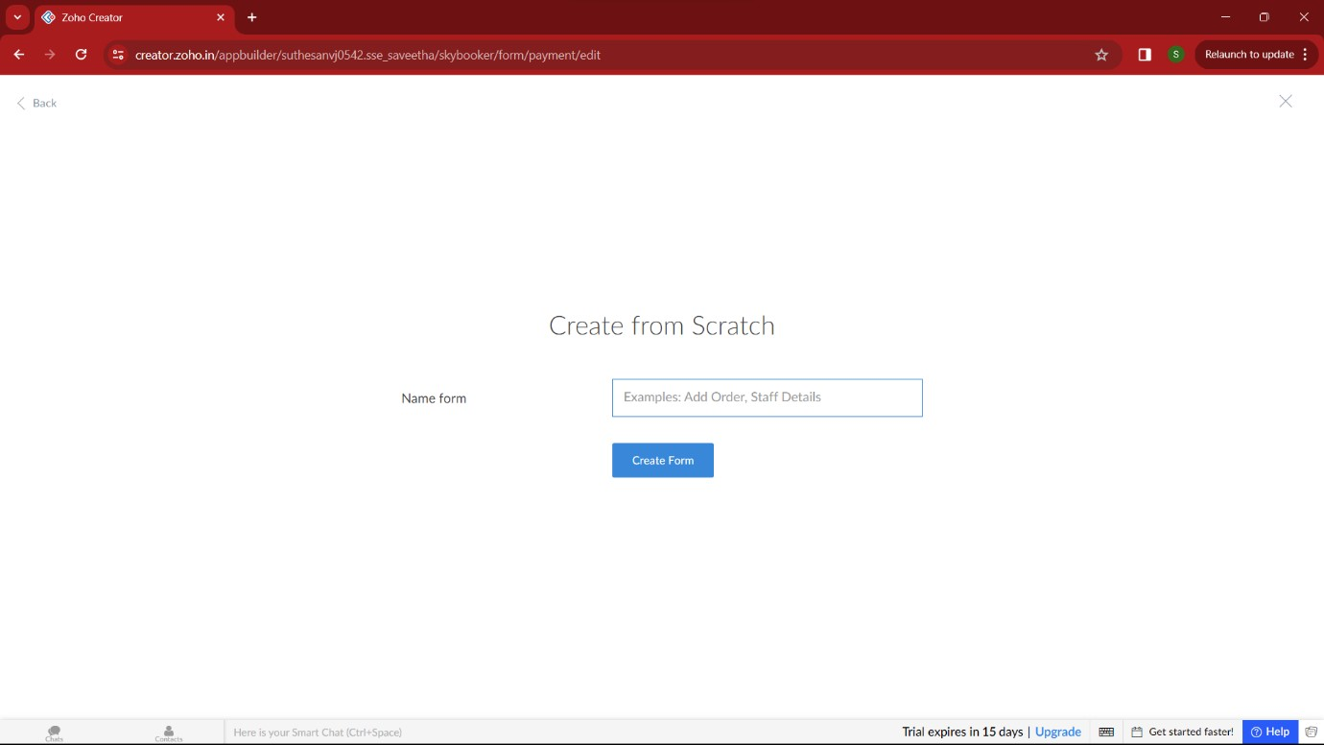

**STEP 5:**

by clicking “+” symbol shown in the picture given below, we can add number of forms in our applica3on. Firstly I placed login form in my applica3on with the essen3al credent

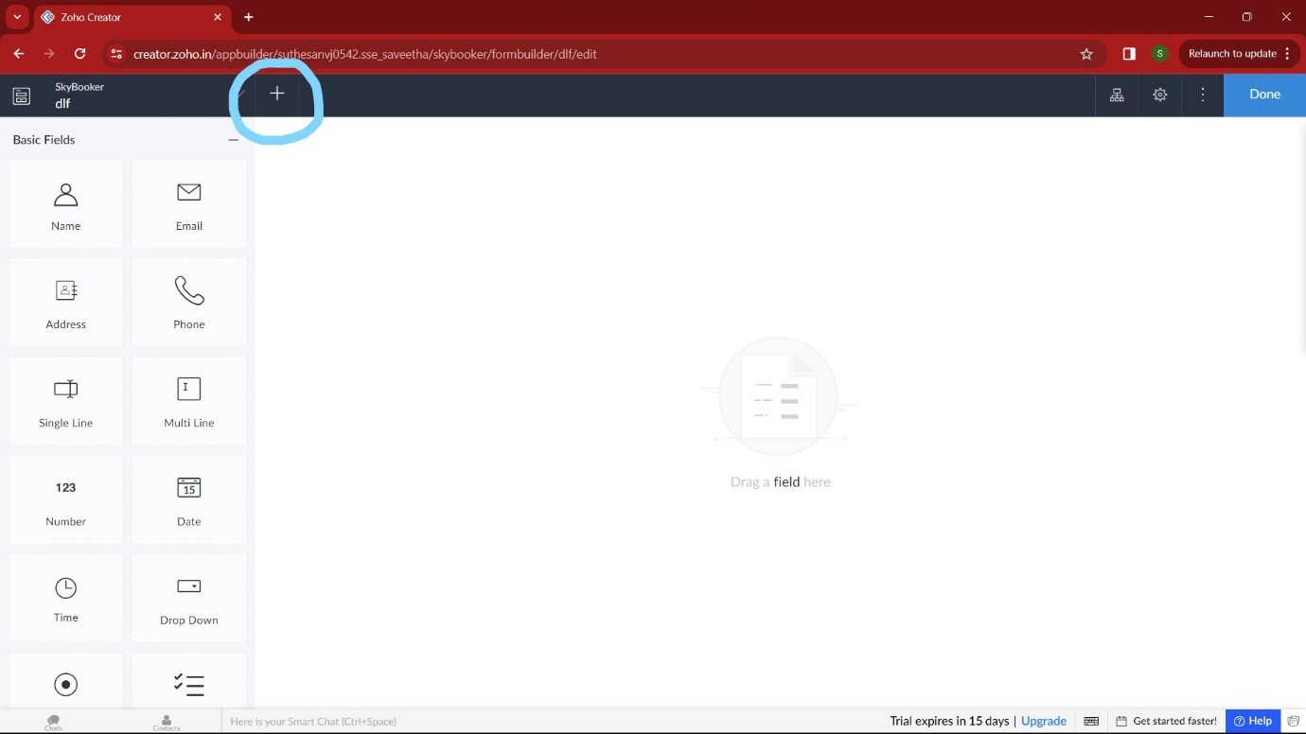

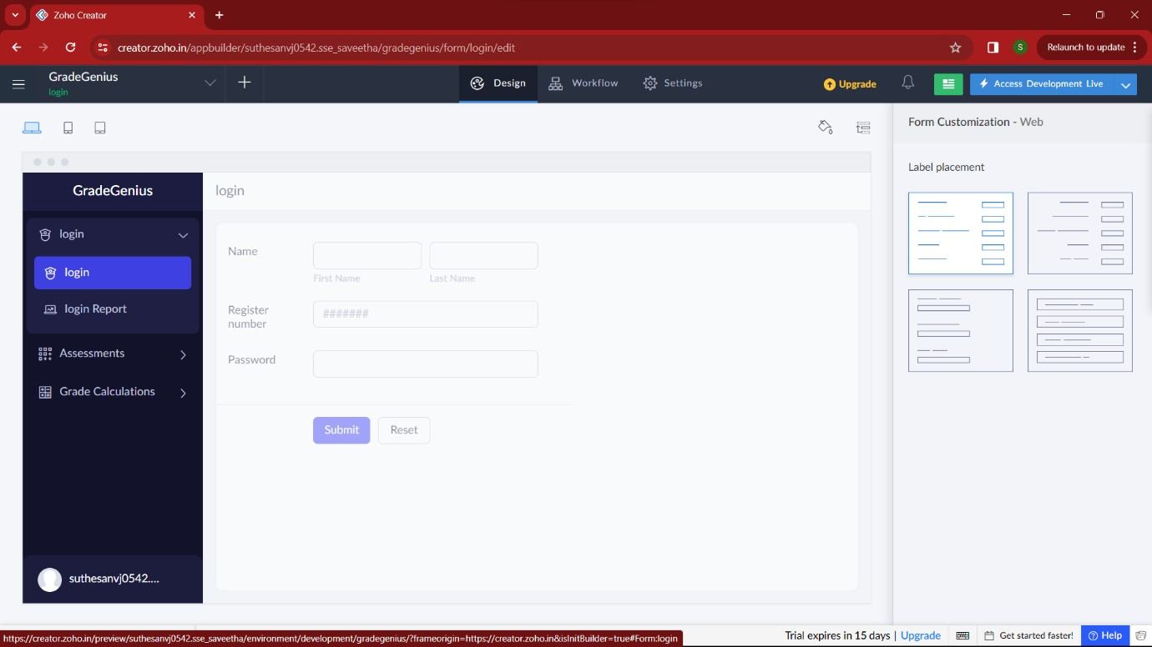

**STEP 7:**

Then I added another form namely “assessments”. It gets all the marks of the stuents for the par3cular semester.

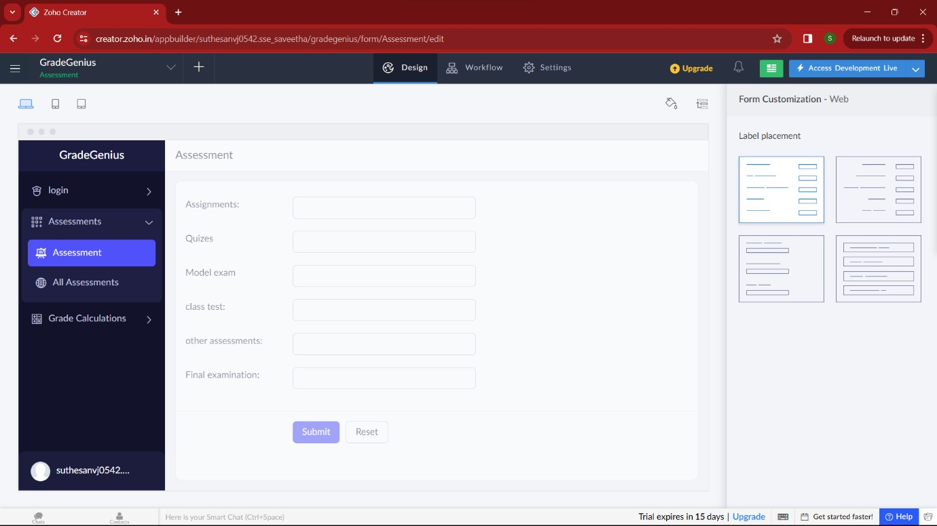

**STEP 8:**

Then I added another form namely “Grade calcula3on” which calculate the marks and grade and verifies it with the higher officials.by these steps mark sheet is processed.

