BRAIN TUMOR CLASSIFICATION AND RISK PREDICTOR

ABSTRACT OF THE PROJECT
Brain tumors are abnormal growths of cells that occur in the brain and can affect different parts of the nervous system. Early identification and classification of brain tumors from Magnetic Resonance Imaging (MRI) images can support medical image analysis and research. This project proposes a machine learning and data mining based system for analyzing brain MRI images and classifying them into different categories.
The system uses image preprocessing techniques to prepare MRI images for analysis. Image enhancement, resizing, normalization, and augmentation techniques are applied to improve the quality and consistency of the input data. Relevant image features are then extracted and used for classification.
A Convolutional Neural Network (CNN) is used as the main deep learning model for brain tumor classification. Additional machine learning algorithms such as Support Vector Machine (SVM), Random Forest, K-Nearest Neighbors (KNN), and Decision Tree can be used for comparison and analysis. Data mining techniques such as K-Means clustering, Apriori association rule mining, and Principal Component Analysis (PCA) can also be applied to discover patterns and relationships within the extracted data.
The system classifies brain MRI images into four categories: Glioma Tumor, Meningioma Tumor, Pituitary Tumor, and No Tumor. The system can also provide a model-based prediction confidence or risk indicator along with the predicted class. A simple web-based interface can be developed where users upload an MRI image and view the predicted category, confidence value, and analytical information.
The project is intended for academic and research purposes. The prediction provided by the system is not a medical diagnosis and should not replace examination or treatment by qualified medical professionals.

DOMAIN OF THE PROJECT
The project operates in the domains of:
Healthcare Informatics, Medical Image Analysis, Data Mining, Machine Learning, Deep Learning, Computer Vision, and Web Application Development.
The system focuses on the analysis of brain MRI images using machine learning and deep learning techniques. Image processing methods are used to prepare MRI images, while classification algorithms are used to identify the type of brain tumor present in the image.
The project also applies data mining techniques to discover patterns and relationships within the extracted image features. The final results are presented through an interactive application interface for easier visualization and analysis.

MODULES OF THE PROJECT IN DETAIL

1. Brain MRI Data Collection Module
This module collects a suitable labelled brain MRI image dataset for training and testing the machine learning models. The selected dataset contains MRI images representing different brain tumor categories.
The main classes used in the project are:
- Glioma Tumor
- Meningioma Tumor
- Pituitary Tumor
- No Tumor
The collected images are organized into suitable training, validation, and testing set

2. Image Preprocessing Module
The image preprocessing module prepares the collected MRI images before they are given to the machine learning model.
The preprocessing operations include:
- Image resizing
- Image normalization
- Noise reduction
- Image enhancement
- Pixel value scaling
- Conversion to suitable image format
These operations help maintain consistent image dimensions and improve the quality of the input data.

3. Image Augmentation Module
Image augmentation is used to increase the variety of training images and reduce the possibility of overfitting.
Different augmentation techniques can include:
- Rotation
- Horizontal flipping where appropriate
- Zooming
- Shifting
- Cropping
- Brightness adjustment
Augmentation helps the model learn useful patterns from different variations of MRI images.

4. Exploratory Data Analysis Module
This module analyzes the collected MRI dataset to understand its structure and distribution.
The analysis includes:
- Number of images in each class
- Training and testing distribution
- Class distribution
- Image dimensions
- Sample MRI images
- Pixel intensity distribution
Charts and visualizations are generated to understand the dataset before model training.

5. Feature Extraction Module
This module extracts useful visual characteristics from brain MRI images.
Important image characteristics can include:
- Shape
- Texture
- Intensity
- Edges
- Tumor-related visual patterns
For the CNN model, important features are automatically learned from the images through convolutional layers. Extracted deep features can also be used with traditional machine learning algorithms for comparison.

6. Feature Selection and Dimensionality Reduction Module
This module identifies important features and reduces unnecessary information from the extracted feature set.
Techniques such as:
- Principal Component Analysis (PCA)
- Feature importance
- Correlation analysis
- Recursive Feature Elimination (RFE)
can be used depending on the extracted feature representation.
Dimensionality reduction helps simplify the feature space and can improve visualization and computational efficiency.

7. Brain Tumor Classification Module
This is the main predictive module of the project.
The system classifies an input brain MRI image into one of the following categories:
Glioma | Meningioma | Pituitary Tumor | No Tumor
A Convolutional Neural Network (CNN) is used as the primary classification model because it is suitable for image classification tasks.
Other machine learning algorithms can be trained using extracted features for comparison.

8. CNN-Based Prediction Module
The CNN model automatically learns important visual features from MRI images.
A typical CNN architecture consists of:
- Input Layer
- Convolutional Layers
- ReLU Activation
- Pooling Layers
- Flatten Layer
- Fully Connected Layers
- Output Layer
The final output layer produces probabilities for the four brain MRI categories.
The class with the highest predicted probability is selected as the model's predicted category.

9. Risk / Confidence Prediction Module
This module provides a model-based confidence or risk indicator along with the classification result.
For example:
Predicted Class: Glioma Tumor
Prediction Confidence: 92%
The confidence value represents how strongly the trained model supports its predicted class.
If risk categories are displayed, they should be clearly described as model-based indicators and not as clinical patient-risk assessments.

10. Pattern Mining Module
This module applies data mining techniques to discover useful patterns within the extracted MRI features and classification results.
The system can analyze relationships between image characteristics and tumor categories.
Association rule mining can be used to identify frequently occurring combinations of extracted feature patterns.

11. Clustering Module
K-Means clustering is used to group similar MRI feature representations without depending directly on the known class labels.
The clusters can be analyzed to identify naturally occurring similarities between different MRI images.
This module demonstrates the use of unsupervised learning for brain MRI data analysis.

12. Association Rule Mining Module
The Apriori algorithm can be applied to suitable discretized or categorical feature representations.
It identifies frequent combinations of characteristics and generates association rules using measures such as:
- Support
- Confidence
- Lift
The results can help demonstrate relationships between extracted MRI characteristics and tumor categories.

13. Data Visualization and Reporting Module
This module presents the results of the analysis using different visualization techniques.
Possible visualizations include:
- Class distribution charts
- Sample MRI images
- Training accuracy graphs
- Training loss graphs
- Confusion matrix
- ROC curves
- Precision-recall curves
- Feature visualizations
- PCA plots
- Clustering plots
- Prediction confidence charts
The system can also generate a report containing the prediction and model results.

14. Model Evaluation Module
This module evaluates the performance of the developed models.
The evaluation metrics include:
- Accuracy
- Precision
- Recall
- F1-Score
- Confusion Matrix
- ROC-AUC where applicable
The performance of CNN and other comparison models can be analyzed using the same test dataset.

15. User Interface and Dashboard Module
The dashboard provides a simple interface for interacting with the prediction system.
The user can:
- Upload a brain MRI image
- Start prediction
- View the predicted tumor category
- View prediction confidence
- View analysis results
- View previous predictions
- Generate reports
The interface should clearly state that the result is an AI-based prediction and not a medical diagnosis.

16. Login and Registration Module
This module provides secure access to the application.
Users can:
- Create an account
- Log in
- Log out
- Manage their account
Authentication can be implemented to protect user-specific prediction history and application information.

17. Prediction History Module
This module stores previous prediction results for authenticated users.
The stored information can include:
- Uploaded image reference
- Date and time
- Predicted tumor category
- Prediction confidence
- Model used
Users can view previous prediction records through the dashboard.

18. Report Generation Module
This module generates a report containing the prediction results and important analytical information.
The report can include:
- Input MRI image
- Predicted tumor category
- Model confidence
- Date and time
- Model information
- Evaluation information
The report should contain a clear statement that the result is intended for academic/research use and is not a clinical diagnosis.

ALGORITHMS USED FOR EACH MODULE / COMPONENT
The system employs machine learning, statistical analysis, association rule mining, clustering, and feature engineering techniques across its analytical pipeline.

Component / Module | Algorithm / Technique | Purpose
Image Preprocessing | Resizing, Normalization | Standardizes MRI images
Image Augmentation | Rotation, Zoom, Shift, Flip | Increases training image variation
Feature Extraction | CNN | Automatically extracts important image features
Classification | CNN | Main brain tumor classification
Classification Comparison | SVM | Classification using extracted features
Classification Comparison | Random Forest | Ensemble-based classification
Classification Comparison | KNN | Distance-based classification
Classification Comparison | Decision Tree | Rule-based classification
Clustering | K-Means | Groups similar MRI feature patterns
Pattern Mining | Apriori | Finds frequent feature associations
Dimensionality Reduction | PCA | Reduces feature dimensions
Feature Selection | RFE / Feature Importance | Identifies important features
Model Evaluation | Confusion Matrix | Analyzes classification errors
Model Evaluation | Accuracy, Precision, Recall, F1 | Measures model performance
Risk/Confidence | Classification Probability | Provides model-based confidence

DATA VISUALIZATION TECHNIQUES
The project uses visualization techniques to understand the dataset and evaluate model performance.

1. Class Distribution Chart
Shows the number of MRI images available for each class.

2. Sample MRI Visualization
Displays representative images from:
- Glioma
- Meningioma
- Pituitary Tumor
- No Tumor

3. Training Accuracy Graph
Shows how the model's accuracy changes during training.

4. Training Loss Graph
Shows how the model's loss changes during training.

5. Confusion Matrix
Shows correctly and incorrectly classified MRI images for each tumor category.

6. PCA Visualization
Displays high-dimensional extracted features in a reduced two-dimensional or three-dimensional representation.

7. Clustering Visualization
Shows groups created by K-Means clustering.

8. Prediction Confidence Chart
Displays the probability/confidence values produced for different tumor categories.

MODEL EVALUATION
Model evaluation is used to measure how accurately the trained model classifies brain MRI images. The main evaluation metrics are Accuracy, Precision, Recall, and F1-Score. A Confusion Matrix is also used to identify correctly and incorrectly classified tumor classes. These measures help compare the performance of CNN and other machine learning models.
SYSTEM ARCHITECTURE
The system accepts brain MRI images through the user interface. The images are preprocessed, and important features are extracted using CNN. Machine learning and data mining algorithms classify the MRI into Glioma, Meningioma, Pituitary Tumor, or No Tumor. The system then displays the prediction, confidence/risk indicator, history, and reports through the dashboard.

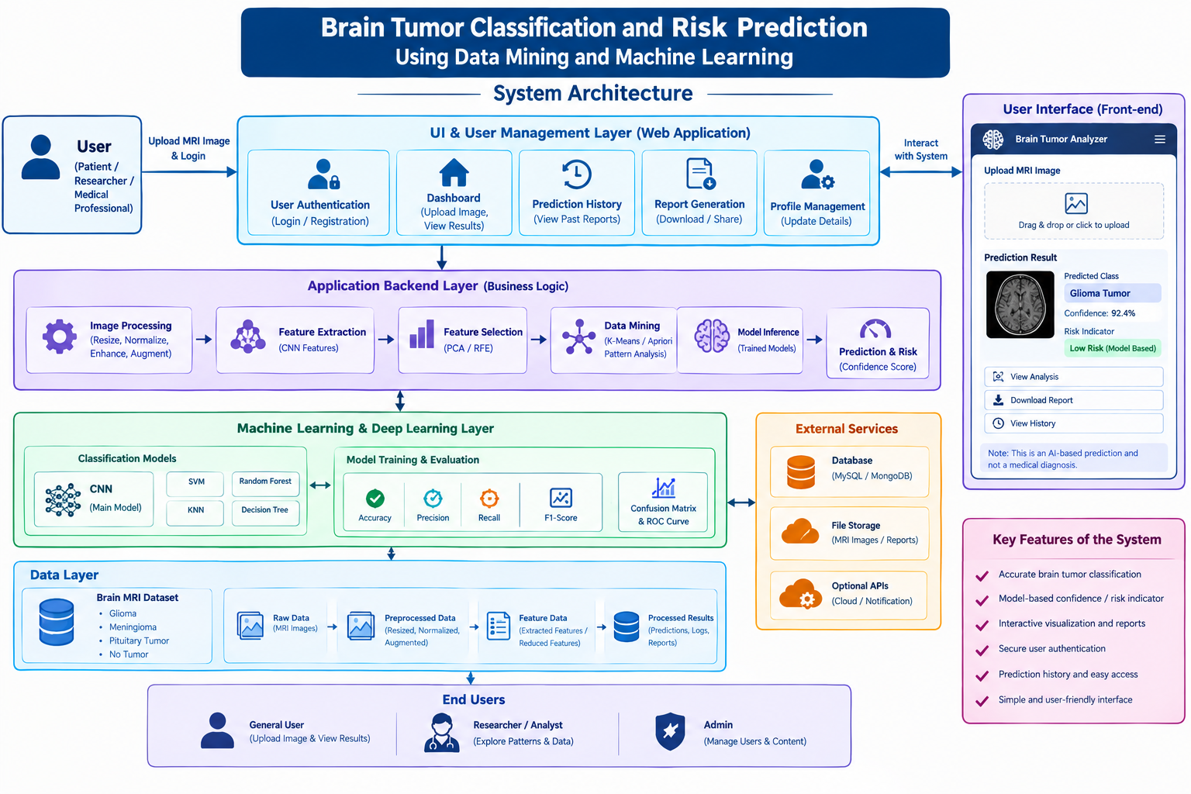

PROJECT WORKFLOW
Brain MRI Data Collection → Image Preprocessing → EDA & Visualization → Feature Extraction / Selection → CNN & ML Classification → Risk / Confidence Prediction → Pattern Mining & Clustering → Model Evaluation → Web Deployment

EXPECTED OUTCOME
The system is expected to classify brain MRI images into categories such as Glioma, Meningioma, Pituitary Tumor, and No Tumor. It will provide a prediction with a confidence/risk indicator and display the results through a simple web interface. The system will also provide visualizations, prediction history, model evaluation results, and report generation for academic and research purposes.

