**CLASS DIAGRAM:**

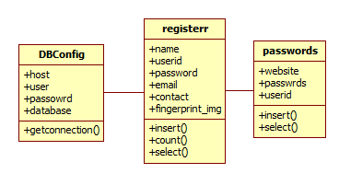

**USE CASE DIAGRAM:**

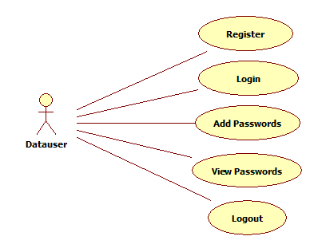

**SEQUENCE DIAGRAM:**

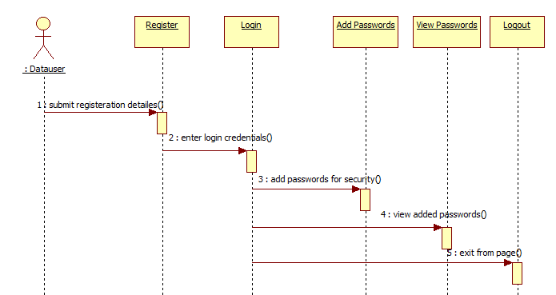

**COLLABORATION DIAGRAM:**

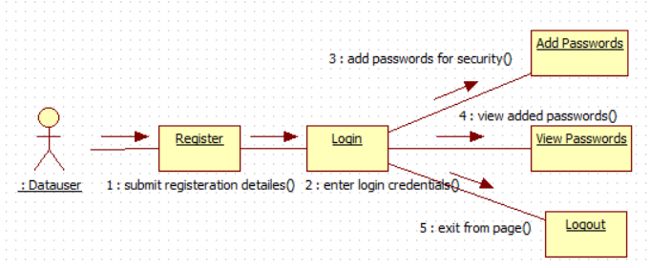

**STATECHART DIAGRAM:**

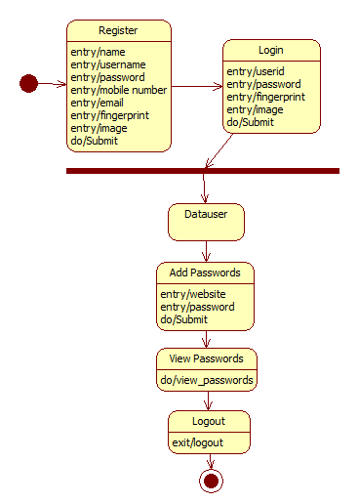

**ACTIVITY DIAGRAM:**

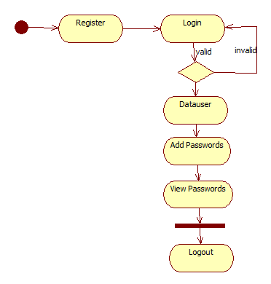

**COMPONENT DIAGRAM:**

