INTRODUCTION
Customer behavior plays a vital role in e-commerce for targeted strategy development. Segmentation of customers, where customers are divided based on common characteristics, enables a firm to personalize its strategy based on their differing requirements. The differences among customer preferences cannot be measured through conventional means, and as a result, machine learning is a great solution for effective segmentation.
The project explores how machine learning can be applied to segmenting customers based on their demographics, behaviors, and spending habits. By analyzing customer data, companies can identify relevant segments, predict behaviors, and improve their marketing efforts, thereby increasing sales and customer engagement. The objective is to demonstrate how data insights can improve decision-making and provide a competitive advantage in the e-commerce sector.
2.1 Background
- In the modern competitive e-commerce business, organizations are endeavoring to understand customers better to deliver personalized experiences and increase engagement. The traditional segmentation practices rely on core demographic data, which lack the dynamics of customer behavior. With the arrival of big data, machine learning has increased in popularity as a means of identifying patterns within customer data, allowing organizations to segment customers effectively.
- Customer segmentation made possible with the help of machine learning algorithms, such as clustering, can identify specific segments of customers based on purchasing behavior, preferences, and expenditures. It provides better insight and aids organizations with targeted marketing, customer retention, and generation of sales. Using customer segmentation with machine learning has therefore emerged as a crucial tool for organizations seeking to remain competitive as well as optimize e-business operations.
2.3 Scope of the study
- This study applies machine learning techniques to e-commerce customer segmentation, focusing on grouping customers based on their demographics, behaviors, and spending habits. The process begins with the collection of customer data, including age, gender, location, and purchase history. After preprocessing, including handling missing values ​​and creating key indicators such as recency, frequency, and monetary value, the study uses clustering algorithms such as K-Means and hierarchical clustering to identify distinct customer segments. The optimal number of clusters is determined using methods such as the elbow method.
- Subsequent segment analysis helps identify high-value customers and opportunities for personalized marketing strategies. Interactive dashboards are created using tools such as Tableau or Streamlit to visualize the segments and their contribution to revenue. The study concludes with a report detailing methods, analyses, and concrete business recommendations to improve customer engagement and drive e-commerce sales growth.
2.4 Objectives
- Employ machine learning techniques on customer segmentation for e-commerce, leveraging customer behavior, demographic, and spending data.
- Pre-process customer data by cleaning, normalizing, and defining crucial measures such as recency, frequency, and monetary value.
- Use clustering algorithms (K-Means, hierarchical clustering) to segment customers into distinct segments based on behavior and attributes.
- Recognize and examine high-value customer segments that drive the most revenue and create focused marketing strategies.
- Visualize and offer insights through interactive dashboards, allowing organizations to find and leverage customer segments for informed decision-making.
- Provide actionable tips to e-commerce companies to increase customer engagement, boost sales growth, and optimize marketing efficiency.
2.5 Motivation for the study
- In today's competitive e-commerce business, customer behavior has a crucial role to play in influencing sales as well as long-term commitment. Marketing efforts have not traditionally addressed the diverse needs and wants of different segments of customers. With the help of machine learning in segmenting customers based on their demographics, behavior, and purchasing patterns, organizations can understand better what they desire and require. It makes their marketing personalized, increases personalization, and maximizes customer interactions. This research aims to provide e-commerce organizations with actionable insights not only for better customer experience but also for revenue and growth in a dynamic marketplace.
2.6 Structure of the report
- The report’s organization is clear. First, the introduction is focused on the role of customer segmentation in e-commerce, as well as the added value of machine learning in targeting and engaging customers. In the “Methodology” section, data collection, data preprocessing, and segmentation clustering K-Means methods and hierarchical K-Means are discussed. In the “Analysis and Results” section, the segments that were defined are studied and the data is analyzed for the important features: recency, frequency, and monetary value of purchases. In the “Tips and Recommendations” segments, a marketing approach based on customer segments is described, which includes personalized marketing, cross-selling, and upselling strategies. The report ends with the conclusions drawn and offers additional analysis for the use of customer segmentation for e-commerce.

LITERATURE REVIEW
Customer segmentation has shifted from traditional demographics to a more complex, data-driven approach with the use of machine learning. The use of age and income as a basis for segmentation covered a fraction of the range of consumer behavior. For some time now, studies have been focused on trying to prove the success of machine learning algorithms such as K-Means and Hierarchical Clustering for defining customer segments by their purchasing behavior and preferences. To find the best number of clusters, commonly used methods include The Elbow Method. Also, the incorporation of RFM metrics has helped target customers anticipated to yield high value and in forecasting future behavior. These studies show that with the appropriate machine learning models, the accuracy of segmentation is greatly improved, which in turn allows businesses to develop marketing campaigns and engagement tactics tailored to the customers. Businesses that adopt these strategies are likely to achieve greater customization, greater customer loyalty and ultimately increased sales.
3.1 Overview of Customer Segmentation
- Segmentation of customers entails dividing buyers into several categories and markets for optimal customer care such as marketing and purchasing based on certain similarities like demographics, and purchase behaviors among others. In the past, businesses employed segmentation methods based on customer age, gender, and income levels. These approaches have proven ineffective in adapting to the shifts in customer behavior, particularly in fast-paced e-commerce settings. Modern approaches to segmentation have emerged that are more modern and focus more on consumer behavioral data insights.
- Businesses nowadays use RFM segmentation which stands for Recency, Frequency, and Monetary value. Recency indicates the last time a customer made a purchase, Frequency indicates the number of purchases a customer makes within a specified period, while Monetary Value in this case captures how much material value a customer purchases. In this regard, businesses can class their customers into meaningful segments such as high-value customers, and frequent buyers, while others can be one-time shoppers. Better customer categories enable companies to manage their marketing budgets more effectively while improving the personalization of their offers to enhance customer loyalty and value upon return.
- Furthermore, customer segmentation has been transformed with the use of machine learning algorithms that break down a reasonably complex data set into distinct regions with a pattern that is identifiable and recognizable to the customers ranging from the pupils to sophisticated buyers.
3.2. Importance of Customer Segmentation in E-commerce
- Customer segmentation is one of the most important strategies in e-commerce, as it enables businesses to categorize their customer audience into specific groups based on certain criteria such as demographics, behavior patterns, and purchasing tendencies. This segmentation assists in marketing strategies and improves customer satisfaction with the business, ultimately increasing sales and loyalty toward the firm.
- Personalized Marketing and Targeted Campaigns: Developing personalized marketing strategies is one of the most significant benefits of segmentation. Businesses can target specific customer groups, thus designing campaigns that are more appealing to each segment leading to more engagements and greater conversion rates. For instance, a business can give exclusive offers to loyal customers while dormant ones are incentivized to come back.
- Optimized Resource Allocation: Customer segmentation enables businesses to distribute their direct efforts to the most profitable or highest-potential segments more efficiently, allocating resources more effectively. Through this specific targeting, marketing time and budgets are well spent with optimum ROI. For example, companies can allocate more resources to high-value customers or highest-growth-potential segments and less to lower-profit segments. This optimization of resource allocation improves business performance in general and customer acquisition and retention programs.
3.3. Techniques and Approaches to Customer Segmentation
3.3.1. Traditional Methods
- Demographic & Geographic Segmentation: Dividing the customers based on age, income, or location is one method of segmentation of the groups.
- Psychographic & Behavioral Segmentation: This type of segmentation is possible based on lifestyle, interests, and purchasing behavior (e.g., RFM analysis).
- Firmographic Segmentation: The method is widely used in B2B to describe companies by their industry, size, and revenues.
3.3.2. Machine Learning Approaches
- Unsupervised Learning (Clustering): K-Means, Hierarchical Clustering, DBSCAN, and GMM are the techniques by which we discover hidden customer data patterns.
- Supervised Learning (Predictive Models): Decision Trees, Random Forests, and Neural Networks are the most important techniques that enable the prediction of customer behavior.
- RFM Segmentation with ML: It will be the technology that promotes customers to be more broadly characterized based on the Recency, Frequency, and Monetary value utilization.
- Deep Learning & AI: Neural Networks and Reinforcement Learning are a few of the methods for providing good customer service and one-to-one marketing.
- Dimensionality Reduction: PCA and t-SNE guarantee that we have the correct dimensionality of the data.
- Replacing manual, tireless customer segmentation, the development of machine learning technology is ushering in the automatization of the process

3.4. Key Algorithms Used for Customer Segmentation
3.4.1. K-Means Clustering
- Groups customers with similar tastes by utilizing a specified number of clusters (K).
- Uses the Elbow method to determine the optimal K value.
- Assigns customers to the nearest centroid and then updates the points iteratively.
- Pros: It quickly resizes and can handle even large datasets efficiently.
- Cons: Requires a predetermined K value and can be affected by outliers.
3.4.2. Hierarchical Clustering
- It creates a hierarchy of sections for customers, which can be done using Agglomerative (Bottom-Up) or Divisive (Top-Down) methods.
- A dendrogram is used to determine the relationships between clusters.
- Pros: No prior division is necessary, and customers can complete the relationship identification.
- Cons: The computational process can be costly when managing large datasets.
- K-Means is suitable for segmenting large-scale data, while Hierarchical Clustering is useful for
3.5. Challenges and Limitations in E-commerce Customer Segmentation
- Despite its advantages, the application of customer segmentation in e-commerce is accompanied by several impediments and limitations that can compromise accuracy and efficiency.
1. Data Quality and Availability
- Examples of Incorrect or Missing Data: Cases of missing or erroneous information, such as duplicate values or wrong customer data, can distort the accuracy of the segmentation results.
- Storable and Isolated Data: The customer data might be processed by different people on different platforms (like the website, social media, and Customer Relationship Management software), making the data integration effortless.
2. Dynamic Customer Behavior
- Changing Product Classification: Customer requirements and behaviors are usually altered at specific times, therefore, constant upgrading of the segmentation models is necessary.
- Short-term Attractions: The shopping patterns are not steady as there is a shift in buying habits due to festivities, fashion, and the economic situation. All these can lead to a situation where a segmentation model becomes irrelevant.

3. Choosing the Right Segmentation Method
- Needing to Pre-specify the Number of Segments: As in the K-Means case, the functioning of the segments depends on the installation of the correct number of them which without knowledge from before would be hard.
- Customers Falling into Multiple Categories: A customer may be a ticket in two categories. Suppose, a customer can be a high ticket item buyer but at the same time be infrequent in purchases. This fact allows hard clustering methods to be less effective.
4. Computational Complexity
- Size-Related Problems: If the dataset is larger than usual, then millions of customers are researched, which means that the clustering algorithm such as Hierarchical Clustering or GMM must process this data, which is a highly computationally expensive task.
- Live-Data Handling: Many companies can't insert consumer segments in real-time, so the out-of-date data might be misleading and the updated ones might not even make a difference.
5. Interpretability and Actionability
- Inadequacy of Machine Learning Models: Advanced segmentation methods can be very difficult to comprehend, which causes obstacles in the business analytics sector.
- Lack of Clear Business Strategies: Not even the very well-structured segments can generate the desired outcome in marketing without the practicality of their implementation.
6. Privacy and Ethical Concerns
- Data Privacy Regulations: Being compliant with GDPR, CCPA, and other data laws means that the data practices regarding data collection and segmentation are being restricted.
- Customer Trust: A large amount of data monitoring might make people feel anxious about personal information and avoid telling you anything.
3.6. Related Work in E-commerce and Machine Learning for Customer Segmentation
Various research works and use cases have targeted customer segmentation to achieve better marketing, increase customer retention, and generate sales in e-commerce and machine learning.
1. Traditional Customer Segmentation Methods
- RFM: Customers were classified based on Recency, Frequency, and Monetary (RFM) analysis in the early studies.
- Rule-Based and Statistical Methods: Methods such as k-means clustering, hierarchical clustering, and logistic regression have been widely used for market segmentation.

2. Methods Based Machine Learning and AI
Unsupervised Learning:
- A few examples of clustering techniques that are effective for customer group identification based on behavior patterns include K-Means, Hierarchical Clustering, DBSCAN, or GMM.
- The Elbow Method and silhouette Score have been employed for the identification of optimal cluster
Supervised Learning:
- Customer segments are predicted using classification models such as Random Forest, Decision Trees, and Neural Networks.
Deep Learning and Reinforcement Learning:
- They have been found highly effective in improving segmentation accuracy with deep learning models such as predictive modeling with autoencoders, convolutional neural networks, etc.
- Reinforcement learning aids in dynamically personalizing customer interactions.
3. Industry Applications and Case Studies
- E-commerce Giants: Amazon and Alibaba use AI-powered segmentation to personalize recommendations and marketing.
- Retail and Fashion: Brands like Zara and Nike apply clustering and predictive analytics to optimize pricing and promotions.
- Subscription Services: Streaming platforms like Netflix and Spotify use behavioral segmentation for content recommendations.
4. Challenges and Future Directions
- Studies highlight issues such as data privacy, evolving customer behaviors, and model interpretability as key challenges in machine learning-based segmentation.
- Future research explores the integration of real-time segmentation, hybrid models, and ethical AI in customer analytics.

METHODOLOGY
Steps Involved
Step 1: Data Collection
The first step is to gather data. Use publicly available datasets, or create a dataset that includes:
- Customer demographics (e.g., age, gender, location)
- Purchase frequency and recency
- Total spending or revenue contributed
- Categories or types of products purchased
Step 2: Data Preprocessing
- Clean the data: Handle missing values, remove duplicate entries, and address outliers.
- Feature creation: Generate meaningful metrics such as:
- Recency: How recently the customer made a purchase.
- Frequency: The number of purchases made.
- Monetary value: Total amount spent by the customer.
- Normalize data: Ensure all features are on the same scale for effective clustering.
Step 3: Exploratory Data Analysis (EDA)
Analyze the data to understand patterns and trends, such as:
- Which age group spends the most?
- Which product categories are most popular?
- The correlation between frequency of purchases and total spending.
- Create visualizations (e.g., bar charts, heat maps) to highlight these patterns.
Step 4: Apply Clustering Algorithms
- Use clustering techniques like K-Means or Hierarchical Clustering to segment customers.
- Identify the optimal number of clusters using methods like the Elbow Method or Silhouette Analysis.
For example:
- High Spenders: Customers who purchase frequently and spend a lot.
- Occasional Buyers: Customers who buy infrequently but spend moderately.
- Low-Value Customers: Those who rarely purchase and spend little.

Step 5: Analyze and Interpret Segments
Once clusters are created:
- Examine the characteristics of each cluster (e.g., average spending, recency of purchases).
- Label each segment based on observed patterns (e.g., VIP Customers, Loyal Buyers, One-Time Shoppers).
Step 6: Generate Business Insights
- Identify which customer segment contributes the most revenue.
- Determine opportunities for cross-selling or upselling within each group.
- Suggest strategies like personalized marketing campaigns for high-value customers and re-engagement campaigns for inactive ones.
Step 7: Build a Presentation or Dashboard
  - Create a dashboard or report to visualize:
  - Customer segments and their key characteristics.
  - Revenue contribution of each segment.
  - Insights for business decision-making.
Tools like Tableau, Stream lit, or Dash can be used to build an interactive interface.
Step 8: Document and Present Findings
Prepare a detailed report that includes:
- The problem statement and objectives.
- Data preprocessing and methods used for segmentation.
- Insights derived from the analysis.
- Actionable recommendations for the business.
- Create a presentation summarizing the key results with visualizations.

REQUIREMENTS
Several Python packages have been implemented for the project. The packages used are listed below.
- Pandas

- Pandas is a powerful Python library for data manipulation and analysis. It provides data structures like Series (1D) and DataFrame (2D) that make it easy to handle structured data.
Key Features:
- DataFrame & Series: Handles tabular and labeled data efficiently.
- Data Cleaning: Handles missing values, duplicates, and transformations.
- Data Analysis: Supports filtering, grouping, merging, and pivoting.
- Integration: Works well with NumPy, Matplotlib, and other data science libraries.
- Numpy

- NumPy is a powerful Python library used for numerical computing. It provides support for large, multi-dimensional arrays and matrices, along with a collection of mathematical functions to operate on them efficiently.
Key Features of NumPy:
- N-dimensional array (ndarray): Supports fast and efficient array operations.
- Mathematical functions: Includes functions for linear algebra, statistics, and more.
- Broadcasting: Allows operations on arrays of different shapes.
- Memory efficiency: Uses less memory compared to Python lists.
- Integration: Works well with other libraries like SciPy, Pandas, and Matplotlib.
- Sklearn

- Scikit-learn (sklearn) is a powerful Python library for machine learning. It provides simple and efficient tools for data mining, data analysis, and predictive modeling. It is built on top of NumPy, SciPy, and Matplotlib.
Key Features of Scikit-Learn
- Supervised Learning: Linear regression, logistic regression, decision trees, random forests, support vector machines (SVM), etc.
- Unsupervised Learning: Clustering (K-means, DBSCAN), dimensionality reduction (PCA), etc.
- Model Selection: Cross-validation, grid search, and hyperparameter tuning.
- Preprocessing: Scaling, normalization, encoding categorical variables.
- Feature Engineering: Feature selection and extraction.
- StandardScalar
StandardScaler in Scikit-Learn
- StandardScaler is a preprocessing tool in sklearn.preprocessing that standardizes features by removing the mean and scaling to unit variance. It transforms data so that it has a mean of 0 and a standard deviation of 1, which helps improve the performance of machine learning models, especially for algorithms that are sensitive to feature scales (e.g.,SVM,k-NN,logisticregression).
Formula Used by StandardScaler
The formula for the transformation is:
z = (x - u) / s
where ,
z is the scaled value,
x is the original value,
u is the mean, and
s is the standard deviation.

- Pickle

- Pickle is a built-in Python module used for serializing and deserializing Python objects. Serialization (or "pickling") means converting a Python object into a byte stream, which can be saved to a file or sent over a network. Deserialization (or "unpickling") means loading that byte stream back into a Python object.

- Streamlit

- Streamlit is a Python framework for building interactive web applications with minimal code. It is especially useful for machine learning, data visualization, and dashboard applications.

- Why Use Streamlit?
Easy to Use: Simple Python scripts turn into full-fledged web apps.
Interactive Widgets: Sliders, buttons, file uploads, etc.
Data Visualization: Supports Matplotlib, Seaborn, Plotly, Altair, etc.
Machine Learning Integration: Works well with scikit-learn,TensorFlow, and PyTorch.
Fast Deployment: Can be shared easily via Streamlit Cloud or Docker.

TECHNOLOGIES AND TECHNIQUES
  - Clustering Algorithms:
- K-Means
- K-Means is an unsupervised machine learning algorithm that partitions data into K clusters by minimizing the variance within each cluster. It iteratively assigns data points to the nearest centroid until convergence.

- Hierarchical Clustering
- Hierarchical clustering is an unsupervised learning technique that builds a tree-like structure (dendrogram) to group similar data points. It can be agglomerative (bottom-up) or divisive (top-down).

  - Data Visualization Tools
- Seaborn
- Seaborn is a Python data visualization library built on Matplotlib, used for creating attractive and informative statistical graphics, including heatmaps, box plots, and pair plots.

- Matplotlib
- Matplotlib is a Python library for creating static, animated, and interactive visualizations, such as line charts, bar charts, and histograms.

  - Analysis Metrics:
- Recency
- Recency measures how recently a customer made a purchase, helping businesses identify active and inactive customers.

- Frequency
- Frequency indicates how often a customer makes a purchase, showing their engagement and loyalty.

- Monetary (RFM) model for customer behavior analysis
- Monetary value represents the total amount a customer has spent, highlighting high-value customers.

APPENDICES
7.1. Output
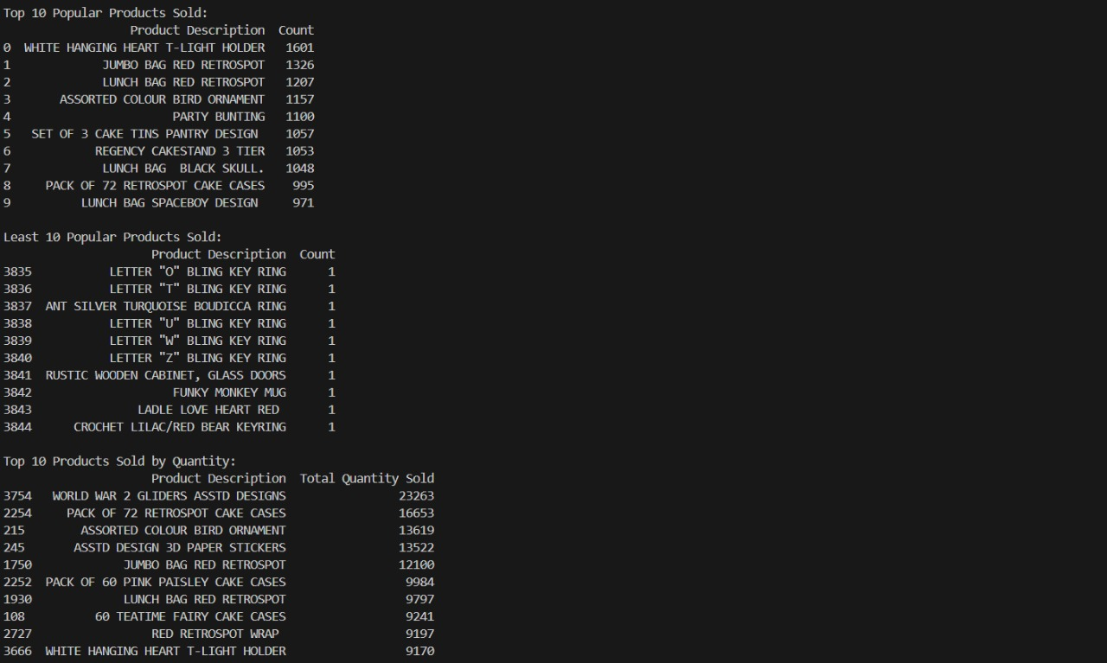
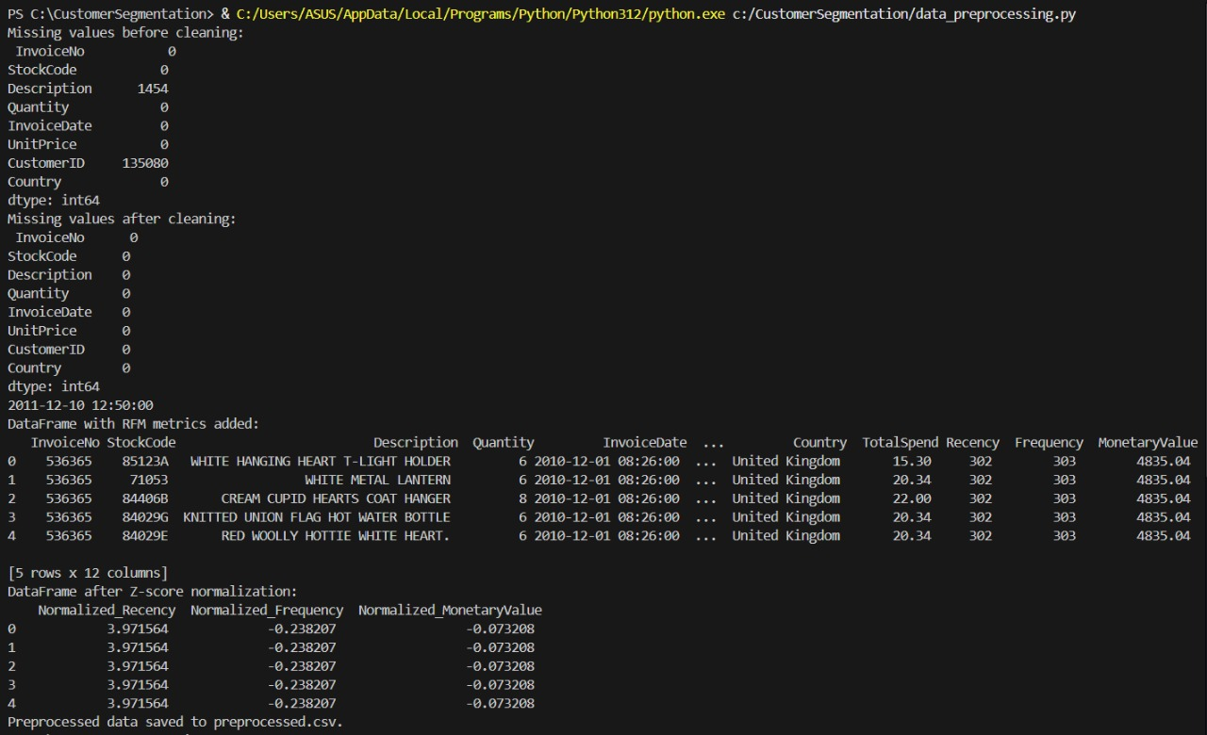
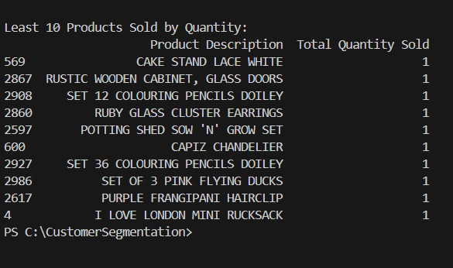
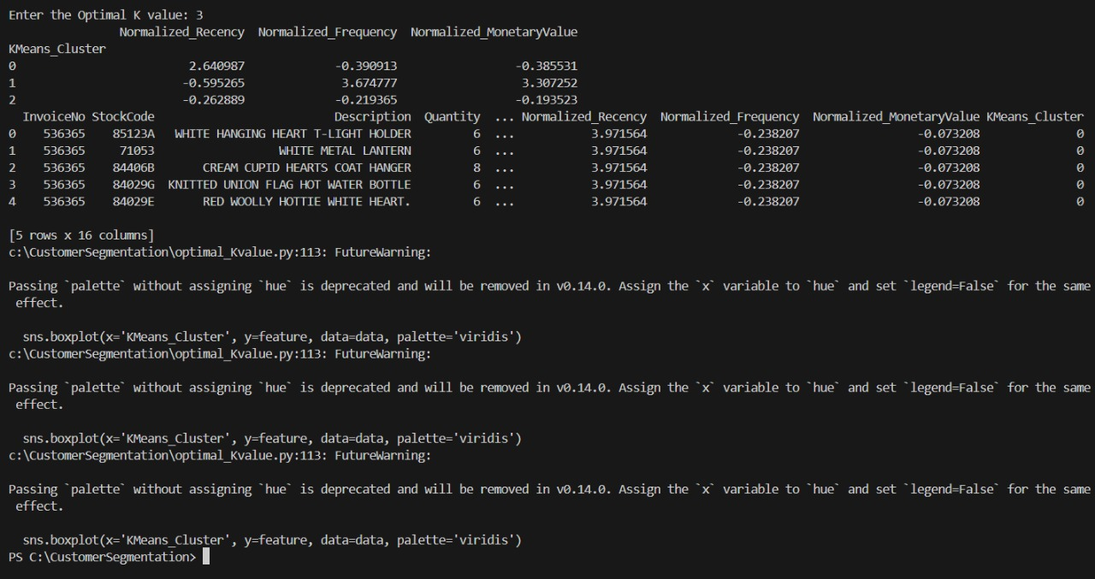
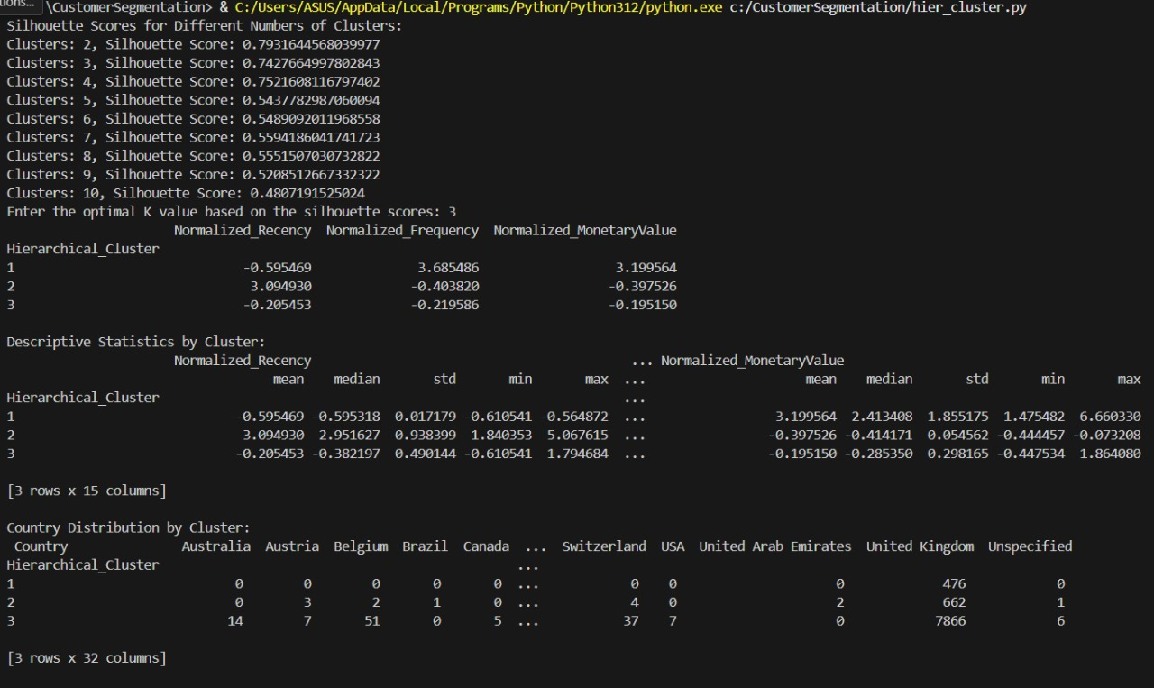
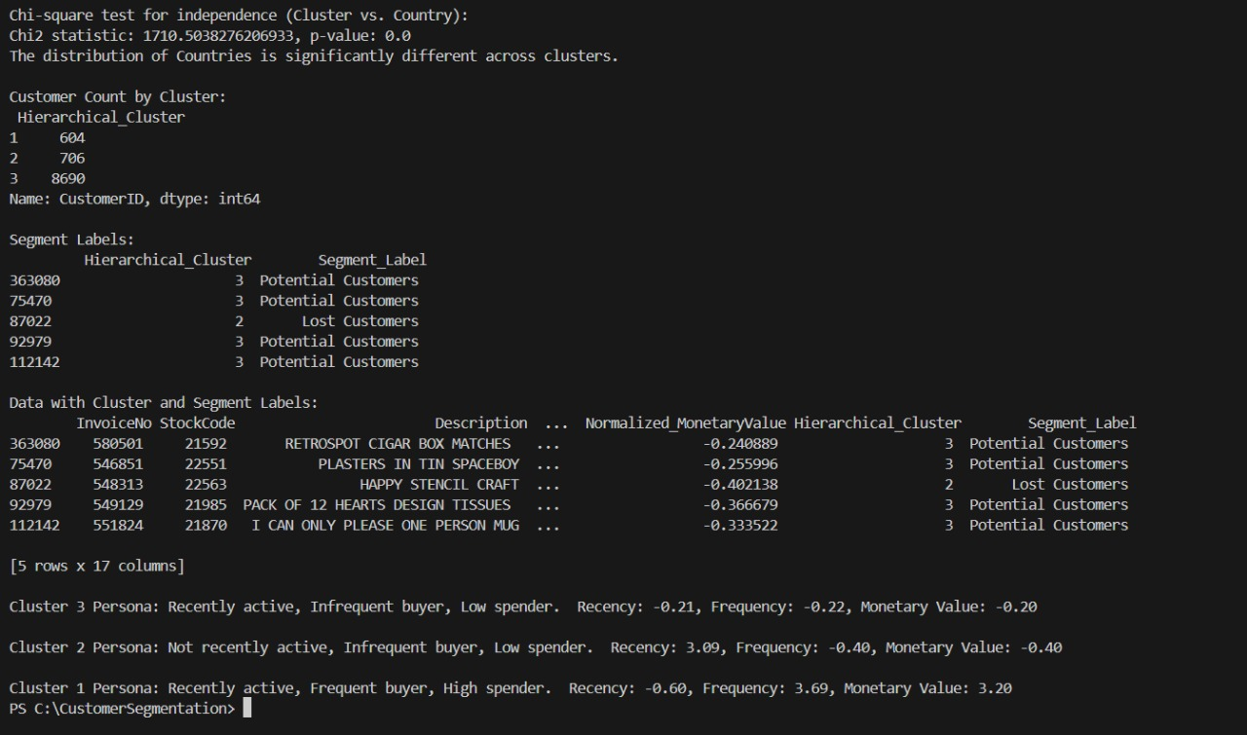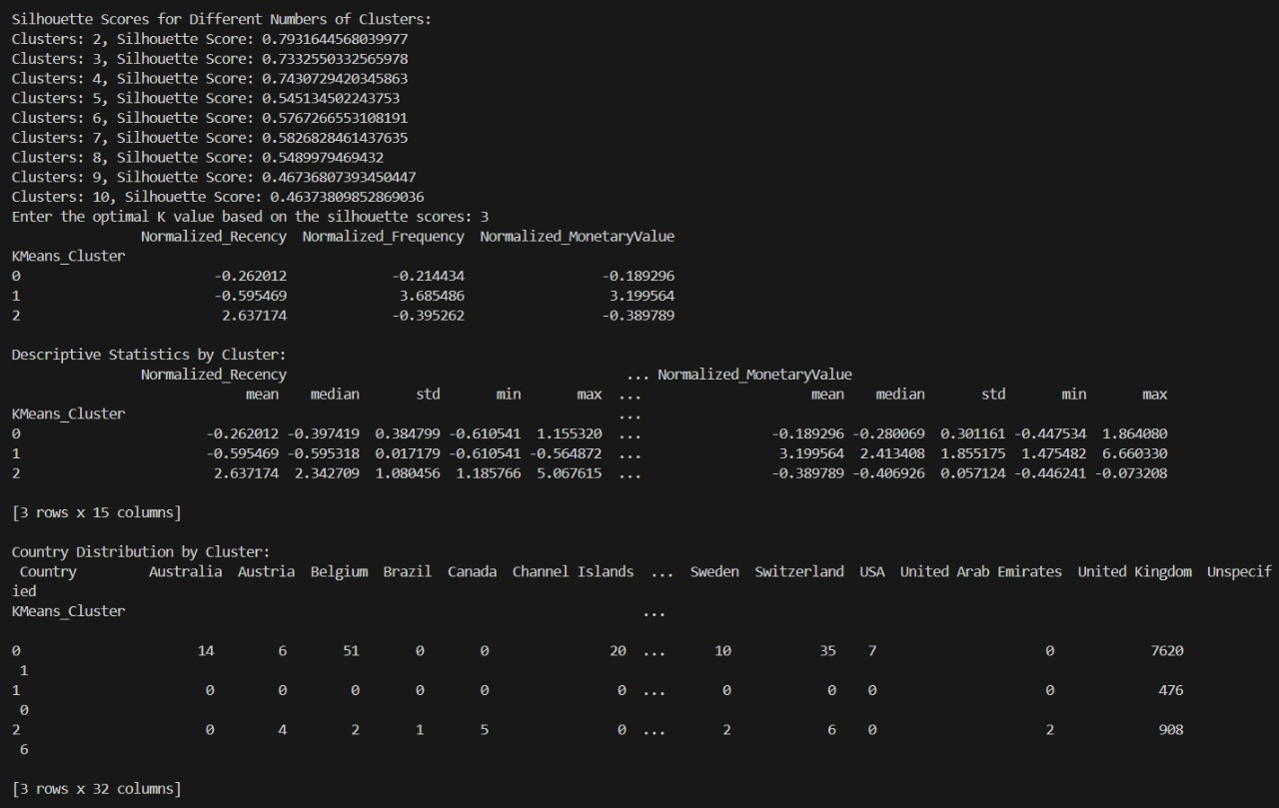
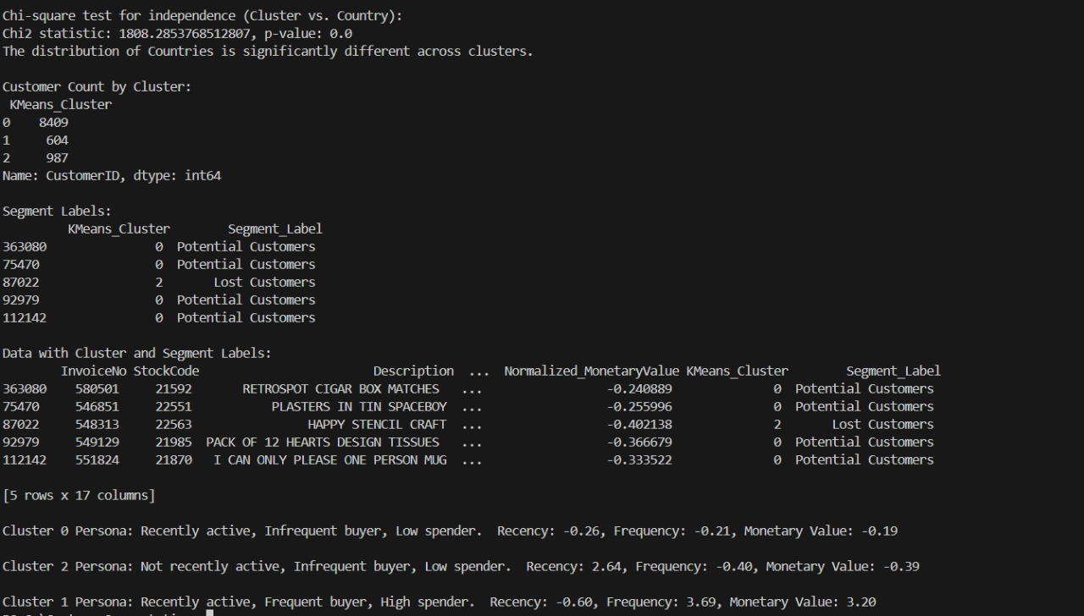

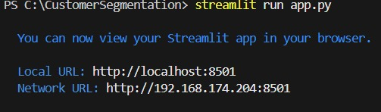
7.2. Charts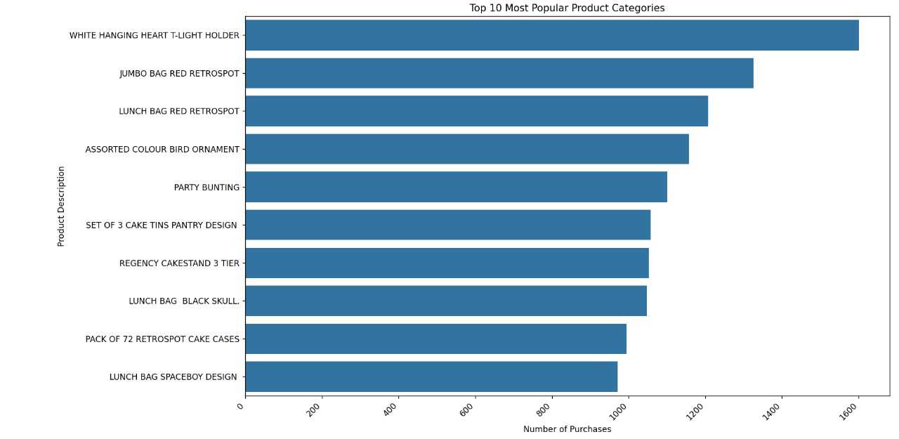
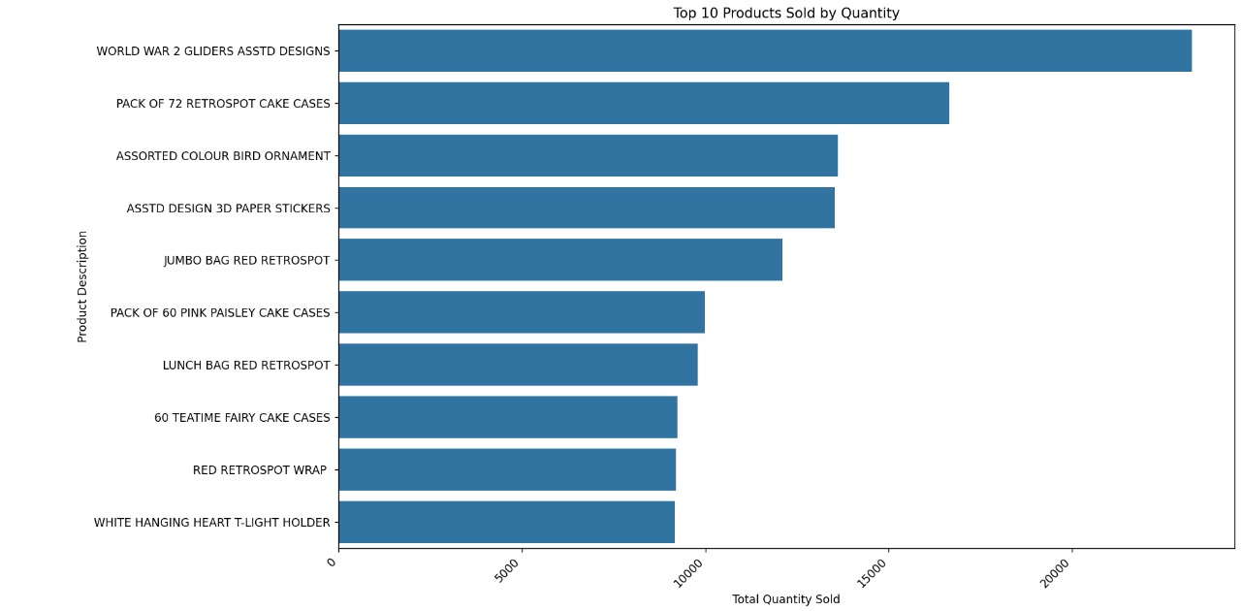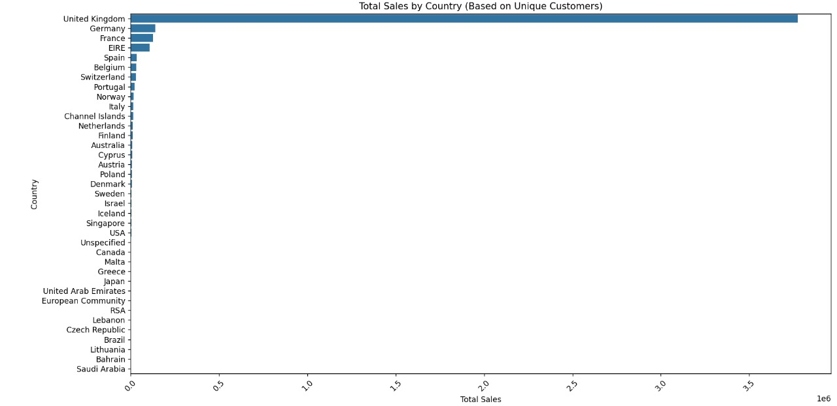
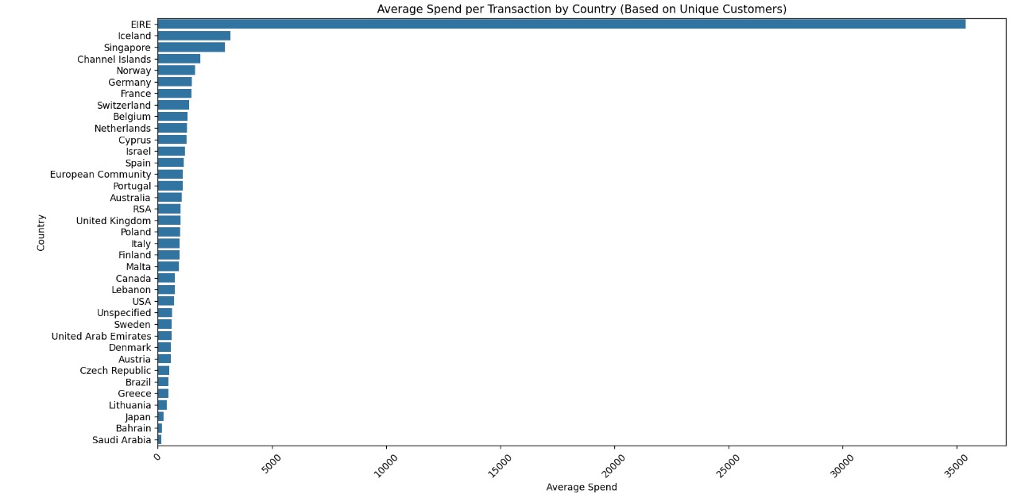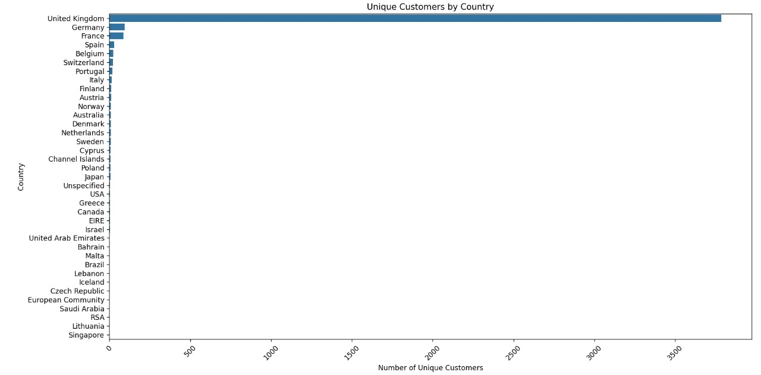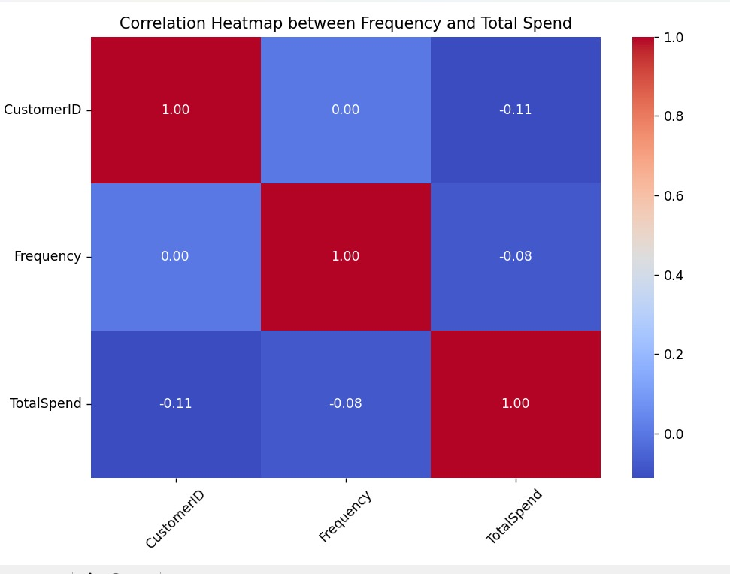
7.3. Optimal K-Value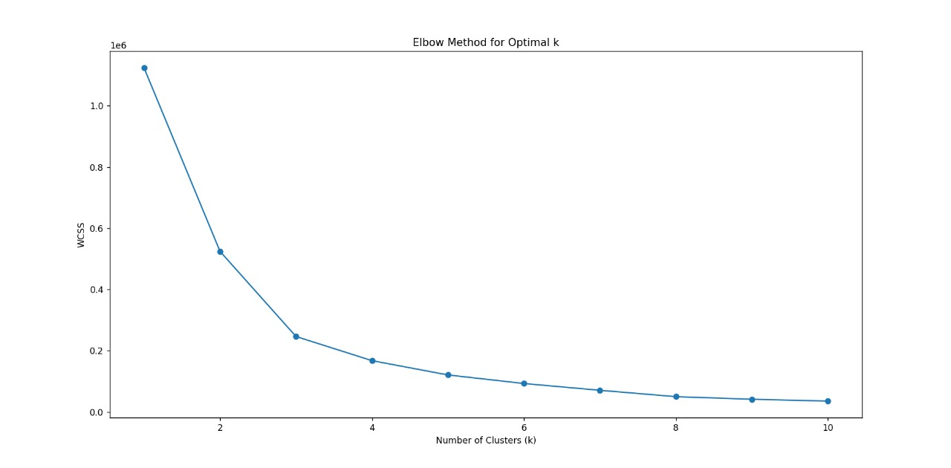

7.4. Clusters 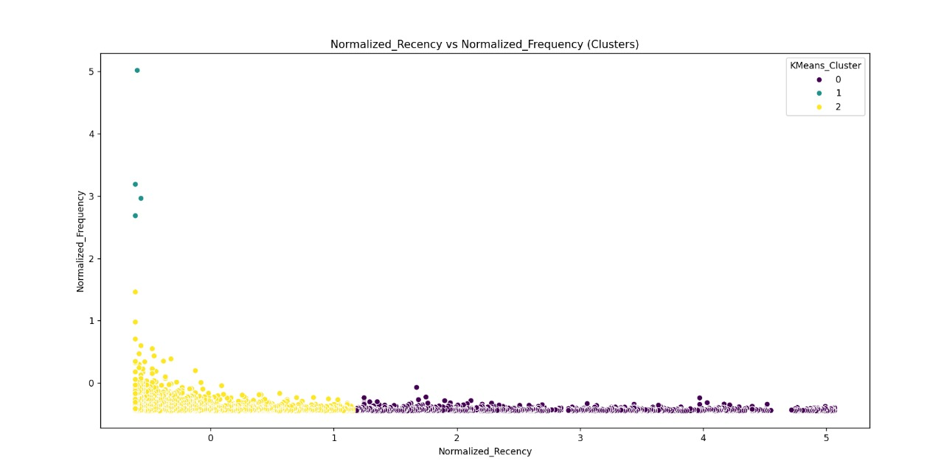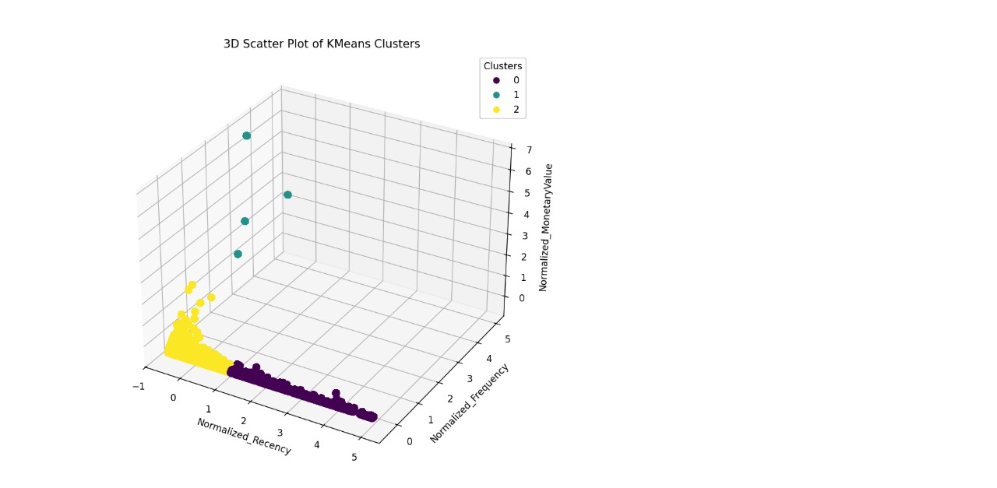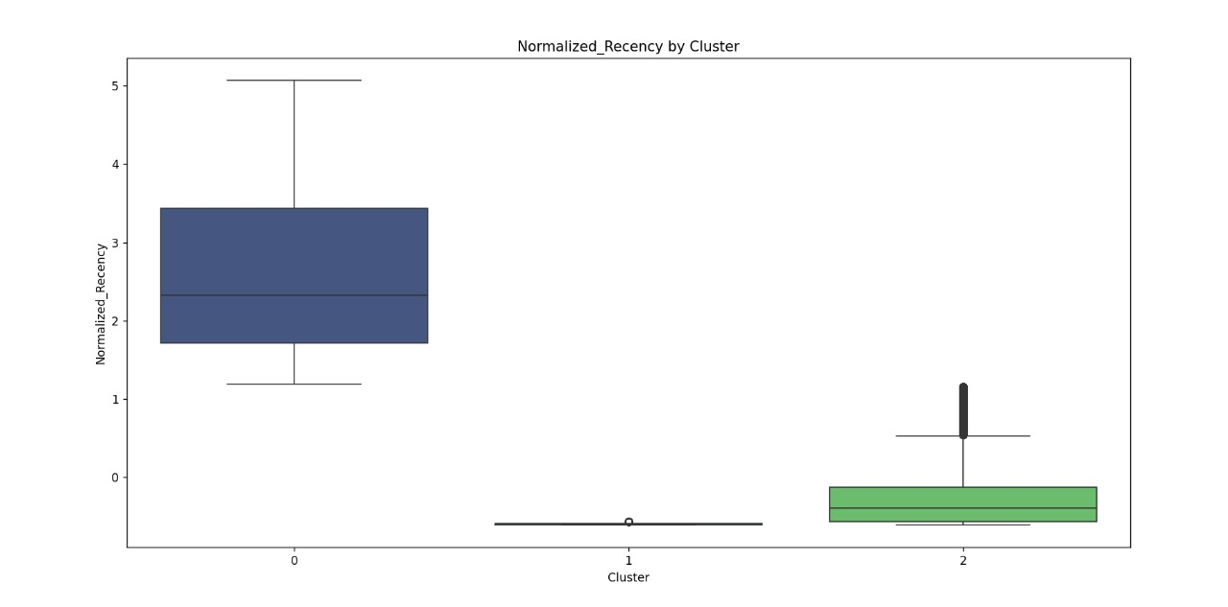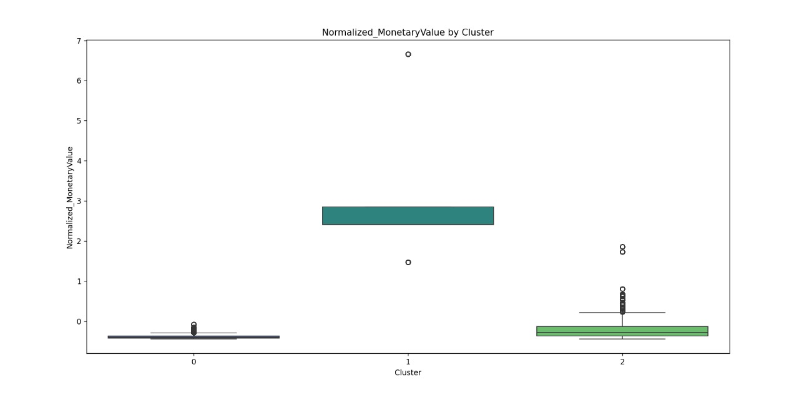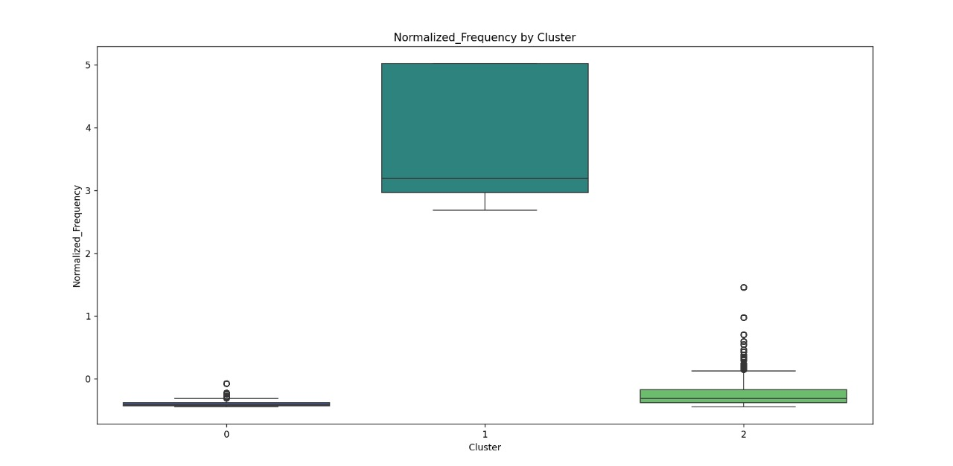
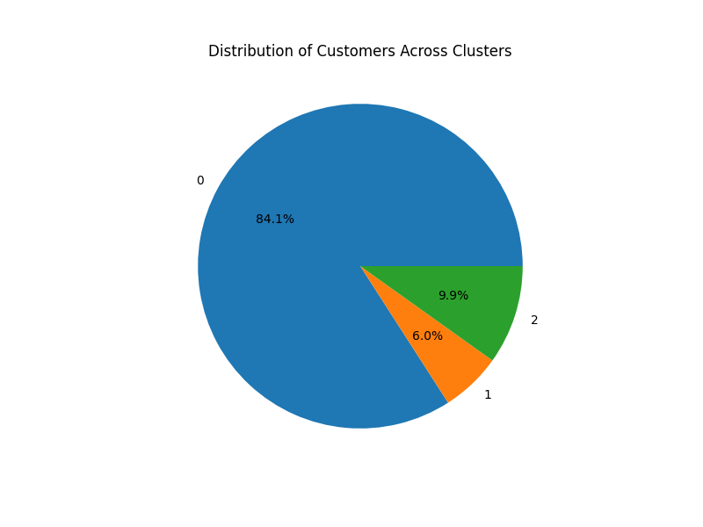
7.4. Streamlit 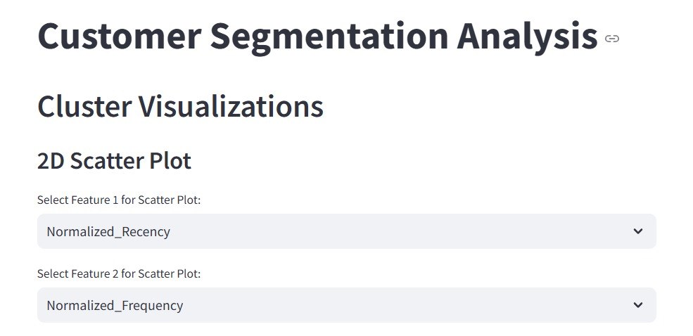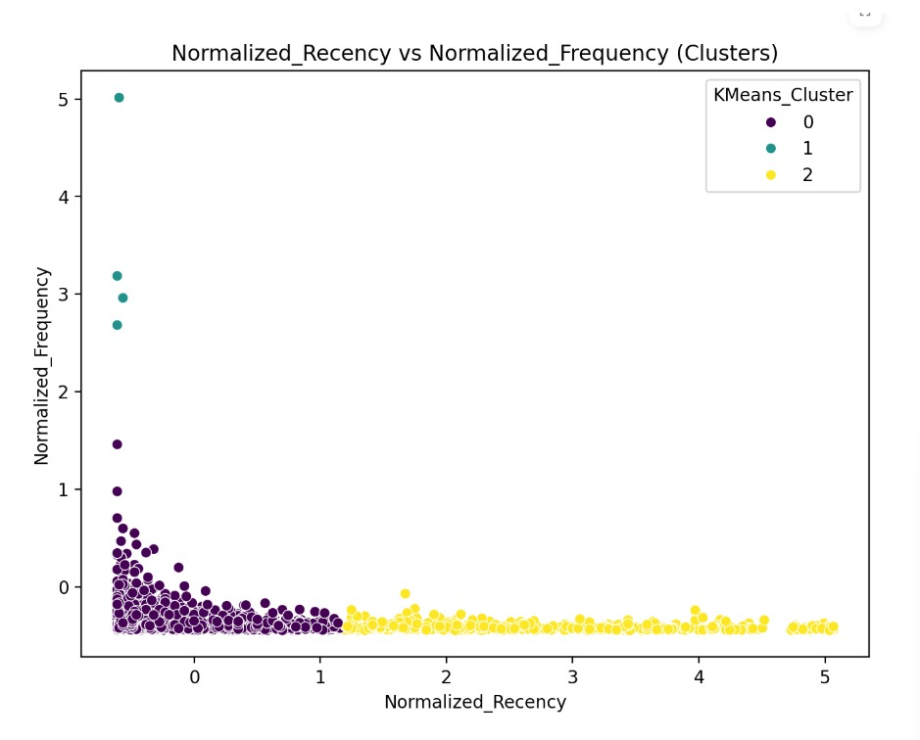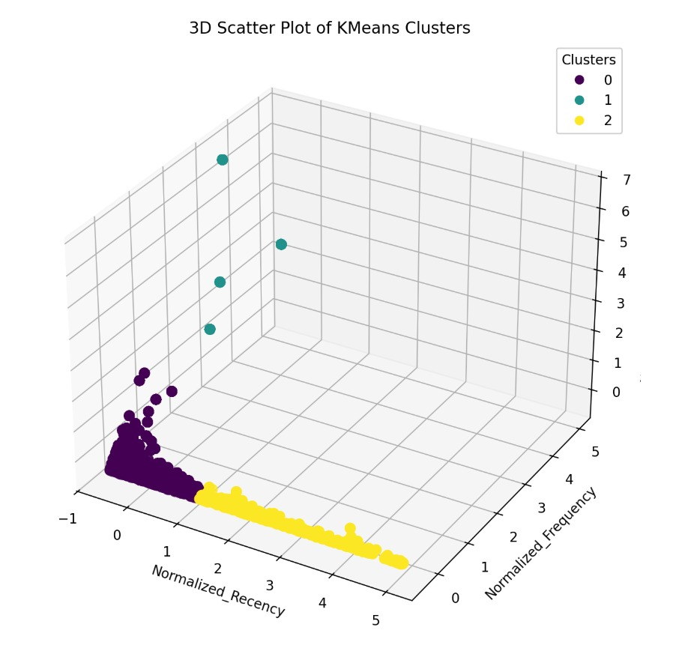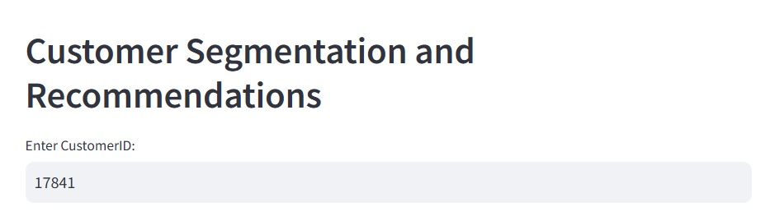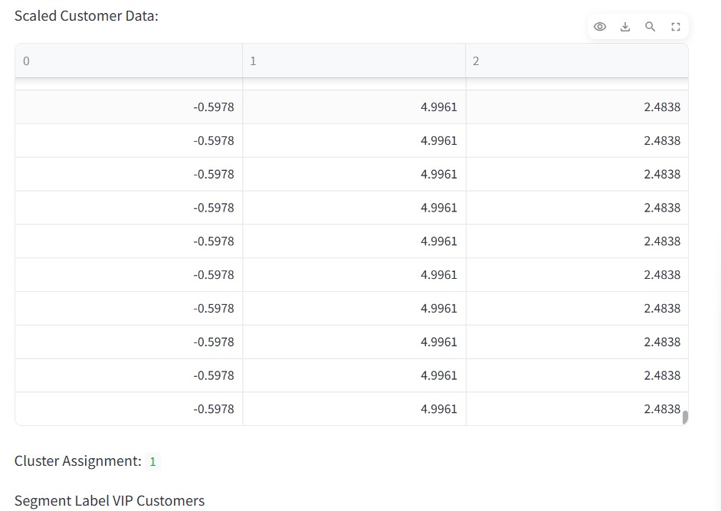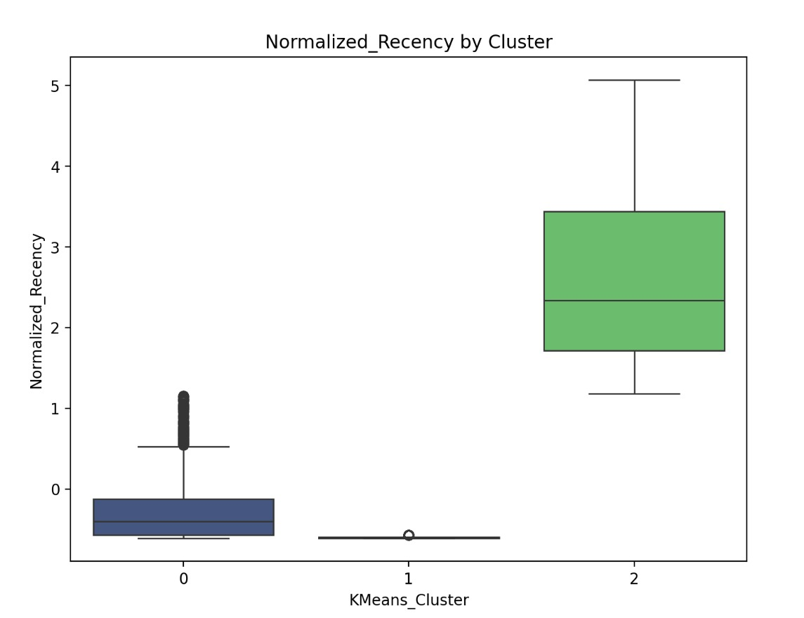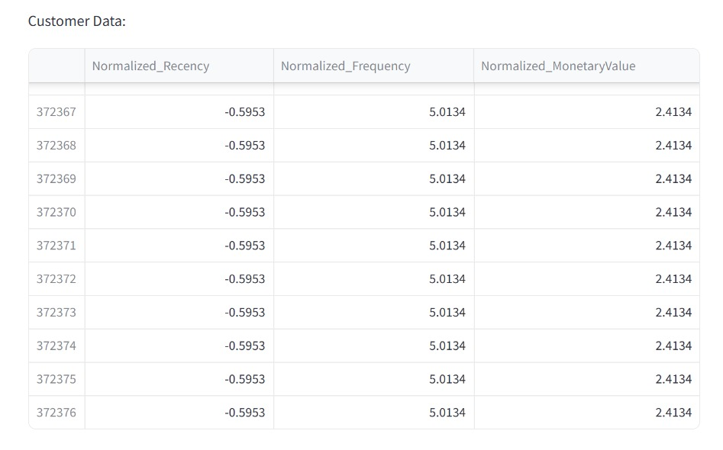

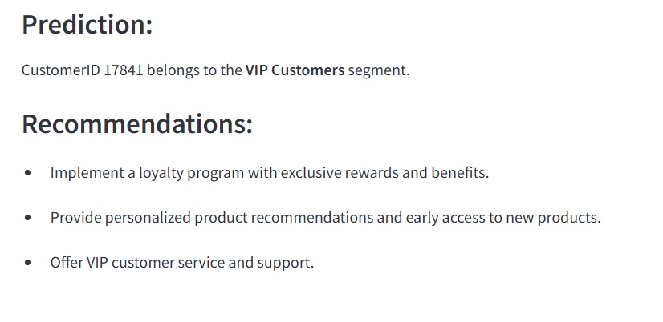

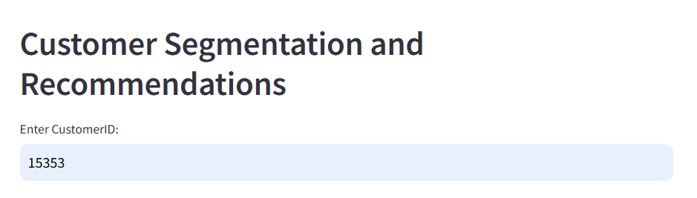

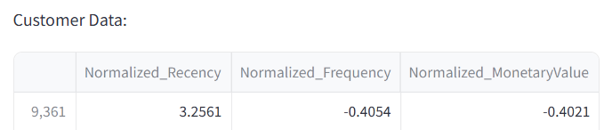

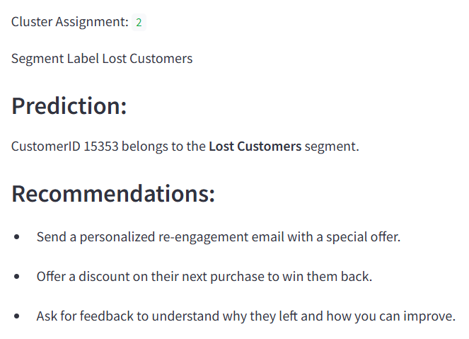

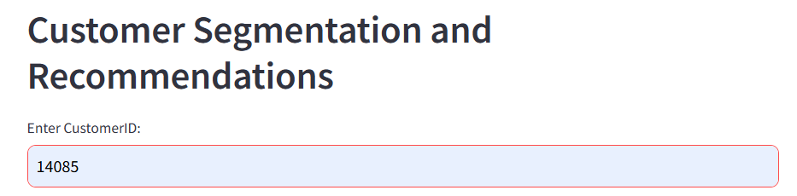

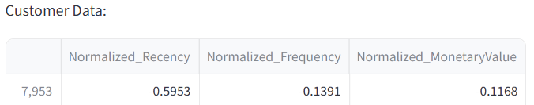

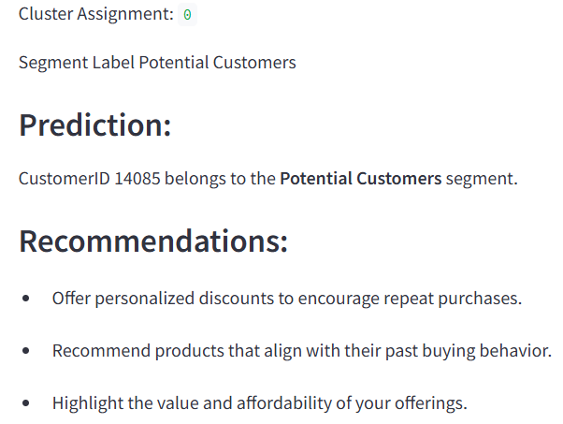

7.6. Code and Algorithms Used
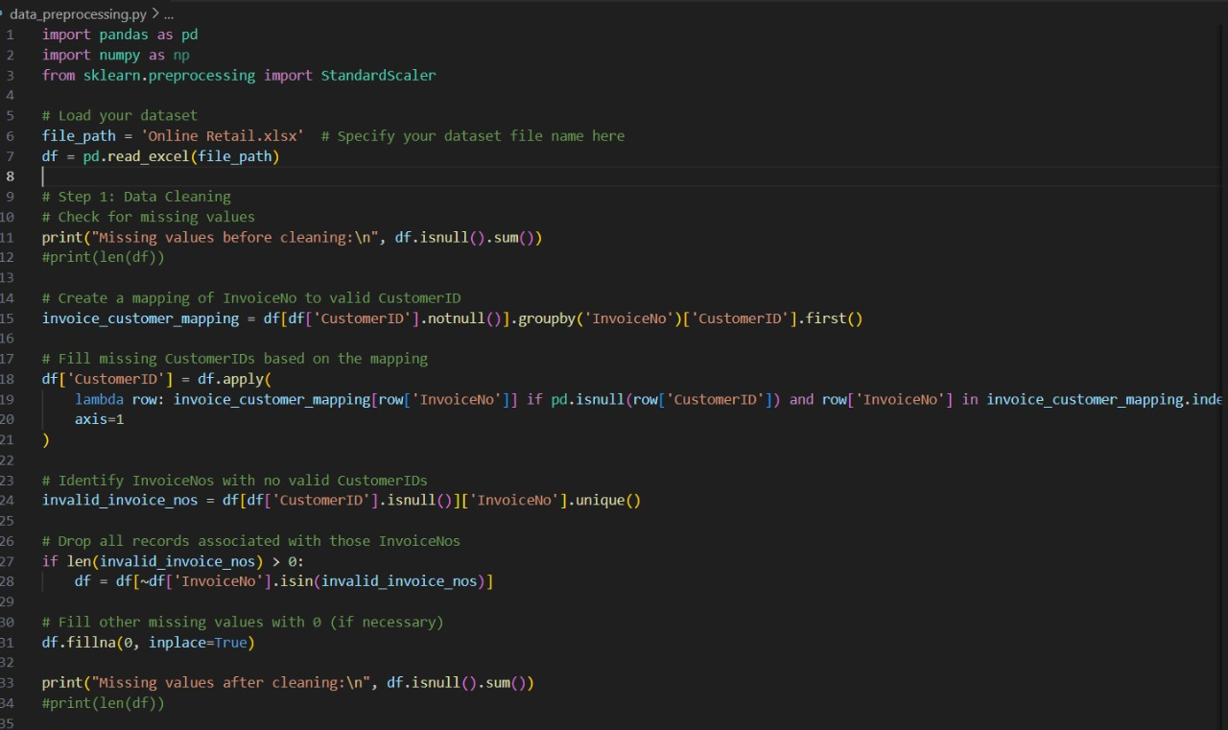
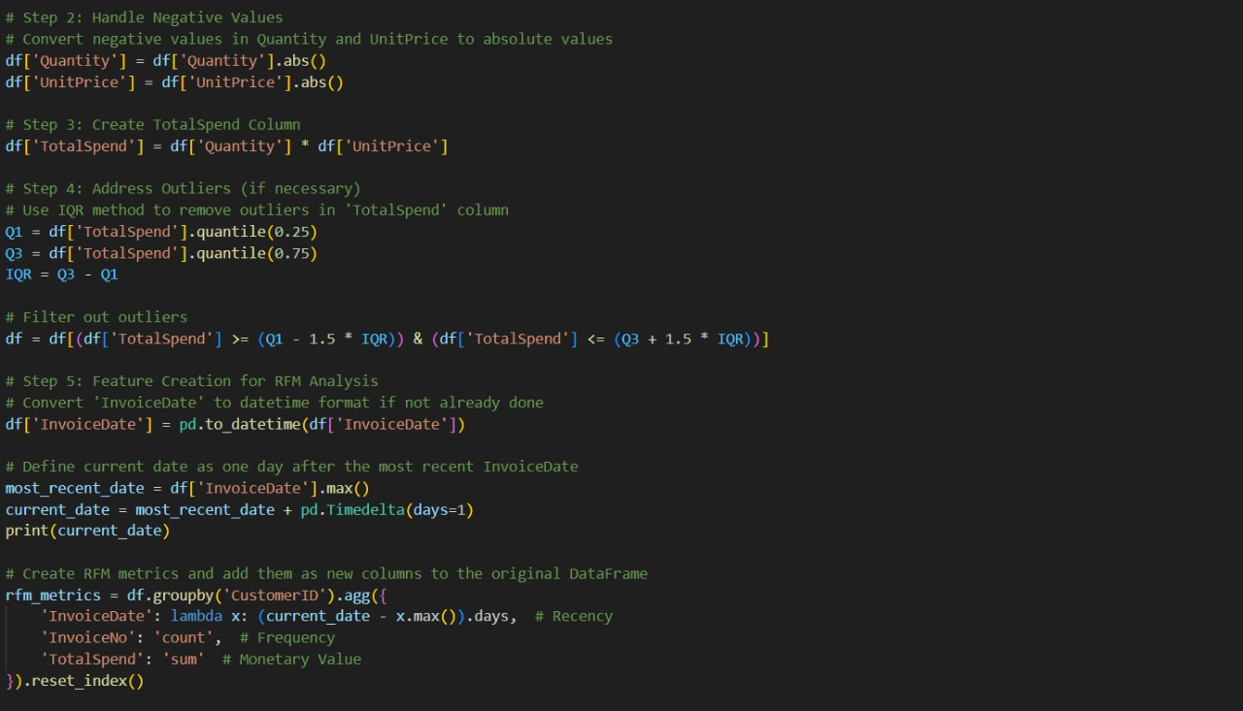

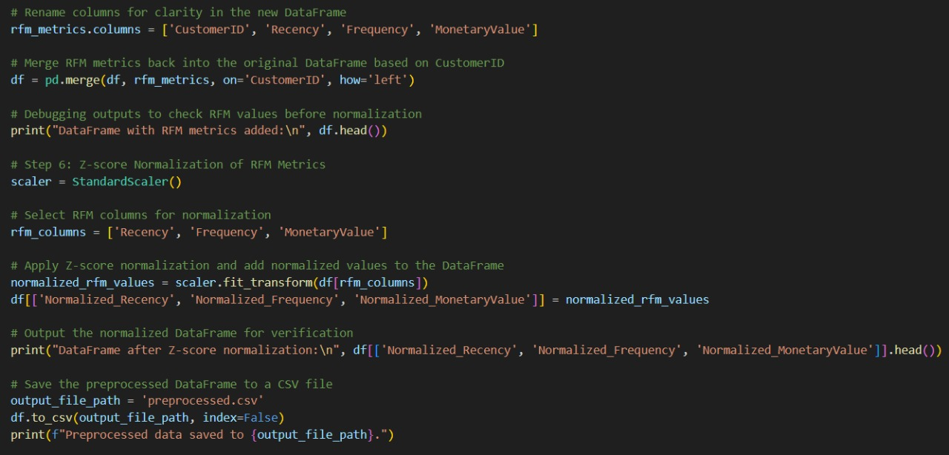
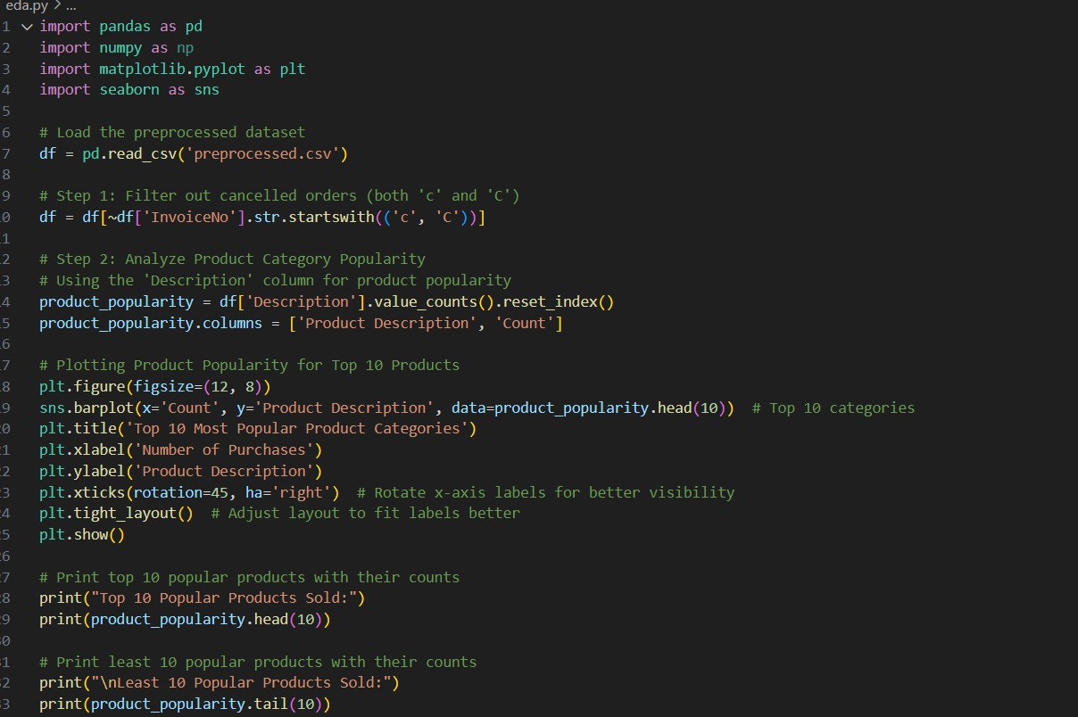
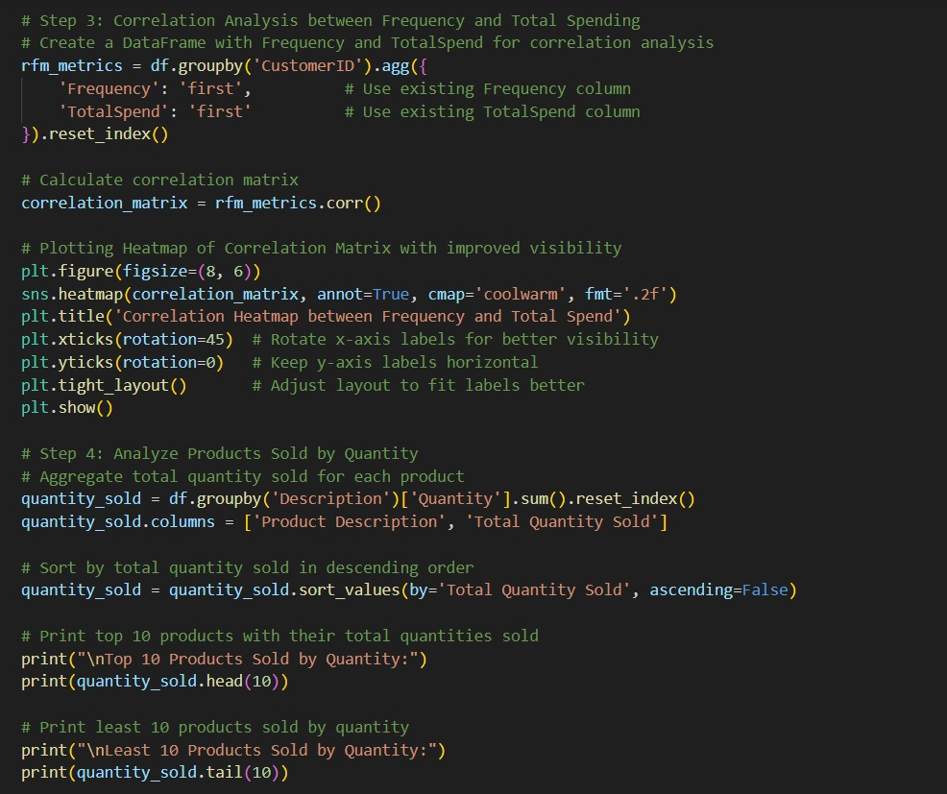
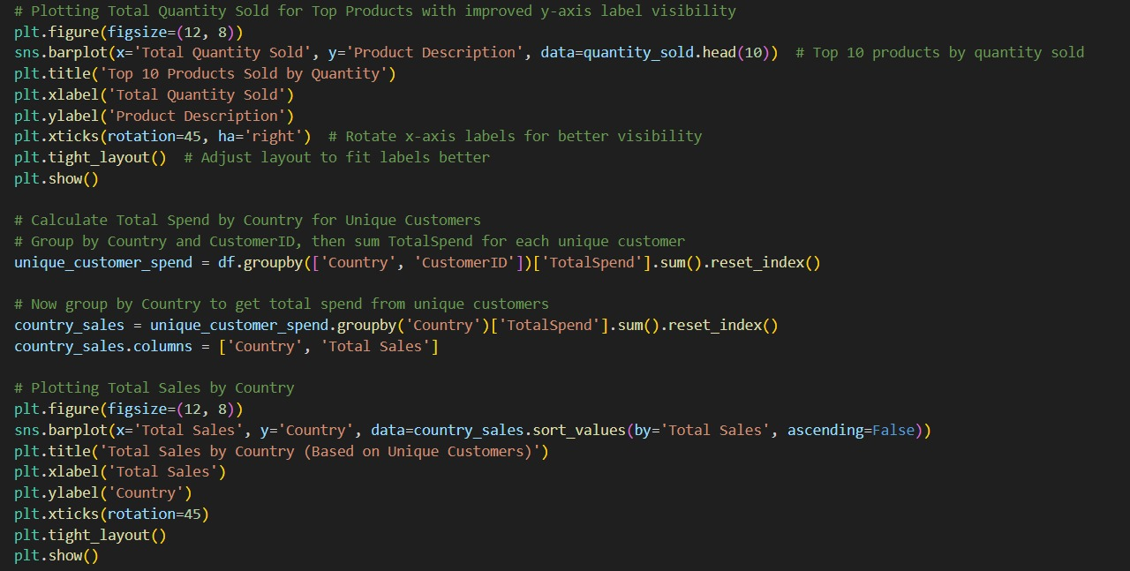
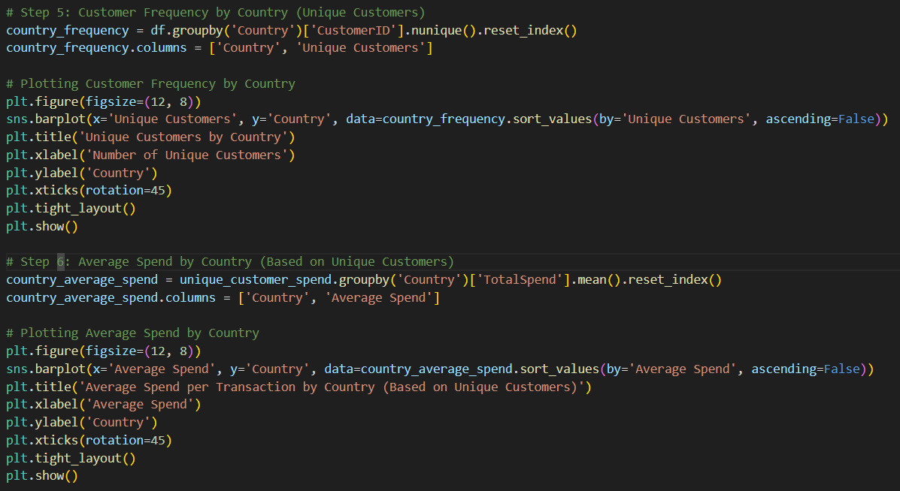
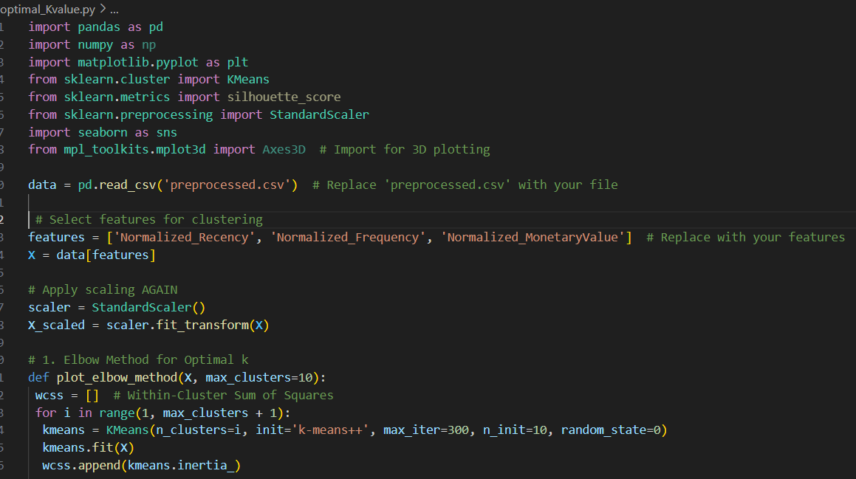
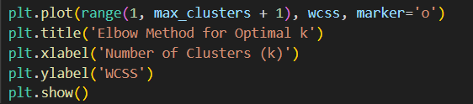
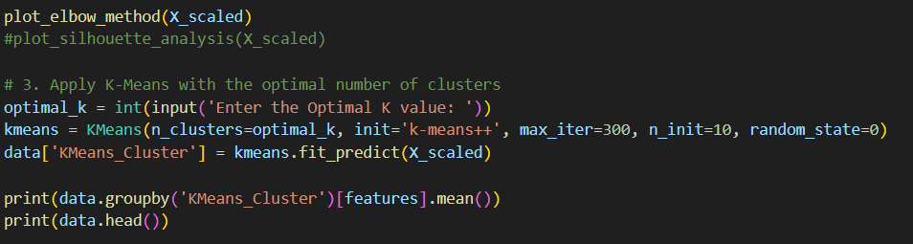
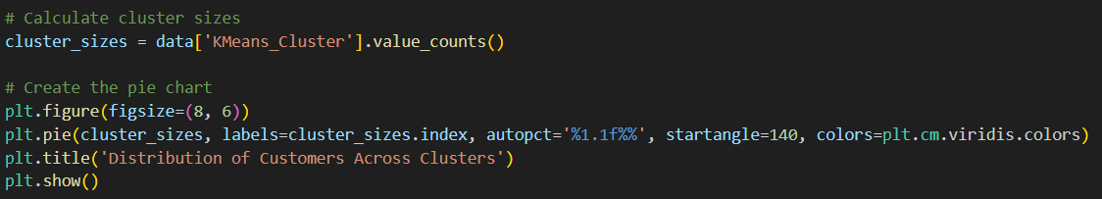
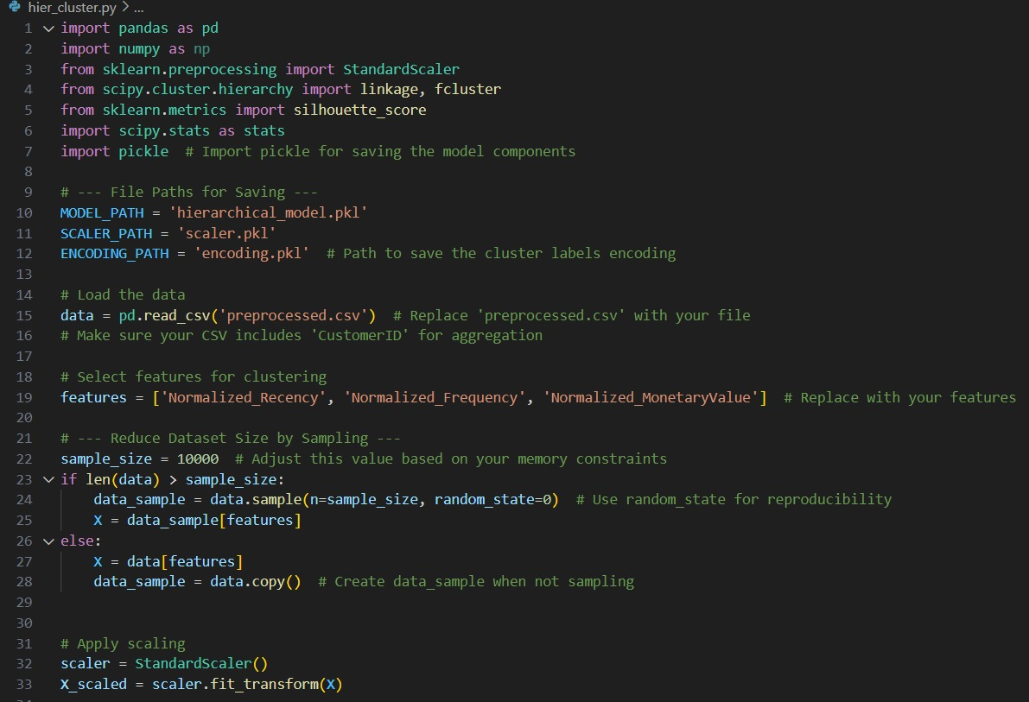
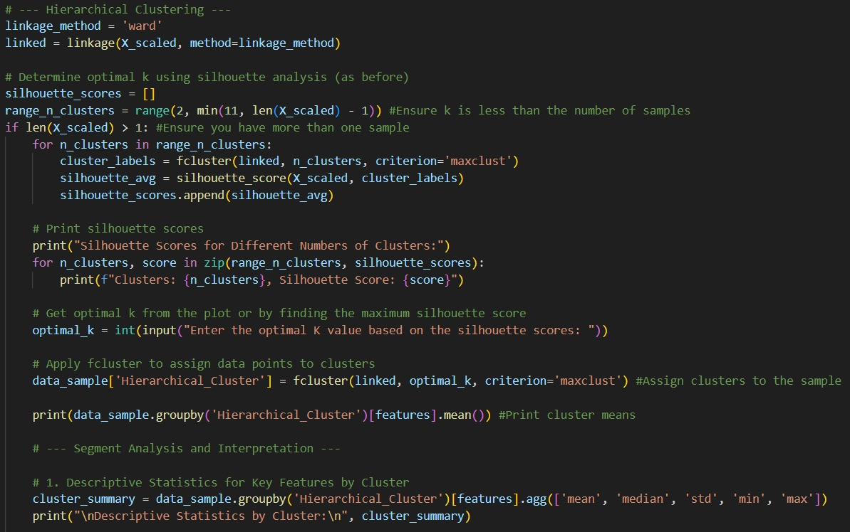
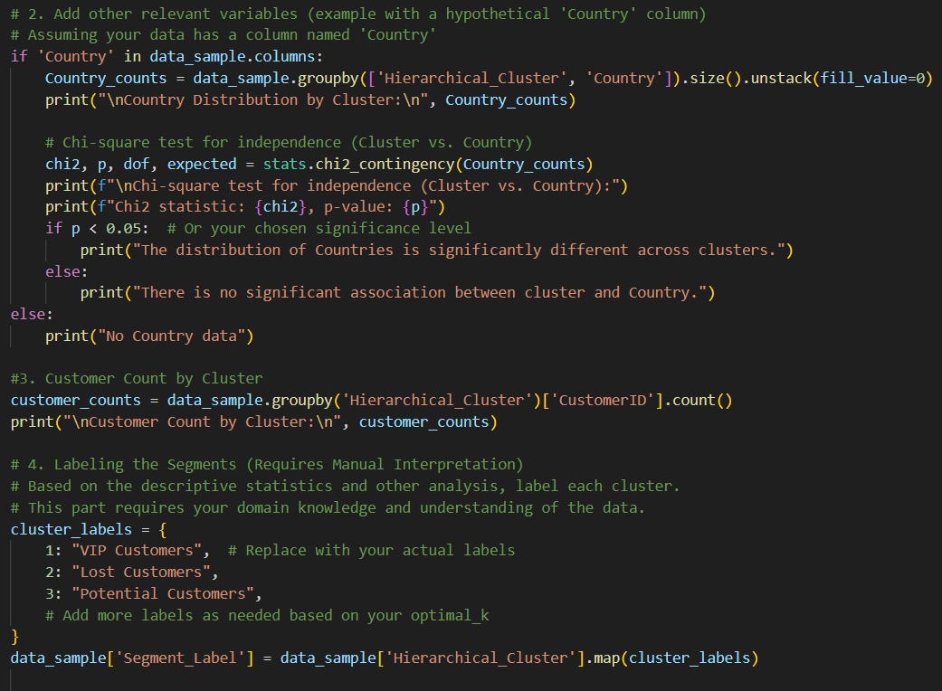
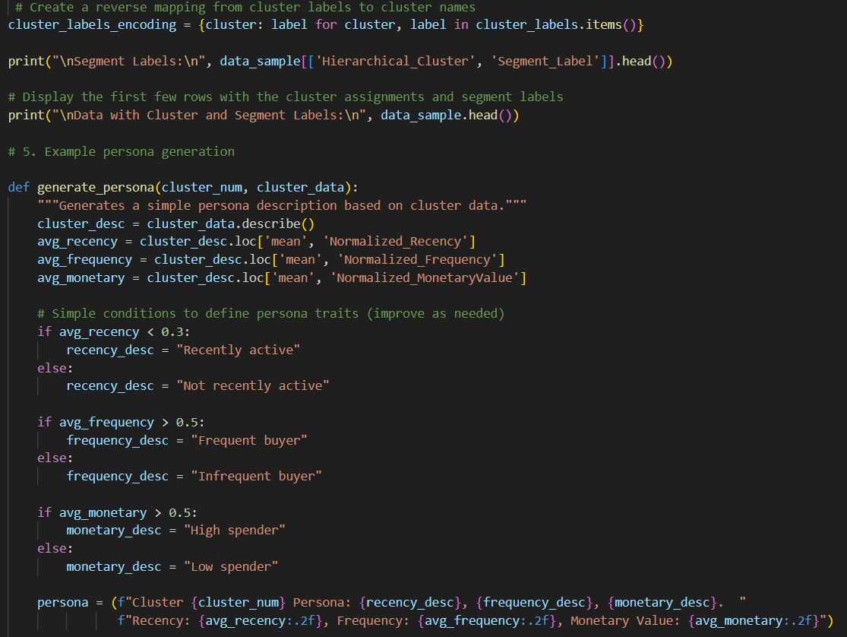
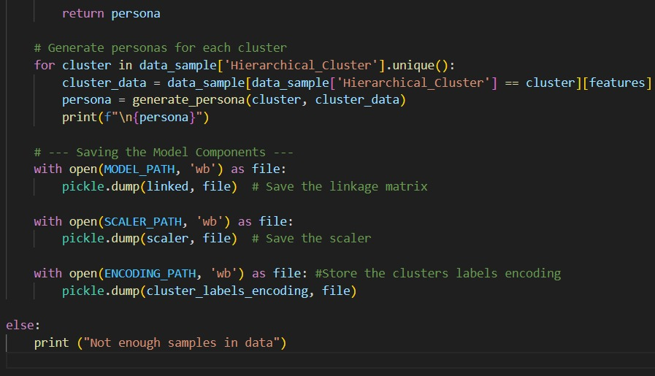
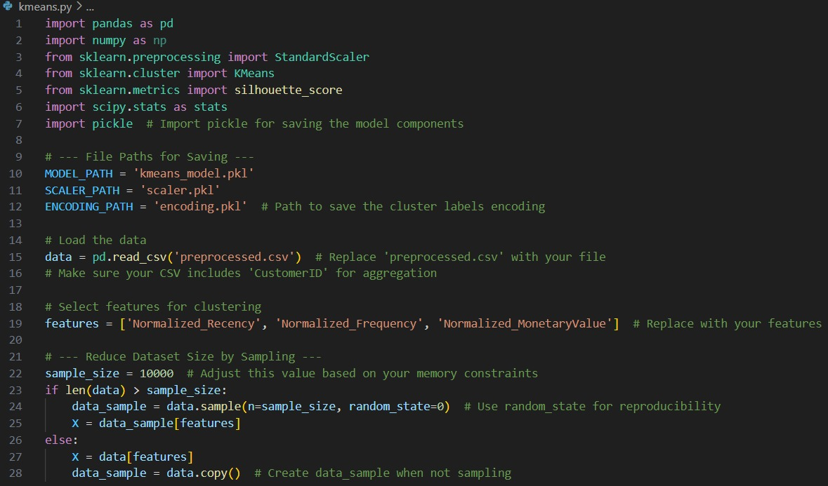
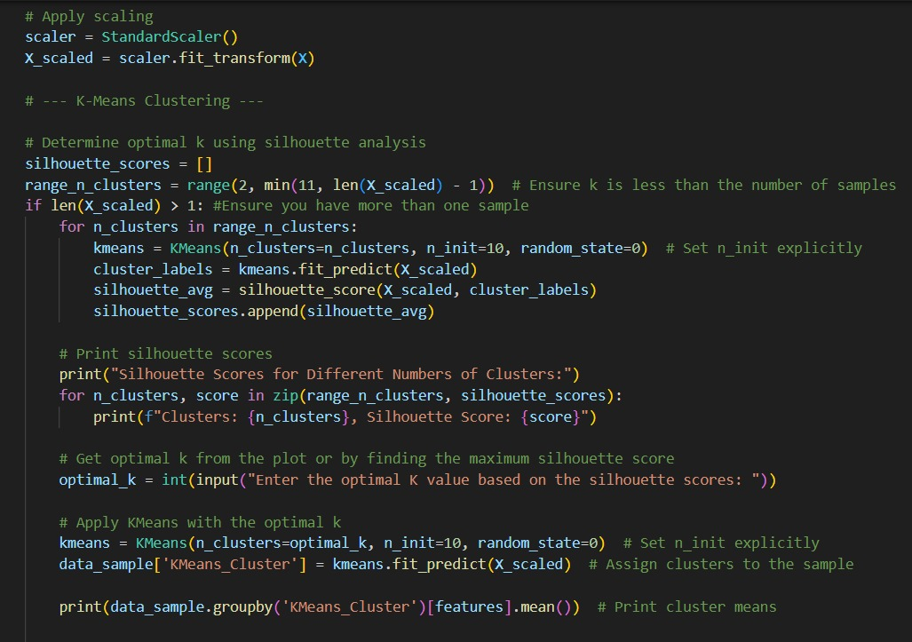
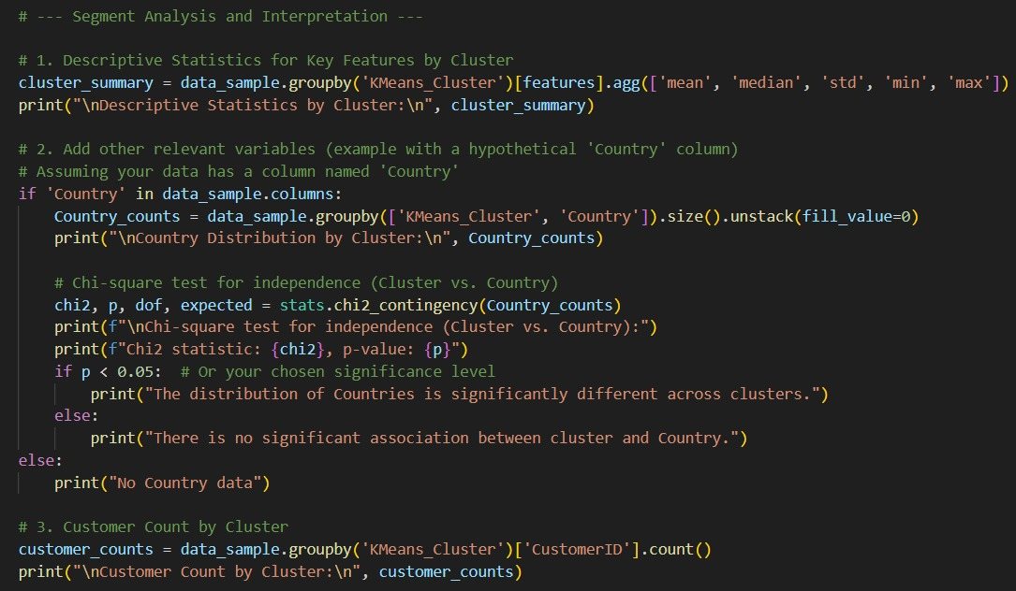
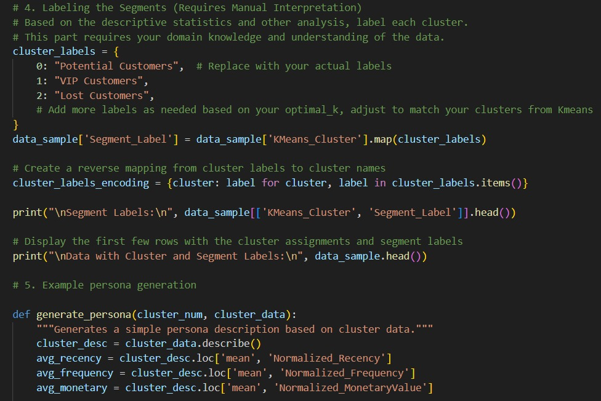
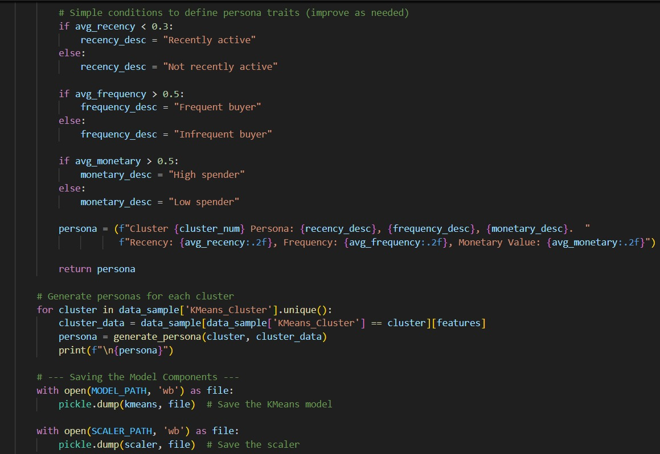
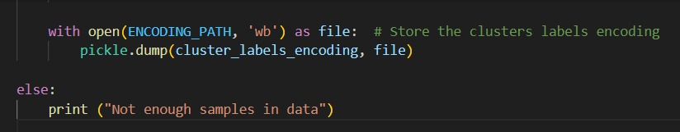
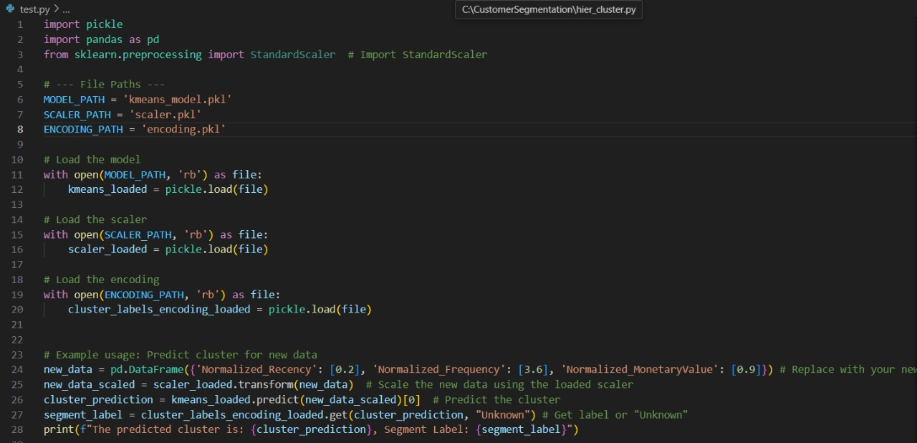
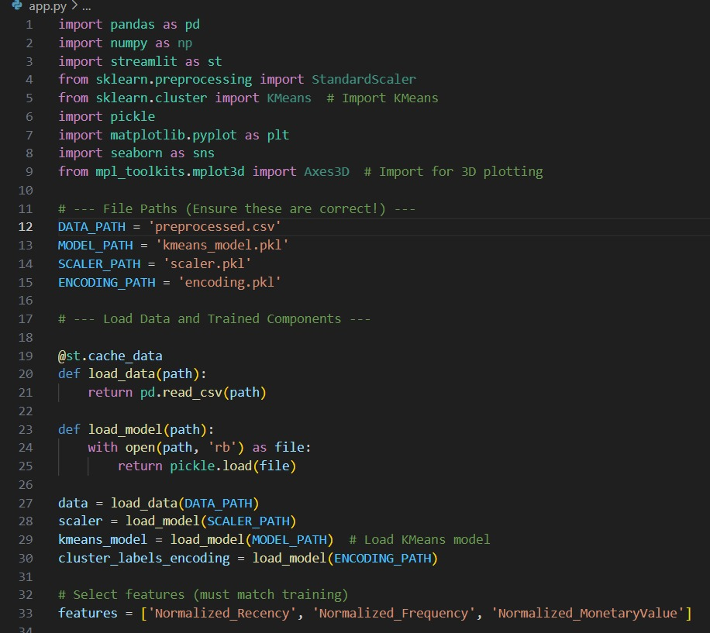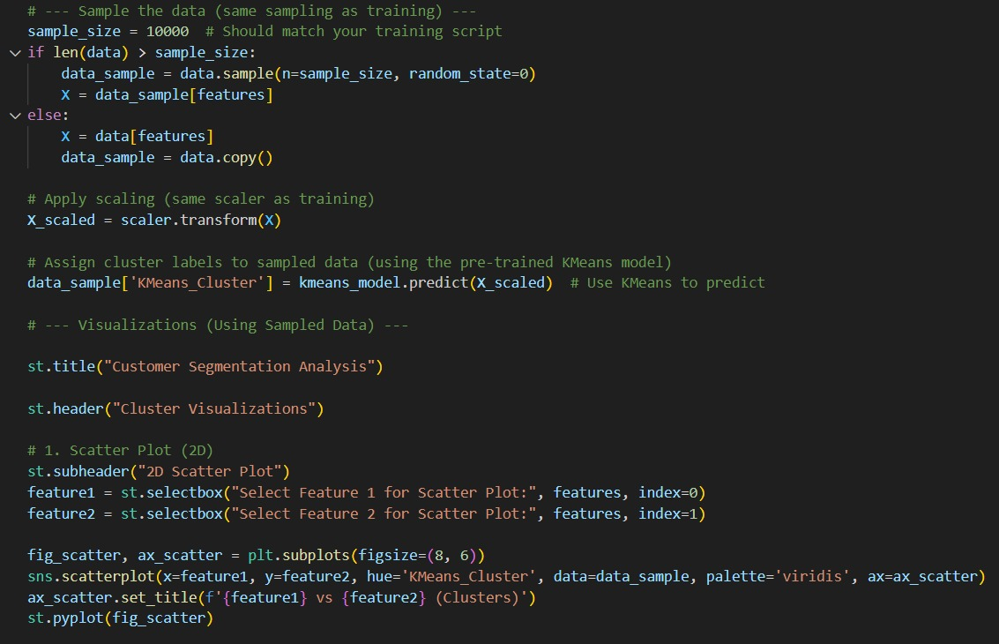
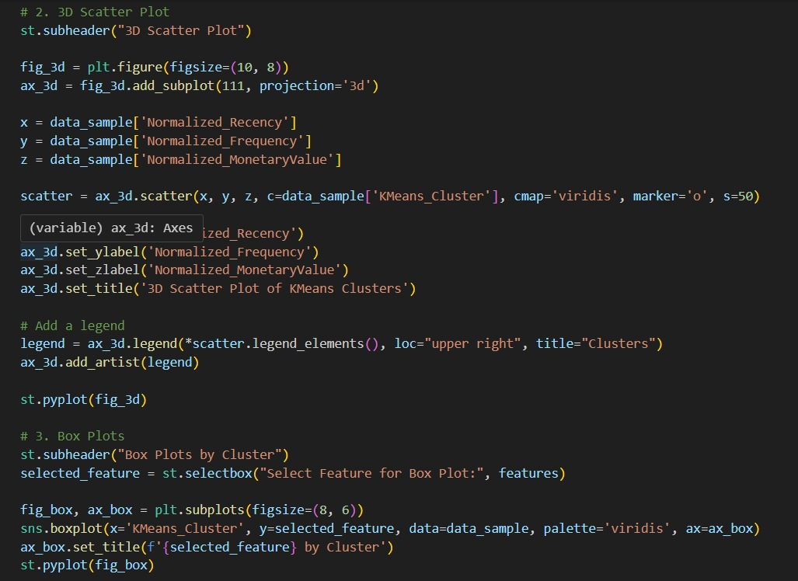
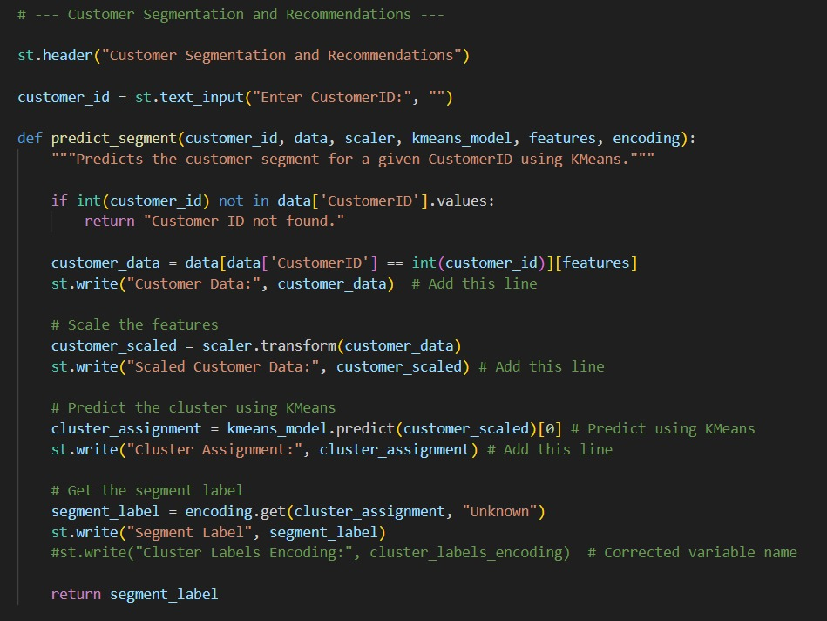
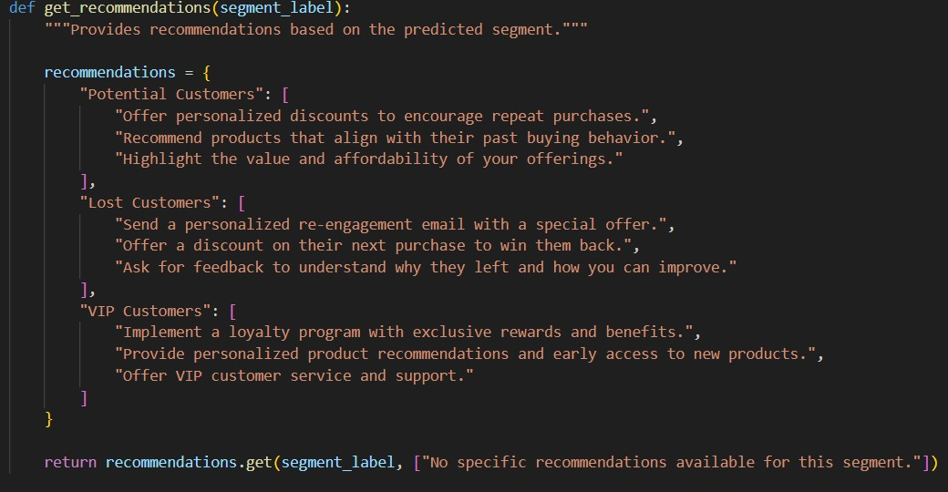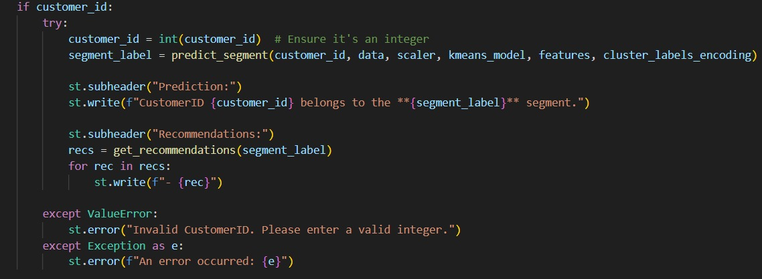

CONCLUSION

Comprised of all approaches to machine learning aimed at customer segmentation, customer behavior analysis, prediction of customer preferences, and personalization, the e-commerce industry has undergone transformational changes. For example, unsupervised K-Means, DBSCAN, and hierarchical clustering methods, as well as supervised algorithm classification, have become pivotal for accentuating marketing campaigns toward retaining customers.
On the other hand, the success of machine learning for customer segmentation would depend upon data quality, feature engineering, and skills in choosing algorithms. Other methods such as RFM (Recency, Frequency, Monetary) analysis, PCA (Principal Component Analysis), and ensemble learning are significantly useful in achieving higher segmentation accuracy regarding useful patterns identified in customer data.
On a broad level, machine learning for customer segmentation has assisted e-commerce companies in *boosting their sales, decreasing customer churn rates, and improving customer satisfaction while optimizing resource utilization*. In an advanced era of technology, the application of AI, deep learning, and real-time analytics for parameters refinement in segmentation models will eventually lead to highly accurate and dynamic customer targeting.

FUTURE ENHANCEMENTS

Machine learning will eventually advance customer segmentation for e-commerce, the focus being on real-time analytics, integration with deep learning, and personalization. Real-time customer segmentation will allow companies to analyze user behavior dynamically to provide quick real-time recommendations and targeted marketing. In uncovering hidden patterns for long-term customer behavior prediction, deep learning methods such as neural networks, autoencoders, and transformers will be harnessed.
XAI methods like SHAP and LIME will foster transparency in segmentation, enabling businesses to make sense of segmentation decisions while aiding their strategic planning. A combination of unsupervised and supervised learning hybrid approaches supplemented with graph-based models will better define customer clusters. Automated Machine Learning (AutoML) makes the processes of model selection and hyperparameter tuning more efficient while decreasing dependency on human interventions.
Reinforcement learning will thus be paramount in enhancing customer interactions because it perpetually interferes with recommendations based on real-time engagement. In addition, other external data sources such as social media insights, geolocation data, and sentiment analysis will enrich the insights on the customer preferences. Segmentation models intend to preserve the privacy of customers' data using federated learning, which allows training across multiple devices without risking exposure of sensitive information.
Cross-channel segmentation will unify all customer data from websites, mobile applications, social media, and offline stores into a 360-degree view of customer interaction. Furthermore, blockchain technology will facilitate secure and transparent data sharing, working against fraud and building trust in AI-driven segmentation. These new capabilities will drive higher accuracy, better engagement, and increased revenues for the e-commerce businesses.

REFERENCES
Books:
Smith, J. (2020). Data Science for E-commerce. Oxford University Press. (2nd edition).
Journal Articles:
Johnson, A., & Lee, M. (2019). Machine learning techniques for customer segmentation in electronic commerce. Journal of Marketing Analytics, 15(3), pp. 45-59.
Websites:
Brown, P. (2021). Customer segmentation and its impact on e-commerce. E-commerce Strategy Conference 2021.
Datasets:
Chen, D. (2015). Online Retail [Dataset]. UCI Machine Learning Repository. https://doi.org/10.24432/C5BW33.

