PHISHING EMAIL DETECTION & AWARENESS SYSTEM

Program: Future Interns Cyber Security Internship
Task: Task 2
Repository: FUTURE_CS_02
Name: HARINI V
Date: May 2026

1. Executive Summary
I analyzed 3 phishing URLs from PhishTank and found that attackers create fake websites to steal user information that look exactly like real ones — such as banks, shopping sites, or email providers. The goal is to trick users into entering their personal details, login credentials, or banking information. Once the victim enters their details, the attacker steals them and uses them for financial fraud or identity theft.
In this report, I analyzed 3 verified phishing URLs collected from PhishTank — a public phishing database. Each URL was examined to identify:
- What brand it was impersonating
- What technique the attacker used
- What risk it poses to victims
- How users can stay safe

2. Methodology
Source: PhishTank (phishtank.com) — a public database of verified phishing websites.
Steps followed for each sample:
- Checked the domain for suspicious elements
- Identified the phishing technique used
- Assessed the risk to victims
- Suggested prevention methods
Tools Used:
Tool | Purpose
PhishTank | Collecting phishing samples
Browser | Viewing technical details
WPS Office | Writing the report

Sample 1: SMBC Bank
Phishing URL: smbc-card.6688expo.com Classification: Phishing
Risk Level: High
Field | Details
Submission ID | #9423191
Target Brand | SMBC Card — Japanese bank
Suspicious Domain | Random numbers in 6688expo.com
Technique | Subdomain Spoofing
Hosted On | Cloudflare
Finding: The URL impersonates SMBC Card by placing smbc-card before the fake domain 6688expo.com. Real banks never use random numbers in their domain. If a victim enters their login details, the attacker can steal their credentials and money.
Prevention:
- Check the full URL carefully
- Look for HTTPS and padlock
- Never click links from emails

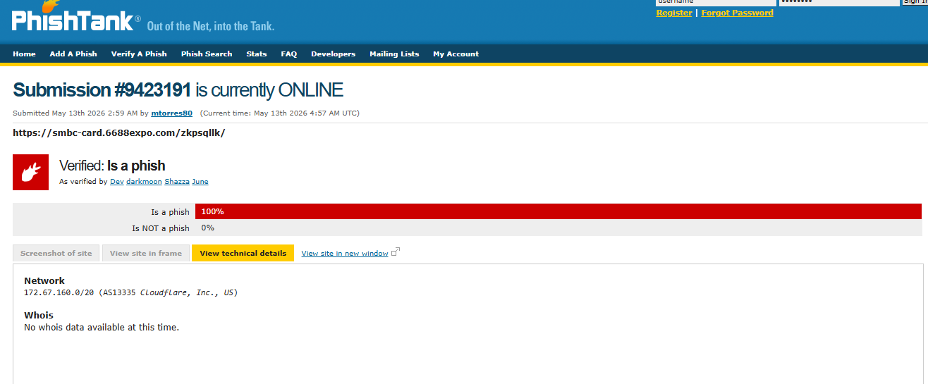

Sample 2: Allegro Lokalnie
Phishing URL: allegro-lokalnie.761273129gf-230.lat
Classification: Phishing Risk Level: High
Field | Details
Submission ID | #9423209
Target Brand | Allegro Lokalnie — Polish online marketplace
Suspicious Domain | Random numbers 761273129gf-230 + unusual .lat extension
Technique | Subdomain Spoofing + No HTTPS
Hosted On | Unknown — Network lookup pending
Finding: Allegro Lokalnie is a real brand but this website is completely fake. The domain contains random numbers and letters which no real company would use. The real Allegro uses .pl domain — not .lat. The URL also uses HTTP instead of HTTPS meaning the connection is not encrypted. If a victim tries to login or shop here, the attacker can steal their card details and money.
Prevention:
- Verify sender email — official Allegro emails come from @allegro.pl
- Never shop on sites using HTTP — always HTTPS
- Check domain carefully before entering card details
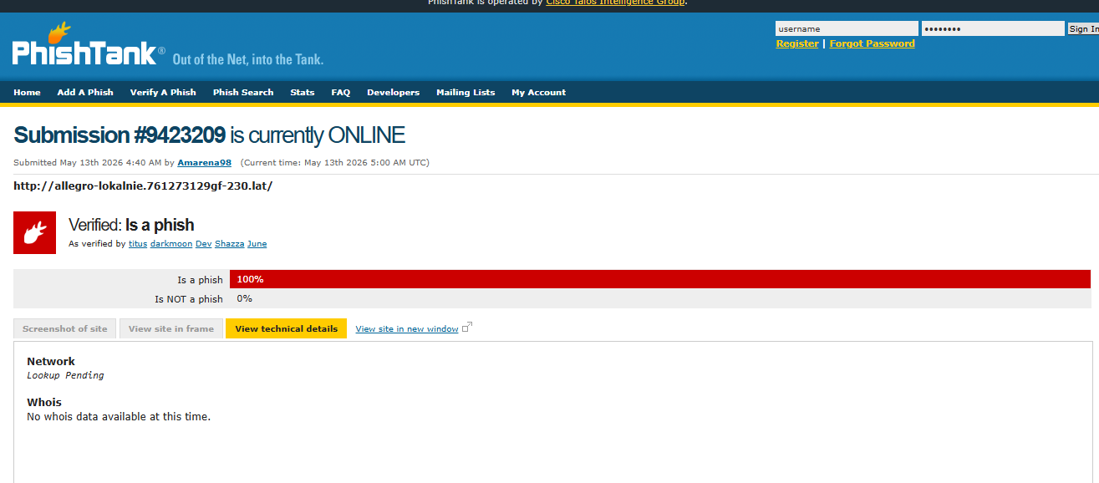

SAMPLE 2 — MOBILE DEVICE PHISHING WEBSITE
Phishing URL:
http://mobiledevice-lbpiaccess.de
Classification:
Phishing
Risk Level:
High

Technical Details
Field | Details
Domain | mobiledevice-lbpiaccess.de
Hosting | Cloudflare
Technique Used | Suspicious Domain / Credential Harvesting
Status | Online
Threat Type | Phishing Website

Prevention Guidelines
• Avoid clicking unknown or suspicious links
• Verify website URLs carefully before entering credentials
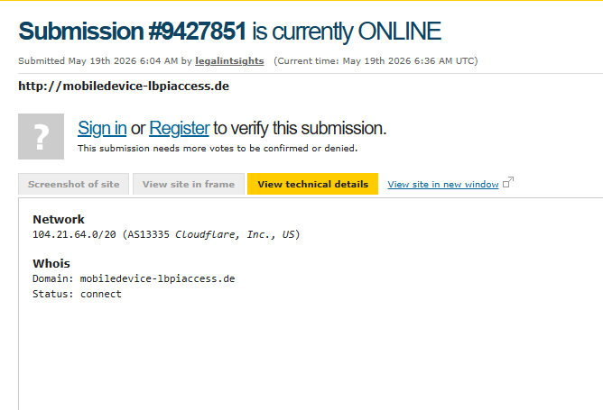

Risk Summary Table

All 3 phishing URLs were verified as 100% phishing by PhishTank. Here is a summary of all samples analyzed:

 | Target Brand | Phishing URL | Technique | Risk Level
1 | SMBC Bank | smbc-card.6688expo.com | Subdomain Spoofing | High
2 | Allegro Lokalnie | allegro-lokalnie.761273129gf-230.lat | Subdomain Spoofing + No HTTPS | High
3 | Mobile device | Mobiledevice-lbpiaccess.de | Domain Lookalike | High

Key Observations:
- All 3 phishing URLs were actively online at the time of analysis
- Subdomain Spoofing was the most commonly used technique
- All attackers hid their WHOIS information to avoid detection
- Cloudflare was used in 2 out of 3 cases to mask the real server
- All 3 attacks targeted financial or commercial brands to maximize theft

Prevention Guidelines

Prevention & Awareness Guidelines

For Users:
- Always verify the full URL before entering any personal or banking details
- Check that the website uses HTTPS and shows a padlock in the address bar
- Never click links from emails — type the official website address directly in the browser
- Always verify the sender email — official brands use their own domain (e.g. @allegro.pl, @raiffeisen.at)
- Never share OTP, account number or password through email or any link — real banks never ask for these online
- If something looks suspicious — call the company directly using the number from their official website
For Organizations:
- Enable Multi Factor Authentication (MFA) on all employee accounts
- Configure SPF, DKIM and DMARC records to prevent email spoofing
- Use email filtering tools to block phishing emails automatically
- Conduct regular phishing awareness training for all employees
- Maintain an updated blocklist of known phishing domains

Conclusion
In this report, I analyzed 3 verified phishing URLs collected from PhishTank. All 3 URLs were confirmed as 100% phishing and were actively online at the time of analysis.
The attackers used techniques such as Subdomain Spoofing and Domain Lookalike to create fake websites that closely resembled real brands like SMBC Bank, Allegro Lokalnie and Raiffeisen Bank. The main goal of these attacks was to steal victims' login credentials, banking details and money.
The key lesson from this analysis is that users should always verify the URL carefully, check the sender email, and never share sensitive information through email links. Real banks and companies will never ask for OTP or passwords through email.

References
Source | Link
PhishTank | phishtank.com
Sample 1 | Submission #9423191
Sample 2 | Submission #9423209
Sample 3 | Submission #9427851
Github repository

