**A Comprehensive Analysis of Financial Performance: Insights from aLeading Banks**

**1.INTRODUCTION :**

**1.1 OVERVIEW:**

The banking industry world-wide is being transformed. The global forces for change include technologicalinnovation; the deregulation of financial services at the national level and opening-up to international competition; and - equally important - changes in corporate behavior, such as growing disintermediation and increased emphasis on shareholder value. In addition, recent banking crises in Asia and Latin America have accentuated these pressures. The banking industries in central Europe and Latin America have also been transformed as a result of privatizations of state-owned banks that had dominated their banking systems in the past. In this project we are trying to analysis the bank related data and able to extract some insights from the data using Business Intelligence tools. To Extract the Insights from the data and put the data in the form of visualizations, Dashboards and Story we employed Tableau tool.

**1.2 PURPOSE:**

This session introduces bank financial statements and provides a traditional, ratio-based procedure for analyzing bank financial performance using historical data. It demonstrates the interrelationship between Rank,assests & Assests Propotion . Data are provided that compare the performance characteristics of small banks versus large banks and differentiate between high and low performers arround the world.

**2. PROBLEM DEFINITION & DESIGN THINKING:**

**Business requirements:**

The business requirements for analyzing the performance and efficiency of banks

in world include identifying KPIs, comparing performance across different

countries and states, identifying patterns and trends over time, identifying

affecting factors, creating interactive dashboards and reports, identifying areas for

improvement, making data-driven decisions, comparing to the industry average

and creating forecasting models for future performance. The ultimate goal is to

gain insights and improve performance through data visualization techniques

**Literature Survey :**

A literature survey for the financial analysis of banks would involve researching

and reviewing previous studies, articles, and reports on the topic. This could

include information on the methods and techniques used for financial analysis of

banks, as well as the results and conclusions of these studies. Some potential areas

of focus for a literature survey on financial analysis of banks could include:

Ratio analysis, which involves comparing different financial metrics (such as

return on assets, return on equity, etc.) to assess a bank's performance and

compare it to industry averages or other benchmarks.

Stress testing, which involves simulating adverse economic scenarios to evaluate

a bank's ability to withstand financial shocks.

Risk management, which involves identifying, assessing, and mitigating the

various risks facing a bank, such as credit risk, market risk, and operational risk.

Basel III, which is a set of international regulatory standards for banks that

includes measures for capital adequacy, liquidity, and leverage.

Social or Business Impact.

Social Impact: Financial analysis of banks can have a significant social impact by

identifying areas where the bank's operations or lending practices may be causing

harm to vulnerable communities or perpetuating inequality. For example, a

financial analysis might reveal that a bank is heavily invested in fossil fuel

companies, contributing to climate change, or that the bank is disproportionately

denying loans to minority-owned businesses, perpetuating economic

discrimination

**Business Model/Impact:**

Financial analysis of banks can have a significant impact

on the business operations of the bank itself and its competitors. For example, a

financial analysis can help the bank identify areas where it is underperforming

compared to its peers, such as in terms of profitability or asset quality. This

information can then be used to develop strategies for improving the bank's

performance, such as by reducing costs, increasing revenue, or improving risk

management practices.

**3.RESULT:**

**3.1 ACTIVITY AND SCREENSHOT:**

1. Top banks according rank and assets

2.Top banks according to country based on total assets

3.Top ten countries with assest proportion

4. Funel chart to display the total assets of banks in a country

5. Total assets analysis according to year and quarter

6.Assests and packed bubbles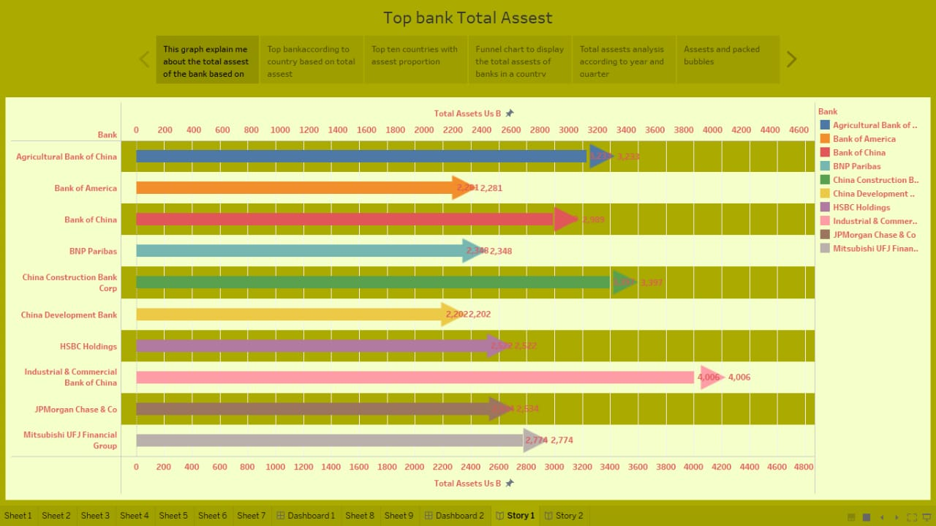

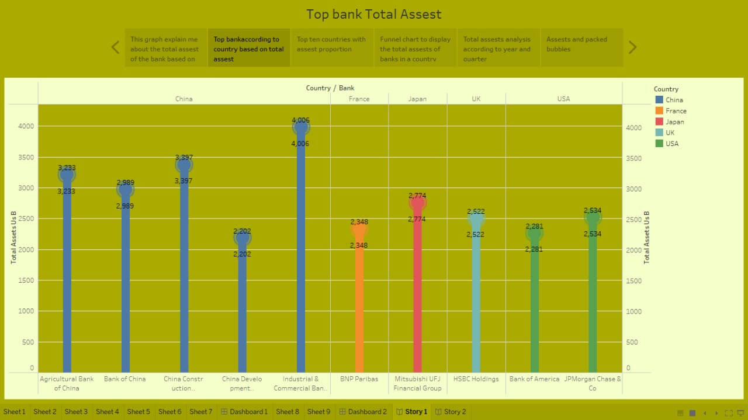

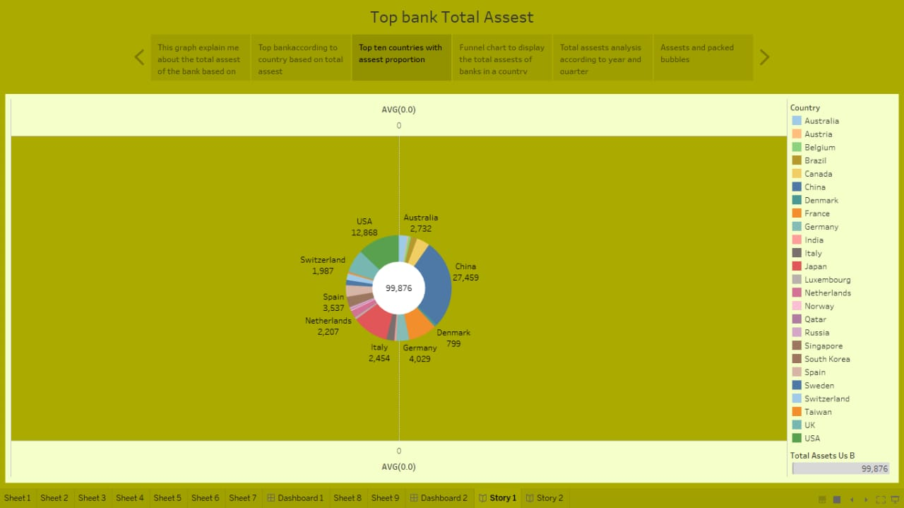

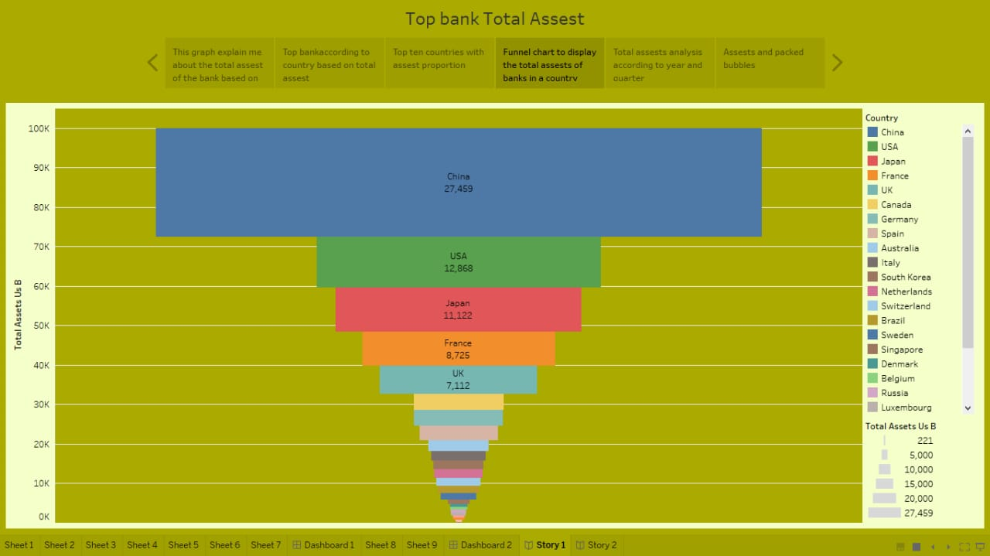

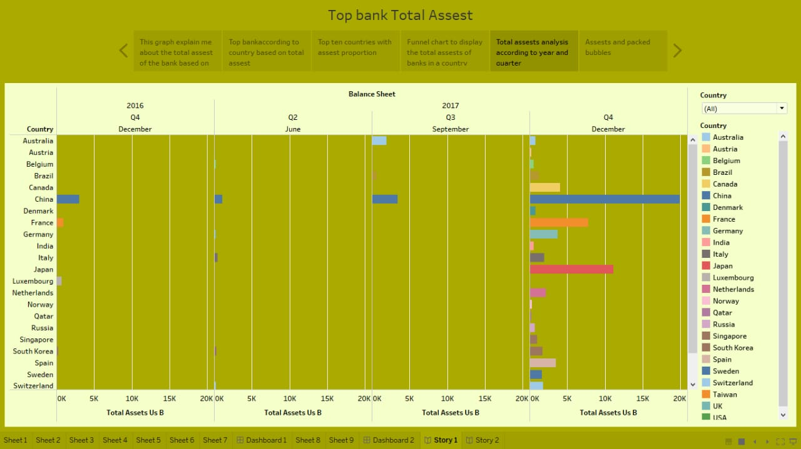

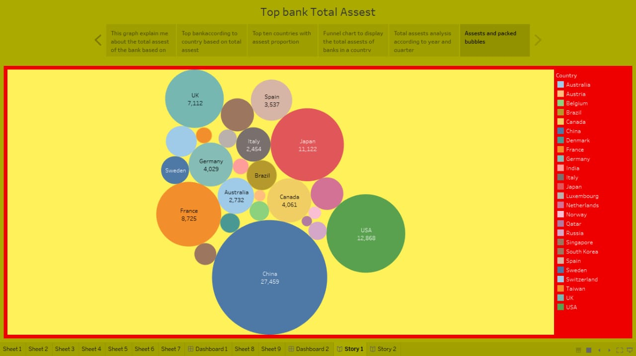

**4.ADVANTAGES :**

The advantages of financial statement analysis are as follows:Financial statements are important to investors because they can provide enormous information about a company's revenue, expenses, profitability, debt load, and the ability to meet its short-term and long-term financial obligations. It helps in deciding whether the company is investible or not. We can analyse the current position of the company in the market by analysing these reports. We can analyse or predict the probability of the future success of the company.

**5. DISADVANTAGES:**

There are some significant limitations of financial analysis which are the following: Financial planners, senior executives and accountants may use financial statements to make decisions regarding future planning, expansions and product launches, but there are disadvantages to using this method.The financial analysis does not consider cost-price level changes. The financial analysis is ambiguous if the prior knowledge of the changes in accounting procedure followed by the company is not known.

**6.APPLICATIONS:**

A finance application form is used by lenders to decide whether to offer a loan to a person requesting credit from a financial institution Financial analysis is used to evaluate economic trends, set financial policy, build long-term plans for business activity, and identify projects or companies for investment. This is done through the synthesis of financial numbers and data.

**7.FUTURESCOPE:**

The field of finance has a huge scope in future. As finance is an integral part of our economy, Financial Managers will always be in high demand. If you want to build a career in finance, the most popular sectors include corporate finance and public banking, credit and financial planning, and asset management.

**8.CONCLUSION:**

Analysis of financial statements is extremely important for every business to grow and increase their revenue. It should not be compromised since it increases the efficiency of business operations. Better processes and expert analysts can help in the detailed analysis process.