Federated Learning Based Mental Health Risk Detection

A report submitted for the Federated Learning course by

Akriti Jaiswal (205225004)
Harini J (205225011)
Surya N (405125056)

Under the Guidance of Dr. (Mrs.) B. Janet Associate Professor
Dept. of Computer Applications, National Institute of Technology, Tiruchirapalli



Department of Computer Applications, National Institute of Technology, Tiruchirapalli

1

Abstract
Due to an increase in the usage of mobile devices and people being active on social media platforms, there has been an increase in the frequency of psychological problems among the users, which makes the detection of these problems through social media data vital. Most of the solution requires the collection of users data within a central- ized infrastructure which can cause concern related to user’s privacy, confidentiality and security. Therefore, this research focused on developing a federated learning based framework solution that can detect the mental health risk of individuals from there so- cial media texts without compromising their data, privacy, confidentiality and security.

In the Federated Learning framework-based solution, the user’s raw data will stay in a decentralized state, which will be located on multiple clients connected to each other through a server node. After each iteration, the central server will receive the updated parameters (mainly the weights and gradient values), which it will then use the FedAvg algorithm to average across all values it received from all clients and construct a global model. For creating local models, machine learning tools such as HashingVectorizer (for feature extraction) and SGDClassifier (for training) have been used.

The ML model that is created will then be responsible for categorizing the content posted on the social media platforms into a specific mental health risk. The main func- tionality of this model is to find out the users who can be at risk of experiencing certain psychological conditions based on their social media texts. The system designed con- sists of multiple clients having decentralized data, a server that will be aggregating the weights and gradients values it receives from the clients, and then updating the global model based on the values, and a dashboard for monitoring predictions.

The results obtained from the experiment show that the federated technique pro- duces good results while maintaining user privacy. In summary, the system proposed of- fers security, scalability, and privacy protection for mental health risk prediction, which emphasizes the use of Federated Learning in such environments.

Contents
- Introduction 3
  - Aim 4
  - Problem Statement 4
  - Objectives of the Project 4
- Literature Review 6
  - Related Work 6
- System Analysis 9
  - Existing System 9
  - Proposed System 9
  - System Architecture 10
  - Technologies Used 13
    - Backend Technologies 13
    - Frontend Technologies 14
- Results 15
  - Analysis 16
- Conclusion 17
- Future Work 18
- Contribution of members 19
- References 20

2

Chapter 1 Introduction
In today’s time mental health has become an important global issue. Large number of people are sharing the psychological struggles they are facing on digital platforms like social media. It is crucial to identify mental health risks such as depression, anxiety, and emotional distress early so that timely support can be provided. The problem is that the traditional machine learning methods that are been used for analyzing mental health de- pends on centralized data collection. This raises significant concerns regarding whether user data will be safe or not and that it is properly being secured and is not being shared with any other organization or entity as the data can be personal to user and can be very sensitive. To tackle these issues, this project suggests a Federated Learning-based system for detecting mental health risks. This approach ensures that without sharing the raw user data amongst themselves the model will be trained collaboratively. In this model, data stays decentralized across various client nodes from different social media platforms like Twitter, Reddit, Facebook, Instagram, and LinkedIn. Only model param- eters i.e. weight and gradient values are shared with a central server which in term will aggregate these values for training the global model. This ensures that the sensitive text data remains in the user’s local environment and protects privacy.
The system features a complete Federated Learning pipeline. Each client node will be training their own models locally, i.e., within their individual machines and using their own dataset. The client then passes their model parameters to the central server which uses the Federated Averaging (FedAvg) algorithm to average out all the param- eters in order to create a global model, which is sent back to all clients. This ongoing process allows the model to improve collectively while strictly adhering to privacy reg- ulations. From a machine learning viewpoint, the system uses efficient and scalable methods like HashingVectorizer for feature extraction and SGDClassifier for incremen- tal learning. These choices avoid the need for shared vocabularies and allow lightweight updates, making the system well-suited for distributed environments. The model is trained such that it can categorize the text that the user has posted in his social media account to the mental health risk categories. Here the positive sentiments signifies that the user is in a safe state whereas the negative sentiment corresponds to the potential mental health risk. Beyond the core learning framework, the project offers a detailed system architecture that includes multiple simulated client nodes, a centralized aggre- gation server, and an interactive dashboard.
This dashboard is used to monitor training progress, assess model performance, and

3

  - AIM 4

visualize privacy metrics. The system enables us to monitor for real-time prediction of mental health risks from user-input text, the practical application of the designed framework. Overall, this project demonstrates how Federated Learning can be used effectively in sensitive areas like mental health analysis. It not only ensures that the privacy if the users will be preserved but is also an ethically sound solution which is scalable. By removing the need for centralized data storage while ensuring model per- formance, this proposed method marks a significant advancement toward secure and trustworthy AI systems.

Aim
The aim of this project is to develop a machine learning model using the Federated Learning framework such that we can get a global model that is robust and generalized. Using the Federated Learning framework enables us to train and create a global model via the collaboration of multiple local models.

These local models will share their parameters which includes the model weight and gradient and using the Federated Averaging algorithm we can combine these parame- ters and create a global model which will be more robust and generalized compared to the local models.

The biggest advantage of doing this is that it ensures that the model is trained on the local machine and only the model parameters are shared, and not the data on which the models are trained. This ensures that user privacy is maintained and that any sensitive information of the user is not shared with anyone.

Problem Statement
To create a global model with the collaborative effort of multiple local models by using the Federated Learning framework such that the global model is more robust to the unseen data, more generalized than the local models, and performs better than the local models. The training of the local models happened in a decentralized way and only the parameters of the local models shared which are used for creation of global model and no raw data of the users are shared, ensuring privacy and security to the sensitive data.

Objectives of the Project

Develop a Mental Health Risk Detection Model:
Develop a machine learning model which is capable of analyzing social media text posted by the user and categorizes it according to different levels of mental health risks (for instance, low, moderate, or high risk).

Implemented Federated Learning Framework
Propose and deploy a federated learning system in which multiple client nodes collaborate together and share their model parameters i.e. weights and gradients

  - OBJECTIVES OF THE PROJECT 5

in order to train a global model without sharing any of the users raw data and ensuring privacy.

Ensure Data Privacy and Security
It safeguard users’ privacy and ensures that the personal textual data of each client remains in its own machine itself and allows only the model parameters to be transferred to the server.

Simulate Distributed Client Environment
Generate various client nodes that will represent different social media platforms which includes Reddit, Twitter, and Facebook, where each platform has its own dataset.

Apply Federated Averaging (FedAvg)
Improve the global model’s performance by averaging local model updates us- ing the FedAvg technique. The improvement is because the different values of the parameters that is received from different clients introduces diversity making model more robust and generalized and making it perform better on the unseen data.

Evaluate Model Performance
The performance of the model will be evaluated based on different metrics, which include accuracy, recall, precision, and F1-score.

Incorporate Privacy Enhancements
Implementing methods like differential privacy or noise injection which enhances the data privacy even further.

Develop an Interactive Dashboard
Create a dashboard for visualizing training results and privacy measures in real time.

Chapter 2 Literature Review

Related Work
The Federated Learning framework can be adapted in the case of preventing data breaches, and can also be used to build models that are based on the use of a remote dataset[1], This framework prevents the data from getting shared as it only allows the model weights to get shared between the clients hence the model can be trained locally i.e. on the local machines and from the local dataset thus preventing real dataset from being shared and preventing data breach[2][3]. Previously, using this framework, research has been carried out related to the task of balancing the imbalanced data, for data dis- tribution and for optimizing the device capabilities. Federated Learning focuses on two types of learning models: vertical and horizontal[4].

Presently, most of the research for the computerized systems has been focused on the NLP-based techniques. One such approach was conducted by Li et al.[5], where they tried to identify the symptoms of depression through Item Response Theory (IRT) based Computer Adaptive Test (CAT). They didn’t use the static questionnaire, rather they focused on using the adaptive questionnaire, which helped them in achieving high accuracy. While the explanation and the interpretation of their model are clear, the rea- sons for the selection of the specific questionnaire and how this affects the response be- haviour are not clear. Twitter data for finding out mental health problems was analysed by Lerman et al. [6]. According to McDonnell et al. [7] the Linguistic Inquiry Word Counts also known as LIWC differs between the control groups and the experimen- tal groups. Two linguistic models (1) Unigram model and (2) Character-based 5-gram model have been employed to analyze word probability and evaluating 5-character se- quences. While the performance of other classifiers can be better at distinguishing between various groups, the trained classifier will distinguish between every group in- cluding the control group. Finally, the relation between the statistical analysis and clas- sification was investigated to understand if there is any link between them [7][8].
In their study, Nguyen et al. [9] focus on a neural network whose learned features corresponds to the conditional probability distribution of the vectors that are given as input. Design approaches for neural networks are numerous in many fields. Multi- ple layers are used in the network, where each layer represents the mean value of the previous layer’s weights. In the final/output layer, the activation function is used for predicting the output. Hidden layers and structural approximations make deep neural

6

networks’ predictions effective. Selecting the appropriate architecture enhances perfor- mance when dealing with complicated issues, with changes to the layer structure and hyperparameters made on a large scale. Learning generalizability may be enhanced with proper feature representation. This research aims to develop ways of improving the user experience through empathy. Cinematically speaking, the user expressions can be utilized to activate games and entertainment functions, which will produce dynamic application behavior. Emotional categorization involves the reality factor.

While deep neural networks improve scalability and enhances generalization across domains, they may encounter difficulties when dealing with subjective input, uncertain situations, or human like reasoning [21]. The use of fuzzy modeling in [10] proves its ability to model uncertainty and reasoning like humans do. In this paper, fuzzy in- ference is combined with deep learning to assign an index based on confidence to the features learned by the network. Feature indexing is, by nature, subjective and uncertain [11]. Adaptive learning is required, which cannot be done by merely layering different modules.

A privacy oriented FL architecture was proposed by Zhuotao et al. [12] by upload- ing multiple model layers for global averaging. Such an architecture reduces the number of communications and increases privacy via local differential privacy. The above ap- proach is applied to three different datasets using the non-IID approach. Jingcheng et al.
[13] in his work described an efficient privacy-preserving data aggregation framework for FL (EPPDA). Secret sharing was used in EPPDA to withstand reverse attacks, and EPPDA can aggregate user models without revealing their models. In addition, EPPDA shows good fault tolerance in case of user dropout and can continue its work even if many users exit during the execution process. From theoretical analysis, EPPDA can provide aggregated models to the server side without revealing the model of any user, and the adversary by any means cannot acquire any non-public information from the communication channel.

While AI driven systems can help optimize power distribution between charging stations and their providers, the frequent data transactions required may pose a threat to the security and privacy of users’ information [14]. One potential solution is the federated learning technique, where only local models are shared rather than data it- self. Along these lines, Wang et al. [15] present a lightweight, secure FL-based system that utilizes a premium penalty scheme to predict energy demand in electric vehicle infrastructures (EVIs). The suggested design seeks to provide an efficient estimation of power consumption resistant to different kinds of attacks on the federated learning process of EVIs. In addition, Wang et al. present a certificate generation scheme based on the latest developments in blockchain and smart contract technologies. They eval- uate the efficiency of the scheme by applying two kinds of simulations – Type I and Type II. This leads to a more secure system design coupled with reduced costs for both computation (40% reduction) and communication (94.7% reduction) overheads.

IDPTs are psychological interventions designed to tackle mental disorders prevalent on the Internet. With increasing demand for evidence-based mental healthcare amid the health crisis, the use of internet-based solutions for IDPTs is growing exponentially. It offers increased reach at reduced costs through greater adaptability and flexibility. In

the proposed approach to classify psychiatric data based on symptoms using IDPTs, Ahmed et al.[11] propose a fuzzy contrast model that relies on an attention network, which focuses on position weighted terms. Embeddings are generated using the model to tag the psychiatric data, followed by the expansion of the vocabulary set through at- tention networks to facilitate transfer learning. In the process of predicting the weight of attention terms, both the similarity and contrast sets are used. Fuzzy logic uses sets to classify mental health data. The authors compare the proposed embedding-free tech- nique to traditional methods to emphasize the suggested paradigm. The feature vector yielded an ROC of 0.82 when applied to nine mental health disorders.

Yuan et al. [16] adopted a multi-attention framework to aid the process of screening, diagnosis, treatment, and evaluation for various cardiovascular and ophthalmic condi- tions. They utilized the UNet framework to make use of the rich information at the lower level as well as the complementary information present at different levels, thus helping them distinguish the vessels from the background. A dense dropout block was included to retain as many details of the vessels as possible after convolution and mitigate over- fitting. The block functions during the contracting stage to evaluate the importance of each channel of features automatically. The next step involves extracting multi-level features, which were further enhanced at each level by attention mechanisms.

The proposed model is based on deep learning for extracting text embeddings [18]. In case of semi-supervised learning, labels have to be used and training of the model takes place using output class. In this project, there is going to be a creation of a tool that will enable extraction of depression symptoms from texts written by patients using the framework of federated learning and natural language processing. Graph embedding will be applied in the extraction, identification, and representation of data focusing on the aspect of graph attention. The issues related to peoples’ mental health can emerge when interacting with such software systems. With the detection of certain patterns, a better understanding of the causes of mental and emotional problems could be derived [17].

Chapter 3 System Analysis

Existing System
Legacy systems are primarily designed to work on a centralized architecture where data from all the clients will be stored in a single server and then from this server the data will be taken and the model will be trained. These systems are highly accurate compare to other but have multiple limitations.

One such limitation is the risk of single point of failure. As the entire data has been stored in the centralized server then if an any case the server goes down or gets crashed then the entire system will come to a halt.

Another such limitation is related to the security issue of the data that is stored in the centralized server. As the stored data contains personal and sensitive information of the individuals, so if any kind of data breach happens then that sensitive information may leak.

Furthermore as the entire data has been store in a centralized server therefore it makes it really difficult to scale the entire system. Hence a collaborative approach is required to overcome such issue.

Proposed System
The proposed system consists of multiple clients where each client corresponds to a specific social media platform. Each client will train the model locally on its system and then will forward its parameters i.e. weight and gradient to the Federated Learning server.

The Federated Learning system will have the FedAvg algorithm. This algorithm will then aggregate all the parameters that it received from its client and then the aggregated values are used to update the parameters of the global model. This process repeats itself for multiple iteration until the training gets over.

9

System Architecture

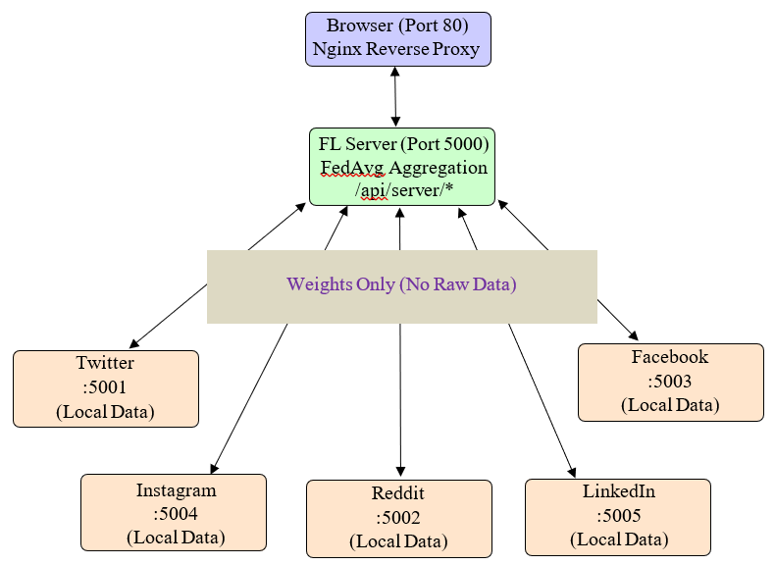

Browser + Nginx Reverse Proxy (Port 80)
The browser acts as the client-side framework through which users can access the ap- plication. It is the system through which the user interface is displayed and user inter- actions are possible without the need for additional software installations.

Components
- Displays the dashboard UI:
Dashboard is shown by the browser—the central control center for the entire sys- tem. This involves visualization of data through the use of items such as graphs, tables, bar graphs, and lights. Key functions are:
  - Upload Dataset:
In addition, file input components are provided by the browser to allow users to upload their datasets directly from their computer. The file types sup- ported could be CSVs, pictures, and structured file formats. Its functions include:
    - Selection and uploading of files.
    - Basic validations like checking file type, its format.
    - Secure transfer of the dataset to the back end for pre-processing and model training.
  - Trigger Training:
User begins training the model through the controls available in the dash- board. The moment you initiate this task:

    - The system sends a request to the server.
    - You can change training parameters such as epochs and batch sizes.
    - Training starts locally or through a distributed/federated learning ap- proach.
    - The web browser will display the status of training in real time, which will include percentages and logs.
This provides a complete picture of how the training is performed in a dis- tributed manner.
  - Run federated rounds:
In the context of federated learning, the users will be able to manage the training process that takes place in multiple decentralized clients. Using the browser, the following becomes possible:
    - Launching the federated learning rounds.
    - Monitoring the interactions between the clients and the centralized server.
    - Observing the model aggregation process (e.g., model averaging).
  - View metrics and predictions:
Results of the system are shown via a graphical browser in an intuitive way, including:
    - Measures of model performance (accuracy, loss, precision, recall, and other similar measures)
    - Visuals that demonstrate progress in training of the model
    - Predictions by the model on any dataset or input values
In essence, the goal is to simplify the complex processes of machine or federated learning through a visual dashboard.
- Nginx Reverse Proxy Layer:
Nginx acts as an efficient intermediary. It lies between the user and other compo- nents of the system, processing all HTTP requests coming in. Its role consists of the following:
  - Analyzing the request (such as its URL, headers, etc.)
  - Figuring out the backend that needs to process it.
  - Passing it to the chosen backend.
This intermediary layer ensures that users have no access to the system internals, including the federated learning server and its clients.
- Federated Learning Server:
The Federated Learning Server acts as the overall controller for the federated learning architecture [19][20]. Instead of training on any data directly, this com- ponent acts as the controller that ensures how many client nodes contribute to- wards training one single common machine learning model while keeping their data safe on their local devices.

Operating mostly on port 5000, the FL Server acts as the brains of the entire fed- erated learning system.

Federated Learning Server is different from traditional centralized machine learn- ing because of the following:
  - Data does not get transferred to a centralized server.
  - In its place, the model goes to the data.
The operation of a federated learning server takes place in this manner:
  - The server sends the global model to the clients.
  - Gathers the updated local models for the construction of a new global model.
This procedure continues for several federated iterations.
The Federated Learning server using the Federated Averaging (FedAvg) algo- rithm which aggregates model updates received from multiple client nodes.

$$W_{global}= \sum_{i=1}^{n}{\frac{n_{i}}{N}W_{i}}$$

where:

  - W_{i} represents the model weights from client i.
  - n_{i} represents the total samples present with client i.
i=1
  - n represents the total number of client nodes.
The algorithm called FedAvg generates a global model through an average of local parameters, wherein every client is assigned a weight relative to its own data size. In other words, clients with larger data sizes carry more weight in generating the global model.
- Client Nodes (Ports 5001–5005):
In federated learning, all clients operate independently on their individual datasets while collaborating with the central server. The process of operation at each client is as follows:
  - Receive Global Model: The central server at the beginning of each federated learning session provides the latest global model to the client. Activities during this phase:
    - The model weights are transmitted by the server.
    - These weights are used by the client for initializing the local model.
The importance of this functionality is that:
    - All clients will have a similar starting point when training begins.
    - Consistency is maintained in the distributed system.

  - Train Locally on Private Data: The client creates and modifies the model locally without the need to involve any other party or machine. The client does all the work using its local dataset, which is never uploaded to the server. This process involves:
    - Preprocessing of data (cleaning and tokenization).
    - Extraction of features (for instance, HashingVectorizer).
    - Training the model (e.g., SGDClassifier).
This training is done exclusively at the client side because it.
    - Ensures the security of the user’s data.
    - Prevents data storage in a central location.
  - Update Model Weights:
Following the training process, the weights of the model will be adjusted based on the information obtained from the local data. This ensures that:
    - The model learns certain patterns in the local data.
    - And also ensures privacy, as without disclosing the original data, the knowledge learned by the model is encoded within itself.
  - Send Weights to Server:
The updated weights are transmitted by the clients to the federated server without transmitting the raw data.:
    - It helps in enhancing the global model.
    - It also ensures privacy in communication.

Technologies Used

Backend Technologies
      - Flask: A lightweight Python web framework. It has been used to build API’s and web applications.
      - Flask-CORSL: It has been used for Cross-Origin Resource Sharing (CORS). Helps in managing the web applications running on different domains or ports to communicate with the Flask server.
      - NumPy: Python library used for numerical computing and array operations.
      - scikit-learn: It is a machine learning library. It has been used for classification, preprocessing, regression, and, clustering.
      - Requests: Library that has been used for API communication. It supports GET, POST, authentication, and JSON handling and is used to send HTTP requests easily.
      - Pandas: Library used for handling structured and tabular data. It provides pow- erful data structures like DataFrames which cab be used for cleaning, processing, and analyzing datasets.

      - SciPy: Library build on top of NumPy. Contains modules for optimization, statis- tics, signal processing, integration, and scientific calculations.
      - Gunicorn: Library used to deploy Flask and Django applications.
      - Werkzeug: It is a utility library for flask and has been used for web development work.

Frontend Technologies
      - HTML: It’s a markup language. It is used for structuring and creating the web pages.
      - CSS: It is a stylesheet language. It has been used for designing the web pages.
      - Javascript: It’s a scripting language that has been used to add dynamic behavior to the website.

Chapter 4 Results
The model has been evaluated across various metrics which includes:
        - Precision
        - Recall
        - F1-Score
        - Robustness
        - Generalization

Table 4.1: Comparison Between Local Models and FedAvg Global Model

Metric | Local Models | FedAvg Global Model
Precision | Moderate (0.72) | High (0.87)
Recall | Lower (0.64) | High (0.83)
F1-Score | Moderate (0.69) | High (0.85)
Robustness | Weak (0.61) | Strong (0.83)
Generalization | Limited (0.63) | Strong (0.82)
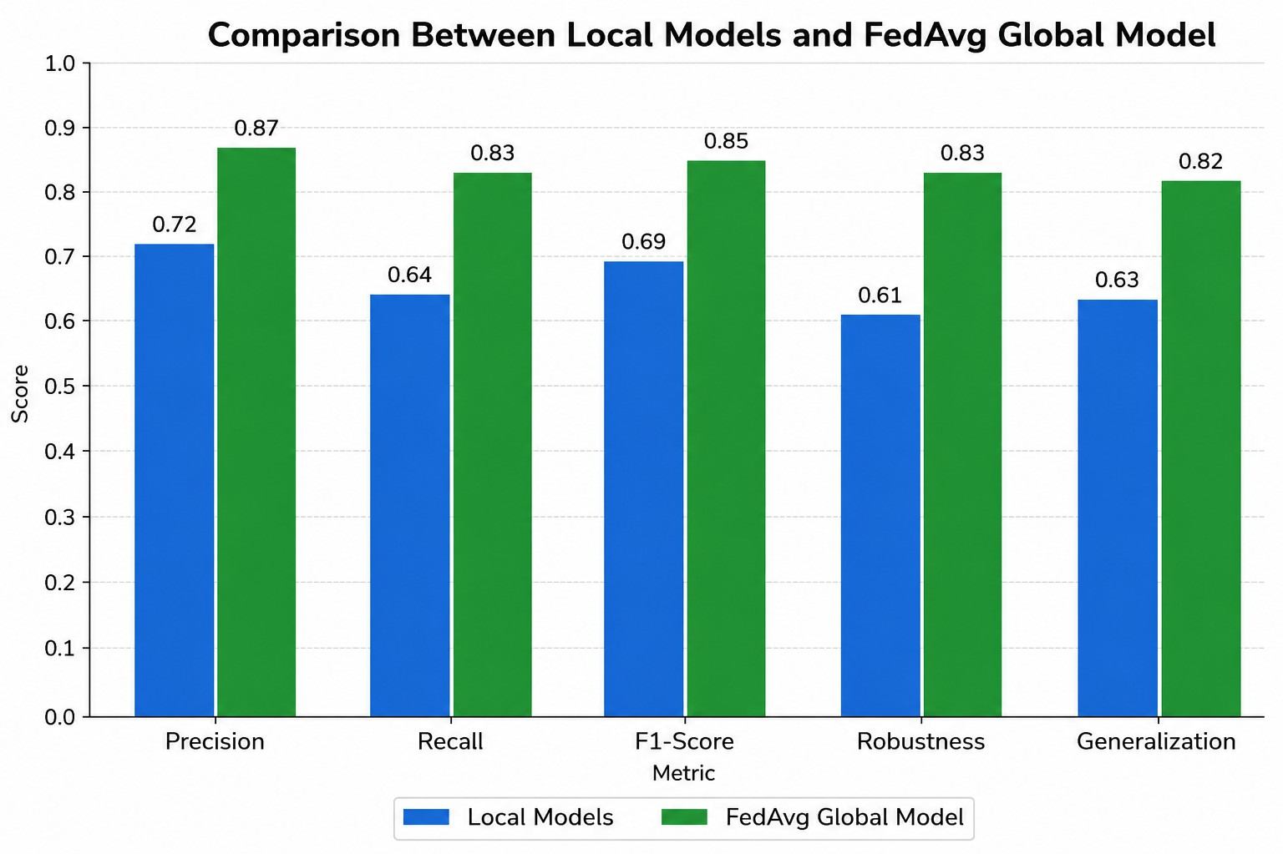
Figure 4.1: Result

15

  - ANALYSIS 16

Analysis
    - Precision: Global model results in higher precision compared to the local models. This means that the global model will have lesser false positives, which ensures that the global model will be more accurate in predicting the risk compared to the local models.
    - Recall: Global Models, which use the federated average algorithm, perform bet- ter than the local models. It meant that the global model will miss fewer cases for correctly predicting the mental health risks, i.e. it will be better at detecting people with mental health risks compared to the local models.
    - F1-Score: Global models have a higher F1-Score compared to the local models, which means that the global model has a balanced performance between recall and precision.
    - Robustness: Global models were way more robust compared to the local models. Reason being that the local models are being trained on their local data, so they are only aware of their dataset, whereas the global model has weights equal to the average weights of all the local models, which ensures that the global model will be less sensitive towards noise when compared with local models and will give consistent results on different datasets.
    - Generalization: Generalization of the global model is higher compared to that of local models because of the difference in how they were trained. As local models were trained locally on the local dataset, they can overfit and will not perform well on the unseen data. On the other hand, as the global model uses the Federated Averaged algorithm, there’s a high chance that it won’t overfit because of different weights of local models and performs better on the unseen data. Hence, they have a better generalization score.

Conclusion

This project is about using federated learning to spot mental health risks from social media posts. It keeps things private for users, which seems really important. Instead of everyone sending their data to some central spot, the sensitive stuff stays right on the devices. Only the model parameters get pulled together from different clients. That setup helps with privacy a lot, and it scales well too. It also tries to fix some issues with applying machine learning to this kind of sensitive area, where data is tricky to handle.

Experiments showed how FedAvg works by mixing in experiences from multiple clients. The global model that comes out of it did better than just sticking to one clients local model. When you look at precision, recall, F1 score, plus how robust it is and how well it generalizes, the federated one wins out. It is kind of impressive how that integration pulls everything together.

For efficiency, they used lightweight parts like the HashingVectorizer and SGD- Classifier. That keeps things running smooth without heavy resources. Sending just the model weights means low communication costs too, so bandwidth is not wasted. Privacy stays protected there as well, which ties back to the whole point.

Adding a real time dashboard made the system easier to use. You can see the training process visualized, along with model performance and those privacy metrics. It feels like that helps users follow along without getting lost.

Overall, federated learning looks effective for picking out people at risk for mental disorders. It gives a reliable way to do it while keeping privacy intact. The paper shows this as a strong setup for ethical AI, especially with personal info that is so sensitive. Some people might worry about accuracy still, but it seems solid enough.

Future stuff could involve adding transformers into the mix, or layering in differential privacy for extra protection. Real world testing on a bigger scale would be next, I suppose, to see how it holds up outside experiments. That part is not fully settled yet, but it points to ways to improve.

17

Future Work

Although the current projects exhibits great potential and promising results but still there are multiple things than can be done further to enhance the result.

Integration of Deep Learning Models: Currently we are using SGDClassifier and HashingVectorizer which are lightweight machine learning techinques. Rather we can focus on replacing this with deep learning architectures such as LSTM, Transformers etc.

Differential Privacy Implementation: To further enhance the security and privacy of the raw data we can implement the differential privacy and integrate it with our system. This will help in the prevention of reconstruction and model inversion attacks.

Multi-Modal Mental Health Analysis: For the time being only the social media posts or texts are being used to detect the mental health risk of the person. But other than this we can also focus on other data modalities such as facial expressions or voice signals. We can then combine these modalities and evaluate the mental health risk of the individual.

18

Contribution of members

Akriti Jaiswal (205225004):
- Contributed to the design and development of the Federated Learning based mental health prediction system.
- Worked on implementation of client-server communication and model aggregation using the FedAvg algorithm.
- Participated in model training, testing, and evaluation across distributed client nodes.
- Assisted in integration of backend services, system workflow design, and project documentation.
- Contributed to presentation preparation and overall project coordination.

Harini J (205225011):
- Contributed to the implementation of the Federated Learning framework and distributed training process.
- Worked on frontend-backend integration and visualization of prediction and analytics results.
- Participated in preprocessing of datasets, local client model handling, and system testing.
- Assisted in development of communication modules and deployment configuration.
- Contributed to documentation, report writing, and presentation activities.

Surya N (405125056):
- Contributed to the development of the Federated Learning architecture and secure distributed model training.
- Worked on machine learning model implementation, aggregation process, and performance evaluation.
- Participated in Docker-based deployment, server configuration, and integration of project modules.
- Assisted in testing, optimization, and validation of prediction accuracy and communication efficiency.
- Contributed to technical documentation, future scope analysis, and project presentation.

19

References
- J. Konecny´, H. B. McMahan, D. Ramage, and P. Richta´rik, “Federated optimiza- tion: Distributed machine learning for on-device intelligence,” 2016, arXiv:1610.02527.
- D. Połap, G. Srivastava, A. Jolfaei, and R. M. Parizi, “Blockchain technology and neural networks for the internet of medical things,” in Proc. IEEE Conf. Comput. Commun. Workshops, 2020, pp. 508–513.
- V. Mothukuri, “A survey on security and privacy of federated learning,” Future Gener. Comput. Syst., 2021, pp. 619–640.
- Q. Yang, Y. Liu, T. Chen, and Y. Tong, “Federated machine learning: Concept and applications,” ACM Trans. Intell. Syst. Technol., vol. 10, no. 2, 2019, Art. no. 12.
- T. M. H. Li, M. Chau, P. W. C. Wong, and P. S. F. Yip, “A hybrid system for online detection of emotional distress,” in Intelligence and Security Informatics. Berlin, Germany: Springer, 2012, pp. 73–80.
- E. Chen, K. Lerman, and E. Ferrara, “Tracking social media discourse about the COVID-19 pandemic: Development of a public coronavirus twitter data set,” JMIR Public Health Surveill., vol. 6, no. 2, 2020, Art. no. e19273.
- M. McDonnell, J. E. Owen, and E. O. Bantum, “Identification of emotional ex- pression with cancer survivors: Validation of linguistic inquiry and word count,” JMIR Formative Res., vol. 4, no. 10, 2020, Art. no. e18246.
- M. McDonnell, J. E. Owen, and E. O. Bantum, “Identification of emotional ex- pression with cancer survivors: Validation of linguistic inquiry and word count,” JMIR Formative Res., vol. 4, no. 10, 2020, Art. no. e18246.
- G. Nguyen, “Machine learning and deep learning frameworks and libraries for large-scale data mining: A survey,” Artif. Intell. Rev., vol. 52, no. 1, pp. 77–124, 2019.
- U. Ahmed, “Attention-based deep entropy active learning using lexical algorithm for mental health treatment,” Front. Psychol., vol. 12, 2021, Art. no. 642347.
- U. Ahmed, J. C.-W. Lin, and G. Srivastava, “Fuzzy contrast set based deep at- tention network for lexical analysis and mental health treatment,” ACM Trans. Asian Low Resource Lang. Inf. Process., vol. 25, 2022, Art no. 87.
- Z. Lian, W. Wang, H. Huang, and C. Su, “Layer-based communication-efficient federated learning with privacy preservation,” IEICE Trans. Inf. Syst., vol. 105, no. 2, pp. 256–263, 2022.

20
- J. Song, W. Wang, T.R. Gadekallu, J. Cao, and Y. Liu, “EPPDA: An efficient privacy-preserving data aggregation federated learning scheme,” IEEE Trans. Netw. Sci. Eng., to be published, doi: 10.1109/TNSE.2022.3153519.

- W. Wang, “Secure-enhanced federated learning for AI-empowered electric vehi- cle energy prediction,” IEEE Consum. Electron. Mag., to be published, 2021, doi: 10.1109/MCE.2021.3116917.
- W. Wang, “Blockchain-based reliable and efficient certificateless signature for IIoT devices,” IEEE Trans. Ind. Informat., to be published,
doi: 10.1109/MCE.2021.3116917.
- Y. Yuan, L. Zhang, L. Wang, and H. Huang, “Multi-level attention network for retinal vessel segmentation,” IEEE J. Biomed. Health Informat., vol. 26, no. 1,
pp. 312–323, Jan. 2022.
- S. Su¨wer, M. S. Ullah, N. Probul, A. Maier, and J. Baumbach, “Privacy-by- Design with Federated Learning will drive future Rare Disease Research,” Journal of neuromuscular diseases, p. 22143602241296276, Aug. 2024,
doi: https://doi.org/10.1177/22143602241296276.
- S. Din, M. Imran, S. Irfan, A. Tariq, Z. Elgamal, and H. Dawood, “Federated learning for melanoma detection: A decentralized and privacy-preserving ap- proach using deep learning,” Biomedical Signal Processing and Control, vol. 112,
pp. 108576–108576, Aug. 2025, doi: https://doi.org/10.1016/j.bspc.2025.108576.
- F. Mahmud, F. Mahmud, and R. M. Rahman, “A Survey of Federated Learning: Advances in Architecture, Synchronization, and Security Threats,” Computers, Materials Continua, vol. 0, no. 0, pp. 1–10, 2025,
doi: https://doi.org/10.32604/cmc.2025.073519.
- M. Ebrahimi, R. Sahay, S. Hosseinalipour, and B. Akram, “The Transition from Centralized Machine Learning to Federated Learning for Mental Health in Educa- tion: A Survey of Current Methods and Future Directions,” IEEE Transactions on Learning Technologies, pp. 1–18, 2026, doi: https://doi.org/10.1109/tlt.2026.3685099.
- Alruwaili E, Moulahi T. A robust and verifiable federated learning framework for preventing data poisonous threats in e-health. Front Public Health. 2026 Mar 17;14:1762346. doi: 10.3389/fpubh.2026.1762346. PMID: 41923773; PMCID: PMC13036150.

21

