Screenshots with Explanation of the Project

1. Dashboard Overview
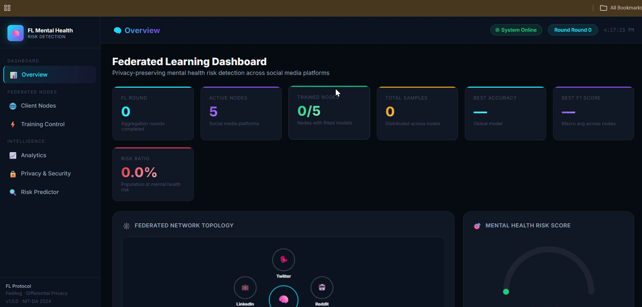
Displays the main federated learning dashboard with system status, KPI metrics, and network topology visualization.

2. Client Nodes Page
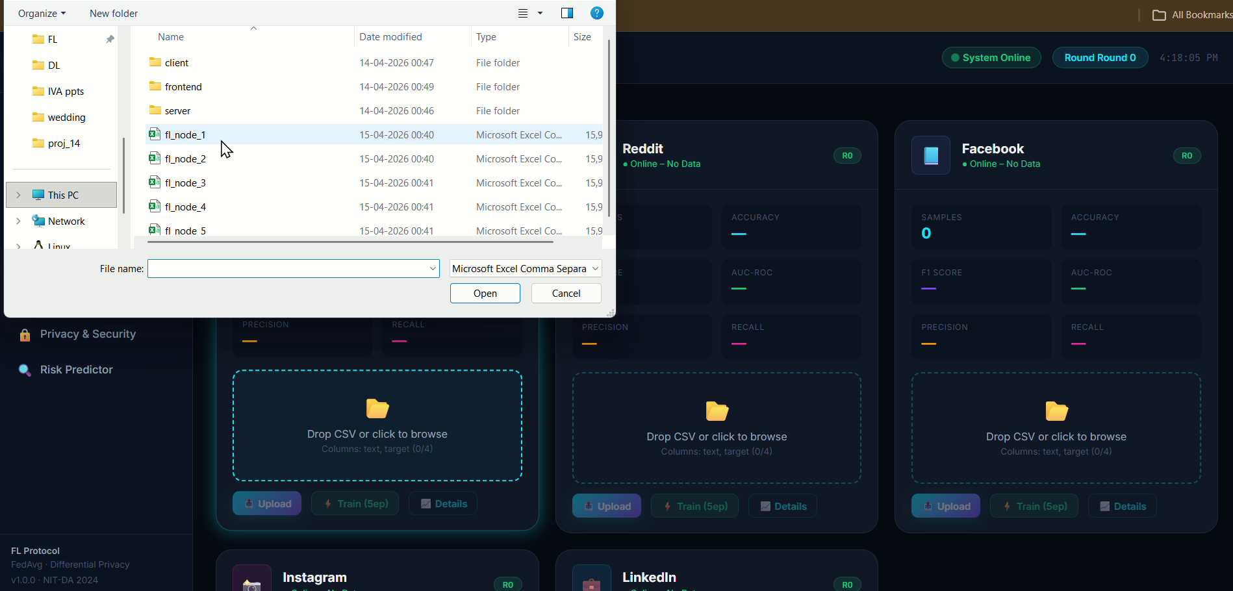
Shows multiple client nodes representing social media platforms where datasets can be uploaded locally.

3. Node Training Metrics
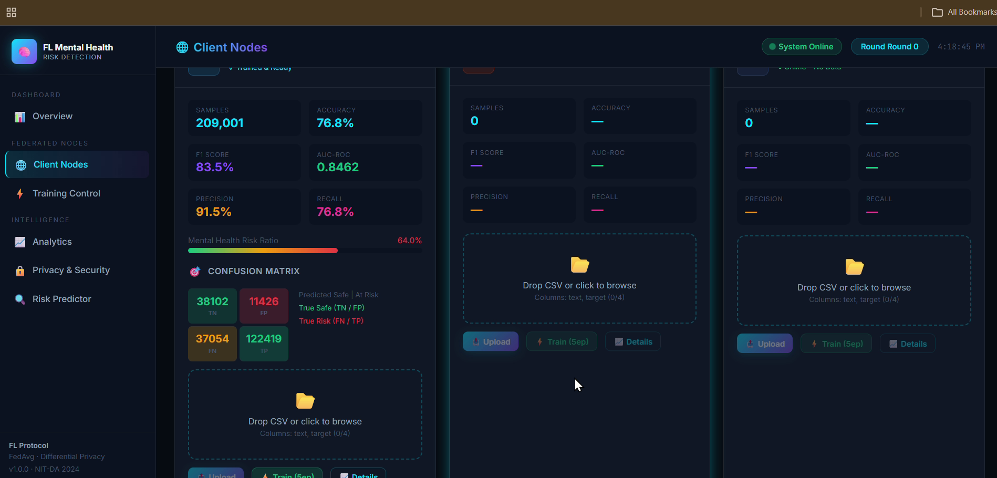
Displays client-wise training statistics including accuracy, F1-score, precision, recall, and confusion matrix.

4. Training Control Panel
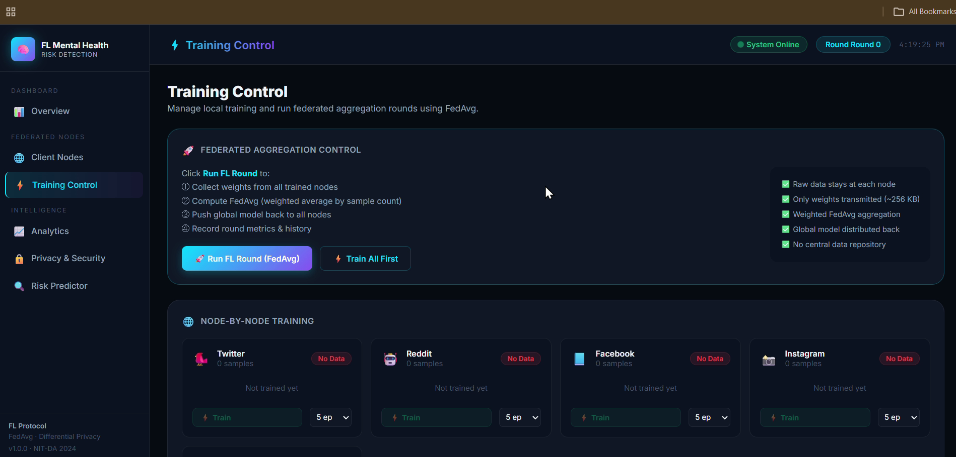
Provides controls for running local training and initiating the Federated Averaging (FedAvg) process.

5. Federated Learning Round
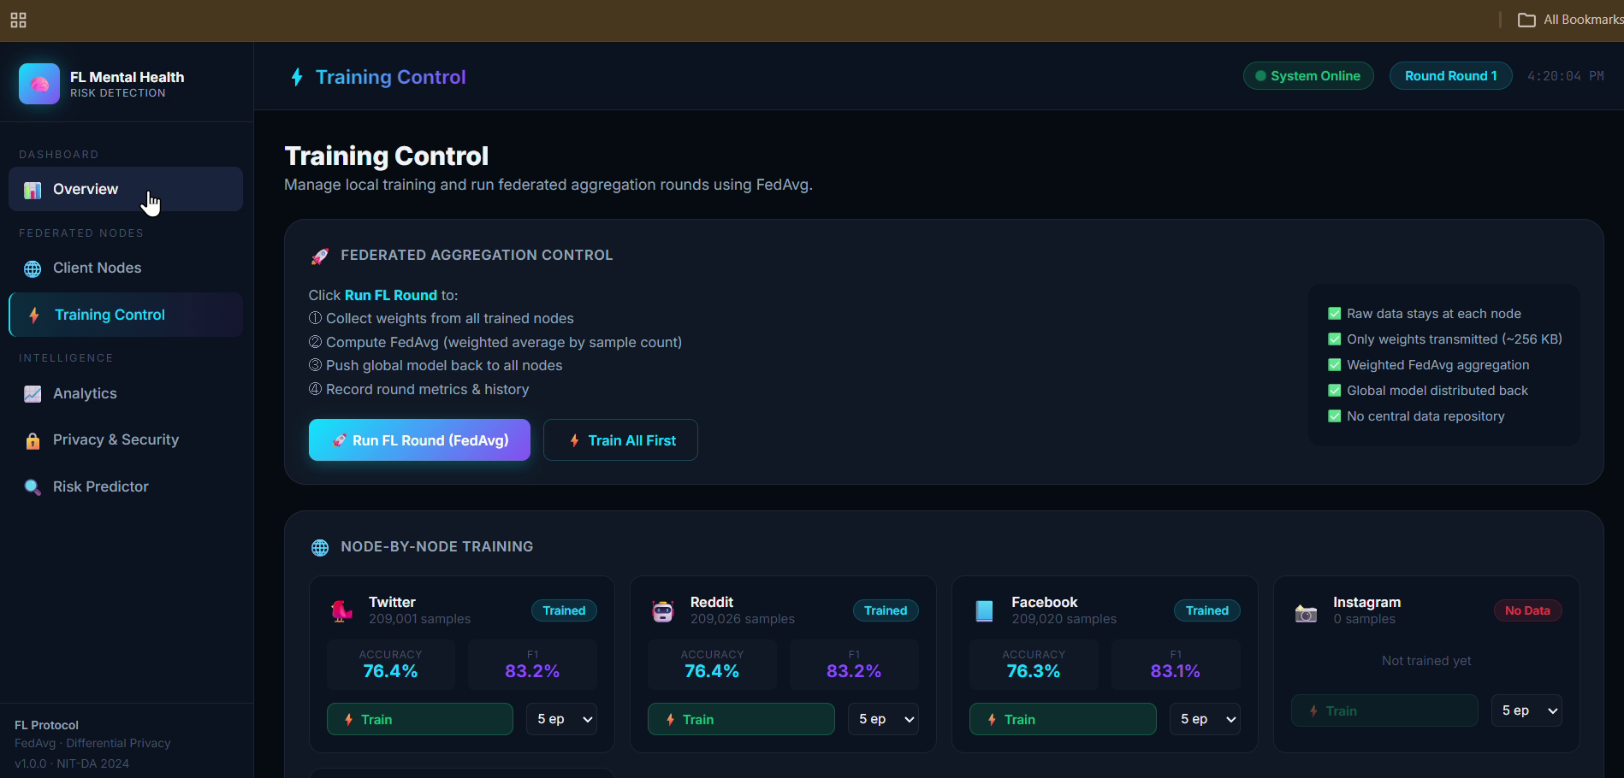
Shows trained client nodes participating in a federated learning round with aggregated model updates.

6. Mental Health Risk Predictor
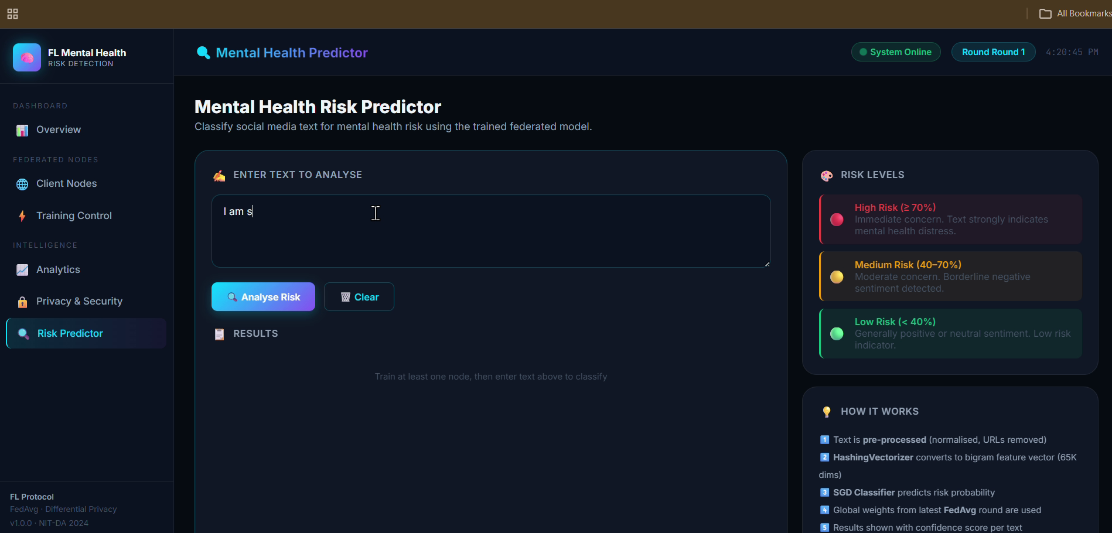
Provides an interface for entering text to analyze mental health risk using the trained global model.

7. Prediction Results
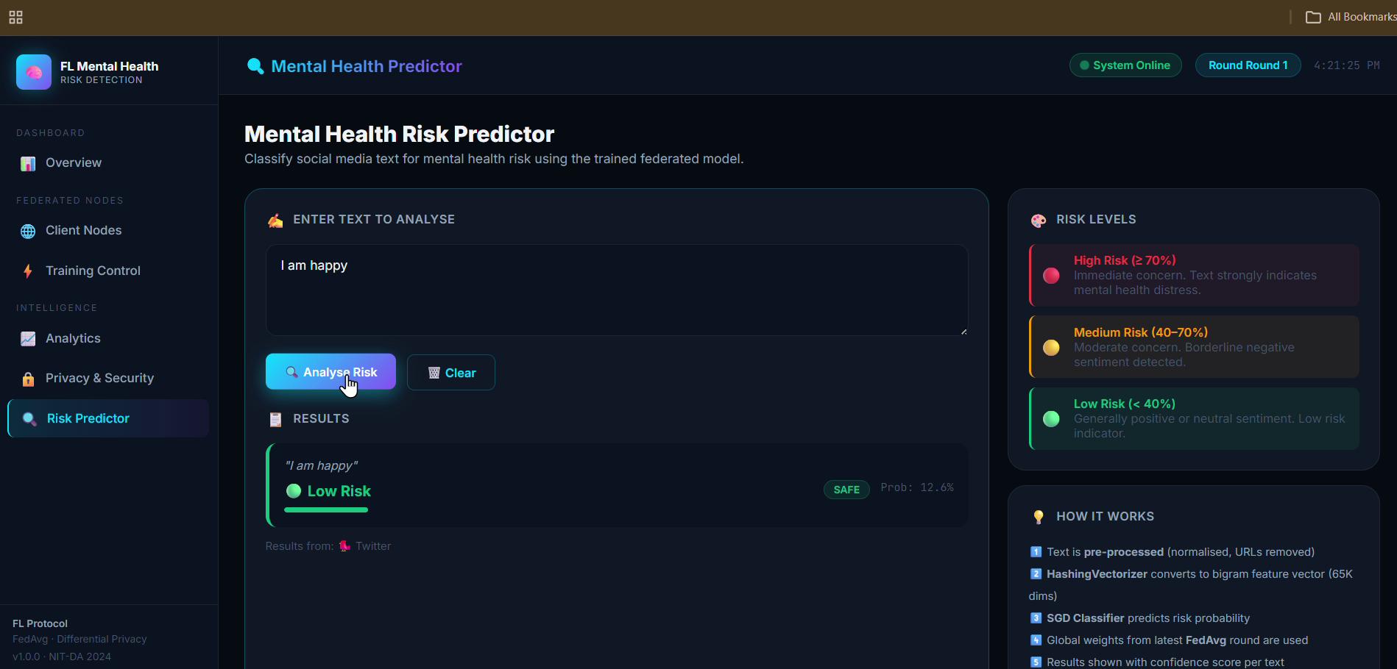
Displays prediction results with risk category and probability score after analyzing the entered text.

