PENETRATION TESTING REPORT
FOOTPRINTING & NETWORK SCANNING PHASES
W2-PM-FINAL | CYBERSECURITY | NETWORK WALKS

Details | Information
Pentester Name (Cybersecurity Trainee) | Harini Madasu
Program/Batch | B084 – Network Walks
Report Date | 12 November 2026
Modules Completed | W2-PM1 – Web Footprinting & Information Gathering; W2-PM5 – Zenmap Network Scanning
Client/Target | 1. example.com – Reserved domain used for educational testing
 | 2. 127.0.0.1 – Own local system (localhost)
Permission / Scope | Testing restricted to the reserved example.com domain and the trainee's own local system. No unauthorized network scanning was performed.
Phases Covered | Phase 1: Reconnaissance & Footprinting; Phase 2: Network Scanning & Analysis

1. Liability Disclaimer
The activities documented in this report were performed for authorized educational and training purposes. The footprinting exercise was conducted against example.com, a reserved domain intended for documentation and testing, while the network scanning exercise was restricted to my own local system using the loopback address 127.0.0.1.
No unauthorized scanning of other devices on the college network was performed.
All findings are intended for educational and research purposes only. The tools and techniques discussed in this report must not be used against systems or networks without appropriate authorization. Any misuse of cybersecurity knowledge may result in legal consequences. The trainee is responsible for ensuring that all security testing remains within the permitted scope.

2. Introduction
This report documents the practical cybersecurity activities completed during Week 2 of my training program at Network Walks. The work covered two major areas: web footprinting and reconnaissance (W2-PM1), followed by network scanning and analysis using Zenmap (W2-PM5).
The first activity focused on collecting publicly available information about the example.com domain. It involved examining domain registration details, identifying website technologies, retrieving DNS information, detecting Web Application Firewall (WAF) protection, and performing DNS enumeration.
The second activity involved using Zenmap, the graphical interface for Nmap, to perform network scanning against my own Windows system through the localhost address 127.0.0.1. The exercises included host discovery, TCP port examination, service version detection, and an attempt at operating system detection.
PM1 was performed using Kali Linux running through Oracle VirtualBox, whereas PM5 was performed using Zenmap and Nmap on Windows.
The practical activities were documented using command outputs, scan results, screenshots, and a topology PDF. This report presents the activities performed, observations, potential security implications, and recommendations.
3. Tools Used
The following tools and technologies were used during the practical activities.
Tool / Technology | Purpose
Kali Linux | Linux-based cybersecurity testing environment used for PM1
Oracle VirtualBox | Virtualization platform used to run Kali Linux
WHOIS | Retrieves publicly available domain registration information
WhatWeb | Identifies website technologies and web server information
Nslookup | Resolves domain names and retrieves DNS records
Wafw00f | Detects Web Application Firewalls
DNSRecon | Performs DNS enumeration and gathers DNS-related information
Windows | Operating system used for PM5
Zenmap | Graphical interface for Nmap used for network scanning
Nmap | Performs host discovery, port scanning, service detection, and OS detection
Windows Command Prompt | Used to examine IP configuration and MAC addresses

4. Activities Performed
4.1 W2-PM1: Web Footprinting & Reconnaissance
For the first activity, I performed web footprinting and information gathering against the example.com domain using five Kali Linux tools: WHOIS, WhatWeb, Nslookup, Wafw00f, and DNSRecon. Each tool was used to collect a different category of publicly available information about the target.
1. WHOIS – Domain Information Gathering
Objective: Retrieve publicly available registration information associated with the target domain.
Command used:
whois example.com
Observation: The command executed successfully and displayed domain registration-related information, including registrar and name server details.
This activity helped me understand how WHOIS can be used during the reconnaissance phase to collect publicly available information about a domain.
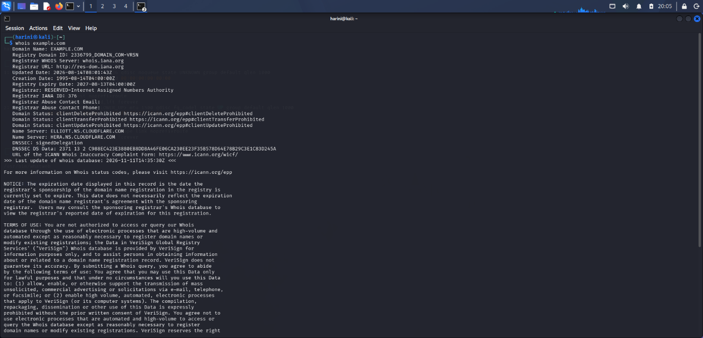
2. WhatWeb – Website Technology Identification
Objective: Identify technologies and web-related information associated with the target website.
Command used: whatweb http://example.com
Observation: The command executed successfully and displayed detected website information. The WhatWeb version used was 0.6.4. An initial HTTPS attempt returned an SSL connection error. Therefore, the successful identification was performed using the HTTP address.
This activity demonstrated how website fingerprinting tools can help identify technologies and gather information useful during security assessments.
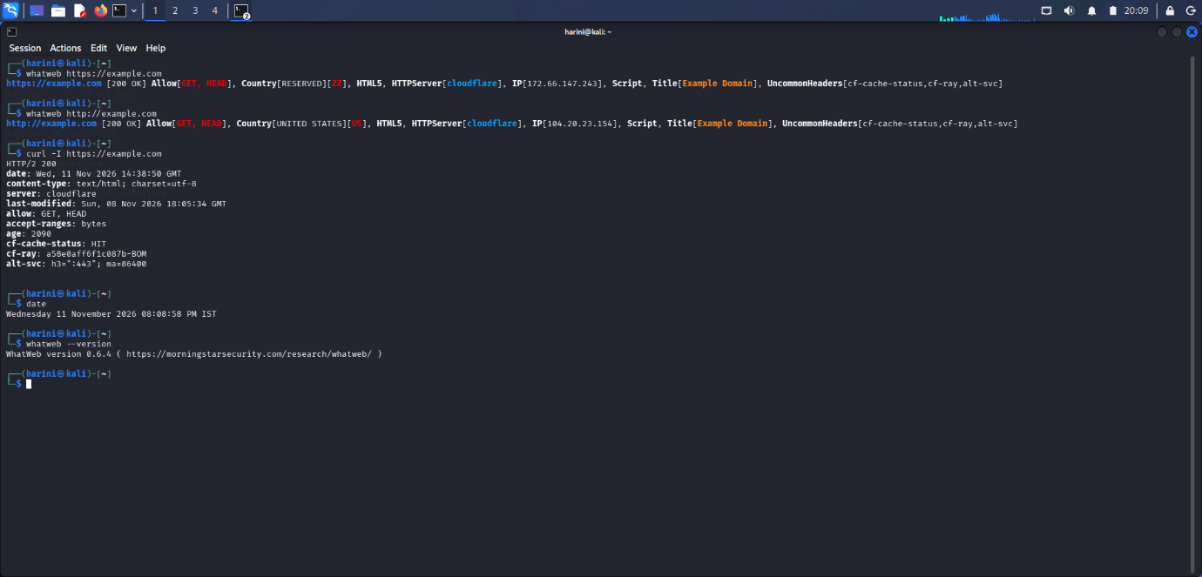
3. Nslookup – DNS Information Gathering
Objective: Retrieve DNS information associated with the target domain.
Commands used:
nslookup example.com
nslookup -type=MX example.com
nslookup -type=NS example.com
Observation: The commands executed successfully and provided domain resolution information along with mail exchange (MX) and name server (NS) records.
This activity helped me understand how DNS queries can reveal information about a domain's network configuration and supporting infrastructure.
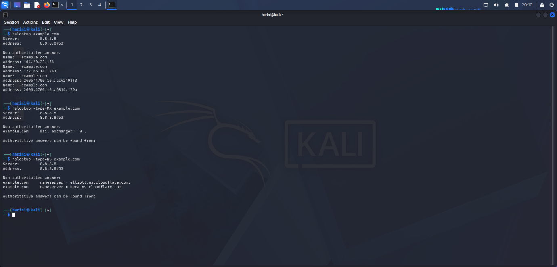
4. cURL – HTTP Response Header Analysis
Objective: Retrieve and examine the HTTP response headers returned by the target website.
Command used: curl -I https://example.com
Observation: The cURL command was used to send an HTTP HEAD request to the target website and retrieve its response headers without downloading the complete webpage. The response headers provide information about the server's HTTP response, content type, caching behaviour, and other web-related details, depending on the headers returned.
This activity helped me understand how cURL can be used to inspect HTTP responses and gather technical information during web reconnaissance.
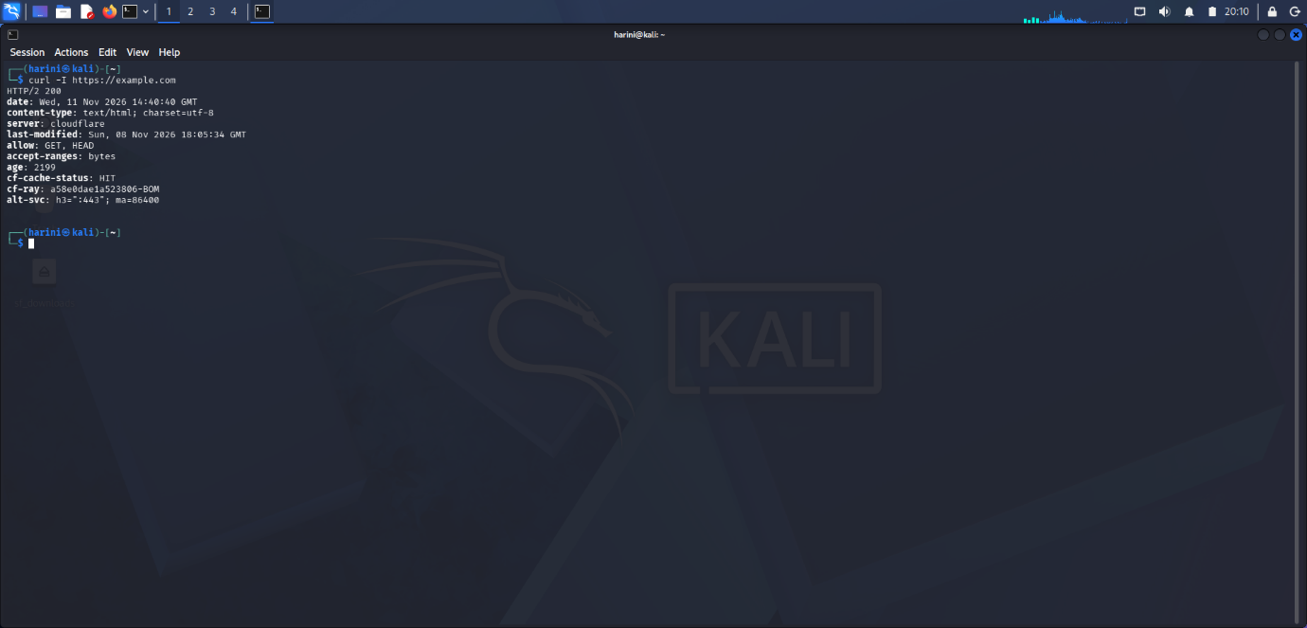
5. Wafw00f – Web Application Firewall Detection
Objective: Identify whether a Web Application Firewall was protecting the target website.
Command used: wafw00f https://example.com
Observation: The tool executed successfully using Wafw00f version 2.4.2. The result identified Cloudflare (Cloudflare Inc.) as the Web Application Firewall protecting the website.
This activity demonstrated how WAF detection tools can help identify security mechanisms deployed in front of web applications.
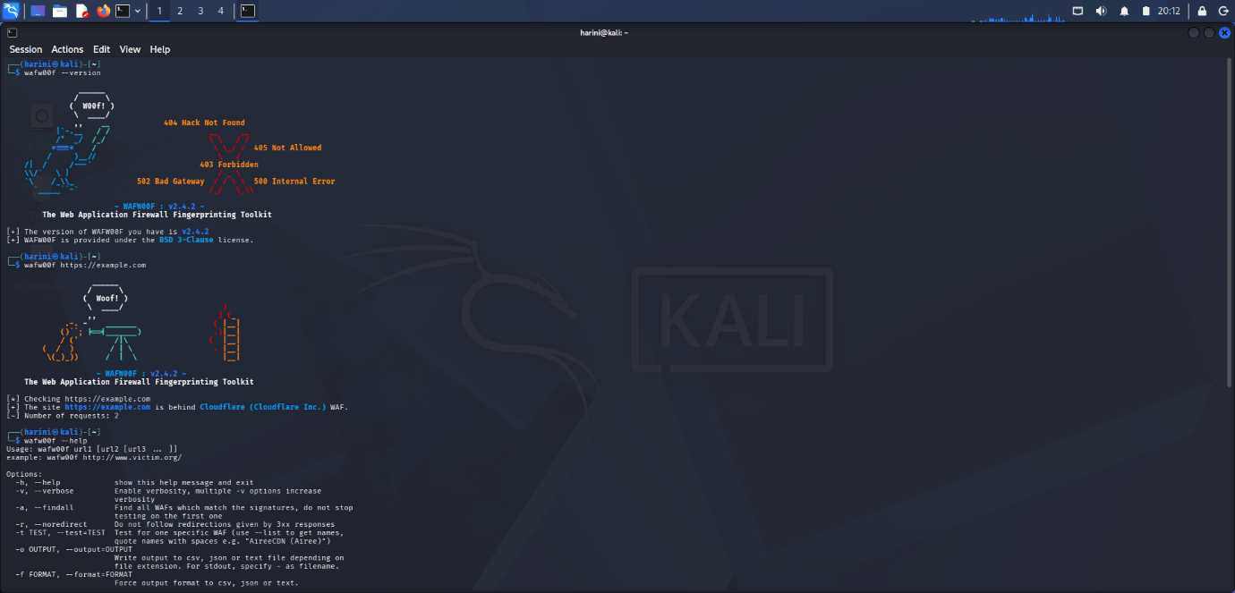

6. DNSRecon – DNS Enumeration
Objective: Perform DNS enumeration against the target domain and collect additional DNS-related information.
Command used: dnsrecon -d example.com -t std
Observation:
The command executed successfully using DNSRecon version 1.3.1 and displayed DNS-related enumeration results.
This activity helped me understand how DNS enumeration can be used to gather information about a domain's infrastructure and associated DNS records.
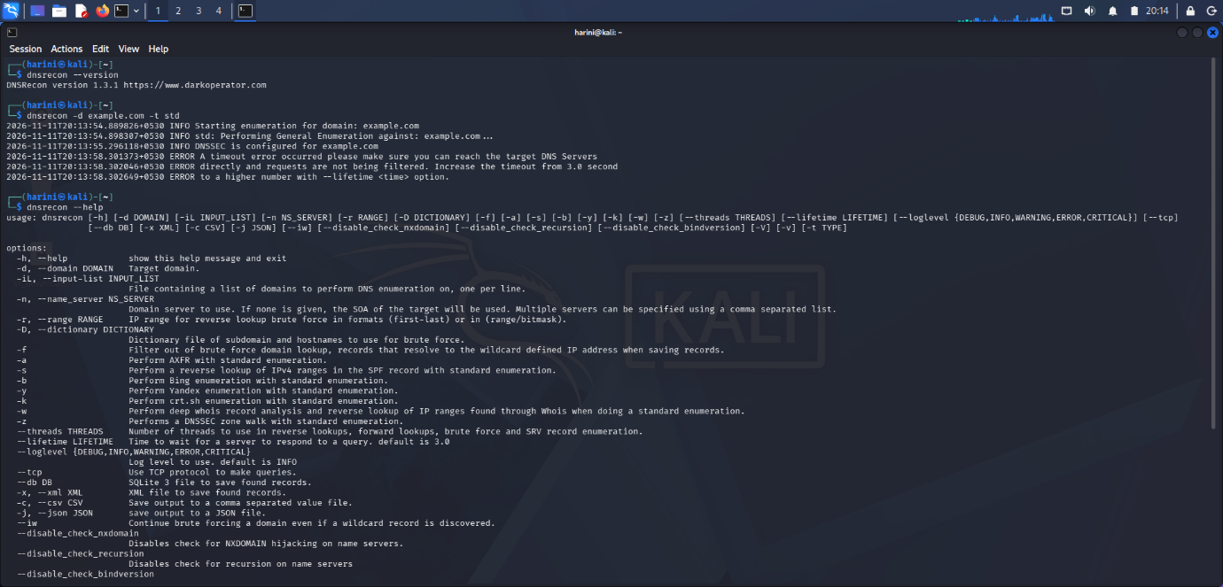

4.2 W2-PM5: Network Scanning with Zenmap
For the second activity, I used Zenmap, the graphical interface for Nmap, on Windows to perform network scanning and host discovery against my own local system. The practical involved exploring the Zenmap interface, checking host availability, examining TCP ports, performing service version detection, and attempting operating system detection. I also examined the Windows IP configuration and network adapter MAC addresses.
1. Zenmap Installation and Interface Exploration
Objective: Install Zenmap and explore its graphical interface and available scanning profiles.
Key Activities:
- Installed and opened Zenmap on Windows.
- Explored the Target field and Profile selection.
- Examined the scan command and output sections.
- Explored available profiles, including Ping Scan, Regular Scan, and Quick Scan.
Observation:
The Zenmap interface provided a graphical way to configure Nmap scans, execute commands, and examine scan results.
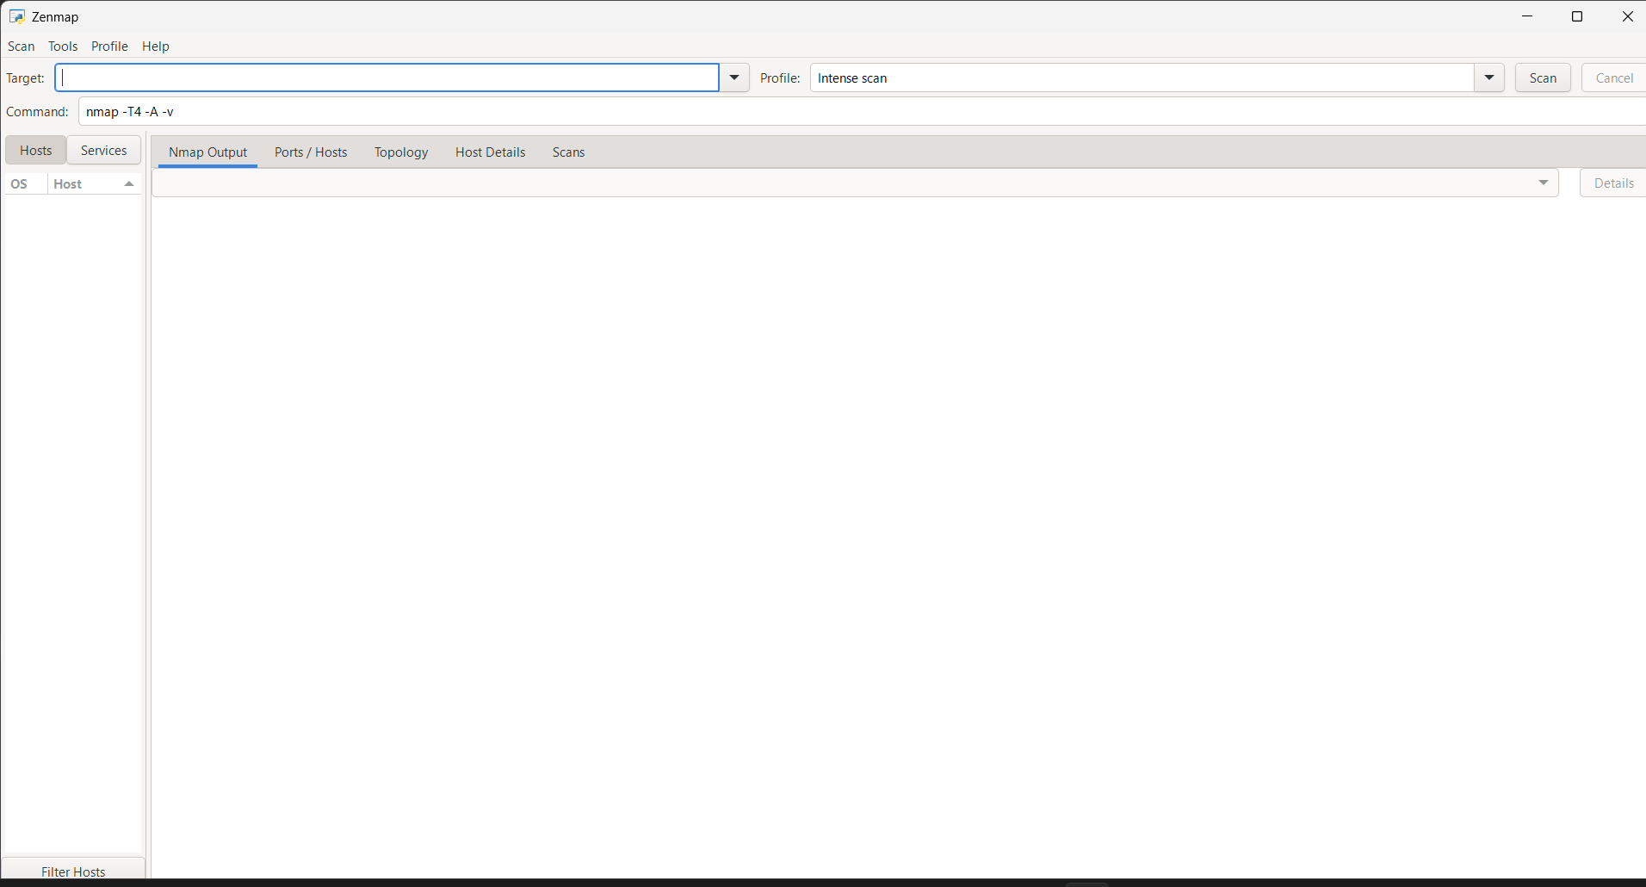2. Windows IP Configuration
Objective: Examine the local system's network configuration.
Command used: ipconfig
Key Activities:
- Examined available network interfaces.
- Identified the active Wi-Fi IPv4 configuration.
- Examined the subnet mask and default gateway.
- Identified the VirtualBox Host-Only network adapter.
Observation:
The command displayed the network configuration of the Windows system, helping me understand the relationship between an IP address, subnet mask, gateway, and network interface.
The college Wi-Fi network was not scanned because authorization to scan other connected devices was unavailable.
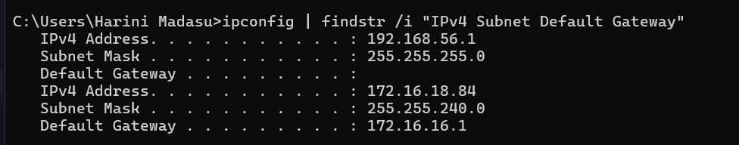
3. Ping Scan – Host Discovery
Objective: Check whether the local host was active and reachable.
Target: 127.0.0.1
Command used: nmap -sn 127.0.0.1
Observation: The scan successfully identified the localhost target as up.
This confirmed the availability of the local system through its loopback address. The scan was restricted to localhost and did not identify other devices on the college network.
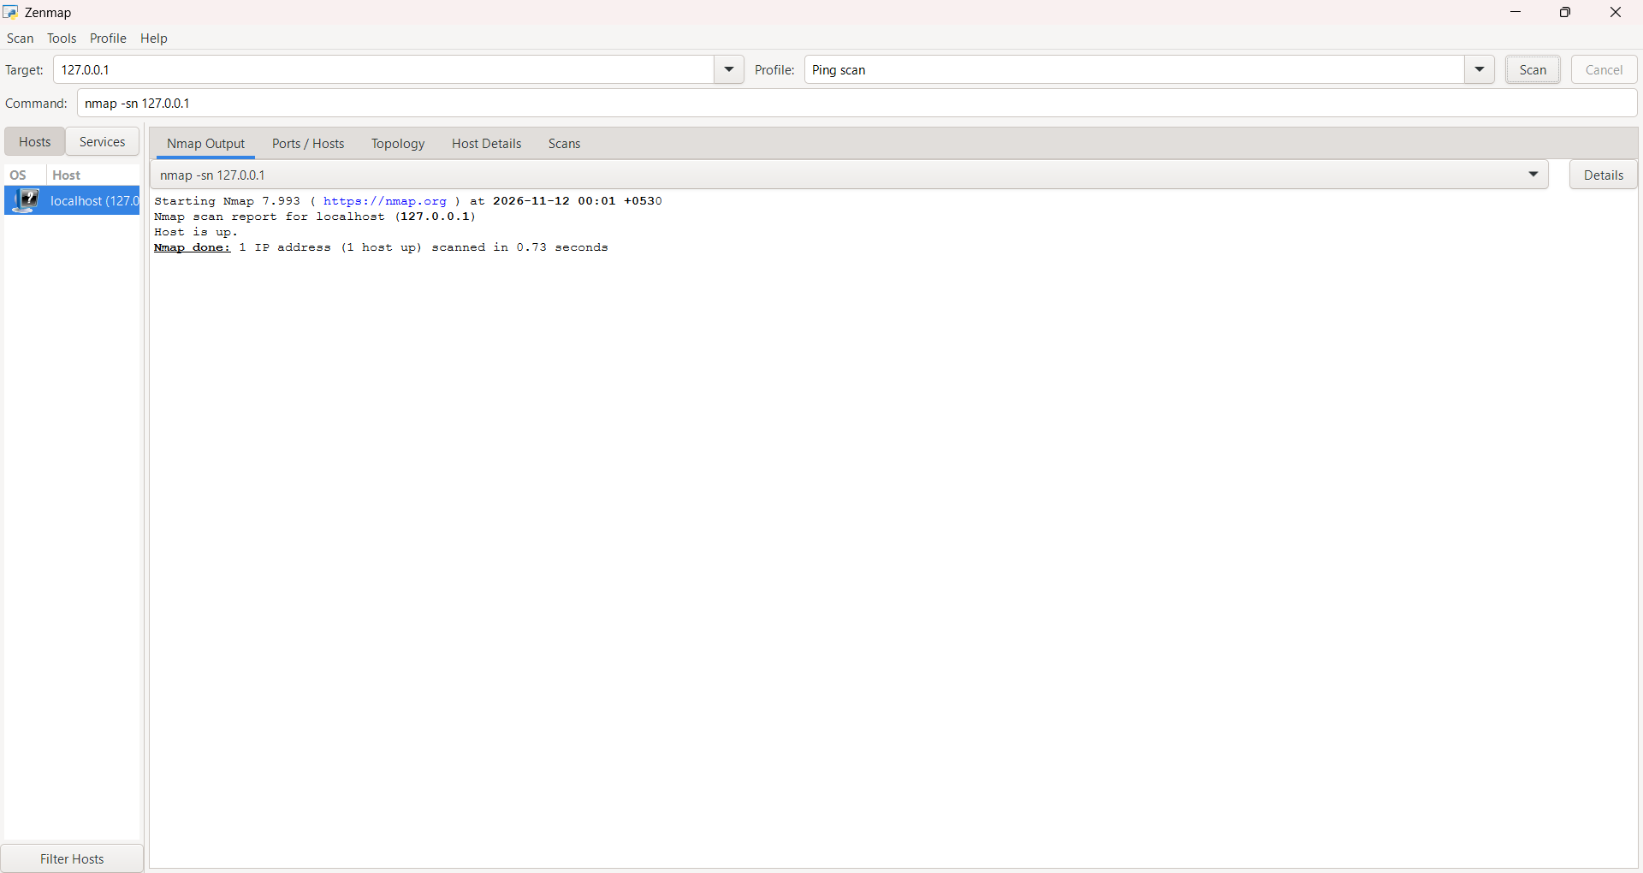
4. MAC Address Identification
Objective: Identify the MAC addresses associated with the local system's network adapters.
Command used: getmac /v
Key Activities:
- Examined the available network adapters.
- Identified the physical address associated with the Wi-Fi adapter.
- Examined the VirtualBox Host-Only adapter's MAC address.
Observation: The command displayed the MAC addresses associated with the system's network interfaces.
These addresses represent my own network adapters and are not MAC addresses discovered from other LAN devices.
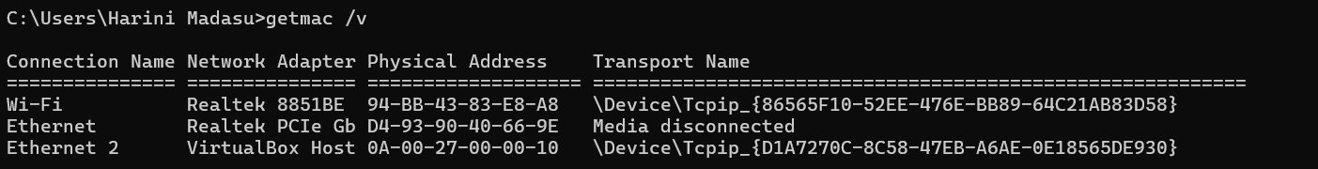
5. Service Version Detection
Objective: Identify services and their version information on open TCP ports.
Command used: nmap -sV 127.0.0.1
Observation: The scan identified the localhost system as up and reported six open TCP ports and 994 closed TCP ports among the default 1,000 scanned TCP ports.
The following services were identified:
Port | State | Service | Detected Information
80/tcp | Open | HTTP | Microsoft IIS httpd 10.0
135/tcp | Open | MSRPC | Microsoft Windows RPC
445/tcp | Open | Microsoft-DS | Version not identified
843/tcp | Open | Unknown | Service not identified
3306/tcp | Open | MySQL | MySQL 8.0.43
5432/tcp | Open | PostgreSQL | PostgreSQL DB
The scan also provided service information indicating a Windows operating system.
This activity demonstrated how Nmap's -sV option can identify services and provide version information about accessible ports.
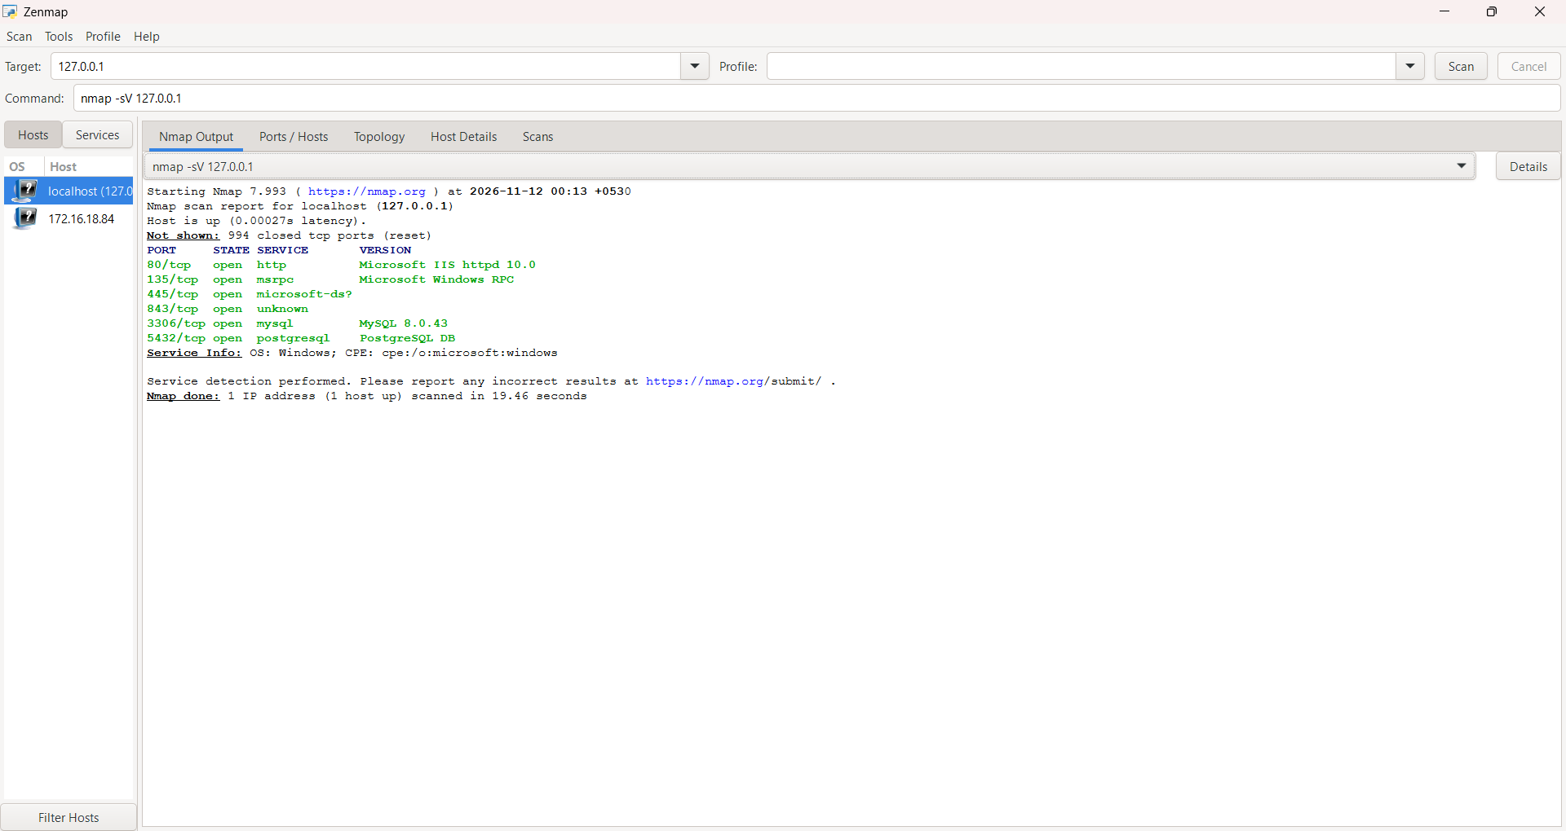
6. Operating System Detection
Objective: Explore operating system fingerprinting using Nmap.
Command used: nmap -O 127.0.0.1
Key Activities:
- Used the -O option to enable operating system detection.
- Examined the host status and TCP port information.
- Explored Nmap's operating system fingerprinting capability.
Observation: The scan was performed successfully. However, a localhost scan may not provide a reliable operating system fingerprint. Therefore, the result was not treated as a definitive OS identification.
This activity helped me understand the purpose and limitations of operating system detection during network scanning.
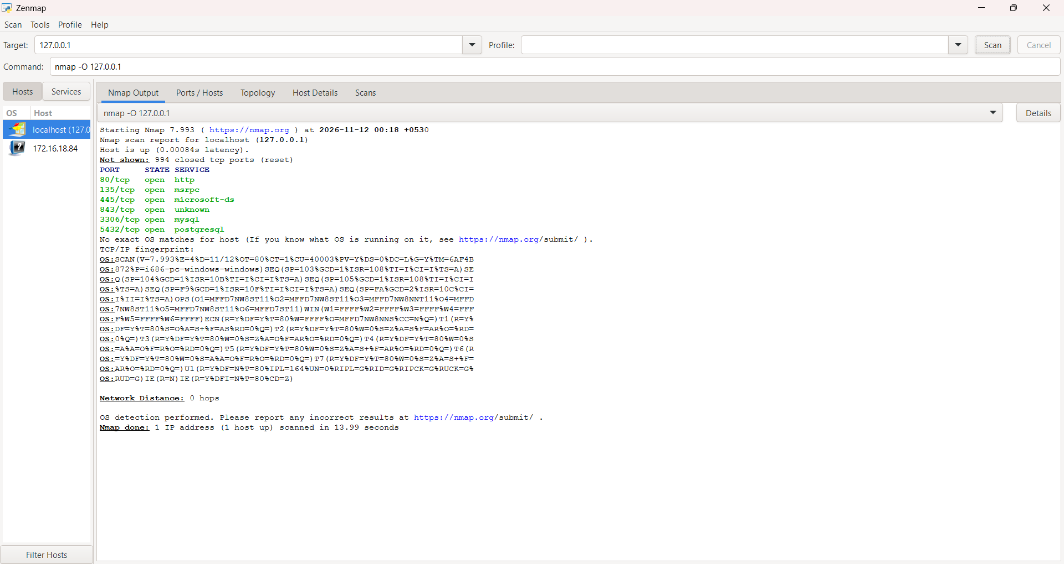
7. Saving Nmap Scan Results
Objective: Preserve scan output for documentation and further analysis.
Scan command: nmap -sV 127.0.0.1
Output File: zenmap_local_scan.txt
Key Activities:
- Executed the service version detection scan.
- Preserved the scan output in a text file.
- Reviewed the saved results for documentation and future reference.
Observation: The scan results were saved as zenmap_local_scan.txt on the Windows Desktop for further reference.
8. Network Topology Visualization
Objective: Examine the topology visualization available in Zenmap.
Key Activities:
- Opened the Topology tab in Zenmap.
- Examined the visualization generated from the localhost scan.
- Captured the topology view and saved it as a PDF.
Output File: Network_Topology.pdf
Observation:
The topology view represented the localhost scan.

5. Risk Analysis / Impact
Based on the information collected during the footprinting and network scanning activities, the following observations and their potential security implications were identified.
No. | Risk / Finding | Evidence / Observation | Potential Impact | Risk Level
1 | Domain registration information available | WHOIS retrieved publicly available domain information. | May help an attacker understand domain registration and infrastructure details. | Low
2 | Website technology information identifiable | WhatWeb successfully fingerprinted the target website. | Technology information may help attackers identify software requiring further security review. | Low
3 | DNS information publicly available | Nslookup retrieved domain resolution, MX, and NS information. | DNS information may assist in mapping domain infrastructure. | Low
4 | WAF technology identifiable | Wafw00f identified Cloudflare as the WAF. | Reveals information about the website's protective infrastructure. | Low
5 | DNS infrastructure information discoverable | DNSRecon successfully performed DNS enumeration. | DNS records may provide information useful for further reconnaissance. | Low
6 | Localhost reachable | Nmap Ping Scan reported 127.0.0.1 as up. | Confirms local host availability but does not indicate external network exposure. | Informational
7 | Open TCP ports identified | Service detection identified six open TCP ports on localhost. | The services may require configuration and security review. | Informational
8 | OS fingerprinting limitations | The localhost OS detection exercise did not establish a definitive fingerprint. | Additional suitable scan conditions may be required for reliable OS identification. | Informational
Risk Level Key: Critical | High | Medium | Low | Informational
The observations above are based on the results of the assigned footprinting and scanning exercises. They do not represent confirmed vulnerabilities. The identification of publicly available information, a WAF, or open local ports does not automatically indicate a security weakness. Further authorized testing would be required to establish whether any actual vulnerability exists.
No exploitation, vulnerability validation, or unauthorized access to external systems was performed.
6. Recommendations
Based on the observations from the footprinting and network scanning activities, the following security recommendations can be considered:
1. Review Publicly Available Domain Information
Organizations should periodically review domain registration information and technical details that are publicly accessible.
2. Keep Website Technologies Updated
Web servers, CMS platforms, plugins, and other software components should be updated regularly to reduce exposure to known vulnerabilities.
3. Monitor DNS Configuration
DNS records should be reviewed periodically to ensure that only required records and services are publicly exposed.
4. Maintain Proper WAF Configuration
Web Application Firewalls should be configured, maintained, and monitored to help protect web applications against malicious traffic.
5. Perform Regular Authorized Network Scanning
Organizations should conduct authorized network scans periodically to identify active hosts, open ports, and potentially unnecessary services.
6. Review Open Network Ports
Open ports should be reviewed to ensure that the associated services are necessary and properly secured.
7. Investigate Unexpected Services
Unknown or unexpected services discovered during network scanning should be investigated and verified by the responsible system administrator.
8. Maintain Scan Documentation
Network scan results should be saved and documented to support future security reviews and comparisons.
9. Follow Authorized Testing Practices
Footprinting, reconnaissance, and network scanning should always be conducted within an approved scope and with appropriate authorization.
7. Conclusion
During Week 2 of my cybersecurity training at Network Walks, I completed practical activities covering web footprinting, reconnaissance, and network scanning.
In the footprinting activity (W2-PM1), I used WHOIS, WhatWeb, Nslookup, Wafw00f, and DNSRecon to collect publicly available domain, website, and DNS-related information about example.com. I learned how these tools can be used to understand domain registration details, identify website technologies, retrieve DNS records, perform DNS enumeration, and detect Web Application Firewalls.
In the network scanning activity (W2-PM5), I used Zenmap and Nmap on Windows to perform host discovery and scanning against my own local system using the address 127.0.0.1. I explored the Zenmap interface and scanning profiles, performed a Ping Scan, examined TCP ports, identified services and their versions, and attempted operating system detection. I also examined the Windows network configuration and MAC addresses, saved scan results in a text file, and generated a localhost topology PDF.
The network scanning exercise was restricted to my own system. LAN-wide host discovery was not performed because authorization to scan other devices on the college network was unavailable.
These practical exercises helped me understand the initial stages of penetration testing and the importance of reconnaissance and network discovery in cybersecurity. I also gained practical experience in using command-line tools, interpreting scan results, troubleshooting, and documenting technical findings.
Overall, Week 2 provided valuable hands-on experience with Kali Linux, Zenmap, and Nmap. I would like to thank Network Walks and Wakis Sir for providing the learning resources, practical guidance, and support throughout the training.

👤 Author
Harini Madasu
Cybersecurity Trainee
B084 – Network Walks
📌 Project Information
- Program Name: Cybersecurity Training Program at Network Walks
- Week: 02
- Modules: W2-PM1 and W2-PM5
- Repository: Network Walks – Week 2 Cybersecurity Projects

