**EXCEL NOTES**

# **Short cut keys:**

1. Microsoft Help – F1
2. To move to the right most corner of the sheet – CTRL+🡪
3. To move to the left most corner of the sheet – CTRL +🡨
4. To move to the bottom of the page – PgDn(A1to A23)
5. To move to the top of the page – PgUp(A23 to A21)
6. To move horizontally forward in a page – Alt+PgUp(A to T)
7. To move horizontally backward in a page – Alt + PgDn(T to A)
8. Move through the right of worksheets – CTRL + PgUp
9. Move through the left of worksheets – CTRL+ PgDn
10. Edit the cell(Content of the cell) – F2
11. To select the specific row fully – Shift + Space
12. To select the specific column fully – CTRL + Space
13. To click multiple cell ranges – Just click and drag the desired cell range(s).
14. To select the current region(cells that contains data) – CTRL + A
15. To select the entire worksheet – CTRL + A(twice)
16. To group the sheets in excel ( This will enable you to make the changes among sheets) – Click CTRL and select the worksheets.

* In the below example, Sheet 2 and Sheet 3 are grouped.

1. Auto fit the content of the cells in a column- Double click on the double headed arrow of the cell.

1. To cut the cells – CTRL + X
2. To copy the cells – CTRL + C
3. To paste the cells – CTRL + V
4. Paste special option ( To paste the data with multiple options) – CTRL + ALT + V [OR] ALT+E+S
5. To find a cell – CTRL + F
6. Go-to option – CTRL + G
7. To replace a cell value – CTRL + H
8. Go-to special – CTRL + G and Click on Special.
9. To insert a comment – SHIFT + F2
10. To open Quick Analysis tool(contains excel’ s most used functionalities like Charts, conditional formatting etc.) – CTRL + Q
11. Format cells dialog box(Number formatting) – CTRL + 1
12. Insert formula – Shift + F3
13. To remove absolute cell reference – Press F4
14. To apply filter – CTRL+SHIFT+L
15. To lock cell references in a formula – **F4**
16. AutoSum- **ALT and =**
17. insert a new row in an Excel spreadsheet- **ALT + H + I + R**
18. to group rows so you can expand/contract a section of data **ALT + A + G + G**–
19. paste special – **ALT + H + V + S**
20. edit formula in a cell – **F2**
21. insert a table – **ALT + N + T**
22. to increase the number of decimal places – **ALT + H + 0**
23. open up the Find and Replace window – **ALT + H + FD + R**

# **To move across a worksheet(s) that has wide range of values:**

There are three ways to move across a worksheet that has wide range of values. The reason is because when you have a large data set you need to move to the start or left of the range every time to check what the data relates to. To perform this Click on the **View** tab and select the following options based on your requirements.

1. New window – The **New Window** option enables you to open a replica window with all the worksheets. One remains static where you can view the column and row headings and the other one can be used for data manipulation.
2. Split panes – The **Split Panes** option allows you to split the entire worksheet into 4 different tabs. Each of the tab is dynamic(only one at a time). For instance, If you wanted to scroll and work on the left most tab , then the remaining tabs remains static.
3. Freeze panes – The **Freeze panes** option is used to freeze the left most row or column heading there by, the freezed row or segment remains throughout. For instance, If the first-row heading is freezed, you can view the rest of the rows by scrolling right . The first row will appear no matter how many rows you have in the sheet.
   1. Freeze pane is an option which is used to freeze both column and row by placing the cursor to the right side of the row and below the column that needs to be freezed.

# **Go-to special:**

1. This option is used to select the cell range based on some criteria.
2. For instance, If you want to select only numbers from the current region, The Go-to special option is used.

# **Customize the ribbon:**

This will allow you to customize the ribbons which is present at the top of your spreadsheet.

To customize a ribbon, click on any of the tab like HOME and right click on it.

* This will have a list of options which includes a option called Customize Ribbons. This is used to customize the ribbons based on our uses. Say if your job uses functions and charts and macros frequently, you can customize your own ribbon where a new tab gets created and that tab will have only groups and options that you want to have, this customize ribbon feature is used.

* Similarly, Quick Access Toolbar can also be customized.

Whatever is ticked will be available in the top.

# **To clear the content/formatting/everything:**

Clear all- clears everything

Clear content- clears only the content of the cell while the formatting remains.

Clear formatting- clears only the formatting while the content is present.

Clear hyperlinks- clears hyperlinks if any(Same for clear comments as well)

# **Tables:**

1. Tables can be extended from the current region by just clicking on **ENTER.**
2. A screenshot of a table

   Description automatically generatedStructured references are nothing, but they are used to refer the formulas inside a table.
3. Here , **@Amount** is referred to us as a structured reference. The structured references are always prefixed by **‘@’.**

1. The formula inside a table always follows the following syntax: =**FUNCTION NAME(Table_Name[column_name])**

1. There are contextual tabs available in excel that appears only if your current region is a table. **Table Design** is a contextual tab that is available in excel which provides various formatting features for you to format and work on the table.

1. **Table Slicers** are used to filter out the data from a table. Say, You have a table with multiple regions and you need to evaluate the performance of each region. Here, the table slicer helps you in the below way.

1. You can format the slicer using **Slicer Settings** dialog box.

# **Formula:**

A formula in excel is used to do mathematical calculations.

## **How to create a formula:**

* Select a cell
* Type the equal sign (=)
* Select a cell or type value
* Enter an arithmetic operator
* Select another cell or type value
* Press enter

## **To create a formula using cell address:**

* Select the cell C1
* Type the equal sign (=)
* Left click on A1, the cell that has the (309) value
* Type the minus sign (-)
* Left click on B2, the cell that has the (35) value
* Hit enter
  + **Tip:** The formula can be typed directly without clicking the cells. The typed formula would be the same as the value in C1 (=A1-B2).

## **Basic Formula:**

The basic operations used in Excel are as follows:

### **Order of Precedence:**

* Exponentiation
* Division or Multiplication
* Addition or Subtraction
* Greater than/Less than/Greater than equal to/Less than equal to.

**Note: Parenthesis**

## Excel Ranges:

Range is an important part of Excel because it allows you to work with selections of cells.

There are four different operations for selection.

* Selecting a cell
* Selecting multiple cells
* Selecting a column
* Selecting a row

## **The Name Box**

The Name Box shows you the reference of which cell or range you have selected. It can also be used to select cells or ranges by typing their values.

You will learn more about the Name Box later in this chapter.

## **Selecting a Cell**

Cells are selected by clicking them with the left mouse button or by navigating to them with the keyboard arrows.

It is easiest to use the mouse to select cells.

To select cell A1, click on it:

## **Selecting Multiple Cells**

More than one cell can be selected by pressing and holding down **CTRL**or **Command**and left clicking the cells. Once finished with selecting, you can let go of **CTRL**or **Command**.

Lets try an example: Select the cells A1, A7, C1, C7 and B4.

Did it look like the picture below?

## **Selecting a Column**

Columns are selected by left clicking it. This will select all cells in the sheet related to the column.

To select **column A**, click on the letter A in the column bar:

## **Selecting a Row**

Rows are selected by left clicking it. This will select all the cells in the sheet related to that row.

To select **row 1**, click on its number in the row bar:

ADVERTISEMENT

## **Selecting the Entire Sheet**

The entire spreadsheet can be selected by clicking the triangle in the top-left corner of the spreadsheet: 

Now, the whole spreadsheet is selected:

**Note:** You can also select the entire spreadsheet by pressing Ctrl+A for Windows, or Cmd+A for MacOS.

## **Selection of Ranges**

Selection of cell ranges has many use areas and it is one of the most important concepts of Excel. Do not think too much about how it is used with values. You will learn about this in a later chapter. For now let's focus on how to select ranges.

There are two ways to select a range of cells

1. Name Box
2. Drag to mark a range.

The easiest way is drag and mark. Let's keep it simple and start there.

How to drag and mark a range, step-by-step:

1. Select a cell
2. Left click it and hold the mouse button down
3. Move your mouse pointer over the range that you want selected. The range that is marked will turn grey.
4. Let go of the mouse button when you have marked the range

Let's have a look at an example for how to mark the range A1:E10.

**Note:** You will learn about why the range is called A1:E10 after this example.

Select cell A1:

Press and hold A1 with the left mouse button. Move to the mouse pointer to mark the selection range. The grey area helps us to see the covered range.

Let go of the left mouse button when you have marked the range A1:E10:

You have successfully selected the range A1:E10

# Filling

Filling makes your life easier and is used to fill ranges with values, so that you do not have to type manual entries.

Filling can be used for:

* Copying
* Sequences
* Dates
* Functions (*)

## How do you fill a series?

Filling is done by selecting a cell, clicking the fill icon and selecting the range using drag and mark while holding the left mouse button down.

The fill icon is found in the bottom right corner of the cell and has the icon of a small square. Once you hover over it your mouse pointer will change its icon to a thin cross.

### Icon used for filing:

### Options available for filing:

### Copy cells:

### Fill series:

#### **Date Series:**

The following options are available for filing the date series. I have demonstrated an example for each of the following options below:

You can also modify the options of fill series by clicking on fill🡪date🡪weekdays/year/date/month as demonstrated below:

**Step 1: Click on Fill in Menu Bar.**

**Step 2: Click on Series option as shown below**

**Step 3: Choose the options per your requirement as show in the below dialog box.**

#### **Customs list:**

Customs list is used to import or create a generic order that can be used for auto filing. To use customs list, Click **File 🡪 Options 🡪 Advanced 🡪 Edit Customs list .**

You can add or import any customs list of your choice and use it in your spreadsheet.

#### **Flash fill:**

Flash fill is used to fill the list in the following order.

## Excel Formulas:

1. A formula always starts with ‘=’ symbol.
   1. You can perform any arithmetic operations using this formula.
   2. You can directly enter the values as shown in the first example(=5+5) and then Click enter to see the result (OR) You can perform SUM operations by clicking on the range of cells(A1:A8) or by mentioning the cell address(A8+B4)

1. You can also perform operations such as SUM,AVERAGE,MAX,MIN,COUNT by clicking on

Formulas-🡪Auto Sum option

Sum🡪 sum of two numbers or range of numbers.

Average🡪 Average of two numbers or range of numbers

Count🡪Count of values in a range.

Max🡪Maximum value in a range

Min🡪Minimum value in a range.

## References:

### Absolute reference:

Reference is used to locate the cell. This is always prefixed by a $ symbol.

**Example:** $A$2

### Relative reference:

This is not prefixed by a $ symbol. This is just the cell address of the cell. For example, If there is a set of values in the A column

**Example: A2**

# Excel Functions:

**Excel Functions – Date and Time**

| **Excel Function** | **Description** |
| --- | --- |
| [**Excel DATE Function**](https://trumpexcel.com/excel-date-function/) | Excel DATE function can be used when you want to get the date value using the year, month and, day values as the input arguments. It returns a serial number that represents a specific date in Excel. |
| [**​Excel DATEVALUE Function**](https://trumpexcel.com/excel-datevalue-function/) | Excel DATEVALUE function is best suited for situations when a date is stored as text. This function converts the date from text format to a serial number that Excel recognizes as a date. |
| [**Excel DAY Function**](https://trumpexcel.com/excel-day-function/) | Excel DAY function can be used when you want to get the day value (ranging between 1 to 31) from a specified date. It returns a value between 0 and 31 depending on the date used as the input. |
| [**Excel HOUR Function**](https://trumpexcel.com/excel-hour-function/) | Excel HOUR function can be used when you want to get the HOUR integer value from a specified time value. It returns a value between 0 (12:00 A.M.) and 23 (11:00 P.M.) depending on the time value used as the input |
| [**Excel MINUTE Function**](https://trumpexcel.com/excel-minute-function/) | Excel MINUTE function can be used when you want to get the MINUTE integer value from a specified time value. It returns a value between 0 and 59 depending on the time value used as the input. |
| [**Excel NETWORKDAYS Function**](https://trumpexcel.com/excel-networkdays-function/) | Excel NETWORKDAYS function can be used when you want to get the number of working days between two given dates. It does not count the weekends between the specified dates (by default the weekend is Saturday and Sunday). It can also exclude any specified holidays. |
| [**Excel NETWORKDAYS.INTL Function**](https://trumpexcel.com/excel-networkdays-intl-function/) | Excel NETWORKDAYS.INTL function can be used when you want to get the number of working days between two given dates. It does not count the weekends and holidays, both of which can be specified by the user. It also enables you to specify the weekend (for example, you can specify Friday and Saturday as the weekend, or only Sunday as the weekend). |
| [**Excel NOW Function**](https://trumpexcel.com/excel-now-function/) | Excel NOW function can be used to get the current date and time value. |
| [**Excel SECOND Function**](https://trumpexcel.com/excel-second-function/) | Excel SECOND function can be used want to get the integer value of the seconds from a specified time value. It returns a value between 0 and 59 depending on the time value used as the input. |
| [**Excel TODAY Function**](https://trumpexcel.com/excel-today-function/) | Excel TODAY function can be used to get the current date. It returns a serial number that represents the current date. |
| [**Excel WEEKDAY Function**](https://trumpexcel.com/excel-weekday-function/) | Excel WEEKDAY function can be used to get the day of the week as a number for the specified date. It returns a number between 1 and 7 that represents the corresponding day of the week. |
| [**Excel WORKDAY Function**](https://trumpexcel.com/excel-workday-function/) | Excel WORKDAY function can be used when you want to get the date after a given number of working days. By default, it takes Saturday and Sunday as the weekend |
| [**Excel WORKDAY.INTL Function**](https://trumpexcel.com/excel-workdayintl-function/) | Excel WORKDAY.INTL function can be used when you want to get the date after a given number of working days. In this function, you can specify the weekend to be days other than Saturday and Sunday. |
| [**Excel DATEDIF Function**](https://trumpexcel.com/excel-datedif-function/) | Excel DATEDIF function can be used when you want to calculate the number of years, months, or days between the two specified dates. A good example would be calculating the age. |

**Excel Functions – Logical**

| **Excel Function** | **Description** |
| --- | --- |
| [**Excel AND Function**](https://trumpexcel.com/excel-and-function/) | Excel AND function can be used when you want to check multiple conditions. It returns TRUE only when all the given conditions are true. |
| [**Excel FALSE Function**](https://trumpexcel.com/excel-false-function/) | Excel FALSE function returns the logical value FALSE. It does not take any input arguments. |
| [**Excel IF Function**](https://trumpexcel.com/excel-if-function/) | Excel IF Function is best suited for situations where you want to evaluate a condition, and the return a value if it is TRUE and another value if it is FALSE. |
| [**Excel IFS Function**](https://trumpexcel.com/excel-ifs-function/) | Excel IFS Function is best suited for situations where you want to test multiple conditions at once and then return the result based on it. This is helpful as you don’t have to create long nested IF formulas that can get confusing. |
| [**Excel IFERROR Function**](https://trumpexcel.com/excel-iferror-function/) | Excel IFERROR function is best-suited to handle formula that evaluates to an error. You can specify a value to show if the formula returns an error. |
| [**Excel NOT Function**](https://trumpexcel.com/excel-not-function/) | Excel NOT function can be used when you want to reverse the value of a logical argument (TRUE/FALSE). |
| [**Excel OR Function**](https://trumpexcel.com/excel-or-function/) | Excel OR function can be used when you want to check multiple conditions. It returns TRUE if any of the given condition is true. |
| [**Excel TRUE Function**](https://trumpexcel.com/excel-true-function/) | Excel TRUE function returns the logical value TRUE. It does not take any input arguments. |
| [**Excel LAMBDA Function**](https://trumpexcel.com/excel-functions/lambda/) | Excel LAMBDA function allows you to create and use your own functions right within the worksheet. |
| [**Excel SWITCH Function**](https://trumpexcel.com/excel-functions/switch-function/) | Excel SWITCH function evaluates an expression (which returns a value) and matches this value with a list of values to return the corresponding result from the first matching value. |

**Excel Functions – Lookup & Reference**

| **Excel Function** | **Description** |
| --- | --- |
| [**Excel COLUMN Function**](https://trumpexcel.com/excel-column-function/) | Excel COLUMN function can be used when you want to get the column number of a specified cell. |
| [**Excel COLUMNS Function**](https://trumpexcel.com/excel-columns-function/) | Excel COLUMNS function can be used when you want to get the number of columns in a specified range or array. It returns a number that represents the total number of columns in the specified range or array. |
| [**Excel HLOOKUP Function**](https://trumpexcel.com/excel-hlookup-function/) | Excel HLOOKUP function is best suited for situations when you are looking for a matching data point in a row, and when the matching data point is found, you go down that column and fetch a value from a cell which is specified a number of rows below the top row. |
| [**Excel INDEX Function**](https://trumpexcel.com/excel-index-function/) | Excel INDEX function can be used when you have the position (row number and column number) of a value in a table, and you want to fetch that value. This is often use with the MATCH function and is a powerful alternative to the VLOOKUP function. |
| [**Excel INDIRECT Function**](https://trumpexcel.com/excel-indirect-function/) | Excel INDIRECT function can be used when you have the references as text and you want to get the values from those references. It returns the reference specified by the text string. |
| [**Excel MATCH Function**](https://trumpexcel.com/excel-match-function/) | Excel MATCH function can be used when you want to get the relative position of a lookup value in a list or an array. It returns a number that represents the position of the lookup value in the array. |
| [**Excel OFFSET Function**](https://trumpexcel.com/excel-offset-function/) | Excel OFFSET function can be used when you want to get a reference which offsets specified number of rows and columns from the starting point. It returns the reference that OFFSET function points to. |
| [**Excel ROW Function**](https://trumpexcel.com/excel-row-function/) | Excel ROW Function function can be used when you want to get the row number of a cell reference. For example, =ROW(B4) would return 4, as it is in the fourth row. |
| [**Excel ROWS Function**](https://trumpexcel.com/excel-rows-function/) | Excel ROWS Function can be used when you want to get the number of rows in a specified range or array. It returns a number that represents the total number of rows in the specified range or array. |
| [**Excel VLOOKUP Function**](https://trumpexcel.com/excel-vlookup-function/) | Excel VLOOKUP function is best suited for situations when you are looking for a matching data point in a column, and when the matching data point is found, you go to the right in that row and fetch a value from a cell which is a specified number of columns to the right. |
| [**Excel XLOOKUP Function**](https://trumpexcel.com/xlookup-function/) | Excel XLOOKUP function is a new function for Office 365 users and is an enhanced version of the VLOOKUP/HLOOKUP functions. It can be used to lookup and fetch the value in a dataset, and can replace most of what we do with older lookup formulas. |
| [**Excel FILTER Function**](https://trumpexcel.com/filter-function/) | Excel FILTER function is a new function for Office 365 users that allows you to quickly filter and extract data based on the given condition (or multiple conditions). |
| [**Excel TAKE Function**](https://trumpexcel.com/excel-functions/take-function/) | TAKE function is a new Excel function that allows you to extract the given number of contiguous rows or columns from a dataset. It’s mostly used in other functions such as FILTER and SORT. |
| [**Excel DROP Function**](https://trumpexcel.com/excel-functions/drop-function/) | DROP function allows you to extract the given number of contiguous rows or columns from a dataset after dropping the specified number of rows or columns (or both). |

**Excel Functions – Math**

| **Excel Function** | **Description** |
| --- | --- |
| [**Excel INT Function**](https://trumpexcel.com/excel-int-function/) | Excel INT Function can be used when you want to get the integer portion of a number. |
| [**Excel MOD Function**](https://trumpexcel.com/excel-mod-function/) | Excel MOD function can be used when you want to get the remainder when one number is divided by another. It returns a numerical value that represents the remainder when one number is divided by another. |
| [**Excel RAND Function**](https://trumpexcel.com/excel-rand-function/) | Excel RAND function can be used when you want to generate evenly distributed random numbers between 0 and 1. It returns a number between 0 and 1 |
| [**Excel RANDBETWEEN Function**](https://trumpexcel.com/excel-randbetween-function/) | Excel RANDBETWEEN function can be used when you want to generate evenly distributed random numbers between a top and bottom range specified by the user. It returns a number between the top and bottom range specified by the user. |
| [**Excel ROUND Function**](https://trumpexcel.com/excel-round-function/) | Excel ROUND function can be used when you want to return a number rounded to a specified number of digits. |
| [**Excel SUM Function**](https://trumpexcel.com/excel-sum-function/) | Excel SUM function can be used to add all numbers in a range of cells. |
| [**Excel SUMIF Function**](https://trumpexcel.com/excel-sumif-function/) | Excel SUMIF function can be used when you want to add the values in a range if the specified condition is met. |
| [**Excel SUMIFS Function**](https://trumpexcel.com/excel-sumifs-function/) | Excel SUMIFS function can be used when you want to add the values in a range if multiple specified criteria are met. |
| [**Excel SUMPRODUCT Function**](https://trumpexcel.com/excel-sumproduct-function/) | Excel SUMPRODUCT function can be used when you want to first multiply two or more sets to arrays and then get its sum |
| [**Excel LN Function**](https://trumpexcel.com/excel-functions/ln-natural-log/) | LN Function in Excel Is used to calculate the natural log of a number |

Also read: [VLOOKUP vs XLOOKUP Function – What’s the Difference?](https://trumpexcel.com/excel-functions/vlookup-vs-xlookup/)

**Excel Functions – Statistics**

| **Excel Function** | **Description** |
| --- | --- |
| [**Excel RANK Function**](https://trumpexcel.com/excel-rank-function/) | Excel RANK function can be used when you want to rank a number against a list of numbers. It returns a number that represents the relative rank of the number against the list of numbers. |
| [**Excel AVERAGE Function**](https://trumpexcel.com/excel-average-function/) | Excel AVERAGE function can be used when you want to get the average (arithmetic mean) of the specified arguments. |
| [**Excel AVERAGEIF Function**](https://trumpexcel.com/excel-averageif-function/) | Excel AVERAGEIF function can be used when you want to get the average (arithmetic mean) of all the values in a range of cells that meet a given criteria. |
| [**Excel AVERAGEIFS Function**](https://trumpexcel.com/excel-averageifs-function/) | Excel AVERAGEIFS function can be used when you want to get the average (arithmetic mean) of all the cells in a range that meets multiple criteria. |
| [**Excel COUNT Function**](https://trumpexcel.com/excel-count-function/) | Excel COUNT function can be used to count the number of cells that contain numbers. |
| [**Excel COUNTA Function**](https://trumpexcel.com/excel-counta-function/) | Excel COUNTA function can be used when you want to count all the cells in a range that are not empty. |
| [**Excel COUNTBLANK Function**](https://trumpexcel.com/excel-countblank-function/) | Excel COUNTBALNK function can be used when you have to count all the empty cells in a range. |
| [**Excel COUNTIF Function**](https://trumpexcel.com/excel-countif-function/) | Excel COUNTIF function can be used when you want to count the number of cells that meet a specified criterion. |
| [**Excel COUNTIFS Function**](https://trumpexcel.com/excel-countifs-function/) | Excel COUNTIFS function can be used when you want to count the number of cells that meet a single or multiple criteria. |
| [**Excel LARGE Function**](https://trumpexcel.com/excel-large-function/) | Excel LARGE function can be used to get the Kth largest value from a range of cells or array. For example, you can get the third largest value from a range of cells. |
| [**Excel MAX Function**](https://trumpexcel.com/excel-max-function/) | Excel MAX function can be used when you want to get the largest value from a set of values. |
| [**Excel MIN Function**](https://trumpexcel.com/excel-min-function/) | Excel MIN function can be used when you want to get the smallest value from a set of values. |
| [**Excel SMALL Function**](https://trumpexcel.com/excel-small-function/) | Excel SMALL function can be used to get the Kth smallest value from a range of cells or arrays. For example, you can get the third smallest value from a range of cells. |

**​Excel Functions – Text Functions**

| **Excel Function** | **Description** |
| --- | --- |
| [**Excel CONCATENATE Function**](https://trumpexcel.com/excel-concatenate-function/) | Excel CONCATENATE function can be used when you want to join 2 or more characters or strings. It can be used to join text, numbers, cell references, or a combination of these. |
| [**Excel FIND Function**](https://trumpexcel.com/excel-find-function/) | Excel FIND function can be used when you want to locate a text string within another text string and find its position. It returns a number that represents the starting position of the string you are finding in another string. It is case-sensitive. |
| [**Excel LEFT Function**](https://trumpexcel.com/excel-left-function/) | Excel LEFT function can be used to extract text from left of the string. It returns the specified number of characters from the left of the string |
| [**Excel LEN Function**](https://trumpexcel.com/excel-len-function/) | Excel LEN function can be used when you want to get the total number of characters in a specified string. This is useful when you want to know the length of a string in a cell. |
| [**Excel LOWER Function**](https://trumpexcel.com/excel-lower-function/) | Excel LOWER function can be used when you want to convert all uppercase letter in a text string to lowercase. Numbers, special characters, and punctuations are not changed by the LOWER function. |
| [**Excel MID Function**](https://trumpexcel.com/excel-mid-function/) | Excel MID function can be used to extract a specified number of characters from a string. It returns the sub-string from a string. |
| [**Excel PROPER Function**](https://trumpexcel.com/excel-proper-function/) | Excel PROPER function can be used when you want to capitalize the first character of every word. Numbers, special characters, and punctuations are not changed by the PROPER function. |
| [**Excel REPLACE Function**](https://trumpexcel.com/excel-replace-function/) | Excel REPLACE function can be used when you want to replace a part of the text string with another string. It returns a text string where a part of the text has been replaced by the specified string. |
| [**Excel REPT Function**](https://trumpexcel.com/excel-rept-function/) | Excel REPT function can be used when you want to repeat a specified text a certain number of times. |
| [**Excel RIGHT Function**](https://trumpexcel.com/excel-right-function/) | The RIGHT function can be used to extract text from the right of the string. It returns the specified number of characters from the right of the string |
| [**Excel SEARCH Function**](https://trumpexcel.com/excel-search-function/) | Excel SEARCH function can be used when you want to locate a text string within another text string and find its position. It returns a number that represents the starting position of the string you are finding in another string. It is NOT case-sensitive. |
| [**Excel SUBSTITUTE Function**](https://trumpexcel.com/excel-substitute-function/)    ​ | Excel SUBSTITUTE function can be used when you want to substitute text with new specified text in a string. It returns a text string where an old text has been substituted by the new one. |
| [**Excel TEXT Function**](https://trumpexcel.com/excel-text-function/) | Excel TEXT function can be used when you want to convert a number to text format and display it in a specified format. |
| [**Excel TRIM Function**](https://trumpexcel.com/excel-trim-function/) | Excel TRIM function can be used when you want to remove leading, trailing, and double spaces in Excel. |
| [**Excel UPPER Function**](https://trumpexcel.com/excel-upper-function/) | Excel UPPER function can be used when you want to convert all lowercase letters in a text string to uppercase. Numbers, special characters, and punctuations are not changed by the UPPER function. |

**Excel Functions – Info**

| **Excel Function** | **Description** |
| --- | --- |
| [**Excel ISBLANK Function**](https://trumpexcel.com/excel-is-function/)    [**Excel ISERROR Function**](https://trumpexcel.com/excel-is-function/)  [**Excel ISNA Function**](https://trumpexcel.com/excel-is-function/)  [**Excel ISNUMBER Function**](https://trumpexcel.com/excel-is-function/)  [**Excel ISEVEN Function**](https://trumpexcel.com/excel-is-function/)  [**Excel ISODD Function**](https://trumpexcel.com/excel-is-function/)  [**Excel ISLOGICAL Function**](https://trumpexcel.com/excel-is-function/)  [**Excel ISTEXT Function**](https://trumpexcel.com/excel-is-function/) | Excel IS function returns TRUE when specified condition is TRUE. For example, ISNA would return TRUE if the cell has a #N/A! error. |

**Excel Functions – Financial**

| **Excel Function** | **Description** |
| --- | --- |
| **​**[**Excel PMT Function**](https://trumpexcel.com/pmt-function/) | Excel PMT function helps you calculate the payment you need to make for a loan when you know the total loan amount, interest rate, and the number of constant payments. |
| [**Excel NPV Function**](https://trumpexcel.com/npv-excel/) | Excel NPV function allows you to calculate the Net Present Value of all the cashflows when you know the discount rate |
| [**Excel IRR Function**](https://trumpexcel.com/calculate-irr-excel/) | Excel IRR function allows you to calculate the Internal Rate of Return when you have the cashflows data |

**VBA Functions**

| **Excel Function** | **Use the VBA DIR function when you want to get the name of the file or a folder, using their path name** |
| --- | --- |
| [**VBA TRIM Function**](https://trumpexcel.com/vba-trim/) | VBA TRIM function allows you to remove the leading and trailing spaces from a text string in Excel. It can be a useful VBA function if you want to quickly clean the data. |
| [**VBA SPLIT Function**](https://trumpexcel.com/vba-split-function/) | VBA SPLIT function alllows you to split a text string based on the delimiter. For example, if you want to split text based on a comma or tab or colon, you can do that with the SPLIT function. |
| [**VBA MsgBox Function**](https://trumpexcel.com/vba-msgbox/) | VBA MsgBox is a function that displays a dialog box that you can use to inform your users by showing a custom message or get some basic inputs (such as Yes/No or OK/Cancel). |
| [**VBA INSTR Function**](https://trumpexcel.com/excel-vba-instr/) | VBA InStr function finds the position of a specified substring within the string and returns the first position of its occurrence. |
| [**VBA UCase Function**](https://trumpexcel.com/vba-ucase/) | Excel VBA UCASE function takes a string as the input and converts all the lower case characters into upper case. |
| [**VBA LCase Function**](https://trumpexcel.com/vba-lcase/) | Excel VBA LCASE function takes a string as the input and converts all the upper case characters into lower case. |
| [**VBA DIR Function**](https://trumpexcel.com/vba-dir-function/) | Use the VBA DIR function when you want to get the name of the file or a folder using their path name |

## Functions:

Functions are pre-defined formulas. Excel Functions are of various types. They are as follows:

### IS:

IS functions are of different types. It returns either “TRUE” or “FALSE” based on the condition. The IS function is of different types as mentioned below:

### AND:

* Returns TRUE or FALSE based on two or more conditions
* **Example:** 
  + In the below example, the function returns true when two or more conditions specified are true and returns false if at least one of the conditions do match the criteria.
  + **Syntax: =AND(Condition 1, Condition 2, Condition 2…. Condition N)**

### INT:

INT function is used to return the integral value of a cell. If there is a negative value, It rounds it off away from zero. Please find the examples below:

### MOD:

MOD function is used to return the reminder of two values.

### ROUND:

It is used to round off a number to certain decimal values.

**Example 1: Rounding off to -3. This will round off the values to nearest 100s. For 2939.392, nearest 100 is 3000.**

**Example 2: Rounding off to 2.**

**Example 3: Rounding off to 0.**

### AVERAGE:

* The **AVERAGE** function is a premade function in Excel, which calculates the average (arithmetic mean).
* It is typed =AVERAGE
* It adds the range and divides it by the number of observations.
* **Syntax: =AVERAGE(range)**
* **Example:**
* A screenshot of a computer

  Description automatically generated
* When you text/string in the range for which you are calculating average, Then the function ignores the text values and takes only the numeric values into consideration.
* A screenshot of a computer

  Description automatically generated

### AVERAGE IF:

The **AVERAGEIF** function is a premade function in Excel, which calculates the [average](https://www.w3schools.com/statistics/statistics_mean.php) of a range based on a **true** or **false** **condition**.

It is typed =AVERAGEIF and has three parts:

**Syntax: =AVERAGEIF(range, criteria, [average_range])**

The **condition** is referred to as criteria, which can check things like:

* If a number is **greater than** another number >
* If a number is **smaller than** another number <
* If a number or text is **equal** to something =

The [average_range] is the range where the function calculates the average.

**Note:** The [average_range] is optional.

If not specified, the function calculates the average of the same range as condition.

### AVERAGE IFS:

* AVERAGE IFS are just like AVERAGE IF but are used when you wanted to specify more than one condition.
* **Syntax: =AVERAGEIFS(average_range, condition_range1,condition_value1,condition_range2,condition_value2…N)**
* **Example: In the below example, You will be categorizing based on two conditions. The first one is Type 1 and the next one is Generation.**

### CONCAT:

* The CONCAT function is used to combine or concatenate two cell values separated by a delimiter(optional).
* **Syntax: =CONCAT(cell1,delimiter,cell2)**
* Example: The below example concatenates Type 1 and Generation

### COUNT:

* The **COUNT** function is a premade function in Excel, which counts cells with numbers in a range.
* It is typed **=COUNT**
* **Note:** The **COUNT** function only counts cells with numbers, **not**cells **with letters**. The [COUNTA](https://www.w3schools.com/excel/excel_counta.php) function is better used if the cells have letters.
* How to use the =COUNT function:
  + Select a cell
  + Type =COUNT
  + Double click the **COUNT**command
  + Select a range
  + Hit enter

**Syntax: =COUNT(range)**

**Example:**

### COUNTA:

* The **COUNTA** function is a premade function in Excel, which counts all cells in a range that has values, both numbers and letters.
* It is typed =COUNTA
* How to use the =COUNTA function:
* Select a cell
* Type =COUNTA
* Double click the **COUNTA** command
* Select a range
* Hit enter
* **Syntax: =COUNTA(range of the cells)**
* **Example:**

### COUNTBLANK:

* The **COUNTBLANK** function is a premade function in Excel, which counts blank cells in a range.
* It is typed =COUNTBLANK
* **Note:** The **COUNTBLANK** function is helpful to find empty cells in a range.
* How to use the =COUNTBLANK function:
* Select a cell
* Type =COUNTBLANK
* Double click the **COUNTBLANK** command
* Select a range
* Hit enter
* **Syntax: =COUNTBLANK(range)**
* **Example:**

### COUNTIF:

* The **COUNTIF** function is a premade function in Excel, which counts cells as specified.
* It is typed =COUNTIF

**NOTE:** The **COUNTIF**function can have basic or more advanced uses. This covers the basic use for how to count specific numbers and words.

Numbers (e.g. 90) and words (e.g. "Water") can be specified.

* How to use the =COUNTIF function:

1. Select a cell
2. Type =COUNTIF
3. Double click the **COUNTIF** command
4. Select a range
5. Type ,
6. Select a cell (the criteria, the value that you want to count)
7. Hit enter

**Syntax: =COUNTIF(range,condition)**

**Example:**

**Making use of the**[**Filling Function**](https://www.w3schools.com/excel/excel_filling.php)**and**[**Absolute References**](https://www.w3schools.com/excel/excel_abs_ref.php)**:**

* You need to use absolute reference only for the range and the criteria should remain as a relative reference.
* This will allow you to fill the formula used for the first cell to the rest of the cells .

***Note: The last example shows that count the cells that has min 1 character in it. The “?” is used to represent at least one in the beginning and the “*” character represents you can have any number of characters towards the end. This is used to count the cells that are not blank.***

### COUNTIFS:

COUNTIFS() is similar to that of AVERAGEIFS(). It counts the values in the range for more than one condition

**Syntax: =COUNTIFS(range1,condition1,range 2,condition2)**

**Example:**

### LARGE():

This is used to return the nth largest value in an array or range.

**Syntax: =LARGE(range/array,nth largest value in the range)**

**Example:**

### SMALL:

This is used to return the nth smallest value in an array or range.

**Syntax: =SMALL (range/array,nth smallest value in the range)**

**Example:**

### RANK:

#### **RANK.EQ():**

* Rank.EQ() is used to return the rank of an array or range. Say there are 4 numbers in an array or range, It returns the result stating that the rank of the cell(when ascending – it tells the position of the cell in ascending order and when descending, it tells the position of the cell in descending order).
* When the order is not mentioned in the formula., it calculates the rank in **descending order by default.**

**Example:**

#### **RANK.AVG():**

It is same as that of the former function but when two values have the same rank, it takes the average of those ranks and gives the average of it. In the below example, Since there are 2 3s, The average of rank 2 and rank 3 is calculated and is given as **2.5.**

**Example:**

### IF:

* + IF function is used to specify a condition and return values based on the condition. That is if the condition matches, the second parameter of the function is returned otherwise the third parameter gets returned.
  + When you use **only IF** function, You can specify only a single condition. Upon using **AND function along with IF function,** You can specify as many as conditions you wish to provide. The IF function can also be used along with **OR function.**
    - **Syntax: =IF(condition;value1;value2)**
    - **To use IF with AND function:**
      * **=IF(AND(condition1,condition2..conditonN),Value1,Value2)**

**Example:**

1. You can use multiple IF condition within the same IF. This can be used when you wanted to give a specific if condition when the primary condition is true. For instance,

* + Excel returns **“Even and Greater”** because It checks if H1 is greater than 50(100>50), Since it is true, It checks for the true condition where 100 is an even number, since 100 is an even number, It returns even and greater.
  + If we have H1=99, Then it returns **“Odd and greater”.**
  + If H1=49, Then it returns “**False”**

***Note: You can use up to 64 IF conditions within another IF condition.***

### IFERROR():

This function returns **TRUE** If there is an error in the formula and it returns **FALSE** if the formula is correct.

In this case **A2=100,A3=10,A4=0;**

### IFS:

* The **IFS** function is a premade function in Excel, which returns values based on one or more **true** or **false** **conditions**.
* It is typed =IFS and has two or more parts:
* **Syntax:** =IFS(**logical_test1**, **value_if_true1**, **[logical_test2, value_if_true2]**, **[logical_test3;** ...)
* **Example:**

### LEFT:

* The **LEFT** function is used to retrieve a chosen number of characters, counting from the left side of an Excel cell. The chosen number has to be greater than 0 and is set to 1 by default.
* **Syntax: =LEFT(cell address, no.of characters to be considered)**
* **Example:**

### LEN:

LEN function is used to find the length of characters in a cell. This can be a number or a text.

**Example:**

### LOWER:

* The **LOWER** function is used to lowercase text in a cell.
* **Syntax: =LOWER(cell)**
* **Example:**

### UPPER:

* The **UPPER**  function is used to uppercase text in a cell.
* **Syntax: =UPPER (cell)**
* **Example:**

### PROPER:

PROPER function is used to capitalize the first character of each string.

**Syntax: =PROPER(cell)**

**Example:**

### FIND:

FIND function is used to find a text and replace it with another text.

**Syntax: = FIND(find_text,within_text,start_pos)**

**Example:**

**=FIND(“e”,A2,1)**

### REPLACE:

REPLACE function is used to replace the old text with new text.

**Syntax: =REPLACE(text,old_text,new_text,start_pos)**

**Example:**

### SUBSTITUTE:

SUBSTITUTE function is used to substitute the old text with a new text for the specified number of instances.

**Syntax: =SUBSTITUTE(text,old_text,new_text,instance_num)**

**Example:**

### TEXT:

TEXT function is used to format the values.

### MAX:

* The **MAX** function is a premade function in Excel, which finds the highest number in a range.
* The function ignores cells with text. It will only work for cells with numbers.
* **Syntax:** =MAX(range)
* **Example:**

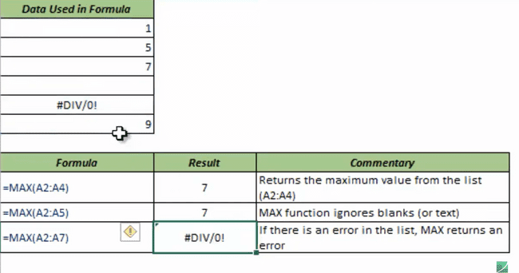

### MEDIAN:

* The **MEDIAN** function is a premade function in Excel, which returns the middle value in the data.
* It is typed =MEDIAN

**Note:** The median is a type of average value, which describes where the center of the data is located.

* **Syntax:** =MEDIAN(range of the cells)
* **Example:**

### MIN:

* The **MIN**  function is a premade function in Excel, which finds the smallest number in a range.
* The function ignores cells with text. It will only work for cells with numbers.
* **Syntax:** =MIN (range)
* **Example:**

### MODE:

#### **MODE.SNGL:**

* The **MODE** function is a premade function in Excel, which is used to find the number seen most times.
* This function always returns a single number.
* It is typed =MODE.SNGL
* It returns the most occurring number in a range or array.
* **Syntax: =MODE.SNGL(range of numbers)**
* **Example:**

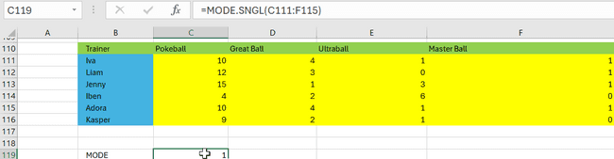

#### **MODE.MULT:**

* The **MODE.MULT** function is a premade function in Excel, which is used to find the numbers seen most times.
* The only difference between **MODE.SINGL and MODE.MULT** is that single is used to return only one value which is repeated in the range while mult is used to return more than one value that is repeated in the range.
* **Syntax: =MODE.MULT (range of numbers)**
* **Example:**

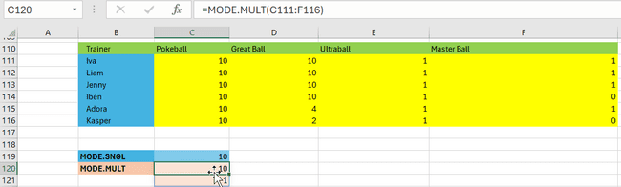

In the above example, Both **10 and 1** are **repeated 10 times** in the range.

### NPV:

* NPV function is used to calculate the Net Present Value(NPV).
* Whenever you do any investments are budgeting, We calculate the profitability of the plan in a long run using Net Present Vaue.
* **Syntax: =NPV(discount rate, range of cells)**
* **Example:**

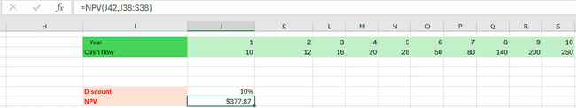

### OR:

* The **OR** function is a premade function in Excel, which returns **TRUE** or **FALSE** based on two or more **conditions**. If any one condition satisfies, It returns TRUE and FALSE vice versa.
* It is typed =OR.
* **Syntax: =OR(Condition1,condition2… condition N)**
* **Example:**

### RAND:

* The RAND function is used to generate random numbers.
* It is typed =RAND.
* **Syntax:** 
  + **To generate a random number without any limits:**
    - =RAND()
    - **Example:**

* **To generate a random number with limits:**
  + =RAND()*number

Here the number is the range(limit) for which you wish to generate a random number.

* **Example:**

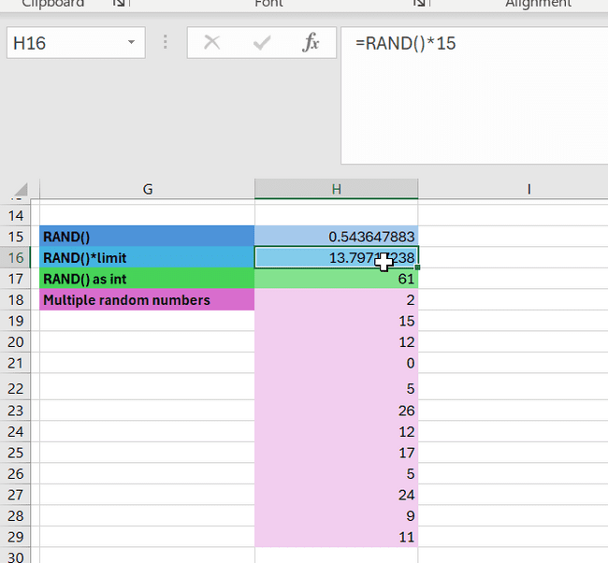

* **To generate multiple random numbers:**
  + =RAND() [or]
  + =RAND()*number.

Use the fill option to generate the list of random numbers.

* **Example:**

* **To generate a random number as integer:**
  + =INT(RAND())
* **Example:**

#### **RANDBETWEEN():**

This function is used to generate a series of number between two numbers.

### RIGHT:

* The **RIGHT** function is used to retrieve a chosen number of characters, counting from the right side of an Excel cell. The chosen number has to be greater than 0 and is set to 1 by default.
* **Syntax:**
  + **Default RIGHT():**
    - =RIGHT(cell address)
    - **Example:**

* **RIGHT() for a specific range:**
  + =RIGHT(cell range)
  + **Example:**

* **RIGHT() to take only chosen number of characters:**
  + =RIGHT(cell range/cell address, number of characters)
  + **Example:**

### MID:

MID functions is used to extract the specified number of characters from a string.

**Syntax: =MID(text, start pos, length)**

**Example:**

### STDEV.P:

* STDEV.P stands for Standard Deviation for a population. Standard Deviation is nothing but how much the data is dispersed from its mean value.
* **Low Standard Deviation** means deviation which is shown below the mean value and **High Standard Deviation** means deviation shown above the mean value.
* **To calculate standard deviation:**
  + Take the mean of the range of numbers.
  + Subtract the mean from each number in the range.
  + Square each number obtained in the step 2.
  + Sum all the squares.
  + Divide the squares by the total number of observations in a range.
  + Take the square root of the value obtained in the former step.
* **Syntax:**
  + =STDEV.P(range of cells)
* **Example:**

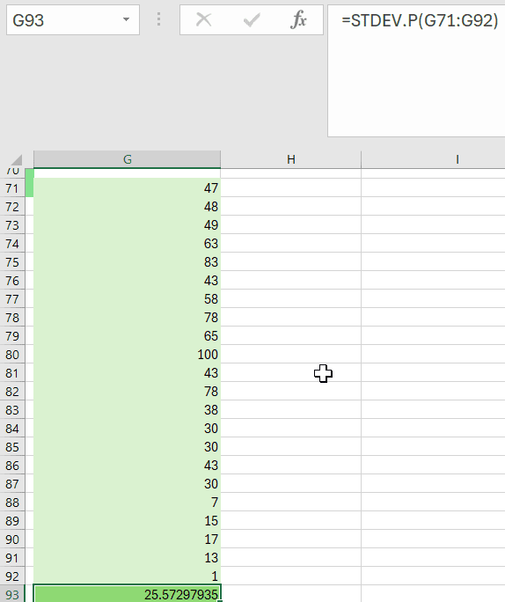

**COMPARISON OF FORMULA AGAINST THE STDEV.P():**

### STDEV.S:

* STDEV.S function works same as STDEV.P function. The only and major difference between STDEV.S and STDEV.P is that the former calculates Standard Deviation only for a sample data while the latter is used to calculate SD a whole chunk of data or the entire data set.
* **Syntax:**
  + =STDEV.S(range of cells)
* **Example:**

### SUM:

* The **SUM** function is a premade function in Excel, which adds numbers in a range.
* It is typed =SUM
* How to use the =SUM function:

1. Select a cell
2. Type =SUM
3. Double click the **SUM**command
4. Select a range
5. Hit enter

**Note:** The =SUM function adds cells in a range, both negative and positive.

**COMPARISON BETWEEN RANGE WITH POSITIVE AND NEGATIVE NUMBERS:**

### SUMIF:

The SUMIF function is used to sum the range of values based on a specified condition.

**Syntax:**

=SUMIF(range,criteria,sum range)

Here, sum range is optional. If not specified, The function considers the range and sum range to be same.

**Example:**

***Note: You can use ‘*’ or ‘?’ as a wild-card operator to specify a condition.***

* ***When you use ‘*’ operator , you can have any number of characters either on the right or left of the string condition.***
* ***When you use ‘?’ operator, you can have only one character either on the right or left of the string.***

**Note: Use absolute reference to fill the values shown above. The absolute reference should be used on values that remains constant. Here the sum range and sum types is going to be constant and only the type over the next table changes. So, Absolute reference is used for the former and relative reference is used for the latter.**

### SUMIFS:

The SUMIF function is used to sum the range of values based on two or more specified conditions.

**Syntax:**

=SUMIF(sum range1,criteria1,range2,criteria2…..rangeN,criteriaN)

**Example:**

***Note: You can use ‘*’ or ‘?’ as a wild-card operator to specify a condition.***

* ***When you use ‘*’ operator , you can have any number of characters either on the right or left of the string condition.***
* ***When you use ‘?’ operator, you can have only one character either on the right or left of the string.***

### SUMPRODUCT:

SUMPRODUCT function is used to return the sum of two arrays after multiplying them.

**Example:**

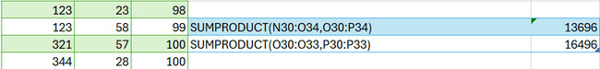

### TRIM:

The TRIM function is used to remove the blank or unwanted spaces from a cell or range of cells.

**Syntax:**

=TRIM(range of cells/cell address)

**Example:**

### XOR:

* XOR is the combination of two or more OR function which is used to return TRUE or FALSE based on two or more conditions.
* For two conditions, you can think of the XOR function as: "**either** this **or** that, but **not both**"
* **Syntax:**

=XOR(condition1,condition2…condition)

**Example:**

**POINTS TO REMEMBER:**

* **One condition is true – TRUE**
* **Each condition is true- FALSE**
* **Each condition is false - FALSE**

## DATE FUNCTIONS:

### DAY:

DAY function is used to return the day in the date.

**Syntax:=DAY(date)**

**Example:**

**;**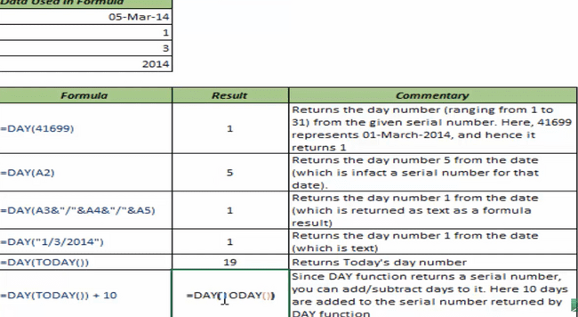

### MINUTE:

MINUTE function is used to return the minutes of the serial number.

**Syntax: =MINUTE(serial number)**

**Example:**

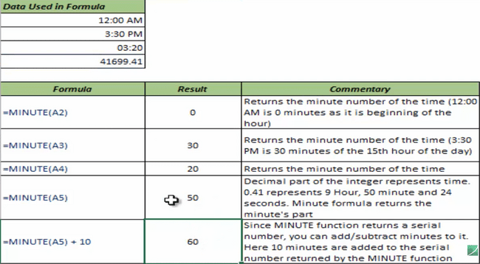

### HOUR:

HOUR function is used to return the Hours in the day.

**Syntax: =HOUR(serial_number)**

### DATE:

DATE function is used to calculate the date value alone in a given date format.

**Syntax: =DATE(date)**

Here, the date can be a serial number, it can be in dd-mm-yyyy,dd/mm/yyyy format.

**Example:**

### DATEVALUE:

DATEVALUE function is used to return the serial number of the date.

**Syntax: =DATEVALUE(date)**

**Example:**

### TODAY:

TODAY function is used to return the current date. This does not require any arguments.

**Syntax: =TODAY()**

### NOW:

NOW function is used to return the current date and time(it usually returns only date, but when you change the formatting, it returns time as well). This does not require any arguments.

**Syntax: =NOW ()**

**Example:**

### WEEKDAY:

WEEKDAY function is used to return the rank or position of weekday of the given date.

**Syntax:**

**=WEEKDAY(serial_number,value) where value is the combination of days like if it is 1, Then Sunday is ranked as 1, Monday is ranked as 2 and respectively.**

### WORKDAY:

Returns a number that represents a date that is the indicated number of working days before or after a date (the starting date). Working days exclude weekends and any dates identified as holidays. Use WORKDAY to exclude weekends or holidays when you calculate invoice due dates, expected delivery times, or the number of days of work performed.

**Syntax:**

WORKDAY(start_date, days, [holidays])

### WORKDAY.INTL:

Returns a number or a date that represents a date that is the indicated number of working days before or after a date (the starting date). Working days exclude weekends and any dates identified as holidays. This is used for different time zones.

**Syntax**

WORKDAY.INTL(start_date, days, [holidays],[weekends])

### NETWORKDAY:

Returns the number of whole working days between start_date and end_date. Working days exclude weekends and any dates identified in holidays. Use NETWORKDAYS to calculate employee benefits that accrue based on the number of days worked during a specific term.

**Syntax**

NETWORKDAYS(start_date, end_date, [holidays])

### NETWORKDAY.INTL:

Returns the number of whole working days between start_date and end_date. Working days exclude weekends and any dates identified in holidays. Use NETWORKDAYS to calculate employee benefits that accrue based on the number of days worked during a specific term. This is used for different time zones

**Syntax**

NETWORKDAYS.INTL(start_date, end_date, [holidays], [weekends]))

**Example:**



### EOMONTH:

Returns the serial number for the last day of the month that is the indicated number of months before or after start_date. Use EOMONTH to calculate maturity dates or due dates that fall on the last day of the month.

**Syntax:**

EOMONTH(start_date, months)

The EOMONTH function syntax has the following arguments:

* **Start_date**    Required. A date that represents the starting date. Dates should be entered by using the DATE function, or as results of other formulas or functions. For example, use DATE(2008,5,23) for the 23rd day of May, 2008. Problems can occur if [dates are entered as text](https://support.office.com/en-us/f1/topic/aaa2159b-4ae8-4651-8bce-d4707bc9fb9f?context=%7B%22themeid%22%3A%220%22%2C%22issasfeedbackenabled%22%3A%22true%22%2C%22isassistedhelpenabled%22%3A%221%22%2C%22isdeeplinkingenabled%22%3A%221%22%2C%22appversionbuild%22%3A%2217830%22%2C%22appversionmajor%22%3A%2216%22%2C%22appversionminor%22%3A%220%22%2C%22appversionupdate%22%3A%2220210%22%2C%22audience%22%3A%22Production_MEC%22%2C%22authtype%22%3A%22aad%22%2C%22channel%22%3A%22MEC%22%2C%22iscopilotenabled%22%3A%22false%22%2C%22osbuildnumber%22%3A%2219045%22%2C%22osmajorver%22%3A%2210%22%2C%22osminorver%22%3A%220%22%2C%22sessionid%22%3A%220414029B-4960-4978-AEE9-57A98D457F04%22%2C%22omkt%22%3A%22en-us%22%7D&helpid=xlmain11.chm60498&lcid=1033&ns=EXCEL&uilcid=1033&version=90).
* **Months**    Required. The number of months before or after start_date. A positive value for months yields a future date; a negative value yields a past date

## LOOKUP REFERENCES:

### VLOOKUP:

VLOOKUP function is used to return the values of the lookup row based on the column index.

**Syntax:**

**=VLOOKUP**(lookup value, range containing the lookup value, the column number in the range containing the return value, Approximate match (TRUE) or Exact match (FALSE)).

**Example:**

### HLOOKUP:

HLOOKUP function is used to return the values of the lookup column based on the column index.

**Syntax:**

**=HLOOKUP**(lookup value, range containing the lookup value, the row number in the range containing the return value, Approximate match (TRUE) or Exact match (FALSE)).

**Example:**

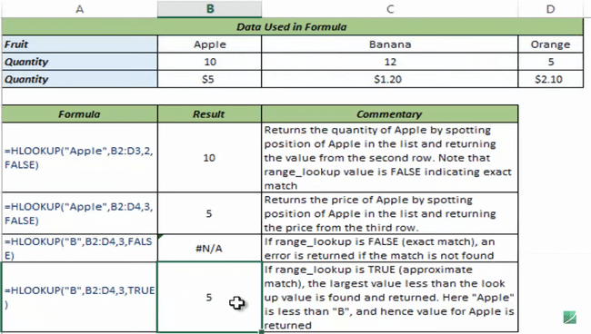

### INDEX:

INDEX function is used to return the data point when the reference or position of the cell is provided.

**Syntax:**

**Syntax**

**INDEX(array, row_num, [column_num])**

The array form of the INDEX function has the following arguments:

* **array**    Required. A range of cells or an array constant.
  + If array contains only one row or column, the corresponding row_num or column_num argument is optional.
  + If array has more than one row and more than one column, and only row_num or column_num is used, INDEX returns an array of the entire row or column in array.
* **row_num**    Required, unless column_num is present. Selects the row in array from which to return a value. If row_num is omitted, column_num is required.
* **column_num**    Optional. Selects the column in array from which to return a value. If column_num is omitted, row_num is required.
* **INDEX(reference, row_num, [column_num],area_num)**
  + **Reference -** A reference to one or more cell ranges.
  + **row_num**    Required, unless column_num is present. Selects the row in array from which to return a value. If row_num is omitted, column_num I is required.
  + **column_num**    Optional. Selects the column in array from which to return a value. If column_num is omitted, row_num is required.
  + **Area_num -** Selects a range in reference from which to return the intersection of row_num and column_num.

**Example:**

### MATCH:

MATCH function is used to return the rank or position of the data point.

**Syntax:**

MATCH(lookup_value, lookup_array, [match_type])

The MATCH function syntax has the following arguments:

* **lookup_value**  -   Required. The value that you want to match in *lookup_array*. For example, when you look up someone's number in a telephone book, you are using the person's name as the lookup value, but the telephone number is the value you want.  
    
  The *lookup_value* argument can be a value (number, text, or logical value) or a cell reference to a number, text, or logical value.
* **lookup_array** -   Required. The range of cells being searched.
* **match_type**  -  Optional. The number -1, 0, or 1. The *match_type* argument specifies how Excel matches *lookup_value* with values in *lookup_array*. The default value for this argument is 1.  
    
  The following table describes how the function finds values based on the setting of the *match_type* argument.

**Example:**

### OFFSET:

OFFSET is a volatile formula which recalculates everytime when you add or delete a value in the workbook making it slow.

Returns a reference to a range that is a specified number of rows and columns from a cell or range of cells. The reference that is returned can be a single cell or a range of cells. You can specify the number of rows and the number of columns to be returned.

**Syntax**

OFFSET(reference, rows, cols, [height], [width])

The OFFSET function syntax has the following arguments:

* **Reference**    Required. The reference from which you want to base the offset. Reference must refer to a cell or range of adjacent cells; otherwise, OFFSET returns the #VALUE! error value.
* **Rows**    Required. The number of rows, up or down, that you want the upper-left cell to refer to. Using 5 as the rows argument specifies that the upper-left cell in the reference is five rows below reference. Rows can be positive (which means below the starting reference) or negative (which means above the starting reference).
* **Cols**    Required. The number of columns, to the left or right, that you want the upper-left cell of the result to refer to. Using 5 as the cols argument specifies that the upper-left cell in the reference is five columns to the right of reference. Cols can be positive (which means to the right of the starting reference) or negative (which means to the left of the starting reference).
* **Height**    Optional. The height, in number of rows, that you want the returned reference to be. Height must be a positive number.
* **Width**    Optional. The width, in number of columns, that you want the returned reference to be. Width must be a positive number.

**Example:**

### INDIRECT:

Returns the reference specified by a text string. References are immediately evaluated to display their contents. Use INDIRECT when you want to change the reference to a cell within a formula without changing the formula itself.

**Syntax**

INDIRECT(ref_text, [a1])

The INDIRECT function syntax has the following arguments:

* **Ref_text**    Required. A reference to a cell that contains an A1-style reference, an R1C1-style reference, a name defined as a reference, or a reference to a cell as a text string. If ref_text is not a valid cell reference, INDIRECT returns the #REF! error value.
  + If ref_text refers to another workbook (an external reference), the other workbook must be open. If the source workbook is not open, INDIRECT returns the #REF! error value.

**Note:** External references are not supported in Excel Web App.

* + If ref_text refers to a cell range outside the row limit of 1,048,576 or the column limit of 16,384 (XFD), INDIRECT returns a #REF! error.
* **A1**    Optional. A logical value that specifies what type of reference is contained in the cell ref_text.
  + If a1 is TRUE or omitted, ref_text is interpreted as an A1-style reference.
  + If a1 is FALSE, ref_text is interpreted as an R1C1-style reference.

**Example:**

### ROW:

This article describes the formula syntax and usage of the **ROW** function in Microsoft Excel.

**Description**

Returns the row number of a reference.

**Syntax**

ROW([reference])

**Example:**

### ROWS:

This article describes the formula syntax and usage of the **ROWS** function in Microsoft Excel.

**Description**

Returns the number of rows in a reference or array.

**Syntax**

ROWS(array)

**Example:**

### COLUMN:

The COLUMN function returns the column number of the given cell reference. For example, the formula **=COLUMN(D10)** returns 4, because column D is the fourth column.

**Syntax**

**COLUMN([reference])**

**Example:**

### COLUMNS:

This article describes the formula syntax and usage of the **COLUMNS**  function in Microsoft Excel.

**Description**

Returns the number of columns in an array or reference.

**Syntax**

COLUMNS(array)

**Example:**

## DATA VALIDATION:

Data Validation is used to validate or examine the data based on some conditions.

### DATA VALIDATION CRITERIA:

* To enable data validation, Go to data ->data validation.

**In the Settings Tab of Data validation dialog box, You can control the type of value that each cell must contain.**

Step 1: Open the data validation dialog box by clicking Data 🡪 Data validation.

Step 2: Go to the settings tab and give condition , min and max value to control the data type and minimum and maximum value for the particular cell.

In the above example, the below table where the cell O30 can have values ranging from 21 and 60. If it exceeds 60 or less than 21, Then you will see the following error message.

Step 3: Please check the error message below. The error message can also be customized.

### INPUT MESSAGES:

Step 1: Go to the Input Message tab of Data Validation dialog box. Tick the check box if you want to display the input message when you hover over the cell.

Step 2: Once you click OK, The output will be as follows:

### ERROR MESSAGES:

**Step 1 :** Go to the **error message** tab of Data Validation dialog box.

**Step 2 :** You can customize the error message by moving to this tab.

**Step 3:** Please select the style as either **stop** which is used to stop you from entering a message, **Warning** is used to caution you.

### CIRCLE INVALID ENTRIES:

**Step 1:** Go to Data validation drop down in the DATA tab. Click on **Circle Invalid entries.**

**Step 2:** This will help you circle the entries that do not meet the criteria.

The below data validation to have data between 200 and 300 is applied . Any value in the list that do not meet the criteria will be **circled in red**

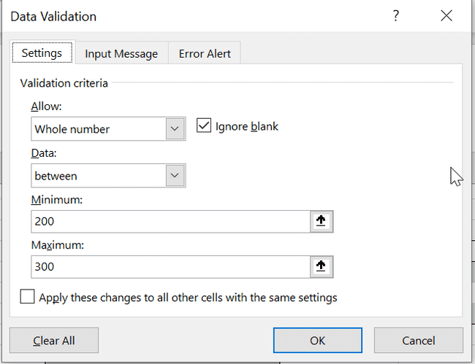

### **ADVANCED DATA VALIDATION TRICKS:**

#### **USE FORMULAS FOR DATA VALIDATION:**

**Step 1:** Go to the Data Validation dialog box and Give **“Custom”** for **Arrow** Drop down list box

**Step 2:** Write the formula that you wish to apply in the formula text box and Click Ok.

**Step 3:** Now, this is applied to all the cells.

In this case, we got an error message since the name field is blank. But, based on the formula the fields must always have some values in it and cannot be left blank. Hence, it threw an error message.

#### **MAKE SUB-HEADINGS FOR VALIDATION:**

**Step 1:**  Enter the values that need to be inserted in a drop-down list.

**Step 2:** Go to the data validation dialog box and click on **list** in the Arrow drop down box by selecting the cell address for which you want to create a drop-down.

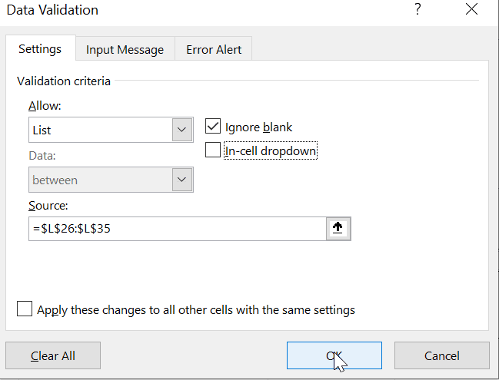

**Step 3:** The result will be as follows:

#### **INDENT THE DROP-DOWN LIST:**

To indent the drop -down list, just indent the source cell by few spaces. This will display the result as follows:

#### **DYNAMIC DROP-DOWN LIST:**

If you wanted to create a dynamic drop-down list, Then always extend the cell range of source so that the extra/additional values given there will be taken into account. Please see the example below:

**Cell range:**

**Data validation dialog box:**

**Output:**

## DATA SORTING AND DATA FILTERING:

This option in the Data tab is used to sort and filter the data.

Without distorting the data, you can sort them by clicking on the Sort Dialog box.