Event Calendar



User Guide

Index No: 19440671

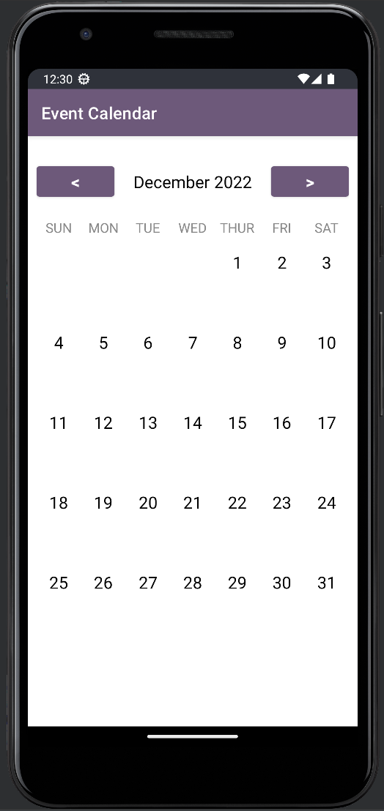

The app will open with a calendar view as shown in figure 1.

Select the date you want to add an event.

After that it’ll navigate to the next window (Figure 2).

Figure : Calendar View

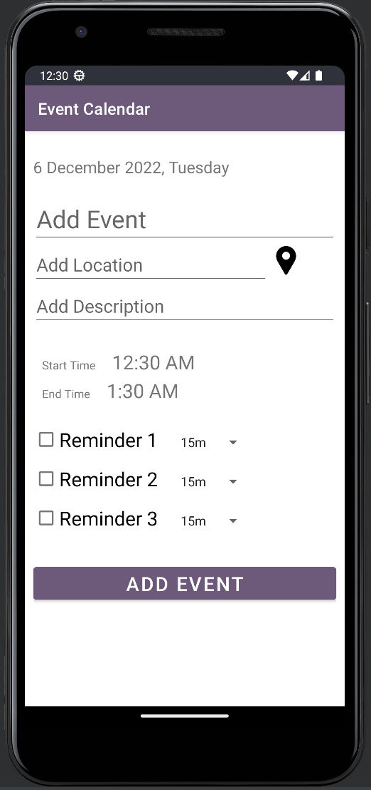

This window will help to save an event (Figure 2).

* Add Event – add the event name
* Add Location – add the location of the event
* Add Description – add the description of the event

The app will automatically set the start and end time of the event from the current time to 1 hour ahead. This time can be changed by tapping on the time.

**Reminders**

You have an option to set 3 reminders in the app. Tap on the checkbox to apply reminders to the event.

Tap on the time next to the reminder option and it’ll show options to set the reminder.

E.g.: 15m means there will be a reminder notification shown before 15 minutes of the scheduled event.

Figure : Insert Event View

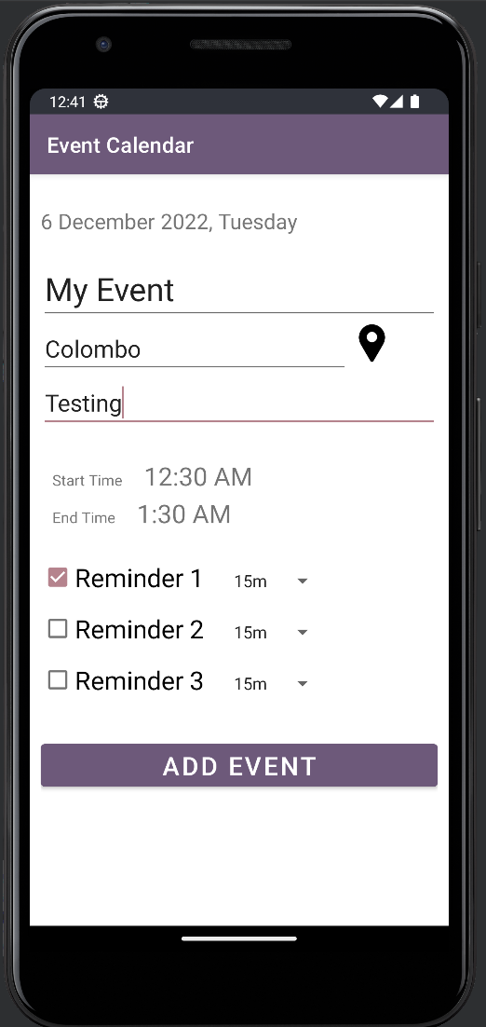

The following event will be added with a reminder of 15 minutes (Figure 3).

One notification will popup 15 minutes before the event. And another will pop up at the event time.

Figure : Adding an Event

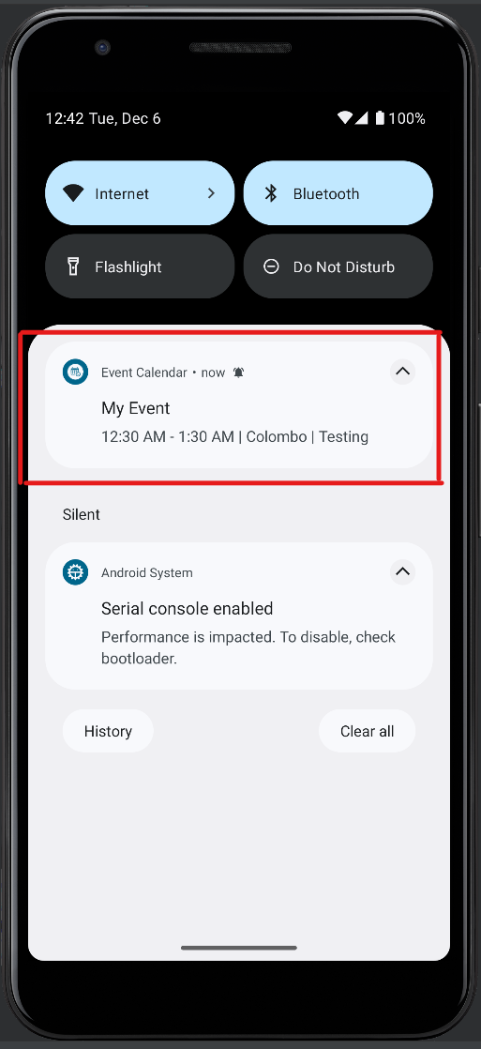

A notification will popup with the event details (Figure 4).

Figure : Notification

Demo : <https://drive.google.com/drive/folders/1KIBa9aa2jxnwiTxEkBQD97C7DQ-henGB?usp=share_link>

|  |  |
| --- | --- |
|  | Reference Resources |
| Creating Calendar View | [(136) Calendar App Example Android Studio Tutorial - YouTube](https://www.youtube.com/watch?v=Ba0Q-cK1fJo) |