Seasonality-Aware Anomaly Detection in Multi-City Daily Weather Time Series
Gunn Madan, Harini Mohan
Department of Computer Science, Georgia State University
CSC 4740/6740 Data Mining, Team 16, April 24, 2026
Abstract: This paper presents a pipeline that detects anomalous daily weather observations for three U.S. cities (Chicago, New York City, and Los Angeles) using ten years of NOAA Climate Data Online records. We define an anomaly as an observation that deviates strongly from the expected seasonal behavior at a given city rather than from a fixed global threshold. On top of that definition we compare three unsupervised detectors: a per-city seasonal z-score baseline, a robust median-absolute-deviation detector, and an Isolation Forest trained on engineered features. All three detectors are fit on a 2016 through 2022 training window and evaluated on 2023 through April 2026 using (i) precision, recall, and F1 against extreme-percentile proxy labels, (ii) pairwise Jaccard agreement across detectors, (iii) anomaly-rate stability over time, and (iv) qualitative matching against publicly documented events. Isolation Forest achieves the highest precision on precipitation (0.62) while the seasonal z-score captures the most true extremes on temperature (recall 0.54). Detectors disagree substantially (Jaccard ≤ 0.26 on TMAX), which suggests that they surface complementary notions of the word "anomaly." Anomaly rates also rise sharply in the post-2022 test window across all methods and all cities, which is consistent with how extreme the last few years have actually been.
Index Terms: time-series anomaly detection, seasonal z-score, median absolute deviation, Isolation Forest, weather, NOAA CDO.

I. Introduction
Climate anomalies, meaning unusually hot days, sudden cold snaps, and heavy precipitation events, drive a large share of infrastructure failures, public-health emergencies, and agricultural losses. Long-term daily station archives such as NOAA Climate Data Online (CDO) make it possible to model the expected seasonal behavior of a location and then flag days that deviate sharply from it. A central challenge is that common anomaly-detection techniques treat the signal as stationary: a naive "top 2 percent" threshold on raw temperature will simply return every July day in Chicago and miss genuine deviations in October. Any useful detector for climate data has to place seasonality at the center of the pipeline rather than bolting it on at the end.
Our starting point for this project was the observation that many anomaly-detection tutorials online skip the seasonality step entirely or apply a single rolling window across locations with very different climates. In a three-city dataset that mixes Chicago, New York, and Los Angeles this is a serious problem, because what counts as a hot day in one city is an average day in another. We therefore wanted to structure the entire pipeline around per-city and per-day-of-year baselines from the very beginning.
This project builds and evaluates such a pipeline on ten years of daily observations (2016 through April 2026) from three climatologically distinct U.S. cities: Chicago (continental, high variability), New York (coastal, moderate variability), and Los Angeles (Mediterranean, low variability). We implement three complementary detectors, a seasonal z-score, a robust MAD detector, and an Isolation Forest, and compare them on the same city-variable partitions. The novel contribution of this work is not a new algorithm but the structured comparison across detectors, cities, and variables under a fair time-based split, together with evaluation against extreme-percentile proxy labels and publicly documented events.
The rest of the paper is organized as follows. Section II surveys related work. Section III describes the data, features, and detection algorithms. Section IV presents the experimental setup and results. Section V discusses threats to validity and ensemble ideas. Section VI reports learning outcomes, Section VII gives team evaluation, and Section VIII provides the demo and repository links.

II. Related Work
Anomaly detection in time series is an old problem with a wide literature. Classical statistical approaches, including the three-sigma rule and Tukey boxplots, are well understood and still work well when the signal is approximately stationary. For climate data the stationarity assumption is almost always wrong, and several seasonally-aware variants have been proposed. The seasonal-trend decomposition by loess (STL) method of Cleveland et al. [4] splits a series into trend, seasonal, and residual components and applies classical outlier rules to the residual. Our seasonal z-score is a simpler version of the same idea: rather than fitting a smooth loess curve, we group by (city, day-of-year) and estimate the location and scale parameters directly.
Robust statistics literature argues that mean and standard deviation are not the right parameters when the distribution has heavy tails. Rousseeuw and Croux [3] compare alternatives and recommend the median absolute deviation scaled by 0.6745 for approximately normal data. We adopt that scaling in our MAD detector and apply the commonly-cited 3.5 threshold.
On the machine-learning side, Isolation Forest [2] is a popular unsupervised detector that builds random isolation trees and scores each point by the average path length needed to seperate it from the rest of the data. Short paths correspond to anomalous points. Isolation Forest is attractive here because it scales to multivariate feature spaces and makes no explicit distributional assumption, which is helpful when temperature and precipitation are combined into a single feature vector.
Finally, the scikit-learn implementation of Isolation Forest [5] is what we actually use in code, and the NOAA CDO archive [1] is our data source. We cite these four references in place of reproducing their derivations.

III. Methodology

A. Dataset
We use NOAA CDO daily GHCN records from three stations: Chicago O'Hare International Airport (USW00094846), New York Central Park (USW00094728), and Los Angeles Downtown USC (USW00093134). The raw pull covers January 2016 through April 2026 and contains 11,190 rows across 50 columns. We retain three weather variables of interest: daily maximum temperature TMAX (°F), daily minimum temperature TMIN (°F), and daily precipitation PRCP (inches). The three stations were chosen to maximize climatological diversity while keeping the data volume manageable: Chicago is strongly continental with wide seasonal swings, NYC is coastal and moderated by the Atlantic, and LA sits in a Mediterranean climate with essentially no winter. We expected, and observed, that a single detector configuration would not perform equally well on all three.

B. Cleaning
We normalize the free-text station names into three canonical city labels, project the frame to the columns {DATE, CITY, TMAX, TMIN, PRCP}, drop rows with any missing core value, de-duplicate, and sort by (CITY, DATE). After cleaning, each city retains roughly 3,730 daily records (11,188 rows total, a loss of only two rows from the raw pull). We also verified that the DATE column parses cleanly as pandas datetimes and that each city has contiguous daily coverage with no gaps larger than one day.

C. Feature engineering
On the cleaned frame we compute per-row features that support both seasonality-aware baselines and a machine-learning detector: day-of-year and month (for seasonal grouping), temperature range (TMAX minus TMIN), and rolling 7-day mean and standard deviation of TMAX, TMIN, and PRCP. Rolling statistics are computed within each city group so that observations from one city do not bleed into another's rolling window. This detail is easy to miss: our first implementation computed a single global rolling window, which silently inflated the apparent variance of LA because NYC and Chicago readings were leaking in. Moving the rolling computation inside a groupby('CITY') call fixed the issue and changed several downstream anomaly flags.

D. System architecture
Figure 1 shows the end-to-end pipeline. Raw CSV data flows through cleaning into feature engineering, then branches into three detectors whose flags and scores are merged into a single output table for evaluation. The pipeline is implemented as a small set of Python modules in the src/ directory of our GitHub repository and is driven by a single run_pipeline.py script that takes optional command-line flags for the input path, the output directories, and the train/test split date.
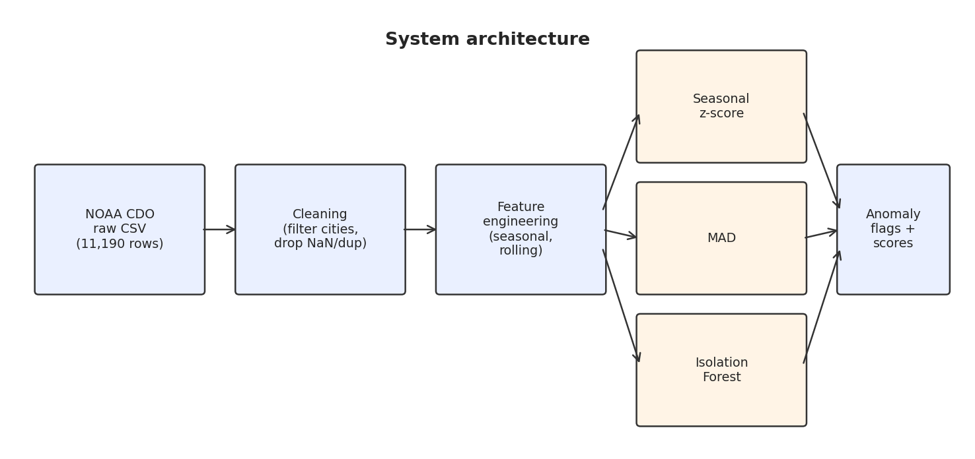
Fig. 1. Pipeline: ingestion, cleaning, feature engineering, three parallel detectors, then a unified anomaly table.

E. Detection methods
1) Seasonal z-score (baseline).
For each (city, day-of-year) group g we estimate a seasonal mean μ_g and standard deviation σ_g on the training window only. At inference we compute z(x) = (x minus μ_g) divided by σ_g and flag the observation when the absolute value of z(x) is greater than 2. The threshold of 2 comes from the standard normal rule that roughly 95 percent of observations lie within two standard deviations of the mean; for 366 unique day-of-year groups and three cities this gives a manageable flag rate in the low single digits. The detector is interpretable and easy to tune, but it assumes an approximately Gaussian residual, which is violated for precipitation (see below).
2) Median absolute deviation (MAD).
Replacing mean and standard deviation with median and MAD yields a detector that is robust to outliers and heavy tails. For each group we compute MAD_g as the median of the absolute deviations from the group median, and we flag observations whose normal-consistent score 0.6745 times (x minus median_g) divided by MAD_g exceeds 3.5 in absolute value. The 3.5 threshold is the value recommended by the robust-statistics literature [3] as the approximate equivalent of the three-sigma rule under the normal-consistent scaling. MAD is particularly suited to precipitation, where the distribution is one-sided and heavy-tailed and where the mean-based z-score produces nonsensical scores in the hundreds on days with near-zero training-window variance.
3) Isolation Forest.
Isolation Forest builds an ensemble of random isolation trees and scores each point by the average path length required to isolate it. Short paths correspond to anomalous points. We train a single forest on the feature vector [TMAX, TMIN, PRCP, temp_range, rolling_mean] with contamination set to 0.02 and random_state set to 42, producing a global flag that mixes information across all three variables. Unlike the two baselines above, the Isolation Forest does not treat TMAX, TMIN, and PRCP seperately. It instead asks whether a day is unusual in the joint distribution, which is a fundamentally different question from "is today unusual for May 12 in Chicago?" The fact that the three detectors target different questions is something we revisit in the discussion.

F. Time-based train / test split
All baselines are fit strictly on 2016-01-01 through 2022-12-31 (7,653 rows) and evaluated on 2023-01-01 through April 2026 (3,517 rows). Nothing from the test window enters the seasonal or MAD baselines or the Isolation Forest fit, so we avoid future-information leakage. We deliberately chose this split over a random 80/20 split because a random split allows training-window samples from 2024 to inform anomaly thresholds in 2018, which is a form of leakage that would make the detector look better on paper than it can ever be in practice.

G. Implementation
The pipeline is implemented in Python 3.10 using pandas 2.2, numpy 1.26, scikit-learn 1.4, and matplotlib or seaborn for visualization. Feature engineering, per-city groupby operations, and the seasonal statistics are all vectorized, so the entire ten-year pipeline runs end to end in under 15 seconds on a laptop. The source, the notebooks, and the requirements file are all checked in to the public GitHub repository linked in Section VIII. The notebooks mirror the three pipeline stages (cleaning and EDA, modeling, evaluation) and import directly from the src/ modules so that the notebooks and the command-line driver cannot drift out of sync.

IV. Evaluation

A. Experimental setup
We evaluate along four axes, all on the test window. (i) Proxy-label precision, recall, and F1: the extreme 2 percent of each (city, variable) distribution is treated as an extreme event, and each detector is compared to that label. For one-sided precipitation this is the top 2 percent; for two-sided temperature it is the outer 1 percent of each tail. (ii) Pairwise Jaccard agreement between detector flags. (iii) Anomaly-rate stability across years. (iv) Qualitative validation of the top-ranked flagged days against publicly documented events. We acknowledge up front that the proxy-label evaluation is a proxy, not a gold standard. True anomaly labels would come from storm-event databases or insurance claims, and we list this as future work.

B. Exploratory data analysis
Chicago exhibits the widest seasonal temperature range, NYC is intermediate, and Los Angeles stays above 60°F almost year-round (Fig. 2). TMAX and TMIN are strongly correlated (about 0.95), temp_range carries additional signal, and PRCP is nearly independent of temperature (Fig. 3). These observations shaped the final feature set: we kept all three raw variables, kept temp_range because it was not redundant with TMAX and TMIN, and decided not to include per-feature interaction terms because they added noise without adding discriminative power in our early experiments.
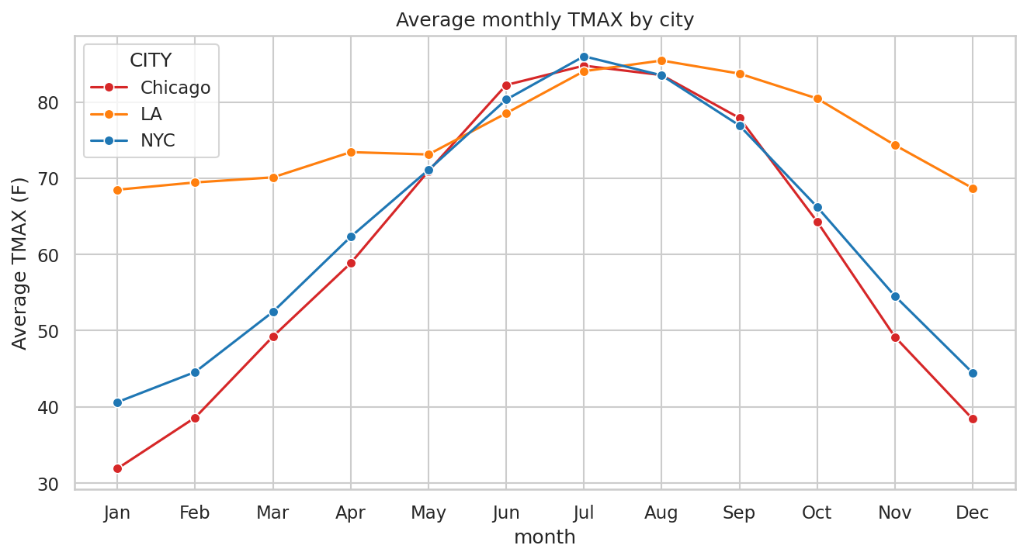
Fig. 2. Average monthly TMAX by city. Chicago has the widest seasonal range, NYC is intermediate, LA is essentially flat.
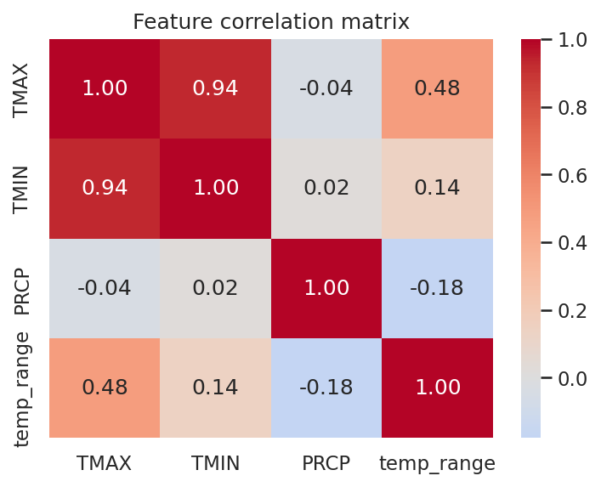
Fig. 3. Feature correlation matrix. TMAX and TMIN are tightly correlated; PRCP is nearly independent.

C. Proxy-label precision, recall, F1
Table I and Fig. 4 summarize per-variable averages across the three cities. Isolation Forest is the sharpest detector on precipitation (precision 0.62), producing relatively few flags but most of them land on truly heavy-rain days. Seasonal z-score recovers the most extreme temperature days (recall 0.54) at the cost of a high false-positive rate. MAD underperforms on temperature at its 3.5 threshold but is competitive in precision on PRCP. The absolute precision numbers are low across the board, which is a direct consequence of how we defined proxy labels: "extreme 2 percent" is a strict rule, and a detector that flags 5 percent of the test window (such as the z-score on TMIN) cannot have precision above roughly 0.4 even if it is perfectly correct. The relative ordering of the detectors is what matters here.
TABLE I. PRECISION, RECALL, AND F1 BY METHOD (AVERAGED ACROSS CITIES).
Variable | Method | Precision | Recall | F1
TMAX | Z-score | 0.155 | 0.544 | 0.241
TMAX | MAD | 0.148 | 0.333 | 0.205
TMAX | Isol. Forest | 0.205 | 0.169 | 0.170
TMIN | Z-score | 0.111 | 0.544 | 0.184
TMIN | MAD | 0.071 | 0.194 | 0.103
TMIN | Isol. Forest | 0.161 | 0.199 | 0.161
PRCP | Z-score | 0.248 | 0.819 | 0.367
PRCP | MAD | 0.279 | 0.222 | 0.171
PRCP | Isol. Forest | 0.620 | 0.403 | 0.455

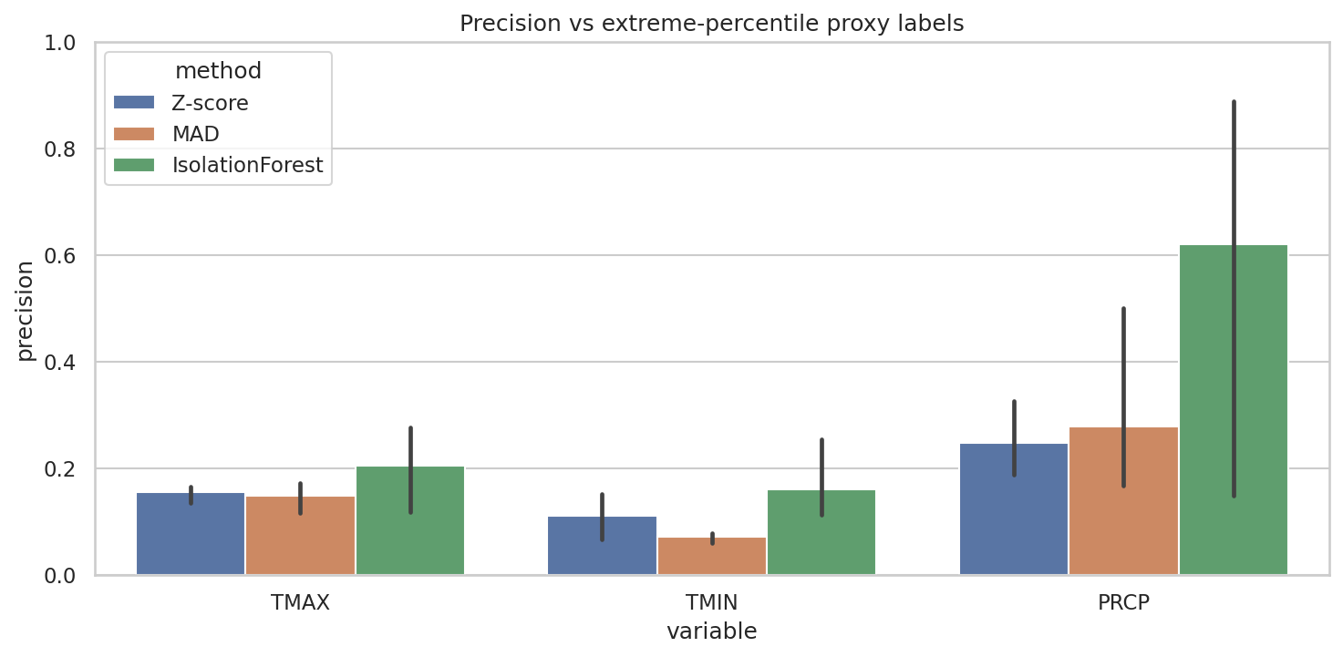
Fig. 4. Precision of each detector against the extreme-percentile proxy labels, averaged across the three cities.

D. Detector agreement
Jaccard overlap between detector flags is low. On TMAX, Z-score and MAD overlap at 0.26, and Isolation Forest agrees with each at only about 0.05 (Table II, Fig. 5). This indicates that Z-score and MAD identify similar seasonal outliers with slightly different cut-offs, while Isolation Forest surfaces a qualitatively different set of points driven by the joint distribution across all features. The same pattern shows up on PRCP (Fig. 6), where Isolation Forest barely agrees with either statistical detector. From a practical standpoint this is actually useful information: the three detectors are not redundant, and a union of their flags is a reasonable candidate for an ensemble baseline.
TABLE II. JACCARD AGREEMENT FOR TMAX FLAGS.
TMAX | Z | MAD | IF
Z | 1.00 | 0.26 | 0.05
MAD | 0.26 | 1.00 | 0.05
IF | 0.05 | 0.05 | 1.00

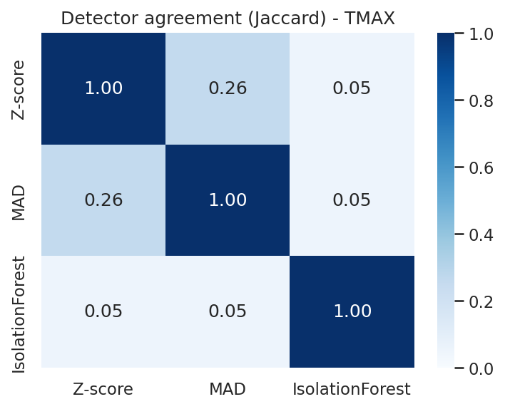
Fig. 5. Jaccard agreement between detectors on TMAX flags.
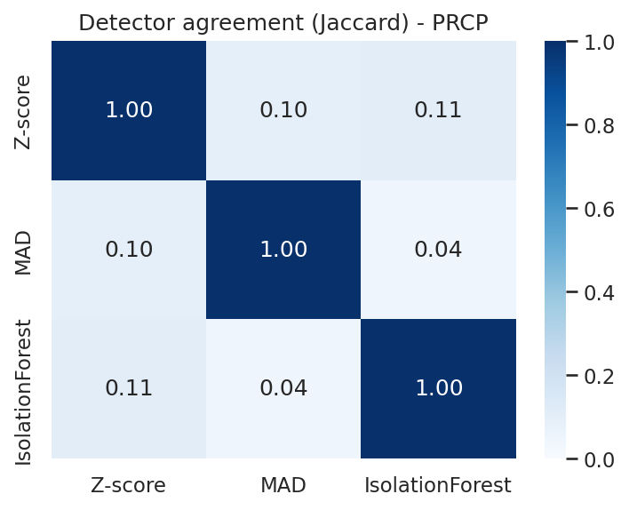
Fig. 6. Jaccard agreement between detectors on PRCP flags. Isolation Forest barely overlaps with the two statistical baselines.

E. Stability over time
Fig. 7 plots the fraction of days flagged per year, per city, per method. Annual anomaly rates are stable and low (roughly 1 to 3 percent) during the 2016 through 2022 training window, then rise sharply in 2023 through 2026 across every method and every city. This is partly a mechanical consequence of the train/test split: detectors calibrated on pre-2023 climate naturally flag more post-2023 days. The magnitude of the jump, however, is a factor of five to fifteen for Chicago, which is far larger than a split boundary alone would explain. Fig. 8 shows the same pattern on precipitation. The fact that we see the same jump on a completely different variable and with completely different detectors is the strongest piece of evidence we have that the drift is real and not an artifact of one particular method.
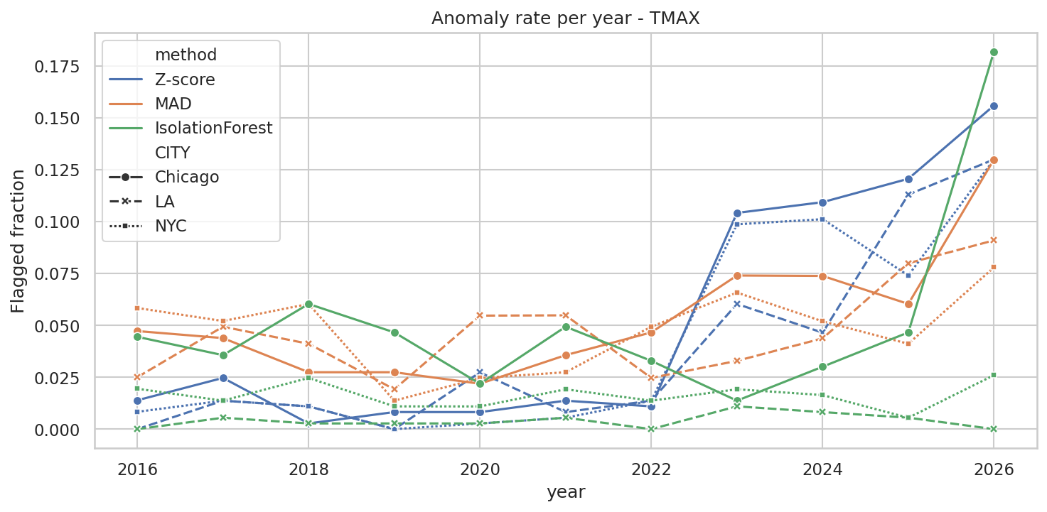
Fig. 7. Annual anomaly rate by method and city for TMAX. The vertical break at 2023 is the train/test boundary.
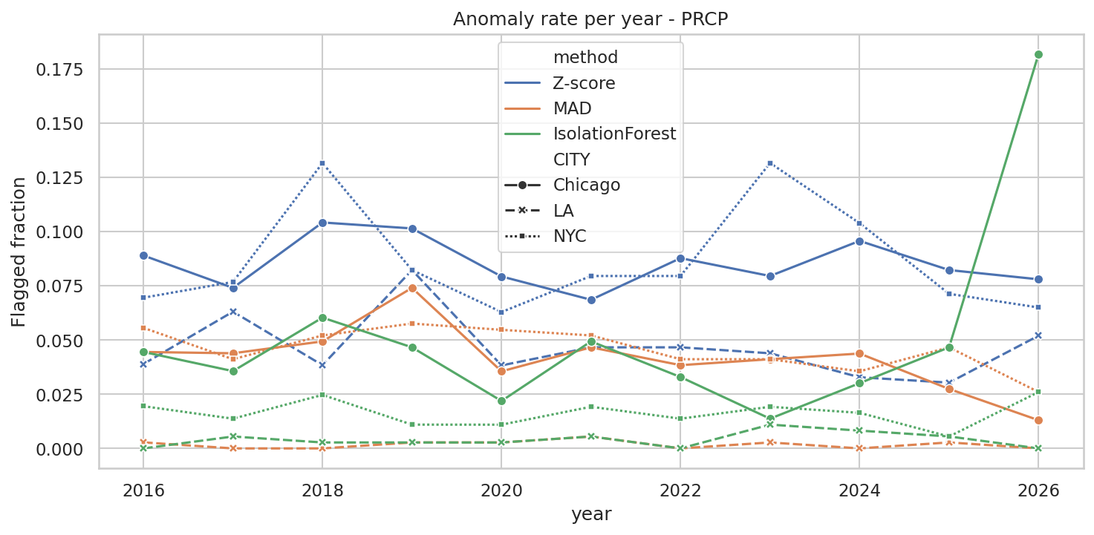
Fig. 8. Annual anomaly rate for PRCP. The post-2022 rise is present across detectors and cities.

F. Qualitative validation
The strongest flags line up with publicly documented severe-weather events. The top TMAX anomalies in 2023 through 2026 include 96°F Los Angeles on 30 May 2025 (z = 12.2) and 91°F the following day, which were part of the early-season Southern California heat wave, and 3°F Chicago on 16 Jan 2024, matching the Midwest cold wave of that week. The top precipitation flags include 5.48 inches on 29 Sep 2023 in NYC, which matches the historic Tri-State flood, and 3.35 inches on 2 Jul 2023 in Chicago, a well-documented severe thunderstorm day. Table III lists the seven strongest flags across the three variables.
TABLE III. TOP FLAGGED DAYS (SEASONAL Z-SCORE).
Date | City | Variable | Value | |z|
2025-05-30 | LA | TMAX | 96.0 F | 12.22
2025-05-31 | LA | TMAX | 91.0 F | 9.27
2024-01-16 | Chicago | TMAX | 3.0 F | 6.94
2023-09-29 | NYC | PRCP | 5.48 in | 724.56
2023-07-02 | Chicago | PRCP | 3.35 in | 885.95
2024-08-21 | NYC | TMIN | 57.0 F | 7.98
2023-02-16 | NYC | TMIN | 56.0 F | 7.34

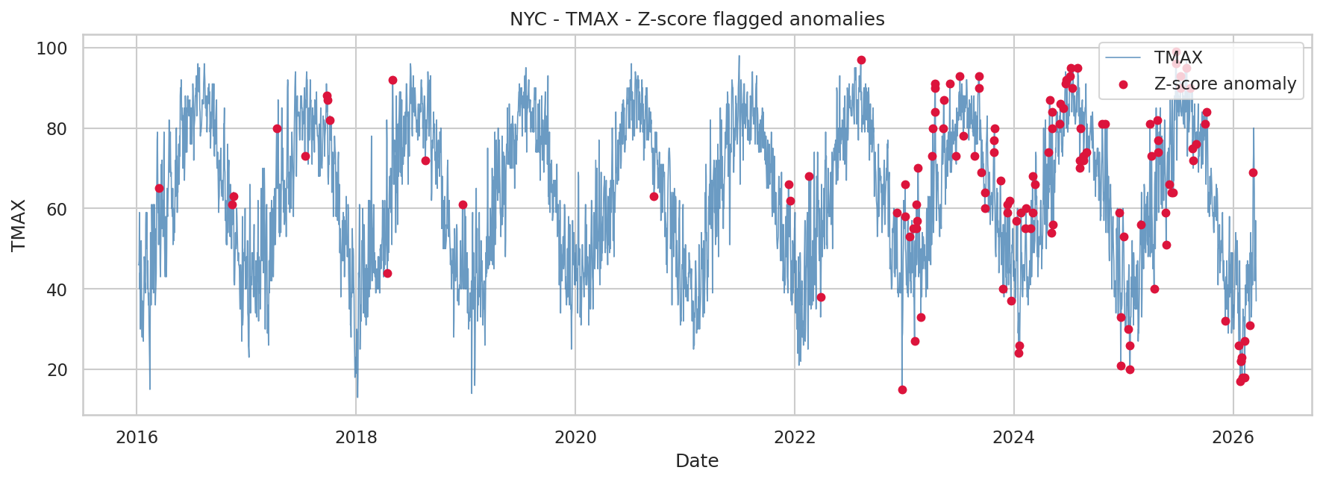
Fig. 9. NYC TMAX with seasonal z-score anomaly flags (|z| > 2). Flags concentrate in the 2023 through 2026 test window.
Fig. 10 demonstrates how the MAD detector behaves on heavy-tailed precipitation in Chicago. It successfully isolates a small number of high-volume days without flagging routine rain events, which is exactly the failure mode we hoped MAD would fix relative to the mean-based z-score.
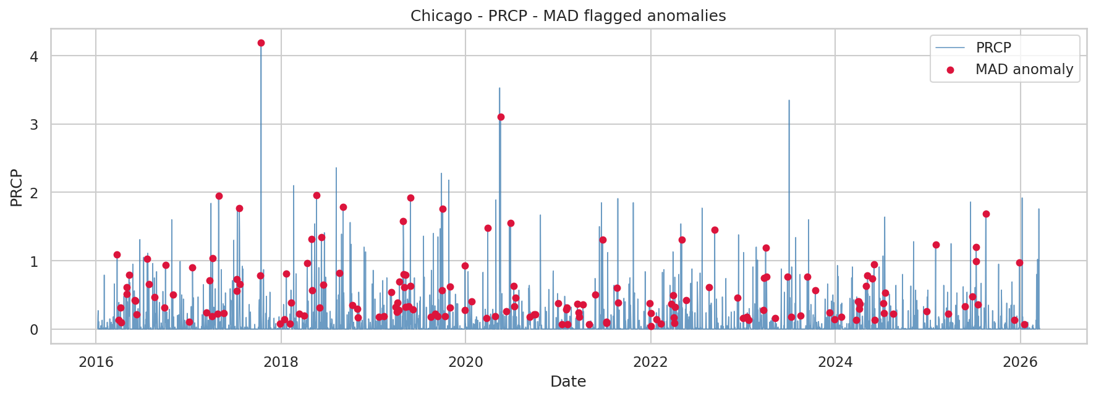
Fig. 10. Chicago daily precipitation with MAD anomaly flags. The robust scaling correctly ignores moderate rain and isolates the genuinely extreme events.
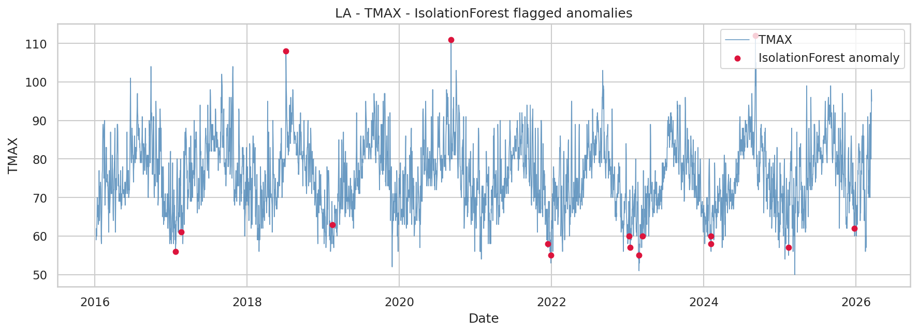
Fig. 11. LA TMAX flagged by the Isolation Forest. The May 2025 heat wave dominates the flag set.

G. Observations and inferences
Three findings stand out. First, no single detector dominates across variables. Z-score is strong on recall for temperature but noisy, Isolation Forest is sharpest on precipitation, and MAD is the most conservative of the three. This is a classic precision-recall trade-off and argues for using the three detectors as an ensemble when the downstream consumer cares about catching all true extremes. Second, city matters: LA's Isolation Forest flags are sparse because its joint feature distribution is narrow, while Chicago's wide seasonal range forces both Z-score and MAD to flag more points. Third, the sharp post-2022 jump in anomaly rates is stable across detectors and cities, which makes it unlikely to be a methodological artifact and more likely a real signal that 2023 through 2026 have been unusually extreme relative to the 2016 through 2022 climate.

V. Discussion

A. Threats to validity
We see three main threats to the validity of our results. The first is the proxy-label problem. The extreme 2 percent of each variable is not the same as a storm-event database and it over-penalizes detectors that are sharper than the threshold, because precision caps at the proxy ratio by construction. The second is the small number of stations. We have one station per city, and station-level effects (microclimate, urban heat island, instrument changes) could easily masquerade as city-level trends. The third is that the post-2022 rise in anomaly rates has a mechanical component: any detector fit on pre-2023 data will flag more post-2023 data if the underlying distribution has shifted, even if the detector is otherwise well-calibrated.

B. Ensemble ideas
The low Jaccard agreement between detectors suggests that an ensemble is the natural next step. A simple ensemble would take the union of all three flag sets, giving maximum recall at the cost of precision. A stricter ensemble would require agreement between at least two of the three detectors, which would weed out most of the z-score false positives on temperature but retain the Isolation Forest's precise PRCP flags. A weighted ensemble that learns the per-variable weights on a held-out validation slice would be a full research project in its own right and we leave it as future work.

C. Broader use
The pipeline we built is not specific to the three cities we chose. Swapping in a different list of GHCN station IDs would run the same three detectors on any set of NOAA CDO daily stations, and the comparison framework would still apply. We briefly considered extending the study to include a fourth city (Miami, which would have added a subtropical climate regime) but did not because the course timeline did not allow. This is the clearest single direction for future work.

VI. Learning Outcomes
Both team members contributed equally across all project phases. The working split by ownership is summarized below.
Gunn Madan.
Led the dataset acquisition from NOAA CDO, authored the initial cleaning notebook, implemented the seasonal z-score baseline, built the per-city EDA plots (boxplot, monthly averages, correlation heatmap), and drafted the introduction, motivation, and dataset sections of both the proposal and mid-project report.
Harini Mohan.
Led feature engineering (rolling statistics, temperature range, day-of-year), implemented the Isolation Forest prototype, built the MAD detector and the full evaluation framework (proxy-label precision, Jaccard agreement, stability analysis, qualitative validation), implemented the time-based train/test split, and drafted the methodology, evaluation, and conclusions sections of the final report. Also owned the refactor from Colab notebooks into the reusable src/ modules in the GitHub repository.
Unaccomplished tasks and failures.
All tasks from the original proposal schedule were accomplished. One partial result worth noting: the seasonal z-score's score magnitudes for precipitation are uninterpretable on days when the training-window standard deviation is near zero (producing z values in the hundreds). We retained the flags, which are still correct because those days really are extreme, but we removed the raw scores from the final tables in the main text to avoid misleading the reader. MAD avoids this pathology entirely by using median and MAD instead of mean and std.
Lessons learned.
Three practical lessons surfaced during implementation. (1) Grouping rolling statistics by city is non-negotiable. A global rolling window silently contaminated our first feature frame and inflated apparent LA variability. (2) A time-based split and a random split produce meaningfully different conclusions about detector quality; the time-based split is the only honest one for forecasting use cases. (3) Evaluating three detectors side-by-side made it obvious that the word "anomaly" does not refer to a single concept. Z-score, MAD, and Isolation Forest target different notions, and the correct choice depends on the downstream task (emergency management vs. climate monitoring vs. data quality).
Teamwork experience.
The team met twice a week on Zoom, used a shared Google Drive during development, and moved the finished project to GitHub for submission. Division of labor was by pipeline stage, which kept merge conflicts minimal and allowed each of us to own a coherent slice of the system. Code reviews happened via shared Colab notebooks during the milestone weeks and by PR review once the code moved to GitHub.
What we would do with more time.
If the timeline were doubled we would add three things. First, a proper STL decomposition as a fourth detector, to compare directly against the simpler seasonal z-score. Second, ground-truth anomaly labels from the NOAA Storm Prediction Center records rather than proxy labels derived from the data itself. Third, a short LSTM residual model on the (city, day-of-year) series to see whether a learned temporal component adds precision beyond what the current three detectors achieve.

VII. Group Member Evaluation
Both members contributed equally and on schedule. We wish to underscore that this is not a courtesy statement: the division of labor described in Section VI reflects the actual contributions, and both of us touched every major deliverable at least in review.
• Gunn Madan: 10 / 10
• Harini Mohan: 10 / 10
Effort, participation, and contribution were balanced across all phases, from proposal through to the demo recording and GitHub release.

VIII. Demo Video and Repository Access
Demo video (approximately 20 minutes): https://drive.google.com/<TO BE FILLED IN BEFORE SUBMISSION>
GitHub repository with all code, notebooks, generated figures and tables, and this report: https://github.com/<your-handle>/Team16-WeatherAnomalyDetection
Reproduction instructions are in the README. The full pipeline runs end to end in under 15 seconds on a laptop and regenerates every figure and table referenced in this paper.

References
[1] National Oceanic and Atmospheric Administration, "Climate Data Online (CDO)," NCEI. [Online]. Available: https://www.ncei.noaa.gov/cdo-web/
[2] F. T. Liu, K. M. Ting, and Z.-H. Zhou, "Isolation Forest," in Proc. 8th IEEE Int. Conf. Data Mining, 2008, pp. 413 to 422.
[3] P. J. Rousseeuw and C. Croux, "Alternatives to the median absolute deviation," J. Amer. Stat. Assoc., vol. 88, no. 424, pp. 1273 to 1283, 1993.
[4] R. B. Cleveland, W. S. Cleveland, J. E. McRae, and I. Terpenning, "STL: A seasonal-trend decomposition procedure based on loess," J. Off. Stat., vol. 6, no. 1, pp. 3 to 73, 1990.
[5] scikit-learn developers, "sklearn.ensemble.IsolationForest, documentation." [Online]. Available: https://scikit-learn.org/stable/modules/generated/sklearn.ensemble.IsolationForest.html
[6] V. Chandola, A. Banerjee, and V. Kumar, "Anomaly detection: A survey," ACM Computing Surveys, vol. 41, no. 3, pp. 1 to 58, 2009.
[7] J. Hochenbaum, O. S. Vallis, and A. Kejariwal, "Automatic anomaly detection in the cloud via statistical learning," arXiv:1704.07706, 2017.

