Drug Order Module

Group Order

In this section, we will study the use-cases and the snapshots displaying the UI relevant to a drug order group. This includes the steps followed by a Physician to create an order, group two or more orders, add an order to an order group, view the order details, edit the order components, discontinue some or all of the order group and renew some or all of an old non-active group order. We will see the list of pre-defined options available to the Physician in the process of creating and discontinuing the orders.

Table of Contents

1. USE CASES 3

1.1 Create Orders 3

1.2 Group Orders 3

1.3 Add Order to Group 3

1.4 View an Order 3

1.5 Edit an Order 4

1.6 Ungroup an Order 4

1.7 Discontinue Order Group 4

1.8 Renew Order Group 4

1.9 Discontinue some Orders from Group 5

1.10 Renew some Orders from Group 5

2. SNAPSHOTS 6

2.1 Create Orders 6

2.2 Group Orders 11

2.3 Add Order To Group 12

2.4 View an Order 13

2.5 Edit an Order 14

2.6 Ungroup an Order 15

2.7 Discontinue Order Group 16

2.8 Renew Order Group 18

2.9 Discontinue some Orders from Group 20

2.10 Renew some Orders from Group 21

# 1. USE CASES

In this section, we will study the use-cases considered relevant to an Order Group while designing the Drug Order module.

*Patient Betty Johnson comes to the clinic to get a cure for her illness. The Physician John Watson after completing the diagnosis of her health decides to place an Order for two or more drugs. He will log into the Patient's Drug Order page through the Patient Dashboard page to do this.*

## 1.1 Create Orders

When the Physician logs into the Patient's Drug Order page, he/she clicks on the '**+**' icon corresponding to the 'Active Individual Drug Order' label. This will load a fragment to enter the composition and instructions pertaining to a Drug Order. Here, the Physician enters (and selects based on auto-complete feature) the drug name and specifies the dose, quantity, duration and frequency. He/She also specifies the start-date, number of refills allowed and text instructions for the Patient as well as the Pharmacist. If the Patient is allergic to the drug being ordered, the Physician is provided a field to specify a reason. Once the Order is created, an alert is displayed and the Order is listed in the Active Drug Orders table. The process is repeated for any number of Orders that the Physician wants to place for the Patient.

## 1.2 Group Orders

When the Orders are created, they are displayed in the Active Drug Orders table. The Physician check marks the check-box corresponding to each Order in the list that he/she wants to be grouped. When that is done, the Physician clicks on the 'Group Selected' button. This will group the Orders selected.

## 1.3 Add Order to Group

After an Order Group has been created, the Physician can create new Drug Orders and add it to the existing Group. He/She clicks on the '**+**' icon in the 'Action' column corresponding to the Group to add an Order to the Group. This will load the 'Create Drug Order' form where the Physician will enter the Order details as described in section 1.1 and save the Order.

## 1.4 View an Order

The Physician can click on any row (corresponding to a Drug Order) in the Active Drug Orders table to view the details of the Order. Upon selecting an Order, it is highlighted and a fragment containing the Order's composition including the drug formulations, start-date, priority and instructions are displayed.

## 1.5 Edit an Order

The Physician can edit an Order once it is created (as long as the Pharmacist has not yet dispatched or discontinued the Order). The Physician clicks on the 'Edit' icon corresponding to an Order in the Active Drug Orders table. This will load a form similar to the 'Create Drug Order' form with all the fields (Drug name, Dose, Duration, Frequency etc.) populated from the selected Order's record. The Physician reviews the data provided in the fields, modifies the entries wherever required and clicks the 'Save' button. This will void the previous Order and create a new Order with these specifications.

## 1.6 Ungroup an Order

The Physician can click on the cross icon corresponding to an Order to remove the Order from the group. A dialog box opens up asking the Physician to confirm this action upon clicking which the Order will be active but not a part of the group.

## 1.7 Discontinue Order Group

To discontinue the Order Group (all the Orders in the Group), the Physician clicks the 'Discontinue' icon in the 'Action' column corresponding to the Group. This will load a fragment displaying the details of the selected Orders and a select field listing a set of pre-defined reasons for discontinuing the Order Group. The Physician can choose from one of these options or select the 'Other' option to manually enter a reason for discontinuing the selected Order Group. Once the reason for discontinuation is selected/entered, the Physician clicks on the 'Confirm' button. This will display an alert informing the user that the Order Group has been discontinued. The Orders in the Group will no longer be visible in the Active Drug Orders table.

## 1.8 Renew Order Group

Below the Active Drug Order table, the page provides a link called 'Discontinued/Canceled/Fulfilled Orders'. Upon clicking this link, a table containing the list of past Drug Orders that are no longer active is displayed. If the Physician wishes to renew one of these Order Groups without having to create a new Orders manually, he/she clicks on the 'Renew' button corresponding to the Order Group. This will load a fragment displaying the details of the selected Orders. Once the Order Group is renewed (new active Orders are created for the Orders in the Group), the Physician can edit the formulations of the individual Orders in the new Group (if required).

## 1.9 Discontinue some Orders from Group

If the Physician wishes to discontinue a single Order from a Group, he/she clicks on the 'Discontinue' icon corresponding to that Order in the Active Drug Orders table. This will load a fragment displaying the details of the selected Order and a select field listing a set of pre-defined reasons for discontinuing the Order. The Physician can choose from one of these options or select the 'Other' option to manually enter a reason for discontinuing the selected Order. Once the reason for discontinuation is selected/entered, the Physician clicks on the 'Confirm' button. This will display an alert informing the user that the Order has been discontinued. The Order will no longer be visible in the Active Drug Orders table.

## 1.10 Renew some Orders from Group

When the Physician selects a group of Orders to be renewed, he/she will have the option to renew not all but some Orders from the selected group. The action will be similar to what is described in the 'Renew Order Group' section, though the Physician needs to un-check the check-boxes corresponding to the Orders that are not to be renewed. (By default, all the check-boxes are checked)

# 2. SNAPSHOTS

The Physician logs into the Patient's dashboard. This dashboard includes a segment for Drug Orders. The Physician clicks on the edit icon on this segment to navigate to the Drug Order homepage.

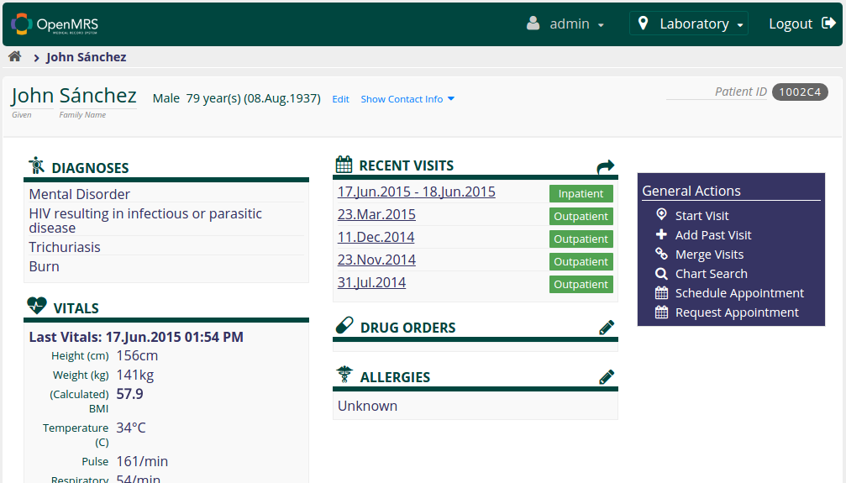

(Fig.1 Patient Dashboard)

## 2.1 Create Orders

The Physician logs into the Drug Order homepage. This page displays Patient information, list of drugs the Patient is allergic to and a table called 'Active Individual Drug Orders' that lists the currently active Drug Orders placed for the Patient including Order ID, Drug Name, Start Date information.

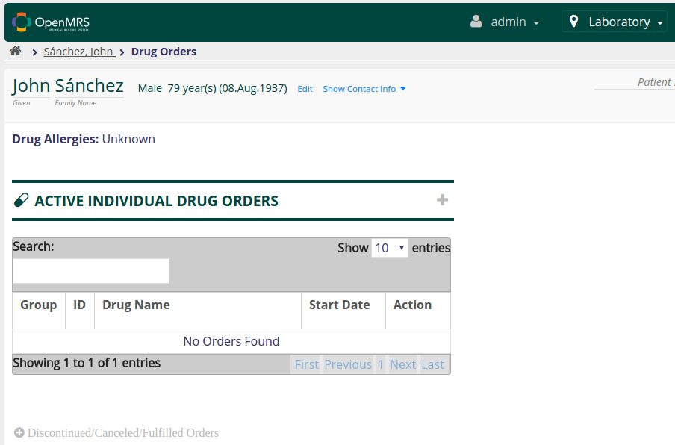

(Fig.2 Drug Order Homepage)

To create a new Drug Order, the Physician clicks on the '+' icon corresponding to the 'Active Individual Drug Orders' label. This loads a form to enter the details of the Order that needs to be placed. Failure to specify even one of these values will not allow the 'Save' button to be clicked. All the fields which are mandatory to be filled are marked with an asterick sign and highlighted until filled.

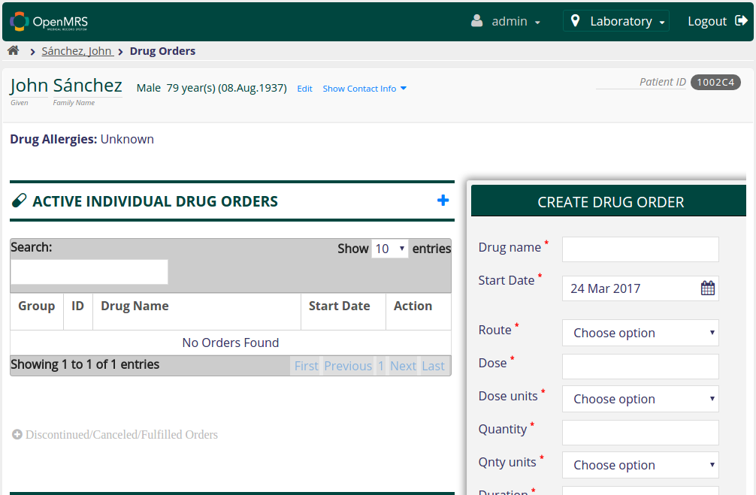

(Fig.3 Create a Drug Order)

When the Physician starts typing the name of the Drug, the field auto-completes itself.

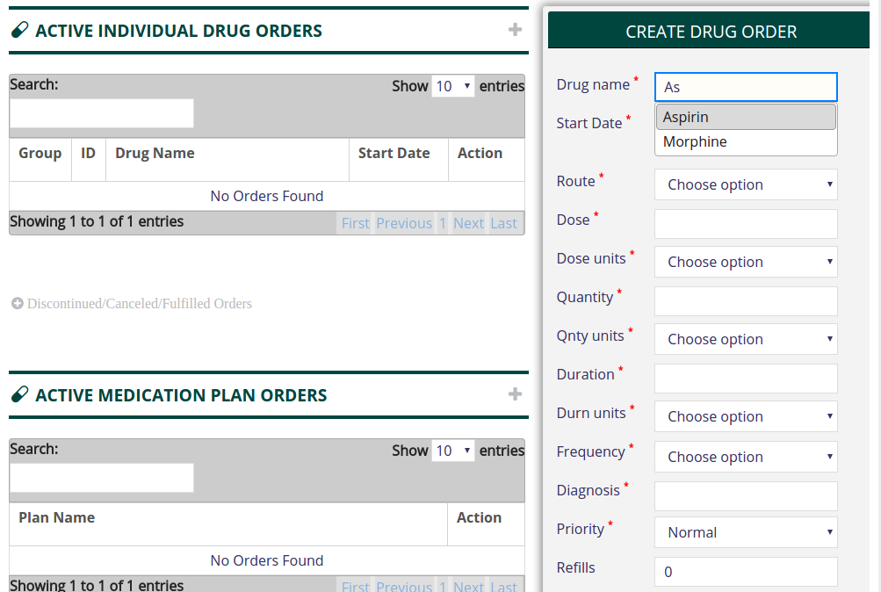

(Fig.4 Auto-complete Drug Name)

Next, the Physician enters the values for Dose, Duration, Quantity and selects the appropriate unit for each of these parameters from the list of options provided in the **select** widget.

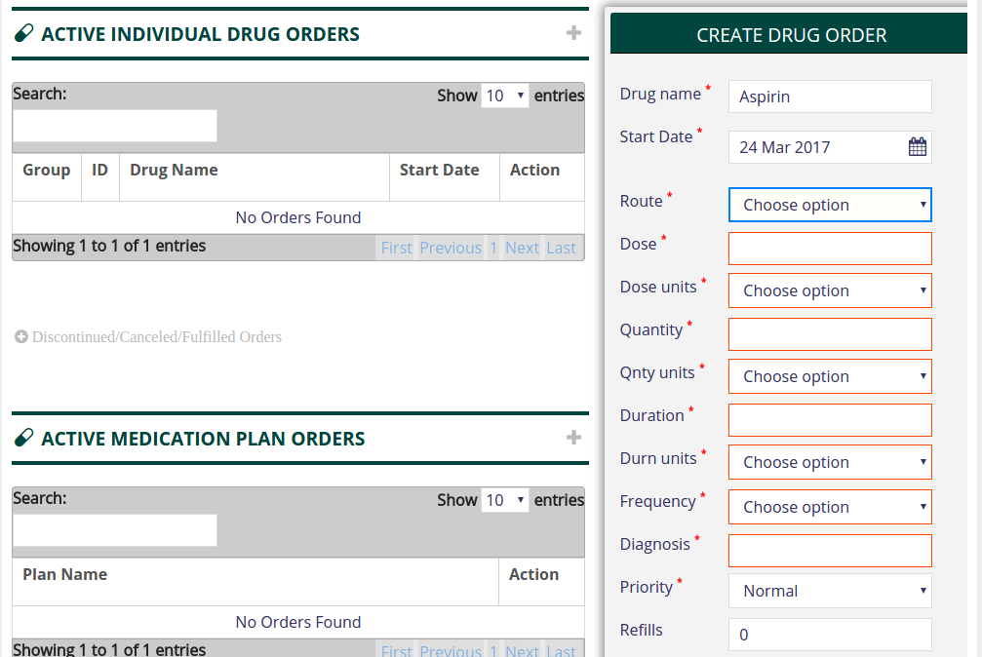

(Fig.5 Specify formulations)

The Physician then specifies the diagnosis made. This indicates the illness to cure which this Drug Order is made. The diagnosis field also works on auto-complete and lists options when the Physician begins to type.

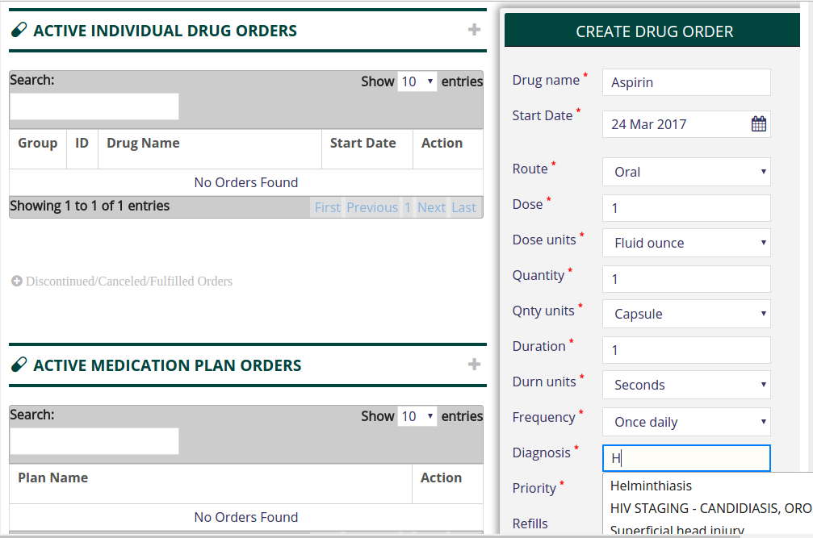

(Fig.6 Specify diagnosis)

The Physician also selects an option for priority which is set to 'Normal' by default. He/She specifies the number of refills that are allowed on the Order and the interval (number of days) between refills. Finally, the Physician will provide free-text instructions for both the Patient and the Pharmacist.

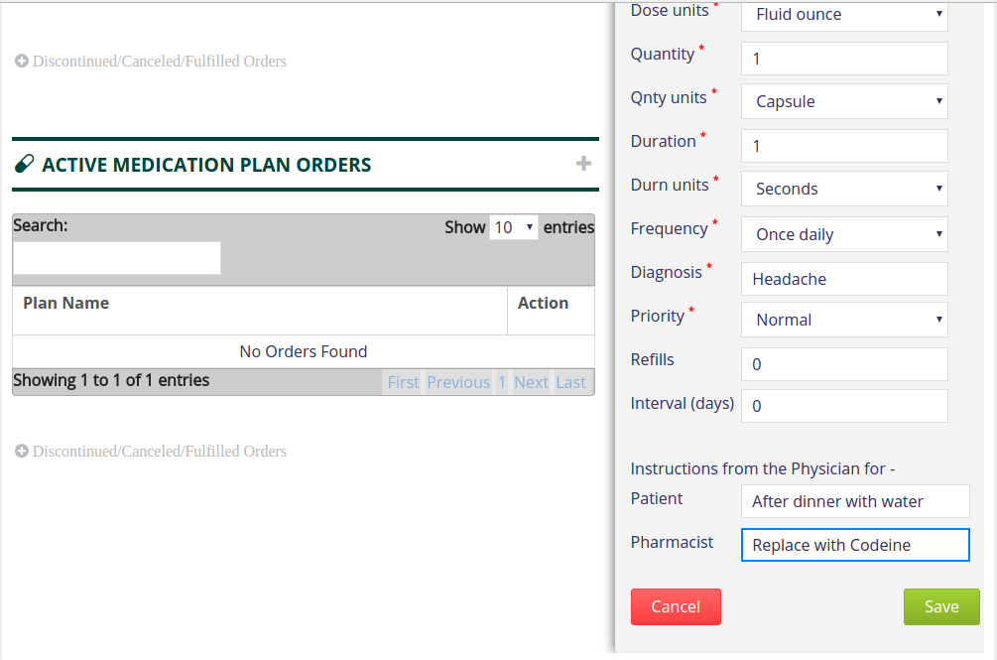

(Fig.7 Save Order)

An Order is created. An alert is displayed confirming the same to the user. The newly created Order is displayed in the Active Drug Orders table.

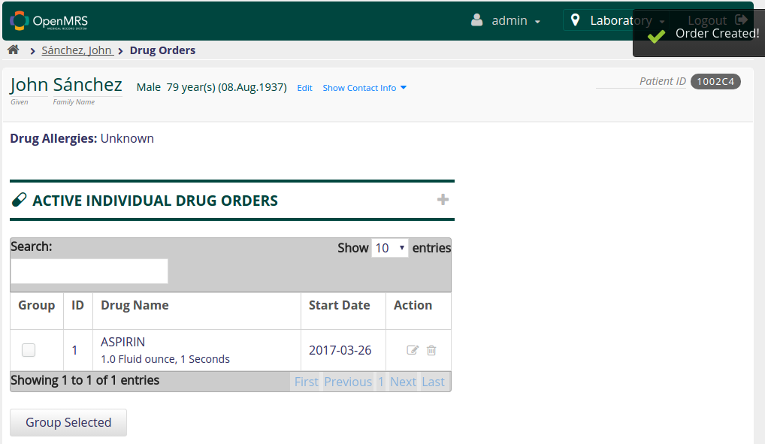

(Fig.8 Order Created)

Repeat the process to create another Order.

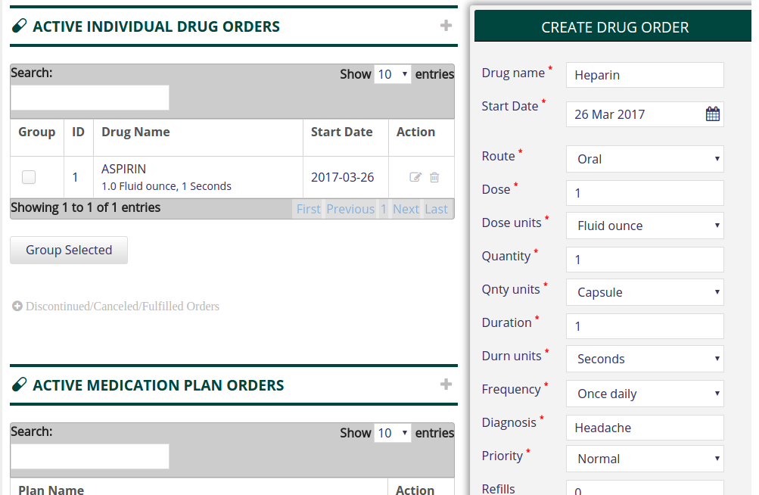

(Fig.9 Create another Order)

The active Orders are listed in the Active Drug Orders table in the Drug Order homepage.

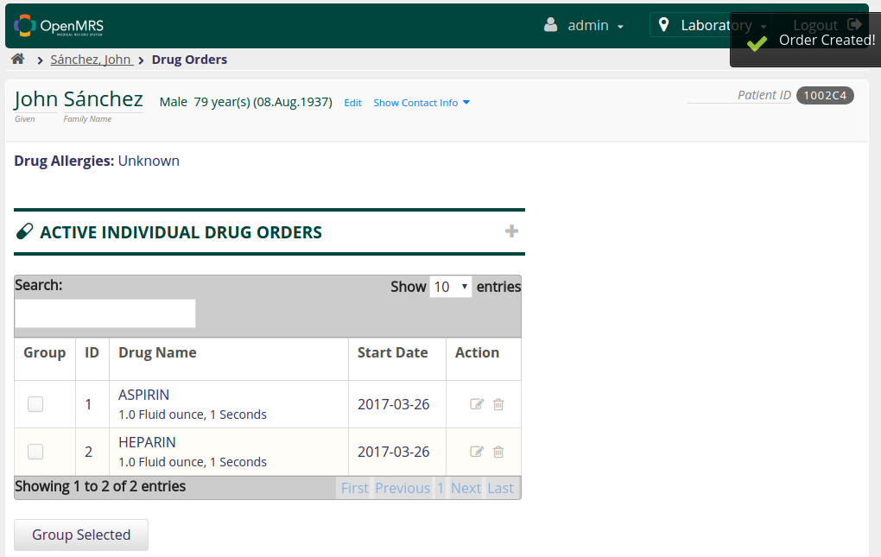

(Fig.10 Active Order List)

## 2.2 Group Orders

To group two or more Orders, the Physician check marks the check-box corresponding to each Order in the list that he/she wants to be grouped. Then the Physician clicks on the 'Group Selected' button.  
  
  
  
  
  
  
  
  
  
  
  
  
  
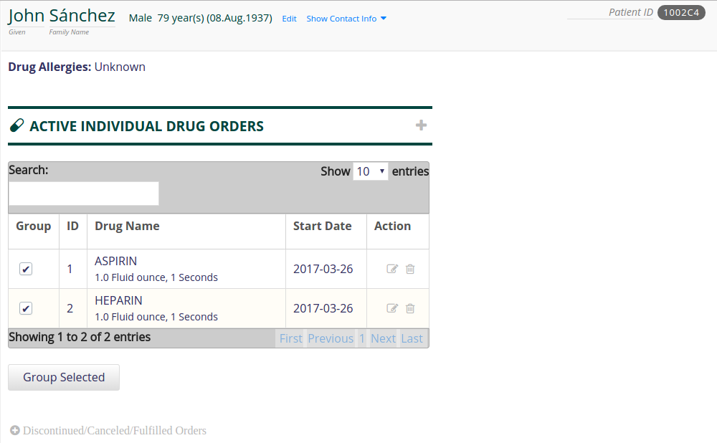

(Fig.11 Group Orders)

This will group the Orders into a single unit.

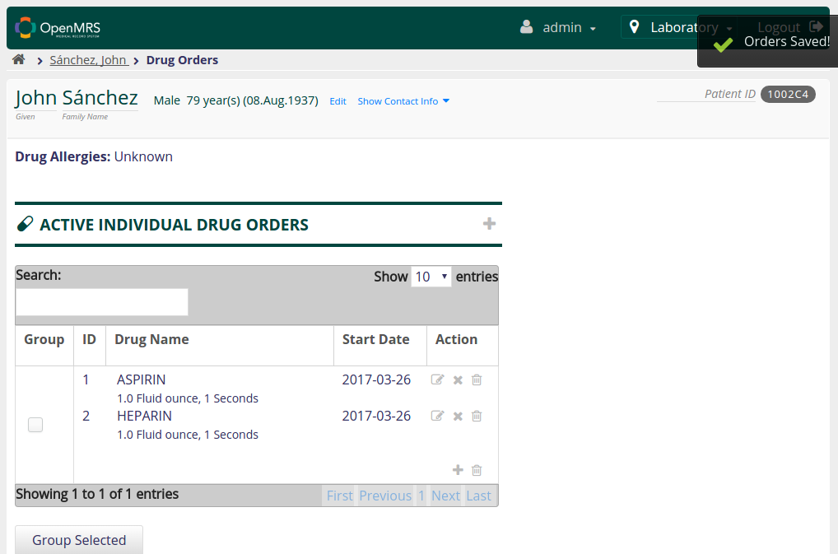

(Fig.12 Orders Grouped)

## 2.3 Add Order To Group

After an Order Group has been created, the Physician can create new Drug Orders to the Group by clicking the '**+**' icon in the 'Action' column corresponding to the Group to add an Order to the Group.

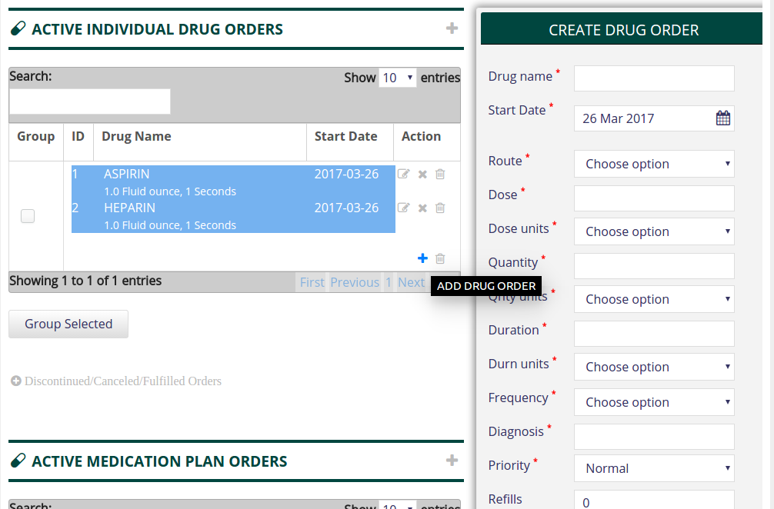

(Fig.13 Add Order to Group)

This loads the form where the Physician enters the Order details as described in section 2.1

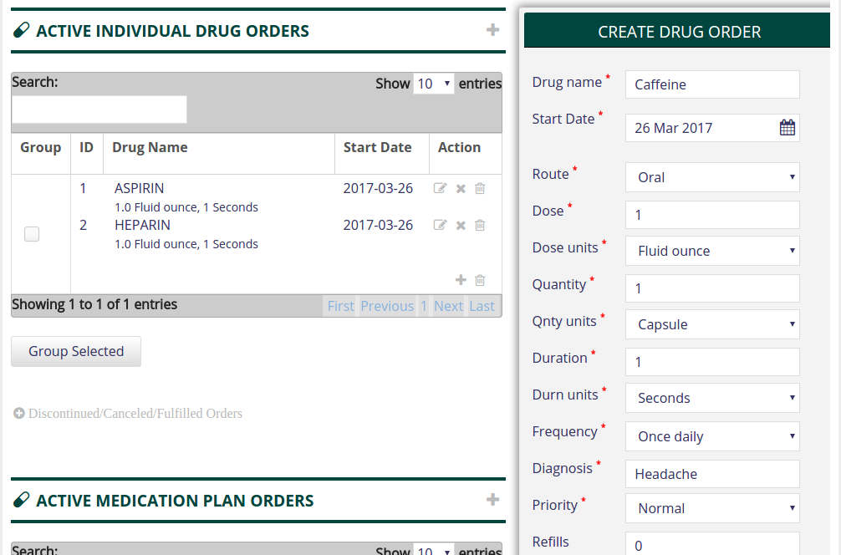

(Fig.14 Create Order to Group)

Now the Order Group has another Order added to it.

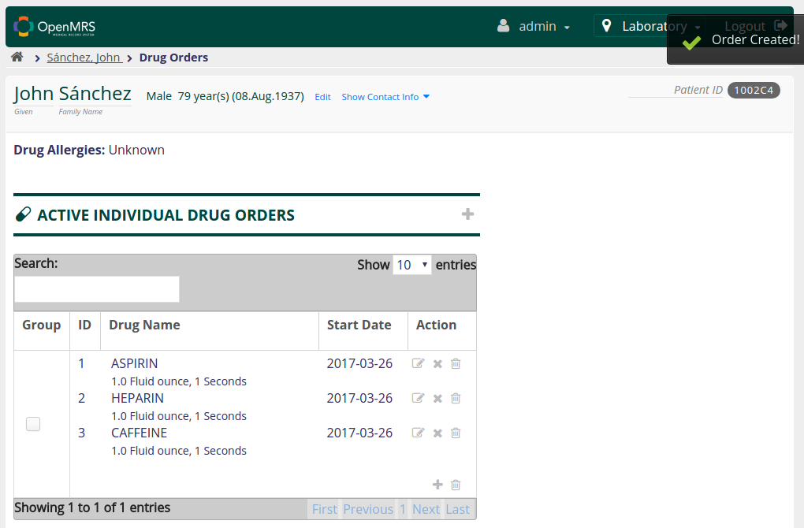

(Fig.15 Order Group)

## 2.4 View an Order

The Drug Order table displays the Drug Name, Start Date and Dosage information. Upon clicking a row (representing an Order), a fragment containing all the information pertaining to the Order is displayed. The selected Order is highlighted in the table.

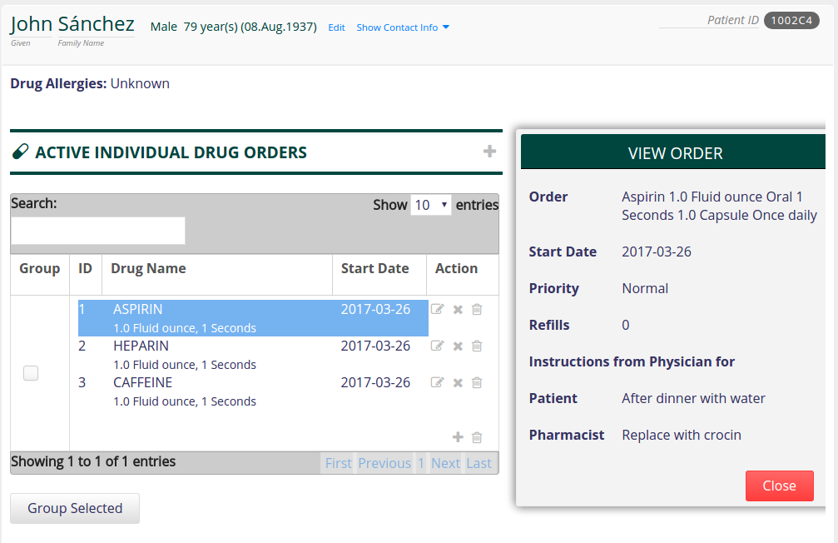

(Fig.16 View Order)

## 2.5 Edit an Order

Once the Physician has placed the Order Group, the individual Orders can be modified. Click on the 'Edit' icon corresponding to an Order. This will load the form with all the Order entries populated.

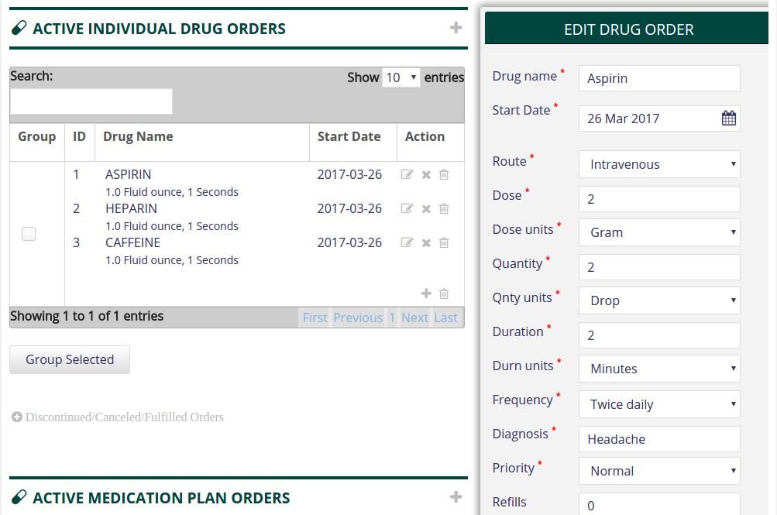

(Fig.17 Edit Order)

The Physician can revise and change one or more of the entries and click the 'Save' button. This will void the previous Order and create a new Order within the Group with new formulations in it's place.

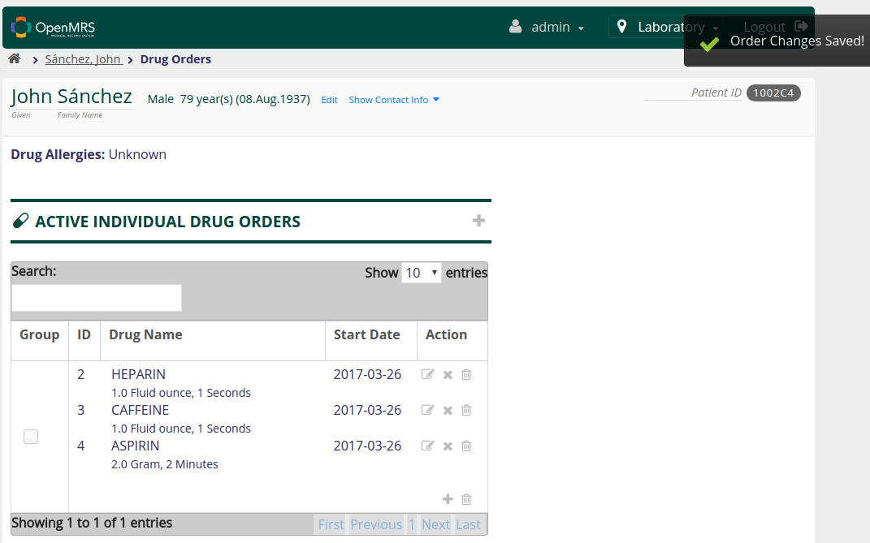

(Fig.18 Saved edited Order)

## 2.6 Ungroup an Order (Remove an Order from a Group)

The Physician can click on the cross icon corresponding to an Order to remove the Order from the group.

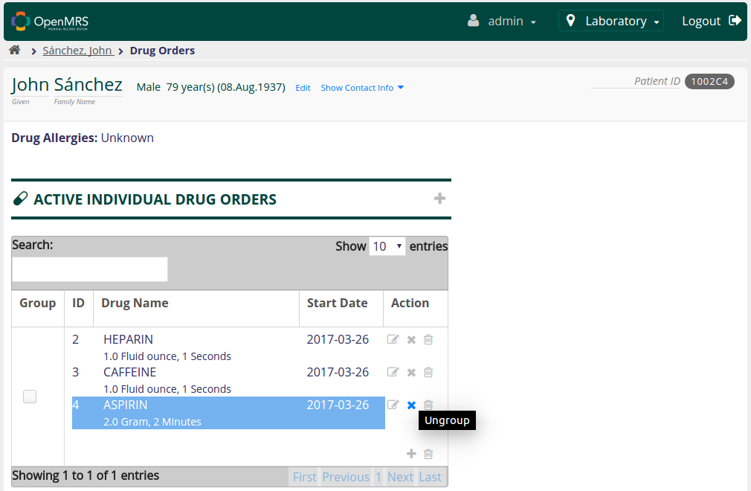

(Fig.19 Select Order to Ungroup)

A dialog box opens up asking the Physician to confirm this action.

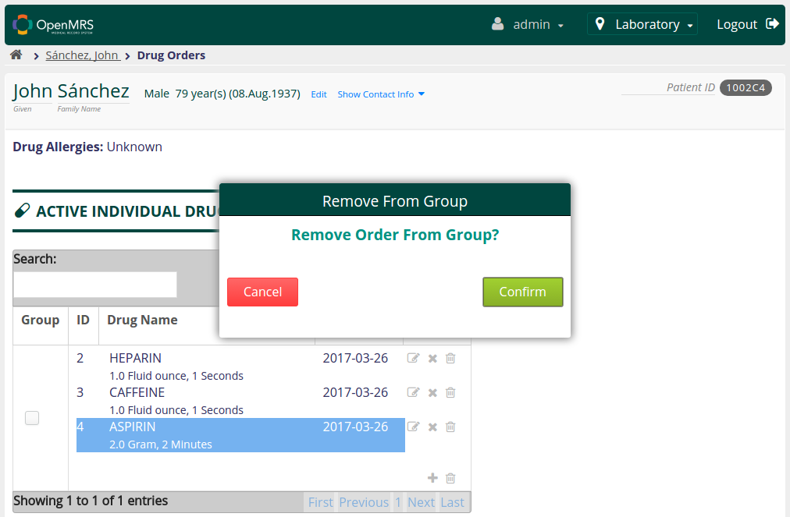

(Fig.20 Ungroup Order)

The Order is now active but not a part of the group.

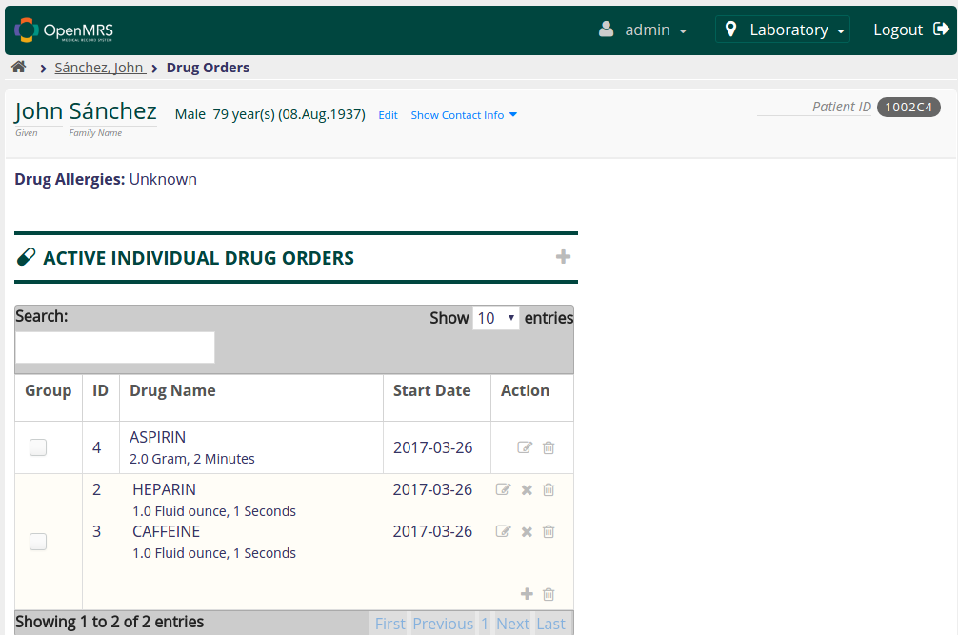

(Fig.21 Order ungrouped)

## 2.7 Discontinue Order Group

To discontinue an Order Group, the Physician clicks the 'Discontinue' icon corresponding to the Group to add an Order to the Group. This will load a fragment displaying the details of the Orders in the selected Group and a select field listing a set of pre-defined reasons for discontinuing the Order Group.

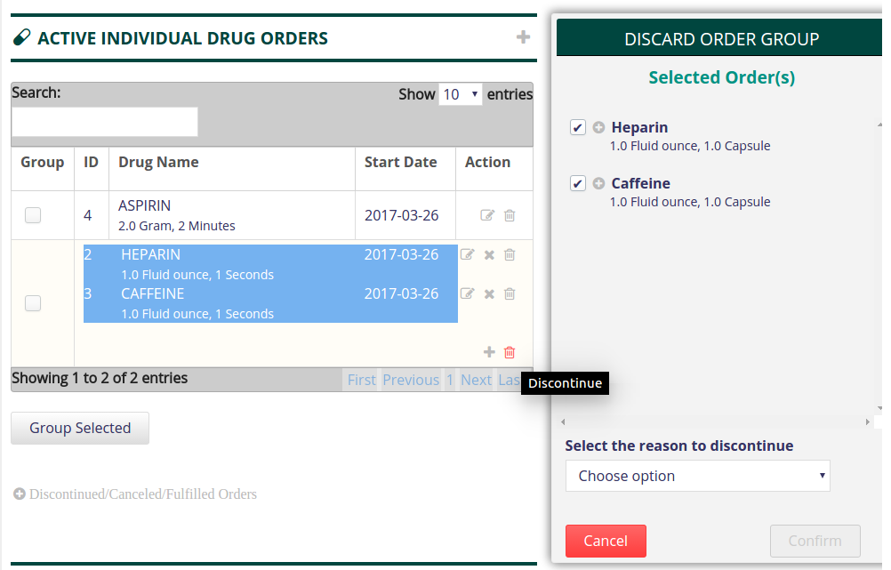

(Fig.22 Discontinue Group)

The Physician selects an option for discontinuing the selected Order. Once the reason for Order Group discontinuation is selected/entered, the Physician clicks on the 'Confirm' button to discontinue.

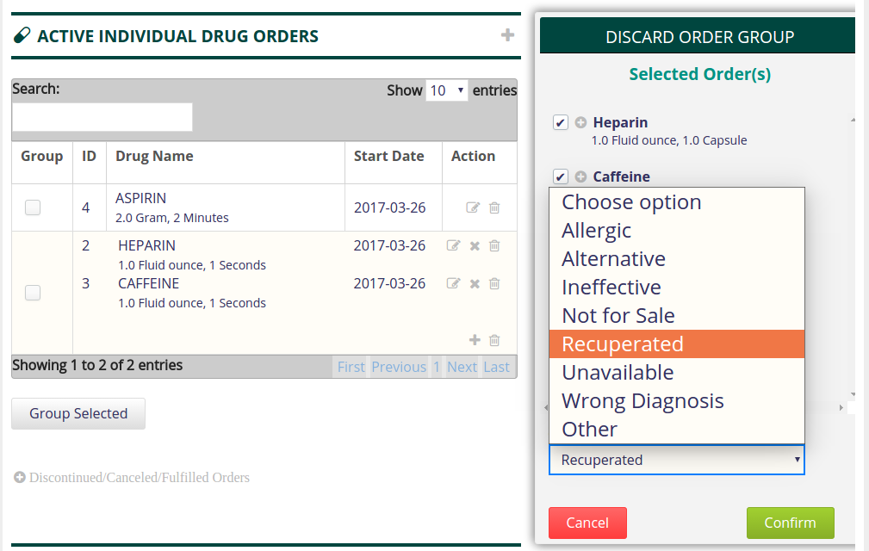

(Fig.23 Select Reason to discontinue)

This will display an alert informing the user that the Order Group has been discontinued. The Orders in the Group will no longer be visible in the Active Drug Orders table.

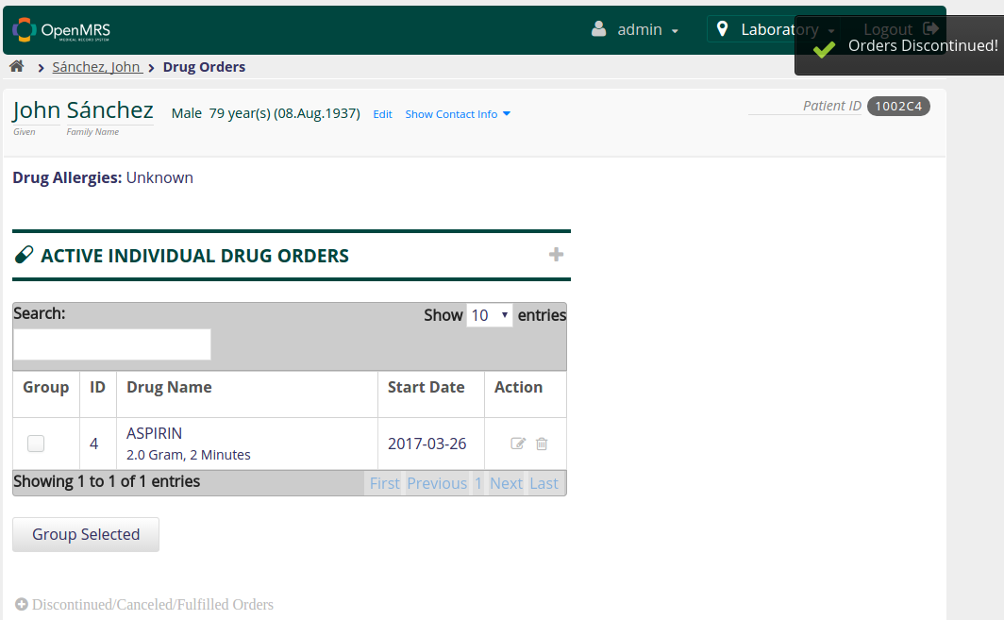

(Fig.24 Group Discontinued)

Consider a situation where the Physician wants to place an Order for the same group of drugs that he/she prescribed earlier. Instead of creating a new Drug Orders, the Physician will simply renew the old non-active Order Group and make changes wherever necessary.

## 2.8 Renew Order Group

Upon clicking 'Discontinued/Canceled/Fulfilled Orders' link, a table containing the list of past Drug Orders that are no longer active is displayed. This table is kept not displayed by default on the page.  
The Physician clicks on the 'Renew' button corresponding to the Order Group.

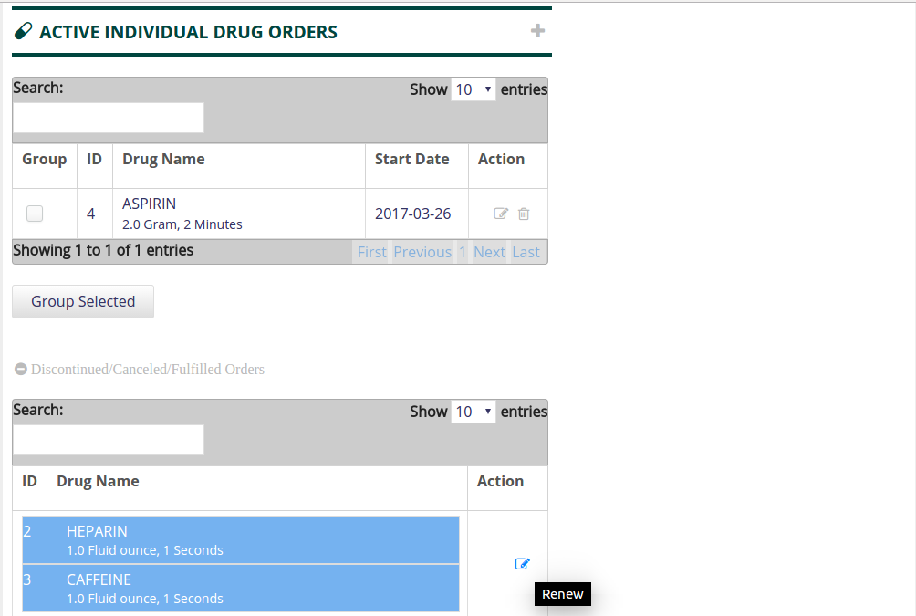

(Fig.25 Renew Orders)

This will load a fragment displaying the details of the selected Orders. By default, the check-box corresponding to each drug is left checked. The Physician can un-check some of them if he/she does not wish for the entire group of Orders to be renewed.

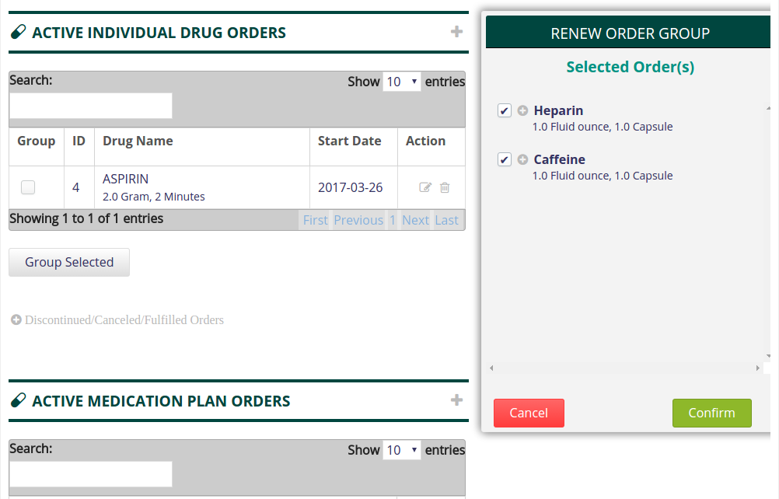

(Fig.26 Renew Order Group)

Once the Order Group is renewed (new active Orders are created for the Orders in the Group), the Physician can edit the formulations of the individual Orders in the new Group (if required).

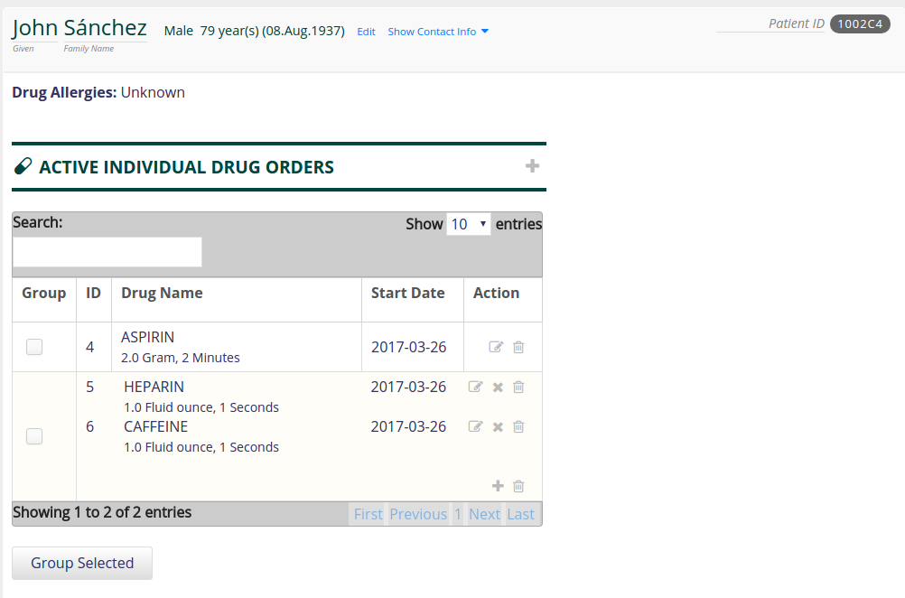

(Fig.27 Order Group Renewed)

## 2.9 Discontinue some Orders from Group

Consider the scenario where the Physician wants to discontinue just one Order in the Group. He/She clicks the 'Discontinue' icon corresponding to an Order. This loads a fragment displaying the details.

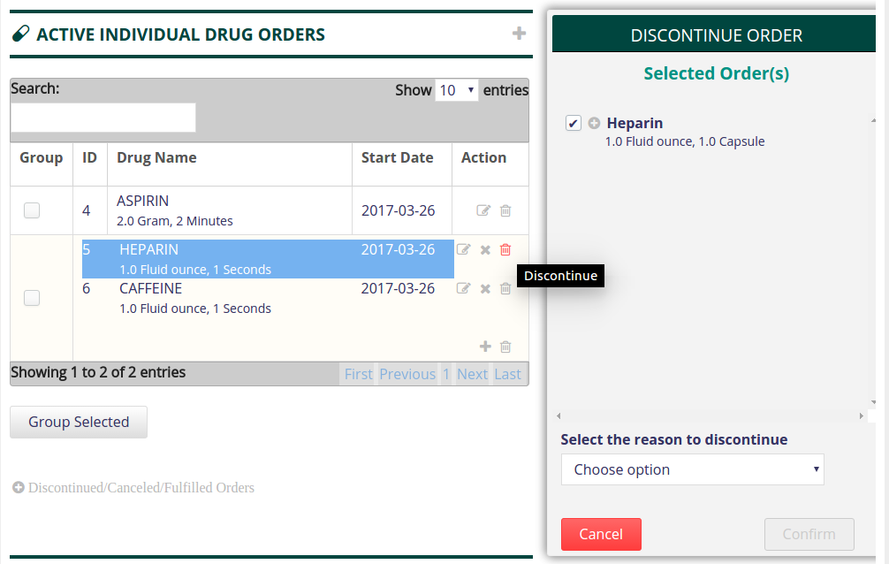

(Fig.28 Discontinue Order)

The Physician specifies the reason for discontinuing the Order and clicks the 'Confirm' button.

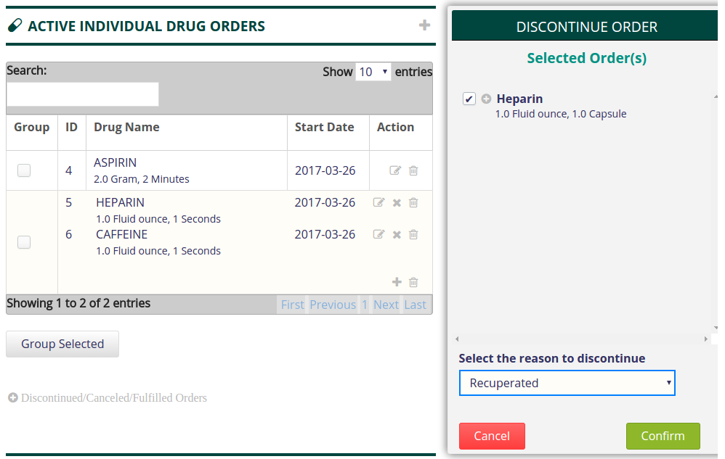

(Fig.29 Discontinue Order – Select reason)

Once the Order is discontinued, an alert will be displayed informing the user that the Order has been discontinued. The Order will no longer be visible in the Active Drug Orders table.

(Fig.30 Order Discontinued)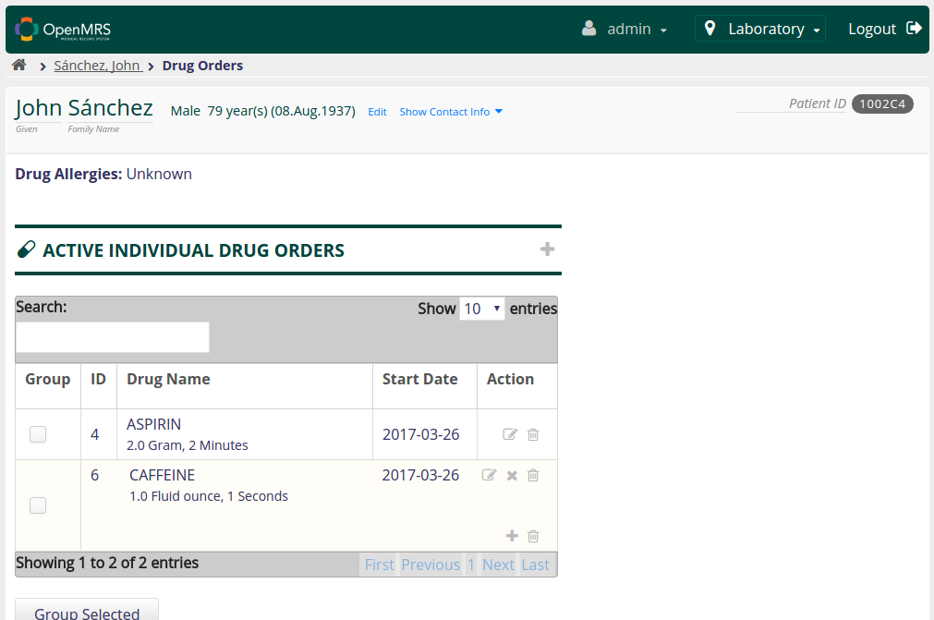

## 2.10 Renew some Orders from Group

When the Physician selects a group of Orders to be renewed, he/she will have the option to renew not all but some Orders from the selected group. The Physician clicks on the 'Renew' button corresponding to the Order Group under the 'Discontinued/Canceled/Fulfilled Orders' link.

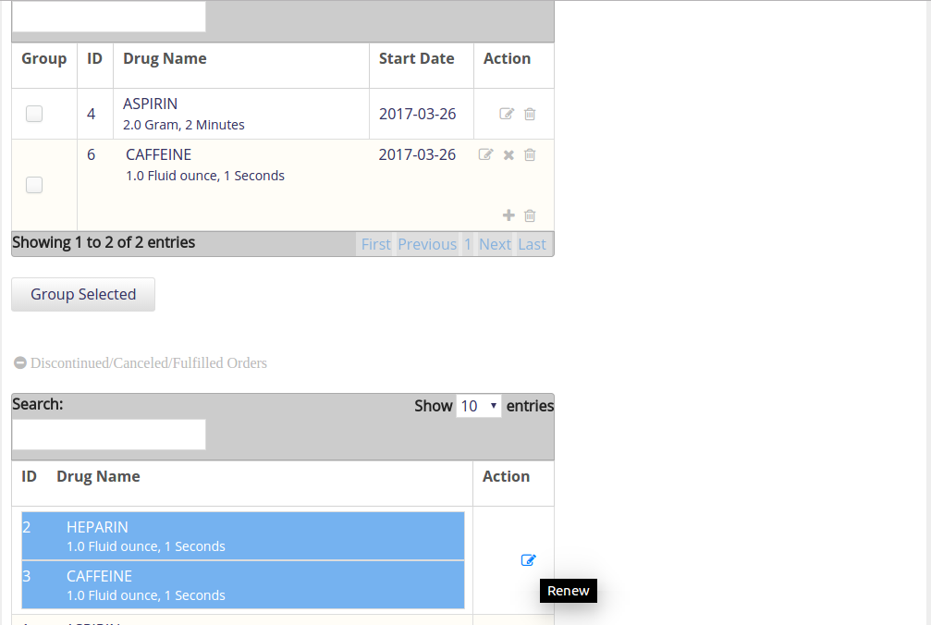

(Fig.31 Order Renewal)

The Physician un-checks the check-boxes corresponding to the Orders that are not to be renewed. (By default, all the check-boxes are checked).

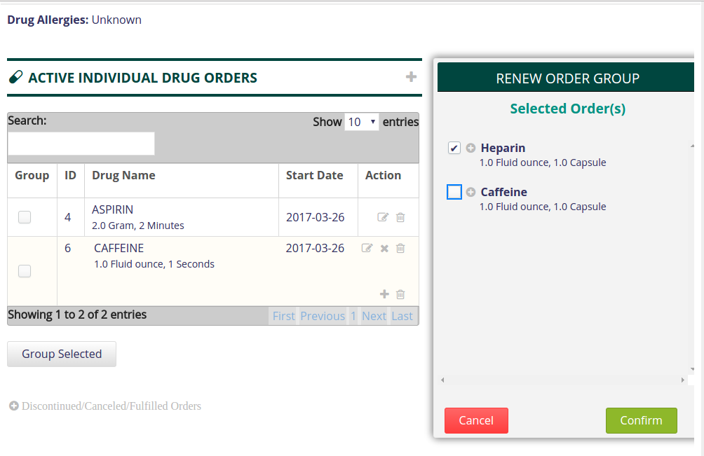

(Fig.32 Select Order(s) for Renewal)

The renewed Orders are now listed in the Active Drug Order table.

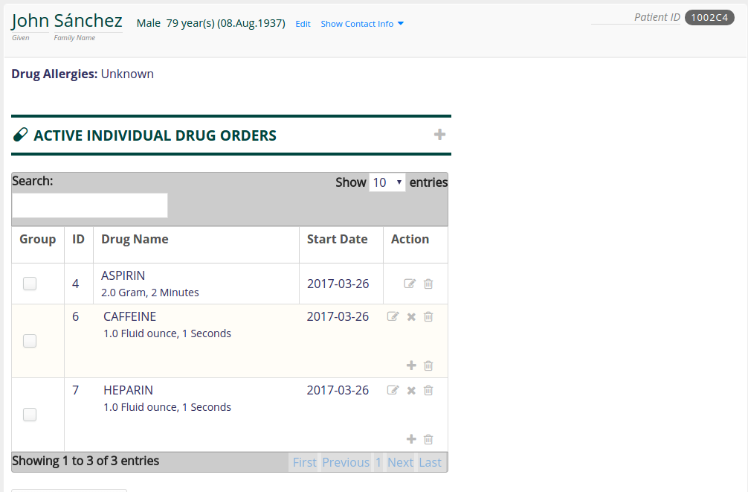

(Fig.33 Order Renewed)