Drug Order Module

Single / Individual Order

In this section, we will study the use-cases and the snapshots displaying the UI relevant to a single, individual Drug Order. This includes the steps followed by a Physician to create an Order, view the Order details, edit the Order components, discontinue the Order and renew an old non-active Drug Order. We will see the list of pre-defined select options available to the Physician to place an Order or discontinue it by providing a specific reason. Also included are the snapshots that describe how the Physician is notified upon ordering an allergic drug or while creating, modifying or discontinuing an Order.

Table of Contents

1. USE CASES 3

1.1 Create an Order 3

1.2 View an Order 3

1.3 Edit an Order 3

1.4 Discontinue an Order 3

1.5 Renew an Order 4

2. SNAPSHOTS 5

2.1 Create an Order 5

2.2 View an Order 11

2.3 Edit an Order 12

2.4 Discontinue an Order 13

2.5 Renew an Order 15

# 1. USE CASES

In this section, we will study the use-cases considered relevant to a single individual Order while designing the Drug Order module.

*Patient Betty Johnson comes to the clinic to get a cure for her illness. The Physician John Watson after completing the diagnosis of her health decides to place an Order for a drug. He will log into the Patient's Drug Order page through the Patient Dashboard page to place an Order for a drug.*

## 1.1 Create an Order

When the Physician logs into the Patient's Drug Order page, he/she clicks on the '**+**' icon corresponding to the 'Active Individual Drug Order' label. This will load a fragment to enter the composition and instructions pertaining to a Drug Order. Here, the Physician enters (and selects based on auto-complete feature) the drug name and specifies the dose, quantity, duration and frequency. He/She also specifies the start-date, number of refills allowed and text instructions for the Patient as well as the Pharmacist. If the Patient is allergic to the drug being ordered, the Physician is provided a field to specify a reason. Once the Order is created, an alert is displayed and the Order is listed in the Active Drug Orders table.

## 1.2 View an Order

The Physician can click on any row (corresponding to a Drug Order) in the Active Drug Orders table to view the details of the Order. Upon selecting an Order, it is highlighted and a fragment containing the Order's composition including the drug formulations, start-date, priority and instructions are displayed.

## 1.3 Edit an Order

The Physician can edit an Order once it is created (as long as the Pharmacist has not yet dispatched or discontinued the Order). The Physician clicks on the 'Edit' icon corresponding to an Order in the Active Drug Orders table. This will load a form similar to the 'Create Drug Order' form with all the fields (Drug name, Dose, Duration, Frequency etc.) populated from the selected Order's record. The Physician reviews the data provided in the fields, modifies the entries wherever required and clicks the 'Save' button. This will void the previous Order and create a new Order with these specifications.

## 1.4 Discontinue an Order

If the Physician wishes to discontinue an active Order, he/she clicks on the 'Discontinue' icon corresponding to an Order in the Active Drug Orders table. This will load a fragment displaying the details of the selected Order and a select field listing a set of pre-defined reasons for discontinuing the Order. The Physician can choose from one of these options or select the 'Other' option to manually enter a reason for discontinuing the selected Order. Once the reason for discontinuation is selected/entered, the Physician clicks on the 'Confirm' button. This will display an alert informing the user that the Order has been discontinued. The Order will no longer be visible in the Active Drug Orders table.

## 1.5 Renew an Order

Below the Active Drug Order table, the page provides a link called 'Discontinued/Canceled/Fulfilled Orders'. Upon clicking this link, a table containing the list of past Drug Orders that are no longer active is displayed. If the Physician wishes to renew one of these Orders without having to create a new Order manually, he/she clicks on the 'Renew' button corresponding to the Order. This will load a form similar to the 'Create Drug Order' form with all the fields (Drug name, Dose, Duration, Frequency etc.) populated from the selected Order's record. The Start-date field will contain the current date by default. The Physician can then review and revise the drug's formulation, Patient/Pharmacist instructions and other fields before clicking the 'Save' button. This will create a new individual Order. An alert is displayed notifying that the Order is created and the Order is listed in the Active Drug Orders table.

# 2. SNAPSHOTS

The Physician logs into the Patient's dashboard. This dashboard includes a segment for Drug Orders. The Physician clicks on the edit icon on this segment to navigate to the Drug Order homepage.

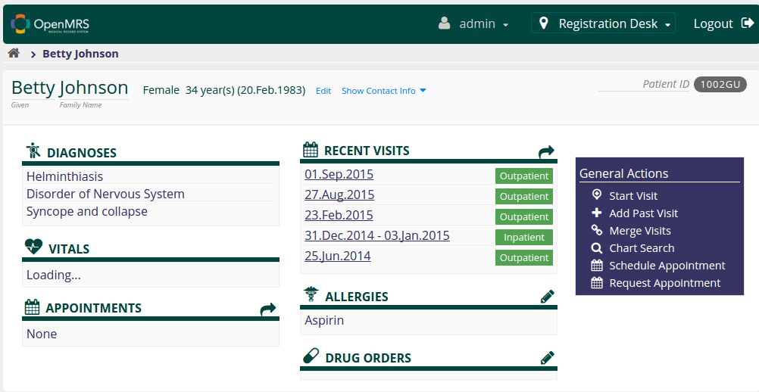

(Fig.1 Patient Dashboard)

## 2.1 Create an Order

The Physician logs into the Drug Order homepage. This page displays Patient information, list of drugs the Patient is allergic to and a table called 'Active Individual Drug Orders' that lists the currently active Drug Orders placed for the Patient including Order ID, Drug Name, Start Date information.

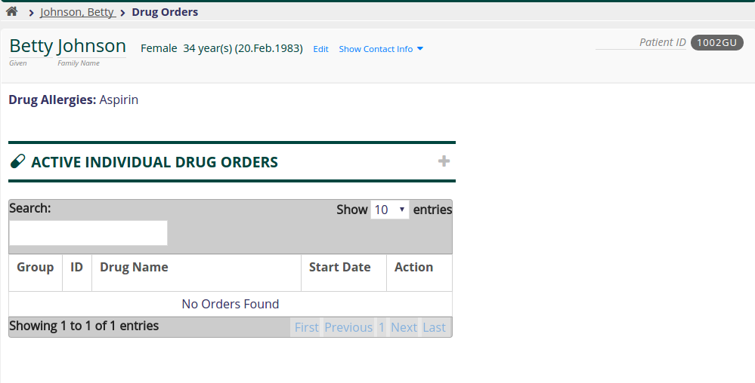

(Fig.2 Drug Order Homepage)

To create a new Drug Order, the Physician clicks on the '+' icon corresponding to the 'Active Individual Drug Orders' label.

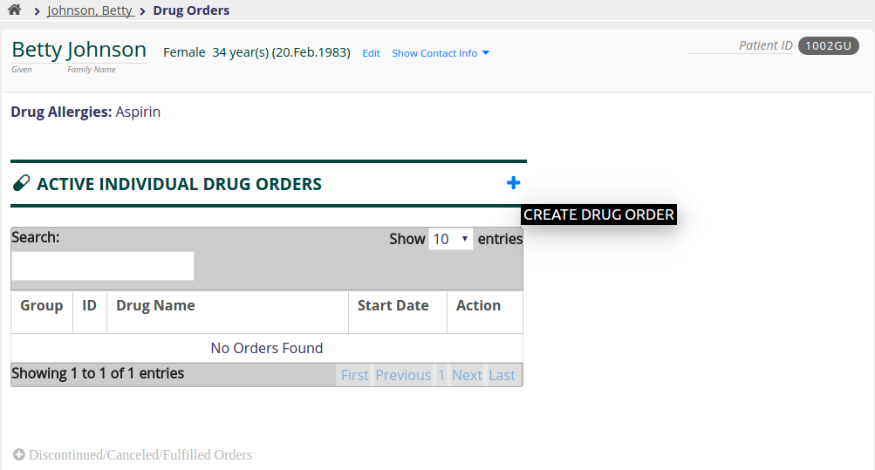

(Fig.3 Create a Drug Order)

This loads a form to enter the details of the Order that needs to be placed. Failure to specify even one of these values will not submit the form (no effect) when the 'Save' button is clicked with all the fields which are mandatory to be filled marked with an asterick sign and highlighted until filled.

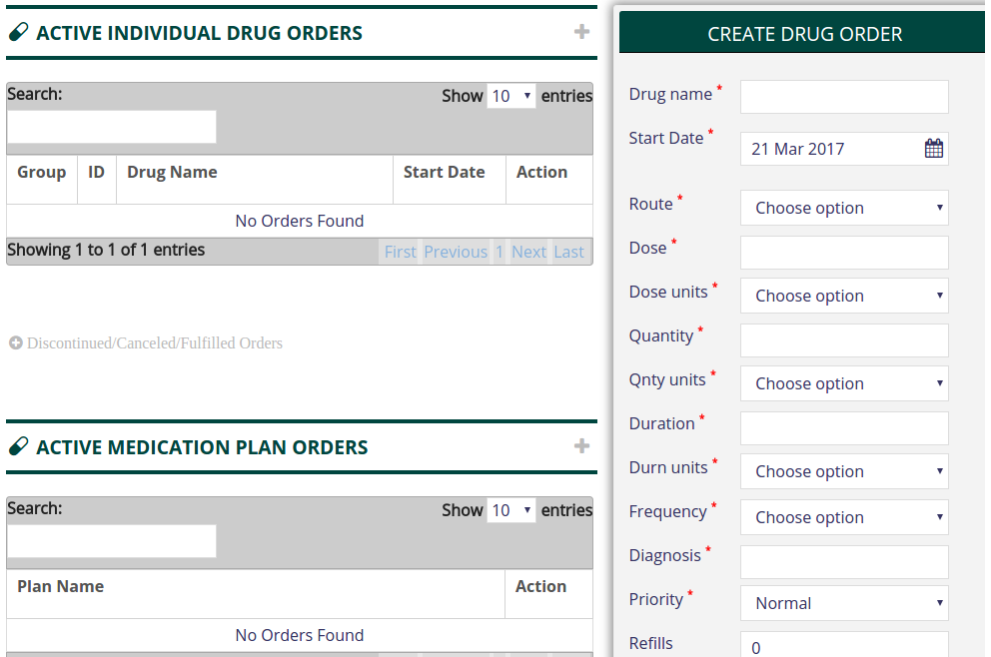

(Fig.4 Create Drug Order form)

When the Physician starts typing the name of the Drug, the field auto-completes itself.

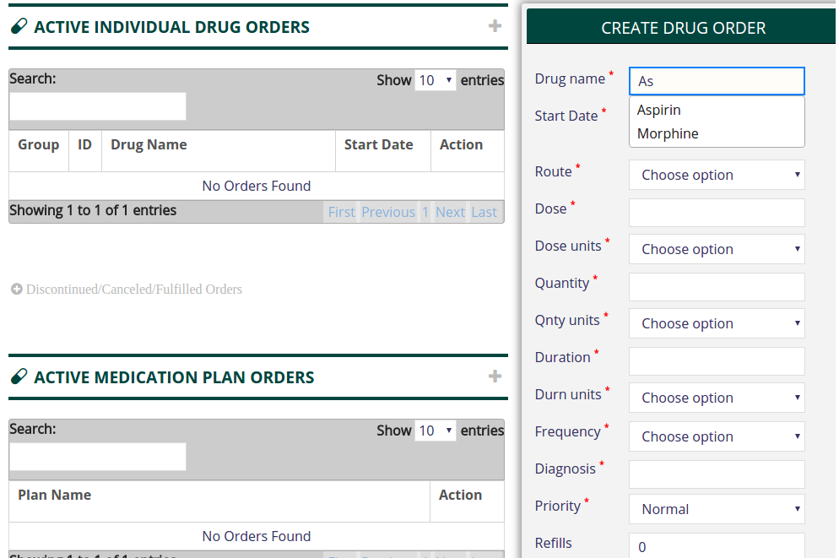

(Fig.5 Auto-complete Drug Name)

The Order selected is Aspirin. Note that the Patient is identified to be allergic to Aspirin (as indicated in the top section of the homepage). This will display a field asking the Physician to enter the reasons for ordering the allergic drug.

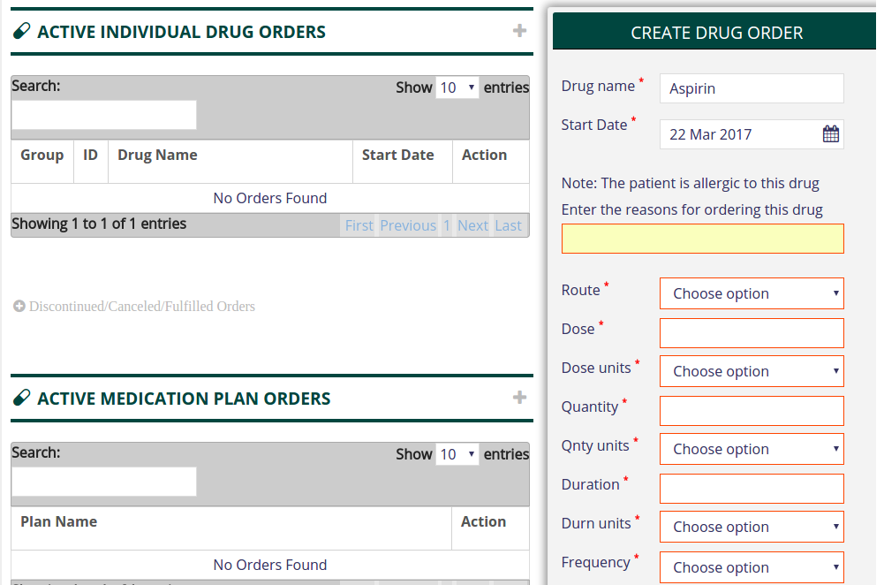

(Fig.6 Allergic Order Reason)

Next, the Physician enters the values for Dose, Duration, Quantity and selects the appropriate unit for each of these parameters from the list of options provided in the **select** widget.

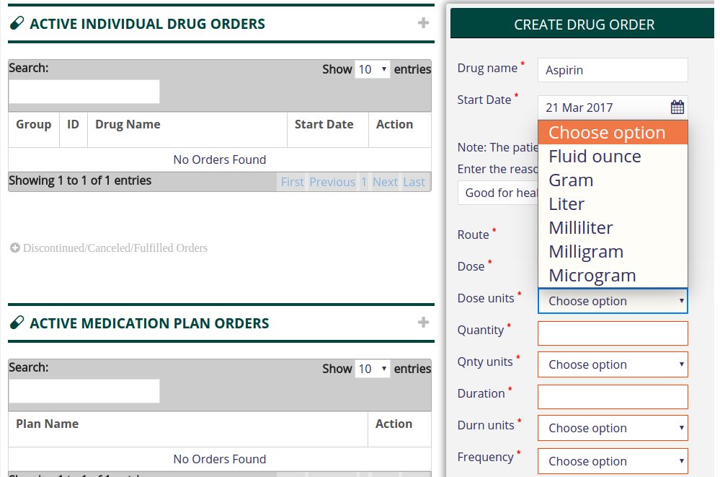

(Fig.7 Specify measurement units - 1)

Scrolling down, each parameter's unit is specified with the widgets provided.

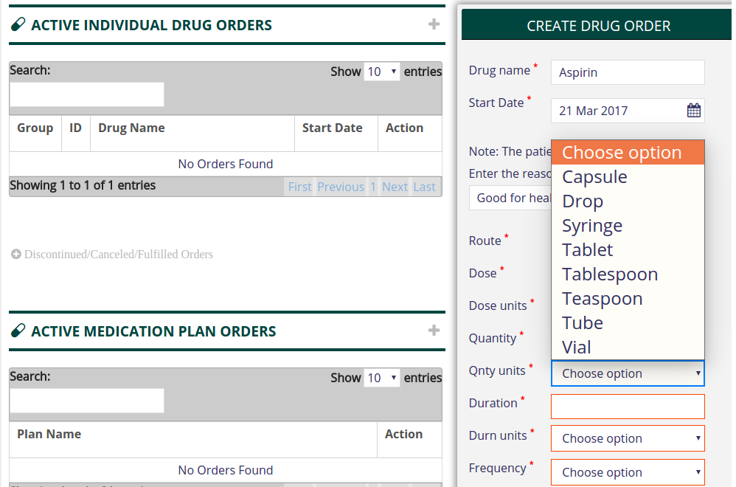

(Fig.8 Specify measurement units – 2)

The Physician then specifies the diagnosis made. This indicates the illness to cure which this Drug Order is made. The diagnosis field also works on auto-complete and lists options when the Physician begins to type.

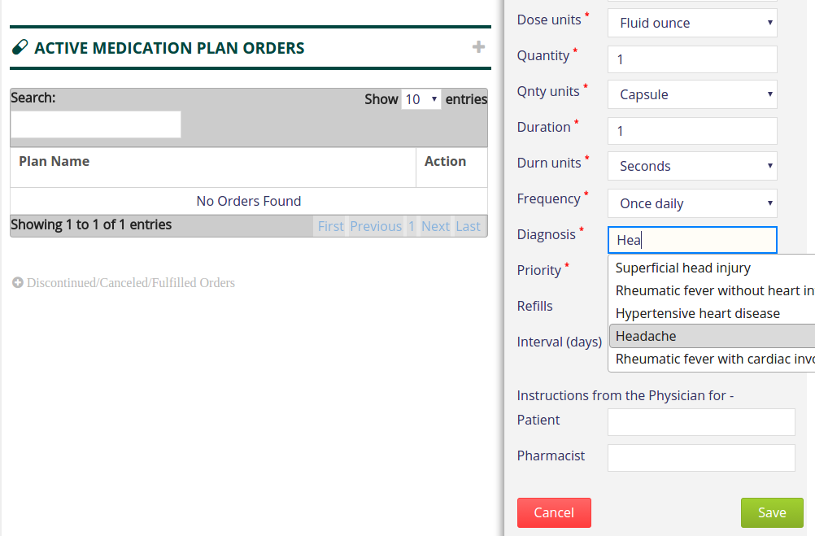

(Fig.9 Specify diagnosis)

The Physician also selects an option for priority which is set to 'Normal' by default. He/She specifies the number of refills that are allowed on the Order and the interval (number of days) between refills.

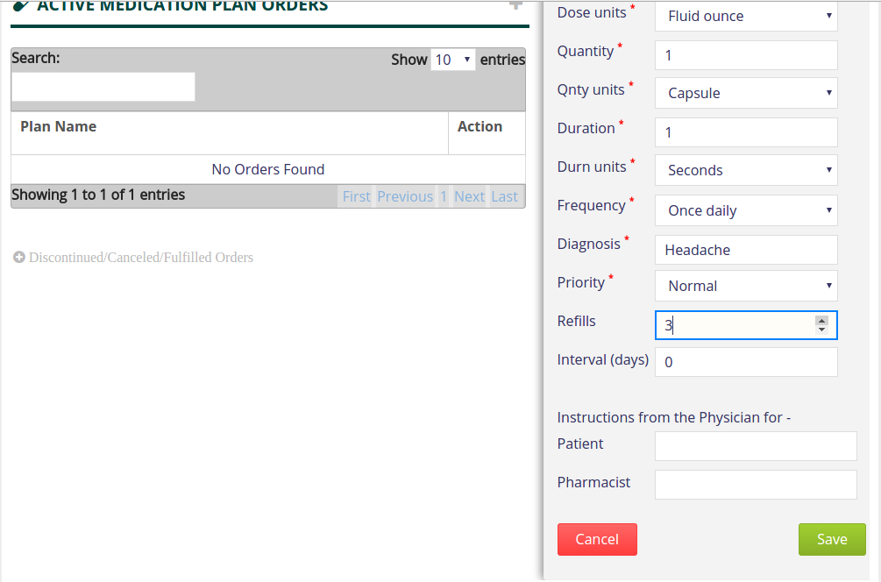

(Fig.10 Specify refill)

Finally, the Physician will provide free-text instructions for both the Patient and the Pharmacist.

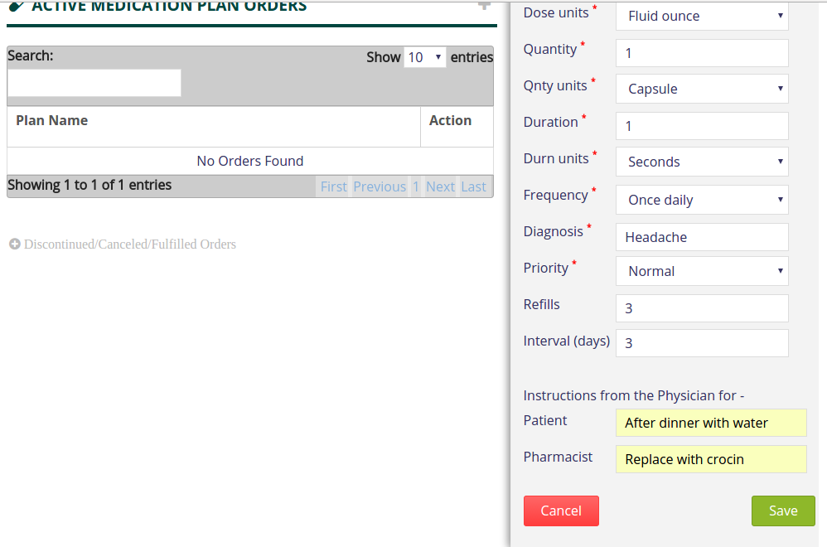

(Fig.11 Additional Instructions)

Assured with the formulation provided, the Physician clicks the 'Save' button and an Order is created. An alert is displayed confirming the same to the user. The newly created Order is displayed in the Active Drug Orders table.

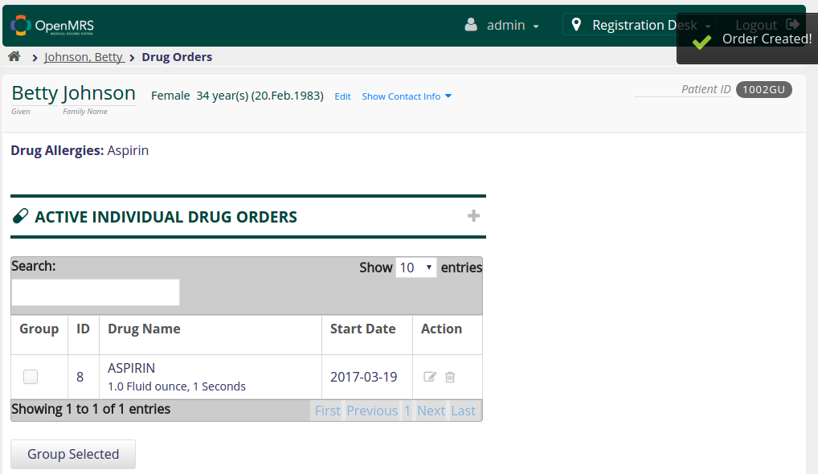

(Fig.12 Order Created)

The active Order is also listed in the Patient Dashboard.

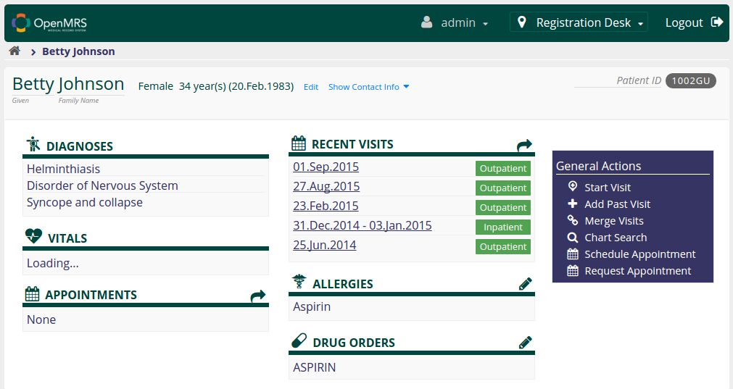

(Fig.13 Dashboard updated)

## 2.2 View an Order

The Drug Order table displays the Drug Name, Start Date and Dosage information. Upon clicking a row (representing an Order), a fragment containing all the information pertaining to the Order is displayed. The selected Order is highlighted in the table.

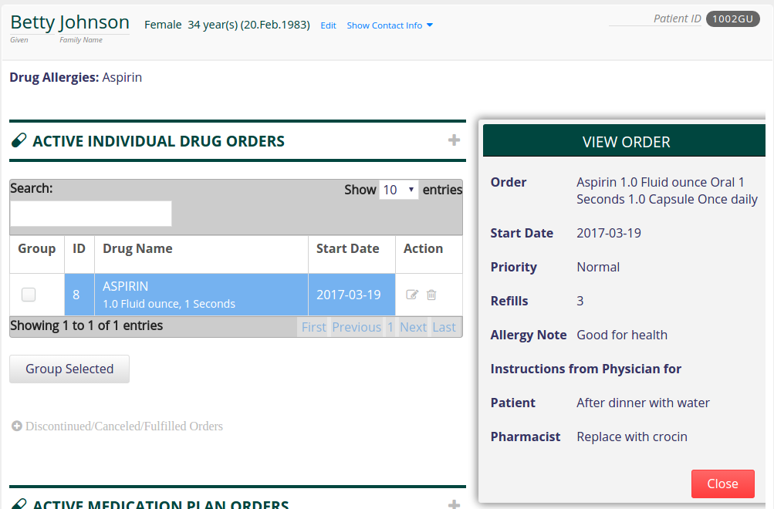

(Fig.14 View Order)

## 2.3 Edit an Order

Once the Physician has placed an Order, the Order can be modified. Click on the 'Edit' icon corresponding to the Order. This will load the form with all the Order entries populated.

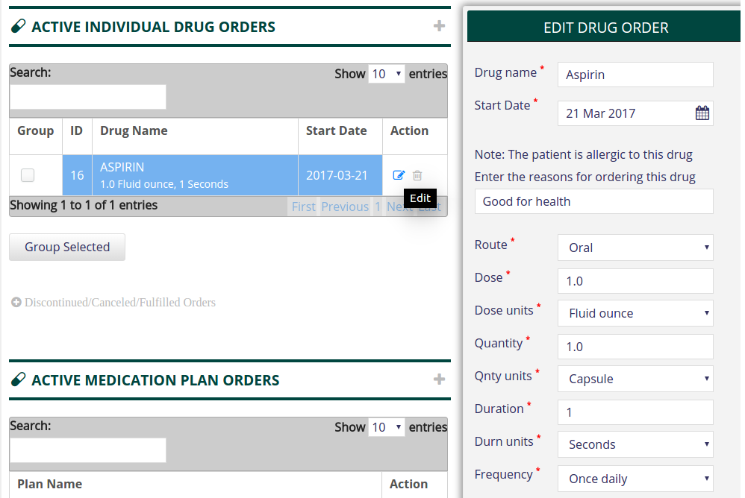

(Fig.15 Edit Order)

The Physician can revise and change one or more of the entries and click the 'Save' button. This will void the previous Order and create a new Order with new formulations in it's place.



(Fig.16 Save edited Order)

## 2.4 Discontinue an Order

Consider the scenario where the Physician wants to discontinue the Order. He/She will click on the 'Discontinue' icon corresponding to an Order. This will load a fragment displaying the details of the Order.

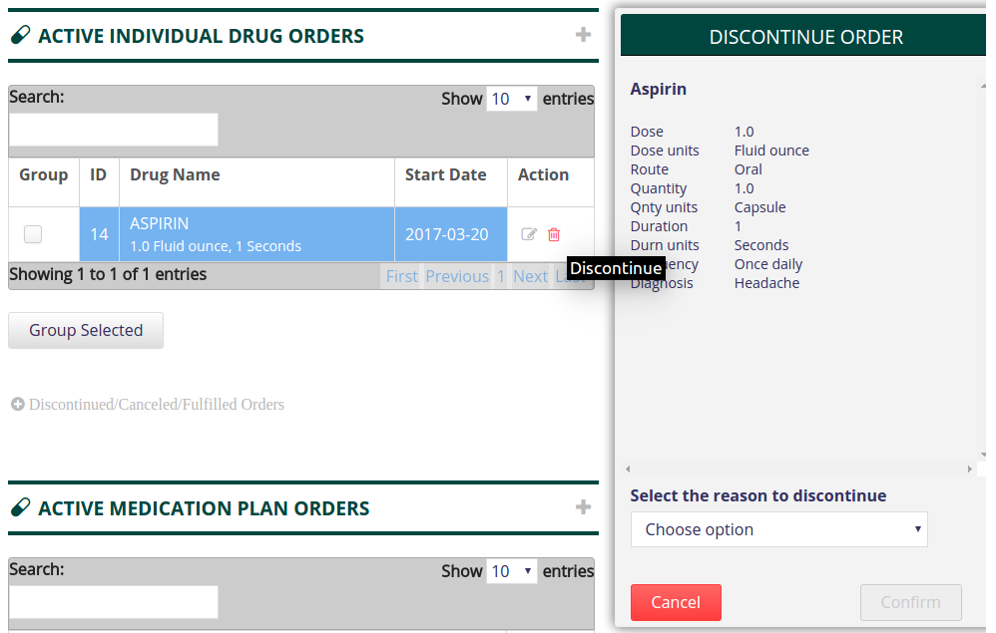

(Fig.17 Discontinue Order)

The Physician can choose from one of the options from the select field listing a set of pre-defined reasons for discontinuing the Order.

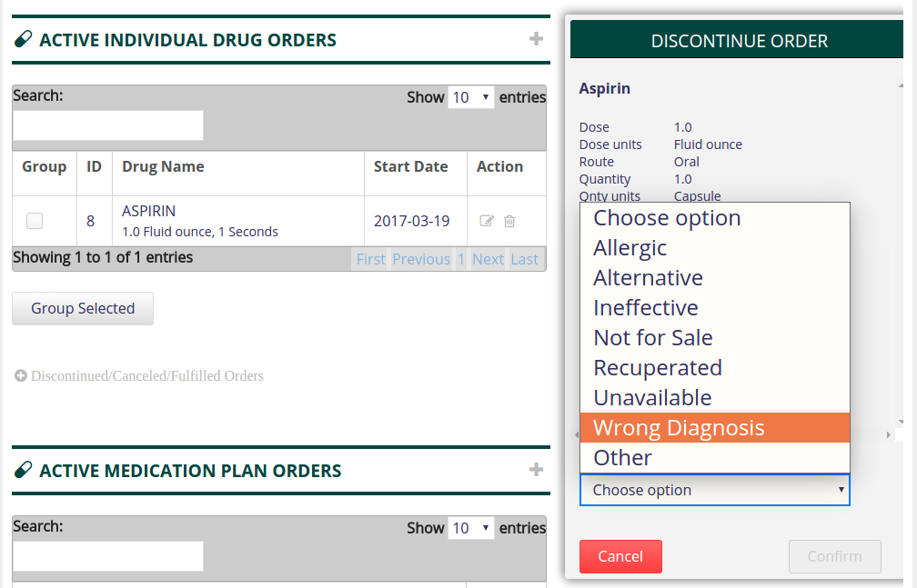

(Fig.18 Discontinue Order – Select reason)

Alternately, the Physician can select the 'Other' option to manually enter a reason for discontinuing the selected Order. Once the reason for discontinuation is selected/entered, the Physician clicks on the 'Confirm' button.

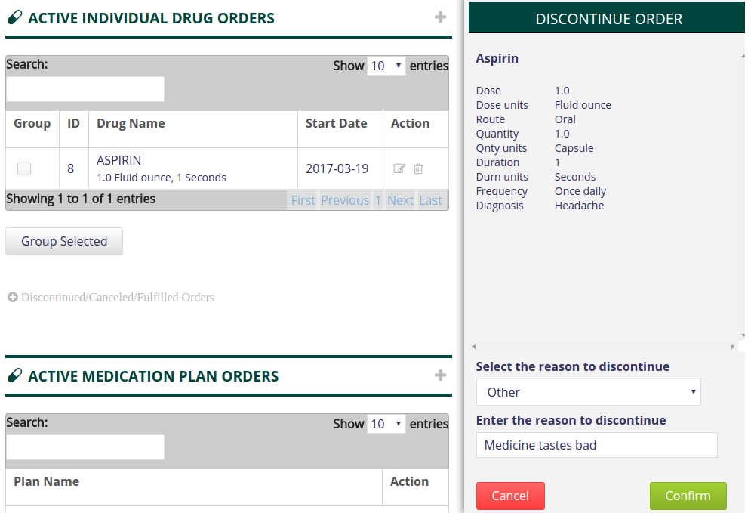

(Fig.19 Discontinue Order – Enter reason)

Once the Order is discontinued, an alert will be displayed informing the user that the Order has been discontinued. The Order will no longer be visible in the Active Drug Orders table.

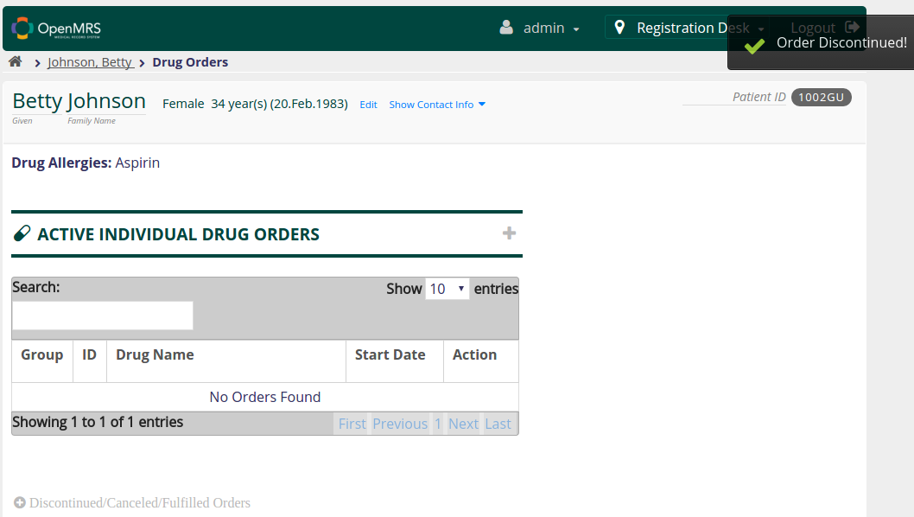

(Fig.20 Order Discontinued)

Consider a situation where the Patient comes back to the Physician after a few months with the same illness. The Physician wants to place an Order for the same drug that he/she prescribed earlier. Instead of creating a new Drug Order, the Physician will simply renew the old non-active Order and make changes wherever necessary.

## 2.5 Renew an Order

Upon clicking 'Discontinued/Canceled/Fulfilled Orders' link, a table containing the list of past Drug Orders that are no longer active is displayed. This table is kept not displayed by default on the page.

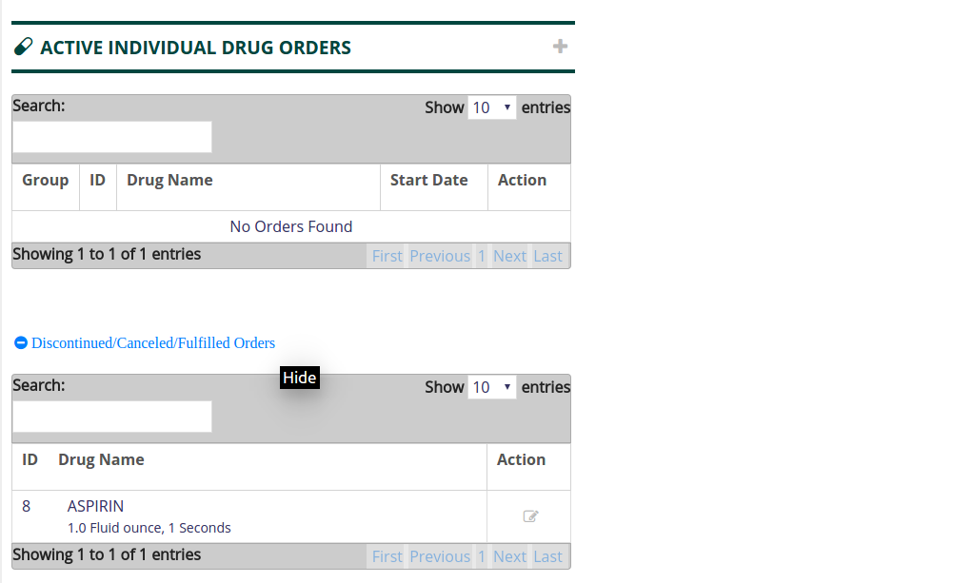

(Fig.21 Non-active Orders)

The Physician clicks on the 'Renew' button corresponding to the Order that needs to be renewed. This will load a form similar to the 'Create Drug Order' form with all the fields (Drug name, Dose, Duration, Frequency etc.) populated from the selected Order's record.

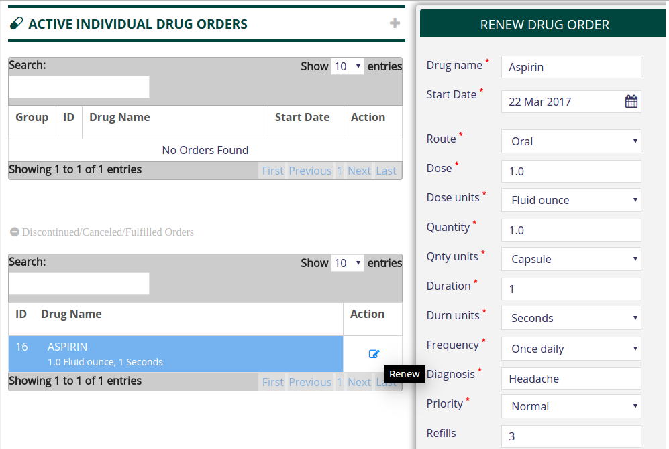

(Fig.22 Renew Drug Order)

The Physician revises the drug's formulation, Patient/Pharmacist instructions and other fields to make changes (if required) before clicking the 'Save' button to create a new individual Order.

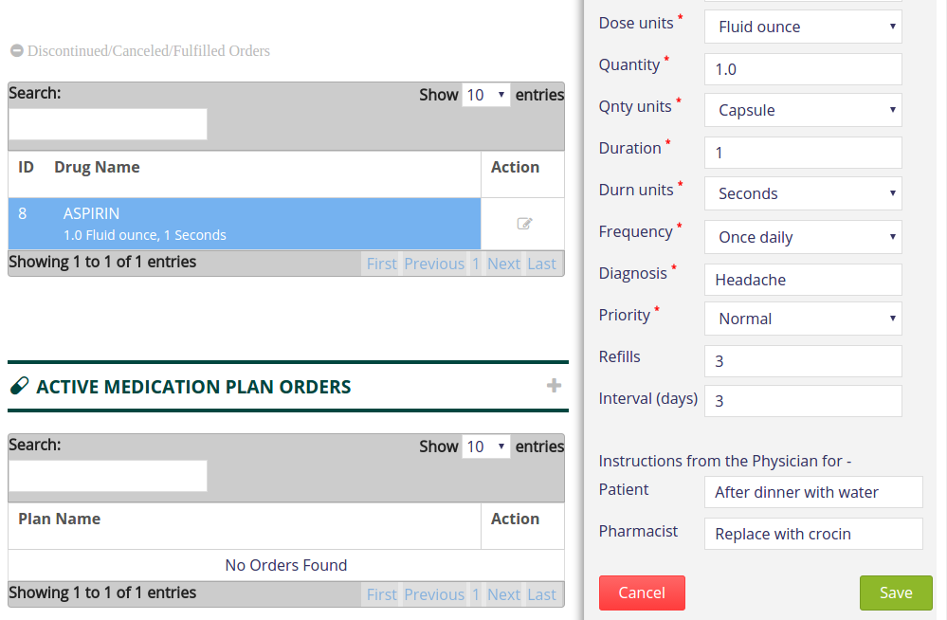

(Fig.23 Save revised Order)

An alert is displayed notifying that the renewed Order is created and the Order is listed in the Active Drug Orders table.

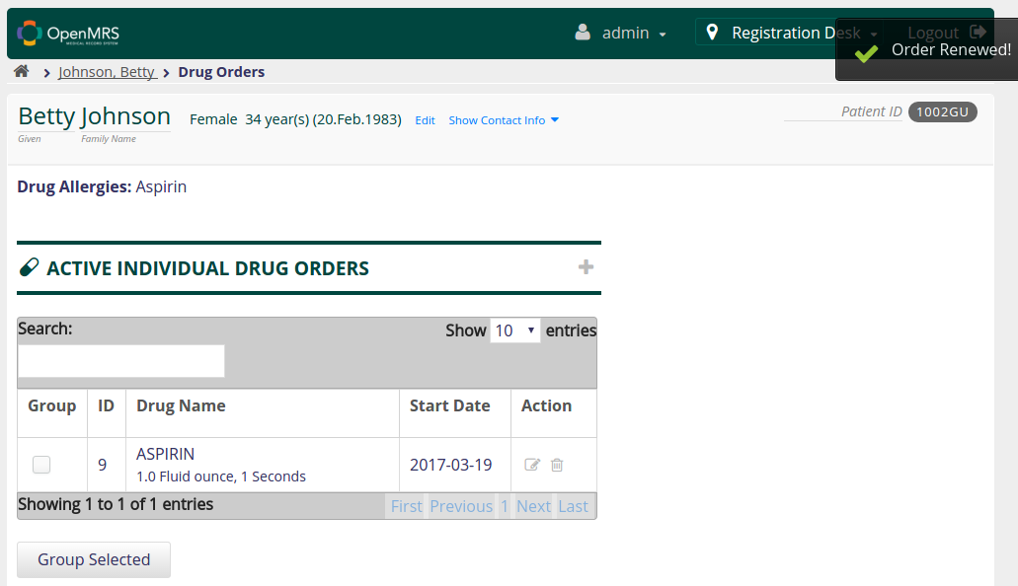

(Fig.24 Order Renewed)