PHARMACY DISPATCH ORDERS

In this section, we will study the use-cases and the wire-frames describing the step-by-step action taken in the process of dispatching an individual order for a single drug, a group of drugs that were placed together or all of the drug orders from an ordered regimen or medication plan. We will see the process in which the pharmacist can mark the orders that are being dispatched, set an expiry date for each drug that is being dispatched, provide instructions to the patient and take a print-out the prescription.

Table of Contents

1. USE CASES 3

1.1 Regimen dispatched by the Pharmacist 3

1.2 Group Order(s) dispatched by the Pharmacist 4

1.3 Single Individual Order dispatched by the Pharmacist 4

2. WIREFRAMES 5

2.1 Regimen dispatched by the Pharmacist 5

2.2 Group Order(s) dispatched by the Pharmacist 8

2.3 Single Individual Order dispatched by the Pharmacist 11

UI DESIGN: When the Pharmacist selects a row representing an Order or a set of Orders, the page loads a fragment that displays additional details associated with each of the Orders. Corresponding to each Order is a check-box (unchecked by default). Before the Pharmacist clicks on a button (say 'Dispatch' button), he/she needs to check the checkboxes corresponding to all those Orders that need to be recorded as dispatched. For example, when the Order(s) that are a part of a Regimen or Medication Plan are being dispatched, check-mark the check-box corresponding to each Order in the list that is being dispatched.

# 1. USE CASES

Consider this - Patient Betty Johnson walks into the Pharmacy to collect drugs Morphine and Crocin that are a part of a standard medication plan for Asthma disease. The Pharmacist John Watson opens Betty's Drug Order page to find active orders for Morphine and Crocin. These drugs are available at the Pharmacy for sale. John will hand over the drugs to Betty and record the Order(s) as dispatched.

## 1.1 Regimen dispatched by the Pharmacist

The Pharmacist John selects a row representing all the Orders ordered as a part of a Regimen. This loads a fragment listing each of those Orders. The Pharmacist verifies the number of allowed refills, the last dispatch date and the refill interval (#days between refills) for each Order to ensure that the drugs can be dispatched to the Patient. John checks the check-boxes corresponding to each Order and clicks the 'Dispatch' button. He then specifies the 'Expiry Date' of each Drug in the list and provides instructions to the Patient in the field provided. Next, the Pharmacist clicks on the link to print the prescription which prints the formulation of the drug(s), the corresponding expiry date and additional instructions. Once confirmed, the number of allowed refills, the last dispatch date and the refill interval fields for each Order are updated.

Consider this - Patient Betty Johnson walks into the Pharmacy to collect drugs Morphine and Crocin that are ordered as a group. The Pharmacist John Watson opens Betty's Drug Order page to find active orders for Morphine and Crocin. These drugs are available at the Pharmacy for sale. John will hand over the drugs to Betty and record the Order(s) as dispatched.

## 1.2 Group Order(s) dispatched by the Pharmacist

The Pharmacist John selects a row representing all the Orders ordered as a part of a Group. This loads a fragment listing each of those Orders. The Pharmacist verifies the number of allowed refills, the last dispatch date and the refill interval (#days between refills) for each Order to ensure that the drugs can be dispatched to the Patient. John checks the check-boxes corresponding to each Order and clicks the 'Dispatch' button. He then specifies the 'Expiry Date' of each Drug in the list and provides instructions to the Patient in the field provided. Next, the Pharmacist clicks on the link to print the prescription which prints the formulation of the drug(s), the corresponding expiry date and additional instructions. Once confirmed, the number of allowed refills, the last dispatch date and the refill interval fields for each Order are updated.

Consider this - Patient Betty Johnson walks into the Pharmacy to collect drug Aspirin that is ordered individually. The Pharmacist John Watson opens Betty's Drug Order page to find active orders for Aspirin This drug is available at the Pharmacy for sale. John will hand over the drug to Betty and record the Order as dispatched.

## 1.3 Single Individual Order dispatched by the Pharmacist

The Pharmacist John selects a row representing the Order. This loads a fragment with the details of the Order. The Pharmacist verifies the number of allowed refills, the last dispatch date and the refill interval (#days between refills) for the Order to ensure that the drug can be dispatched to the Patient. John checks the check-boxe corresponding to the Order and clicks the 'Dispatch' button. He then specifies the 'Expiry Date' of the Drug and provides instructions to the Patient in the field provided. Next, the Pharmacist clicks on the link to print the prescription which prints the formulation of the drug, the corresponding expiry date and additional instructions. Once confirmed, the number of allowed refills, the last dispatch date and the refill interval fields for the Order are updated.

# 2. WIREFRAMES

## 2.1 Regimen dispatched by the Pharmacist

In this section, we will view the snapshots of the screens where the Pharmacist requests for the Order(s) in the Regimen/Medication Plan to be dispatched.

Consider this - Patient Betty Johnson walks into the Pharmacy to collect drugs Morphine and Crocin that are a part of a standard medication plan for Asthma disease. The Pharmacist John Watson searches for the Patient by his/her name. This displays the list of Patients named Betty Johnson. Using the D.O.B. and address as reference, the Pharmacist determines the correct row for the patient present.

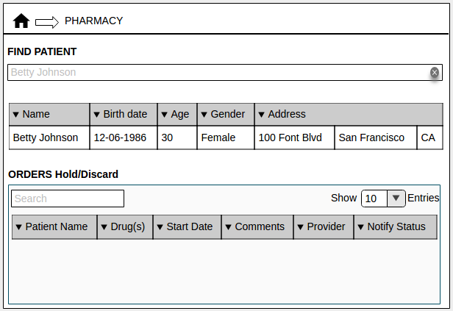

(Fig. 1 Pharmacy homepage)

John opens Betty's Drug Order page to find active orders for Morphine and Crocin. These drugs are available in the Pharmacy. John will now proceed to dispatch these Order(s). The Pharmacist verifies the number of allowed refills, the last dispatch date and the refill interval (#days between refills) for each Order to ensure that the drugs can be dispatched to the Patient.

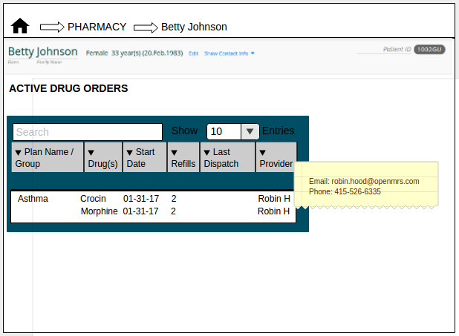

(Fig. 2 Drug Order page)

The Pharmacist John selects a row representing all the Orders ordered as a part of a Regimen. This loads a fragment listing each of those Orders. John checks the check-boxes corresponding to each Order and clicks the 'Dispatch' button.

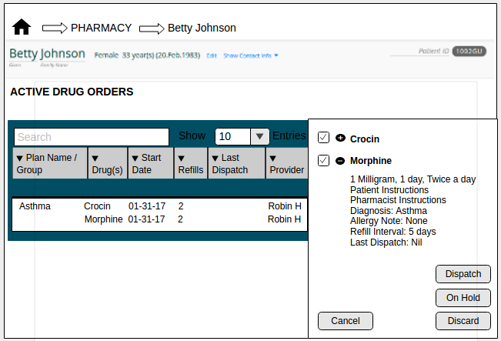

(Fig. 3 Order Select)

The Pharmacist sets the 'Expiry Date' field for each Order in the list. He then provides additional instructions to the Patient in the field provided.

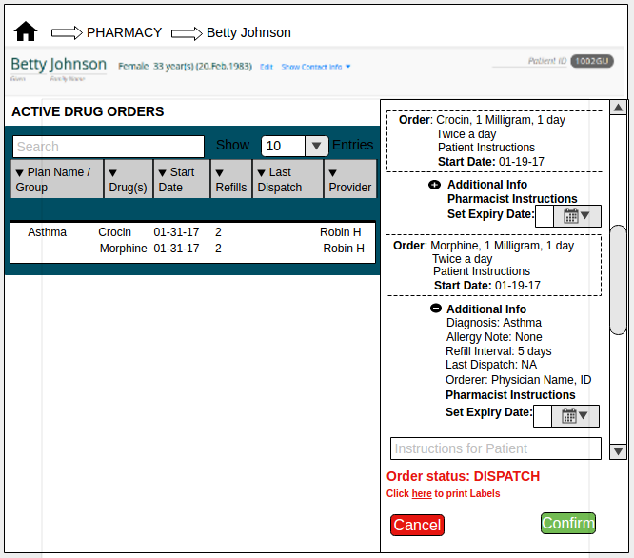

(Fig. 4 Order Record)

The Pharmacist then clicks on the 'here' link in Fig.4 to print the labels or the prescription. This prints the formulation of the drug, the corresponding expiry date and additional instructions.

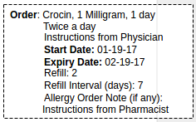

(Fig. 5 Prescription Label)

Finally the Pharmacist clicks on the 'Confirm' button in Fig.4 which will record the transaction and update the number of allowed refills and the last dispatch date fields.

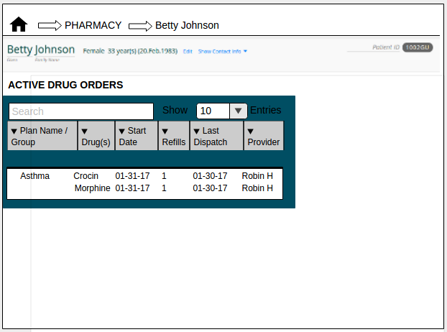

(Fig. 6 Order(s) dispatched)

## 2.2 Group Order(s) dispatched by the Pharmacist

In this section, we will view the snapshots of the screens where the Pharmacist requests for the Order(s) in the Group to be dispatched.

Consider this - Patient Betty Johnson walks into the Pharmacy to collect drugs Morphine and Crocin that are ordered as a group. The Pharmacist John Watson searches for the Patient by his/her name. This displays the list of Patients named Betty Johnson. Using the D.O.B. and address as reference, the Pharmacist determines the correct row for the patient present.



(Fig. 7 Pharmacy homepage)

John opens Betty's Drug Order page to find active orders for Morphine and Crocin. These drugs are available in the Pharmacy. John will now proceed to dispatch these Order(s). The Pharmacist verifies the number of allowed refills, the last dispatch date and the refill interval (#days between refills) for each Order to ensure that the drugs can be dispatched to the Patient.

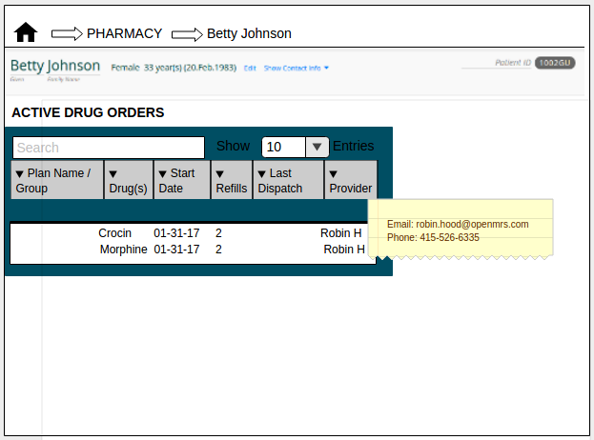

(Fig. 8 Drug Order page)

The Pharmacist John selects a row representing all the Orders ordered as a part of a Group. This loads a fragment listing each of those Orders. John checks the check-boxes corresponding to each Order and clicks the 'Dispatch' button.



(Fig. 9 Order Select)

The Pharmacist sets the 'Expiry Date' field for each Order in the list. He then provides additional instructions to the Patient in the field provided.

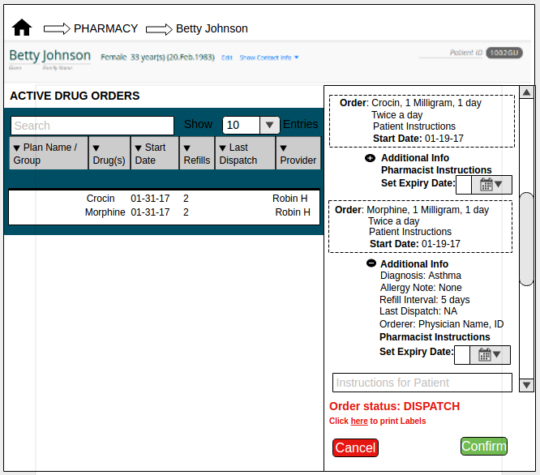

(Fig. 10 Order Record)

The Pharmacist then clicks on the 'here' link in Fig.10 to print the labels or the prescription. This prints the formulation of the drug, the corresponding expiry date and additional instructions.



(Fig. 11 Prescription Label)

Finally the Pharmacist clicks on the 'Confirm' button in Fig.10 which will record the transaction and update the number of allowed refills and the last dispatch date fields.

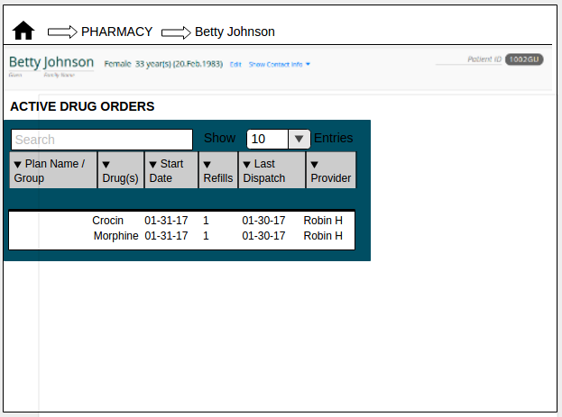

(Fig. 12 Order(s) dispatched)

## 2.3 Single Individual Order dispatched by the Pharmacist

In this section, we will view the snapshots of the screens where the Pharmacist requests for a Single Individual Order to be dispatched.

Consider another scenario where patient Betty Johnson walks into the Pharmacy to collect Aspirin drug. The Pharmacist John Watson searches for the Patient by his/her name. This displays the list of Patients named Betty Johnson. Using the D.O.B. and address as reference, the Pharmacist determines the correct row for the patient present.



(Fig. 13 Pharmacy homepage)

John opens Betty's Drug Order page to find active orders for Aspirin However, this drug are not available in the Pharmacy. In fact, it is not available for sale in the country. John realises that he cannot dispatch the Order prescribed by the Physician. John will now request for the Order to be discarded.

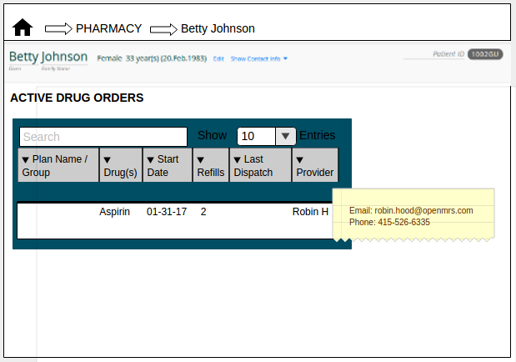

(Fig. 14 Drug Order page)

The Pharmacist John selects a row representing the Aspirin Order. This loads a fragment listing the Order and it's details. John checks the check-box corresponding to the Order and clicks the 'Discard' button.

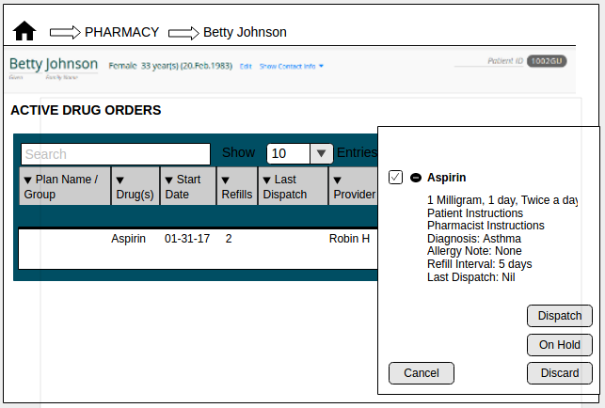

(Fig. 15 Order Select)

The Pharmacist sets the 'Expiry Date' field for the Order. He then provides additional instructions to the Patient in the field provided.

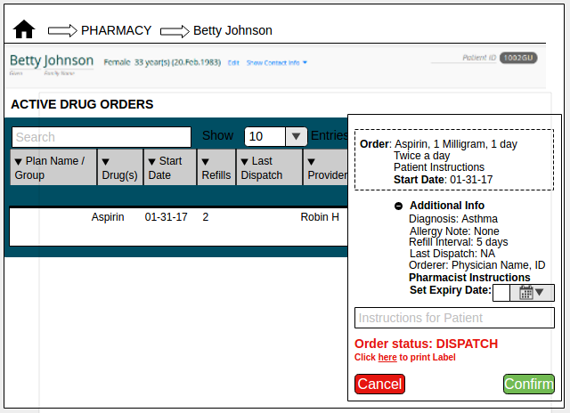

(Fig. 16 Order Record)

The Pharmacist then clicks on the 'here' link in Fig.16 to print the label or the prescription. This prints the formulation of the drug, the corresponding expiry date and additional instructions.

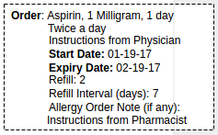

(Fig. 17 Prescription Label)

Finally the Pharmacist clicks on the 'Confirm' button in Fig.16 which will record the transaction and update the number of allowed refills and the last dispatch date fields.

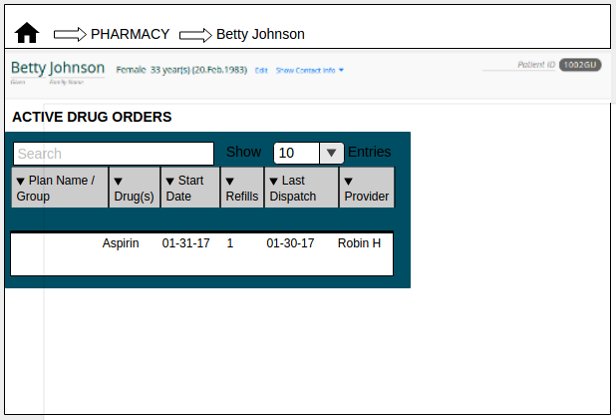

(Fig. 18 Order(s) dispatched)