**PHARMACY DISCARD ORDERS**

In this section, we will study the use-cases and the wire-frames describing the step-by-step action taken in the process of discontinuing an individual order for a single drug or a group of drug orders that were placed together or some or all of the drug orders from an ordered regimen/medication plan. We will see the process in which the pharmacist can mark an order or one or more orders from a pre-defined medication regimen or order group and request for the order(s) to be discontinued by providing reasons and sending out an email to the ordering physician. Next, we will see how the order(s) requested to be discarded are highlighted and how the physician is notified about the same. Also described are the steps showing what happens when the orderer subsequently modifies, discontinues or replaces the order(s).

Table of Contents

1. USE CASES 3

1.1 Request a Regimen to be Discarded 3

1.2 Regimen Discarded by Physician 3

1.3 Request some Orders from a Regimen to be Discarded 4

1.4 Orders Discarded by Physician 4

1.5 Orders Modified by Physician 4

1.6 Request Order Group to be Discarded 5

1.7 Orders Discarded by Physician 5

1.8 Request some Orders from a Order Group to be Discarded 5

1.9 Orders Discarded by Physician 6

1.10 Orders Modified by Physician 6

1.11 Request a Single Individual Order to be Discarded 6

1.12 Order Discarded by Physician 6

1.13 Order Modified by Physician 6

2. WIREFRAMES 7

2.1 Request a Regimen to be Discarded 7

2.2 Regimen Discarded by Physician 10

2.3 Request some Orders from a Regimen to be Discarded 11

2.4 Orders Discarded by Physician 14

2.5 Orders Modified by Physician 15

2.6 Request Order Group to be Discarded 16

2.7 Orders Discarded by Physician 19

2.8 Request some Orders from a Order Group to be Discarded 20

2.9 Orders Discarded by Physician 23

2.10 Orders Modified by Physician 24

2.11 Request a Single Individual Order to be Discarded 25

2.12 Order Discarded by Physician 28

2.13 Order Modified by Physician 29

*UI DESIGN: When the Pharmacist selects a row representing a set of Orders, the page loads a fragment that displays additional details associated with each of those Orders. Corresponding to each Order is a check-box (unchecked by default). Before the Pharmacist clicks on a button (say 'Discard' button), he/she needs to check the checkboxes corresponding to all those Orders that need to be discarded. In other words, for each Order that is listed in that Regimen on which the 'Request to Discard' action has to be applied, check-mark the corresponding check-box.*

In this section, we will discuss the scenarios pertaining to what happens when a Pharmacist requests for a Regimen or one or more Drug Orders to be discarded.

*Consider this - Patient Betty Johnson walks into the Pharmacy to collect drugs* ***Morphine and Crocin that are a part of a standard medication plan for Asthma disease****. The Pharmacist John Watson opens Betty's Drug Order page to find active orders for Morphine and Crocin. However, these drugs are not available in the Pharmacy. In fact, the drugs are not available for sale in the country. John realises that he cannot dispatch the Orders prescribed by the Physician. John will now request for the Orders to be discarded.*

# 1. **USE CASES**

## 1.1 Request a Regimen to be Discarded

The Pharmacist John selects a row representing all the Orders ordered as a part of a Regimen. This loads a fragment listing each of those Orders. John checks the check-boxes corresponding to each Order and clicks the 'Discard' button. He then provides some comments regarding why the Regimen needs to be discarded. In addition, the Pharmacist sends an email to the Orderer about the Orders that are a part of that Regimen being requested to be discarded. Once that is done (these are required actions), the Orders involved continue to be listed in the Patient's Active Drug Orders table (albeit marked with strike-through line) until the Orderer discards/replaces the regimen. The Orders requested to be discarded are also listed in the 'Hold/Discard' Order table in the Pharmacy homepage.

## 1.2 Regimen Discarded by Physician

The Orderer or Physician logs into the Patient's Drug Order page and discontinues the Active Regimen that is requested to be discarded. The Orders which were a part of the discarded regimen are no longer displayed on the Pharmacy's homepage or the Patient's Drug Order page.

*Consider another situation where Patient Betty Johnson walks into the Pharmacy to collect drugs Morphine and Crocin for treatment of Asthma. The Pharmacist John Watson opens Betty's Drug Order page to find active Orders for Morphine and Crocin. While Morphine drug is available at the Pharmacy, Crocin is not. In fact, Crocin is not available for sale in the country. John realises that he cannot dispatch a part of the prescription without the Physician's authorization. John will now request for the Crocin Order to be discarded.*

## 1.3 Request some Orders from a Regimen to be Discarded

The Pharmacist John selects a row representing all the Orders ordered as a part of a Regimen. As described in the UI design, he ignores the checkbox corresponding to the Order for Morphine and checks the check-box corresponding to *Crocin* Order before clicking the 'Discard' button. John provides some comments regarding why the Order needs to be discarded. In addition, he sends an email to the Orderer about the Order(s) that is requested to be discarded. Once that is done, the Orders for Morphine and Crocin continue to be listed in the Patient's Active Drug Orders table though only Crocin Order is marked with a strike-through line. This tells the users that Morphine and Crocin are ordered together but the Order for Crocin has been requested to be discarded.

When the Pharmacist requests for some Orders from a Regimen to be discarded, he/she cannot dispatch the remaining Orders unless the Orderer authorizes it. Hence, the remaining Orders which are a part of the same Regimen are put on Hold with an indication that the associated Orders are requested to be discarded. In this example, Order for Morphine is put on Hold when the Order for Crocin is requested to be discarded. The Physician is notified by the Pharmacist via email about the Order(s) that are requested to be discarded and the associated Order(s) that are put on Hold.

## 1.4 Orders Discarded by Physician

The Orderer or Physician logs into the Patient's Drug Order page and discontinues the Active Order(s) (for Crocin in this example) that are requested to be discarded. As for the associated active Orders from the same group that are put on Hold, the Physician can provide comments to the Pharmacist in the 'Instructions to Pharmacist' field associated with those Orders if the Physician decides to allow the Pharmacist to dispatch them. The Order for Crocin is no longer displayed on the Pharmacy's homepage or the Patient's Drug Order page but the remaining Orders from the group are listed.

## 1.5 Orders Modified by Physician

In some cases, an Order might be marked for discard since a specific formulation of the drug is unavailable. The Orderer or Physician logs into the Patient's Drug Order page, discontinues the Order requested to be discarded and replaces it with a new Order with updated formulations .

*Consider another situation where Patient Betty Johnson walks into the Pharmacy to collect Morphine and Crocin drugs. These drugs are ordered and grouped together by the Physician. The Pharmacist John Watson opens Betty's Drug Order page to find an active orders for Morphine and Crocin. However, these drugs are not available in the Pharmacy. In fact, the drugs are not available for sale in the country. John realises that he cannot dispatch the Orders prescribed by the Physician. John will now request for the Order Group to be discarded.*

## 1.6 Request Order Group to be Discarded

The Pharmacist John selects a row representing all the Orders ordered as a part of a Group. This loads a fragment listing each Order from the Group. John checks the checkboxes corresponding to each Order and clicks the 'Discard' button. He then requests for them to be discarded by providing some comments regarding why the Group of Orders need to be discarded. In addition, the Pharmacist sends an email to the Orderer or Physician about the Orders that are a part of that Group being requested to be discarded. Once that is done (both actions are mandatory), the Orders involved continue to be listed in the Patient's Active Drug Orders table (albeit marked with strike-through line) until the Orderer discards the Order Group. The Orders requested to be discarded are also listed in the 'Hold/Discard' Order table in the Pharmacy homepage.

## 1.7 Orders Discarded by Physician

The Orderer or Physician logs into the Patient's Drug Order page and discontinues the Active Order Group that is requested to be discarded. The Orders which were a part of the discarded group are no longer displayed on the Pharmacy's homepage or the Patient's Drug Order page.

*Consider another situation where Patient Betty Johnson walks into the Pharmacy to collect drugs Morphine and Crocin that were ordered together as a group. The Pharmacist John Watson opens Betty's Drug Order page to find active Orders for Morphine and Crocin. While Morphine drug is available at the Pharmacy, Crocin is not. In fact, Crocin is not available for sale in the country. John realises that he cannot dispatch a part of the prescription without the Physician's authorization. John will now request for the Crocin Order to be discarded.*

## 1.8 Request some Orders from a Order Group to be Discarded

The Pharmacist John selects a row representing all the Orders ordered as a part of a Group. As described in the UI design, he ignores the check-box corresponding to the Order for Morphine and checks the check-box corresponding to Crocin drug before clicking the 'Discard' button. John requests for Crocin Drug Order to be discarded by providing some comments regarding why the Order needs to be discarded. In addition, he sends an email to the Orderer or Physician about the Order being requested to be discarded. Once that is done, the Orders for Morphine and Crocin ordered as a group continue to be listed in the Patient's Active Drug Orders table though only Crocin Order is marked with a strike-through line. This represents to both the Pharmacist and the Physician that Morphine and Crocin were ordered together but the Order for Crocin has been requested to be discarded.

When the Pharmacist requests for some Orders from a Group to be discarded, he/she cannot dispatch the remaining Orders unless the Orderer authorizes it. Hence, the remaining Orders which are a part of the same Group are put on Hold with an indication that the associated Orders are requested to be discarded. In this example, Order for Morphine is put on Hold when the Order for Crocin is requested to be discarded. The Physician is notified by the Pharmacist via email about the Order(s) that are requested to be discarded and the associated Order(s) that are put on Hold

## 1.9 Orders Discarded by Physician

The Orderer or Physician logs into the Patient's Drug Order page and discontinues the Active Order(s) (for Crocin in this example) that is requested to be discarded. As for the associated active Orders from the same group, if the Physician decides to allow the Pharmacist to dispatch them, the Physician can provide comments to the Pharmacist in the 'Instructions to Pharmacist' field associated with those Orders. The Order for Crocin is no longer displayed on the Pharmacy's homepage or the Patient's Drug Order page but the remaining Orders from the group are listed.

## 1.10 Orders Modified by Physician

In some cases, an Order might be marked for discard since a specific formulation of the drug is unavailable. The Orderer or Physician logs into the Patient's Drug Order page, discontinues the Order requested to be discarded and replaces it with a new Order with updated formulations

*Consider another situation where Patient Betty Johnson walks into the Pharmacy to collect Aspirin drug. The Pharmacist John Watson opens Betty's Drug Order page to find an active orders for Aspirin that has been ordered individually. However, Aspirin is not available for sale in the country. John will now request for the Order for Aspirin to be discarded.*

## 1.11 Request a Single Individual Order to be Discarded

This is a simple case where the Pharmacist selects a row representing a single Order – for Aspirin drug. He now clicks the 'Discard' button, enters comments in the field provided regarding why the Order needs to be discarded. Simultaneously, a mail is sent from the Pharmacist to the Orderer about the Order being requested to be discarded. The Order that has been marked for discard is now listed in the 'Hold/Discard' Order table in the Pharmacy homepage.

## 1.12 Order Discarded by Physician

The Orderer or Physician logs into the Patient's Drug Order page and discontinues the Active Order for Aspirin that is requested to be discarded. The Order is no longer displayed on the Pharmacy's homepage or the Patient's Drug Order page.

## 1.13 Order Modified by Physician

In some cases, an Order might be marked for discard since a specific formulation of the drug is unavailable. The Orderer or Physician logs into the Patient's Drug Order page, discontinues the Order requested to be discarded and replaces it with a new Order with updated formulations.

# 2. **WIREFRAMES**

In this section, we will view the snapshots of the screens where the Pharmacist requests for some or all Orders in the Regimen/Medication Plan to be discarded.

## 2.1 Request a Regimen to be Discarded

Consider this - Patient Betty Johnson walks into the Pharmacy to collect drugs Morphine and Crocin that are a part of a standard medication plan for Asthma disease. The Pharmacist John Watson searches for the Patient by his/her name. This displays the list of Patients named Betty Johnson. Using the D.O.B. and address as reference, the Pharmacist determines the correct row for the patient present.

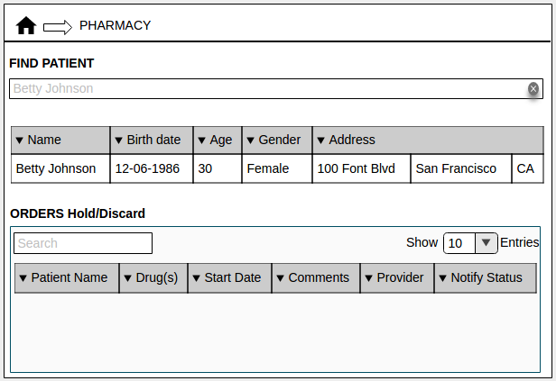

(Fig. 1 Pharmacy homepage)

John opens Betty's Drug Order page to find active orders for Morphine and Crocin. However, these drugs are not available in the Pharmacy. In fact, the drugs are not available for sale in the country. John realises that he cannot dispatch the Orders prescribed by the Physician. John will now request for the Orders to be discarded.

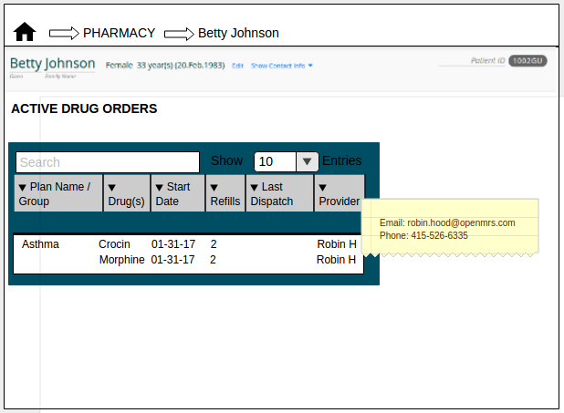

(Fig. 2 Drug Order page)

The Pharmacist John selects a row representing all the Orders ordered as a part of a Regimen. This loads a fragment listing each of those Orders. John checks the check-boxes corresponding to each Order and clicks the 'Discard' button.

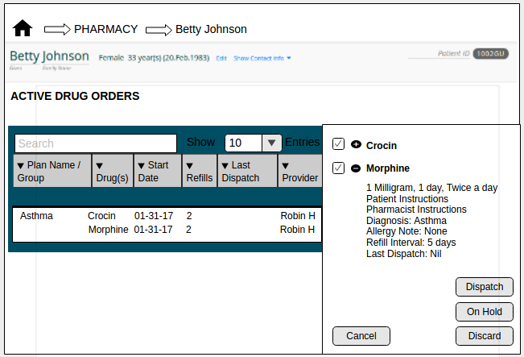

(Fig. 3 Order Select)

He then provides some comments regarding why the Regimen needs to be discarded.

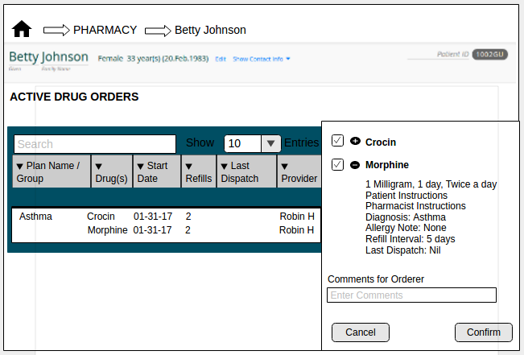

(Fig. 4 Order Record)

In addition, the Pharmacist sends an email to the Orderer about the Orders that are a part of that Regimen being requested to be discarded.

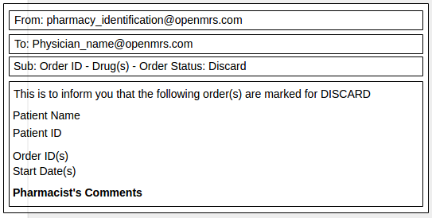

(Fig. 5 Mail Notification)

Once that is done (these are required actions), the Orders involved continue to be listed in the Patient's Active Drug Orders table (albeit marked with strike-through line) until the Orderer discards/replaces the regimen.

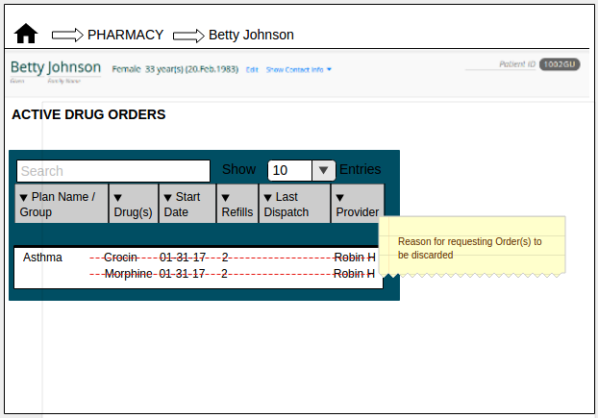

(Fig. 6 Drug Order page)

The Orders requested to be discarded are also listed in the 'Hold/Discard' Order table in the Pharmacy homepage.

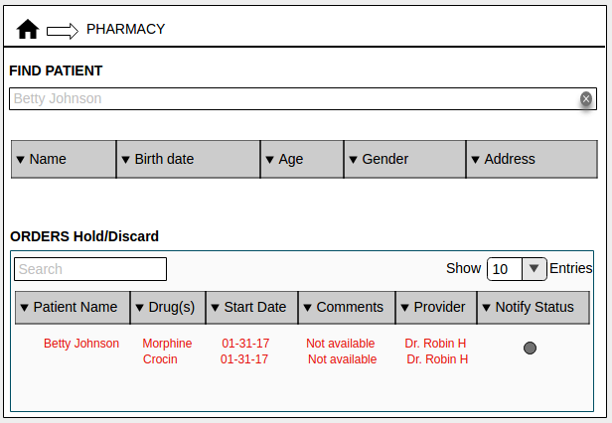

(Fig. 7 Pharmacy homepage)

## 2.2 Regimen Discarded by Physician

The Orderer or Physician logs into the Patient's Drug Order page and discontinues the Active Regimen that is requested to be discarded. The Orders which were a part of the discarded regimen are no longer displayed on the Pharmacy's homepage or the Patient's Drug Order page.

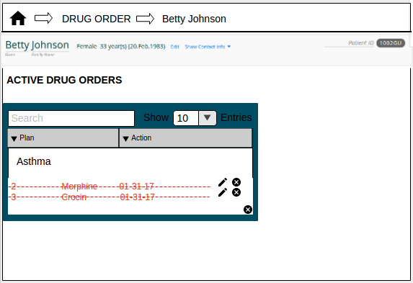

(Fig. 8 Drug Order Module)

## 2.3 Request some Orders from a Regimen to be Discarded

*Consider another situation where Patient Betty Johnson walks into the Pharmacy to collect drugs Morphine and Crocin for treatment of Asthma.* The Pharmacist John Watson searches for the Patient by his/her name. This displays the list of Patients named Betty Johnson. Using the D.O.B. and address for reference, the Pharmacist determines the correct row for the patient present.



(Fig. 9 Pharmacy homepage)

*The Pharmacist John Watson opens Betty's Drug Order page to find active Orders for Morphine and Crocin. While Morphine drug is available at the Pharmacy, Crocin is not. In fact, Crocin is not available for sale in the country. John realises that he cannot dispatch a part of the prescription without the Physician's authorization. John will now request for the Crocin Order to be discarded.*



(Fig. 10 Drug Order page)

The Pharmacist John selects a row representing all the Orders ordered as a part of a Regimen. As described in the UI design, he ignores the checkbox corresponding to the Order for Morphine and checks the check-box corresponding to *Crocin* Order before clicking the 'Discard' button.



(Fig. 11 Order Select)

John provides some comments regarding why the Order needs to be discarded.



(Fig. 12 Order Record)

In addition, he sends an email to the Orderer about the Order(s) that is requested to be discarded.



(Fig. 13 Mail Notification)

Once that is done, the Orders for Morphine and Crocin continue to be listed in the Patient's Active Drug Orders table though only Crocin Order is marked with a strike-through line. This tells the users that Morphine and Crocin are ordered together but the Order for Crocin has been requested to be discarded.

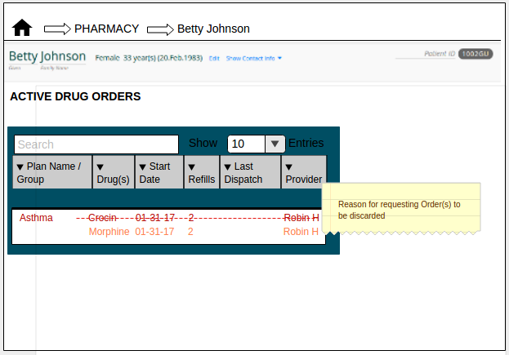

(Fig. 14 Drug Order page)

When the Pharmacist requests for some Orders from a Regimen to be discarded, he/she cannot dispatch the remaining Orders unless the Orderer authorizes it. Hence, the remaining Orders which are a part of the same Regimen are put on Hold with an indication that the associated Orders are requested to be discarded. In this example, Order for Morphine is put on Hold when the Order for Crocin is requested to be discarded. The Physician is notified by the Pharmacist via email about the Order(s) that are requested to be discarded and the associated Order(s) that are put on Hold.

## 2.4 Orders Discarded by Physician

The Orderer or Physician logs into the Patient's Drug Order page and discontinues the Active Order(s) (for Crocin in this example) that are requested to be discarded.

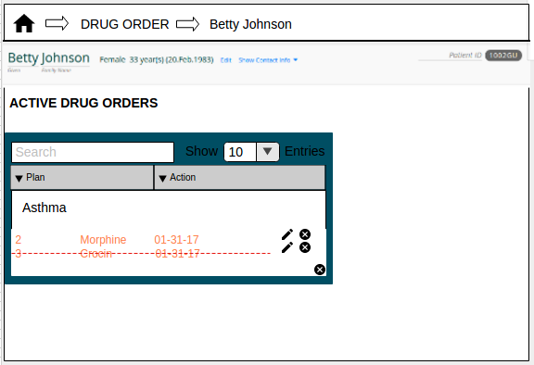

(Fig. 15 Drug Order discard)

As for the associated active Orders (Morphine) from the same group that are put on Hold, the Physician can provide comments to the Pharmacist in the 'Instructions to Pharmacist' field associated with those Orders if the Physician decides to allow the Pharmacist to dispatch them.

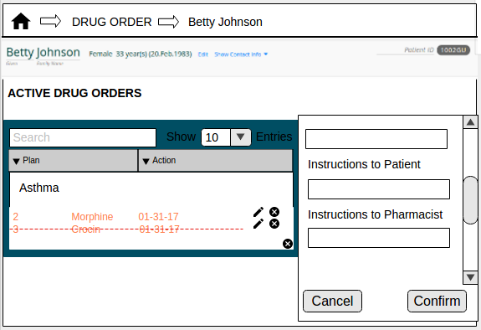

(Fig. 16 Drug Order Details Fragment)

The Order for Crocin is no longer displayed on the Pharmacy's homepage or the Patient's Drug Order page but the remaining Orders from the Regimen are listed.

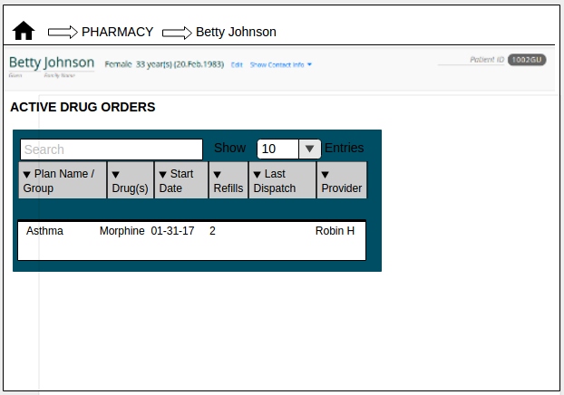

(Fig. 17 Pharmacy homepage)

## 2.5 Orders Modified by Physician

In some cases, an Order might be marked for discard since a specific formulation of the drug is unavailable. The Orderer or Physician logs into the Patient's Drug Order page, discontinues the Order requested to be discarded and replaces it with a new Order with updated formulations.

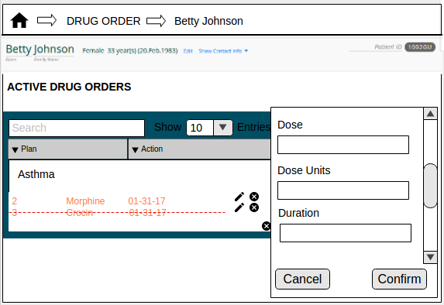

(Fig. 18 Drug Order modified)

In this section, we will view the snapshots of the screens where the Pharmacist requests for some or all Orders in a Order Group to be discarded.

## 2.6 Request Order Group to be Discarded

Consider another scenario where patient Betty Johnson walks into the Pharmacy to collect drugs Morphine and Crocin that were ordered together as a group. The Pharmacist John Watson searches for the Patient by his/her name. This displays the list of Patients named Betty Johnson. Using the D.O.B. and address as reference, the Pharmacist determines the correct row for the patient present.



(Fig. 19 Pharmacy homepage)

John opens Betty's Drug Order page to find active orders for Morphine and Crocin. However, these drugs are not available in the Pharmacy. In fact, the drugs are not available for sale in the country. John realises that he cannot dispatch the Orders prescribed by the Physician. John will now request for the Orders to be discarded.



(Fig. 20 Drug Order page)

The Pharmacist John selects a row representing all the Orders ordered as a part of the group. This loads a fragment listing each of those Orders. John checks the check-boxes corresponding to each Order and clicks the 'Discard' button.



(Fig. 21 Order Select)

He then provides some comments regarding why the group of Orders need to be discarded.



(Fig. 22 Order Record)

In addition, the Pharmacist sends an email to the Orderer about the Orders that are a part of that group being requested to be discarded.



(Fig. 23 Mail Notification)

Once that is done (these are required actions), the Orders involved continue to be listed in the Patient's Active Drug Orders table (albeit marked with strike-through line) until the Orderer discards/replaces the Orders within the group.



(Fig. 24 Drug Order page)

The Orders requested to be discarded are also listed in the 'Hold/Discard' Order table in the Pharmacy homepage.



(Fig. 25 Pharmacy homepage)

## 2.7 Orders Discarded by Physician

The Orderer or Physician logs into the Patient's Drug Order page and discontinues the Active group of Orders that are requested to be discarded. The Orders which were a part of the discarded group are no longer displayed on the Pharmacy's homepage or the Patient's Drug Order page.

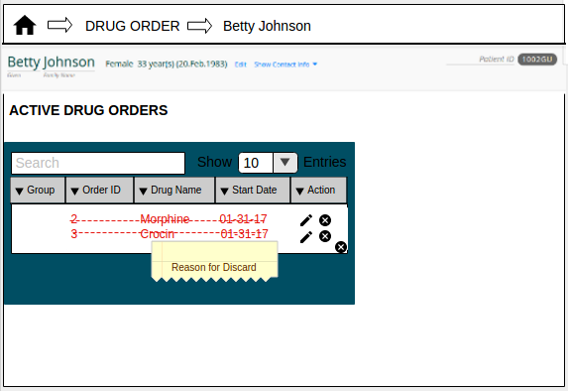

(Fig. 26 Drug Order Module)

## 2.8 Request some Orders from a Order Group to be Discarded

*Consider another situation where Patient Betty Johnson walks into the Pharmacy to collect drugs Morphine and Crocin that were ordered as a group.* The Pharmacist John Watson searches for the Patient by his/her name. This displays the list of Patients named Betty Johnson. Using the D.O.B. and address for reference, the Pharmacist determines the correct row for the patient present.



(Fig. 27 Pharmacy homepage)

*The Pharmacist John Watson opens Betty's Drug Order page to find active Orders for Morphine and Crocin. While Morphine drug is available at the Pharmacy, Crocin is not. In fact, Crocin is not available for sale in the country. John realises that he cannot dispatch a part of the prescription without the Physician's authorization. John will now request for the Crocin Order to be discarded.*



(Fig. 28 Drug Order page)

The Pharmacist John selects a row representing all the Orders ordered as a part of a group. As described in the UI design, he ignores the checkbox corresponding to the Order for Morphine and checks the check-box corresponding to *Crocin* Order before clicking the 'Discard' button.



(Fig. 29 Order Select)

John provides some comments regarding why the Order(s) needs to be discarded.



(Fig. 30 Order Record)

In addition, he sends an email to the Orderer about the Order(s) that is requested to be discarded.



(Fig. 31 Mail Notification)

Once that is done, the Orders for Morphine and Crocin continue to be listed in the Patient's Active Drug Orders table though only Crocin Order is marked with a strike-through line. This tells the users that Morphine and Crocin are ordered together but the Order for Crocin has been requested to be discarded.



(Fig. 32 Drug Order page)

When the Pharmacist requests for some Orders from a group to be discarded, he/she cannot dispatch the remaining Orders unless the Orderer authorizes it. Hence, the remaining Orders which are a part of the same group are put on Hold with an indication that the associated Orders are requested to be discarded. In this example, Order for Morphine is put on Hold when the Order for Crocin is requested to be discarded. The Physician is notified by the Pharmacist via email about the Order(s) that are requested to be discarded and the associated Order(s) that are put on Hold.

## 2.9 Orders Discarded by Physician

The Orderer or Physician logs into the Patient's Drug Order page and discontinues the Active Order(s) (for Crocin in this example) that are requested to be discarded.

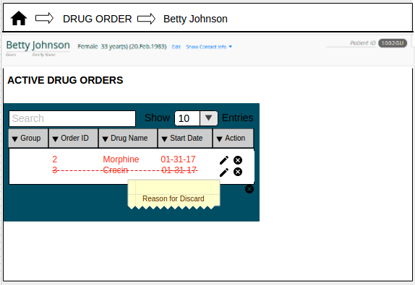

(Fig. 33 Drug Order discard)

As for the associated active Orders (Morphine) from the same group that are put on Hold, the Physician can provide comments to the Pharmacist in the 'Instructions to Pharmacist' field associated with those Orders if the Physician decides to allow the Pharmacist to dispatch them.

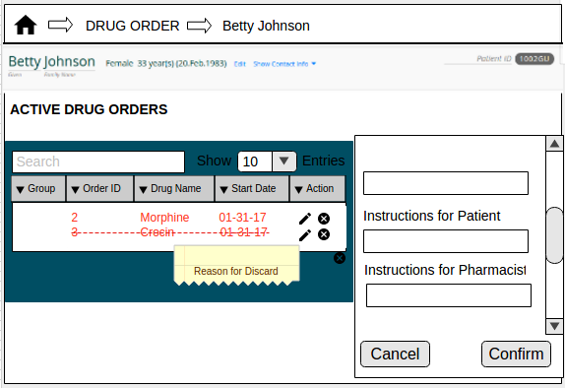

(Fig. 34 Drug Order Details Fragment)

The Order for Crocin is no longer displayed on the Pharmacy's homepage or the Patient's Drug Order page but the remaining Orders from the group are listed.



(Fig. 35 Drug Order page)

## 2.10 Orders Modified by Physician

In some cases, an Order might be marked for discard since a specific formulation of the drug is unavailable. The Orderer or Physician logs into the Patient's Drug Order page, discontinues the Order requested to be discarded and replaces it with a new Order with updated formulations.

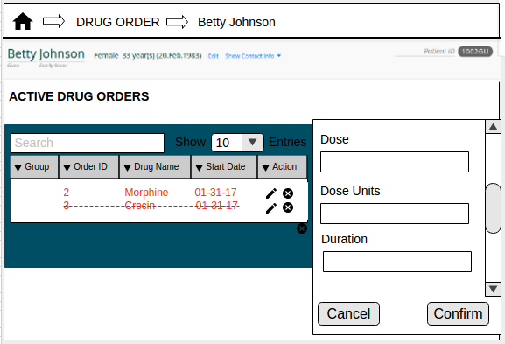

(Fig. 36 Drug Order modified)

In this section, we will view the snapshots of the screens where the Pharmacist requests a single individual Order to be discarded.

## 2.11 Request a Single Individual Order to be Discarded

Consider another scenario where patient Betty Johnson walks into the Pharmacy to collect Aspirin drug. The Pharmacist John Watson searches for the Patient by his/her name. This displays the list of Patients named Betty Johnson. Using the D.O.B. and address as reference, the Pharmacist determines the correct row for the patient present.



(Fig. 37 Pharmacy homepage)

John opens Betty's Drug Order page to find active orders for Aspirin However, this drug are not available in the Pharmacy. In fact, it is not available for sale in the country. John realises that he cannot dispatch the Order prescribed by the Physician. John will now request for the Order to be discarded.

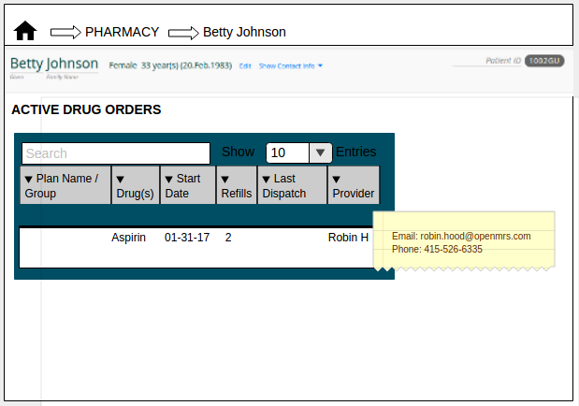

(Fig. 38 Drug Order page)

The Pharmacist John selects a row representing the Aspirin Order. This loads a fragment listing the Order and it's details. John checks the check-box corresponding to the Order and clicks the 'Discard' button.

## 

(Fig. 39 Order Select)

John provides some comments regarding why the Order needs to be discarded.

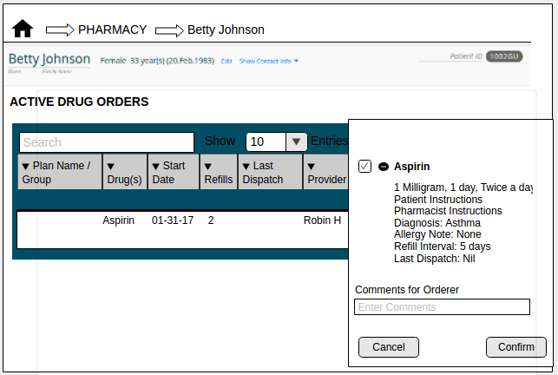

(Fig. 40 Order Record)

In addition, he sends an email to the Orderer about the Order that is requested to be discarded.



(Fig. 41 Mail Notification)

Once that is done, the Order for Aspirin continue to be listed in the Patient's Active Drug Orders table though marked with a strike-through line. This tells the users that Aspirin Order has been requested to be discarded.

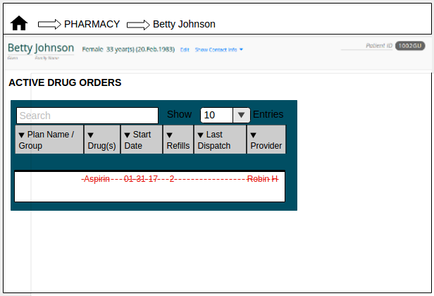

(Fig. 42 Drug Order page)

The Pharmacy homepage will also list the Aspirin Order, indicating that it is requested to be discarded.

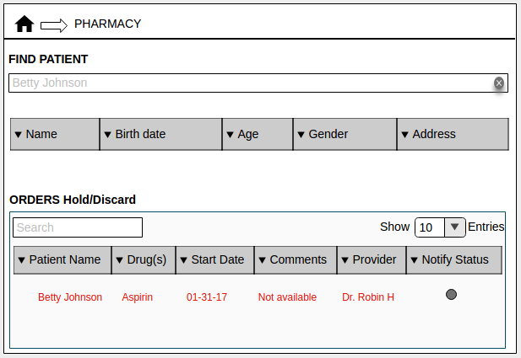

(Fig. 43 Pharmacy homepage)

## 2.12 Order Discarded by Physician

The Orderer or Physician logs into the Patient's Drug Order page and discontinues the Active Order(for Aspirin in this example) that is requested to be discarded.

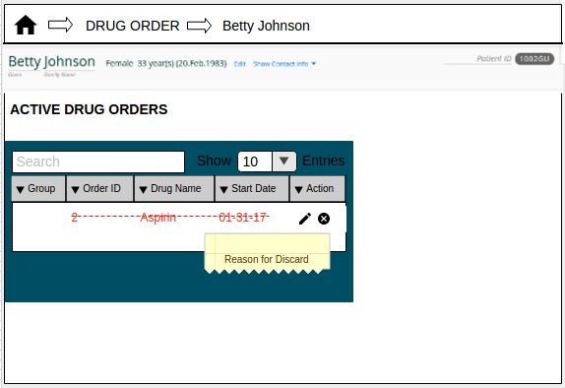

(Fig. 44 Order Discard)

## 2.13 Order Modified by Physician

In some cases, an Order might be marked for discard since a specific formulation of the drug is unavailable. The Orderer or Physician logs into the Patient's Drug Order page, discontinues the Order requested to be discarded and replaces it with a new Order with updated formulations.

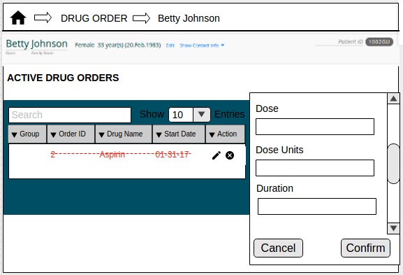

(Fig. 45 Order Modify)