**PHARMACY ORDERS ON-HOLD**

In this section, we will study the use-cases and the wire-frames describing the process of putting on hold - an individual order, some or all orders from a group of drug orders placed together and some or all of the drug orders from an ordered regimen/medication plan. We will see the process by which the pharmacist can mark an order, one or more orders from a regimen order or from an order group and put them on hold due to unavailability or other reasons and also send out an email to the ordering physician providing the reason for placing the order(s) on hold. We will see, how the order(s) which are put on hold are highlighted and notified. Also described are the steps that show what happens when the physician subsequently modifies, discontinues and replaces or removes the hold on the order(s) as well as the steps that show how the pharmacist can remove the hold on order(s).

Table of Contents

1. USE CASES 4

1.1 Put Order(s) in a Regimen On-Hold 4

1.2 Orderer discards the Order(s) put on hold 4

1.3 Orderer modifies the Order(s) put on hold 4

1.4 Pharmacist removes the hold on the Order(s) 5

1.5 Put some Order(s) in a Regimen On-Hold 5

1.6 Orderer discards the Order(s) put on hold 5

1.7 Orderer modifies the Order(s) put on hold 5

1.8 Pharmacist removes the hold on the Order(s) 6

1.9 Put Order(s) in a Group On-Hold 6

1.10 Orderer discards the Order(s) put on hold 6

1.11 Orderer modifies the Order(s) put on hold 6

1.12 Pharmacist removes the hold on the Order(s) 6

1.13 Put some Order(s) in a Group On-Hold 7

1.14 Orderer discards the Order(s) put on hold 7

1.15 Orderer modifies the Order(s) put on hold 7

1.16 Pharmacist removes the hold on the Order(s) 7

1.17 Put an individual Order On-Hold 8

1.18 Orderer discards the Order put on hold 8

1.19 Orderer modifies the Order put on hold 8

1.20 Pharmacist removes the hold on the Order 8

2. WIREFRAMES 9

2.1 Put Order(s) in a Regimen On-Hold 9

2.2 Orderer discards the Order(s) put on hold 12

2.3 Orderer modifies the Order(s) put on hold 13

2.4 Pharmacist removes the hold on the Order(s) 14

2.5 Put some Order(s) in a Regimen On-Hold 15

2.6 Orderer discards the Order(s) put on hold 18

2.7 Orderer modifies the Order(s) put on hold 19

2.8 Pharmacist removes the hold on the Order(s) 20

2.9 Put Order(s) in a Group On-Hold 22

2.10 Orderer discards the Order(s) put on hold 25

2.11 Orderer modifies the Order(s) put on hold 26

2.12 Pharmacist removes the hold on the Order(s) 27

2.13 Put some Order(s) in a Group On-Hold 28

2.14 Orderer discards the Order(s) put on hold 31

2.15 Orderer modifies the Order(s) put on hold 32

2.16 Pharmacist removes the hold on the Order(s) 34

2.17 Put an individual Order On-Hold 35

2.18 Orderer discards the Order put on hold 38

2.19 Orderer modifies the Order put on hold 39

2.20 Pharmacist removes the hold on the Order(s) 40

*UI DESIGN: When the Pharmacist selects a row representing a set of Orders, the page loads a fragment that displays additional details associated with each of those Orders. Corresponding to each Order is a check-box (unchecked by default). Before the Pharmacist clicks on a button (say 'On Hold' button), he/she needs to check the checkboxes corresponding to all those Orders that need to be put on hold. In other words, for each Order that is listed in that Regimen on which the 'On Hold' action has to be applied, check-mark the corresponding check-box.*

# 1. **USE CASES**

In this section, we will discuss the scenarios pertaining to what happens when a Pharmacist puts one or more Orders from a medication plan or regimen on hold.

*Consider this - Patient Betty Johnson walks into the Pharmacy to collect drugs Morphine and Crocin that are a part of a standard medication plan for Asthma disease. The Pharmacist John Watson opens Betty's Drug Order page to find active orders for Morphine and Crocin. However, these drugs are not available in the Pharmacy for the next few days. John realises that he cannot dispatch the Orders immediately. John will now put these Orders on hold.*

## 1.1 Put Order(s) in a Regimen On-Hold

The Pharmacist John selects a row representing all the Orders ordered as a part of a Regimen. This loads a fragment listing each of those Orders. John checks the check-boxes corresponding to each Order and clicks the 'On Hold' button. He then provides some comments regarding why the Orders for that regimen are put on hold. If the Orders are being placed on hold due to lack of clarity on the formulation of the drugs or consumption instructions or if the Physician has instructed the Pharmacist (provided instructions in the 'Instructions for Pharmacist' field) to notify him/her if the Orders are placed on hold, the Pharmacist sends an email to the Orderer. Once that is done, the Orders involved continue to be listed in the Patient's Active Drug Orders table (albeit displayed in a different color) until the Orderer discards, replaces or provides some clarification on the Order(s). These Order(s) are also listed in the 'Hold/Discard' Order table in the Pharmacy homepage.

## 1.2 Orderer discards the Order(s) put on hold

The Orderer or Physician logs into the Patient's Drug Order page and discards the Order(s) that are placed on hold. He/She may choose to create new Order(s) for the Patient.

## 1.3 Orderer modifies the Order(s) put on hold

The Orderer or Physician logs into the Patient's Drug Order page and edits the formulation of the drugs, thus replacing some of the components to address the reason why the Order(s) were put on hold. Alternatively, the Orderer will provide comments to the Pharmacist in the 'Instructions from Physician for Pharmacist' field to address the reason why the Order(s) were put on hold.

## 1.4 Pharmacist removes the hold on the Order(s)

Once the Pharmacist is assured that the Orders that were placed on hold earlier, can be dispatched now, he/she logs into the Pharmacy homepage and check marks the check-box corresponding to the Order(s) on which the hold has to be removed and clicks on the 'Remove Hold' button. This will display a pop-up to confirm removal of the hold on the Order(s) and set the Order status as 'Active'.

*Consider another situation where Patient Betty Johnson walks into the Pharmacy to collect drugs Morphine and Crocin for treatment of Asthma. The Pharmacist John Watson opens Betty's Drug Order page to find active Orders for Morphine and Crocin. While Morphine drug is available at the Pharmacy, Crocin is not available for a few days. John realises that he cannot dispatch a part of the prescription without the Physician's authorization. John will now put the Crocin Order on hold.*

## 1.5 Put some Order(s) in a Regimen On-Hold

The Pharmacist John selects a row representing all the Orders ordered as a part of a Regimen. As described in the UI design, he ignores the checkbox corresponding to the Order for Morphine and checks the check-box corresponding to *Crocin* Order before clicking the 'On Hold' button. John provides some comments regarding why the Order is put on hold. If the Crocin Order is being placed on hold due to lack of clarity on drug formulation or consumption instructions or if the Physician has instructed the Pharmacist (provided instructions in the 'Instructions for Pharmacist' field) to notify him/her if the Order is placed on hold, the Pharmacist sends an email to the Orderer. Once that is done, the Orders for Morphine and Crocin continue to be listed in the Patient's Active Drug Orders table though only Crocin Order is displayed in a different color. This tells the users that Morphine and Crocin are ordered together but the Order for Crocin has been put on hold.

When the Pharmacist puts some Orders from a Regimen on hold, he/she cannot dispatch the remaining Orders unless the Orderer authorizes it. The Physician is notified by the Pharmacist via email about the Order(s) that are put on Hold.

## 1.6 Orderer discards the Order(s) put on hold

The Orderer or Physician logs into the Patient's Drug Order page and discards the Order(s) that are placed on hold. He/She may choose to create new Order(s) for the Patient.

## 1.7 Orderer modifies the Order(s) put on hold

The Orderer or Physician logs into the Patient's Drug Order page and edits the formulation of the drugs, thus replacing some of the components to address the reason why the Order(s) were put on hold. Alternatively, the Orderer will provide comments to the Pharmacist in the 'Instructions from Physician for Pharmacist' field to address the reason why the Order(s) were put on hold.

## 1.8 Pharmacist removes the hold on the Order(s)

Once the Pharmacist is assured that the Order(s) that were placed on hold earlier, can be dispatched now, he/she logs into the Pharmacy homepage and check marks the check-box corresponding to the Order(s) on which the hold has to be removed and clicks on the 'Remove Hold' button. This will display a pop-up to confirm removal of the hold on the Order(s) and set the Order status as 'Active'.

*Consider another situation where Patient Betty Johnson walks into the Pharmacy to collect Morphine and Crocin drugs. These drugs are ordered and grouped together by the Physician. The Pharmacist John Watson opens Betty's Drug Order page to find an active orders for Morphine and Crocin. However, these drugs are not available in the Pharmacy for a few days. John realises that he cannot dispatch the Orders prescribed by the Physician. John will now put the Order(s) on hold.*

## 1.9 Put Order(s) in a Group On-Hold

The Pharmacist John selects a row representing all the Orders ordered as a part of a group. This loads a fragment listing each of those Orders. John checks the check-boxes corresponding to each Order and clicks the 'On Hold' button. He then provides some comments regarding why the Orders in that group are put on hold. If the Orders are being placed on hold due to lack of clarity on the formulation of the drugs or consumption instructions or if the Physician has instructed the Pharmacist (provided instructions in the 'Instructions for Pharmacist' field) to notify him/her if the Orders are placed on hold, the Pharmacist sends an email to the Orderer about the Orders that are put on hold. Once that is done, the Orders involved continue to be listed in the Patient's Active Drug Orders table (albeit displayed in a different color) until the Orderer discards, replaces or provides some clarification on the Order(s). These Order(s) are also listed in the 'Hold/Discard' Order table in the Pharmacy homepage.

## 1.10 Orderer discards the Order(s) put on hold

The Orderer or Physician logs into the Patient's Drug Order page and discards the Order(s) that are placed on hold. He/She may choose to create new Order(s) for the Patient.

## 1.11 Orderer modifies the Order(s) put on hold

The Orderer or Physician logs into the Patient's Drug Order page and edits the formulation of the drugs, thus replacing some of the components to address the reasons why the Order(s) were put on hold. Alternatively, the Orderer will provide comments to the Pharmacist in the 'Instructions from Physician for Pharmacist' field to address the reason why the Order(s) were put on hold.

## 1.12 Pharmacist removes the hold on the Order(s)

Once the Pharmacist is assured that the Orders that were placed on hold earlier, can be dispatched now, he/she logs into the Pharmacy homepage and check marks the check-box corresponding to the Order(s) on which the hold has to be removed and clicks on the 'Remove Hold' button. This will display a pop-up to confirm removal of the hold on the Order(s) and set the Order status as 'Active'.

*Consider another situation where Patient Betty Johnson walks into the Pharmacy to collect drugs Morphine and Crocin that were ordered together as a group. The Pharmacist John Watson opens Betty's Drug Order page to find active Orders for Morphine and Crocin. While Morphine drug is available at the Pharmacy, Crocin is not available for a few days. John realises that he cannot dispatch a part of the prescription without the Physician's authorization. John will place the Crocin Order on hol.*

## 1.13 Put some Order(s) in a Group On-Hold

The Pharmacist John selects a row representing all the Orders ordered as a part of a group. As described in the UI design, he ignores the checkbox corresponding to the Order for Morphine and checks the check-box corresponding to *Crocin* Order before clicking the 'On Hold' button. John provides some comments regarding why the Order is put on hold. If the Crocin Order is being placed on hold due to lack of clarity on drug formulation or consumption instructions or if the Physician has instructed the Pharmacist (provided instructions in the 'Instructions for Pharmacist' field) to notify him/her if the Order is placed on hold, the Pharmacist sends an email to the Orderer. Once that is done, the Orders for Morphine and Crocin continue to be listed in the Patient's Active Drug Orders table though only Crocin Order is displayed in a different color. This tells the users that Morphine and Crocin are ordered together but the Order for Crocin has been put on hold.

When the Pharmacist puts some Orders from a Regimen on hold, he/she cannot dispatch the remaining Order(s) unless the Orderer authorizes it. The Physician is notified by the Pharmacist via email about the Order(s) that are put on Hold.

## 1.14 Orderer discards the Order(s) put on hold

The Orderer or Physician logs into the Patient's Drug Order page and discards the Order(s) that are placed on hold. He/She may choose to create new Order(s) for the Patient.

## 1.15 Orderer modifies the Order(s) put on hold

The Orderer or Physician logs into the Patient's Drug Order page and edits the formulation of the drugs, thus replacing some of the components to address the reason why the Order(s) were put on hold. Alternatively, the Orderer will provide comments to the Pharmacist in the 'Instructions from Physician for Pharmacist' field to address the reason why the Order(s) were put on hold.

## 1.16 Pharmacist removes the hold on the Order(s)

Once the Pharmacist is assured that the Orders that were placed on hold earlier, can be dispatched now, he/she logs into the Pharmacy homepage and check marks the check-box corresponding to the Order(s) on which the hold has to be removed and clicks on the 'Remove Hold' button. This will display a pop-up to confirm removal of the hold on the Order(s) and set the Order status as 'Active'.

*Consider another situation where Patient Betty Johnson walks into the Pharmacy to collect Aspirin drug. The Pharmacist John Watson opens Betty's Drug Order page to find an active order for Aspirin that has been ordered individually. However, Aspirin is not available for a few days. John will now place the Order for Aspirin on hold.*

## 1.17 Put an individual Order On-Hold

The Pharmacist John selects a row representing the Order. This loads a fragment listing the details of the Order. John checks the check-box corresponding to the Order and clicks the 'On Hold' button. He then provides some comments regarding why the Order is put on hold. Once that is done (these are required actions), the Order involved continues to be listed in the Patient's Active Drug Orders table (albeit displayed in a different color) until the Orderer discards, replaces or provides some clarification on the Order. This Order is also listed in the 'Hold/Discard' Order table in the Pharmacy homepage.

## 1.18 Orderer discards the Order put on hold

The Orderer or Physician logs into the Patient's Drug Order page and discards the Order that is placed on hold. He/She may choose to create a new Order for the Patient.

## 1.19 Orderer modifies the Order put on hold

The Orderer or Physician logs into the Patient's Drug Order page and edits the formulation of the drug, thus replacing some of the components to address the reason why the Order was put on hold. Alternatively, the Orderer will provide comments to the Pharmacist in the 'Instructions from Physician for Pharmacist' field to address the reason why the Order was put on hold.

## 1.20 Pharmacist removes the hold on the Order

Once the Pharmacist is assured that the Orders that were placed on hold earlier, can be dispatched now, he/she logs into the Pharmacy homepage and check marks the check-box corresponding to the Order(s) on which the hold has to be removed and clicks on the 'Remove Hold' button. This will display a pop-up to confirm removal of the hold on the Order(s) and set the Order status as 'Active'.

# 2. **WIREFRAMES**

In this section, we will view the snapshots of the screens where the Pharmacist puts on hold all Orders in the Regimen/Medication Plan.

## 2.1 Put Order(s) in a Regimen On-Hold

Consider this - Patient Betty Johnson walks into the Pharmacy to collect drugs Morphine and Crocin that are a part of a standard medication plan for Asthma disease. The Pharmacist John Watson searches for the Patient by his/her name. This displays the list of Patients named Betty Johnson. Using the D.O.B. and address as reference, the Pharmacist determines the correct row for the patient present.

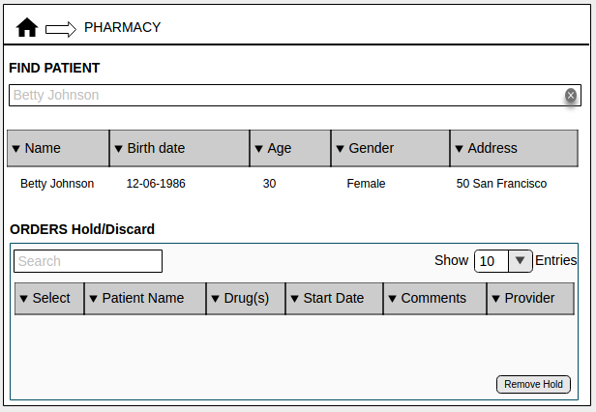

(Fig. 1 Pharmacy homepage)

John opens Betty's Drug Order page to find active orders for Morphine and Crocin. He selects a row representing all the Orders ordered as a part of a Regimen. This loads a fragment listing each of those Orders with the details. However, it is not clear to John if the prescribed drugs must be dispatched in capsule form or syrup form. Thus, he will now put the Orders on hold.

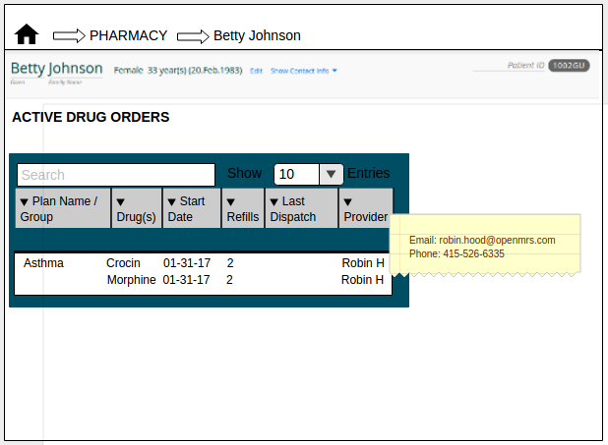

(Fig. 2 Drug Order page)

The Pharmacist John John checks the check-boxes corresponding to each Order and clicks the 'On Hold' button.

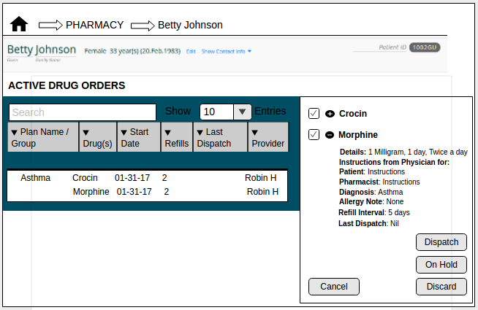

(Fig. 3 Order Select)

John then provides some comments regarding why the Orders from the Regimen need to be put on hold. Note, only in situations where the Order formulation/instructions is not clear or if the Physician has requested to be notified when the Order is placed on hold, these comments will be forwarded.

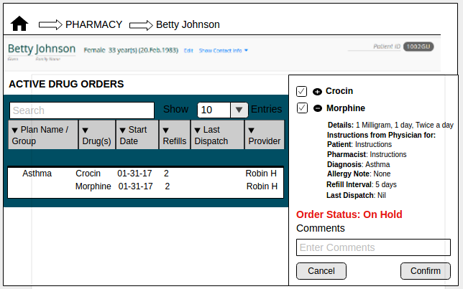

(Fig. 4 Order Record)

In this case, the Pharmacist sends an email to the Orderer informing that the Order(s) are put on hold.

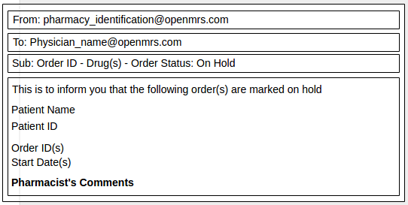

(Fig. 5 Mail Notification)

Once that is done (these are required actions), the Orders involved continue to be listed in the Patient's Active Drug Orders table (albeit displayed in a different color) until the Orderer edits, discards/replaces or the Pharmacist removes the hold on the regimen.

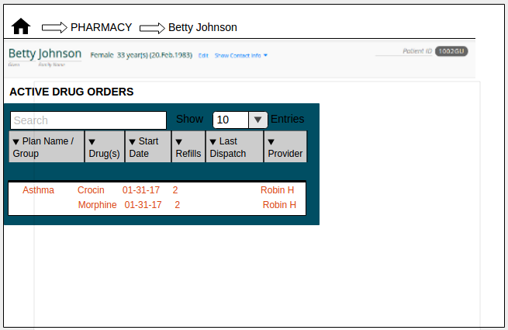

(Fig. 6 Drug Order page)

The Orders put on hold are also listed in the 'Hold/Discard' Order table in the Pharmacy homepage.

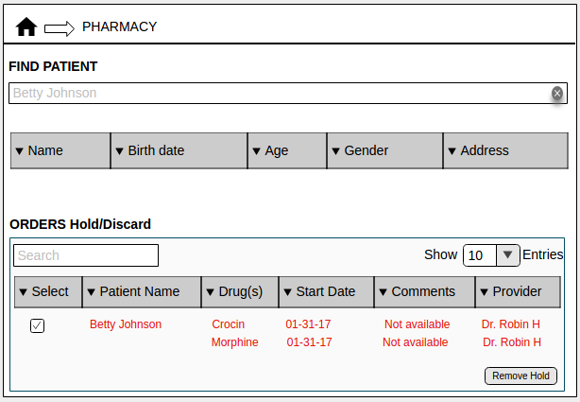

(Fig. 7 Pharmacy homepage)

## 2.2 Orderer discards the Order(s) put on hold

The Orderer or Physician logs into the Patient's Drug Order page and discontinues the Active Regimen that is put on hold. Then, the Orders that were a part of the discontinued regimen are no longer displayed on the Pharmacy's homepage or the Patient's Drug Order page.

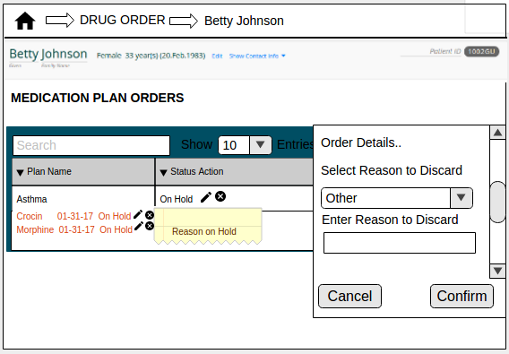

(Fig. 8 Discard Orders)

## 2.3 Orderer modifies the Order(s) put on hold

The Orderer or Physician logs into the Patient's Drug Order page and edits the formulation of the drugs, thus replacing some of the components to address the reason why the Order(s) were put on hold.

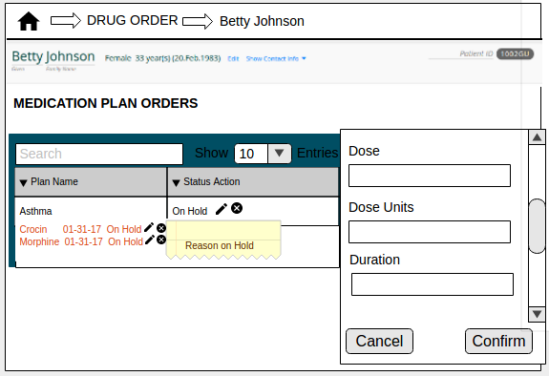

(Fig. 9 Edit Orders)

Alternatively, the Orderer will provide comments to the Pharmacist in the 'Instructions from Physician for Pharmacist' field to address the reason why the Order was put on hold.

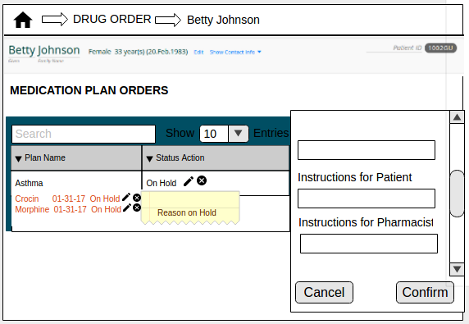

(Fig. 10 Edit Orders)

## 2.4 Pharmacist removes the hold on the Order(s)

Once the Pharmacist is assured that the Orders that were placed on hold earlier, can be dispatched now, he/she logs into the Pharmacy homepage and check marks the check-box corresponding to the Order(s) on which the hold has to be removed and clicks on the 'Remove Hold' button.



(Fig. 11 Pharmacy homepage)

This will display a pop-up to confirm removal of the hold on the Order(s) and set the Order status as 'Active', thus removing the Order(s) from this list.

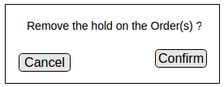

(Fig. 12 Confirm hold removal)

In this section, we will view the snapshots of the screens where the Pharmacist puts on hold some Orders in the Regimen/Medication Plan.

## 2.5 Put some Order(s) in a Regimen On-Hold

Consider another situation where Patient Betty Johnson walks into the Pharmacy to collect drugs Morphine and Crocin for treatment of Asthma.The Pharmacist John Watson searches for the Patient by his/her name.



(Fig. 13 Pharmacy homepage)

The Pharmacist John Watson opens Betty's Drug Order page to find active Orders for Morphine and Crocin. While Morphine drug is available at the Pharmacy, Crocin is not available for a few days. John selects a row representing all the Orders ordered as a part of a Regimen. This loads a fragment listing each of those Orders with the details with instructions from Physician asking to be notified if the Order is put on hold. 

(Fig. 14 Drug Order page)

As described in the UI design, he ignores the checkbox corresponding to the Order for Morphine and checks the check-box corresponding to Crocin Order before clicking the 'On Hold' button.



(Fig. 15 Order Select)

John provides some comments regarding why the Order needs to be put on hold and click 'Confirm'.

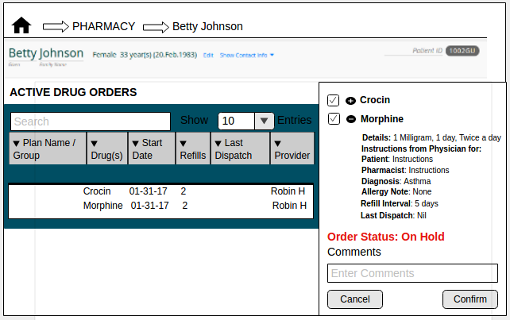

(Fig. 16 Order Record)

In this case, the Pharmacist sends an email to the Orderer informing that the Crocin Order is put on hold.



(Fig. 17 Mail Notification)

Once that is done (these are required actions), the Orders involved continue to be listed in the Patient's Active Drug Orders table (albeit displayed in a different color) until the Orderer edits, discards/replaces or the Pharmacist removes the hold on the regimen.

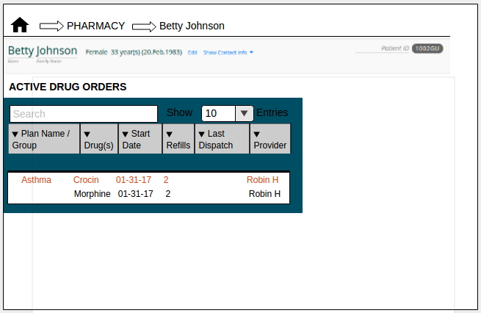

(Fig. 18 Drug Order page)

The Orders put on hold are also listed in the 'Hold/Discard' Order table in the Pharmacy homepage.

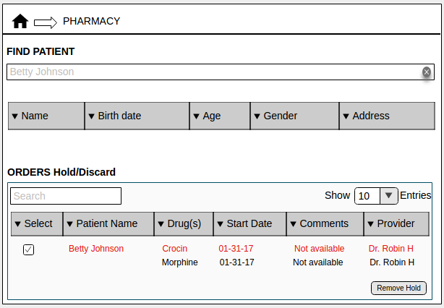

(Fig. 19 Pharmacy homepage)

## 2.6 Orderer discards the Order(s) put on hold

The Orderer or Physician logs into the Patient's Drug Order page and discontinues the Active Regimen that is put on hold. Then, the Orders that were a part of the discontinued regimen are no longer displayed on the Pharmacy's homepage or the Patient's Drug Order page.

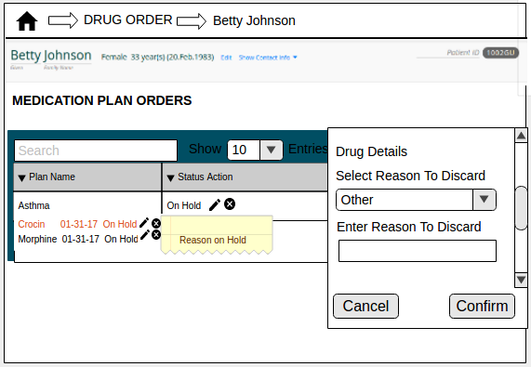

(Fig. 20 Discard Orders)

## 2.7 Orderer modifies the Order(s) put on hold

The Orderer or Physician logs into the Patient's Drug Order page and edits the formulation of the drugs, thus replacing some of the components to address the reason why the Order(s) were put on hold.

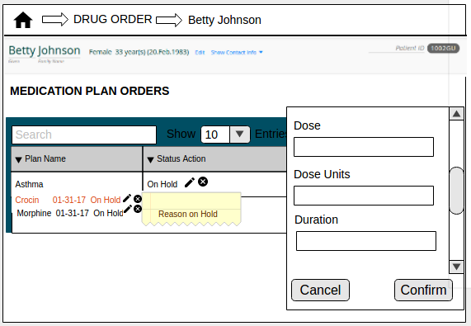

(Fig. 21 Edit Orders)

Alternatively, the Orderer will provide comments to the Pharmacist in the 'Instructions from Physician for Pharmacist' field to address the reason why the Order was put on hold.

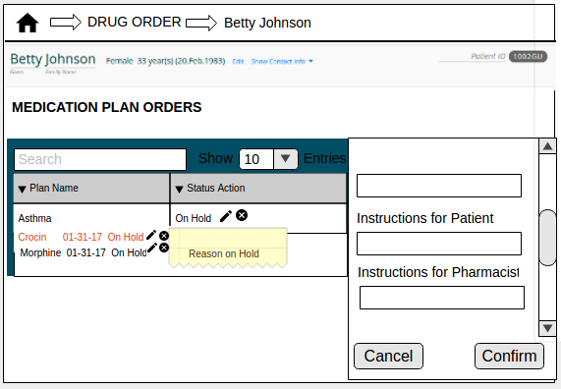

(Fig. 22 Edit Orders)

In this section, we will view the snapshots of the screens where the Pharmacist puts on hold some Orders in the Regimen/Medication Plan and removes the hold (without Physician's intervention).

## 2.8 Pharmacist removes the hold on the Order(s)

The Orders put on hold are listed in the 'Hold/Discard' Order table in the Pharmacy homepage. When the Pharmacist logs into the system, he/she will be able to view the list of individual/group/regimen Orders that are placed on hold. Consider the isituation where one of the Orders placed as a part of a Regimen is put on hold due to the drug not being immediately available. In this case, the Pharmacist would not send out an email to the Orderer (unless the Orderer has requested to be notified).



(Fig. 23 Pharmacy homepage)

Once the Pharmacist is assured that the Orders that were placed on hold earlier, can be dispatched now, he/she logs into the Pharmacy homepage check-marks the check-box corresponding to the Order(s) on hold and then clicks the 'Remove Hold' button. This will open a prompt asking the Physician to confirm if he/she wants the hold on the Order(s) to be removed.



(Fig. 24 Hold removal confirmation)

Once the Pharmacist clicks the 'Confirm' button, the hold on the selected Order(s) are removed. The Order(s) on hold are no longer displayed in the Hold/Discard table in the Pharmacy homepage.

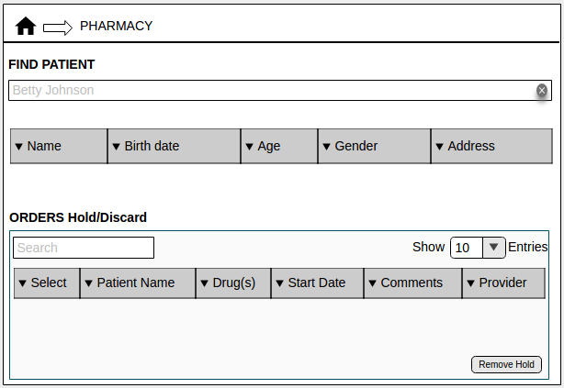

(Fig. 25 Hold removed)

In this section, we will view the snapshots of the screens where the Pharmacist puts on hold all Orders in an Order Group.

## 2.9 Put Order(s) in a Group On-Hold

Consider another scenario where patient Betty Johnson walks into the Pharmacy to collect drugs Morphine and Crocin that were ordered together as a group. The Pharmacist John Watson searches for the Patient by his/her name. This displays the list of Patients named Betty Johnson. Using the D.O.B. and address as reference, the Pharmacist determines the correct row for the patient present.



(Fig. 26 Pharmacy homepage)

John opens Betty's Drug Order page to find active orders for Morphine and Crocin. He selects a row representing all the Orders ordered as a part of a Regimen. This loads a fragment listing each of those Orders with the details. However, it is not clear to John if the prescribed drugs must be dispatched in capsule form or syrup form. Thus, he will now put the Orders on hold.

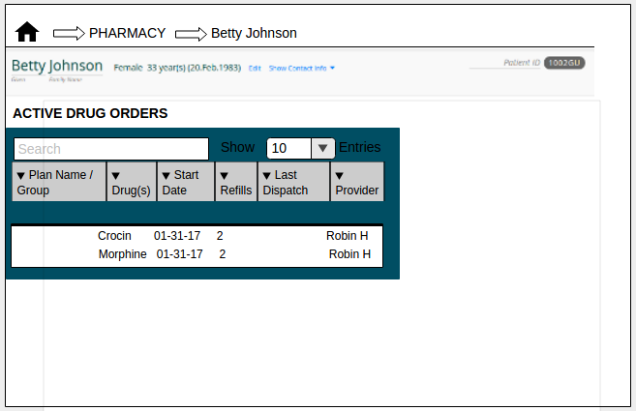

(Fig. 27 Drug Order page)

The Pharmacist John selects a row representing all the Orders ordered as a part of the group. This loads a fragment listing each of those Orders. John checks the check-boxes corresponding to each Order and clicks the 'On Hold' button.

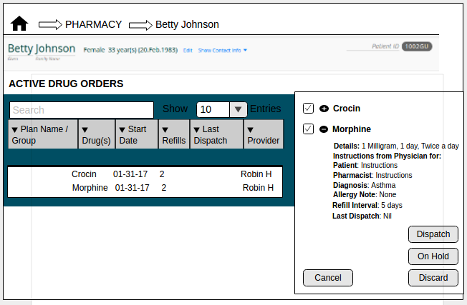

(Fig. 28 Order Select)

He then provides some comments regarding why the group of Orders need to be put on hold. In this case, the Pharmacist will send a mail to the Physician informing him that the Order(s) are placed on hold.



(Fig. 29 Order Record)

In addition, the Pharmacist sends an email to the Orderer about the Orders that are a part of that group being put on hold.



(Fig. 30 Mail Notification)

Once that is done (these are required actions), the Orders involved continue to be listed in the Patient's Active Drug Orders table (albeit displayed in a different color) until the Orderer edits, discards/replaces or provides clarification on the Orders within the group.

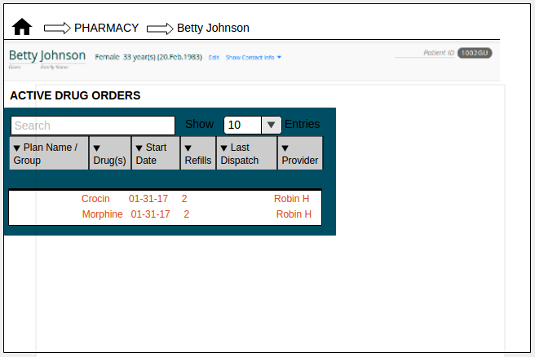

(Fig. 31 Drug Order page)

The Orders put on hold are also listed in the 'Hold/Discard' Order table in the Pharmacy homepage.



(Fig. 32 Pharmacy homepage)

## 2.10 Orderer discards the Order(s) put on hold

The Orderer or Physician logs into the Patient's Drug Order page and discards the Order(s) that are placed on hold. He/She may choose to create new Order(s) for the Patient.

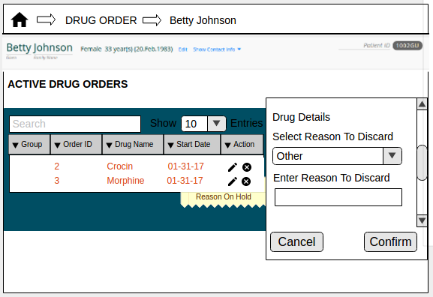

(Fig. 33 Discard Order)

## 2.11 Orderer modifies the Order(s) put on hold

The Orderer or Physician logs into the Patient's Drug Order page and edits the formulation of the drugs, thus replacing some of the components to address the reason why the Order(s) were put on hold.

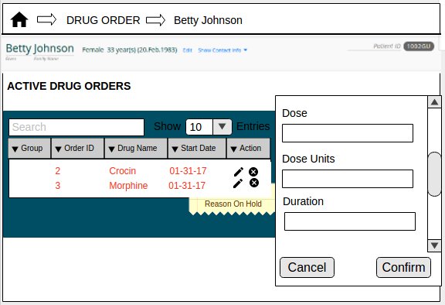

(Fig. 34 Edit Order - Formulations)

Alternatively, the Orderer will provide comments to the Pharmacist in the 'Instructions from Physician for Pharmacist' field to address the reason why the Order was put on hold.

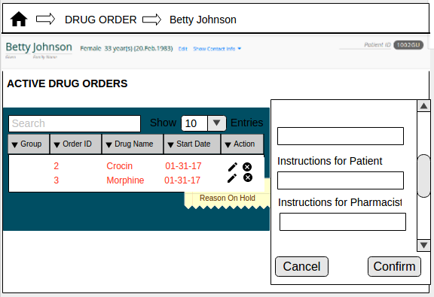

(Fig. 35 Edit Order - Instructions)

## 2.12 Pharmacist removes the hold on the Order(s)

Once the Pharmacist is assured that the Orders that were placed on hold earlier, can be dispatched now, he/she logs into the Pharmacy homepage and check marks the check-box corresponding to the Order(s) on which the hold has to be removed and clicks on the 'Remove Hold' button.



(Fig. 36 Pharmacy homepage)

This will display a pop-up to confirm removal of the hold on the Order(s) and set the Order status as 'Active', thus removing the Order(s) from this list.



(Fig. 37 Confirm hold removal)

In this section, we will view the snapshots of the screens where the Pharmacist puts on hold some Orders in an Order Group.

## 2.13 Put some Order(s) in a Group On-Hold

Consider another situation where Patient Betty Johnson walks into the Pharmacy to collect drugs Morphine and Crocin that were ordered as a group.The Pharmacist John Watson searches for the Patient by his/her name. This displays the list of Patients named Betty Johnson. Using the D.O.B. and address for reference, the Pharmacist determines the correct row for the patient present.



(Fig. 38 Pharmacy homepage)

The Pharmacist John Watson opens Betty's Drug Order page to find active Orders for Morphine and Crocin. However, it is not clear to John if the prescribed the Crocin drug must be dispatched in capsule form or syrup form. Thus, he will now put the Crocin Order on hold.

**

(Fig. 39 Drug Order page)

The Pharmacist John selects a row representing all the Orders ordered as a part of a group. As described in the UI design, he ignores the checkbox corresponding to the Order for Morphine and checks the check-box corresponding to Crocin Order before clicking the 'On Hold' button.



(Fig. 40 Order Select)

John provides some comments regarding why the Order(s) needs to be put on hold.



(Fig. 41 Order Record)

In this case, he sends an email to the Orderer about the Order(s) that is requested to be discarded.



(Fig. 42 Mail Notification)

Once that is done, the Orders for Morphine and Crocin continue to be listed in the Patient's Active Drug Orders table though only Crocin Order is displayed in a different color. This tells the users that Morphine and Crocin are ordered together but the Order for Crocin has been put on hold.

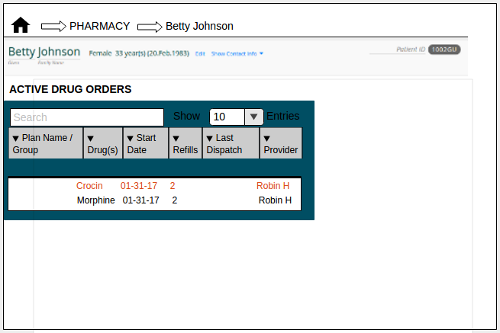

(Fig. 43 Drug Order page)

When the Pharmacist puts some Orders from a group on hold, he/she cannot dispatch the remaining. The Orders put on hold are also listed in the 'Hold/Discard' Order table in the Pharmacy homepage.



(Fig. 44 Pharmacy homepage)

## 2.14 Orderer discards the Order(s) put on hold

The Orderer or Physician logs into the Patient's Drug Order page and discards the Order(s) that are placed on hold. He/She may choose to create new Order(s) for the Patient.

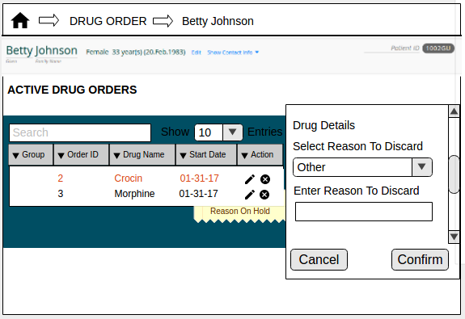

(Fig. 45 Order discard)

The Order for Crocin is no longer displayed on the Pharmacy's homepage or the Patient's Drug Order page but the remaining Orders from the group are listed.

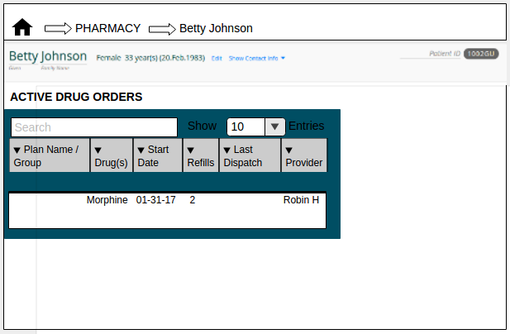

(Fig.46 Drug Order page)

## 2.15 Orderer modifies the Order(s) put on hold

The Orderer or Physician logs into the Patient's Drug Order page and edits the formulation of the crocin drug, thus replacing some of the components to address the reason why the Order(s) were put on hold.

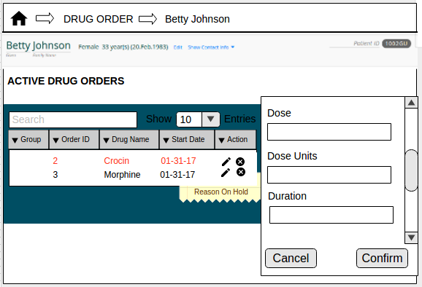

(Fig. 47 Edit Order – Formulations)

Alternatively, the Orderer will provide comments to the Pharmacist in the 'Instructions from Physician for Pharmacist' field to address the reason why the Order was put on hold.

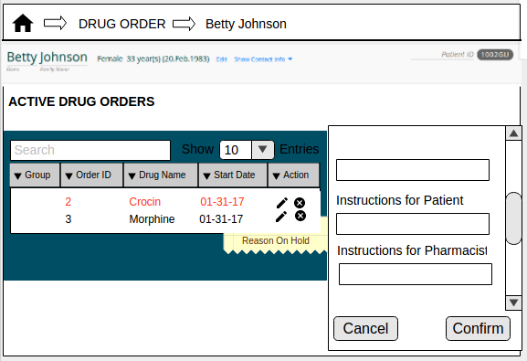

(Fig. 48 Edit Order - Instructions)

## 2.16 Pharmacist removes the hold on the Order(s)

Once the Pharmacist is assured that the Orders that were placed on hold earlier, can be dispatched now, he/she logs into the Pharmacy homepage and check marks the check-box corresponding to the Order(s) on which the hold has to be removed and clicks on the 'Remove Hold' button.



(Fig. 49 Pharmacy homepage)

This will display a pop-up to confirm removal of the hold on the Order(s) and set the Order status as 'Active', thus removing the Order(s) from this list.



(Fig. 50 Confirm hold removal)

In this section, we will view the snapshots of the screens where the Pharmacist requests a single individual Order to be put on hold.

## 2.17 Put an individual Order On-Hold

Consider another scenario where patient Betty Johnson walks into the Pharmacy to collect Aspirin drug. The Pharmacist John Watson searches for the Patient by his/her name. This displays the list of Patients named Betty Johnson. Using the D.O.B. and address as reference, the Pharmacist determines the correct row for the patient present.



(Fig. 51 Pharmacy homepage)

John opens Betty's Drug Order page to find active order for Aspirin. He selects a row representing the Order. This loads a fragment listing the Order details. However, it is not clear to John if the prescribed drug must be dispatched in capsule form or syrup form. Thus, he will now put the Order on hold.

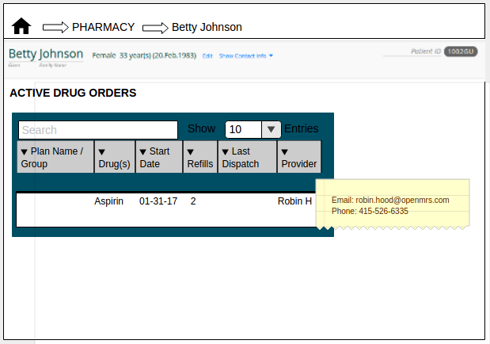

(Fig. 52 Drug Order page)

John checks the check-box corresponding to the Order and clicks the 'On Hold' button.

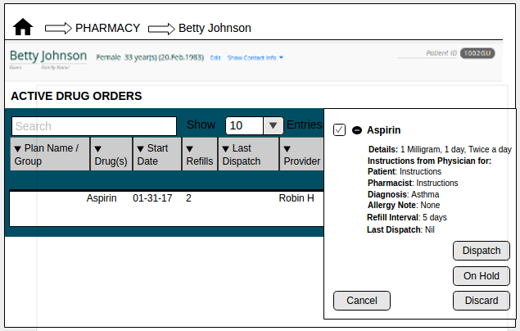

(Fig. 53 Order Select)

John provides some comments regarding why the Order needs to be put on hold. In this case, a mail will be forwarded to the Orderer with these comments.

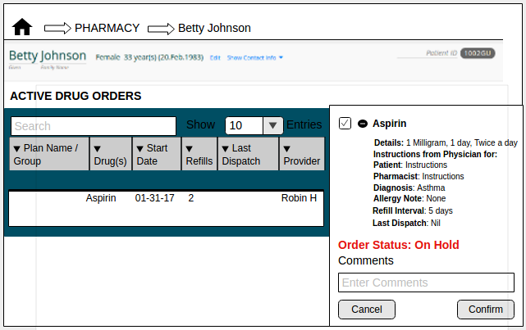

(Fig. 54 Order Record)

The Pharmacist sends an email to the Orderer about the Order that is put on hold.



(Fig. 55 Mail Notification)

Once that is done, the Order for Aspirin continue to be listed in the Patient's Active Drug Orders table though displayed with a different color. This tells the users that Aspirin Order has been put on hold.

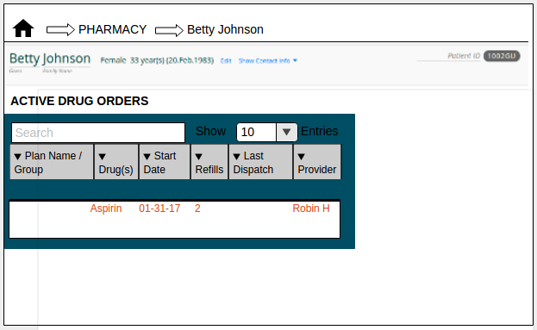

(Fig. 56 Drug Order page)

The Pharmacy homepage will also list the Aspirin Order, indicating that it is put on hold.

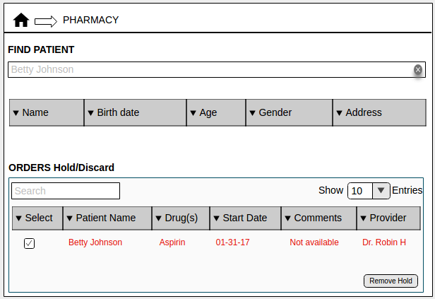

(Fig. 57 Pharmacy homepage)

## 2.18 Orderer discards the Order put on hold

The Orderer or Physician logs into the Patient's Drug Order page and discontinues the Active Order(for Aspirin in this example) that is put on hold.

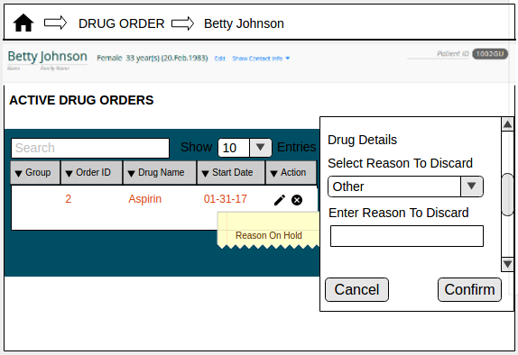

(Fig. 58 Order Discard)

## 2.19 Orderer modifies the Order put on hold

In some cases, an Order might be put on hold since a specific formulation of the drug is unavailable. The Orderer or Physician logs into the Patient's Drug Order page, discontinues the Order put on hold and replaces it with a new Order with updated formulations.

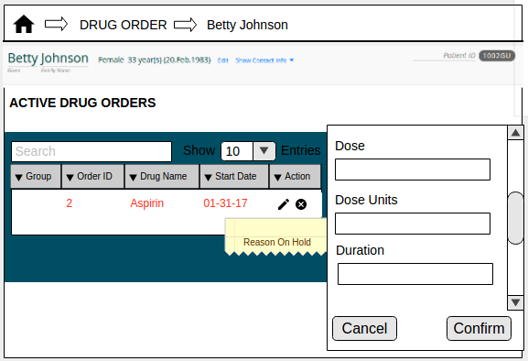

(Fig. 59 Edit Order – Formulations)

Alternatively, the Orderer will provide comments to the Pharmacist in the 'Instructions from Physician for Pharmacist' field to address the reason why the Order was put on hold.

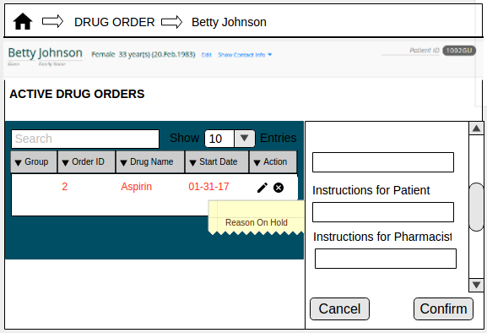

(Fig. 60 Edit Order – Instructions)

## 2.20 Pharmacist removes the hold on the Order(s)

Once the Pharmacist is assured that the Orders that were placed on hold earlier, can be dispatched now, he/she logs into the Pharmacy homepage and check marks the check-box corresponding to the Order(s) on which the hold has to be removed and clicks on the 'Remove Hold' button.



(Fig. 61 Pharmacy homepage)

This will display a pop-up to confirm removal of the hold on the Order(s) and set the Order status as 'Active', thus removing the Order(s) from this list.



(Fig. 62 Confirm hold removal)