**CREATE A CHATBOT USING PYTHON**

**PHASE2: PROJECT SUBMISSION**

**NAME: R. HARINI SRI**

**ABSTRACT:** Chatbots, often referred to as chatboxes, are AI-powered conversational agents that have gained prominence in various domains, including customer support, virtual assistants, and information retrieval. This abstract explores the fundamental components and functionalities of chatboxes

**Key components of a chatbox include**:

1. **User Interface**: Chatboxes interact with users through text or speech, often using messaging apps, websites, or voice assistants.
2. **Natural Language Understanding (NLU)**: NLU is the core component that enables chatbots to comprehend user messages. It involves tasks like intent recognition, entity extraction, and sentiment analysis.
3. **Dialogue Management**: Chatbots need to manage conversations effectively, maintaining context and guiding the conversation flow. Dialogue management can be rule-based or learned from data.
4. **Knowledge Base**: Many chatbots rely on a knowledge base or database of information to provide accurate answers to user queries. This can include FAQs, product information, or other relevant data.
5. **Machine Learning Models**: Machine learning-based chatbots employ various algorithms and models, such as recurrent neural networks (RNNs) or transformer models, to generate responses.
6. **Integration**: Chatbots often integrate with other systems or APIs to perform tasks like booking appointments, making reservations, or retrieving real-time information.
7. **Continuous Learning**: Machine learning-based chatbots continuously learn from user interactions, improving their accuracy and adaptability over time.
8. **Privacy and Security**: Ensuring user data privacy and security is crucial for chatbots, especially when handling sensitive information.
9. **Evaluation and Testing**: Chatbox performance is evaluated through metrics like response accuracy, user satisfaction, and task completion rates.

Chatboxes have a wide range of applications, from providing customer support 24/7 to enhancing user experiences on websites and apps. As AI technology continues to advance, chatboxes are expected to become even more sophisticated and seamlessly integrated into various aspects of our daily lives.

**INNOVATION :**

1. **AI and Natural Language Processing (NLP) Advancements:** Chatbots are becoming more sophisticated with advancements in AI and NLP. They can understand and respond to human language more accurately and contextually. This allows for more natural and engaging conversations.
2. **Multimodal Chatbots:** These chatbots combine text-based chat with other modalities like voice, video, and images. They can understand and respond to various types of inputs, making interactions more versatile.
3. **Emotional Intelligence:** Some chatbots are designed to detect and respond to users' emotions. They use sentiment analysis and tone recognition to provide more empathetic and personalized responses.
4. **Chatbots in Healthcare:** There's been significant innovation in using chatbots in healthcare for tasks such as symptom checking, appointment scheduling, and medication reminders. They can provide patients with instant information and support.
5. **Chatbots in Customer Service:** Many businesses have integrated chatbots into their customer service operations. These chatbots can handle routine inquiries, freeing up human agents to focus on more complex issues.
6. **Virtual Assistants:** Chatbots are being used as virtual personal assistants. They can help with tasks like setting reminders, sending messages, and providing recommendations.
7. **AI-Generated Content:** Chatbots are used to generate content, including news articles, reports, and creative writing. They use AI algorithms to produce human-like text.
8. **Industry-Specific Chatbots:** There are chatbots designed for specific industries like finance, e-commerce, and education. They are tailored to address industry-specific needs and questions.
9. **Chatbots for Language Translation:** Some chatbots can translate languages in real-time, enabling multilingual conversations.
10. **Enhanced Security:** Innovations in chatbot security are crucial to protect user data and privacy. Advancements include end-to-end encryption and secure authentication methods.
11. **Continuous Learning:** Chatbots are being equipped with the ability to learn from interactions and improve over time. Reinforcement learning and user feedback mechanisms help them become more effective.
12. **Chatbots with Avatars:** Some chatbots are represented by avatars or animated characters, providing a more visually engaging user experience.
13. **Voice-Activated Chatbots:** With the rise of voice assistants like Siri and Alexa, chatbots are being integrated with voice-activated platforms to enable hands-free interactions.
14. **Integration with IoT Devices:** Chatbots can be connected to IoT devices, allowing users to control smart home appliances or get information from connected devices through chat interfaces.
15. **Personalization:** Chatbots are becoming more personalized, taking into account user preferences and past interactions to provide tailored responses and recommendations.

* keep in mind that the field of chatbots is rapidly evolving, and new innovations may have emerged since my last update. To stay current with the latest developments, it's a good idea to follow industry news and research in the field of artificial intelligence and conversational interfaces.

**Here's a step-by-step guide to creating a simple chatbot:**

**Step 1: Set Up Your Environment** Make sure you have Python installed on your computer. You'll also need a text editor or an integrated development environment (IDE) like Visual Studio Code or PyCharm.

**Step 2: Import Necessary Libraries** We'll use the **random** library to generate rand

PYTHON CODE

import random

**Step 3: Define Your Chatbot's Responses** Create a dictionary where the keys are user inputs, and the values are the chatbot's responses.

pythoncode

responses = { "hello": ["Hi there!", "Hello!", "Hey!"], "how are you": ["I'm just a chatbot, but thanks for asking!", "I'm doing well, thanks."], "what's your name": ["I'm a chatbot.", "I don't have a name, but you can call me Chatbot."], "bye": ["Goodbye!", "See you later!", "Bye! Have a great day."], }

**Step 4: Create a Function to Respond to User Input** Write a function that takes user input, checks if it matches any of the keys in the **responses** dictionary, and returns a random response if there's a match. If there's no match, you can provide a default response.

python code:

def chatbot_response(user_input): user_input = user_input.lower() # Convert user input to lowercase for case insensitivity if user_input in responses: return random.choice(responses[user_input]) else: return "I'm not sure how to respond to that."

**Step 5: Implement the Main Loop** Create a loop that continuously takes user input, passes it to the **chatbot_response** function, and prints the chatbot's response.

pythoncode

while True: user_input = input("You: ") if user_input.lower() == "exit": print("Chatbot: Goodbye!") break response = chatbot_response(user_input) print("Chatbot:", response)

**Step 6: Run Your Chatbot** Execute your Python script, and your chatbot should be ready to respond to user inputs. Type "exit" to exit the chatbot loop.

This is a very basic chatbot that uses simple rule-based responses. For more advanced chat bots, you can explore natural language processing libraries like NLTK, spaCy, or even consider building a machine learning model using deep learning frameworks like TensorFlow or

PyTorch. These libraries will allow your chatbot to understand and generate more complex responses based on context.

**CHATBOAT DIAGRAM**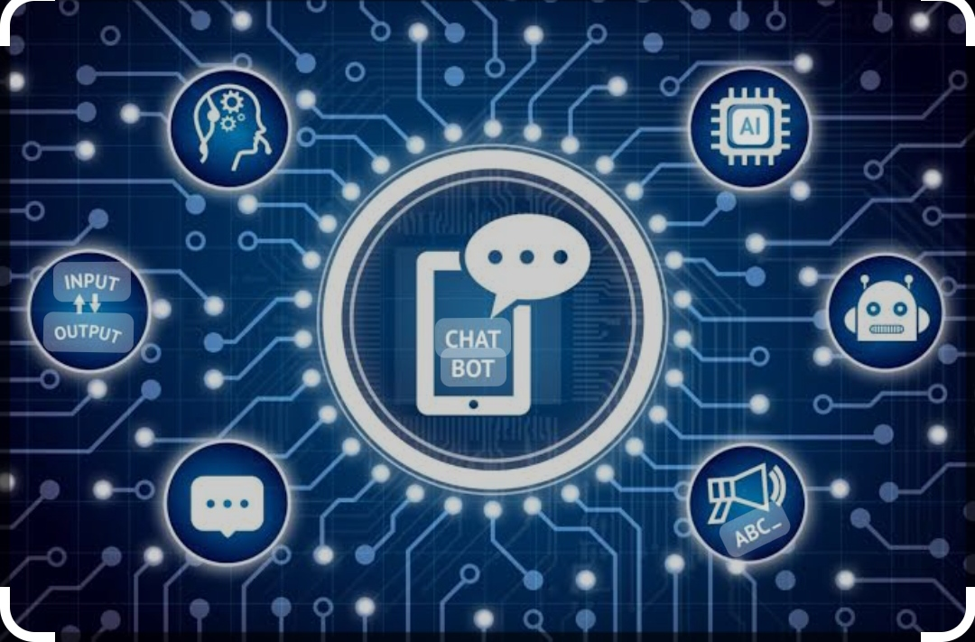

**CHATBOAT ARCHITECTURE**

**Top of Form**

**A chatbot's architecture usually consists of the following components:**

1. **User Interface**: This is the front-end component that allows users to interact with the chatbot. It can be a web-based interface, a mobile app, a messaging platform (e.g., Facebook Messenger or WhatsApp), or even a voice interface like Amazon Alexa or Google Assistant.
2. **Natural Language Processing (NLP):** NLP is a core component of chatbots that enables them to understand and generate human language. It includes several sub-components, such as:
   * Text Tokenization: Breaking down text into words or tokens.
   * Named Entity Recognition (NER): Identifying entities like names, dates, and locations.
   * Part-of-Speech Tagging: Labeling words with their grammatical roles.
   * Sentiment Analysis: Determining the sentiment (positive, negative, neutral) of user inputs.
   * Intent Recognition: Identifying the user's intent or purpose behind a message.
3. **Dialogue Management:** This component manages the conversation flow by determining how the chatbot should respond to user inputs based on identified intents and context. It maintains a conversation history and decides the appropriate next step in the conversation.
4. **Knowledge Base/Database:** Chatbots may need access to a knowledge base or database to retrieve information or answer user queries. This can be a structured database, a set of FAQs, or access to external data sources.
5. **Response Generation:** Once the chatbot has determined the appropriate response, it generates a natural-sounding reply in the form of text, speech, or other media, depending on the chatbot's capabilities.
6. **Integration:** Chatbots often need to integrate with various external services or APIs to perform tasks like making reservations, fetching weather information, or interacting with third-party systems.
7. **Machine Learning:** Some chatbots employ machine learning techniques to improve their performance over time. This may involve training on historical data to enhance intent recognition or dialogue management.
8. **Analytics and Monitoring:** To improve the chatbot's performance and user experience, it's important to collect and analyze user interactions and feedback. Analytics tools help in measuring the chatbot's effectiveness and identifying areas for improvement.
9. **Security and Privacy:** Chatbots need to handle user data securely and ensure compliance with privacy regulations. This includes encryption, user authentication, and data protection measures.

The specific architecture and technologies used can vary widely depending on the chatbot's goals and the technologies available at the time of development. Some chatbots are rule-based and follow predefined scripts, while others are powered by machine learning models and can learn from user interactions. The architecture may also be cloud-based, on-premises, or a combination of both, depending on the deployment requirements.

Top of Form

**ARCHITECTURE DIAGRAM:**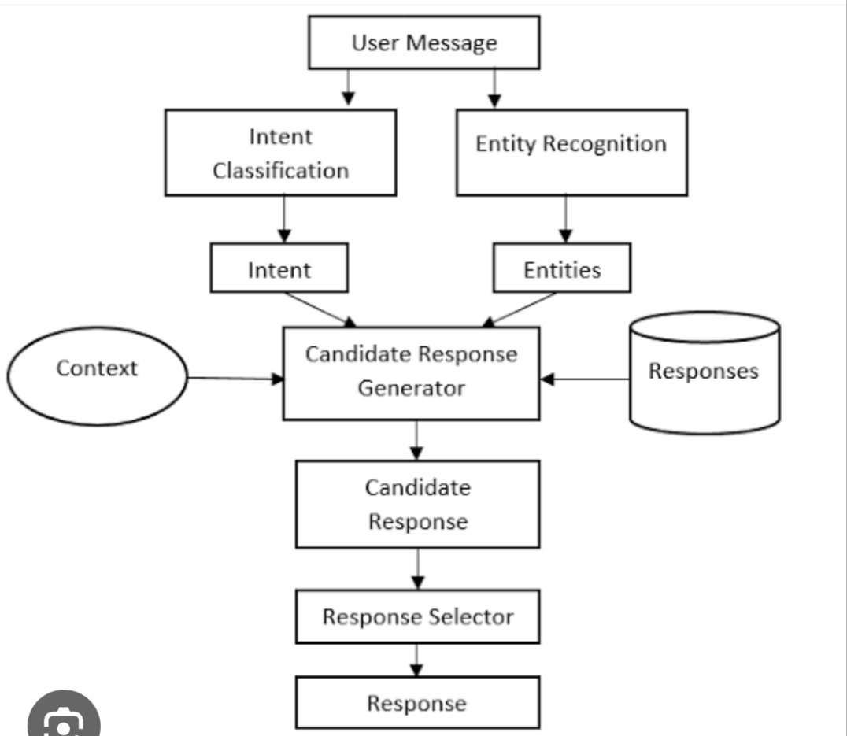

**CHATBOAT INSTALLATION:**

**Step 1: Define Your Chatbot's Purpose**

Before installing a chatbot, determine its purpose and the tasks it should perform. Identify the common questions or issues users may have that the chatbot can assist with.

**Step 2: Choose a Chatbot Platform**

There are various platforms and tools available for creating and deploying chatbots. Some popular options include:

* Dialogflow by Google
* Microsoft Bot Framework
* IBM Watson Assistant
* Chatfuel (for Facebook Messenger)
* ManyChat (for Facebook Messenger)
* Custom development using programming languages like Python or JavaScript with frameworks like BotPress or Rasa.

Select a platform that aligns with your needs and technical expertise.

**Step 3: Create or Configure Your Chatbot**

Depending on your chosen platform, you'll either create a new chatbot from scratch or configure an existing template. Here's a general outline of the process:

a. Sign up or log in to the chosen platform. b. Create a new chatbot project. c. Configure the chatbot's settings, such as its name, profile picture, and welcome message. d. Define the chatbot's intents and responses. Intents are user inputs, and responses are what the chatbot should reply with. Train the chatbot by providing sample user queries.

**Step 4: Integration with Your Platform**

To install the chatbot on your website or platform, you'll typically need to integrate it using API or plugin options. This step varies depending on your platform and the integration method it provides. Here's a general outline:

a. Generate API keys or tokens from your chatbot platform. b. Use these keys or tokens to integrate the chatbot with your website or platform. This may involve adding code snippets to your website's HTML or using plugins or widgets provided by the chatbot platform. c. Configure the chatbot's appearance and behavior to match your website's design and functionality.

**Step 5: Testing and Training**

Before making your chatbot live, thoroughly test it to ensure it understands user queries and provides appropriate responses. Continue to train the chatbot by adding more sample interactions and refining its responses based on user feedback.

**Step 6: Deployment**

Once you're satisfied with the chatbot's performance, deploy it to your website or platform. Make it accessible to users, and monitor its performance regularly.

**Step 7: Continuous Improvement**

A chatbot should be an evolving tool. Collect user feedback, analyze chat logs, and make improvements to enhance its effectiveness and user experience over time.

Remember that the specific steps and tools you need may vary based on the platform you choose and your project's requirements. Be sure to consult the documentation and support resources provided by your chosen chatbot platform for detailed installation instructions.

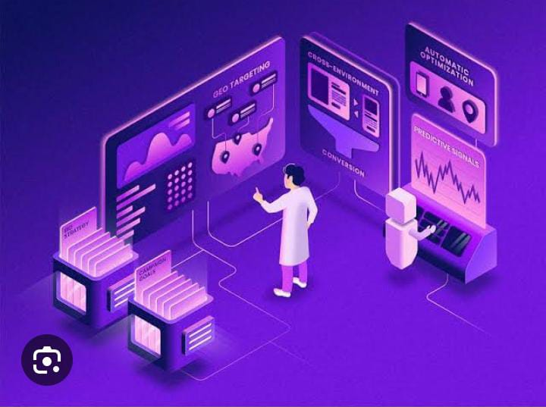

**THANK YOU**