AWS CLOUD IMPLEMENTATION DOCUMENTATION
LegalDocs – Round 2 and Round 3
AWS Storage • Lifecycle Management • IAM • EC2 Deployment • Data Integration

Name | Harini D
Register Number | 722824148032
Application | LegalDocs – Customer Document Management

1. Problem Statement
LegalDocs stores customer documents in Amazon S3. Recently created documents are accessed frequently, while older documents are accessed less frequently but must be retained for several years. The AWS implementation therefore uses S3 storage, S3 Lifecycle Policies, S3 storage classes, IAM and EC2 to provide controlled storage and application deployment.

2. Round 2 – Implement AWS Storage and Build the AWS Solution
Objective: Create the LegalDocs S3 storage, upload a document, configure lifecycle management, demonstrate a storage-class change, and prepare the IAM role required by the application.

2.1 S3 Bucket Creation
1. Open Amazon S3 — Open AWS Management Console → search for S3 → open Amazon S3.
2. Create the bucket — Create a bucket named legaldocs-yourname-2026. The supplied evidence shows the bucket was created successfully.
3. Verify the bucket — Open the bucket and confirm that the Objects tab is available and the bucket is ready for document storage.
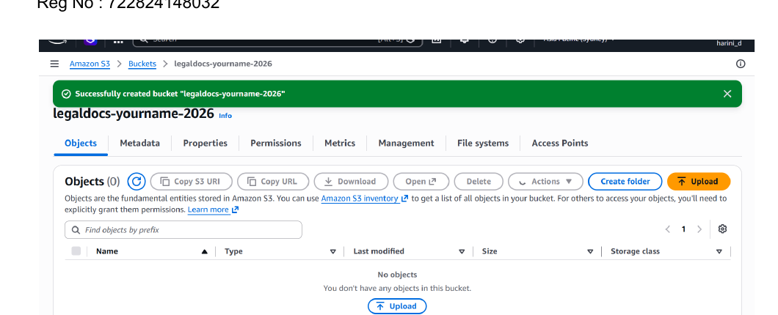
Figure 1. LegalDocs S3 bucket created successfully.

2.2 Upload the LegalDocs File
4. Start upload — Inside the LegalDocs bucket, select Upload → Add files and choose the document to be stored.
5. Verify destination — Confirm that the destination is the LegalDocs S3 bucket before completing the upload.
6. Complete upload — Select Upload and verify that the object appears in the bucket.
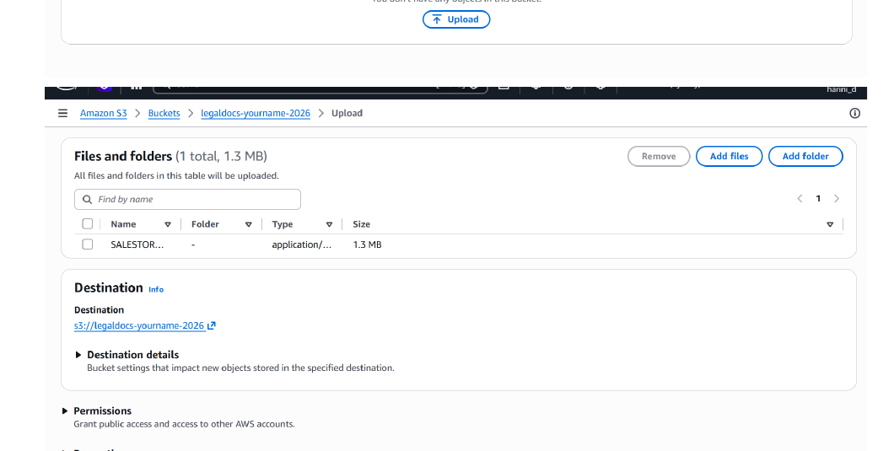
Figure 2. S3 upload screen showing the selected file and LegalDocs bucket destination.

2.3 Verify Successful Upload
7. Check upload result — Verify the green Upload succeeded message and confirm that 1 file was uploaded successfully.
8. Verify object — Confirm that the uploaded file is listed under Files and folders in the bucket.
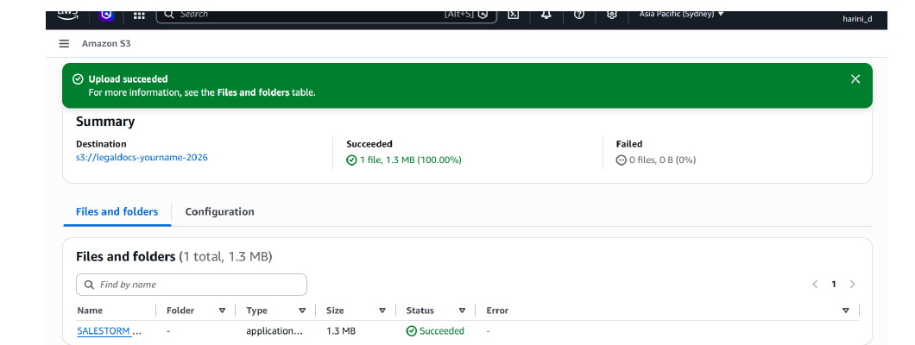
Figure 3. Successful LegalDocs file upload.

2.4 Configure S3 Lifecycle Management
9. Open Lifecycle configuration — Open the LegalDocs S3 bucket → Management → Lifecycle rules.
10. Create the lifecycle rule — Create a lifecycle rule named LegalDocs-Lifecycle-Rule and apply it to the required LegalDocs objects/bucket.
11. Configure transitions — Configure the lifecycle transitions required by the problem: frequently accessed documents remain in S3 Standard; older documents transition to a less frequently accessed class and then to archival storage according to the retention policy.
12. Configure expiration — Configure expiration/deletion according to the organization's retention requirement.
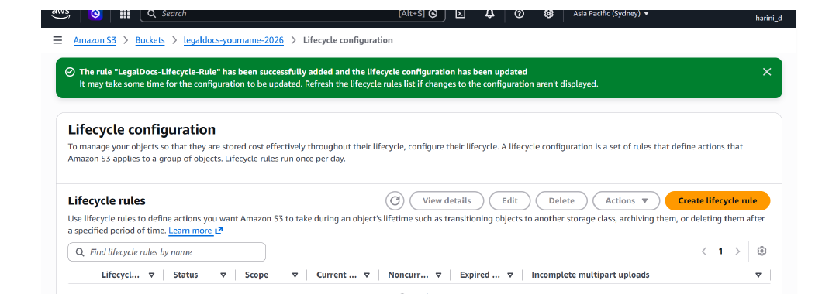
Figure 4. AWS confirmation that LegalDocs-Lifecycle-Rule was successfully added.
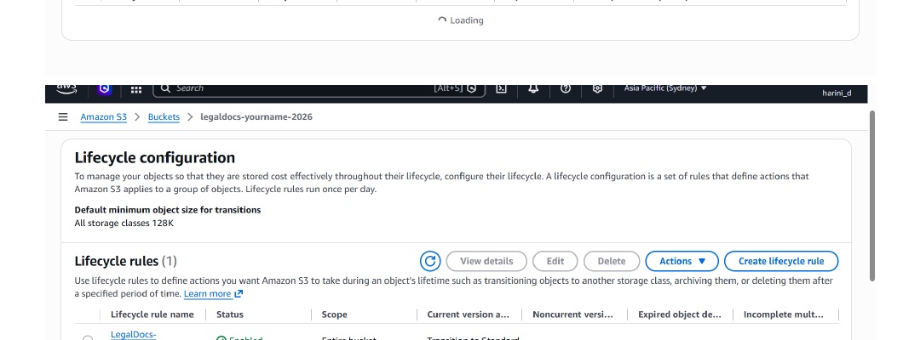
Figure 5. Lifecycle rule shown as Enabled for the entire bucket.
Evidence note: the supplied screenshot confirms creation and enabling of the lifecycle rule. It does not visibly expose the complete transition/expiration values, so the exact configured transition periods should be verified in View details before final submission.

2.5 Demonstrate S3 Storage-Class Management
13. Select the test object — Select the uploaded LegalDocs object and use the object Actions menu to change its storage class for demonstration.
14. Verify the operation — Confirm the successful storage-class edit and verify that no objects failed to update.
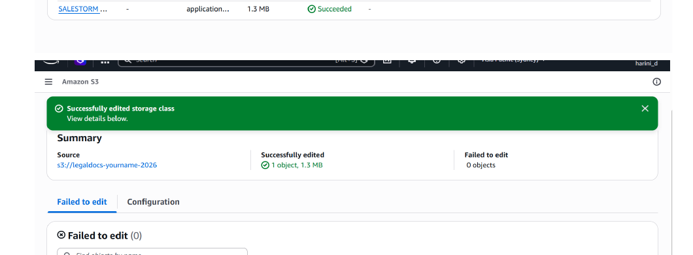
Figure 6. Successful S3 storage-class edit for the LegalDocs object.

3. Round 3 – Data Integration and Deployment
Objective: provide the application with controlled AWS access through IAM, deploy the compute environment on EC2, and integrate the deployed application with the S3 LegalDocs storage.

3.1 Create the IAM Role for EC2
15. Open IAM — AWS Console → IAM → Roles → Create role.
16. Select trusted service — Select AWS service as the trusted entity and choose EC2 as the service/use case.
17. Attach permissions — Attach an S3 policy containing only the permissions required by the application, such as listing the bucket and getting/putting LegalDocs objects.
18. Name the role — Use the role name LegalDocs-EC2-S3-Role.
19. Create and verify — Create the role and verify that it appears in IAM Roles with EC2 as its trusted entity.
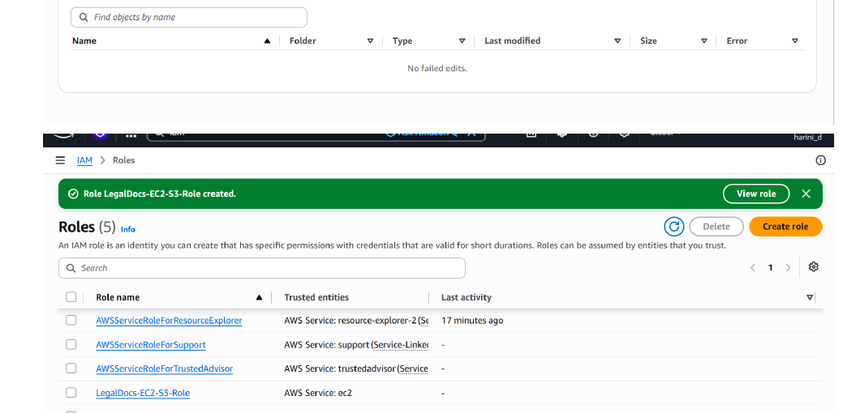
Figure 7. LegalDocs-EC2-S3-Role created successfully with EC2 as the trusted service.

3.2 Launch the EC2 Application Server
20. Open EC2 — AWS Console → EC2 → Instances → Launch instance.
21. Configure the instance — Select the required Amazon Linux/approved AMI, instance type, key pair, VPC/subnet and security group for the practical.
22. Attach IAM role — In Advanced details, select LegalDocs-EC2-S3-Role as the IAM instance profile.
23. Launch — Launch the EC2 instance and wait for the instance to enter the Running state and pass its status checks.
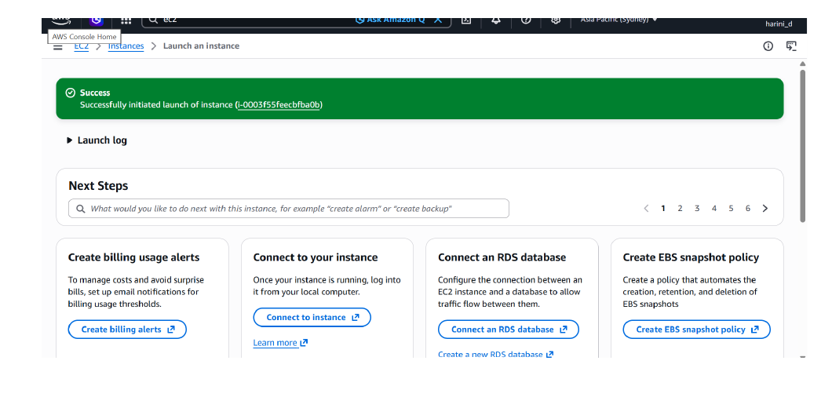
Figure 8. EC2 instance launch completed successfully.

3.3 Data Integration with S3
24. Connect to EC2 — From EC2 → Instances, select the running instance → Connect → use the available EC2 Instance Connect/SSH method.
25. Prepare the application — Install the runtime and dependencies required by the LegalDocs application and copy/deploy the application to the EC2 instance.
26. Use IAM-based S3 access — Configure the application to use the attached EC2 IAM role for S3 access rather than embedding AWS access keys in the application.
27. Test upload — Upload a LegalDocs document through the application and verify that the object is created in the LegalDocs S3 bucket.
28. Test retrieval — Retrieve/download the uploaded document through the application and verify successful access from S3.
29. Verify integration — Confirm that the application can perform the required S3 operations using the IAM role and that the S3 bucket remains non-public.

3.4 CloudWatch Monitoring
30. Open CloudWatch — AWS Console → CloudWatch.
31. Monitor resources — Monitor the EC2/application resources and relevant AWS metrics/logs.
32. Create an alarm — Create an appropriate CloudWatch alarm for the selected application/EC2 metric and configure notification if required.
33. Verify monitoring — Confirm that the metric is visible and the alarm is in the expected state.

4. Final End-to-End Verification
- LegalDocs S3 bucket exists and stores the customer document.
- Document upload to S3 succeeds.
- S3 Lifecycle rule LegalDocs-Lifecycle-Rule is enabled.
- Storage-class management has been demonstrated successfully.
- IAM role LegalDocs-EC2-S3-Role has been created for EC2 access.
- EC2 instance has been launched successfully.
- The deployed application uses the EC2 IAM role to access S3.
- Application upload and retrieval of LegalDocs documents are verified.
- CloudWatch monitoring and alarms are configured for the deployed resources.

5. Expected Final Architecture
Employee → LegalDocs Application on EC2 → IAM Role → Amazon S3
↓
S3 Lifecycle Management
Standard → IA → Glacier → Expiration
↓
CloudWatch Monitoring

6. Evidence Status from the Supplied PDF
The supplied PDF directly evidences: S3 bucket creation, file upload, lifecycle rule creation and enabled status, a successful storage-class edit, IAM role creation, and successful EC2 launch. The PDF does not contain a screenshot proving application execution on EC2 or CloudWatch configuration; those should be captured after completing the corresponding Round 3 steps.

