AWS CLI + GUI DevOps Lab Guide

Overview
- CLI: VPC, Subnets, Route Tables, NACL, Security Group
- GUI: IAM Role, EC2 Instance
- Region: us-east-1

: EC2 Instance (GUI)
1. Go to EC2 Console → Launch Instance
2. Name: DevOps-Server
3. AMI: Ubuntu (e.g., ami-0fc5d935ebf8bc3bc)
4. Instance type: t2.micro
5. Key pair: DevOps-Key
6. Network: Select DevOps-VPC, DevOps-Public-Subnet
7. Security Group: DevOps-SG
8. IAM Role: Attach DevOps-Profile
9. Enable public IP.
10. Launch.
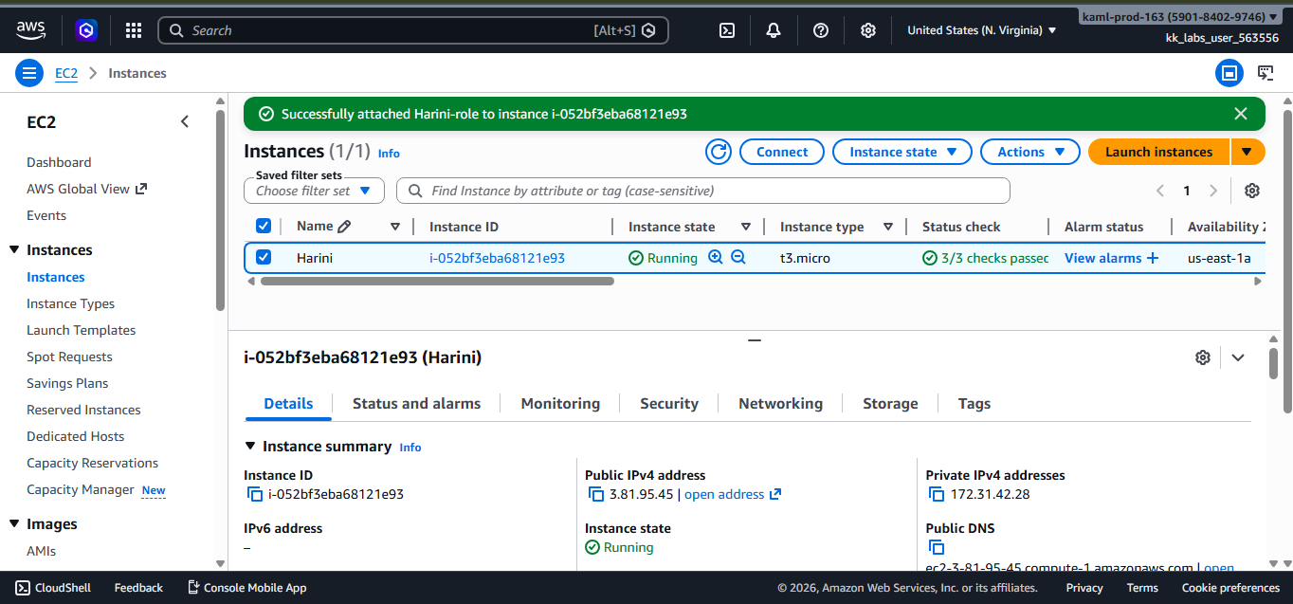

Section 2: IAM Role (GUI)
1. Go to IAM Console → Roles → Create Role
2. Select EC2 as trusted entity.
3. Attach policies:
- AmazonSSMManagedInstanceCore
- AmazonS3ReadOnlyAccess
4. Name role: DevOps-EC2-Role
5. Create Instance Profile (IAM → Instance Profiles → Create → Add Role).
6. Name profile: DevOps-Profile.
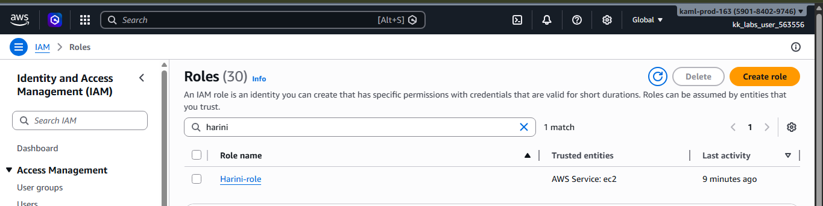

Section 3: Prerequisites

Install AWS CLI
Commands:
curl "https://awscli.amazonaws.com/awscli-exe-linux-x86_64.zip" -o "awscliv2.zip"
unzip awscliv2.zip
sudo ./aws/install
aws --version
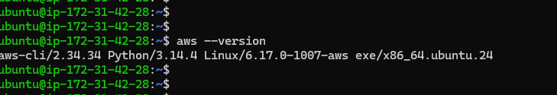

Section 4: Network Setup (CLI)
Variables:
REGION=us-east-1
AZ=us-east-1a
VPC_CIDR=10.0.0.0/16
PUBLIC_SUBNET_CIDR=10.0.1.0/24
PRIVATE_SUBNET_CIDR=10.0.2.0/24
Step 1: Create VPC
VPC_ID=$(aws ec2 create-vpc --cidr-block $VPC_CIDR --region $REGION --query 'Vpc.VpcId' --output text)
aws ec2 create-tags --resources $VPC_ID --tags Key=Name,Value=harini-VPC --region $REGION
aws ec2 modify-vpc-attribute --vpc-id $VPC_ID --enable-dns-support '{"Value":true}' --region $REGION
aws ec2 modify-vpc-attribute --vpc-id $VPC_ID --enable-dns-hostnames '{"Value":true}' --region $REGION
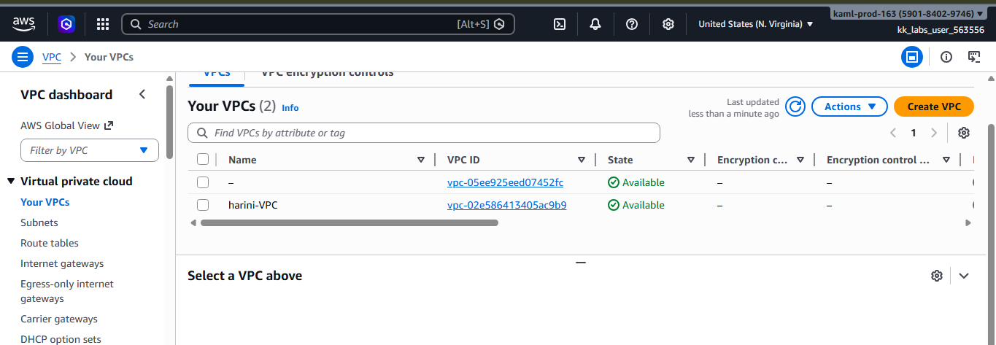
Step 2: Create Internet Gateway
IGW_ID=$(aws ec2 create-internet-gateway --region $REGION --query 'InternetGateway.InternetGatewayId' --output text)
aws ec2 create-tags --resources $IGW_ID --tags Key=Name,Value=harini-IGW --region $REGION
aws ec2 attach-internet-gateway --internet-gateway-id $IGW_ID --vpc-id $VPC_ID --region $REGION
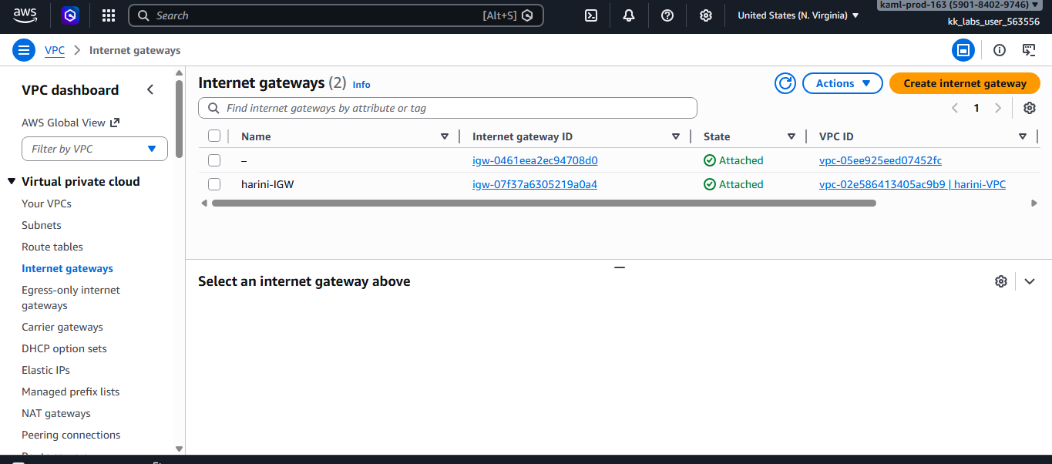
Step 3: Create Public Subnet
PUB_SUBNET_ID=$(aws ec2 create-subnet --vpc-id $VPC_ID --cidr-block $PUBLIC_SUBNET_CIDR --availability-zone $AZ --region $REGION --query 'Subnet.SubnetId' --output text)
aws ec2 create-tags --resources $PUB_SUBNET_ID --tags Key=Name,Value=harini-Public-Subnet --region $REGION
aws ec2 modify-subnet-attribute --subnet-id $PUB_SUBNET_ID --map-public-ip-on-launch --region $REGION
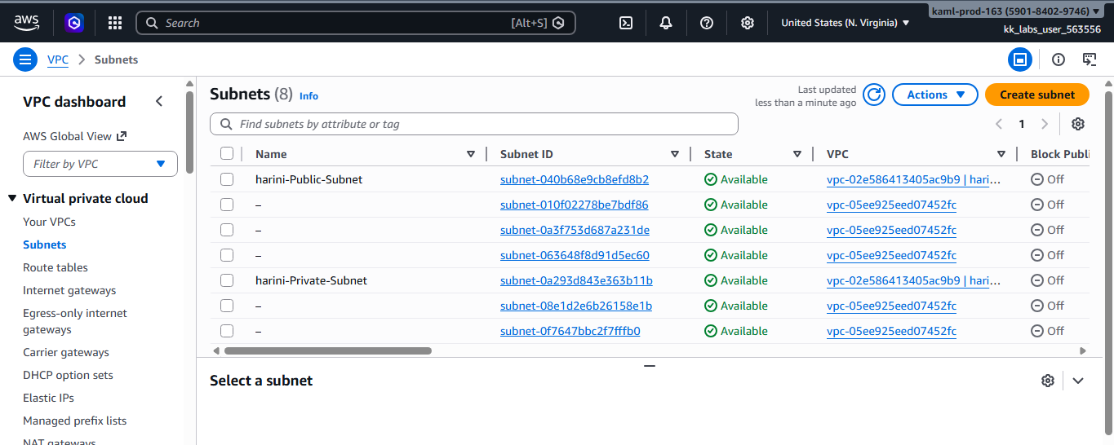
Step 4: Create Private Subnet
PRIV_SUBNET_ID=$(aws ec2 create-subnet --vpc-id $VPC_ID --cidr-block $PRIVATE_SUBNET_CIDR --availability-zone $AZ --region $REGION --query 'Subnet.SubnetId' --output text)
aws ec2 create-tags --resources $PRIV_SUBNET_ID --tags Key=Name,Value=harini-Private-Subnet --region $REGION

Step 5: Create Public Route Table
PUB_RT_ID=$(aws ec2 create-route-table --vpc-id $VPC_ID --region $REGION --query 'RouteTable.RouteTableId' --output text)
aws ec2 create-tags --resources $PUB_RT_ID --tags Key=Name,Value=harini -Public-RT --region $REGION
aws ec2 create-route --route-table-id $PUB_RT_ID --destination-cidr-block 0.0.0.0/0 --gateway-id $IGW_ID --region $REGION
aws ec2 associate-route-table --route-table-id $PUB_RT_ID --subnet-id $PUB_SUBNET_ID --region $REGION

Step 6: Create Private Route Table
PRIV_RT_ID=$(aws ec2 create-route-table --vpc-id $VPC_ID --region $REGION --query 'RouteTable.RouteTableId' --output text)
aws ec2 create-tags --resources $PRIV_RT_ID --tags Key=Name,Value=harini-Private-RT --region $REGION
aws ec2 associate-route-table --route-table-id $PRIV_RT_ID --subnet-id $PRIV_SUBNET_ID --region $REGION
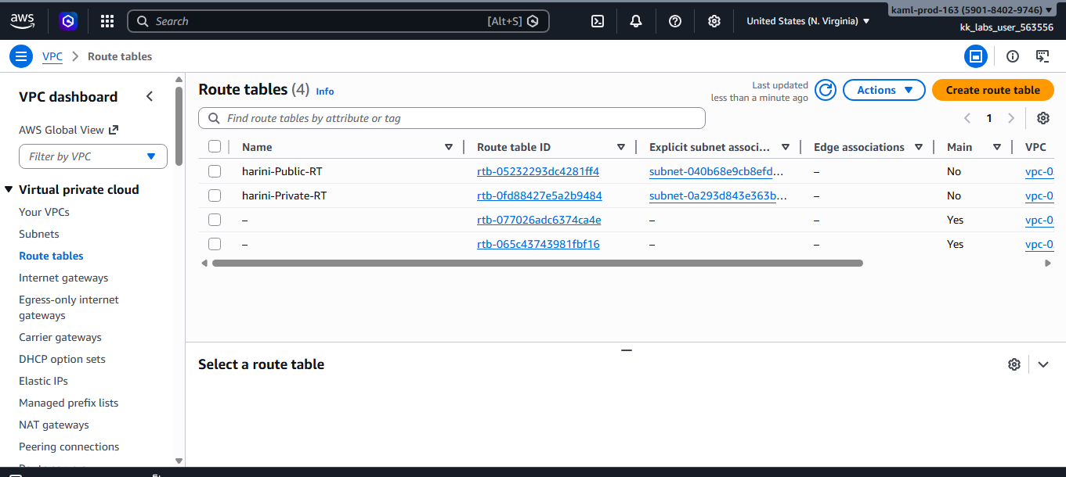
Step 7: Create NACL
NACL_ID=$(aws ec2 create-network-acl --vpc-id $VPC_ID --region $REGION --query 'NetworkAcl.NetworkAclId' --output text)
aws ec2 create-tags --resources $NACL_ID --tags Key=Name,Value=harini-NACL --region $REGION
aws ec2 create-network-acl-entry --network-acl-id $NACL_ID --rule-number 100 --protocol tcp --port-range From=80,To=80 --cidr-block 0.0.0.0/0 --rule-action allow --ingress --region $REGION
aws ec2 create-network-acl-entry --network-acl-id $NACL_ID --rule-number 110 --protocol tcp --port-range From=22,To=22 --cidr-block 0.0.0.0/0 --rule-action allow --ingress --region $REGION
aws ec2 create-network-acl-entry --network-acl-id $NACL_ID --rule-number 100 --protocol -1 --cidr-block 0.0.0.0/0 --rule-action allow --egress --region $REGION
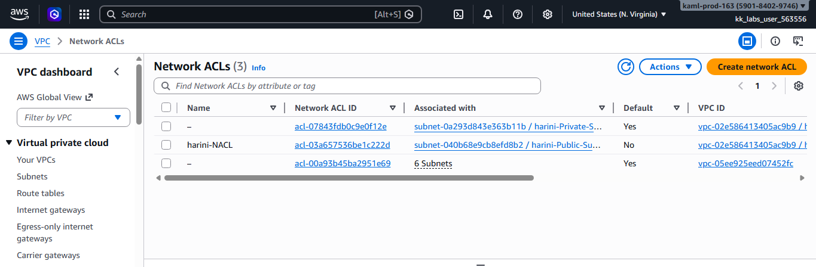
Step 8: Create Security Group
SG_ID=$(aws ec2 create-security-group --group-name DevOps-SG --description 'Allow SSH and HTTP' --vpc-id $VPC_ID --region $REGION --query 'GroupId' --output text)
aws ec2 create-tags --resources $SG_ID --tags Key=Name,Value=harini-SG --region $REGION
aws ec2 authorize-security-group-ingress --group-id $SG_ID --protocol tcp --port 22 --cidr 0.0.0.0/0 --region $REGION
aws ec2 authorize-security-group-ingress --group-id $SG_ID --protocol tcp --port 80 --cidr 0.0.0.0/0 --region $REGION
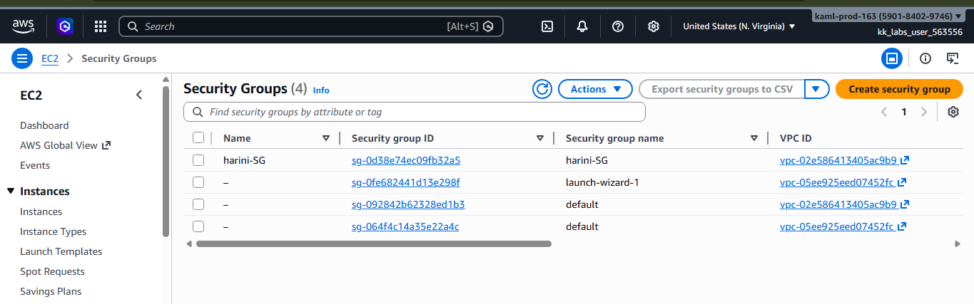

Section 5: Verification (CLI)
aws ec2 describe-vpcs --region $REGION
aws ec2 describe-subnets --region $REGION
aws ec2 describe-instances --region $REGION
aws iam get-role --role-name DevOps-EC2-Role

Notes
- Replace AMI if needed.
- Use least privilege policies.
- Restrict SSH CIDR.

