**CODING:**

#!/usr/bin/python

import time

import RPi.GPIO as GPIO

import time

import os, sys

from urllib.parse import urlparse import paho.mqtt.client as paho

GPIO.setmode (GPIO.BOARD)

GPIO.setwarnings (False)

#define pin for lcd.

# Timing constants

E_PULSE = 0.0005

E_DELAY 0.0005

delay = 1

# Define GPIO to LCD mapping

LCD_RS = 7

LCD_E = 11

LCD_D4 = 12

LCD_D5 = 13

LCD_D6 = 15

LCD D7 = 16

slot1_Sensor = 29

slot2_Sensor = 31

GPIO.setup(LCD_E, GPIO.OUT) # E

GPIO.setup(LCD_RS, GPIO.OUT) # RS

GPIO.setup(LCD_D4, GPIO.OUT) # DB4 GPIO.setup(LCD_D5, GPIO.OUT) # DB5

GPIO.setup(LCD_D6, GPIO.OUT) # DB6

GPIO.setup(LCD_D7, GPIO.OUT) # DB7 GPIO.setup(slot1_Sensor, GPIO.IN)

GPIO.setup(slot2_Sensor, GPIO.IN)

# Define some device constants

LCD_WIDTH = 16 # Maximum characters per line

LCD_CHR = True

LCD_CMD= False

LCD_LINE_1 = 0x80 # LCD RAM address for the 1st line.

LCD_LINE_2 = 0xC0 # LCD RAM address for the 2nd line

LCD_LINE_3 = 0x90# LCD RAM address for the 3nd line

def on_connect(self, mosq, obj, rc):

self.subscribe("Fan", 0)

def on_publish(mosq, obj, mid):

print("mid: " + str(mid)) mqttc paho.Client()

object declaration

# Assign event callbacks mqttc.on_connect on connect mqttc.on_publish on publish

url_str=os.environ.get('CLOUDMQTT_URL', 'tcp://broker.emqx.io: 1883') url =

urlparse(url_str) mqttc.connect(url.hostname, url.port)

Function Name :lcd_init()

Function Description: this function is used to initialized lcd by sending the different

def lcd_init():

# Initialise display

lcd_byte(0x33, LCD_CMD)

# 110011 Initialise

lcd_byte(0x32, LCD_CMD)

# 110010 Initialise

lcd_byte(0x06, LCD_CMD)

# 000110 Cursor move

direction

lcd_byte(0x0C, LCD_CMD)

# 001100 Display On,

Cursor Off, Blink off

lcd_byte(0x28, LCD_CMD) #

101000 Data length,

number of lines, font size

lcd_byte(0x01, LCD_CMD) #

000001 Clear display

time.sleep(E_DELAY)

Function Name: lcd_byte(bits,mode)

Fuction Name: the main purpose of this function to convert the byte data into bit and send to

lcd port

def lcd_byte(bits, mode):

# Send byte to data pins

# bits = data

# mode = True for character

#False for command

GPIO.output (LCD_RS,

mode) # RS

# High bits

GPIO.output (LCD_D4, False) GPIO.output (LCD_D5, False)

GPIO.output (LCD_D6, False) GPIO.output (LCD_D7, False)

if bits&0x10==0x10:

GPIO.output (LCD_D4, True)

if bits&0x20==0x20:

GPIO.output (LCD_D5, True)

if bits&0x40==0x40:

GPIO.output (LCD_D6, True)

if bits&0x80==0x80:

GPIO.output (LCD_D7, True)

# Toggle 'Enable' pin lcd_toggle_enable()

# Low bits

GPIO.output (LCD_D4, False)

GPIO.output (LCD_D5, False)

GPIO.output (LCD_D6, False) GPIO.output (LCD_D7, False)

if bits&0x01==0x01:

GPIO.output (LCD_D4, True)

if bits&0x02==0x02:

GPIO.output (LCD_D5, True)

if bits&0x04==0x04:

GPIO.output (LCD_D6, True)

if bits&0x08==0x08:

GPIO.output (LCD_D7, True)

# Toggle 'Enable' pin lcd_toggle_enable()

Function Name: lcd_toggle_enable()

Function Description: basically this is used to toggle Enable pin

def lcd_toggle_enable():

# Toggle enable

time.sleep(E_DELAY)

GPIO.output (LCD_E, True)

time.sleep(E_PULSE)

GPIO.output (LCD_E, False)

time.sleep(E_DELAY)

Function Name : lcd_string(message, line) Function Description: print the data on lcd

def lcd_string (message, line):

# Send string to display

message= message.1just

(LCD_WIDTH," ")

lcd_byte(line, LCD_CMD)

for i in range(LCD_WIDTH):

lcd_byte(ord(message[i]),

LCD_CHR)

lcd_init()

lcd_string("welcome",LCD_LINE_1)

time.sleep(0.5)

lcd_string("Car Parking ", LCD_LINE_1)

lcd_string("System ", LCD_LINE_2) time.sleep(0.5)

lcd_byte(0x01, LCD_CMD) # 000001 Clear display

# Define delay between readings delay = 5

while 1:

# Print out results

rc = mqttc.loop()

slot1_status = GPIO. input

(slot1_Sensor)

time.sleep(0.2)

slot2_status = GPIO.input

(slot2_Sensor)

time.sleep(0.2)

if (slot1_status==False):

lcd_string("Slot1 Parked ',

LCD_LINE_1)

mqttc.publish("slot1", "1")

time.sleep(0.2)

else:

lcd_string("Slot1 Free ",

LCD_LINE_1)

mqttc.publish("slot1","0")

time.sleep(0.2)

if (slot2_status == False):

lcd_string("Slot2 Parked ",

LCD_LINE_2)

mqttc.publish("slot2", "1")

time.sleep(0.2)

else:

lcd_string("Slot2 Free ",

LCD_LINE_2)

mqttc.publish("slot2","0")

time.sleep(0.2)

**OUTPUT :**

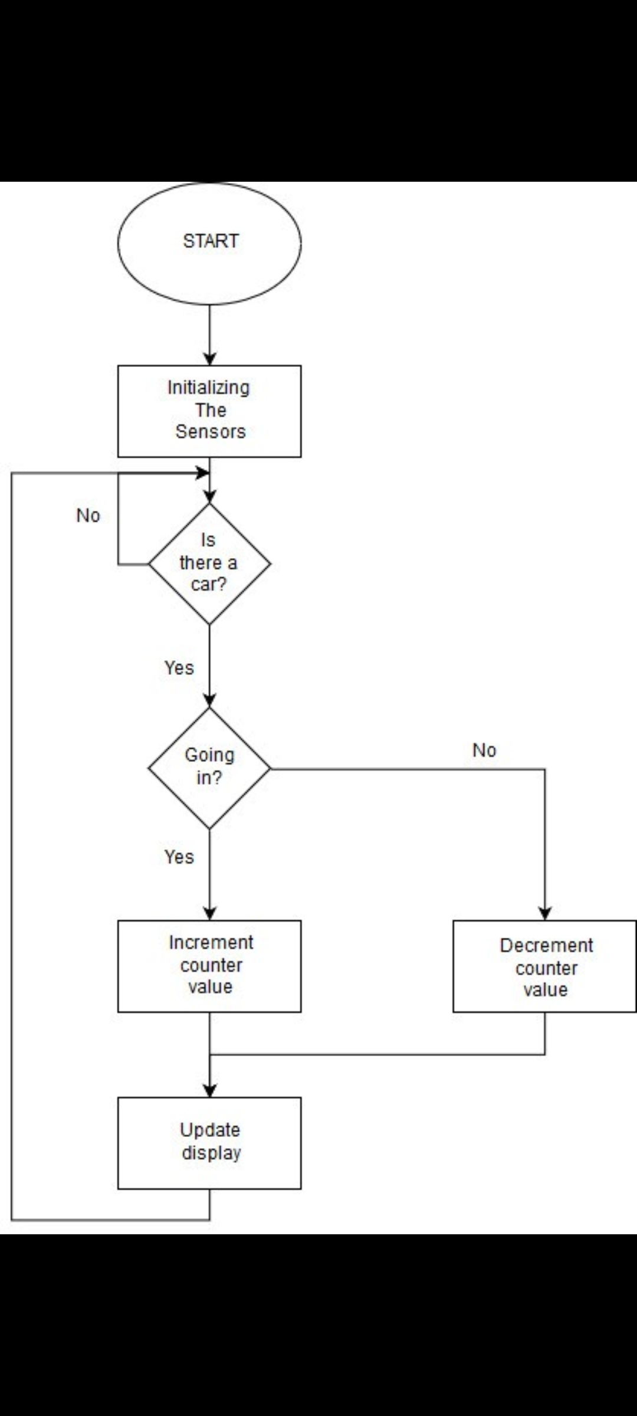

**CONNECTION:**

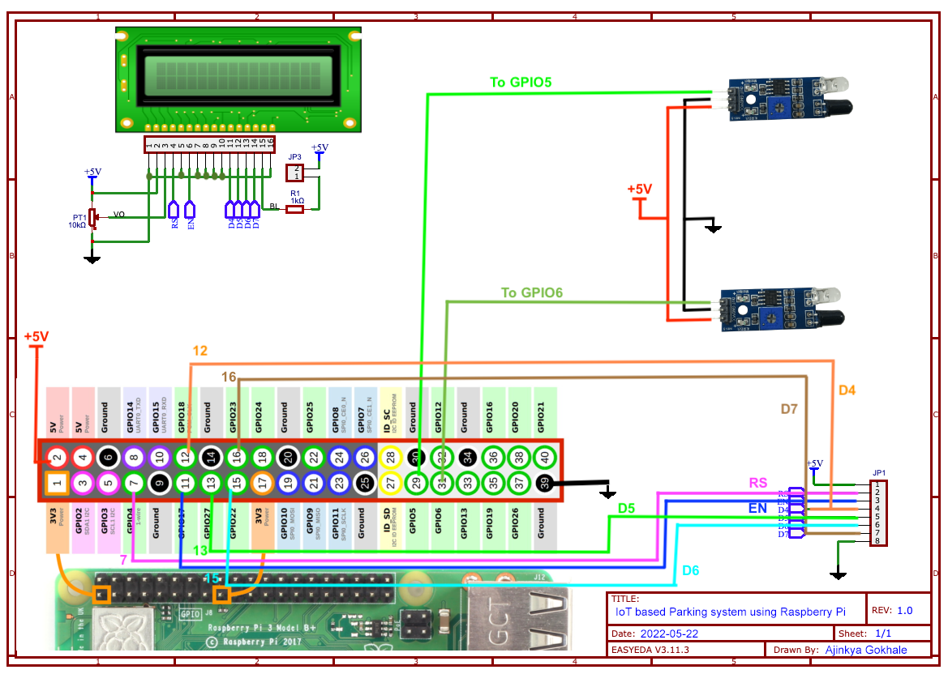

**OUTPUT:**

Output 1:

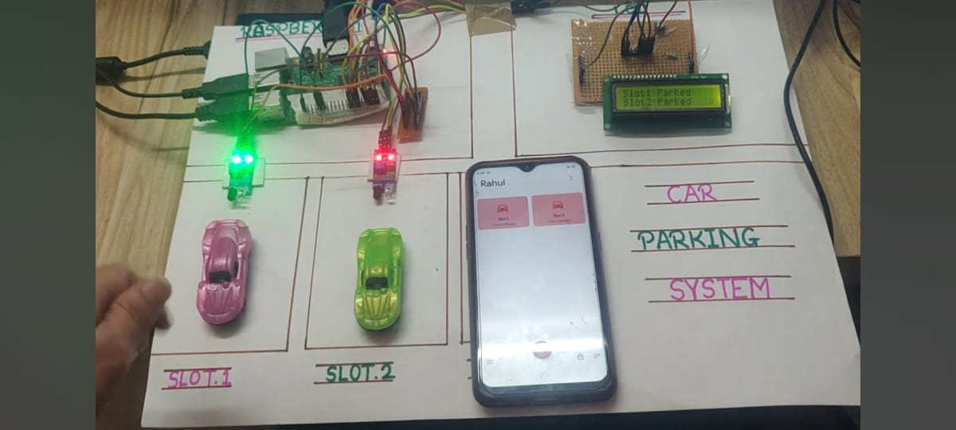

Output 2:

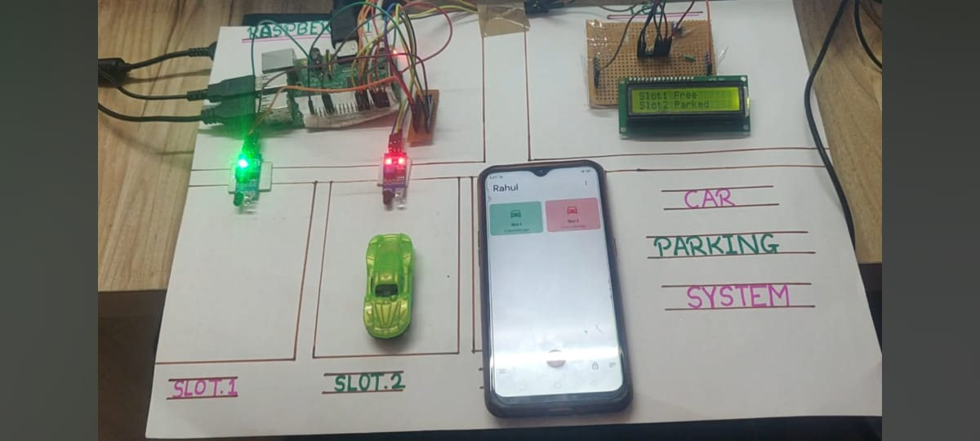

Output 3:

