Assignment-1

2303A52426


WEEK-1-(GREEDY TECHNIQUE)
Problem Statement:
You are given N meetings. Each meeting has a start time Si and an end time Ei. You want to attend the maximum number of meetings. You can attend meeting j after meeting i,
only if the start time of meeting j is strictly greater than the end time of meeting i (Sj > Ei). For each test case, output the maximum number of meetings that can be attended.
Input Format: The first line contains an integer T, the number of test cases. For each test case:
- The first line contains an integer N.
- The next N lines each contain two integers Si and Ei.
Output Format: For each test case, print a single integer: the maximum number of meetings that can be attended.
Constraints:
- 1 ≤ T ≤ 20
- 1 ≤ N ≤ 200000 (sum of N over all test cases ≤ 200000)
- 0 ≤ Si < Ei ≤ 10^9 Sample Input:

1
3
1 3
2 4
3 5
Expected Output: 2

Python Code:
T = int(input()) for _ in range(T):
N = int(input()) meetings = []
for _ in range(N):
s, e = map(int, input().split()) meetings.append((s, e))
# Sort meetings by end time meetings.sort(key=lambda x: x[1]) count = 0
last_end = -1
for s, e in meetings:
if s >= last_end: # ALLOW equal start and end
count += 1 last_end = e

print(count)
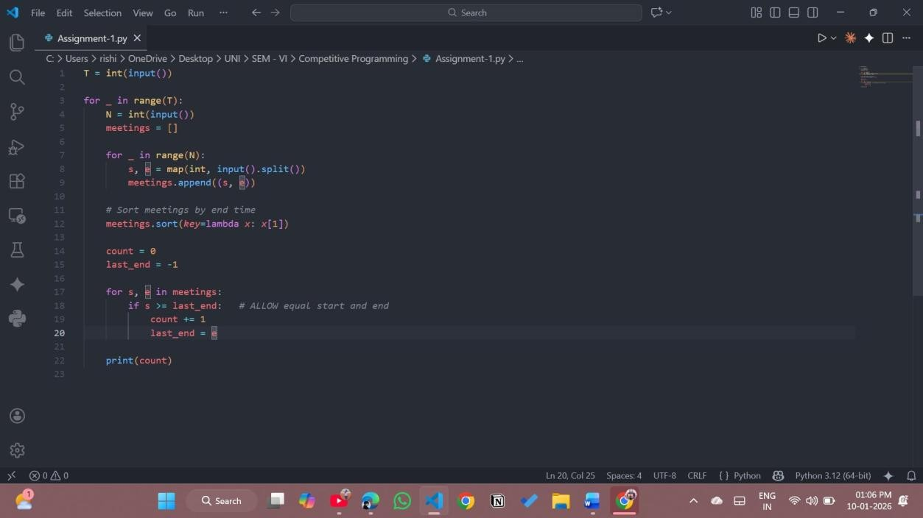

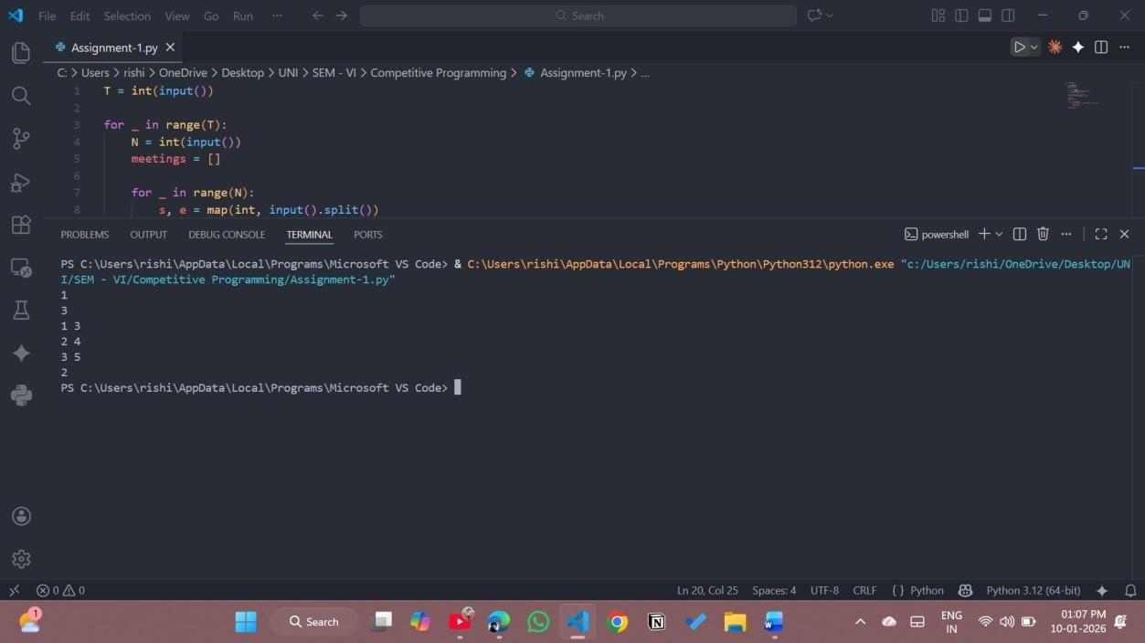

C Code:
#include <stdio.h> #include <stdlib.h> struct Meeting {
long long start; long long end;
};
// Comparator to sort by end time
int compare(const void *a, const void *b) { struct Meeting *m1 = (struct Meeting *)a; struct Meeting *m2 = (struct Meeting *)b;
return (m1->end > m2->end) - (m1->end < m2->end);
}
int main() { int T;
scanf("%d", &T);
while (T--) { int N;
scanf("%d", &N);
struct Meeting *meetings =
(struct Meeting *)malloc(N * sizeof(struct Meeting));

for (int i = 0; i < N; i++) {
scanf("%lld %lld", &meetings[i].start, &meetings[i].end);
}
// Sort meetings by end time
qsort(meetings, N, sizeof(struct Meeting), compare); int count = 0;
long long last_end = -1; for (int i = 0; i < N; i++) {
if (meetings[i].start >= last_end) { // STRICT condition count++;
last_end = meetings[i].end;
}
}
printf("%d\n", count); free(meetings);
}
return 0;
}

