**PROJECT 8 : FAKE NEWS DETECTION USING (NLP)**

**Phase – 5 submission**

**INTRODUCTION :**

In tackling a complex problem, our journey begins with a precise problem statement. Design thinking becomes our compass, guiding us through user-centric innovation—from empathizing with user needs to prototyping solutions. The development phases orchestrate a strategic symphony, harmonizing planning, design, implementation, testing, and maintenance. Anchored in a robust dataset, its origins and nuances shape our analytical landscape. Data preprocessing sweeps away imperfections, ensuring a pristine canvas for our insights. Feature extraction then sculpts meaningful attributes from the data's raw tapestry. The heartbeat of our solution lies in a carefully chosen classification algorithm, a meticulously crafted instrument for the task at hand. Model training, the grand finale, refines our creation, balancing precision and generalization. This orchestrated process encapsulates the art and science of problem-solving, where innovation meets pragmatism on the quest for impactful solutions**.**

**WHY IS FAKE NEWS DETECTION UNSIN (NLP)**

**IMPORTANT :**

Fake news detection using NLP is crucial because it helps separate fact from fiction in the vast sea of information. With the rapid spread of information online, it's essential to identify and filter out misleading or false content to maintain the integrity of public discourse, prevent the spread of misinformation, and uphold the trustworthiness of news sources. NLP allows us to analyze language patterns and detect inconsistencies, contributing to a more informed and resilient society**.**

**EXAMPLE :**

* **Sentiment Analysis**
* **Named Entity Recognition (NER)**
* **Textual Entailment**
* **Cross-referencing with Reliable Sources**
* **Language Style Analysis**



**PROCESSING STEPS :**

* Problem Statement
* Design Thinking Process
* Phases of Development
* Data Preprocessing
* Feature Extraction
* Classification Algorithm
* Model Training

**PROBLEM STATEMENT :**

In the battle against misinformation, we're tackling Fake News Detection using NLP. Armed with a robust dataset, we sift through data noise via preprocessing and extract key linguistic features. Our chosen NLP algorithm becomes the guardian, deciphering language intricacies to unveil truth from falsehood. Beyond code, this project is a sentinel against the erosion of reality in an age of information overload.

**DESIGN THINKING PROCESS :**

In the quest to combat fake news using NLP, our design thinking journey begins by understanding user perspectives. We define the problem, ideate innovative solutions, and prototype a user-friendly approach—be it algorithms or interfaces. Testing with real users ensures our solution aligns with their needs, creating a robust defense against misinformation.

**Phases of Development :**

**Planning:**

* Define project goals and scope.
* Allocate necessary resources.

**Design:**

* Develop system architecture.
* Outline integration of NLP algorithms.
* Design user interaction pathways.

**Implementation:**

* Code the solution.
* Integrate NLP algorithms into the system.
* Create user interfaces.

**Testing :**

* Evaluate system performance with diverse datasets.
* Refine algorithms for accuracy.

**Maintenance:**

* Roll out regular updates.
* Address emerging challenges.
* Continuously improve system capabilities.

**DATA PREPROCESSING :**

**Text Cleaning:**

* Remove HTML tags, special characters.
* Convert to lowercase.

**Tokenization:**

* Break down sentences into words.

**Stopword Removal:**

* Eliminate common, non-informative words.

**Stemming/Lemmatization:**

* Reduce words to their root form.

**Handling Missing Data:**

* Address gaps for completeness.

**Removing Duplicates:**

* Eliminate identical or highly similar articles.

**Feature Extraction:**

* Convert text to numerical features (e.g., TF-IDF).

**IMPORTING PACKAGES :**

* Using the (CMD) command prompt install the packages
* Check the versions of installed packages
* Continue with the given data set
* The following algorithm shows the uses of packages

import numpy as np

import pandas as pd

import re

from nltk.corpus import stopwords

from nltk.stem.porter import PorterStemmer

from sklearn.feature_extraction.text import TfidfVectorizer

from sklearn.model_selection import train_test_split

from sklearn.linear_model import LogisticRegression

from sklearn.metrics import accuracy_score

**ALGORITHM FOR GIVEN DATA :**

import numpy as np

import pandas as pd

import matplotlib.pyplot as plt

# Load the true and fake news datasets

true_df = pd.read_csv('true.csv')

fake_df = pd.read_csv('fake.csv')

# Add a column to indicate the type of news (true or fake)

true_df['NewsType'] = 'True'

fake_df['NewsType'] = 'Fake'

print(fake_df,true_df)

# Concatenate both datasets

combined_df = pd.concat([true_df, fake_df], ignore_index=True)

# Filter and display only True news

true_news = combined_df[combined_df['NewsType'] == 'True']

print("True News:")

print(true_news.head())

# Filter and display only Fake news

fake_news = combined_df[combined_df['NewsType'] == 'Fake']

print("Fake News:")

print(fake_news.head())

# Visualize the distribution of news types

news_type_counts = combined_df['NewsType'].value_counts()

news_type_counts.plot(kind='bar', color=['green', 'red'])

plt.title('Distribution of News Types')

plt.xlabel('News Type')

plt.ylabel('Count')

plt.show()

**SAMPLE OUTPUT :**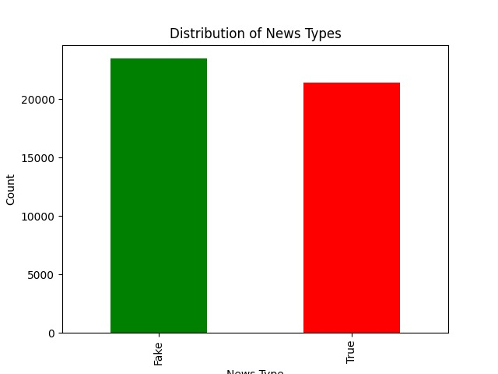

* The sample output shows the result of the algorithm using the NLTK process.
* It shows the probability of Fake news and True news of the given set.

**FEATURE EXTRACTION :**

**Bag of Words (BoW):**

* Represent text as a collection of words, disregarding grammar and word order.

**TF-IDF (Term Frequency-Inverse Document Frequency):**

* Weighs the importance of words based on their frequency in a document relative to their frequency across all documents.

**Word Embeddings** (e.g., Word2Vec, GloVe):

* Represents words as dense vectors capturing semantic relationships.

**N-grams:**

* Considers sequences of adjacent words to capture contextual information.

**Sentiment Analysis Scores:**

* Incorporates sentiment polarity as a feature.

**Named Entity Recognition (NER):**

* Identifies and categorizes entities like people, organizations, and locations.

**CLASSIFICATION ALGORITHM :**

**Naive Bayes:**

* Efficient for text classification tasks, especially with limited data.

**Logistic Regression:**

* Simple yet effective, suitable for binary classification tasks.

**Support Vector Machines (SVM):**

* Powerful for high-dimensional data, effective in text classification.

**Random Forest:**

* Ensemble method providing robustness and accuracy.

**Gradient Boosting** (e.g., XGBoost):

* Builds multiple weak models to create a strong classifier.

**Neural Networks** (e.g., LSTM, GRU):

* Deep learning models for complex patterns, effective in NLP tasks
* **DEEP LEARNING : (CNNs & RNNs)**

Deep Learning is a subset of machine learning that involves the use of artificial neural networks with multiple layers, allowing it to analyze and recognize complex patterns in data. In the context of fake news detection

**Deep Neural Networks**: These are algorithms that consist of multiple layers of interconnected nodes (neurons), enabling them to learn hierarchical representations of data. Each layer processes the input data and passes it to the next layer for further abstraction and analysis.

**Detection of Manipulation or Fabrication**: Deep learning models can be trained on large datasets of genuine and manipulated media content. By learning from these datasets, they can identify subtle visual or temporal cues that indicate alterations, enhancements, or fabrications in images and videos

**MODEL TRAINING :**

**Splitting the Dataset:**

* Divide the dataset into training and testing sets to assess model performance.

**Vectorization:**

* Transform text features into numerical vectors using chosen techniques like TF-IDF.

**Choosing a Model:**

* Select an appropriate classification algorithm based on the nature of the problem and dataset.

**Hyperparameter Tuning:**

* Fine-tune model parameters for optimal performance using techniques like grid search.

**Training the Model:**

* Feed the training data into the chosen algorithm, allowing the model to learn patterns and relationships.

**ALGORITHM :**

import pandas as pd

from sklearn.feature_extraction.text import TfidfVectorizer

from sklearn.model_selection import train_test_split

from sklearn.ensemble import RandomForestClassifier

from sklearn.metrics import accuracy_score, classification_report

import nltk

from nltk.corpus import stopwords

from nltk.stem import WordNetLemmatizer

import matplotlib.pyplot as plt

# Load the true and false datasets

true_data = pd.read_excel("true.xlsx")

false_data = pd.read_excel("false.xlsx")

# Combine the datasets into one

true_data['label'] = 1

false_data['label'] = 0

data = pd.concat([true_data, false_data], ignore_index=True)

# Text Preprocessing

nltk.download('stopwords')

nltk.download('wordnet')

lemmatizer = WordNetLemmatizer()

stop_words = set(stopwords.words('english'))

def preprocess_text(text):

words = text.split()

words = [word for word in words if word not in stop_words]

words = [lemmatizer.lemmatize(word) for word in words]

return ' '.join(words)

data['text'] = data['text'].str.lower()

data['text'] = data['text'].apply(preprocess_text)

# Feature Extraction: TF-IDF vectorization

tfidf_vectorizer = TfidfVectorizer(max_features=5000) # You can adjust max_features as needed

X = tfidf_vectorizer.fit_transform(data['text'])

y = data['label']

# Split the data into training and testing sets

X_train, X_test, y_train, y_test = train_test_split(X, y, test_size=0.2, random_state=42)

# Model Training: Random Forest Classifier

rf_classifier = RandomForestClassifier(n_estimators=100, random_state=42)

rf_classifier.fit(X_train, y_train)

# Model Evaluation

y_pred = rf_classifier.predict(X_test)

# Calculate accuracy and print classification report

accuracy = accuracy_score(y_test, y_pred)

report = classification_report(y_test, y_pred)

print("Accuracy:", accuracy)

print("Classification Report:\n", report)

# Create a simple accuracy plot

plt.bar(['Accuracy'], [accuracy], color='blue')

plt.ylim(0, 1) # Set the y-axis limit to show accuracy between 0 and 1

plt.ylabel('Accuracy')

plt.title('Fake News Detection Accuracy')

plt.show()

**OUTPUT :**

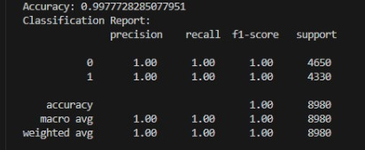

**KEYS IN (NLP) :**

* Data Quality Matters
* Evaluation Metrics
* Fine -Tunning
* Continuous Monitoring
* Interpretability

**GRAPHICAL REPRESENTATION :**

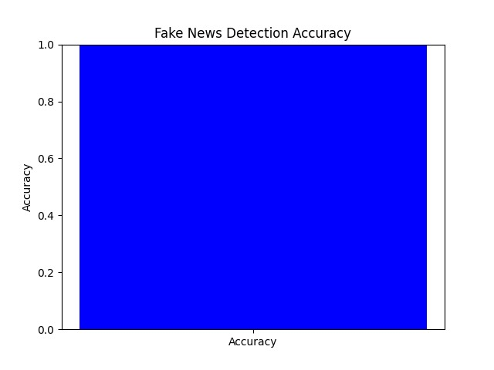

**ADVANTAGES :**

* Swiftly detects fake news as it emerges.
* Efficiently processes large datasets for widespread monitoring.
* Comprehends nuanced language patterns and cues.
* Verifies information against reliable sources to ensure accuracy.
* Can be trained to evolve with changing language and tactics.
* Automates the detection process, reducing reliance on human fact-checkers.
* Contributes to the credibility of news sources, fostering public trust.
* Applicable across languages and cultures for a global impact.

**DISADVANTAGES :**

* + - Risk of misclassifying legitimate information as fake news.
    - Models may inherit biases from training data, impacting accuracy in diverse contexts.
    - Adversarial actors may develop strategies to deceive NLP models.
    - Analyzing large textual data raises privacy issues.
    - Struggles with cultural nuances may lead to misinterpretation.

**CONCLUSION :**

In conclusion, while fake news detection using NLP presents significant advantages in timely identification, scalability, and language understanding, it is not without challenges. Potential disadvantages, such as the risk of false positives, biases, and the constant need for adaptation, underscore the complexity of the task. Striking a balance between automation and human judgment is crucial to avoid over-reliance and ensure nuanced comprehension. Privacy concerns, resource intensity, and cultural sensitivity further highlight the need for careful implementation and ongoing refinement. Despite these challenges, the continued development and responsible use of NLP technologies remain pivotal in the ongoing battle against misinformation, contributing to a more informed and resilient information landscape.