**AIR QUALITY MONITORING USING ARDUINO-UNO IN WOKWI SIMULATOR**

1. **ARDUINO-UNO**

Arduino Uno R3 is one kind of ATmega328P based microcontroller board. It includes the whole thing required to hold up the microcontroller; just attach it to a PC with the help of a USB cable, and give the supply using AC-DC adapter or a battery to get started.

The term Uno means “one” in the language of “Italian” and was selected for marking the release of Arduino’s IDE 1.0 software. The R3 Arduino Uno is the 3rd as well as most recent modification of the Arduino Uno.

Arduino board and IDE software are the reference versions of Arduino and currently progressed to new releases. The Uno-board is the primary in a sequence of USB-[**Arduino boards**](https://www.elprocus.com/different-types-of-arduino-boards/), & the reference model designed for the Arduino platform.

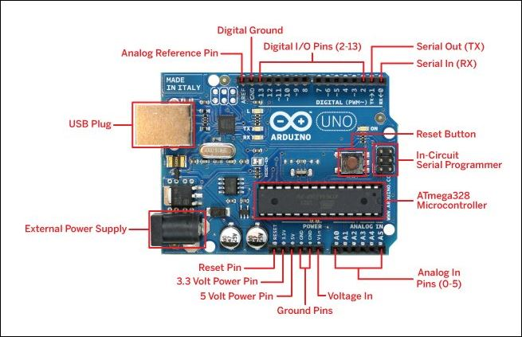

1. **WOKWI**

Wokwi is an online Electronics simulator. Used it to simulate Arduino, ESP32, STM32, and many other popular boards, parts and sensors.

**Features**[**​**](https://docs.wokwi.com/?utm_source=wokwi#unique-features)**:**

* [**WiFi simulation**](https://docs.wokwi.com/guides/esp32-wifi) - Connect your simulated project to the internet. You can use MQTT, HTTP, NTP, and many other network protocols.
* [**Virtual Logic Analyzer**](https://docs.wokwi.com/guides/logic-analyzer) - Capture digital signals in your simulation (e.g. UART, I2C, SPI) and analyze them on your computer.
* [**Advanced debugging with GDB**](https://docs.wokwi.com/gdb-debugging) - Powerful Arduino and Raspberry Pi Pico debugger for advanced users.
* [**SD card simulation**](https://docs.wokwi.com/parts/wokwi-microsd-card) - Store and retrieve files and directories from your code. [Paying users](https://wokwi.com/pricing?ref=docs_sdcard) can also upload binary files (such as images)
* [**Chips API**](https://docs.wokwi.com/chips-api/getting-started) - Create your own custom chips and parts, and share them with the community.
* [**Visual Studio Code integration**](https://docs.wokwi.com/vscode/getting-started) - Simulate your embedded projects directly from VS Code.

1. **OLED**

OLED (Organic Light Emitting Diodes) is a flat light emitting technology, made by placing a series of organic thin films between two conductors. When electrical current is applied, a bright light is emitted. OLEDs are emissive displays that do not require a backlight and so are thinner and more efficient than LCD displays (which do require a white backlight).

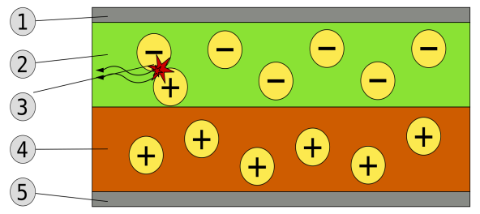

Schematic of a bilayer OLED: 1. Cathode (−), 2. Emissive Layer, 3. Emission of radiation, 4. Conductive layer, 5. Anode (+)

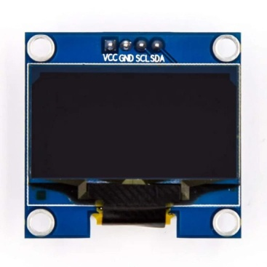

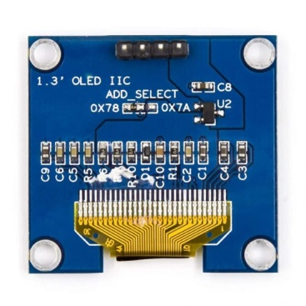

1. **SKETCH CODE**

#include <Wire.h>

#include <Adafruit_SSD1306.h>

#define POT_PIN A0

#define BUZZER_PIN 8

Adafruit_SSD1306 display(128, 64, &**Wire**, -1);

void setup() {

  pinMode(POT_PIN, INPUT);

  pinMode(BUZZER_PIN, OUTPUT);

**Serial**.begin(9600);

  if (!display.begin(SSD1306_SWITCHCAPVCC, 0x3C)) {

**Serial**.println(F("SSD1306 allocation failed"));

    for (;;);

  }

  display.clearDisplay();

}

void loop() {

  int sensorValue = analogRead(POT_PIN);

**Serial**.print("Air Quality: ");

**Serial**.println(sensorValue);

  display.clearDisplay();

  display.setTextSize(2);

  display.setTextColor(WHITE);

  display.setCursor(10, 20);

  display.print("AQI: ");

  display.print(sensorValue);

  display.display();

  if (sensorValue > 600) {

    digitalWrite(BUZZER_PIN, HIGH);

  } else {

    digitalWrite(BUZZER_PIN, LOW);

  }

  delay(1000);

}

1. **SETUP**

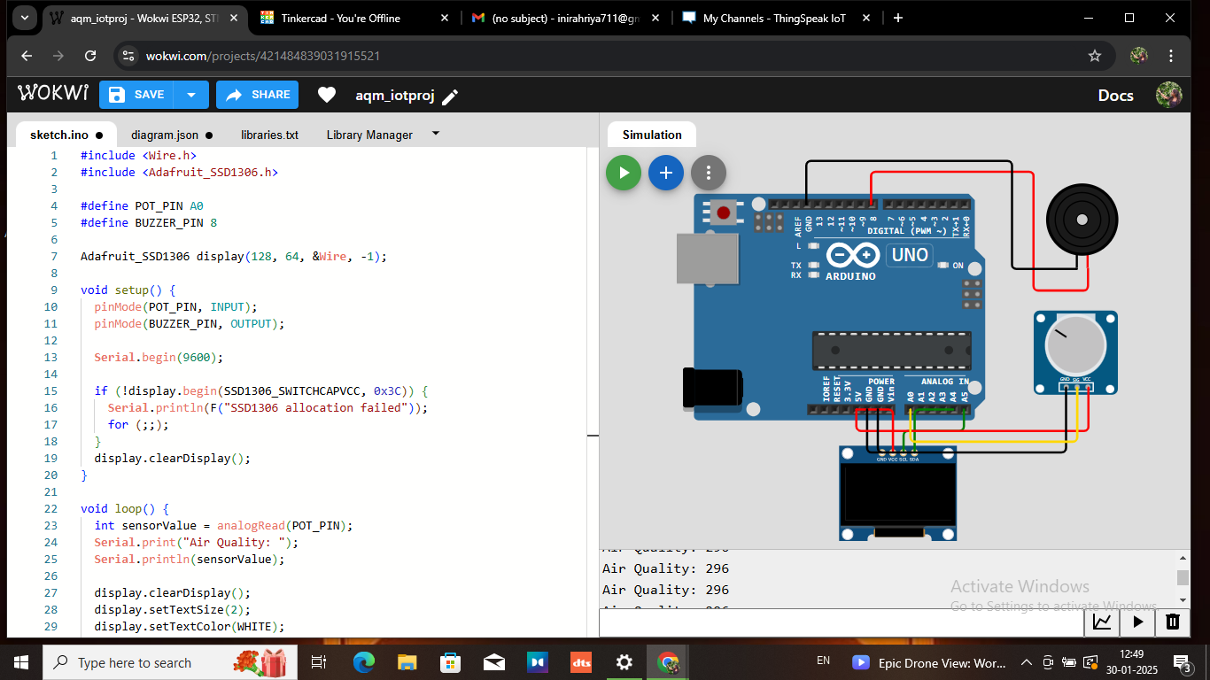

1. **OUTPUT**

