**DISTANCE MEASUREMENT OF OBJECTS USING ULTRASONIC SENSOR AND ARDUINO UNO IN TINKERCAD**

1. **ARDUINO UNO R3**

* The **Arduino UNO R3** is frequently used[**microcontroller board**](https://www.elprocus.com/avr-atmega8-microcontroller-architecture-applications/) in the family of an Arduino(ATmega328P).
* This is the latest third version of an Arduino board and released in the year 2011.
* The main advantage of this board is if we make a mistake we can change the microcontroller on the board.
* The main features of this board mainly include, it is available in DIP (dual-inline-package), detachable and ATmega328 microcontroller.
* The programming of this board can easily be loaded by using an Arduino computer program.

**PIN-DIAGRAM**

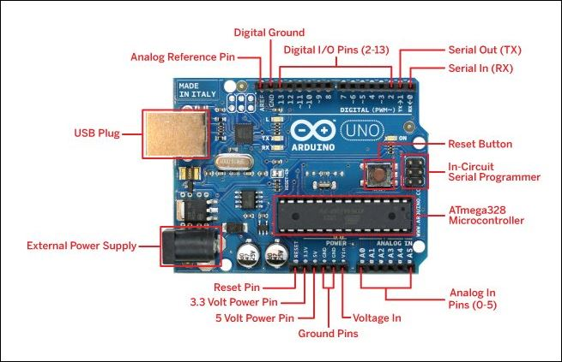

**SPECIFICATIONS**

* It is an ATmega328P based Microcontroller
* The Operating Voltage of the Arduino is 5V
* The recommended input voltage ranges from 7V to 12V
* The i/p voltage (limit) is 6V to 20V
* Digital input and output pins-14
* Digital input & output pins (PWM)-6
* Analog i/p pins are 6
* DC Current for each I/O Pin is 20 mA
* DC Current used for 3.3V Pin is 50 mA
* Flash Memory -32 KB, and 0.5 KB memory is used by the boot loader
* SRAM is 2 KB
* EEPROM is 1 KB
* The speed of the CLK is 16 MHz
* In Built LED
* Length and width of the Arduino are 68.6 mm X 53.4 mm
* The weight of the Arduino board is 25 g

1. **I2C LCD**

* LCD stands for Liquid Crystal Display, flat-paneled display. It uses liquid crystals combined with polarized to display the content. LCD uses the light modulation property of LCD. LCD is available both in Monochrome and Multicolor. It cannot emit light directly without a backlight. In some LCDs, It displays the content only with the help of a backlight in a dark place.

**I2C communication:**

* I2C or IIC stands for Inter-Integrated Communication. I2C is a serial communication interface to communicate with other I2C devices. I2C uses multi-master / multi slave method. I2C uses 2 lines named SCL and SDA for transmission/reception and another 2 lines for power supply and ground. Each and every I2C device has I2C address to identify. I2C addresses of multiple devices may have the same address. The address is in the format of “0x20” (Example address). Steps to find out I2C address device is discussed in the following (step 4).The serial Clock (SCL) pin is to synchronize the transmitter and receiver. Serial Data (SDA) pin is to transfer data.
* I2C LCD uses I2C communication interface to transfer the information required to display the content. I2C LCD requires only 2 lines (SDA and SCL) for transferring the data. So, the complexity of the circuit is reduced.

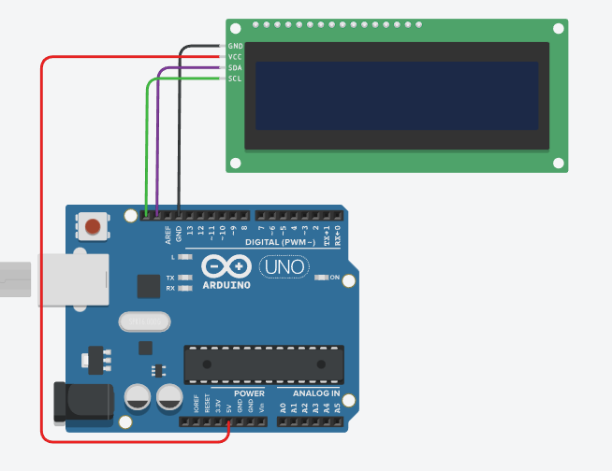

1. **ULTRASONIC SENSOR**

* Sensors are widely used for detecting devices by approximating their distance from the source. One such example of a sensor is the HC-SR04 ultrasonic sensor which uses the SONAR technique for the sensing purpose.
* The main feature of this sensor is to mimic the nature of bats and therefore predict the distance of objects without actually establishing contact with the device.
* The Arduino Ultrasonic Sensor as a device that uses the ultrasonic sensing technique to estimate the distance of an object
* Arduino is used for creating this sensor since it needs to be programmed to detect the reflected rays from objects and display the distance in the desired format.
* Ultrasonic sensor has four terminals namely +5V, Trigger, Echo, and and ground(GND).
* The formula used is distance is half times the speed multiplied by the time.

**Distance =(speed × times)/2**

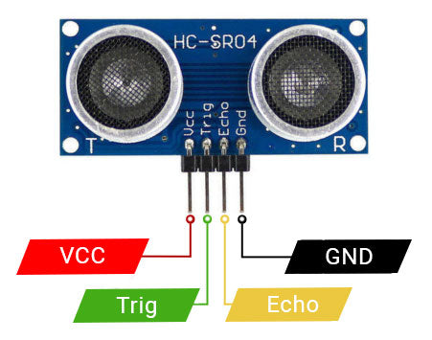

1. **TINKERCAD**

* Tinkercad is a free, online 3D modeling tool that allows users to create and modify 3D objects. It's owned by Autodesk and is often used for 3D printing.

**Features:**  
**Easy to use**: Tinkercad has a simple learning curve and is often used as an introduction to 3D design in schools   
**3D printing**: Users can export their designs for 3D printing   
Electronic circuits: Users can build electronic circuits and coding blocks to control their 3D objects   
**Align objects**: Users can preview and align multiple objects along any axis   
Custom code blocks: Users can create custom code blocks by making changes to an existing code block

1. **SKETCH CODE**

#include <Wire.h>

#include <LiquidCrystal_I2C.h>

LiquidCrystal_I2C lcd(0x27, 16, 2);

#define trigPin A0

#define echoPin A1

long distanceInch;

void setup()

{

  pinMode(trigPin, OUTPUT);

  pinMode(echoPin, INPUT);

  lcd.init();

  lcd.backlight();

  lcd.clear();

  lcd.setCursor(0,0);

  lcd.print("Simple  Circuits");

  delay(2000);

  lcd.clear();

  lcd.setCursor(0,0);

  lcd.print("Distance:");

  lcd.setCursor(0,1);

  lcd.print("Distance:");

}

void loop()

{

  long duration, distance;

  digitalWrite(trigPin, LOW);

  delayMicroseconds(2);

  digitalWrite(trigPin, HIGH);

  delayMicroseconds(10);

  digitalWrite(trigPin, LOW);

  duration = pulseIn(echoPin, HIGH);

**distance = (duration/2) / 29.1;**

**distanceInch = duration*0.0133/2;**

  lcd.setCursor(9,0);

  lcd.print("                         ");

  lcd.setCursor(9,0);

  lcd.print(                distance);

  lcd.print(" cm");

  lcd.setCursor(9,1);

  lcd.print("                         ");

  lcd.setCursor(9,1);

  lcd.print(distanceInch);

  lcd.print(" inch");

  delay(200);

}

1. **OUTPUT**

