SALES ANALYSIS WITH SQLITE AND PYTHON:
A CASE STUDY ON SOAP BRANDS
Objective
To Use SQL within Python to analyze basic sales metrics such as:
- Total quantity sold per product
- Total revenue per product
- To Visualize the results using print statements and a simple bar chart.
Tools Used
- Python 3
- SQLite (sqlite3)
- Pandas for data manipulation
- Matplotlib for data visualization
- Jupyter Notebook - VSCode
Implementation steps
step 1. Set Up SQLite Database
- Created a database file: sales_data.db in sqlite shell
- Created a table named sales with columns:
id: Primary key
product: Soap brand
quantity: Number of units sold
price: Unit price
sale_date: Date of sale
script python:
conn = sqlite3.connect("sales_data.db")
cursor = conn.cursor()
cursor.execute("""
CREATE TABLE sales (
id INTEGER PRIMARY KEY,
product TEXT,
quantity INTEGER,
price REAL,
sale_date TEXT
)
""")
step 2. Inserting The Sample Data created
now it is added records for various soap brands with quantity, price, and sale date:
script python:
soap_sales = [
("Lifebuoy", 20, 25, "2024-12-01"),
("Dove", 15, 45, "2024-12-01"),
# ... more rows ...
]
cursor.executemany("INSERT INTO sales (product, quantity, price, sale_date) VALUES (?, ?, ?, ?)", soap_sales)
conn.commit()
step 3. To Run SQL Query Inside Python using VScode Jupiter notebook
now, Query to get total quantity and revenue per product:
script python:
query = """
SELECT product,
SUM(quantity) AS total_qty,
SUM(quantity * price) AS revenue
FROM sales
GROUP BY product
"""
df = pd.read_sql_query(query, conn)
print(df)
step 4. To Visualize Results obtained from dataset
Basic bar chart to show revenue per soap brand:
df.plot(kind='bar', x='product', y='revenue', legend=False)
plt.title("Revenue by Soap Brand")
plt.ylabel("Revenue (INR)")
plt.tight_layout()
plt.savefig("sales_chart.png")
plt.show()
step 5. Time-Based Analysis on dataset
- Added a sale_date column
- Grouped data by month using Pandas
- Visualized:
Monthly quantity sold
Monthly revenue
Revenue trends per brand over time

Deliverables
1. Python script: sales_summary.py
import sqlite3
import pandas as pd
import matplotlib.pyplot as plt

conn = sqlite3.connect("sales_data.db")
cursor = conn.cursor()
cursor.execute("DROP TABLE IF EXISTS sales")

cursor.execute("""
CREATE TABLE sales (
id INTEGER PRIMARY KEY,
product TEXT,
quantity INTEGER,
price REAL,
sale_date TEXT
)
""")

soap_sales = [
("Lifebuoy", 20, 25, "2024-12-01"),
("Dove", 15, 45, "2024-12-01"),
("Lux", 30, 30, "2024-12-02"),
("Pears", 10, 50, "2024-12-03"),
("Lifebuoy", 25, 26, "2025-01-10"),
("Dove", 18, 44, "2025-01-12"),
("Lux", 22, 32, "2025-01-15"),
("Pears", 12, 48, "2025-01-20"),
("Cinthol", 16, 28, "2025-02-05"),
("Medimix", 14, 20, "2025-02-10")
]

cursor.executemany("""
INSERT INTO sales (product, quantity, price, sale_date)
VALUES (?, ?, ?, ?)
""", soap_sales)

conn.commit()

query = """
SELECT product,
SUM(quantity) AS total_qty,
SUM(quantity * price) AS revenue
FROM sales
GROUP BY product
"""
df = pd.read_sql_query(query, conn)
print("\nTotal Sales by Product:")
print(df)

df_all = pd.read_sql_query("SELECT * FROM sales", conn)
df_all['sale_date'] = pd.to_datetime(df_all['sale_date'])

monthly_sales = df_all.groupby(df_all['sale_date'].dt.to_period('M')).agg({
'quantity': 'sum',
'price': 'mean'
}).reset_index()
monthly_sales['sale_date'] = monthly_sales['sale_date'].astype(str)

monthly_sales.plot(kind='bar', x='sale_date', y='quantity', legend=False)
plt.title("Total Quantity Sold per Month")
plt.ylabel("Quantity")
plt.xlabel("Month")
plt.tight_layout()
plt.savefig("monthly_quantity.png")
plt.show()

conn.close()

df_all['revenue'] = df_all['quantity'] * df_all['price']
monthly_revenue = df_all.groupby(df_all['sale_date'].dt.to_period('M'))['revenue'].sum().reset_index()
monthly_revenue['sale_date'] = monthly_revenue['sale_date'].astype(str)

monthly_revenue.plot(kind='bar', x='sale_date', y='revenue', legend=False, color='orange')
plt.title("Total Revenue per Month")
plt.ylabel("Revenue (INR)")
plt.xlabel("Month")
plt.tight_layout()
plt.savefig("monthly_revenue.png")
plt.show()

brand_monthly = df_all.groupby([df_all['sale_date'].dt.to_period('M'), 'product'])['revenue'].sum().unstack().fillna(0)
brand_monthly.index = brand_monthly.index.astype(str)

brand_monthly.plot(kind='line', marker='o')
plt.title("Revenue per Brand Over Time")
plt.ylabel("Revenue (INR)")
plt.xlabel("Month")
plt.legend(title="Brand", bbox_to_anchor=(1.05, 1), loc='upper left')
plt.tight_layout()
plt.savefig("brand_revenue_trend.png")
plt.show()

df_all.to_csv("sales_dataset.csv", index=False)
print("Dataset exported to sales_dataset.csv")

2. SQLite DB: sales_data.db

- Dataset: sales_dataset.csv
id | product | quantity | price | sale_date | revenue
1 | Lifebuoy | 20 | 25 | 01-12-2024 | 500
2 | Dove | 15 | 45 | 01-12-2024 | 675
3 | Lux | 30 | 30 | 02-12-2024 | 900
4 | Pears | 10 | 50 | 03-12-2024 | 500
5 | Lifebuoy | 25 | 26 | 10-01-2025 | 650
6 | Dove | 18 | 44 | 12-01-2025 | 792
7 | Lux | 22 | 32 | 15-01-2025 | 704
8 | Pears | 12 | 48 | 20-01-2025 | 576
9 | Cinthol | 16 | 28 | 05-02-2025 | 448
10 | Medimix | 14 | 20 | 10-02-2025 | 280
4. Charts:
sales_chart.png
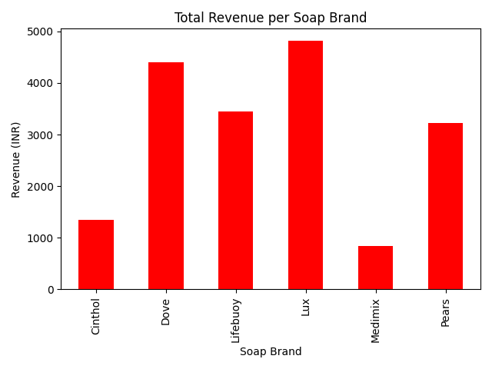
monthly_quantity.png
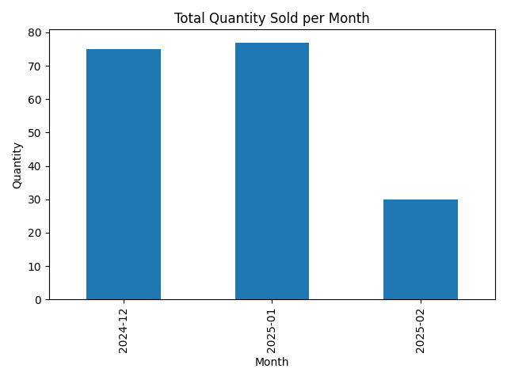

monthly_revenue.png
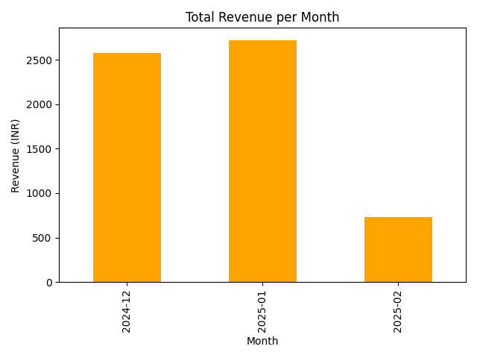

brand_revenue_trend.png
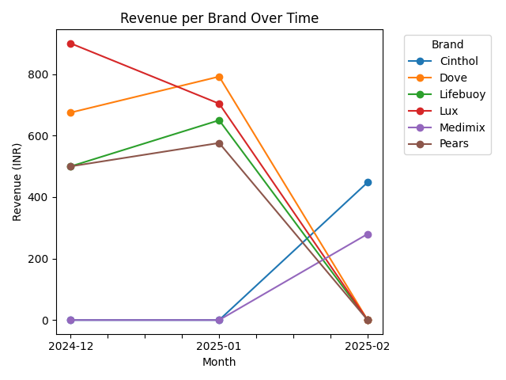
Conclusion
This project helped to demonstrates how to:
- Use SQLite in Python for basic analytics
- Query data using SQL
- Visualize results with Matplotlib
- Simulate real-world product sales

